Local Government Rates

The Local Government Act 1989 allows councils to raise revenue through rates on property which are a type of tax. Councils do this through their annual budgeting process, in consultation with their communities.
Each year the Minister for Local Government determines a rate cap, which has been set at 3.5 per cent for FY 23/24.
Once the rate cap is set, councils are then responsible for setting rates within that cap. This means that councils are only able to increase their total revenue from general rates by 3.5 per cent year on year for FY 23/24. How to apply rates and charges is a decision for individual councils to make in consultation with their community.
The rate cap is not applied to individual property rates, which move in accordance with their individual valuations. Property values are used to allocate the rates paid by individual properties in a municipality. A council determines the amount to be paid in rates by each property by applying a rate in the dollar to the assessed value of each property. Residents can object to their property valuation online here within two months of the issue of the rates notice.

Example:
If a council plans to raise total rate revenue of $50 million, and the total value of all rateable properties in the municipality is $20,000 billion, then the rate in the dollar is calculated by dividing $50 million by $20,000 billion = 0.0025 (the ‘rate in the dollar’).
Each property’s value is then multiplied by 0.0025 to establish how much the property owner must pay in rates.
Each property’s value is different, which means that rates payable by each property are different. In simple terms, higher valued properties tend to pay more in rates compared to lower valued properties in the same municipality.
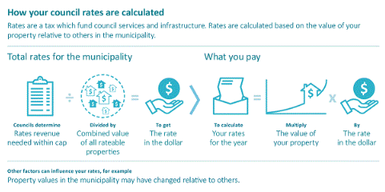

Why are my rates different to my neighbours?
Councils can collect a uniform rate across all properties in council annual budgets, or two or more differential rates for different categories of land. A council may, for example, have differential rates for farmland, various categories of residential property or commercial/industrial properties – each paying a different rate in the dollar.
Changes in rates year to year for each property are often different from the rate cap. Some ratepayers will pay more and some will pay less than the cap amount, depending on the new value of their property in relation to other properties in their municipality.
Service Rates and Charges
A council is able to levy a service rate or charge for kerbside waste and recycling collection services. This appears as a sperate item on the rate notice. Most councils offer additional or larger bins on request, along with hard rubbish collection services.

Finding it difficult to pay your rates?

Councils may charge interest on overdue payment. Victorian councils offer financial hardship provisions for those experiencing financial stress, including a payment plan. Anyone facing difficulties paying their rates should contact their council for assistance and advice.
Need more info? Visit https://www.localgovernment.vic.gov.au/council-innovation-and-performance/council-rates-and-charges

