Local Government Performance Reporting Framework
Directions Paper

December 2012

Authorised and published by the Victorian Government 2012
Local Government Victoria
Department of Planning and Community Development
1 Spring Street, Melbourne VIC 3000

Telephone 03 9208 3631
Email performance@dpcd.vic.gov.au
Web www.dpcd.vic.gov.au/localgovernment/performance-reporting

Disclaimer

This paper is intended for discussion purposes only and does not represent final policy or commitment to a particular course of action.

TABLE OF CONTENTS
1. Foreword 1
2. The need for a new framework 3
2.1. Current reporting 3
2.2. Objective of a new framework 3
3. Features of the new framework 4
3.1. Based on a conceptual model 4
3.2. Builds a comprehensive picture of performance 5
3.3. Minimises the reporting burden 7
3.4. Allows for meaningful comparisons 7
3.5. Implementation support 7
3.6. Enabled through legislation 8
3.7. Aligned to audit requirements 8
4. Delivering the new framework 9
4.1. Project implementation 9
4.2. Stakeholder input 9
4.3. Monitoring and evaluation 11
5. Your feedback 12
6. Further reading 13
Appendix A: ESC indicators 14
Appendix B: Existing reporting requirements 16
Appendix C: Local Government Reform Strategy Reference Group 17

Foreword
Effective local government is the backbone of strong communities. It is responsible for aspects of everyday life that people care about deeply – from vibrant and safe public spaces, to well-stocked libraries, to strong local business and employment opportunities. Effective performance reporting by councils is essential for ensuring accountability to residents and ratepayers as to how public money is being spent and the quality of services delivered.
Improved performance reporting by local government has been a topic of discussion in Victoria for more than a decade. The issue has been shaped in recent years by increased attention from the Victorian Auditor General’s Office (VAGO) on council reporting. In 2008 VAGO undertook an audit of performance reporting by local government which found that, for most councils, reporting had limited relevance to ratepayers because it lacked information about the quality of council services, the outcomes being achieved and how these related to councils’ strategic objectives.
In 2009 the then Minister for Finance asked the Essential Services Commission (ESC) to develop and implement a statewide performance monitoring framework for local government service delivery. Following extensive engagement with the sector, the ESC released a prototype report in 2010 which included an assessment of council performance against 17 or 18 service indicators and between 17 and 20 supporting indicators (see Appendix A).
In 2012 VAGO undertook a follow-up audit to assess the effectiveness of existing local government performance reporting arrangements and the adequacy of statewide initiatives to assist the sector to achieve better practice performance reporting. VAGO found that while some improvements were evident since the 2008 audit, performance reporting by councils on the whole remained inadequate. Further to this, VAGO has indicated from the 2014-2015 financial year onwards they will be auditing council performance statements on the basis of performance measures which fulfil the criteria of relevance and appropriateness.
The Minister for Local Government recognises the need for better performance reporting by councils and has committed to developing a performance reporting framework that will be compulsory for councils for the 2014-2015 financial year. The timeline for implementation will incorporate a 12 month voluntary implementation and refinement process and will also assist councils prepare for the changes to the VAGO audit approach. The Local Government Performance Reporting Framework (LGPRF) project will be delivered by the Department of Planning and Community Development (DPCD), through Local Government Victoria (LGV) in close collaboration with the sector.
The LGPRF will build on the service indicators developed by the ESC and where possible data used for performance monitoring will be drawn from existing sources. The Victorian Government is also reviewing current local government reporting obligations to identify reductions which offset any additional requirements arising from implementation of the LGPRF.
This Directions Paper outlines the key features of a new performance reporting framework for local government and the approach to implementation. It is intended to invite discussion and highlight opportunities to participate in development of a new performance reporting framework for local government.
Improved performance monitoring by councils combined with meaningful data analysis and reporting will improve public accountability as well as provide evidence and opportunities for councils and the Victorian Government to drive and support continuous improvement.

The need for a new framework

Current reporting
The Local Government Act 1989 (the Act) is the main legislative instrument for Victoria’s 79 councils. A number of reforms to the Act in 2003 combined with the introduction of the Local Government (Finance and Reporting) Regulations 2004 (the Regulations) have established the current financial management and public reporting requirements. Much progress has been made by councils to adapt to these requirements and support improved reporting.
Whilst the 2003 changes to the Act have improved transparency and accountability of public reporting by councils, the current requirements are not well integrated. There are currently eight separate sections and regulations which require performance reporting impacting on all key council strategic planning, budgeting and annual reporting documents (see Appendix B). In addition, councils are regularly required to report on a range of activities to State and Commonwealth Government departments. These reporting requirements are varied and can include administration of grants, reporting on compliance with other regulations and participation in sector customer satisfaction surveys. Further, many councils’ choose to disclose information about their performance above and beyond the minimum standards prescribed by legislation.
The current system of local government performance reporting ensures a base level of accountability, however it does not provide communities with an accurate and comprehensive picture of council performance. The system is made up of separate reporting requirements many of which are not made public and require a range of council resources. Local government would benefit from a streamlined and structured reporting system which provides meaningful information on the effectiveness, efficiency, and quality of each council’s performance.

Objective of a new framework
The objective of the LGPRF is to provide comprehensive performance information that meets the needs of all stakeholders. In meeting this objective:
- councils will have information to support strategic decision making and continuous improvement;
- communities will have information about council performance and productivity;
- regulators will have information that complies with relevant reporting requirements; and
- State and Commonwealth Governments will have information that informs capacity building and investment decisions.

Features of the new framework
Measuring local government performance is not a new concept and there is much that can be learnt from best practice examples. Further learnings specific to the Victorian local government context can be gained from the ESC initiative. In reviewing these examples, key features of an effective performance reporting system can be observed, including that the framework:
- is based on a robust conceptual model;
- builds a comprehensive picture of performance;
- minimises the reporting burden;
- allows for meaningful comparisons of performance;
- is accompanied by implementation support and guidance;
- is enabled through legislation; and
- is aligned to audit requirements.
These best practice features will be incorporated into the LGPRF and are discussed in turn below.

Based on a conceptual model
Conceptual models support performance reporting because they define the scope of an enquiry, describe important concepts associated with a topic and organise information into a logical understandable structure. While conceptual frameworks involve some assumptions, they bring together information and data which can then be presented and contextualised to improve understanding.
Applying a common conceptual framework has a number of benefits, including that it provides:
- a consistent model to assess performance across common service areas;
- greater scope for councils to learn from and collaborate with one another; and
- a capacity to systematically address measurement issues that might arise as a result of the framework.
It is proposed that the LGPRF is based on a robust conceptual model such as that outlined in Figure 1. This model reflects the process through which inputs can be transformed into outputs and outcomes in order to achieve desired program or service objectives.

Figure 1. Conceptual Model for Performance Reporting
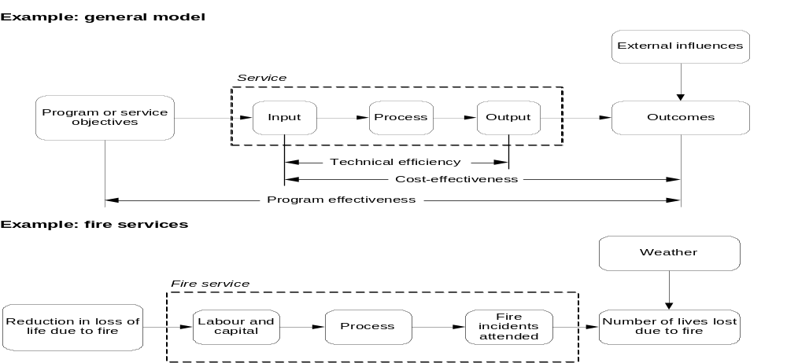
The model distinguishes between efficiency (the ratio of inputs to outputs) and effectiveness (the ratio of inputs to outcomes), and also recognises that other influences affect overall program or service effectiveness (the extent to which outcomes achieve the objectives of the service).
Adoption of a conceptual model that focuses on outputs and outcomes, such as that outlined in Figure 1, represents a major departure from the traditional focus of reporting on inputs. Reporting on outputs and outcomes helps to shift the focus from the level of resources allocated to how efficiently and effectively those resources are used.

Builds a comprehensive picture of performance
With a strong conceptual model to underpin the framework, it is also important that the LGPRF builds a comprehensive picture of council performance. As such, the new framework will be based on a set of core indicators that measures:
- both financial and non-financial performance;
- effectiveness – how well the outcomes of a service achieve the stated objectives;
- efficiency – how well resources (inputs) are used to produce outputs and outcomes, expressed as a ratio of outputs to inputs; and
- quality – the extent to which a service is suited to its purpose, conforms to specifications and meets users’ needs.
To implement the LGPRF, LGV will develop sets of indicators across three thematic areas as outlined in Figure 2 below.
Figure 2. LGPRF indicator sets
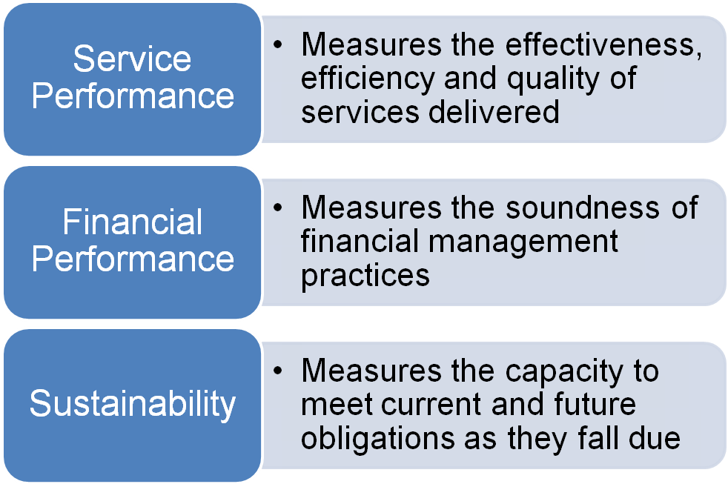

Service performance
The service performance indicator set will be informed by the service and supporting indicators developed by the ESC (see Appendix A) as well as the outcomes of the best value review project being undertaken by LGV. Service indicators relevant to local government will also be sourced from the Productivity Commission’s annual ‘Report on Government Services’.
Opportunities to align the annual statewide Community Satisfaction Survey and to use existing data collection processes will be examined in the development of the service performance indicators.

Financial performance
The financial performance indicator set will be informed by the current suite of financial indicators reported on in the audited financial statements required to be prepared by councils annually in accordance with the Act.

Sustainability
The sustainability indicator set is designed to provide insight into the sustainability of councils and their capacity to meet current and future service, infrastructure and other obligations as they fall due. The sustainability indicator set will be informed by VAGO’s six financial sustainability risk indicators and current research work being led by LGV in collaboration with peak bodies and subject-matter experts into the long term sustainability of local government.

Minimises the reporting burden
There are a number of government reporting requirements placed on local government. One of the aims of the project is to reduce the reporting burden on councils by streamlining current reporting requirements and utilise existing data sources in the implementation of the LGPRF.
LGV is leading a concurrent project across government to streamline existing reporting requirements and enhance the use of the data being collected. Streamlining current local government reporting requirements will work to offset additional requirements that may arise from implementation of the LGPRF.

Allows for meaningful comparisons
Performance measures are more useful when appropriate comparisons are developed and provided on a longitudinal basis. Sector-wide reporting and council comparisons will be a key feature of the new framework. This is central to establishing a performance assessment and reporting regime that meets community and government expectations. Meaningful comparisons can also enable councils to identify others that are delivering better or more cost-effective services, from which they can learn. Performance information will be reported in two ways.
First, performance will be reported in councils’ individual annual budget and the performance statement with the budgeted and actual results audited annually by VAGO. Councils will have the opportunity to include comments on the variances and provide contextual information.
Second, the data will be aggregated and analysed by LGV and publicly communicated in an annual report on sector performance. The Victorian Government recognises that no two councils are the same and as such the report will include contextual information, for example population size and demographics; geographic information; environmental conditions and local economic and socio-economic trends. Possible analysis could include individual, regional, common attribute and sector-wide comparisons. Further work will be undertaken to determine appropriate factors on which to base council comparisons.
The Victorian Government is committed to reporting in a timely manner in order to make information available to the sector to support informed decision-making, drive continuous improvement and foster innovation.

Implementation support
Improved performance reporting will be a significant challenge for local government and there is a role for the Victorian Government to support councils during the LGPRF implementation. A range of guidance and implementation support will be developed as part of the project including training for officers to ensure the performance reporting is completed accurately and in a timely way and for councillors and senior officers to understand and interpret the results.

Enabled through legislation
The commitment by the Victorian Government to implement a compulsory performance reporting framework for local government will require consideration of the existing reporting requirements. As part of this task, LGV will identify opportunities to make the current reporting requirements more streamlined and effective to support the LGPRF and create a more integrated approach to local government strategic planning and reporting. An integrated approach will strengthen transparency of decision-making for communities and support better decision-making by councils.

Aligned to audit requirements
There is an opportunity to better align council performance reporting with the priorities for external assessment. VAGO currently undertakes annual audits of council performance statements and expresses its opinion on the basis of presenting fairly in accordance with the Act. From the 2014-2015 financial year the audit opinion will be expressed on the basis of:
- appropriateness: the measures provide sufficient information to support the interpretation and assessment of actual performance;
- relevance: the measures have a logical and consistent relationship to the council’s objectives and desired outcomes;
- fair presentation: the measures must be measurable and represent actual performance; and
- auditable: the measures are supported by quantifiable, consistent and verifiable data.
This change in audit opinion will place greater emphasis on the development of appropriate and relevant performance indicators and the LGPRF will aim to assist councils in this audit process.

Delivering the new framework

Project implementation
The project will be delivered in three phases over the 2012-13 and 2013-14 financial years, with implementation of the first mandatory reporting period commencing in the 2014-15 financial year, as outlined in Figure 3 below.

Figure 3. Timeline

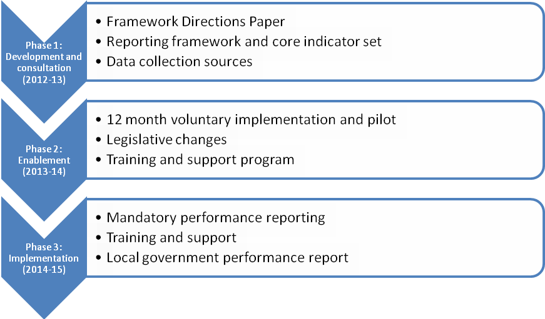
An initial set of indicators will be developed and trialled on a voluntary basis during a 12 month period, throughout which there will be opportunities to refine and develop the LGPRF. Input can be provided up until the legislative changes are enacted to make the LGPRF compulsory for councils.

Stakeholder input
There will be challenges in developing a suite of indicators which meet the needs of all stakeholders. To ensure the project achieves its objectives, input will be sought from a range of stakeholders.

Local Government Expert Advisors
LGV has appointed former local government Chief Executive Officers (CEOs), Michael Ulbrick and Mark Davies to guide the projects implementation. Michael will be the key advisor on sector liaison, providing leadership on engagement with local government, peak bodies and key stakeholders to implement the LGPRF. Mark will be the key advisor on project implementation, providing leadership on system design, indicator set development, legislative change and performance reporting.

Technical Working Groups
The project will be supported by three technical working groups sourced from the local government sector that will undertake the technical work of defining indicators, addressing potential implementation issues and producing supporting documentation across each of the three indicator sets. A working paper outlining the draft framework and indicator sets will be released for public consultation and input in April/May 2013.

Local Government Reform Strategy Reference Group
A Local Government Reform Strategy (LGRS) Reference Group will provide high level advice and input to the project. The LGRS Reference Group will be chaired by the Executive Director, LGV with membership drawn from sector peak bodies, local government CEOs, VAGO and the Local Government Investigations and Compliance Inspectorate. The members for 2012-2014 are included at Appendix C.

Local Government Ministerial-Mayors Advisory Panel
The Local Government Ministerial-Mayors Advisory Panel (MMAP) will provide an elected voice and input to the project. Mayors are appointed to the MMAP by the Minister for Local Government and are appointed in their individual capacity on account of their insights into the operations of councils and local government views on particular issues.

Local Government Inter-departmental Network
The reducing reporting burden project will be undertaken in consultation with the Local Government Inter-departmental Network (LGIDN). The LGIDN membership is drawn from each of the 11 Victorian Government departments. The LGIDN will be tasked with leading the reporting mapping and streamlining work for each department with guidance and support from LGV.

Community input
The LGPRF seeks to provide communities with information about council performance and productivity in terms that can be easily understood. Input will be sought from members of the community in relation to the draft indicator set and the content and form of the annual report on sector performance.
Figure 4. Stakeholder engagement
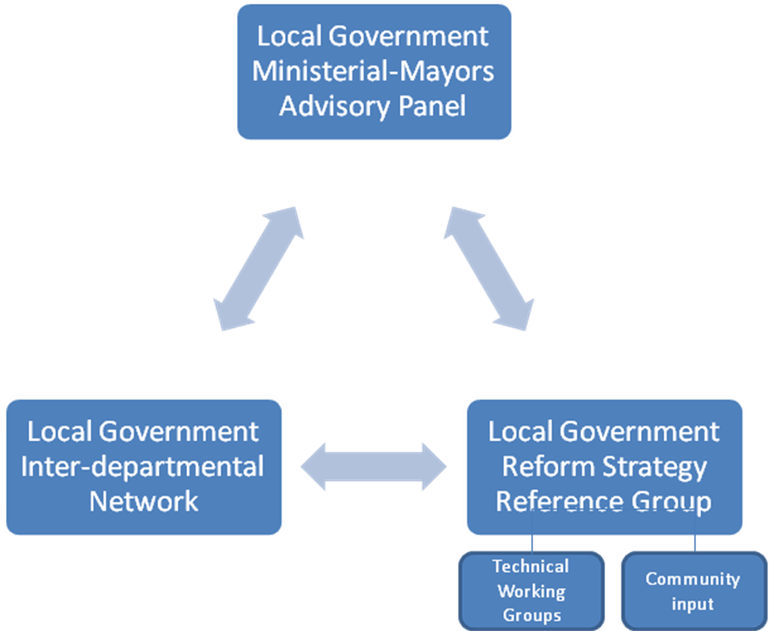

Monitoring and evaluation
The LGPRF will be monitored and evaluated throughout its implementation.
Sector-wide input will be sought at the draft indicator stage and throughout the voluntary adoption period up until the development of legislation.
At the end of the implementation phase, an ongoing monitoring process will be established to measure the participation of councils, monitor the achievement of program goals to track progress and identify program issues.

Your feedback
LGV would like to hear what you think of the ideas presented in this Directions Paper and what other ideas you may have on a new performance reporting framework for Victorian councils.
Interested stakeholders are invited to join a discussion about the project via the online discussion forum at
www.dpcd.vic.gov.au/localgovernment/performance-reporting
Feedback can also be sent via email to performance@dpcd.vic.gov.au
Formal submissions and sector input will be sought in relation the draft framework and indicator sets in April/May 2013.

Further reading
Australian Productivity Commission, 2010, “Review of the Report on Government Services’ performance indicator framework” viewed 12 November 2012, http://www.pc.gov.au/__data/assets/pdf_file/0006/102957/independent-reference-group-report.pdf
Essential Services Commission, 2010, “Establishing a Victorian Local Government Services Report, Final Report” June, Melbourne.
Victorian Auditor-General’s Office, 2001, “Departmental performance management and reporting” viewed 14 November 2012, http://download.audit.vic.gov.au/files/dpmr_report.pdf
Victorian Auditor-General’s Office, 2008, “Performance Reporting in Local Government”, viewed 17 April 2012, http://download.audit.vic.gov.au/files/20080611-Local-Government-Performance-Reporting.pdf
Victorian Auditor-General’s Office, 2012, “Performance Reporting in Local Government”, viewed 17 April 2012, http://www.audit.vic.gov.au/publications/20120418-LG-Reporting/20120418-LG-Reporting.pdf

Appendix A: ESC indicators
Figure 5. Service indicators
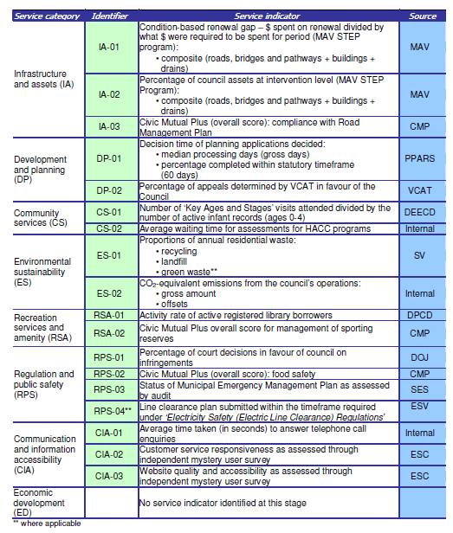

Figure 6. Supporting indicators
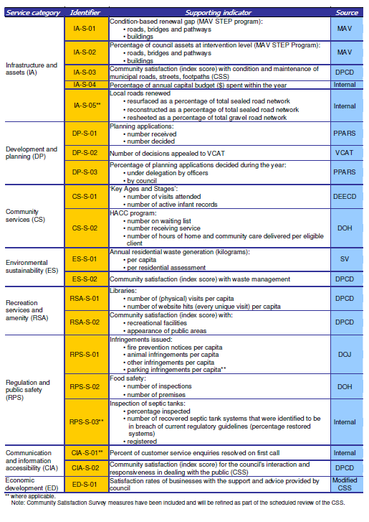

Appendix B: Existing reporting requirements
Existing performance reporting requirements in the Local Government Act 1989 and Local Government (Finance and Reporting) Regulations 2004:
- Council Plan: strategic indicators for monitoring the achievement of objectives must be included in the council plan
- Annual Budget: separately identified key strategic activities and performance targets and measures for monitoring the key strategic activities must be included in the annual budget
- Annual Report: a council must in respect of each financial year prepare an annual reporting containing:
  - a report on the council’s operations during the financial year
  - audited standard statements for the financial year
  - audited financial statements for the financial year
  - a copy of the performance statement prepared under section 132
  - a copy of the report on the performance statement prepared under section 133
  - any other matter required by the regulations
- Performance Statement: the actual results achieved for key strategic activities having regard to the performance targets and measures to be included in the annual report must be included in the performance statement
- Best Value Principles: a report to the community on what has been done to ensure compliance with the Best Value Principles
- Performance against strategic indicators: a statement which reviews the performance of the council against the council plan including outcomes in relation to the strategic indicators to be included in the annual report
- Equal opportunity: a statement of the objectives and indicators of any equal opportunity program to be included in the annual report
- Financial ratios: a set of financial ratios to be included in the financial statements which is to be included in the annual report.

Appendix C: Local Government Reform Strategy Reference Group
The members of the Local Government Reform Strategy Reference Group for 2012-2014 are:
- Ms Kendrea Pope, Acting Executive Director, LGV (Chair)
- Mr Mark Grant, Acting Director Sector Development, LGV (Deputy Chair)
- Mr Rob Spence, Chief Executive Officer, Municipal Association of Victoria
- Mr Graeme Emonson, President, Local Government Professionals Inc.
- Dr Kathy Alexander, Chief Executive Officer, Melbourne City Council
- Ms Helen Anstis, Chief Executive Officer, Baw Baw Shire Council
- Ms Noelene Duff, Chief Executive Officer, Whitehorse City Council
- Mr Stephen Griffin, Chief Executive Officer, Greater Geelong City Council
- Mr David Madden, Chief Executive Officer, Moyne Shire Council
- Mr Craig Niemann, Chief Executive Officer, Greater Bendigo City Council
- Mr Andrew Newton, Chief Executive Officer, Glen Eira City Council
- Ms Juliana Phelps, Chief Executive Officer, Towong Shire Council
- Mr Anthony Schinck, Chief Executive Officer, Ballarat City Council
- Ms Kerry Thompson, Chief Executive Officer, Wyndham City Council
LGV has invited the following officers as observers:
- Mr David Wolf, Chief Municipal Inspector, Local Government Investigations and Compliance Inspectorate
- Mr Ron Mak, Director, Victorian Auditor-General’s Office

VAGO Report on Performance Reporting by Local Government, April, 2008.
Service indicators were intended to convey relatively clear information on performance, based on measurable outputs. The supporting indicators provide for a more comprehensive understanding of the underlying services, but were not in their own right indicative of whether higher or lower performance was preferable.
VAGO report on Performance Reporting by Local Government, April 2012.
That is, that performance indicators have a logical and consistent relationship to council objectives, and that there is appropriate contextual information to interpret results and form a conclusion.
From the Australian Productivity Commission (2010) Review of the Report on Government Services’ performance indicator framework, page 10.
From the Australian Productivity Commission (2010) Review of the Report on Government Services’ performance indicator framework, Figure 3.2, page 11.
Section 131 of the Local Government Act 1989.
Through a review of relevant sections of the Local Government Act 1989 and Local Government (Finance and Reporting) Regulations 2004.
Further definitions for audit assessment of performance indicators can be found in Table 1B, section 1.16 of the Victorian Auditor-General Office 2001 report Departmental performance management and reporting.
Section 125(2)(c) of the Local Government Act 1989
Section 127(2) of the Local Government Act 1989
Section 131(1)(a) of the Local Government Act 1989
Section 132 of the Local Government Act 1989
Section 208G of the Local Government Act 1989
Regulation 11(a) of the Local Government (Finance and Reporting) Regulations 2004
Regulation 11(i) of the Local Government (Finance and Reporting) Regulations 2004
Regulation 15 of the Local Government (Finance and Reporting) Regulations 2004

