Councils & Emergencies
Phase Three Regional Consultation Report
June 2021

Liability limited by a scheme approved under Professional Standards Legislation. Member of Deloitte Asia Pacific Limited and the Deloitte organisation. © [2021] [Deloitte Risk Advisory Pty Ltd/ Deloitte Touche Tohmatsu].

Content Page
Executive summary 05
Introduction 07
Councils and Emergencies Project 07
Purpose of this report 07
Wider emergency management reforms 07
Consultation Overview 08
Workshops 08
Interviews 09
Capability & Capacity Issues 10
- People 12
- Resources 15
- Governance 16
- Systems 18
- Processes 19
- Other 21
Actions Identified for Capability & Capacity Issues 22

The Services provided are advisory in nature and have not been conducted in accordance with the standards issued by the Australian Auditing and Assurance Standards Board and consequently no opinions or conclusions under these standards are expressed.
Because of the inherent limitations of any internal control structure, it is possible that errors or irregularities may occur and not be detected. The matters raised in this report are only those which came to our attention during the course of performing our procedures and are not necessarily a comprehensive statement of all the weaknesses that exist or improvements that might be made.
Our work is performed on a sample basis; we cannot, in practice, examine every activity and procedure, nor can we be a substitute for management’s responsibility to maintain adequate controls over all levels of operations and their responsibility to prevent and detect irregularities, including fraud.
Any projection of the evaluation of the control procedures to future periods is subject to the risk that the systems may become inadequate because of changes in conditions, or that the degree of compliance with them may deteriorate.
Recommendations and suggestions for improvement should be assessed by management for their full commercial impact before they are implemented.
We believe that the statements made in this report are accurate, but no warranty of completeness, accuracy, or reliability is given in relation to the statements and representations made by, and the information and documentation provided by Department of Jobs, Precincts and Regions personnel. We have not attempted to verify these sources independently unless otherwise noted within the report

Limitation of Use
This report is intended solely for the information and internal use of the Department of Jobs, Precincts and Regions in accordance with our letter of engagement of 26 April 2021 and is not intended to be and should not be used by any other person or entity. No other person or entity is entitled to rely, in any manner, or for any purpose, on this report. We do not accept or assume responsibility to anyone other than of the Department of Jobs, Precincts and Regions for our work, for this report, or for any reliance which may be placed on this report by any party other than of the Department of Jobs, Precincts and Regions.
Deloitte refers to one or more of Deloitte Touche Tohmatsu Limited (“DTTL”), its global network of member firms, and their related entities (collectively, the “Deloitte organisation”). DTTL (also referred to as “Deloitte Global”) and each of its member firms and related entities
are legally separate and independent entities, which cannot obligate or bind each other in respect of third parties. DTTL and each DTTL member firm and related entity is liable only for its own acts and omissions, and not those of each other. DTTL does not provide services to clients. Please see www.deloitte.com/about to learn more.

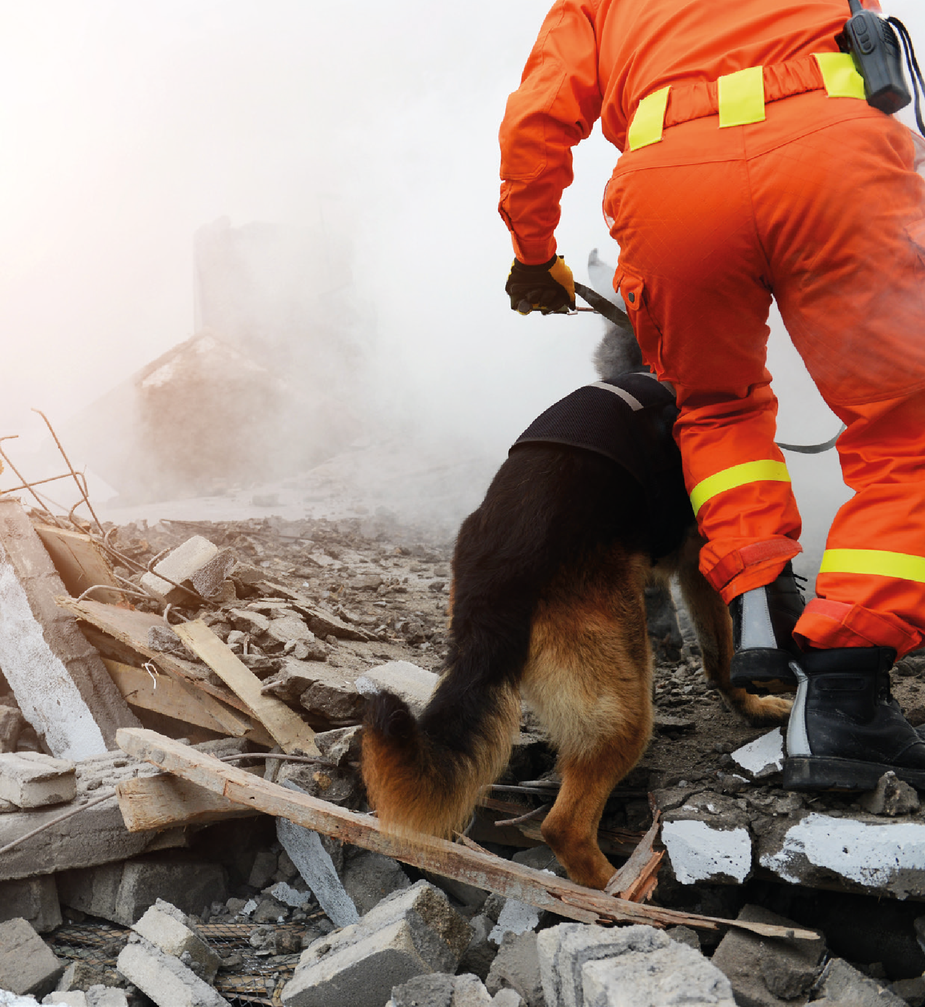

Nine council consultation sessions and eleven agency interviews were conducted with a common aim of enabling the Department of Jobs, Precincts and Regions to further understand councils’ emergency management capability and capacity issues and identify strategies and actions to address these issues.

Executive summary

Victoria has a long history of disasters that are linked to natural hazards. Climate change has resulted in an increase in both the frequency and intensity of extreme weather events globally, with further rises expected over the next several decades. Floods and fires are likely to occur more often due to an increased frequency of heatwaves, record high temperatures and reduced annual average rainfall in some areas. More concurrent and consecutive hazard events can also be expected.
Victoria is committed to building safer and more resilient communities. As the level of government closest to communities, councils are a critical partner in the delivery of emergency management in Victoria. The 94 emergency management responsibilities and activities identified for councils in the Councils and Emergencies Position Paper, is a clear testament to the central and indispensable role that councils play in supporting communities before, during and after emergencies.
The Councils and Emergencies Project provides a unique opportunity for local governments and the sector to evaluate and address areas for improvement in their emergency management capacity and capability. The Councils and Emergencies project is a multi-year, three phase project which aims to enhance the emergency management capability and capacity of local governments to meet their emergency management obligations. It is aligned with priority four of the Victorian Emergency Management Strategic Action Plan 2019 – 2022, which seeks
to address the following challenge: “Workforces across the sector have variable levels of capacity and capability as well as different organisational cultures and values. A more consistent, collaborative, integrated and innovative approach towards workforce management and services is needed.”
The project has already completed two phases. Phase One clarified and confirmed the emergency management responsibilities and activities of councils and produced the Councils and Emergencies Position Paper in 2017. Phase Two provided an understanding of councils’ emergency management capability and capacity based on the needs and risk profile of each municipality. It produced the Councils and Emergency Capability and Capacity Evaluation Report in 2019.
With 59% of councils identified as below their target maturity in Phase Two, the focus of Phase Three is on the development of strategies and action plans to increase the capability and capacity required to fulfil their critical on-the-ground role in emergency management. As part of Phase Three, this project undertook extensive consultation with councils and agencies with the objective of:
- Confirming capability and capacity issues following Phase Two of the Councils and Emergencies Project.
- Generating actions/projects that could address these capability and capacity issues and areas for improvement.
- Ensuring that councils as critical stakeholders feel that their perspectives have been heard and that the diversity of their contexts and perspectives are recognized.
- Support councils to better understand how this project will support them to deliver their emergency management responsibilities.
A total of nine workshops were held from 26 May 2021 to 10 June 2021. The workshops covered all eight emergency management regions in Victoria, with a final virtual session held for those who were unable to attend prior sessions. Additionally, a series of eleven interviews were held with a range of agencies that play a pivotal role in emergency management.
Although the Department of Jobs, Precincts and Regions had planned for all workshops and most interviews to be conducted face-to-face, the return of COVID-19 circuit breaker restrictions on 27 May 2021 resulted in all workshops and interviews being conducted virtually via Zoom.
In all, a total of 126 Local Government employees attended the workshops, representing 71 of the 79 Victorian councils. During the consultation period, both the return of circuit breaker restrictions and a severe storm event that impacted the State of Victoria from 9 June 2021 prevented some councils and agencies from actively participating in workshops and interviews.

1 https://naturaldisaster.royalcommission.gov.au/publications/html-report/chapter-02

This project has confirmed many of the capability and capacity issues identified during Phase Two of the Councils and Emergencies Project. A range of ideas for actions to address these issues were generated by workshop participants. These ideas will need to be further developed, including consideration of the costs, benefits and other impacts.
Key themes on council capability and capacity identified from this project include:
- People
  - Lack of trained staff for emergency management
  - Lack of experienced emergency management planning staff
  - Further staff supports and recognition within emergency management
  - Challenges with balancing emergency management responsibilities with BAU roles
  - Loss of organisational knowledge and impacts on capability due high staff turnover
  - Boosting capacity from external sources
- Resources
  - Outdated relief and recovery centres
  - Lack of transport resources
- Governance
  - Inconsistent funding arrangements
  - Insufficient funding arrangements
  - Lack of clear direction and complex reporting requirements given by State
  - Relationship with agencies and the broader emergency management sector
  - Emergency management budget allocation within councils
  - Emergency management profile within councils
- Systems
  - Lack of standardised training for emergency management
  - Emergency management training is not available or accessible
  - Difficulty navigating existing platforms and applications
  - Lack of standardised IT platforms
- Processes
  - Unstandardised and inconsistent processes
  - Criticality of resource sharing
  - Challenges with maintaining community engagement in emergency management
  - Lack of consistent IT hardware guidelines
- Other
  - Differing geographic risk profiles and changing demographics and cultural profiles must be taken into account in emergency management planning

Introduction

Councils and Emergencies Project
The Councils and Emergencies Project provides a unique opportunity for local governments and the sector to evaluate and address areas for improvement in their emergency management capacity and capability. The Councils and Emergencies project is a multi-year, three phased project that aims to enhance the emergency management capability and capacity of local governments to meet their emergency management obligations. It is aligned with priority four of the Victorian Emergency Management Strategic Action Plan 2019 – 2022, which seeks
to address the following challenge: “Workforces across the sector have variable levels of capacity and capability as well as different organisational cultures and values. A more consistent, collaborative, integrated and innovative approach towards workforce management and services is needed.”
The project has already completed two phases. Phase One of the Project published a position paper in 2017 describing councils’ emergency management responsibilities and activities. Phase Two established a baseline understanding of councils’ emergency management capability and capacity relative to the requirements and risk profile of each of Victoria’s 79 municipalities. The Phase Two report was published in 2019, prior to the East Victoria Bushfires of 2019-2020 which highlighted specific emergency management issues and prompted the Inspector General for Emergency Management (IGEM) Inquiry.
Phase Two identified a range of capability and capacity issues and state-wide areas for improvement, including issues related to:
- Capability issues: Organisational knowledge, emergency event experience, training, procedures, and organisational changes
- Capacity issues: staffing (before, during and after), budget, funding, procedures, geographic size, and population
- State-wide areas for improvement: relief and recovery, integration with business as usual, community engagement
in emergency management, further clarification of council roles in emergency management, and budget and funding
With 59% of councils identified as below their target maturity in Phase Two, the focus of Phase Three is on developing
strategies and action plans to increase the capability and capacity required to fulfil their critical on-the-ground role in emergency management.

Purpose of this report
This report provides an overview of feedback received from
(a) workshops conducted with councils across all eight emergency management regions, and (b) a series of interviews with key agencies. The objective of these engagements was to confirm the capability and capacity issues and areas for improvement identified in Phase Two of the Project and to elicit views on what other actions could be put in place to address these issues.
In developing this report, information obtained in the workshops was synthesised to identify common themes and create a list of ideas for potential future projects or actions. This report will be used to develop a multi-year action plan containing a prioritised list of projects that will enhance the capability and capacity of councils to meet their emergency management obligations.
Stakeholders will be engaged in the development of this action plan which will be delivered by December 2021.

Wider emergency management reforms
There is a large reform program underway across the emergency sector in response to several emergency inquiries and recent incidents. The Councils and Emergencies Project provides a response to recommendations from the IGEM Inquiry into the 2019– 20 Victorian Fire Season. Recommendation 15 and Action 15.3 are relevant to this Project:
Recommendation 15: The Inspector-General for Emergency Management recommends that Emergency Management Victoria collaborate with the emergency management sector to develop
a capacity model that considers current and future a) career and volunteer emergency management personnel requirements b) identified and trained personnel for surge requirements c) emergency risks and climate scenarios.
Action 15.3: Local Government Victoria will continue its work with local government authorities to implement its Councils and Emergencies Project. This multi-year project utilises the Victorian Preparedness Framework to model capability and capacity of local government in emergency management.

Consultation Overview

Consultation was undertaken through a series of workshops with councils and interviews with agencies. The objectives of the consultation was to:
- Confirm capability and capacity issues identified in Phase Two of the Project.
- Generate actions/projects that could address these capability and capacity issues.
- Ensure that local councils as critical stakeholders feel that their perspectives have been heard and that the diversity of their contexts and perspectives are recognized.
- Support councils to better understand how this project will support them to deliver their emergency management responsibilities.
All consultation was facilitated by Deloitte.

Workshops
As detailed in Table 1, a total of nine workshops were conducted from 26 May 2021 to 10 June 2021. The workshops covered all eight emergency management regions in Victoria, with a final virtual session held for those who were unable to attend prior sessions.
Although the Department of Jobs, Precincts and Regions had planned for all workshops and most interviews to be conducted face-to-face, the return of COVID-19 circuit breaker restrictions on 27 May 2021 resulted in all workshops and interviews conducted virtually via Zoom.
In all, a total of 126 Local Government employees attended the workshops. Attendees were primarily council staff in emergency management roles, including for example, Municipal Emergency Management Officers (MEMO), and Municipal Recovery Managers (MRM). They represented 71 of the 79 councils in the State
of Victoria. Representatives from the Inspector-General for Emergency Management and the Municipal Association of Victoria attended in an observer capacity. In addition to the COVID-19 restrictions mentioned above, on 9 June 2021 severe weather event affected the State of Victoria. This prevented some councils from actively participating in workshops.
Each workshop comprised of a series of plenary and break-out group activities. Each activity was completed in two break-out groups, each group had a Deloitte facilitator and notetaker and was typically comprised of 6 – 10 people per group. To encourage impartial feedback and discussion, DJPR did not participate in the break-out groups. Participants completed the following break-out group activities:

- Break-out activity one addressed objective (1) above. In addition to confirming the capability and capacity issues identified during Phase Two of the Project, participants were encouraged to extend on or add to these issues as required. Participants had 40 minutes for this activity.
- Break-out activity two addressed objective (2) above. Participants were invited to brainstorm as many potential activities or projects as they would like, to address capability and capacity issues. They were asked not to be constrained by considerations such as cost or level of effort. Participants had 60 minutes for this activity.

Table 1: Nine workshops were conducted across 8 different emergency management regions.

Region | Date | No. of attendees
Grampians | 26 May 2021 | 12
Loddon Mallee | 27 May 2021 | 13
Barwon South West | 31 May 2021 | 15
Gippsland | 2 June 2021 | 14
Southern Metropolitan | 3 June 2021 | 15
Eastern Metropolitan | 7 June 2021 | 17
North Western Metropolitan | 8 June 2021 | 22
Hume | 9 June 2021 | 17
Combined virtual session | 10 June 2021 | 6

Interviews
In addition to the above, eleven, one-hour interviews were also conducted with agencies involved in emergency management. Interviewees were a combination of executive-level and officer- level staff with subject matter expertise, council liaison and/or regional roles. The number of representatives per agencies varied.
For some agencies one-on-one interviews were conducted, for others, several staff were interviewed in a small group. Due to a significant storm event in Victoria mentioned above, many of these interviews were delayed. All interviews were conducted by Deloitte. To allow for impartial feedback and discussion, DJPR were not present during these interviews.

Table 2: Eleven agencies interviewed

Stakeholder | Date
Bushfire Recovery Victoria | 4 June 2021
Department of Jobs, Precincts and Regions (DJPR) – Rural and Regional Victoria | 11 June 2021
Department of Transport (DoT)/VicRoads | 11 June 2021
Red Cross | 15 June 2021
Victoria Police | 15 June 2021
Department of Education (DET) | 15 June 2021
Municipal Association of Victoria (MAV) | 15 June 2021
Ambulance Victoria | 17 June 2021
Department of Justice and Community Safety (DJCS) | 17 June 2021
Fire Rescue Victoria (CFA) | 17 June 2021
Department of Jobs, Precincts and Regions (DJPR) – Agriculture Victoria | 17 June 2021
State Emergency Service (SES) | Rescheduled
Department of Environment, Land, Water and Planning (DELWP) | Rescheduled
Department of Health | Rescheduled
Department of Families, Fairness and Housing (DFFH) | Rescheduled

Capability & Capacity Issues

This section provides an overview of key capability and capacity issues identified during break-out activity one. Break-out activity one asked participants to confirm capability and capacity issues identified during Phase Two of the Project. Participants were also encouraged to extend on or add to these issues as required. Participants had 40 minutes for this
activity. Following the workshops, outputs were reviewed, and common themes were identified. The capability and capacity
issues identified were aligned with the outputs from Councils and Emergencies Phase Two. The themes outlined below were raised by most regions consulted. They are arranged by the Core Capability Elements of the Victorian Preparedness Framework. The Core Capability Elements and a summary of the key themes are outlined in Figure 1. These are provided in more detail on the following pages.

Figure 1: Core Capability Elements of the Victorian Preparedness Framework and key themes identified through consultation

Core Capability Elements

People

All personnel involved in understanding emergency management activities from community, government, agencies and business.
Capability and Capacity Issues
  - Lack of trained staff for emergency management
  - Lack of experienced emergency management planning staff
  - Further staff supports and recognition within emergency management
  - Challenges with balancing emergency management responsibilities with BAU roles
  - Loss of organisational knowledge and impacts to capability due to high staff turnover
  - Boosting capacity from external sources

Resources

The physical equipment and assets needed to undertake emergency management activities.

  - Outdated relief and recovery centres
  - Lack of transport resources

Governance

The enabling factors that emergency management operates within including legislation, funding, arrangements, policy, etc.

  - Inconsistent funding arrangements
  - Insufficient funding arrangements
  - Lack of clear direction and complex reporting requirements given by State
  - Relationship with agencies and the broader emergency management sector
  - Emergency management budget allocation within councils
  - Emergency management profile within councils

Systems
The systems, including data, that are used to deliver emergency management outcomes such
as learning and development, information technology, etc.

  - Lack of standardised training for emergency management
  - Emergency management training is not available or accessible
  - Difficulty navigating existing platforms and applications
  - Lack of standardised IT platforms

Processes
Documented or undocumented ways of delivering emergency management.

  - Unstandardised and inconsistent processes
  - Criticality of resource sharing
  - Challenges with maintaining community engagement in emergency management
  - Lack of consistent IT hardware guidelines

Other

Other issues relating to capability and capacity that do not fall within the given core capability elements.

6.1 Differing geographic risk profiles and changing demographics and cultural profiles must be taken into account in emergency management planning

- People

All personnel involved in undertaking emergency management activities from community, government, agencies and business.
This includes people with appropriate knowledge and skills with
a focus on leadership skills, technical skills and a culture of working as one.
  - Lack of trained staff for emergency management Councils:
- Councils across all regions agree that staff training for emergency
management is critical, particularly for legislated roles, and that such training isn’t adequately available.
- Training for council staff that provide surge capacity for operational support during an emergency is also required.
- Many councils are constrained in their ability to provide staff with the time (including travel) and financial support needed to attend training sessions.
- Many councils have had to place excessive reliance on existing emergency management staff to deliver training. As a result, these staff members are overwhelmed with additional training burdens, which can reduce the quality of training delivered, and impact negatively on their mental health.
- Many councils acknowledged that part-time staff often lack the time to participate in additional emergency management
training, therefore resulting in a difference of training knowledge across staff within the same council.
- Many councils indicated that there is currently an insufficient number of staff trained in emergency management. Councils also expressed concerns around reputational risk for their staff as it leads to a lack of trust which can undermine the cohesiveness of emergency management arrangements given the independence between community and councils. They may face situations for which they are not adequately trained, and later experience repercussions through possible legal actions or formal inquiries. Furthermore, it is a struggle for them to juggle their personal and professional commitments on top of participating in training.
- Councils expressed the lack of formal accreditation and qualification associated with the current emergency management training as it results in a lack of incentive and value for staff to undertake additional training.
Agencies/organisations:
- Many agencies highlighted their concern that recovery staff are often pushed into roles for which they have very little experience and training. It was indicated that this compromises the quality of services delivered and also leads to staff members being fatigued and stressed by their role.

“We’ve all got families, we’ve all got professional responsibilities, we can’t be expected to just drop everything travel 3-4 hours to attend training sessions.”
  - Lack of experienced emergency management planning staff
Councils:
- The majority of councils indicated that the lack of experienced emergency management staff leads to an inefficiency in staff being able to effectively plan, respond and deliver recovery services in an event. Many councils identified the flow-on effect resulting in substandard emergency services for the community and neighbouring councils.
Agencies/organisations:
- Many agencies identified that obtaining skilled resources who understand emergency management as well as relief and recovery is often difficult, especially due to high staff turnover.
- Majority of agencies have observed that the level of emergency management knowledge significantly differs between councils across the State. It was expressed that the high-risk and hazard- prone regions had a much higher level of wisdom and experience compared to metropolitan councils.

  - Further staff supports and recognition within emergency management
Councils:
- There is a general expectation from the community that
emergency management staff are resilient. However, many councils reiterated the mental health burden of emergency management and have urged a focus on mental health support for staff wellbeing and to improve staff retention.
- Many councils indicated that emergency management staff are experiencing extreme fatigue due to the compounding effect of emergencies especially where multiple events overlap. This is particularly the case with the COVID-19 pandemic.
- Many emergency staff work extended shifts due to a lack of shift planning and the absence of staff availability to replace them, therefore leading to fatigue, burnout, and exhaustion.
- Councils indicated that consideration also needs to be given to the mental health of surge staff, who don’t operate within the emergency management domain regularly and could therefore be confronted with situations they are not familiar with.
- Councils expressed that staff need to be recognised for the extra time and effort that they put into their added roles, particularly in times of emergency events. Currently, there is no form of any recognition for going the extra mile.
- Many councils indicated that high turnover of staff is strongly linked to fatigue and burn out. It was expressed that many staff members are struggling to have work/life balance. Inadequate rest and concurrent emergency events, are contributing to staff leaving.
- Tight timeframes often results in increased job pressures with staff being snowed under with work and minimal resources, therefore greatly affecting their mental health.
Agencies/organisations:
- Many agencies acknowledged the lack of support mechanisms for staff dealing with a highly traumatised community after an event. It was also expressed that emergency management staff struggle with resilience as a result of the community trauma.

“The community expects emergency management staff to be the resilient ones, and that they can roll through this. People easily assume that they are okay, and that they don’t need any help.”
  - Challenges with balancing emergency management responsibilities with BAU roles
Councils:
- Councils highlighted that emergency management staff face significant pressure to balance multiple demands as some emergency management roles, such as Municipal Recovery Manager (MRM) and Municipal Emergency Management Officer (MEMO), are held in addition to existing substantive roles.
- The current capacity of smaller council means that staff are already having to balance multiple roles simultaneously in addition to emergency management roles.
- The maintenance of plans and sub-plans is primarily reliant on councils. Council staff are finding it difficult to complete administrative work on top of their operational roles.
- During an emergency event, often staff must ‘volunteer’ in order to boost the capacity and carry out necessary responsibilities.
- The role of a duty officer is often’ voluntary’ as many councils are unable to fund this role.
- Many councils stated that emergency management is often not included in position descriptions.
- Many surge staff do not understand complicated terminology
Agencies/organisations:
- No comments were made in relation to this specific theme.

“We’re snowed under with a mountain of work and minimal resources for emergency management.”

  - Loss of organisational knowledge and impacts to capability
Councils:
- For some councils, the large gap between different types
of emergency events leads to a lack of practice and exercising of event procedures.
- This also affects new starters as they are unable to gain current emergency management experience.
- This issue also extends more broadly to other areas of council.
- There is a lack of knowledge sharing across councils and the State, particularly after an event.
- Councils have acknowledged the lack of a discussion space where emergency management staff can voice common challenges and tactics they use. This would help increase the knowledge of staff across the state and enable them to be better equipped when tackling their own regional events.
- Many councils indicated that executives tend to lack emergency management knowledge, and this is often reflected in their decisions when passed down, especially during event responses.
- Majority of the councils have linked the loss of key emergency management personnel to the difference in roles across the state. It was expressed that staff members often get attracted to a higher salary package offered by other councils and agencies.
Agencies/organisations:
- Many agencies observed there is high staff turnover which consistently results in a loss of knowledge and wisdom across the councils.

“We need to transfer the stuff in people’s minds and write it down somewhere.
There’s an abundance of wisdom that just isn’t being accessed.”
  - Boosting capacity from external sources Councils:
- No comments were made in relation to this specific theme.
Agencies/organisations:
- Many agencies have highlighted the heavy reliance on volunteers and goodwill in times of recovery. It was also observed that many elderly people are on the ground and involved in relief centres during emergencies.

- Resources

The physical equipment and assets needed to undertake emergency management activities. For example infrastructure, fleet, IT equipment, radios, communications equipment, consumables and personal protective clothing and equipment.
  - Outdated relief and recovery centres Councils:
- Many councils have highlighted that recovery centres are
outdated and lack basic amenities. The absence of adequate heating, air-conditioning, power generators and internet was expressed across many of the emergency management regions.
Agencies/organisations:
- No comments were made in relation to this specific theme.
  - Lack of transport resources Councils:
- Many councils have expressed that there are not enough council
vehicles available to transport emergency management staff to relevant training and events.
Agencies/organisations:
- No comments were made in relation to this specific theme.

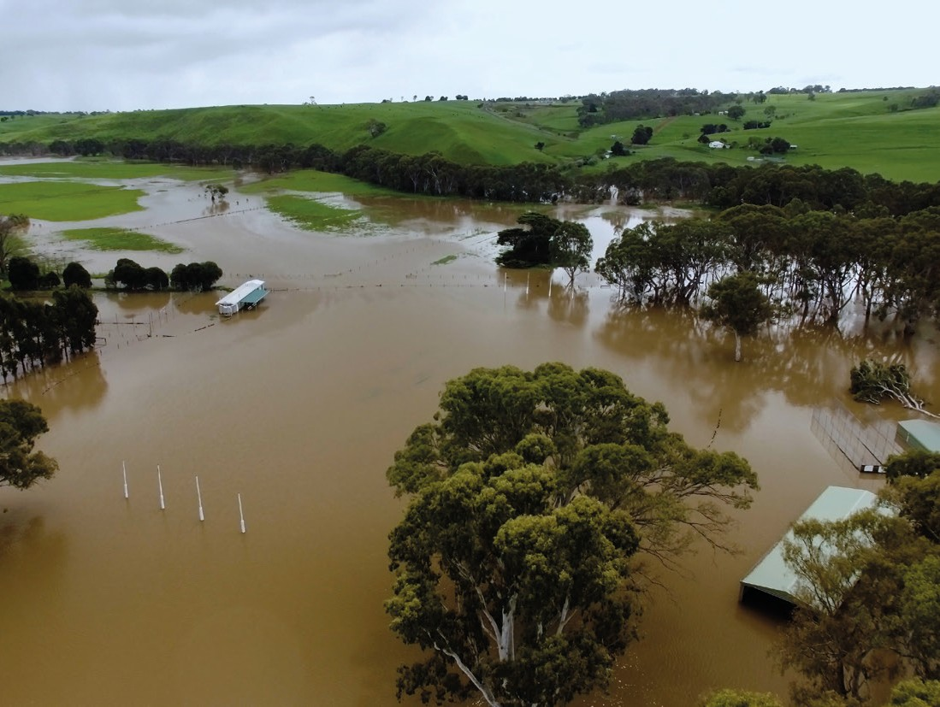

- Governance

The enabling factors that emergency management operates within including legislation, funding, authorising environment, emergency management arrangements, doctrine and policy.
  - Inconsistent funding arrangements Councils:
- Many councils highlighted the starkly differing amounts of
Municipal Emergency Resourcing Program (MERP) funding across the State and noted that these were unfair.
- The uncertainty of the continuation of MERP funding past 2024 was also stressed by many of the councils.
- Councils have indicated a preference for MERP funding to be permanent and recurring so that it can be better embedded into councils’ core business planning.
Agencies/organisations:
- The issue of inconsistent funding between recovery and relief was highlighted by many agencies. It was stated that the response phase of events is often flexible and available whereas in the recovery phase, councils often have to resort to regular funding arrangements.
- It was expressed that councils are often taking on additional financial burden during an emergency, with minimal guarantee that they will be able to recoup the costs from State Government. Thus, many agencies have highlighted the current gap of certainty and clarity in this matter
  - Insufficient funding arrangements Councils:
- Many councils rely on funding received through the MERP. It was
observed that this program has changed very little in recent years and has not been increased to reflect the growing or changing risk profiles.
- Councils have stressed the lack of this funding has resulted in many constraints, particularly within the areas of training, human resources, and project output.
- The tightening and consistent reduction of rate capping was identified as an issue across many councils.
- The Local Governments are finding it extremely difficult to conduct long term recovery and maintain a strong connection with the community as a result of insufficient funding.
- Most councils use MERP funding to fund emergency management roles, which are often part time. This makes it difficult to achieve and undertake emergency roles and responsibilities.
- The need for further funding to support community resilience was identified by several councils. Resilience grants are limited and often require councils to group together to apply.
- Majority of agencies also indicated the lack of additional resources after an event, to engage with affected communities and perform debrief activities.
Agencies/organisations:
- Agencies highlighted that rate capping potentially limits the budget for adequate emergency management within Local Government.
- Many agencies acknowledged the current lack of funding to support Municipal Emergency Management Planning Committees (MEMPC) which councils are a part of.
- Majority of agencies indicated there was a significant lack
of emergency management staff funding for councils across the State.

  - Lack of clear direction and complex reporting requirements from the State Government
Councils:
- Councils have indicated there is a lack of specific funding guidance from the State. Thus, councils have expressed they are often left feeling confused and this lack of clarity limits their ability to produce effective and successful outputs.
- Many councils have highlighted burdensome reporting required by the State as a significant issue. Councils feel that this heavily constrains their time and impacts their capacity to perform other operational tasks.
- Majority of councils have highlighted that the frequently changing rules and regulations driven by political decisions makes it difficult for staff to build a consistent emergency management framework. It was expressed that is a significant challenge to maintain a level of flexibility when there is an influx of regulatory changes.
- It was observed by agencies that regulatory changes tend to add to the limited capacity of councils which therefore results in unnecessary pressure to staff.
- The majority of councils acknowledged the issue of tight timeframes often assigned by the State. It was indicated that the funding being offered does not always align to the responsibilities handed to them.
Agencies/organisations:
- The lack of clarification of Local Government roles and responsibilities, including their role in an emergency was highlighted by many agencies.
  - Relationship with agencies and the broader emergency management sector
Councils:
- Many councils have indicated that there is a lack of opportunities to adequately network as well as develop strong partnerships with agencies.
- It was highlighted that the lack of a strong bond between agencies and councils also results in a poor document and resource sharing mechanism between the various groups, particularly in the event of an emergency.
- Majority of councils have observed that agency bodies often don’t fully understand the role of the emergency
management staff within councils. Thus, there are often gaps, miscommunications and assumptions in terms of the shared responsibilities between agencies and councils.
- Many councils find it difficult to plan with agencies as the majority of agencies lack dedicated emergency management planning staff within the municipality or region.
- Agencies have legislated responsibilities for the development and implementation of the Regional/Municipal Emergency Management Planning Committee (MEMPC) strategic plan, but councils find it difficult to efficiently collaborate with the agencies on these responsibilities.
Agencies/organisations:
- Agencies have observed a disconnect between council economic development teams and emergency management teams. It was expressed that the two teams would highly benefit in working with each other, but this is currently a significant gap.
- Many agencies indicated that the procedure of rotational staffing has caused some disconnection issues within their departments and this has caused further difficulties when coordinating resources during emergency events.
  - Emergency management budget allocation within councils
Councils:
- It was expressed that emergency management roles varies significantly across the State, due to the different allocation in council budgets.
- Differences in allowances for on-call work was highlighted across many of the emergency management council regions.
Agencies/organisations:
- No comments were made in relation to this specific theme.
  - Emergency management profile within councils Councils:
- Councils indicated the insufficient number of trained staff results
in a lack of adequate operational support and direction to council executives and managers during an emergency.
Agencies/organisations:
- Many agencies observed that some councils have substantial resources, whereas others have very limited capacity. Due to these inconsistent processes in place, many agencies identified that most councils are having difficulties maintaining business as usual during major events.

- Systems

The systems, including data, that are used to deliver emergency management outcomes such as learning and development, information technology, financial, infrastructure and assets management, workforce management, workplace health and safety, quality control and the Australasian Inter-service Incident Management System (AIIMS).
  - Lack of standardised training for emergency management
Councils:
- At present, most councils are required to organise their own emergency management training, which has led to significant inconsistency in the quality of training delivered across the State.
- Councils indicated that the current training available is outdated and that there is a need for a standardised training programme to be made available, particularly for legislated roles such as MEMO and MRM.
- It was highlighted that lack of trained staff creates challenges for resource sharing during emergencies.
- The need for ongoing Crisisworks and recovery training was indicated as a particular area of focus by many councils.
- Councils have stressed that there is a need for all staff to participate in mandatory psychological training, rather than just relying on staff to reach out when they need help.
Agencies/organisations:
- Many agencies expressed the need for standardised and
- In the absence of standardised training, many councils use private training organisations, but often face constraints such as the budget or travel required to attend the training with these organisations. Councils also highlighted the current lack of simulation-based training. The importance of practical and experiential based training was heavily emphasised across many of the emergency management regions.
- Councils expressed the lack of formal accreditation and qualification associated with the current emergency management training.
Agencies/organisations:
- Many agencies highlighted the lack of adequate training and development for emergency management staff particularly due to the closure of Mount Macedon.
4.3 Difficulty navigating existing platforms and applications Councils:
- Councils highlighted challenges using the Emergency
Management Common Operating Picture (EMCOP).
- Similarly, many councils find Crisisworks challenging to use and note that infrequent usage means navigating Crisisworks in an emergency can be challenging. This has led to inconsistent uptake and usage reducing efficiency and interoperability between councils.
Agencies/organisations:
- No comments were made in relation to this specific theme.

consistent training to be provided by the State to all emergency management staff across both councils and agencies.
“When we get to an emergency, nobody

“We’ve all got families, we’ve all got professional responsibilities, we can’t be expected to just drop everything travel 3-4 hours to attend training sessions.”
4.2 Emergency management training is not available or accessible
Councils:
- Councils indicated that the closure of the Australian Emergency Management Institute at Mount Macedon has left a significant gap in opportunities that has not been filled. Councils have expressed the closure of the facility has led to a lack of staff training, a decrease in inter-council and agency networking as well as an added cost to Local Governments.
knows how to use it.”
4.4 Lack of standardised IT platforms Councils:
- Councils also highlighted a lack of standardised IT platform for
document storage and sharing which results in inaccessibility of key documents, and no formal document sharing mechanism.
Agencies/organisations:
- The lack of a data management sharing system integrated between agencies and councils to allow smoother data sharing was expressed by many organisations.

- Processes

Documented or undocumented ways of delivering emergency management such as capacity planning, risk management, continuous improvement, information flow and planning.
  - Unstandardised and inconsistent processes Councils:
- Councils noted that current planning documents are inconsistent across all regions. Thus, in the event of an emergency, it is difficult to share staff from neighbouring councils.
- Many councils have expressed that procedures are currently technically complex and difficult to understand.
- Councils have indicated there is a lack of document and knowledge sharing between councils and agencies. Councils previously relied heavily on document sharing between councils as it allowed them to keep processes consistent. While some clusters do this strongly, this practice is no longer common for others.
- Councils have also highlighted the lack of simple and easy-to-use templates for plans and sub-plans. It was indicated that many councils are inconsistent with each other, with some taking out sub-plans and replacing them with complementary plans.
- Majority of councils expressed there is an excessive amount of administration requirements on procedure writing. It was indicated that it is often not feasible for all emergency management processes to have an associated document as some processes are more ad-hoc and therefore require on-the- spot thinking.
Agencies/organisations:
- Many agencies acknowledged the lack of opportunities for both agencies and councils to debrief after an event. The importance of this knowledge sharing session post an event was highlighted by many agencies.
- It was highlighted that school emergency management plans are sometimes not well coordinated with Municipal Emergency Management Plans (MEMP). For example, schools have different evacuation points to MEMPs.

“The processes between councils and agencies just don’t seem to align perfectly.”
  - Criticality of resource sharing Councils:
- Resource sharing is critical to councils in emergency management. Councils are heavily dependent on neighbouring councils and regions for support during an emergency. As a result of this, councils struggle to staff emergencies for longer than 1-2 days.
- Councils have indicated that it is currently challenging to understand where capability and capacity is located and available across councils, regions, and agencies and who they can draw on for support.
- Many councils highlighted that cross-region and cross-State emergencies cause confusion and constantly pose resourcing challenges.
Agencies/organisations:
- Many agencies observed the lack of formal resource-sharing agreements and detailed procedures on activating a resource- sharing agreement.

  - Challenges with maintaining community engagement in emergency management
Councils:
- Many councils indicated that they find it difficult to establish and maintain the engagement of community members in emergency management. They have indicated, often there is a lack of interest from the community members, therefore it is harder for councils to plan relevant activities and forum sessions for their population.
- Councils have highlighted that responses from community expressions of interest are low, thus creating community targeted workshops adds to their high amount of administrative tasks, which prove to be ineffective when only a few members of the community are interested to participate.
- Councils have also acknowledged the lack of effective coordination between councils as well as funding for these engagement efforts and programs.
- Councils emphasised they are facing capacity and capability challenges in engaging their disinterested communities across regions.
- Currently, Culturally and Linguistically Diverse communities are not well catered for.
Agencies/organisations:
- Many agencies expressed that councils in remote areas struggle to build resilience with the community due to a lack in interest by the community as well as time constraints by emergency management staff in councils.

“It’s extremely difficult to engage all groups of the population, especially the youth and the elderly.”
  - Lack of consistent IT hardware guidelines Councils:
- Councils indicated that the absence of an Information Technology (IT) hardware guideline makes it extremely difficult to connect with staff particularly in an event.
- Many councils also highlighted the lack of consistency in the IT hardware being used across councils, in terms of phones and tablets.
Agencies/organisations:
- No comments were made in relation to this specific theme.

“When we get to an emergency, nobody knows how to use it.”

- Other

Other issues relating to capability and capacity that do not fall within the given core capability elements.
  - Differing geographic risk profiles, changing demographics and cultural profiles are currently ignored in emergency management planning
Councils:
- Each region has a different geographic risk profile and distinct demographics (e.g. permanent residents, semi-permanent residents and visitors). These groups all require different engagement strategies.
- The difference in physical landscape such as valleys, hills and lakes was also acknowledged by councils. It was expressed that these physical landscape differences often result in varied events as certain regions are more prone to specific hazards.
- Many councils noted that changes in lifestyles and dwelling preferences also pose a challenge for emergency management. Metropolitan geographies tend to have more high-rise buildings whereas regional geographies often consist of wide-spread dwellings, therefore resulting in a difference of emergency management techniques needed in the case of an event.
Agencies/organisations:
- Agencies stated that smaller councils often have limited capability and significantly higher risk profiles compared to larger councils.
- Many agencies identified that the geography (size of council boundaries) and population of towns are significant factors which pose difficulties when there is a lack of resources to draw from over large areas, in times of an event.

“A smaller geographic area doesn’t mean there are less risks. This needs to be understood.”

Actions Identified for Capability & Capacity Issues
This section provides a list of the potential actions identified in break out activity two, which could address the capability and capacity issues identified in the previous section.
Break-out activity two invited participants to brainstorm as many potential actions as they would like, to address capability and capacity issues. They were asked not to be constrained by considerations such as cost or level of effort. Participants had 60 minutes for this activity.
Common actions identified have been detailed below, arranged by the Core Capability Elements, and highlighted by region. These actions represent ideas only and as mentioned in the Introduction, further analysis and development is required to consider the costs, benefits, practicality, and potential impact of the proposed initiative should they be implemented. This report will be used to develop a multi-year action plan containing a list of projects that will enhance the capability and capacity of councils to meet their emergency management obligations. Stakeholders will be engaged in the development of this action plan which will be delivered by December 2021.
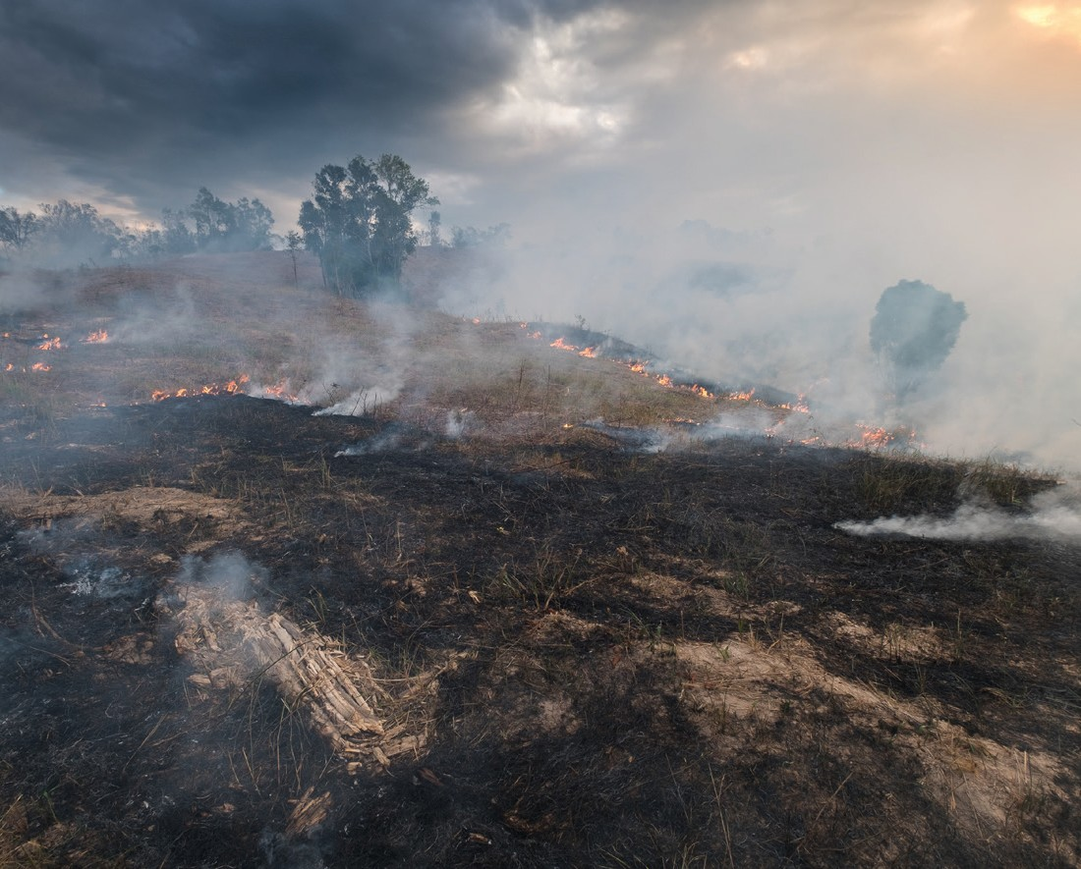

 |  |  | Region that raised action
ID | Theme | Actions Identified | Grampians | Loddon Mallee | Barwon South West | Gippsland | Southern Metro | Eastern Metro | Northern Metro | Hume | Agencies
1 | People
1.1 | Lack of trained staff for emergency management | Use of non-government organisation (NGO) resources and other groups to build capacity before and after an event.
1.2 | Lack of experienced emergency management staff | No specific actions were suggested for this theme. Refer to Systems section for actions surrounding the training of emergency management staff.
 |  | Full-time emergency management resources to fulfill the following needs: community-based recovery planning, community capacity building, resilience projects and regional coordination programs.
 |  | A semi-annual regional workshop whereby councils could share experiential knowledge particularly after an event. This would greatly aid councils in strengthening their knowledge of emergency management.
 |  | Establishment of a regional recovery ‘flying squad’ which would be trained and have expertise in recovery. The State Government would establish a recovery team in each region, and they would assist municipalities in recovery. This team of experts would be ideal in managing class 1 and 2 emergencies. Alternatively, a consultancy model could be used for this mobilised crew.
 |  | Establishment of a regional emergency authority that would have a control centre within each region. The authority would assist councils in planning, responding, and recovering from major emergencies.
 |  | A “brother and sister arrangement program” whereby staff are seconded across multiple municipalities in times of disaster.
1.3 | Further staff supports and recognition within emergency management | Availability of additional mental health support for emergency management staff, before, during and after an event.
 |  | Regular debrief sessions where staff are able seek appropriate help. This could be internal sessions or a formalised ‘debrief program’ run by an external consultant.

ID | Theme | Actions Identified | Region that raised action
 |  |  | Grampians | Loddon Mallee | Barwon South West | Gippsland | Southern Metro | Eastern Metro | Northern Metro | Hume | Agencies
1.4 Challenges with balancing emergency management responsibilities with BAU roles |  | No specific actions were suggested for this theme.
1.5 Loss of organisational No specific actions were suggested for this theme. knowledge and
impacts to capability due to high staff turnover
1.6 Boosting capacity from external sources |  | No specific actions were suggested for this theme.
2 | Resources
2.1 Outdated relief and recovery centres |  | Mobile ‘Recovery Trailers’ that can be deployed throughout the region. The trailers would be equipped with quality resources and new technology. It would act as a centralised command centre for directing long term recovery efforts and would also improve connection with the community, as any member would be able to access it and obtain required support.
2.2 Lack of transport resources |  | The availability of government transport vehicles to be provided for staff commuting to training or in times of an emergency.
3 | Governance
3.1 Inconsistent funding arrangements |  | Greater certainty surrounding MERP funding. Having certainty in funding could allow councils to develop and deliver on strategies more efficiently.
 |  | A new funding model, which would allow NGOs to have greater involvement in emergencies.

 |  |  | Region that raised action
ID | Theme | Actions Identified | Grampians | Loddon Mallee | Barwon South West | Gippsland | Southern Metro | Eastern Metro | Northern Metro | Hume | Agencies
3.2 | Insufficient funding arrangements | MERP funding to be increased to appropriately reflect the CPI.
 |  | Review of MEMP funding in order for it to include “all hazard”. Disaster activity to also be considered.
 |  | MERP funding to provide for multiple Full Time Equivalent (FTE) employees for each council dedicated to emergency management to align with legislated requirements. FTE employees could also be provided to all 8 emergency management regions to support councils throughout the State.
 |  | An increase in MEMPC funding to enable a higher frequency of these planning sessions in order to strengthen collaboration with agencies.
 |  | Funding for a community recovery committee which would be used following an event.
 |  | The establishment of a regional coordination unit funded by the State Government.
3.3 | Lack of clear direction and complex reporting requirements given by State | State to target funding into different streams to ensure consistency in how funding is used between councils across the State and provide further clarity. This would ensure that funds given by the State are used for the right purposes.
3.4 | Relationship with agencies and the broader emergency management sector | Ongoing debrief session and related activities to build and strengthen stakeholder relationships between agencies dealing with emergency management.
 |  | Development pathways that facilitate inter-agency collaboration and an expanded multi-agency exercising program, which involves exercising responses to different class 1 and class 2 emergencies.
 |  | Training and advocacy for the broader emergency management sector on councils’ role.
 |  | Standardised playbook which outlines where each emergency management role fits. This could allow agencies to leverage this playbook to fully understand the emergency management staffing network.

ID Theme Actions Identified |  | Region that raised action
 |  | Grampians | Loddon Mallee | Barwon South West | Gippsland | Southern Metro | Eastern Metro | Northern Metro | Hume | Agencies
3.5 Emergency No specific actions were suggested for this theme. management budget
allocation within councils
3.6 Emergency  management profile within councils | Internal service level agreements could be strengthened by council planning. This will provide greater clarity to ensure council staff can understand each other’s roles and responsibilities more efficiently.
 | A standardised training program specifically targeted at executive management. This would allow executives to filter information down throughout their organisations, which should increase overall awareness of emergency management.
 | An internal council education program, which would allow councils to identify how business as usual roles are impacted by an emergency, and adequately respond to this impact. The training also allows councils to network and develop professional relationships across the region through face-to-face delivery.
4 Systems
4.1 Lack of standardised training for emergency management | A standardised training program provided to all councils through a combination of face-to-face and online modules to cater for different needs and allow networking and relationship building within the sector.
 | Training should also include modules on management, decision making and leadership, mental health, data management and other non-EM specific skills.
 | Additional simulation-type training which opportunities for staff to participate in practical training exercises and workshops
 | A Continuing Professional Development program for fully trained staff to ensure they are up to date with the latest knowledge, tools, and techniques. This could be delivered through a society or an accredited training provider.
 | Training to include the notion of certificates and recognition for staff putting in the time and effort to be trained. This would improve staff morale and would act as a great incentive for staff to be interested to train.

 |  |  | Region that raised action
ID | Theme | Actions Identified | Grampians | Loddon Mallee | Barwon South West | Gippsland | Southern Metro | Eastern Metro | Northern Metro | Hume | Agencies
4.2 | Emergency management training is not available or accessible | A training facility similar to Mount Macedon which is funded by the State and offers different modules of training as well as stronger networking opportunities.
 |  | Emergency management training scholarships’ from the State Government distributed annually to cover the cost of staff participating in a standardised training program.
 |  | A mentoring program whereby experienced emergency management staff would be allocated a mentee going through the ‘emergency management training scholarships’ system, so that these staff can obtain practical knowledge in addition to formal training.
 |  | A “coaching” program could be implemented, to allow Local Government emergency staff to learn from experienced agency staff.
4.3 | Difficulty navigating existing platforms and applications | Refer to 4.4 Lack of Standardised IT platforms" for relevant actions.
4.4 | Lack of standardised IT platforms | A standardised set of IT software guidelines so that systems used are consistent across councils state-wide
 |  | A system like Crisisworks that encompasses all-hazards and can be linked with other council and agency corporate systems. They system should be user friendly with minimal training required for use. This system would be an integrated incident management system which would be linked to existing databases. This would allow for easier extraction of data to make well informed decisions to effectively manage an event.
 |  | A centralised emergency management webpage which would allow the State Government to keep all information up to date and reduce the workload for councils in an efficient manner.

ID Theme Actions Identified |  | Region that raised action
 |  | Grampians | Loddon Mallee | Barwon South West | Gippsland | Southern Metro | Eastern Metro | Northern Metro | Hume | Agencies
5 Processes
5.1 Unstandardised and inconsistent practices | A suite of standardised policy and procedural documents based on current best practice.
 | A review and reconsideration of the eligibility and complexity for submitting a Natural Disaster Financial Assistance or Disaster Recovery Funding Arrangements claim. The simplification of this process would lead to a reduction in staff pressure and time spent on administrative tasks.
 | Clearer articulation of roles and responsibilities in Municipal Emergency Recovery Plans .
 | Standardised MEMPs across the State in order to improve resource sharing.
 | Policy building to be completed in close collaboration with council. This would allow the hardships, experience and emergency management knowledge to be engrained into these policies.
5.2 Criticality of resource sharing | A process whereby councils and agencies are able to effectively share documents and knowledge amongst each other. This would include various assessments, procedural documents and plans.
 | A platform used by all regions and agencies which would allow for templates and examples to be easily shared without data privacy issues. This would save council staff time and will allow for greater analysis of the data being collected by different bodies.
 | A formalised and standardised resource sharing mechanism whereby councils can share staff from one another in an efficient manner, especially in times of an event. The notion of regional clustering at several levels for different events could be examined when developing this mechanism.

 |  |  | Region that raised action
ID | Theme | Actions Identified | Grampians | Loddon Mallee | Barwon South West | Gippsland | Southern Metro | Eastern Metro | Northern Metro | Hume | Agencies
5.3 | Challenges with maintaining community engagement  in emergency management | The delivery of community engagement could be combined into one large meeting with all agencies and stakeholders. This would result in greater communication and collaboration between bodies. There would also be less fatigue compared to hosting several information nights with varying agencies.
 |  | A panel of both council and agency specialists to support with the design programs aimed to support communities. These programs would incorporate emergency management and safety while underpinning the key values of community strengthening and resilience.
 |  | Regular community group sessions which would have the capacity for 200 community members to attend from across the shire. The community group catch-ups could be run through a hybrid model of online and in person delivery.
 |  | A program such as “heat health” which would provide support to municipalities to run emergency management focused programs for their communities.
5.4 | Lack of consistent IT hardware guidelines | A standardised IT guideline with detail surrounding which IT hardware should be used and for what purpose. This would reduce confusion when staff are seconded and shared across councils.
6 | Other
6.1 | Differing geographic risk profiles  and changing demographics and cultural profiles must be taken into account in emergency management planning | No specific actions were suggested for this theme.

Deloitte refers to one or more of Deloitte Touche Tohmatsu Limited (“DTTL”), its global network of member firms, and their related entities (collectively, the “Deloitte organisation”). DTTL (also referred to as “Deloitte Global”) and each of its member firms and related entities are legally separate and independent entities, which cannot obligate or bind each other in respect of third parties. DTTL and each DTTL member firm and related entity is liable only for its own acts and omissions, and not those of each other. DTTL does not provide services to clients. Please see www.deloitte.com/about to learn more.

Deloitte is a leading global provider of audit and assurance, consulting, financial advisory, risk advisory, tax, and related services. Our global network of member firms and related entities in more than 150 countries and territories (collectively, the “Deloitte organisation” serves four out of five Fortune Global 500® companies. Learn how Deloitte’s approximately 312,000 people make an impact that matters at www.deloitte.com.

Deloitte Asia Pacific
Deloitte Asia Pacific Limited is a company limited by guarantee and a member firm of DTTL. Members of Deloitte Asia Pacific Limited and their related entities, each of which are separate and independent legal entities, provide services from more than 100 cities across the region, including Auckland, Bangkok, Beijing, Hanoi, Hong Kong, Jakarta, Kuala Lumpur, Manila, Melbourne, Osaka, Seoul, Shanghai, Singapore, Sydney, Taipei and Tokyo.

Deloitte Australia
In Australia, the Deloitte Network member is the Australian partnership of Deloitte Touche Tohmatsu. As one of Australia’s leading professional services firms. Deloitte Touche Tohmatsu and its affiliates provide audit, tax, consulting, and financial advisory services through approximately 8000 people across the country. Focused on
the creation of value and growth, and known as an employer of choice for innovative human resources programs, we are dedicated to helping our clients and our people excel. For more information, please visit our web site at https://www2.deloitte.com/au/en.html.

Liability limited by a scheme approved under Professional Standards Legislation. Member of Deloitte Asia Pacific Limited and the Deloitte Network.
©2021 Deloitte Access Economics. Deloitte Touche Tohmatsu. Designed by CoRe Creative Services. RITM0764179.

