Asset Plan GUIDANCE 2022

Local Government Victoria

Table of contents
1 Executive Summary
2 Introduction
2.1 Purpose of the Asset Plan
2.2 Compliance with the Local Government Act 2020
2.3 Strategic and Legal Context
3 Other Considerations from the Act
3.1 Integrated Strategic Planning and Reporting Framework
3.2 Community Engagement
4 Principles
5 Key Components of an Asset Plan and Outcomes
5.1 Strategic Intent
5.2 Linkage to the Community Vision, Council Plan and Financial Plan
5.3 Financial Integration
5.4 Asset Classes
5.5 State of the Assets
6 Appendices
6.1 Integrated Strategic Planning and Reporting Framework
6.2 Overview and Outcomes of the Asset Plan
6.3 Further readings

Executive Summary
This guide has been produced by Local Government Victoria (LGV), in collaboration with representatives of the sector, to assist councils with the development of an Asset Plan, a requirement under the Local Government Act 2020 (the Act).
Local governments across Victoria are the custodians of infrastructure and other assets valued at over $115 billion (VAGO 2020-21 Annual Financial Audit). Local governments are considered an ‘asset intensive’ operation and it is these assets that determine the ability of a local government to deliver on community expectations and needs. Assets primarily include local roads, bridges, major culverts and associated traffic infrastructure, land, buildings, stormwater infrastructure, parks, and recreation facilities. The Act requires councils to develop an Asset Plan to transparently and clearly set its direction and priorities that support the efficient and responsible management of these assets on behalf of the community.
This document identifies some of the guiding principles that will assist councils in this process.
Purpose of the Asset Plan
The Asset Plan is a document that communicates the importance and magnitude of the infrastructure assets for which council is the custodian. This will result in more informed community engagement and a mutual understanding of the best use of council assets in the interest of the community.
Compliance with the Local Government Act 2020 and Regulations
The Local Government Act (Planning and Reporting) Regulations requires councils to record their compliance with section 92 (the Asset Plan) of the Act by completing the Governance and Management Checklist. This checklist will continue to be published on the Know Your Council website and in the council’s Annual Report; and will remain as the key instrument to display transparency and accountability to reassure the public that their assets are being responsibly managed.
Strategic Context
The Asset Plan referred to in the Act is intended to be a strategic public facing document that informs the community on how the council-controlled (infrastructure) assets are to be managed to achieve the Community Vision and supporting Council Plan objectives.
Integrated Strategic Planning and Reporting Framework
The Asset Plan is a vital component of the Local Government ISPRF (See Appendix 6.1). As such, the plan should align with and complement other council planning and reporting documentation, including the Council Plan, Council Budget, Annual Report, as well as the other longer-term planning documents, the Community Vision, and the Financial Plan.
Community Engagement
The deliberative engagement practices described in the Act refers to the development and preparation of the Asset Plan. This requirement, alongside due engagement on the Community Vision, Council Plan and Financial Plan, demonstrates a consistent message among the four documents. It is important when executing the community engagement policy to consider the concept of asset performance, cost, and consequence of asset management choices.
Principles
To support the implementation of the Asset Plan, some principles were identified in the pursuit of better practice. As such, the Asset Plan should:
- Be community focussed and non-technical:
- clear in scope and definition
- simple to understand
- accessible to all members of the community
- Use reliable inputs:
  - a reliable and robust asset register
  - up-to-date annual forecasts and analytics
  - informed maintenance programs
  - an informed understanding of service requirements
  - employ a continuous improvement process
  - draw on learnings from the deliberative engagement process
- Be integrated and strategic:
- make a positive contribution to the pursuit of the Community Vision and the delivery of the Council Plan, Financial Plan and Annual budget process
- successfully address the strategic planning principles in the Local Government Act 2020.
Key components of an Asset Plan
The Act identifies some of the key components of an Asset Plan such as information about maintenance, renewal, acquisition (i.e., new, expansion, upgrade), and disposal (e.g., decommissioning) in relation to each class of infrastructure asset under the control of the council. This document provides guidance on what may be included in an Asset Plan to satisfy the previously identified principles and objectives. These may include:
- Strategic Intent
- Linkage to the Community Vision, Council Plan and Financial Plan
- Financial Integration
- Asset Classes
- State of the Assets
- Challenges and Choices
While the Act identifies key themes, the ISPRF provides insight into how these may align or fit.
However, there is no single best solution that will work for all councils, and the final components are at the discretion of the council.
Conclusion
This guidance document was developed by a working group made up of sector-representatives and industry experts. Members of the working group shared their expertise in asset planning, including both current and best practices. As such, this plan demonstrates the requirements of the Act whilst also providing guidance on how sector experts and peers may develop an Asset Plan in a manner that addresses the requirements of the Act.
For maximum use of this guide, it is intended for foundational asset planning, as opposed to best practice asset planning. Councils may choose to incorporate some or all the recommended elements in this guide; or develop their own version of the Asset Plan, ensuring it meets the objectives of the Act.

Introduction
The Asset Plan referred to in the Act is the community facing document that shows how the council’s assets will be managed and maintained, while meeting the community’s needs and interests.
Improvements have been made since the implementation of accrual accounting in the early 1990s and the Nationally Consistent Frameworks for local government asset and financial management – and associated reform programs – were implemented in the 2000s.
The assets managed by local government include the very extensive network of local roads which represents 87% of the state’s road network (by length). Other assets such as land, buildings, parks, and recreation facilities may have lower financial values or be less in quantity, but it is just as important to ensure their life cycles are being managed from inception to retirement. All assets come with responsibilities and financial burdens for current and future generations.
Illustration 1 - Council Assets and Infrastructure 2020-21, VAGO ($ b)
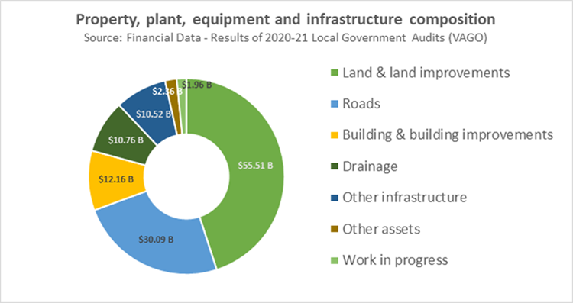

Good asset management is critical to the asset intensive nature of local government, more so for rural councils with proportionately higher operating costs of assets than metropolitan councils. For every council, it is important to consider the needs, demands and expectations of communities and to deliver services from infrastructure assets in a sustainable and affordable way.
This guide was developed in consultation with the local government sector as part of the Act’s implementation program of works. It provides the core elements for inclusion in an integrated Asset Plan. Councils may choose to incorporate these elements and produce their own layout when drafting their plan.
This guide is not a best practice guide. It has been developed to assist in applying foundational asset planning concepts at a core level of maturity as defined by the International Infrastructure Management Manual. Councils are encouraged to seek additional information or advice in determining their needs to improve their asset management practices as they move towards a more advanced level of maturity based on their resource capability and capacity.
Finally, the Asset Plan is not the Asset Management Plan. It is not intended for the Asset Plan to be a highly technical document. Rather, it is an opportunity for councils to communicate and gain input to their long-term decision-making considerations in an accessible manner. This refocus will help to lift the profile of asset planning and reporting, ensuring it plays a key role in implementing council’s strategic goals.

Purpose of the Asset Plan
The Asset Plan is intended to be a strategic public facing document that informs the community on how the council-controlled infrastructure and other assets are to be managed to achieve the Council Plan objectives and Community Vision statement.
In keeping with the ‘enabling nature’ of the Act, the purpose of the Asset Plan has been identified to:
- improve the transparency around asset value and performance
- better inform the community on the type of assets under council management and the financial impost
- embed responsible asset management practices into the ISPRF
- contribute to council’s long-term objectives, strategic intent, and finances
- improve the efficiency and effectiveness of asset management practices through a more engaged community and informed council
- better align decisions around assets to community needs, service levels and standards, and financial sustainability
- articulate and communicate the challenges on service levels, costs, risks, and the considerations for the decisions made.

Compliance with the Local Government Act 2020
Section 92 of the Act highlights the requirement for good asset management practices across the local government sector in Victoria. Under the Act, councils must adopt an Asset Plan by 31 October following each election. The plan must be developed in accordance with deliberative engagement practices.
The Local Government Act 2020 (Planning and Reporting) Regulations requires councils to record their compliance with section 92 of the Act by completing the Governance and Management Checklist. While the Checklist only requires a simple Yes/No response, and the Mayor and Chief Executive Officer certifying the checklist, the Act further requires Councils to ensure that the Asset Plan aligns with the Council Plan, Council Budget, Annual Report, Community Vision and Financial Plan, in keeping with the ISPRF.
The Governance and Management Checklist will still be included in the Annual Report. It will remain as the key instrument to display transparency and accountability to reassure the public that their assets are being responsibly managed.

Strategic and Legal Context
The Asset Plan is a vital component of the Local Government ISPRF (See Appendix 6.1). As such, the plan should align with and complement the other council planning and reporting documents, including the Council Plan, Council Budget, Annual Report, as well as the other longer-term planning documents, the Community Vision, and the Financial Plan.
The integration of the Asset Plan within the ISPRF ensures that assets are appropriate for current and future plans of the council; that they remain fit for purpose; and that optimum use is achieved through appropriate maintenance, renewal, and replacement programs.
An Asset Plan, with a focus of at least 10 financial years, should set out how council’s stewardship of the community’s assets will respond to the Community Vision within the Financial Plan parameters.
An Asset Plan must inform and respond to changing community needs and expectations.
Illustration 2 – How the Asset Management System relates to the Asset Plan and council’s key strategic plans
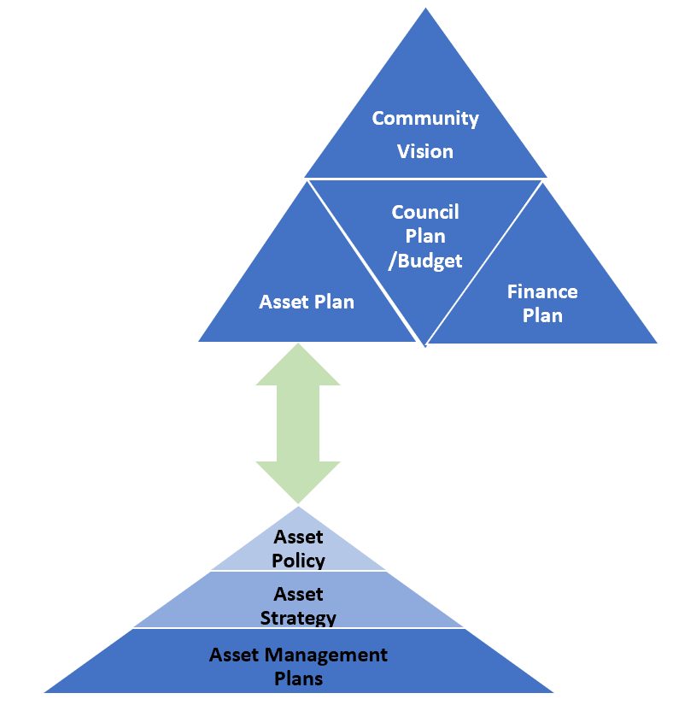
Source: ISO55000 Asset Management System documents: International Infrastructure Management Manual (Institute of Public Works Engineering Australasia (IPWEA), 2020, Section 1.3.3)
The adopted Asset Plan effectively represents a statement by elected officials of their commitment to the integrated framework (the top group of triangles in illustration 2), as well as how their decision-making has been informed by the Asset Management System documents of the council (suggested by the lower group of triangles in illustration 2).
However, an Asset Plan should be more than a duplication or summary of the Asset Management System documents.
Councils may also need to consider legacy assets which are the result of previous decisions.
An Asset Plan is therefore informed by existing asset management practices, data and processes, and a commitment to a continual improvement process. The ISO 55000 Asset Management System provides a good reference on the expectations and benefits to be realised from good asset management.
ISO 55000 series of standards: Asset Management System
The ISO 55000 series of standards defines the Asset Management System as the set of interrelated or interacting elements of an organization, whose function is to establish the asset management policy and asset management objectives, and processes to achieve those objectives.
The Asset Management System comprises the following key documents:
Asset Management Policy
- Establishes the goals and objectives for asset management providing a platform for service delivery.
- Integrates long-term asset and financial management with council’s strategic objectives.
- Maximises value for money by adoption of life cycle costing, combined with disciplined performance measurement.
- Assigns accountability and responsibility for service delivery together with asset management.
- Promotes sustainability to protect the needs of future generations.
Asset Management Strategy
- Links and integrates council’s plans and resources, indicating which services are to be delivered through which assets.
- Forecasts future service delivery needs and the capacity of assets to meet those, on a short, medium, and long-term basis.
- Identifies assets that are critical to the council’s operations and outline risk management strategies for these assets.
- Includes specific actions required to improve the council’s asset management capability and projected resource requirements and timeframes.
- establishes systems for asset performance measurement.
Asset Management Plan/s
- Encompasses all the assets under council’s control.
- Connects the investment of community wealth in assets with service outcomes.
- Presents at least one scenario that balances with the available funds from the Long-Term Financial Plan.
- Identifies and communicates risks associated with affordable service levels and how these risks will be managed.
- Allows for additional lifecycle scenarios that manage assets to provide optimal life cycle costs to inform the asset management strategy and Long-Term Financial Plan.
- Includes one scenario that balances the available funds from the Long-Term Financial Plan with affordable service level targets and sets out a strategy to communicate the corresponding service levels and risks and how these will be managed to Council and the community.
- For each scenario, presents cash flow forecasts for acquisition (upgrade/new/expansion), operating, maintenance, renewal and where relevant, disposal.

The accuracy and currency of a council’s asset management system will directly impact the quality of an Asset Plan. It is important that these related documents are up to date and in line with the LGV Asset Management Better Practice Guide (see reference section).

Other Considerations from the Act

Integrated Strategic Planning and Reporting Framework
Factors which could be considered within this framework include the future impacts of:
- climate change
- service delivery
- demographic change
- emerging technologies and practices
- political environments
- asset volume (such as duplication, redundancy, or scarcity)
- asset condition
- other drivers identified by council
- financial capacity.
The Act introduced strategic planning principles for Victorian councils, which include an integrated approach to planning, monitoring, and performance reporting.
The importance of integration is reinforced by section 89 of the Act.
89 Strategic planning principles
(1) A Council must undertake the preparation of its Council Plan and other strategic plans in accordance with the strategic planning principles.
(2) The following are the strategic planning principles—
(a) an integrated approach to planning, monitoring and performance reporting is to be adopted;
(b) strategic planning must address the Community Vision;
(c) strategic planning must take into account the resources needed for effective implementation;
(d) strategic planning must identify and address the risks to effective implementation;
(e) strategic planning must provide for ongoing monitoring of progress and regular reviews to identify and address changing circumstances.

Community Engagement
The first Asset Plan must be adopted by 30 June 2022 and should be developed and prepared in accordance with each council’s Community Engagement Policy. Deliberative engagement is not mandatory for the first iteration of the Asset Plan unless council’s own Community Engagement Policy prescribes it.
Thereafter, councils must adopt a community engagement policy that includes deliberative engagement practices. These practices are designed to protect the democracy of local government practices and decision making while ensuring the community’s voice and priorities match that of the council. In practice, this process can be as simple as bringing together a group of people representative of the community to discuss an issue, options to address the issue and together decide on a way forward.
Any council community engagement strategy should be designed with the Community Engagement principles in mind. These are stipulated under section 56 of the Act:
56 Community Engagement Principles
(a) a community engagement process must have a clearly defined objective and scope;
(b) participants in community engagement must have access to objective, relevant and timely information to inform their participation;
(c) participants in community engagement must be representative of the persons and groups affected by the matter that is the subject of the community engagement;
(d) participants in community engagement are entitled to reasonable support to enable meaningful and informed engagement;
(e) participants in community engagement are informed of the ways in which the community engagement process will influence Council decision making.

When delivering engagement on the Asset Plan, councils may want to consider communicating to the community the challenges they face when making decisions that must balance between infrastructure performance and expenditure choices. The transparency that councils display at this stage can be helpful to answer the questions councils face concerning the trade-off between planned budgets and asset requirements (see illustration 3).
The Asset Plan should be prepared and reviewed alongside the Community Vision, Council Plan and Financial Plan so that the documents are truly integrated. By doing this, the service planning for assets is focused on the priorities of the community but framed in a financial context that leads to informed, responsible, and effective decision making.
Illustration 3 – Example trade-off between upgrade and new assets vs maintenance and capital renewal in a financially constrained environment
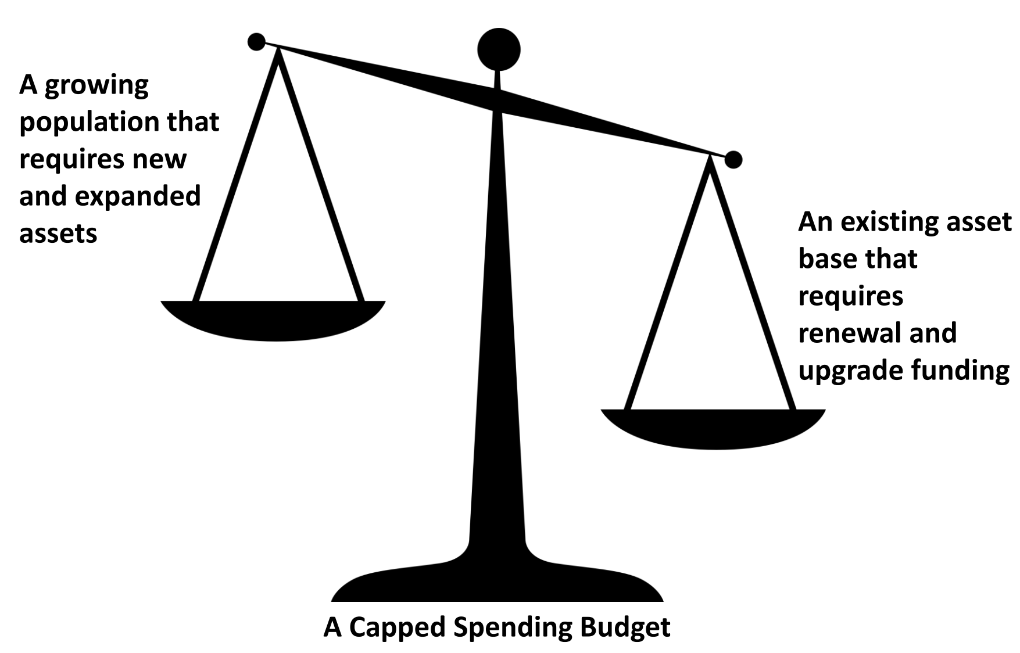
The level of engagement on the Asset Plan will depend on the identified needs of the community in accordance with the ISPRF. Each council will have its own unique requirements for community input and the extent this input will impact the decision-making process.

The IAP2 Public Participation Spectrum below describes the community engagement spectrum from a low-level engagement (inform) to a high-level engagement (empower).
Community Engagement Framework
Inform – 1 | Consult – 2 | Involve – 3 | Collaborate – 4 | Empower – 5
Low Level High Level
Provide community awareness and keep them informed of the completion of the Asset Plan. | Ask the community for feedback then inform them of how their input affected decision making. | Work directly with the community to ensure their views and aspirations are considered. | Partner with the community to develop joint solutions and incorporate their advice to the Asset Plan. | Community decides what is implemented and included to the Asset Plan.

Principles
The Act does not specifically state the core principles of an Asset Plan, but it has provided sufficient direction to enable the development of a set of core principles. Therefore, the Asset Plan Working Group, developed some core principles which are set out below. This will also support continuous improvement in asset management decision making.
These principles can be applied to the Asset Plan at the initial development stage where they can be revised and revisited by the author, who would ensure the principles are applied to the first draft of the plan. Further, the editor or approver of the document may choose to use those principles at the editing stage to ensure they are reflected across the document.
As the Asset Plan will be a public facing document, it is recommended that the communications team in council is consulted before the document is released to the public to ensure it is accessible and easy to digest by the community.
- Be community focussed and non-technical:
  - clear in scope and definitions
  - simple to understand
  - accessible to all members of the community
- Use reliable inputs:
  - a reliable and robust asset register
  - up-to-date annual forecasts

  - employ a continuous improvement process
  - draw on learning from deliberative engagement process
- Be integrated and strategic:
  - make a positive contribution to the pursuit of the Community Vision and the delivery of the Council Plan, Financial Plan and Annual budget process
  - successfully address the strategic planning principles in the Local Government Act 2020

Key Components of an Asset Plan and Outcomes
The following key components represent a collection of both legislative requirements and emerging better practice in asset management which may assist in the development of an Asset Plan.

Strategic Intent
Councils must be clear on their strategic intent regarding how they manage their assets and should be able to articulate this in the Asset Plan. Statements about the council’s commitment to manage its assets or an outline of a program of works to drive continuous improvement will help guide the overall direction of asset management decisions.
These statements of strategic intent could include:
- commitment to improve long-term financial sustainability
- review of council facilities to identify those which are surplus to current needs –– with the potential for repurpose or disposal
- greater understanding of the annual consumption cost of infrastructure
- increased investment in climate adaptation strategies to protect council’s assets
- expand sporting facilities to encourage greater female participation.
The PESTLE or similar process will provide valuable input into these principles or priorities.

Linkage to the Community Vision, Council Plan and Financial Plan
A key challenge for councils under the Act is to demonstrate integration with the other strategic documents in the ISPRF. Together, the elements of this framework must demonstrate where the community wants to go, how council can contribute to the achievement of the council vision and what is the most efficient allocation of resources to make it happen.
Accordingly, there needs to be some line of sight between Community Vision, Council Plan, Financial Plan, and the Asset Plan. It needs to be demonstrated that there has been a discussion with the community during the Community Vision development that infrastructure performance, costs, and risks have been considered — including trade-offs between investment in new and existing assets, and other priorities of council.
Ultimately, all the long-term strategies should tell a similar story: i.e., the future that the community envisions; a council’s contribution to that vision; and the level of expenditure that will be required to deliver on that vision. This should be done within the financial capacity of council when assessed against all other priorities. If a council considers that there is a mechanism available that expresses this alignment more succinctly, then there is certainly the freedom in the legislation to include this approach.

Financial Integration
The Asset Plan must be consistent with the Financial Plan and must demonstrate that responsible choices were made around budget allocations to infrastructures assets. One way of doing this is to ensure that the lifecycle cost forecasts to deliver services are balanced with the Financial Plan budget projections. This is supported through appropriate indicators. These include:
- infrastructure per head of the municipal population
- population density per length of road
- asset renewal and asset upgrade as a percentage of depreciation
- financial integration
- asset renewal funding ratio
(proposed renewal budget for the next 10 years / forecast renewal costs for next 10 years)
- lifecycle indicator
(proposed 10-year lifecycle financial plan / forecast 10-year lifecycle costs).
Current practice shows that each asset has an average target band of 90 to 110 per cent over a rolling 3- to 5-year period, which demonstrates that council is operating in a financially sustainable responsible way. Although this is at the discretion of each council, it is worth noting anything outside this band is high-risk.
As previously stated, the relationship between the key long-term enabling documents of council is straight forward. The Financial Plan outlines the financial reality; and the Asset Plan is where the financial reality and asset reality meet.
The final Asset Plan should also be the outcome of informed and reasoned engagement with the community, who may also gain a better understanding of the financial implications of such council decisions.

Asset Classes
The Act requires that the Asset Plan include information in relation to each class of infrastructure assets under council control. Although an ‘asset’ is not defined in the Act, there are many types of assets that can be included in the definition of infrastructure assets. Likely, it will mean different things to different councils, which is also an accurate reflection of the diversity of councils across Victoria. The Model Budget produced by LGV and the sector has a standard set of asset classes.
The objective of the Asset Plan is to support an informed discussion with the community regarding such things. What is in and what is out of that discussion is open to each council to determine and to justify if needed.
Current asset management practices suggest alignment with the financial planning and reporting classes, enabling a council to plan and report the dollar value and, in some instances, the number of assets by asset class. Equally, a snapshot of planned renewal, upgrade, replacement, acquisition, or retirement costs by asset class would be valuable.
The assessment of the level of detail is at the discretion of each council, however, more is not always considered the better approach in a strategic document. A summation of the Asset Management Plans for each asset class is desirable.
Councils should focus on the level of detail and transparency that enables informed discussions to take place at the local level.

State of the Assets
Assessing the current state of council assets will help councils in determining the prioritisation and planning for the maintenance, management, and renewal of council’s assets. In addition to this, a council should be able to articulate in the Asset Plan its assessment of asset classes to inform the community on infrastructure and service performance, costs, and risks.
Below is an example of asset classes and possible issues that may impact each class. This section of the Asset Plan should consider how asset classes interact with future challenges and risks. The assessment of the state of assets should demonstrate consideration of the condition and performance assessments, history of investment towards a particular asset and asset classes as well as community demand and expectations.

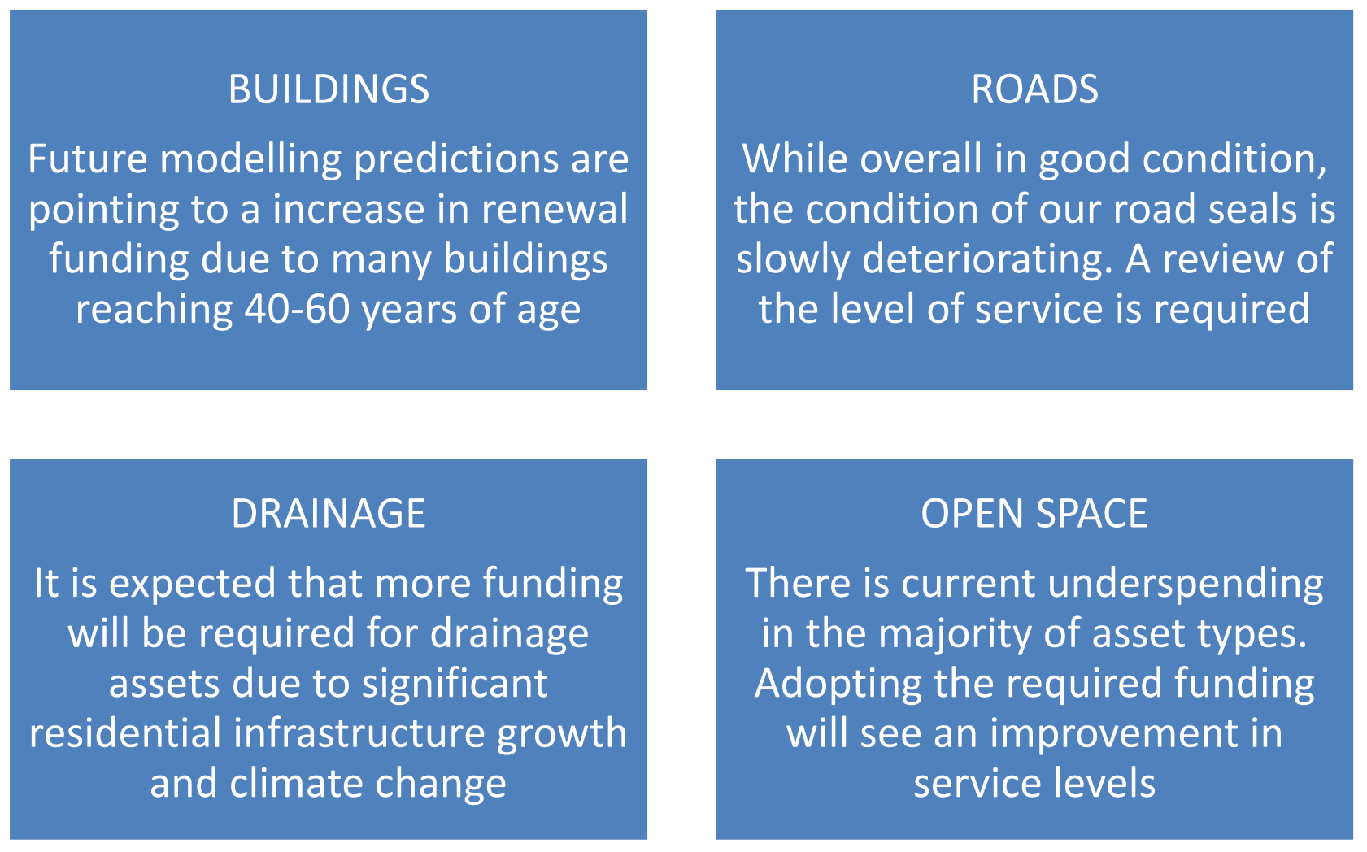
Measured and reported on a consistent basis, state of the assets reporting provides an evidence base for future investment.
In the Victorian local government environment, and to meet the expectations of the Act, the Asset Plan should be able to answer the questions in the table below.

❐ | Linkage to the Community Vision and/or Council Plan  - Do the current assets support delivery of the Community Vision and the Council Plan?  - Is there a need to realign asset practices to deliver on the Council Plan?  - If not, why not and what are the intentions to rectify?
❐ | Asset Classes  - What is the quantum and value of assets that councils currently have?  - What is the ongoing carrying cost of those assets?  - Are assets assigned to their best use and maintained in an appropriate condition?  - Are existing programs adequate to maintain these classes of assets?
❐ | Challenges and Choices  - What are the potential risks and costs of not having in place adequate resources and management practices?  - What are the environmental, social, and financial implications of these considerations and choices?  - What trade-offs are the community and council in agreement on?
❐ | State of the Assets – current and future outlook  - Are the assets fit for future? If not, how will council get there?  - Are there any major shortcomings in different classes of assets?
❐ | Strategic intent  - What are the strategic imperatives that should drive councils’ thinking in respect of assets?  - Are there future events that may compromise the integrity of the asset base and hence the ability to deliver on community expectations?  - What action is required and when?
❐ | Financial Integration  - What is the current situation regarding council’s capacity to finance and maintain these assets to support its services to the community?  - What are the trade-offs that still need be negotiated with your community in respect of capacity to support the asset base?

Appendices

Integrated Strategic Planning and Reporting Framework
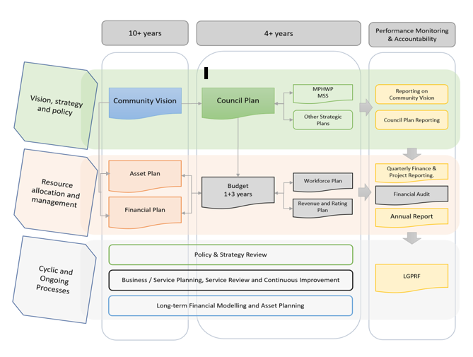

Overview and Outcomes of the Asset Plan
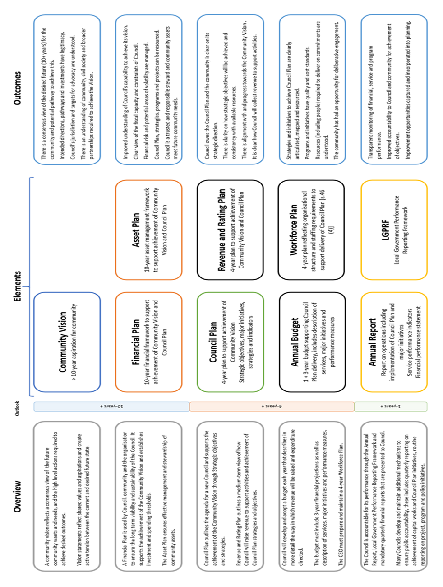

Further readings

Government Legislation:
- Section 92 of the Local Government Act 2020 on the Asset Plan
- Section 56 of the Local Government Act 2020 on Engagement principles
- Section 89 (1) and (2) of the Local Government Act 2020 on Strategic Planning Principles

Government Resources:
- Integrated Strategic Planning and Reporting Framework Guidance
- Asset Management Better Practice Guide 2015
- Financial and Asset Management Resources for Council Infrastructure, Land and Asset Management.
- Local Government Assets VAGO Audit 2019
- Australian Standard Climate Change Adaptation for Settlements and Infrastructure

Non-Government Specific Resources:
- Climate Asset Vulnerability Assessment Toolkit, South East Councils Climate Change Alliance
- International Infrastructure Financial Management Manual, IPWEA, 2020
- International Infrastructure Management Manual, IPWEA, 2020
- NAMS+ Toolkit for asset management planning, IPWEA
- ISO, 2014, ISO 55000:2014, Asset management
- ISO, 2014, ISO 55001:2014, Asset management

In 2007, all levels of government agreed on three Frameworks to improve local government’s financial sustainability and management of assets. Refer to the Local Government and Planning Ministers’ Council (LGPMC) Frameworks.
The first Asset Plan must be adopted by 30 June 2022, in accordance with each council’s Community Engagement Policy. Deliberative engagement techniques are not mandatory for this first iteration unless council’s own Engagement Policy prescribes it.
Section 89 (2) (a) of the Local Government Act 2020
Section 92 (6) of the Local Government Act 2020
IAP2’s Public Participation Spectrum

