Altered municipal boundary (from 1 July 2008)
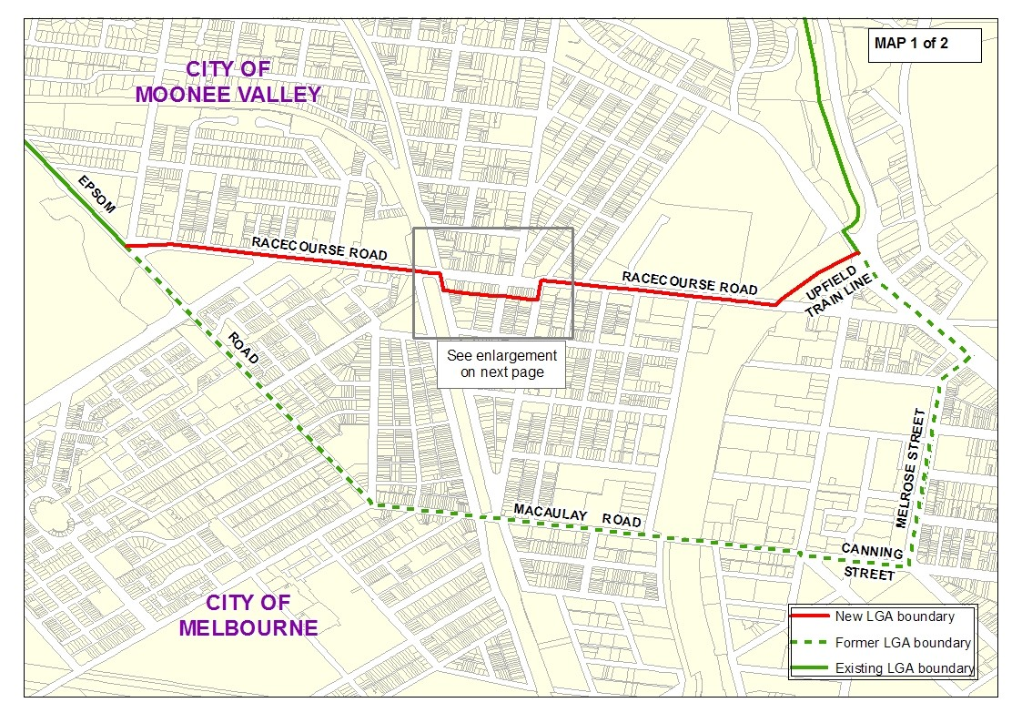
Altered municipal boundary (from 1 July 2008)
