Local Government
Better Practice Guide
Annual REport
PERFORMANCE STATEMENT 2021-22

Table of contents
Acronyms and Abbreviations 2
Introduction 3
Objectives and purpose 3
Role of a council 3
1. Integrated strategic planning and reporting framework 5
2. Framework performance statement (overview) 8
For further information refer to: 9
3. Performance statement (guidance) 10
Quality and integrity of information 10
Preparation of the performance statement 15
4. Sample workplan and timetable 21
5. Materiality guidelines 23
6. Glossary 25
7. References 27

Acronyms and Abbreviations
AAS | Australian Accounting Standards
CEO | Chief Executive Officer
EMT | Executive Management Team
LGPRF | Local Government Performance Reporting Framework
LGV | Local Government Victoria
VAGO | Victorian Auditor-General’s Office
VCAT | Victorian Civil and Administrative Tribunal

Introduction
Local government in Victoria manages approximately $114.07 billion of community assets and infrastructure and spends around $9.8 billion on the provision of services annually. Local government, in partnership with other levels of government, is responsible for aspects of everyday life that people care about deeply – from vibrant and safe public spaces, to accessible libraries, to strong local business and employment opportunities. Effective planning and reporting by councils is essential for ensuring transparency and accountability to the community and other levels of government as to how public money is being spent and the quality of services delivered.

The Local Government Act 2020

Objectives and purpose
The Local Government Act 2020 (the Act) received Royal Asset on 24 March 2020 with proclamation to occur in stages. The Act is a principles-based Act, removing unnecessary regulatory and legislative prescription.
The objectives of the Act are as follows:
The objectives of this Act are to ensure that –
- local government continues to be constituted as a democratically elected tier of Government in Victoria; and
- Councils are constituted as representative bodies that are accountable, transparent, collaborative, efficient and engaged with their communities; and
- Councils have the functions and powers necessary to enable Councils to perform their role.
The purpose of the Act is as follows:
The purpose of this Act is to give effect to section 74A(1) of the Constitution Act 1975 which provides that local government is a distinct and essential tier of government consisting of democratically elected Councils having the functions and powers that the Parliament considers are necessary to ensure the peace, order and good government of each municipal district.

Role of a council
The Act specifies the role of a council is:
“…to provide good governance in its municipal district for the benefit and wellbeing of the municipal community.”
The provision of good governance includes a council performing its role in accordance with the overarching governance principles. The overarching governance principles are set out in section 9(2) of the Act. The overarching governance principles include (amongst other principles) that:
- Council decisions are to be made and actions taken in accordance with the relevant law;
- The economic, social and environmental sustainability of the municipal district, including mitigation and planning for climate change risks, is to be promoted;
- The ongoing financial viability of the Council is to be ensured; and
- The transparency of Council decisions, actions and information is to be ensured.
The overarching governance principles are supplemented by the supporting principles. Section 9(3) requires councils to take into account the supporting principles in giving effect to the overarching governance principles. The supporting principles are:
- The community engagement principles;
- The public transparency principles;
- The strategic planning principles;
- The financial management principles; and
- The service performance principles.

It is a statutory requirement under the Act that councils prepare and report on long, medium and short-term plans to discharge their duties of accountability and transparency to their communities.
About this guide
Councils are required to prepare an annual report for each financial year consisting of three parts:
- Report of operations: information about the operations of the council
- Performance statement: audited results achieved against the prescribed performance indicators and measures
- Financial statements: audited financial statements prepared in accordance with the Australian Accounting Standards.
This guide has been developed to help local government in meeting the statutory requirements for the preparation of an audited performance statement. Guidance on the preparation of the report of operations and audited financial statements can be found at the Local Government website https://www.localgovernment.vic.gov.au/council-innovation-and-performance/sector-guidance-planning-and-reporting. This guide is presented in four sections.
- Integrated Strategic Planning and Reporting Framework provides an overview of the relationship between the key planning and reporting documents
- Performance statement (overview) provides an overview of the statutory requirements and best practice guidance for preparing a performance statement
- Performance statement (guidance) provides detailed guidance on the preparation and audit of the performance statement, including guidance for ensuring the quality and integrity of information
This guide is intended for use by specialists in the field of local government planning and reporting. It will also be instructive for senior officers including chief executive officers (CEOs) and councillors. Each council retains the responsibility for preparing their performance statement, including the format and the disclosures made. This guide represents the required presentation of LGV.
A separate full model of the performance statement has been prepared as a separate document to outline the Act’s requirements for inclusion in the annual report.
Within this guide there are references to related information and further guidance. A full list of resources can be found in the reference section. Footnotes are used to reference legislative provisions and other information. Illustrative information and examples are provided in tables and boxed text.

1. Integrated strategic planning and reporting framework
Part 4 of the Local Government Act 2020 addresses planning and financial management. The legislative requirements to develop strategic planning, budgeting and annual reporting documents in Part 4 came into operation on 24 October 2020.
The Act introduces strategic planning principles for Victorian councils which include an integrated approach to planning, monitoring and performance reporting. This important shift from a more prescriptive form of legislation to a new Act that is principles-based is explored further in the Integrated Strategic Planning and Reporting Discussion Paper which is available at https://engage.vic.gov.au/local-government-act-2020.
Part 4 of the Local Government Act 2020 requires councils to prepare the following:
- A Community Vision (for at least the next 10 financial years);
- A Council Plan (for at least the next 4 financial years);
- A Financial Plan (for at least the next 10 financial years);
- An Asset Plan (for at least the next 10 financial years);
- A Revenue and Rating Plan (for at least the next 4 financial years);
- An Annual Budget (for the next 4 financial years);
- A Quarterly Budget Report;
- An Annual Report (for each financial year); and
- Financial Policies.
The Act also requires councils to prepare:
- A Workforce Plan (including projected staffing requirements for at least 4 years);
The legislative timeframes for development, review and adoption of the elements of the Integrated Strategic Planning and Reporting Framework (ISPRF) and the time horizons for each element vary. However, there are also many linkages, including the central importance of community engagement. It is therefore vital to recognise the relationships and degrees of integration between different elements. To aid this process, visual representations of the ISPRF have been developed.
The following diagram provides an overview of the core legislated elements of an integrated strategic planning and reporting framework and outcomes.
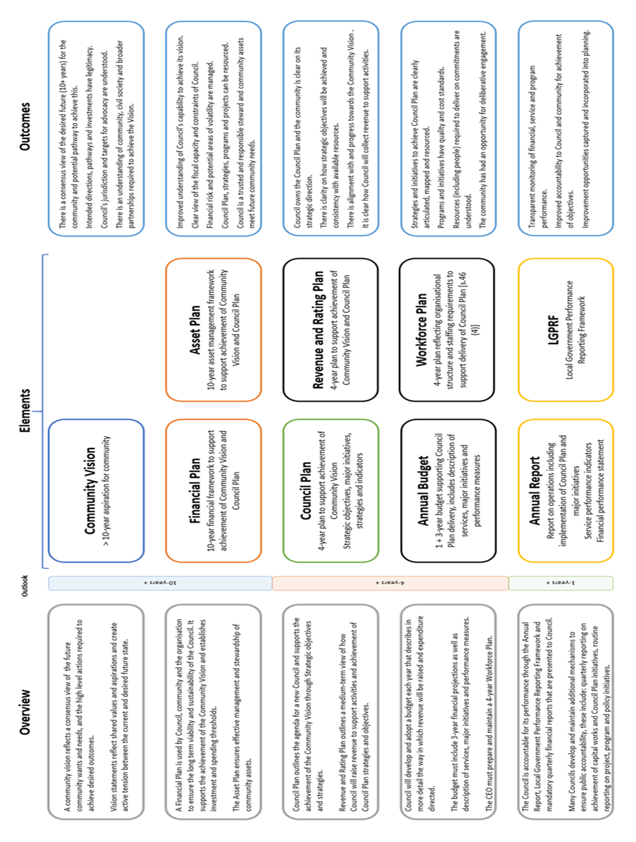
Figure 1: Department of Jobs, Precincts and Regions 2020

The following figure demonstrates how each element might inform or be informed by other parts of the integrated framework.

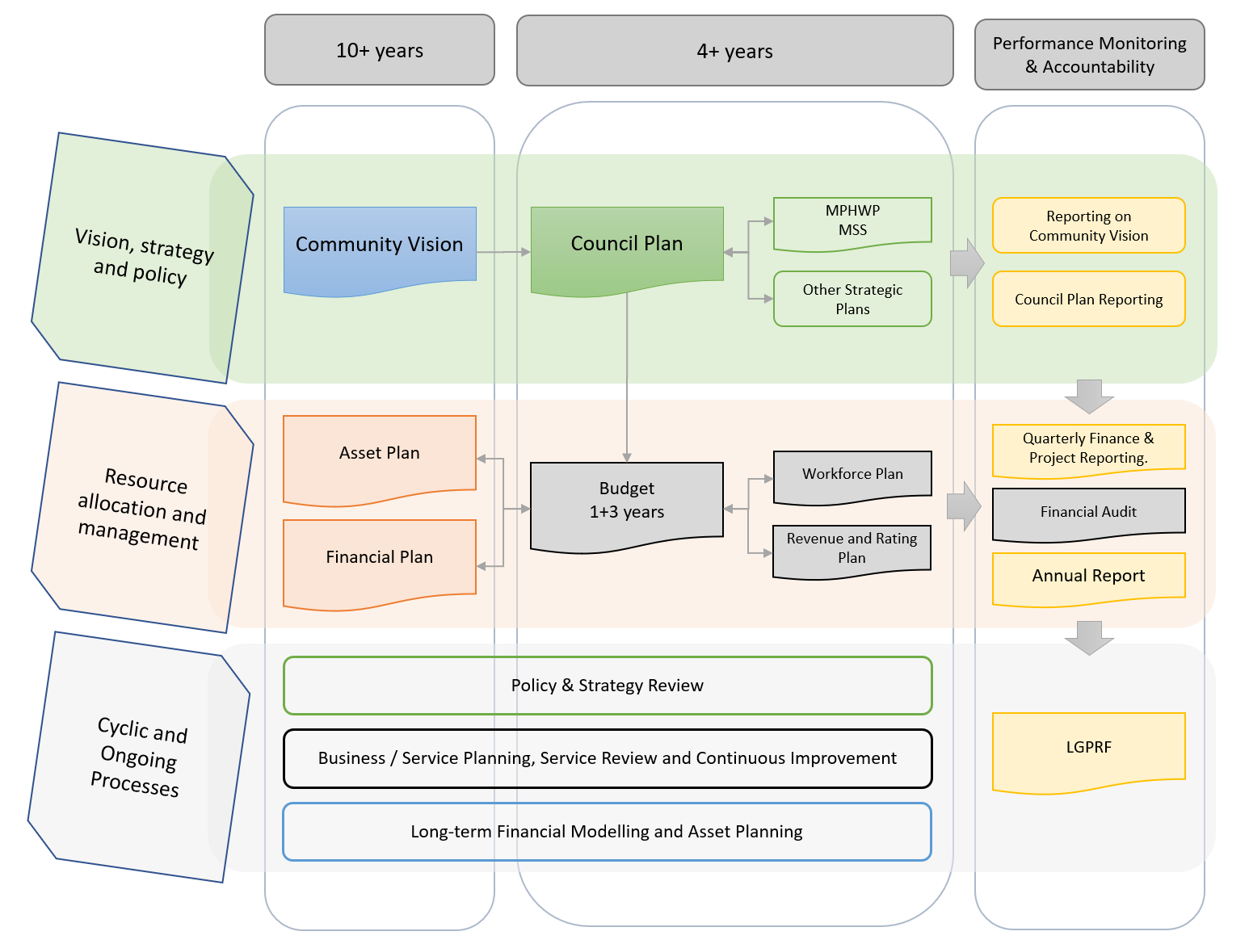

Note: this shape denotes mandated plans and strategies. 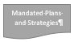

Figure 2: Department of Jobs, Precincts and Regions 2020
While this guide is focused on one element of the ISPRF, the Annual Report – it is important to recognise the broader framework within which this reporting occurs.

Framework performance statement (overview)
Statutory requirements
“The Act requires a council’s annual report to contain an audited performance statement”
Sections 98 and 99 of the Act state that:
- the performance statement must contain the prescribed indicators and measures of service performance outcome, financial performance and sustainable capacity and the results for each indicator
- the performance statement must be submitted to the auditor as soon as possible after the end of the financial year and certified in its final form by two councillors, the CEO and principal accounting officer
- the auditor must prepare a report on the performance statement to be included in the annual report.
In addition to sections 98, 99 and 100 of the Act, councils should review Part 4 (Annual Report) of the regulations for further information required in the performance statement.
Checklist
The performance statement must include:
- the indicators, measures and results of the prescribed service performance outcome indicators
- the indicators, measures and results of the prescribed financial performance indicators
- the indicators, measures and results of the prescribed sustainable capacity indicators
- any other information required by the regulations.

Better practice guidance
The performance statement is a key section of the annual report whereby council makes itself accountable to the community and contains information about the performance of the council for the financial year.
In 2012, the Victorian Auditor-General’s Office (VAGO) recommended that all councils should critically review the performance information in their annual reports to ensure it is relevant, balanced, appropriate and clearly aligned with their council plan strategic objectives to ensure performance reporting is meaningful to the community. In response, the Victorian Government introduced a mandatory system of performance reporting (Local Government Performance Reporting Framework – LGPRF) in 2014-15 which prescribes performance information to be included in council annual reports. Further guidance to support councils report against the prescribed performance indicators and measures can be found in the Local Government Performance Reporting Framework Indicator Guide.
Councils must describe the prescribed indicators and measures in the performance statement so it is clear to the audience what is being measured. In addition, the performance statement must include the results achieved in relation to the prescribed service performance outcome, financial performance and sustainable capacity for the financial year and three preceding years. For the financial performance indicators and measures, the performance statement must also include the forecast results for four years based on Council’s budget. Reporting trend information helps the reader understand changes in council performance over time and acts as a point of reference for results.
The regulations require that councils must provide commentary and an explanation of any material variations in the results between the current year and other years disclosed, to enable the reader to form an understanding of the reason for the variation. To provide context to the performance results, the regulations also require the performance statement to contain a description of the municipal district, including its size, location and population.
Additional performance indicators can be included by councils in the performance statement but they will be subject to audit by the VAGO and must pass the test of relevance and appropriateness as defined by VAGO.
Councils are also required to disclose other performance-related information in the report of operations in the annual report including:
- a governance and management checklist
- the prescribed indicators and measures of service performance, results achieved and an explanation of material variations
- a statement that reviews the performance of the council against the council plan including results achieved in relation to the strategic indicators included in the council plan.
This performance information in the report of operations along with that in the performance statement should form part of a performance reporting framework with quarterly or bi-annual reporting of performance results to senior management, the audit committee and councillors. Taking an integrated approach to performance reporting can help councils understand how well they are performing in meeting the needs of their communities as well as achieving the strategic objectives in their council plan.

For further information refer to:
- Department of Jobs, Precincts and Regions (2022), Local Government Better Practice Guide Performance Reporting Framework Indicator Guide, State of Victoria
- Department of Jobs, Precincts and Regions (2022), Local Government Better Practice Guide Report of Operations, State of Victoria
- Department of Jobs, Precincts and Regions (2022), Local Government Better Practice Guide Model Financial Report, State of Victoria.

Performance statement (guidance)

Quality and integrity of information
Internal control environment
All performance information reported by a council to the community, ratepayers and other stakeholders should be subjected to a robust review to ensure the factual accuracy and integrity of the information signed off by the CEO and councillors.
Internal control environment in this context refers to:
- a council’s tone and attitude towards transparent performance reporting
- the level of commitment to high quality internal and external reporting
- the policies, procedures and quality assurance protocols implemented to provide reasonable assurance regarding the accuracy of performance measures reported
- the level of oversight by a council’s Executive Management Team (EMT), audit committee and the councillors themselves.
In plain language, what the organisation does to provide councillors with assurance about the performance information the council reports to the community.
Councillors take ultimate responsibility for the performance of a council and are accountable to the ratepayers and community of the municipality. As councillors are not involved in the day-to-day operations of the council, they rely on the organisation’s policies, procedures and quality assurance protocols to provide assurance about the information reported to them and in turn reported to the community and other stakeholders.
Performance reporting by a council in the annual report, whether it is in the report of operations or the performance statement, can often be more readily understood by members of the community than the financial reports. While councils have an extensive and mature environment in place to provide assurance around financial performance information, the environment for reporting non-financial performance information about services and outcomes has not historically been as developed.

Policy
To support the need to have a strong internal control environment around performance reporting, a council should adopt a performance reporting policy providing an overview of a council’s attitude and commitment to performance reporting. Suggested content for a performance reporting policy is outlined below.
A performance reporting policy should include:
- the council’s objectives in reporting performance (i.e. is it a compliance exercise, or does council seek internal focus and motivation from performance reporting?)
- identification of the council’s stakeholders (i.e. does compliance with the regulations through the annual report disclosures meet stakeholders’ information requirements?)
- the protocols for the dissemination of performance information by the council in circumstances other than formal published performance reports (i.e. are performance measures reported to the audit committee and councillors throughout the year and how rigorous is the process of verifying the performance measures reported?)
- whether the council considers the prescribed indicators of service performance, financial performance and sustainable capacity to be a relevant, appropriate and comprehensive set of indicators of the council’s performance against its stated strategic objectives (i.e. has council identified a need to provide additional information, indicators and measures to communicate performance?)
- the level of assurance that the CEO and principal accounting officer require to enable them to certify the performance statement (i.e. is the assurance provided by a direct review of the supporting evidence by the CEO and principal accounting officer or is assurance provided by the responsible directors for each relevant service area?)
- the role of the audit committee in advising the council of the adequacy of the council’s performance reporting to external stakeholders
- the level of assurance the councillors require to enable adoption of the performance statement.

Procedures
The council should also document the procedures involved in preparing performance reporting information to build and retain the organisation’s knowledge. Formalised procedures can provide efficiency and enhance planning to ensure timeframes are met where performance reporting is prepared infrequently throughout the year or in circumstances of staff transition. Standardised procedures for performance reporting can also enhance consistency of the information reporting, particularly where the measures are reported across a time span of several years. Suggested content for performance reporting procedures is outlined below.

Performance reporting procedures should include:
- specific sources of data for each indicator (i.e. software, report name, report fields selected, any filters applied and supported with screen captures or hard copy examples)
- contact details for relevant personnel both internally and where data is provided to the council by third parties (e.g. Department of Health or operators of outsourced services)
- nomination of officers responsible for the collation and verification of data collected
- the frequency at which data needs to be collected (i.e. daily, weekly, monthly, quarterly or annually) and the lead time on collecting the data
- identification of other controls that may exist in the collection and verification of indicator data to ensure it is complete and accurate (e.g. is the data monitored on a regular basis to identify unusual or unexplained variances?)
- nomination of the council officer responsible for ensuring performance reporting data is centrally collated in time for:
- internal reporting
- preparation of the performance statement
- audit of the performance statement
- the timing and frequency with which performance indicators and measures are reviewed by the EMT
- the actions to be taken by the audit committee when reviewing the draft performance statement
- the format of any formal statements provided by responsible officers to the CEO, principal accounting officer and councillors.

Third party information
Some of the prescribed indicators require the collection of supporting data from sources external to the council. These include:
- annual community satisfaction survey results from LGV or recognised supplier
- municipal population and socio-economic disadvantage data from the Australian Bureau of Statistics
- statutory planning results from the Planning Permit Activity Reporting System (PPARS)
- maternal and child health results from the Child Development Information System (CDIS) or equivalent system
- notice of decisions from VCAT hearings.
The planning process for the preparation of performance reporting should separately identify data required from external sources and the reporting timetable and data format requirements should be communicated to the third party data providers to ensure the council receives the correct data at the required time.
The format and content of the data received from third parties should be sufficiently robust to support the level of assurance required by councillors, the CEO and the principal accounting officer in certifying the performance statement. As a number of the indicators will be subject to audit, council officers should request supporting evidence at a level that enables a critical review and assessment of the reliability of the data provided. For example, an email advising a numeric input for a measure’s numerator or denominator does not provide the same level of assurance as a copy of the source report from that third party’s operational software.
It is not uncommon for a council to outsource the operation of some service areas such as the operation of swimming pools or the kerbside garbage and recycling collections. While a council can outsource some day-to-day operational activities, it still retains responsibility for the oversight of the provision of the service to the community and ultimate risk in the management of facilities and operations.
Councils may need to review and revise service level agreements with contracted service providers to ensure the data required for performance reporting is provided within the council’s required timeframe.

Operational control
In some instances, a council that has outsourced the provision of services or transferred the functional operation of facilities through formalised contracts, leases or funding agreements may believe that it no longer has operational control of the service. If a council does not believe it has operational control of one of the prescribed services and does not collect data to facilitate performance reporting, it will need to obtain and document an understanding of the background of the original outsourcing decision and why it does not believe it can influence the outcome of the service delivered. Suggested tests for determining operational control of a service are outlined below.
Tests for operational control of a service:
- If the service is asset dependent such as in the case of a pool then the first test will be whether all the risks and rewards associated with owning the asset have been transferred away from the council (e.g. this could be done through a lease agreement)
- The second test relates to whether the council has significant influence over the service outcomes (i.e. does the council have the capacity [ability or power] to substantially affect the outcomes of the service. For example, this might be the case if, despite the council making a financial contribution, decisions over the service outcomes rest with the funding agency).

In many instances a council retains a sufficient level of responsibility and obligation under the formal agreement that would suggest the service is still ultimately under the control of council.

Audit committee
The audit committee is an advisory committee to the council and its membership is usually a combination of councillors and independent advisors. This provides a balance between in-depth understanding of the council’s strategic objectives and operations and the independence required to challenge the information presented to the council for consideration. The draft performance statement should be reviewed by the audit committee as part of the internal control environment to provide an informed basis for a recommendation to the council for adoption. The audit committee’s review should include an assessment of the materiality thresholds applied for each indicator and the resulting explanations of material variations to ensure the explanations are adequate and consistent with their understanding of the council’s performance.
The audit committee’s assessment of the quality of the assurance provided to support the draft performance statement will be enhanced if the audit committee receives reports on the performance indicators at least on a quarterly basis throughout the year enabling the members to establish a level of normalised and expected results. The audit committee’s charter should include its roles and responsibilities in regard to the council’s reporting of performance as part of an overall performance reporting framework.

Events after year end
Occasionally an event will occur after the end of the reporting year that could impact on the manner in which the performance indicators and measures are reported or interpreted. For example a particular service provided by the council could cease after 30 June.
The format of the certification of the performance statement specified in the regulations includes a representation that:
At the date of signing, we are not aware of any circumstances that would render any particulars in the performance statement to be misleading or inaccurate.
The council’s framework for performance reporting should include procedures to ensure any events that occur after year end that could impact on the results are identified and brought to the attention of the council, CEO and principal accounting officer prior to certification of the performance statement.
A mechanism for this procedure could be to seek a formal certification from each of the responsible directors dated as close as possible to the date of certification.
Roles and responsibilities
In order to meet the reporting timelines for preparation and audit of the performance statement a council should formally allocate roles and responsibilities across the council. The following table provides a summary of the responsibilities for each of the key parties in the performance statement reporting process.
Role | Responsibilities
Service area officer | - extract /collate data to calculate results  - request and obtain data from third parties (if applicable)  - critically review data to ensure the data is accurate and complete  - provide supporting evidence in preparation for management review
Service area manager/director | - review results  - review the supporting source data to verify the calculation of the results  - investigate unusual or unexpected results  - monitor negative or unanticipated trends and recommend options for an appropriate response  - provide explanations for material variations  - provide assurance representations to EMT as to the accuracy and completeness of the results and the adequacy of the supporting source data
Performance reporting officer | - prepare the performance reporting workplan and timetable  - communicate requirements to responsible service areas  - collate quarterly and final results to be reported  - provide quarterly performance reports to the EMT, audit committee and Council  - prepare the draft performance statement and supporting data evidence for audit
Executive Management Team (EMT) | - receive and consider quarterly performance reports  - consider recommendations for intervention where unfavourable or unanticipated trends are identified  - review the draft performance statement and consider the results in the context of the quarterly reports received throughout the year  - identify material variations at the council level for explanation (i.e. in the context of the council’s priorities)  - review the assurance representations provided by service area managers/directors  - provide a recommendation to the CEO and principal accounting officer
Principal accounting officer | - review the materiality levels adopted in identifying the variations requiring explanations in the performance statement  - review and approve the draft explanations for material variances in the performance statement  - review the recommendation provided by EMT for certification of the performance statement  - once satisfied with the quality of reporting, certify the performance statement in the required format
Chief Executive Officer (CEO) | - review the materiality levels adopted in identifying the variations requiring explanations in the performance statement  - review and approve the draft explanations for material variations in the performance statement  - review the recommendation provided by EMT for certification of the performance statement  - provide a recommendation to the audit committee  - provide a recommendation to the council  - certify the performance statement in the required format following completion of the audit
Audit committee | - receive and consider quarterly performance reports  - review the draft performance statement and consider the results in the context of the quarterly reports received throughout the year challenging any unusual or unexpected results  - enquire as to the internal control framework and level of assurance received around the accuracy and completeness of the information reported  - discuss the results of the audit of the performance statement with the external auditor  - provide a recommendation to the council
Council | - receive and consider quarterly performance reports  - review the draft performance statement and consider the results in the context of the reports received throughout the year challenging any unusual or unexpected results  - review the recommendations received from the CEO, principal accounting officer and audit committee  - adopt the performance statement in principle  - have two councillors certify the performance statement in the required format following completion of the audit  - adopt the annual report  - submit the annual report to the Minister
In addition to the above key parties, it is recommended that councils establish a performance reporting team to improve the coordination and integration of the performance reporting process. The team should be made up of the performance reporting officer, service area officers and principal accounting officer.
Each of the parties in the above table also has similar responsibilities in regard to performance information disclosed in the report of operations in the annual report including:
- the governance and management checklist
- the prescribed indicators and measures of service performance and the results achieved
- a statement that reviews the performance of the council against the council plan including results achieved in relation to the strategic indicators included in the council plan.

For further information refer to:
- Department of Jobs, Precincts and Regions (2022), Local Government Better Practice Guide Report of Operations, State of Victoria

Preparation of the performance statement
Form and content
While the format of the performance statement is not prescribed, the Act and regulations require the performance statement to contain:
- a description of the municipal district, including its size, location and population
- the results of the prescribed indicators and measures for:
  - service performance
  - financial performance
  - sustainable capacity performance
- for the prescribed indicators and measures, the results for:
  - the current financial year
  - the three preceding years
  - the estimates forecast by the council for the financial performance indicators
- explanations of any material variations in the results
- certification in the prescribed format by two councillors, the CEO, and the principal accounting officer
- a copy of the auditor’s report on the performance statement.
See The Local Government Model Performance Statement for an example of a performance statement.

Basis of preparation
The primary purpose of the performance statement is to communicate the council’s performance to the community in the context of prior performance and for the financial performance indicators, forecast performance. To help the reader understand the objective and purpose of the performance statement and provide a context, the council should explain the performance reporting framework and key estimates and judgements used in preparing the performance statement.

Materiality
The regulations require the performance statement to contain an explanation of any material variations in the results contained in the performance statement. Materiality, in the context of performance reporting, is the threshold at which omission or misstatement of information could influence the decisions made and expectations formed by reference to the data reported. For example:
- a significant change in a service performance result that does not have an explanation could give the reader the impression that the service is not important to the council
- a significant misstatement in a sustainable capacity result could result in incorrect strategic planning decisions being made by the council in the future.
The decision about what is material has both qualitative and quantitative factors. The qualitative factors include:
- the council’s overall strategic objectives and priorities as identified in the council plan
- the relative importance of the service to the council in the context of its whole operations
- what is important to the stakeholders and readers of the performance statement
- the relevance and appropriateness of the indicator in accurately reporting performance
- the drivers underlying the calculation of the measure.
An indicator that is more important to a council or its stakeholders will be more sensitive and therefore will have a lower materiality threshold and require more expansive explanations. Conversely a less sensitive indicator can bear a higher materiality threshold and will require less of variances.
Quantitative factors are easier to define as indications of materiality, however councils should be aware that even though a variance may not be significantly different when quantified the variance may be important and warrant explanation when assessed against the qualitative materiality factors. The results of the prescribed indicators and measures consist of absolute numbers, percentages, ratios and dollars and accordingly the materiality threshold decision will be different for each indicator.
Section 5 of this guide contains quantitative materiality guidance for explaining material variations in the results of the prescribed performance indicators and measures in the performance statement for the following comparisons:
- current year versus the prior year results
- current year versus the three preceding year results
- current year versus the results forecast by the strategic resource plan (for financial performance indicators only).
Each council will need to make its own assessment of the appropriate materiality threshold using their actual 2020-21 results, and taking account of both qualitative and quantitative factors and circumstances specific to that council. Councils should also be cognisant when preparing explanations of material variations that they will be subject to audit and must be capable of substantiation and supported by adequate source documentation.

Material Variations
There is only a minor difference between material variation statements (or ‘material variations’) and comments. Comments, while not mandatory, are strongly encouraged to allow councils to provide context around their results, especially in cases of particularly high or low results. Material variations on the other hand, are mandatory, and explain a year-on-year variation exceeding the materiality threshold (which is either set by council or taken from Local Government Victoria’s Report of Operations and Performance Statement Better Practice Guidance).
Material variation explanations should be provided in the following circumstances:
- material variations between the current year and prior years’ results (as explained under ‘Materiality’). For the Financial Performance indicators, this will also include material variations between the current year and forecast results.
- zero results. This includes where the Council has operational control over the service but did not provide the service during the reporting period or is unable to report any data for the service.
- major changes. This includes changes to services or unplanned financial or other events which have impacted the result(s).
- differing figures to annual report. This includes any discrepancies between figures published in the annual report or the Know Your Council website.
Where results sit inside the materiality threshold, councils are encouraged to provide a qualitative statement. In the case of Council not wishing to make a comment, the material variations section should simply be left blank in the Performance Reporting template. Councils may wish to publish the term ‘no material variations’ in the Annual Report, however comments on the expected or permissible range should be avoided in both the template and Annual Report. It is recommended that Council consider providing commentary around all indicators where possible, to provide context to readers, even in cases where year on year variances may be immaterial.
The nature of the Know Your Council website is to ensure council performance is accessible to the public, and as such, councils should consider their audience when drafting comments or material variations. LGV allows comments on material variations to differ on the Know Your Council website from the Annual Report, to address different audiences. These comments and material variations should convey the same message, and must be careful not to contradict each other. In the case of website comments, for example, councils may wish to include a URL link to corresponding documents or council pages where relevant. The link will then appear as a hyperlink on the Know Your Council website, however may not be useful in the context of the Annual Report.
In 2016, it was agreed with VAGO that for 2015-16 and 2016-17 previous year results, if incorrect, could be changed by councils to ensure comparable year on year data. In 2018 it was agreed that from 2017-18 onwards there would be no further changes to data from previous years. If information has come to light which changes the result for a previous year following the data being published on the Know Your Council website, councils should reference this in the current year commentary, particularly where it results in a significant year on year variation.
Councils are also required to identify whether data is to be reported for each measure using the DATA APPLICABLE column in the Performance Reporting Template. For each measure, councils must select from the drop-down box either APPLICABLE or NO DATA.
Material variations should be provided in some of these examples, as explained in the following table:
APPLICABLE | Council provides and has operational control of the service, and data will be reported in the template.
NO DATA | Council either provides the service but is unable to report data in the template for the reporting period, or does not have operational control of the service. If council provides the service, but is unable to report data, a material variation/comment must be provided in Input 4 of the template.
In the cases of ‘No Data’, this should be reflected accordingly in the Annual Report.
Certification
The regulations prescribe the format and content of the performance statement certification and require that it be certified by two councillors, the CEO and principal accounting officer. The content of the certification should include:
- an opinion as to the fair presentation of the council’s performance presented in accordance with the Act and regulations
- confirmation that the performance statement contains the relevant performance indicators, measures and results in relation to service performance, financial performance and sustainable capacity
- confirmation that at the date of signing, the persons signing are not aware of any circumstances that would render any particulars in the performance statement to be misleading or inaccurate
- confirmation that the persons signing have been authorised by the council to certify the performance statement in its final form.
The council, the CEO and principal accounting officer need to obtain sufficient assurance about the quality of performance reporting and the explanation of variations to enable them to certify the performance statement. A suggested checklist for certification is outlined below.
Checklist for certification
The checklist for certification must include:
- the results of the prescribed indicators and measures are supported by sufficient and appropriate documentation
- the explanations for material variations are consistent with the adopted materiality thresholds and include explanation for unusual or unexpected results
- appropriate enquiries have been made up to, including and post the date of certification about the existence of any circumstances that may have arisen that would render the performance statement misleading or inaccurate
- the performance statement includes all the indicators, measures, results and other information prescribed by the Act and regulations
- the certification is in the format prescribed by the regulations
- the EMT has reviewed the results of the prescribed indicators and measures, materiality thresholds and explanations provided for material variations and provided a recommendation that the performance statement be certified by the CEO and principal accounting officer
- the audit committee has reviewed the performance statement and explanations for material variations and recommended the performance statement be adopted in principle by the council and certified
- the council has adopted the performance statement in principle and authorised the relevant officers and councillors to certify the performance statement once audit clearance has been obtained
- all issues raised by the auditor have been resolved and VAGO has provided clearance to certify the performance statement.

Audit of the performance statement
The purpose of an audit is to enhance the credibility of the information reported through the provision of an independent opinion on the report. The opinion provided is in addition to the certification of the performance statement by the relevant officers and councillors. The audit opinion does not take the place of this certification.
The audit will be conducted by VAGO or appointed contractors in accordance with the Audit Act 1994, Australian auditing standards and professional and ethical requirements. This audit framework provides a methodology for auditors to plan an audit, gather sufficient appropriate audit evidence and conclude on results of testing to form an audit opinion on the performance statement. The opinion provided is not a guarantee that the information is 100 per cent correct, rather it is an opinion providing reasonable, but not absolute assurance.
The major objectives of the audit process from a council’s point of view are:
- to provide sufficient supporting documentation for the results of the prescribed indicators and measures and explanations of material variations in the results to obtain a ‘clear’ audit opinion to co-ordinate the preparation for and conduct of the audit to meet the performance statement reporting milestones
- to have the audit conducted in an efficient and effective manner with as little disruption to the organisation’s operations as possible.
A council will have the best chance of achieving these objectives through the creation of a strong internal control environment, planning and coordinating the year-end performance statement preparation and anticipating the amount and persuasiveness of the supporting data required to be presented for audit.
During the audit, the council’s officers will be required to make a number of representations to the auditors about the completeness and accuracy of the performance reporting data and about the occurrence of any events after year end that could impact on the performance statement. The Australian auditing standards require the auditor to obtain confirmation of such representations in writing in the form of a management representation letter signed by the CEO and principal accounting officer. This is usually requested at the end of the audit prior to certification of the performance statement. A suggested checklist for audit is outlined below.

Checklist for audit
Before the audit, the council must ensure:
- the audit committee, principal accounting officer and performance reporting officer have met with VAGO regarding the audit plan and there is a clear understanding of the audit requirements and expectations as they relate to the performance statement audit
- the performance statement has been drafted and includes all the indicators, measures, results and other information prescribed by the Act and regulations
- the results of each indicator and measure is supported by copies of documentation identifying the data source of the numerator and denominator and has been collated centrally
- information provided as source data by third parties is robust, the source of the data is evident and the calculation of the measures is supported by copies of documents
- the explanation of material variations in the results is capable of substantiation, is supported by adequate source documentation and the basis for identifying the materiality threshold for each indicator and measure has been documented
- the draft performance statement including the results, explanation of material variations and supporting documentation has been reviewed by the relevant service area director
- the draft performance statement including the results and explanation of material variations has been reviewed by the principal accounting officer, CEO and EMT
- staff in each service area are aware that the audit is being conducted and additional information may be requested (the auditor has authorisation to request access to confidential file data)
- third party data providers are aware that the audit is being conducted, that their information is subject to audit and they will respond to any additional information requests from the auditor
- the basis for a decision to not report the results of the indicators and measures for a funded service in the performance statement, is documented and is available for review by the auditor.

Sample workplan and timetable
Before year end
Meet with VAGO to discuss the audit plan as it relates to the performance statement audit | (Prior to 30 June)
Communicate performance reporting plan and timetable to all personnel involved in providing data | (Prior to 30 June)
Notify third party providers of source data of the data required and the timetable for reporting (examples) | (Prior to 30 June)
-Aquatic facility managers
-Australian Taxation Office (ABR)
-Local Government Victoria (CSS)
-Department of Health
-Regional library corporation
-Animal prosecutor
After year end
Collated data for measures and copies of supporting documentation to be provided to performance reporting officer for drafting of the performance statement (examples)
-Aquatic facilities
-Animal management
-Food safety
-Governance
-Libraries
-Maternal and Child Health
-Roads
-Statutory planning
-Waste collection
-Finance
Draft performance statement is provided to Directors for review. Material variances are identified at service area level and explanations are provided
Draft performance statement, including explanations of material variances, is reviewed by the EMT. Materiality thresholds are reviewed and confirmed in the context of the whole council
Draft performance statement is reviewed by the principal accounting officer
Draft performance statement is reviewed by the CEO
Supporting documentation is made available for audit of the draft performance statement
Preliminary clearance from auditors
Review of the draft performance statement by the audit committee
Adoption in principle of the performance statement by council
VAGO provides clearance for certification of the performance statement
Pre-certification confirmation of any events occurring after balance date that should be disclosed
Performance Statement is certified by:
-two councillors
-CEO
-principal accounting officer
The original, certified report is sent to the auditors, together with the signed management representation letter
VAGO provides the audit opinion on the performance statement to council
Preparation of the annual report
The printers proof and web-file versions of the annual report are provided to auditors for review prior to publication
Council adopts the annual report
Annual report is published on council’s website

Materiality guidelines
This section is provided as a guide to establish quantitative materiality thresholds for explaining material variations in results for the following comparisons:
- Current year result versus the prior year results
- Current year result versus the three preceding year results
- Current year result versus the results forecast by the strategic resource plan (for financial performance indicators only).
The example materiality thresholds in the table below are based on +/- 10% of the state average results. Councils will need to make their own assessment of the appropriate materiality threshold, using their actual 2020-21 results and taking account both quantitative and qualitative factors and circumstances specific to their council.

SERVICE PERFORMANCE (EXAMPLES)
Service / indicator / measure | Measure expressed as: | Materiality threshold:
Aquatic Facilities  Utilisation  Utilisation of aquatic facilities | Number of visits to aquatic facilities per head of municipal population | Movement of +/- 0.5 visits  (Based on the state average of 5.02 visits multiplied by +/-10%)
Food Safety  Health and safety  Critical and major non-compliance outcome notifications | % of critical and major non-compliance outcome notifications that are followed up by council | Movement of +/- 9%  (Based on the state average of 89.90% multiplied by +/-10%)
Governance  Satisfaction  Satisfaction with council decisions | Community satisfaction rating out of 100 | Movement of +/- 5  (Based on the state average of 55 multiplied by +/-10%)

FINANCIAL PERFORMANCE INDICATORS (EXAMPLES)
Dimension / indicator / measure | Measure expressed as: | Materiality guideline:
Efficiency  Revenue level  Average rate per property assessment | General rates & Municipal charges per Number of property assessments | Movement of +/- $140  (Based on the state average of $1,409.36 multiplied by +/-10%)
Liquidity  Working capital  Current assets compared to current liabilities | Current assets as a % of current liabilities | Movement of +/- 23%  (Based on the state average of 231.21% multiplied by +/-10%)

SUSTAINABLE CAPACITY INDICATORS (EXAMPLES)
Indicator / measure | Measure expressed as: | Materiality guideline:
Population  Expenses per head of municipal population | Total expenses per head of municipal population | Movement of +/- $180  (Based on the state average of $1,805.28 multiplied by +/-10%)
Disadvantage  Relative socio-economic disadvantage | Relative socio-economic disadvantage of the municipality by decile | Movement of +/- 1 decile  (Based on the state average of 6 multiplied by +/-10%)

Glossary
Act | means the Local Government Act 2020
Annual report | means a report of the council’s operations of the previous financial year and contains a report of operations, audited financial statements and an audited performance statement
Appropriateness | means indicators or measures that provide users with sufficient information to assess the extent to which an entity has achieved a pre-determined target, goal or outcome
Australian Accounting Standards (AAS) | means the accounting standards published by the Australian Accounting Standards Board
Budget | means a plan setting out the services and initiatives to be funded for the financial year and how they will contribute to achieving the strategic objectives specified in the council plan
Council plan | means a plan setting out the medium-term strategic objectives, strategies, strategic indicators and resources reflecting vision and aspirations of the community for the next four year
Financial performance indicators | means a prescribed set of indicators and measures that assess the effectiveness of financial management in a council covering operating position, liquidity, obligations, stability and efficiency
Financial statements | means the financial statements and notes prepared in accordance with the Local Government Model Financial Report, Australian Accounting Standards and other applicable standards as they apply to the general purpose financial reports and statement of capital works, included in the annual report
Financial year | means the period of 12 months ending on 30 June each year
Indicator | means what will be measured to assess performance
Measure | means how an indicator will be measured and takes the form of a computation, typically including a numerator and denominator
Minister | means the Minister for Local Government
Performance statement | means a statement including the results of the prescribed service outcome indicators, financial performance indicators and sustainable capacity indicators for the financial year and included in the annual report
Planning and accountability framework | means the key statutory planning and reporting documents that are required to be prepared by councils to ensure accountability to local communities in the performance of functions and exercise of powers under the Act
Principal accounting officer | means the person designated by a council to be responsible for the financial management of the council
Regulations | means the Local Government (Planning and Reporting) Regulations 2020
Relevance | means indicators or measures that have a logical and consistent relationship to an entity's objectives and are linked to the outcomes to be achieved
Report of operations | means a report containing a description of the operations of the council during the financial year and included in the annual report
Services | means assistance, support, advice and other actions undertaken by a council for the benefit of the local community
Service outcome indicators | means the prescribed service performance indicators to be included in the performance statement which measure whether the stated service objective has been achieved
Service performance indicators | means a prescribed set of indicators measuring the effectiveness and efficiency of council services covering appropriateness, quality, cost and service outcomes
Financial plan | means a plan of the financial and non-financial resources for at least the next ten years required to achieve the strategic objectives in the council plan
Sustainable capacity indicators | means a prescribed set of indicators measuring whether councils have the capacity to meet the agreed service and infrastructure needs of the local community and absorb foreseeable changes and unexpected shocks into the future covering financial performance, capacity and governance and management

References
Department of Jobs, Precincts and Regions (2022), Local Government Better Practice Guide Model Performance Statement, State of Victoria, https://www.localgovernment.vic.gov.au/council-innovation-and-performance/sector-guidance-planning-and-reporting

Department of Jobs, Precincts and Regions (2022), Local Government Better Practice Guide Model Financial Report, State of Victoria, https://www.localgovernment.vic.gov.au/council-innovation-and-performance/sector-guidance-planning-and-reporting

Department of Jobs, Precincts and Regions (2022), Local Government Better Practice Guide Performance Reporting Framework Indicator Guide, State of Victoria, https://www.localgovernment.vic.gov.au/council-innovation-and-performance/sector-guidance-planning-and-reporting

Department of Jobs, Precincts and Regions (2022), Local Government Better Practice Guide Report of Operations, State of Victoria, https://www.localgovernment.vic.gov.au/council-innovation-and-performance/sector-guidance-planning-and-reporting
Authorised by Local Government Victoria
Department of Jobs, Precincts and Regions
1 Spring Street Melbourne Victoria 3000
Telephone (03) 9651 9999
© Copyright State of Victoria,
Department of Jobs, Precincts and Regions 2021
Except for any logos, emblems, trademarks, artwork and photography this document is made available under the terms of the Creative Commons Attribution 3.0 Australia license.
This document is also available in an accessible format at djpr.vic.gov.au

Victorian Auditor-General’s Office (2021), Results of 2020-21 Audits: Local Government
Section 4(a),4(b) and 4(c) of the Local Government Act 2020
Section 1 of the Local Government Act 2020
Section 8(1) of the Local Government Act 2020
Section 9(2) of the Local Government Act 2020
Section 9(3) of the Local Government Act 2020
Section 89(2)(a) of the Local Government Act 2020
Section 88 of the Local Government Act 2020
Section 90 of the Local Government Act 2020
Section 91 of the Local Government Act 2020
Section 92 of the Local Government Act 2020
Section 93 of the Local Government Act 2020
Section 94 of the Local Government Act 2020
Section 97 of the Local Government Act 2020
Section 98 of the Local Government Act 2020
Section 102 of the Local Government Act 2020
Section 46(4)(a) of the Local Government Act 2020
. Section 98(4) of the Local Government Act 2020
. Section 99(2) and (3) of the Local Government Act 2020
. Section 99(4) of the Local Government Act 2020
. Victorian Auditor-General's Office (2012), Performance Reporting by Local Government
. Regulation 12(b) of the Local Government (Planning and Reporting) Regulations 2020
. Regulation 12(d) of the Local Government (Planning and Reporting) Regulations 2020.
. Regulation 12(c) of the Local Government (Planning and Reporting) Regulations 2020
. Regulation 9(2)(c) of the Local Government (Planning and Reporting) Regulations 2020
. Regulation 9(2)(a) and (b) of the Local Government (Planning and Reporting) Regulations 2020
. Section 98(3)(a) of the Local Government Act 2020
. The officer responsible for centrally collating the performance reporting data
. Section 3 of this guide contains a sample workplan and timetable for performance reporting
. Regulation 9(2)(c) of the Local Government (Planning and Reporting) Regulations 2020
. Section 98(3)(c) of the Local Government Act 2020
. Section 98(3)(a) of the Local Government Act 2020
. Regulation 12(c) of the Local Government (Planning and Reporting) Regulations 2020
. Regulation 11(1) of the Local Government (Planning and Reporting) Regulations 2020
. Regulation 11(2) of the Local Government (Planning and Reporting) Regulations 2020
. Regulation 11(3) of the Local Government (Planning and Reporting) Regulations 2020
. Regulation 12(a) of the Local Government (Planning and Reporting) Regulations 2020
. Regulation 12(b) of the Local Government (Planning and Reporting) Regulations 2020

