Local Government Better Practice Guide
Revenue and Rating Plans

Supporting Documents

Table of Contents
How Rates Work 3
Local Government Rates and Charges 3
Property Valuations 4
Rateable Land and Exemptions 5
General Rates 6
Councillor Consideration Checklist 16
Application for Rate Exemption 23

The Local Government Better Practice Guide: Revenue and Rating Plans was compiled with assistance from:

How Rates Work
Councils decide how they calculate and allocate rates across properties as part of their annual budget process. The following information provides an overview of the rating system.

Local Government Rates and Charges
Across Australia, local government rates are primarily based on property values. In Victoria, the State Government’s valuation authority, the Valuer-General Victoria, conducts valuations of properties in Victoria every year. Councils use the most up to date valuations when setting their rates for the forthcoming financial year.
In preparing its annual budget, and before resolving on the rates and charges it will declare for its ratepayers for the forthcoming financial year, a council must determine the total amount of income it needs (including all rates, charges, user fees and other sources of revenue) to deliver services and infrastructure which it resolves as the priorities for its community.
These decisions are made alongside longer-term financial planning for significant spending such as roads and other infrastructure.
The Local Government Act 1989 (the Act) sets rules around how councils can raise rates. It allows councils to raise rates by using the following:

- General Rates, which are raised via:

  - A Uniform Rate; or
  - Differential Rates; or
  - Limited Differential Rates; and
  - Municipal Charges (optional);

- Service Rates and Charges; and
- Special Rates and Charges.

Having reached agreement on their rates and charges, councils then issue rates notices for each rateable occupancy in their municipality.
Generally, property owners are liable for paying rates (whether they are occupying the property or not). Occasionally commercial leases specify that the tenant pays outgoing costs on the property (including rates) on behalf of the owners, however these contracts do not override the owners’ liability should the tenant fail to make these payments.

Property Valuations
Rating valuations (also known as statutory valuations) reflect the fair market value of a property as at the 1st of January each year.
While valuations were once determined as part of the annual general valuation process by individual councils, this process has been completed by the Valuer-General Victoria since 2018. Councils are no longer responsible for the determination of property valuations.
Valuations are used by councils to apportion rates and the State Revenue Office for both land tax and the Fire Services Property Levy. Councils collect the Fire Services Property Levy on behalf of the State Revenue Office, which is why it is present on rate notices.
Annual valuations are made by the Valuer General Victoria following:

- The Valuation of Land Act 1960; and
- The Valuation Best Practice Specifications Guidelines.

All valuations are made by certified practising valuers on behalf of the Valuer-General Victoria. To make a valuation, valuers collect and analyse:

- Property transactions (sales and rental transactions);
- External/internal inspection data;
- Historical government property data records;
- Planning permit/building permit records;
- Planning (zones and overlay) information;
- Property transaction statistics; and
- Property title and occupancy details.

The information enables a level of value to be established and applied to each property within a group of properties that have similar characteristics.

The amount a council collects in rates in any year is determined by the council budget process – not property values. The various property values within a municipality determine the distribution of rates.
Higher valued properties will tend to pay more than lower value properties in the same municipality.

Objections to a Valuation
If you disagree with the valuation given to your property you can lodge an objection either directly with your Council, or through the Valuer-General Victoria’s website.
The objection must:

- Be in writing;
- Be lodged within 2 months of the Date of Issue on your rates notice; and
- Explain why you are objecting.

While written objections must be lodged directly with your Council, the Valuer-General Victoria provides an electronic portal which allows you to lodge an objection online. This Objection Portal may be accessed at:

https://ratingvaluationobjections.vic.gov.au/

The Valuer-General Victoria is Victoria’s leading property valuation authority and is responsible for the administration of the Valuation of Land Act 1960. Questions about provisions of this Act and disputes about valuations should be directed to the Valuer General Victoria.

Rateable Land and Exemptions
Rates exemptions allow for some types of property to be exempt from paying rates.
All land is considered rateable in Victoria, except where it is specified as exempt in the Act. Many of the current exemptions are long standing and some can be traced back to the Local Government Act 1874, the first specific local government legislation in Victoria. Other exemptions exist within the Cultural and Recreational Lands Act 1963.
The current exemptions include:

- State and Commonwealth land (Crown Land), where it is either unoccupied or it is used exclusively for public or municipal purposes;
- Crown land leased to a rail transport operator;
- Land used exclusively for charitable purposes;
- Land used as a residence of ministers of religion;
- Cultural and Recreational lands;
- Mines; and
- Returned Services League (RSL) clubs.

General Rates
The amount raised using uniform or differential rates, or a municipal charge, to fund council expenditures.
Councils calculate rates using a property valuation base, which in Victoria is either the Site Value (SV), Net Annual Value (NAV) or Capital Improved Value (CIV) of all properties in the municipality. Property valuations can also be appealed by the ratepayer.
Before allocating rates to individual rateable properties, councils declare if they wish to use a uniform rate or differential rates and an optional municipal charge.

Uniform Rate
Where councils raise rates by applying one rate in the dollar to all properties in a municipality.
If a council chooses to set a uniform rate, the total amount of rates to be collected is divided across the total value of all rateable properties. This results in the rate in the dollar which is a percentage amount.
The rate in the dollar is then multiplied by the value of an individual property to calculate the amount to be paid by each ratepayer.
Under a uniform rate, all ratepayers pay the same rate in the dollar on their property’s value.
In the example below, the City of Pleasantville:

- Seeks to raise $50 million in rates for its budget; and
- The value of all the rateable properties in the municipality have been valued at $20 billion (CIV).

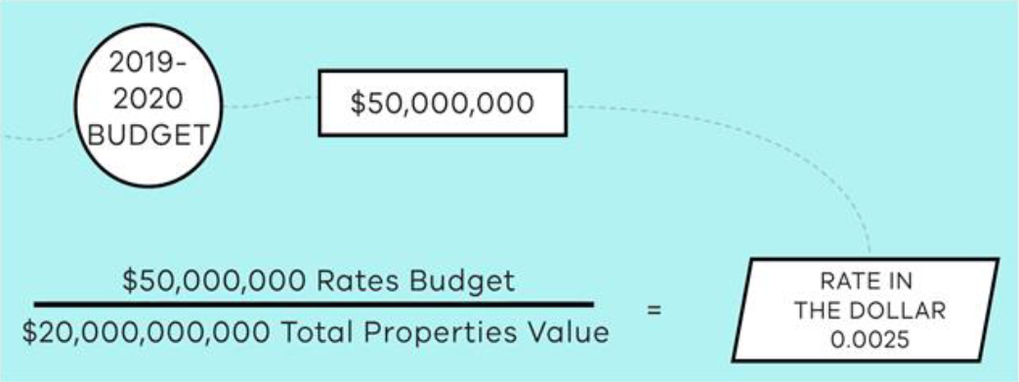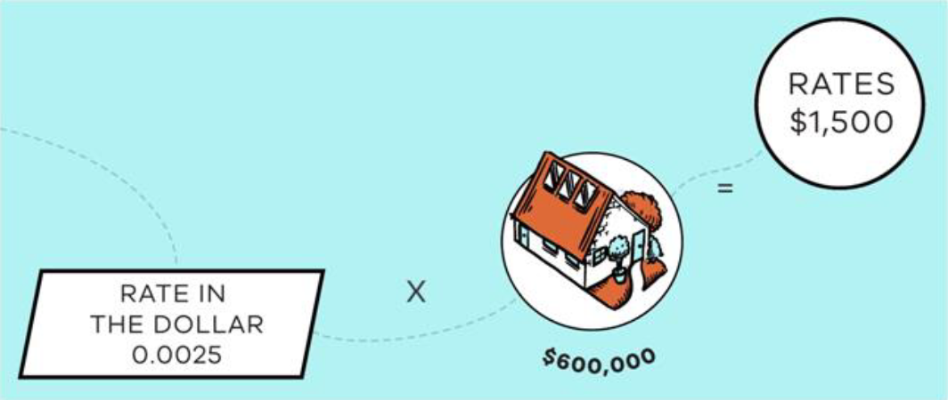

In this example, the council’s uniform rate in the dollar will be 0.0025. This means that for every dollar of your property’s value in the City of Pleasantville, you would pay 0.0025 cents in rates.
So, if you owned a property valued at $600,000, that value would be multiplied by 0.0025, to get $1,500 in rates.

Differential Rates
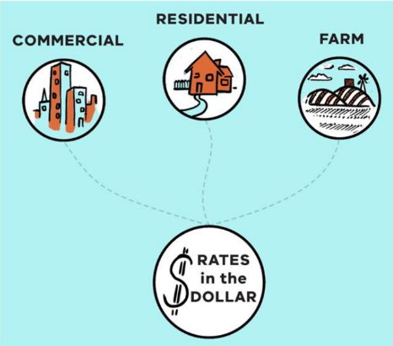
Where councils raise rates by applying different rates in the dollar for certain property categories.
When using differential rates, councils must declare the type of property categories and the rate in the dollar for each of these specified categories. Councils are free to declare whatever categories they choose. Some common categories for councils using CIV include Residential, Commercial and Farm Land. Other more specific categories can be determined, such as Quarrying Land, Vacant Commercial Land or Indoor Recreational Land.
Each category is assigned a separate rate in the dollar. Once this is determined, differential rates are calculated using the same method as a Uniform Rate. The following table gives a simple example of differential rates and rates payable for three different categories, each equally valued at $600,000.

Example Differential Rating Categories (Sample Valuation: $600,000)

Category | Rate in the Dollar | Rates Payable
Residential Land | 0.00250 | $1,500
Commercial Land | 0.00500 | $3,000
Farm Land | 0.00125 | $750

In the example above, the council has elected to levy the highest rate in the dollar on commercial land and the lowest on farm land. Each property will pay a different amount in rates even though the three properties have been valued equally at $600,000.
There is no limit on the number of differential rates a council may levy in Victoria. However, the highest differential rate is restricted to being no more than four times the lowest differential rate in a financial year.
Use of differential rates are further governed by the 2013 Ministerial Guidelines for Differential Rating. The Guidelines set out some suitable and unsuitable uses of differential rates, limit their use in some specific ways and describe instances where councils should consider their use (such as farm land and retirement villages).

Municipal Charges
A fixed charge declared to cover some of council’s administrative costs.
Councils can opt to use a municipal charge which applies equally to all properties regardless of their value. Because a municipal charge is a fixed dollar amount, the value of the property has no relationship to the amount charged. The greater the level of a municipal charge, the less the influence of the property’s value in determining the total amount levied in general rates and charges.
Using the uniform rates example above, if a council declared that it wanted to raise $10 million (out of the budgeted $50 million in general rates) in municipal charges across the municipality’s 50,000 properties then:

- Each property would be levied a fixed amount of $200 in municipal charges;
- The rate in the dollar would be reduced to 0.002 cents in the dollar (as the amount to be raised lowers to $40 million);
- The uniform rates portion for our example property would total $1,200 (0.002 cents in the dollar x $600,000 property value);
- The total rates payable for this example property using this system would be $1,400 (Municipal Charge + Uniform Rates) instead of $1,500.

Municipal charges can be used when levying differential rates as well as a uniform rate. The Act also allows an exemption from multiple municipal charges for the same ratepayer if they can show that they are operating a single farm business across multiple properties.

Rate Capping
A rate cap is a restriction or limit on the annual increase in rates from a previous year.
The current legislative rate cap system commenced in 2016-2017 and operates by limiting the amount of revenue a council can collect each year through general rates to a percentage increase from the previous year.
This percentage increase is not applied to individual properties, but the overall amount collected in general rates. Valuation movements and alterations to council’s rating structure can result in an individual experiencing either a higher or lower percentage increase than what was set by the rate cap.
For example, the City of Pleasantville raised a total of $10,000,000 in 2023/2024. If the rate cap for 2024/2025 was set at 2%, then the council could only raise a total of $10,200,000 in rates. This amount would then be distributed amongst their ratepayers based on the valuations of their properties.
The rate cap is determined annually by the Minister for Local Government.
After the required consultation with their community, councils may choose to apply for a higher rate cap to be applied to their overall rates for either a single or multiple years. This application is lodged with the Essential Services Commission.

Rebates, Discounts and Deferments
Local governments can adjust the impact of rates by applying discounts, rebates, concessions, and deferments of payment.
A State-wide concession on rates is provided for eligible pensioners by the State Government. The rate rebate for eligible pensioners is 50 per cent of the General Rates up to a maximum set annually by the State Government. This amount typically increases annually in line with inflation.
Application of further rebates, discounts and deferments are at the discretion of individual councils.
Some Victorian councils provide an additional rebate on rates for eligible pensioners on top of the State Government rebate. Councils may provide rebates and concessions for the purpose of:

- Assisting the proper development of the whole or part of the municipal district;
- Preserving buildings or places in the municipal district which are of historical or environmental interest;
- Restoring or maintaining buildings or places of historical, environmental, architectural or scientific importance in the municipal district;
- Supporting the provision of affordable housing, to a registered agency; and
- Public benefit land use.

Councils can also offer incentives for instalment payments received at an earlier date, which are generally offered for payments by lump sum.
Deferment schemes, whereby rates owed can be paid upon a specified future date (including upon sale of the property), can also include a waiver of interest on the deferred rate or charge. Such schemes can temporarily address the affordability issue for some people who own property but do not have a high cash income. They permit individual circumstances to be considered, including (but not limited to) financial hardship due to long-term illness.

Hardship Policies and Waivers
All 79 Victorian councils provide for financial hardship considerations by application, and many have a published policy for circumstances of financial hardship.
Commonly, councils provide details of the financial hardship assessment process, along with a payment arrangement application form. The Act does not provide a specific definition of financial hardship.
Councils may set up different payment arrangements for people whom they assess as experiencing hardship or waive part of, or even all, unpaid rates and charges.

Service Rates and Charges
A Service Rate or Charge funds a specific service, commonly used to fund the collection and disposal of waste.
The Act permits councils to levy charges on a property for a specific service, such as:

- Waste, recycling, or resource recovery services; and
- Any other prescribed service.

Waste charges for the collection and disposal of refuse, which fund kerbside waste and recycling services, are in widespread use in Victoria. Waste charges are separate from the State Government landfill levy, which is paid by licenced landfill operators (though some councils are landfill operators). Water services are no longer provided by Victorian councils, although some still provide limited sewage services for septic tanks.

Special Rates and Charges
A Special Rate or Charge funds a specific project that only affects a limited number of ratepayers.
Councils can choose to declare a special rate or charge to fund a project that only affects a limited number of ratepayers. This ensures that the ratepayers that benefit from the project contribute to funding it.
These projects can be initiated by councils or by ratepayers petitioning council for the new service. The special rate or charge to be raised also has separate financial accounting requirements, methods of declaration and objection, calculation of amounts due, and public consultation is required for the proposal to be implemented.
Examples of a special rate or charge scheme may include:

- Street beautification works;
- Raising funds for commercial marketing, development, and promotion via Business/Trader Associations;
- Creation of car parking to support commercial businesses;
- Infrastructure improvements (such as roads, stormwater drainage, and water and sewer mains) in a limited access street;

Each Special Rate and Charge is calculated and apportioned differently depending on the funding required and number of ratepayers responsible for payment.

Supplementary Rates and Charges
If a property’s valuation changes outside the annual revaluation process, councils issue amended notices updating the rates payable.
These valuation changes can occur for a variety of reasons, some of which are:

- Something occurs to make the land rateable (or exempt from rates) per the requirements of the Act;
- The land is subdivided or consolidated;
- A new building is constructed on the land;
- There is an alteration made to an existing construction (such as a renovation or demolition);

When the new valuation is determined, councils then issue revised rates notices to the owner showing the change in valuation and the updated rates and charges. This is generally called a supplementary rates notice and councils issue thousands of these notices annually as land uses change over time.

Alternate Rating Arrangements
Some ratepayers make payment directly to councils instead of paying rates based on a property’s value or can enter into upgrade agreements that only affect their property.
Some specialist property types are subject to different methods of rating under other legislation, allowing councils to raise revenue via rating agreements. These apply to properties such as electricity generators and land used for cultural and recreational activities (such as sporting facilities). In these instances, the rates are calculated quite differently from using the market value of the property. In some instances, land that is exempt from rates altogether may also pay a contribution to the council to fund municipal services.
The introduction into State legislation of Environmental Upgrade Agreements and Cladding Rectification Agreements allows councils to help ratepayers obtain finance to alter their properties and pay back their loans via their rates payments. These agreements can reduce the interest rates on the loans as future property rates are used as a financial guarantee. By their nature, these agreements can involve complex methods of calculation which vary across councils.

Rate Notices and Payments
Councils are required to issue rates notices which contain significant detail about the ratepayer’s property and the dates that payments are due.
The notices that councils issue ratepayers contain a significant amount of detail including the property’s various legal descriptions, the assessed value of the property, rates and charges, liability of payment, payment options, ratepayer rights and methods of objection.
Councils are required to allow ratepayers to make payment of the amount due over four instalments over the year and may also choose to offer the ability to pay in a lump sum (in full).
The due dates for these options were set in 1998 in the Government Gazette and are:

Four Instalments
- 30 September
- 30 November
- 28 February
- 31 May

Lump Sum (optional)
- 15 February

Other payment arrangements can be offered by councils which are often used to provide instalments paid via direct debit.

The Fire Services Property Levy
Council rate notices also include the Fire Services Property Levy, a State Government charge, to pay for fire and emergency services. Councils are required to collect this levy on behalf of the State Government, which is used to fund Victoria’s fire and emergency services.
Before 1 July 2013, a fire services levy charge was added onto insurance premiums to recover the cost of insurers’ contributions to the Country Fire Authority and Metropolitan Fire Brigade.
Following a recommendation from the Victorian Bushfires Royal Commission, the collection method was changed. From 1 July 2013, the levy was removed from insurance premiums, with property owners contributing via their council rates.
The levy comprises two parts:

- A Fixed Charge, and
- A Variable Rate.

Before 1 July 2020, there were different rates depending on whether a property was located in the Metropolitan Fire Brigade or Country Fire Authority area. The separate levies recognised the different costs associated with funding each service.
From 1 July 2020, this no longer applies. Instead, the same rates will apply to properties in the same property classification across Victoria.
Holders of pensioner concession cards and Department of Veterans’ Affairs Gold Cards (Totally and Permanently Incapacitated and War Widows) receive a concession on their home (principal place of residence). Only one concession applies per property per annum.
Property owners who currently receive a council rate concession in respect of their home (principal place of residence) automatically receive the levy concession.

The Fire Services Property Levy is not subject to the rate cap.

Penalty Interest and Recovering Unpaid Rates and Charges
Councils may charge interest on unpaid rates and charges as well as pursuing legal action which may include sale of the property.
Like taxes at other levels of government, if any rate or charge remains unpaid after its due date, councils can charge the ratepayer interest on these amounts.
Penalty interest rates are set by the State Government. However by using waivers, councils have the option to apply either the full amount, a partial amount or not to charge interest at all. Councils do not need to have a policy outlining when they will apply penalty interest, nor are they required to issue new notices once the interest has been applied to the debt. Councils can also choose to recover the unpaid amounts by legal action in the Magistrates’ Court.
If rates remain unpaid for over three years, councils can sell the property to recover the outstanding amount, or transfer the land in question to itself, thereby gaining ownership of it.
In some circumstances the occupier of the land may become liable for payment instead of the owner. This may require them to make payment of rent to council instead of the owner, to pay the outstanding debt. In such cases the payments to council cannot exceed the amount of rent owed by the occupier.

Councillor Consideration Checklist
This form is to be used by councillors when considering their council’s draft Revenue and Rating Plan under section 154 of the Local Government Act 1989.
If being stored in Council’s content management system, please complete all relevant sections and attach any relevant notes and/or supporting documentation.

- Are you satisfied that your draft Revenue and Rating Plan aligns with your council’s:

s88 | Community Vision | Yes | No
Notes

s90 | Council Plan | Yes | No
Notes

s91 | Financial Plan | Yes | No
Notes

s92 | Asset Plan | Yes | No
Notes

- Are you satisfied that your draft Revenue and Rating Plan aligns with the following principles detailed within the Local Government Act 2020:

s89 | Strategic Planning Principles | Yes | No
Notes

s101 | Financial Management Principles | Yes | No
Notes

s106 | Service Performance Principles | Yes | No
Notes
- While considering non-rate revenue, are you satisfied that you have considered each services:

 | Direct Costs  E.g. Labour, Accommodation/Materials, Asset/Equipment Maintenance | Yes | No
Notes

 | Indirect Costs  E.g. Corporate Services, Asset/Equipment Maintenance | Yes | No
Notes

- While considering non-rate revenue, are you satisfied with the categorisation of each service as:

 | Subsidised Pricing  (the full cost of providing the service is not passed on and is subsidised by other revenue) | Yes | No
Notes

 | Full Cost Recovery Pricing  (prices are set to recover all direct and indirect costs incurred, also known as cost-neutral) | Yes | No
Notes

 | Market Pricing  (prices are set based on benchmarked competitive prices of alternate suppliers) | Yes | No
Notes

 | Profitable Pricing  (prices are based on council’s desire to generate a profit used to subsidise other services) | Yes | No
Notes

- For each Rate or Charge proposed (including each differential rate), have you considered the key principles of:

 | Equity | Yes | No
Notes

 | Fairness | Yes | No
Notes

 | Efficiency | Yes | No
Notes

 | Simplicity | Yes | No
Notes

 | Sustainability | Yes | No
Notes

Application for Rate Exemption
This application form is to be used by organisations seeking a rates exemption pursuant to either:

- Section 154 of the Local Government Act 1989; or
- Section 4 of the Cultural and Recreational Lands Act 1963.

Please complete all relevant sections of this form and attach supporting documentation. The provision of the exemption will result in a decision by council, and you will be advised of the outcome in due course.
.
Council Assessment Number
Property Address
Postcode

Applicant Details
Full Name / Company Name
Postal Address
Postcode
Telephone / Mobile
Email

Are you the owner of the property? Yes No
If “No”, please provide details of the property owner:

Owner Details
Full Name / Company Name
Postal Address
Postcode
Telephone / Mobile
Email

SECTION A – Initial Classification

 | Section 154 of the Local Government Act 1989
2(a) | Is the land unoccupied vacant land or land used exclusively for public or municipal purposes?  If yes, proceed to Section C | Yes | No
2(b) | Is the land Crown Land, land vested in a Minister, Council, public statutory body or trustees appointed under an Act to hold that land in trust for public or municipal purposes?  If yes, proceed to Section C | Yes | No
2(c) | Is the land used exclusively for charitable purposes? | Yes | No
2(d) | Is the land vested in or held in trust for a religious body and used exclusively as:  - A residence of a practicing minister of religion; or  - For the education and training of persons to be ministers of religion.  If yes, proceed to Section C | Yes | No
2(e) | Is the land used exclusively for mining purposes?  If yes, proceed to Section C | Yes | No

2(f) | Is the land held in trust and used exclusively:  - As a sub-branch of the Returned Services League of Australia  - By the Air Force Association (Victoria Division)  - By the Australian Legion of Ex-Servicemen and Women (Victorian Branch) | Yes | No
 | Section 4 of the Cultural and Recreational Lands Act 1963
2(a) | Is the land:  - Vested in or occupied for the purpose of providing or promoting cultural or sporting recreation; and  - Your organisation applies its profits in promoting its objectives; and  - Prohibits the payment of any dividend or amount to its members.  - Used for outdoor sporting recreational or cultural purposes or activities | Yes | No
2(b) | Is the land used primarily as agricultural showgrounds? | Yes | No

SECTION B – Use of Land

Section 154 of the Local Government Act 1989

Does your organisation have a charity tax concession and/or endorsement as a deductable gift recipient (DGR)? | Yes | No
If you lease the land, does the lease agreement require you to pay rates on behalf of the owner? | Yes | No
Is any part of the land separately occupied and used for a non-charitable purpose? | Yes | No
Is there a house or flat on the land used as a residence? | Yes | No
Are commercial activities being conducted on the land? | Yes | No
Is the land used for the retail sale of goods? | Yes | No

Section 4 of the Cultural and Recreational Lands Act 1963

Does your organisation have a charity tax concession and/or endorsement as a deductable gift recipient (DGR)? | Yes | No
If you lease the land, does the lease agreement require you to pay rates on behalf of the owner? | Yes | No
Is any part of the land separately occupied and used for a non-charitable purpose? | Yes | No
Is there a house or flat on the land used as a residence? | Yes | No
Are commercial activities being conducted on the land? | Yes | No
Is the land used for the retail sale of goods? | Yes | No

SECTION C – Supporting Documentation

Section 154 of the Local Government Act 1989

Evidence of tax exemption or DGR status | Yes | No
Organisation Charter, Statement of Purpose and/or Articles of Association | Yes | No
Copy of lease for land (including rental payments) | Yes | No
Request for Tenant to be nominated as the land’s Ratepayer  (to be completed by owner of land) | Yes | No
Section 4 of the Cultural and Recreational Lands Act 1963

Evidence of promotion of cultural or sporting recreational facilities or objectives in the community | Yes | No
Financial documentation showing promotion of objectives and prohibition of dividends or amounts to members | Yes | No

DECLARATION

I certify that I am authorised to complete this application and that the answers given are to the best of my knowledge are true and correct.

I understand that an approved exemption from rates may not apply to some levies and charges, which will remain liable for payment by the owner of the land.

I understand that an application without relevant supporting documentation may be declined.

I understand that rate exemptions are subject to annual review, and I may be required to verify ongoing eligibility should an exemption be approved.

Full Name
Organisation |  | Position
Signed |  | Date

Dates for Payment of Rates and Charges
This information has been reprinted from page 632 of the Victoria Government Gazette No. G 12, Thursday 26 March 1998:

Local Government Act 1989
DATES FOR PAYMENT OF RATES AND CHARGES

I, Robert Maclellan, MLA, Minister for Planning and Local Government, acting under section 167 of the Local Government Act 1989 fix:

- 15 February as the date on which the while of the rate or charge (ither than a special rate or charge) is due in 1998/99 and subsequent years; and

- 30 September, 30 November, 28 February and 31 May as the dates on which payments by 4 instalments of the rate or charge (other than a special rate or charge) are due in 1998/99 and subsequent years.

Dated 20 March 1998.

ROBERT MACLELLAN, MLA
Minister for Planning and Local Government

Authorised by Local Government Victoria
Department of Government Services
1 Spring Street Melbourne Victoria 3000
Telephone (03) 9651 9999
© Copyright State of Victoria,
Department of Government Services 2023
Except for any logos, emblems, trademarks, artwork and photography this document is made available under the terms of the Creative Commons Attribution 3.0 Australia license.
This document is also available in an accessible format at www.vic.gov.au/department-government-services

From 1 July 2018 land valuations were centralised under Valuer-General Victoria (VGV), with a new annual cycle of valuations. Prior to that date, valuations in Victoria were generally conducted by councils every two years.
https://www.legislation.vic.gov.au/in-force/acts/valuation-land-act-1960/155
https://www.land.vic.gov.au/valuations/valuations-for-rate-and-land-tax/the-valuation-processes
If a council uses NAV as their valuation base for rates, they are permitted to use only a few differential rate categories. This is known as ‘Limited Differential Rates’.
https://www.localgovernment.vic.gov.au/__data/assets/pdf_file/0026/165554/Ministerial_Guidelines_for_Differential_Rating_April_2013-PDF.pdf
A prescribed service is one which has been specified in regulations by the Minister via a power in the Local Government act 1989.
The use of Special Rates and Charges are governed by the ‘Special Rates and Special Charges: Calculating Maximum Total Levy Ministerial Guideline’.
S158(4) of the Local Government Act 1989 and s10 of the Local Government (General) Regulations 2015, set out all details required to be present on a rate notice.
Government Gazette – pg.632 (http://www.gazette.vic.gov.au/gazette/Gazettes1998/GG1998G012.pdf)
The Local Government Act 1989 requires that penalty interest is to be calculated at the rate fixed under section 2 of the Penalty Interest Rates Act 1983.
This question may require additional attached information, or multiple copies of this page to be provided where more space is required.
This question should be completed for each rate or charge proposed. Each differential rating category should be considered separately.
http://www.gazette.vic.gov.au/gazette/Gazettes1998/GG1998G012.pdf

