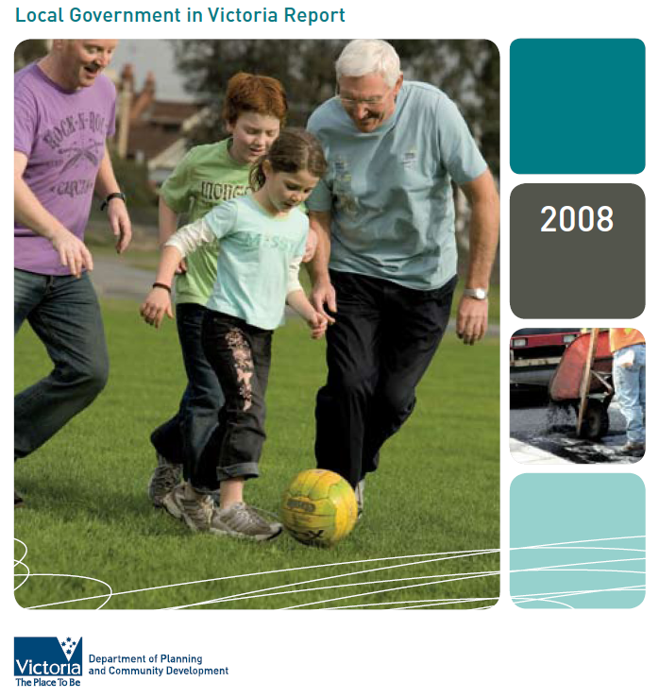

Local Government in Victoria Report
2008

Map of Victorian local government areas

“Local government is a distinct and essential tier of
government consisting of democratically elected
Councils having the functions and powers that
the Parliament considers are necessary to ensure
the peace, order and good government of each
municipal district.” Section 74A(1) Constitution Act
(Vic) 1975

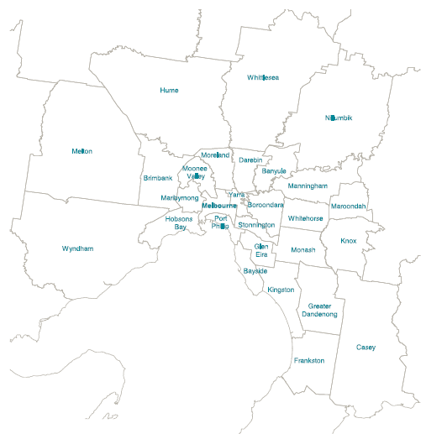

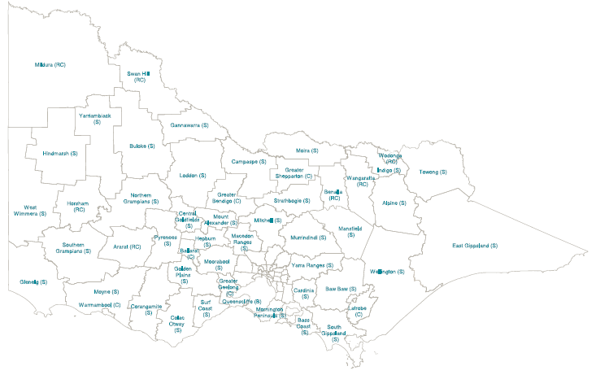

Measuring Performance

This report presents an overview of the performance of local government in Victoria in 2008. Councils in this state provide a wide range of services, manage critical assets, and represent their communities on diverse issues. In all these activities, councils are accountable to those communities.

A key part of being accountable is presenting information to the community on how each council is performing. This report discusses results from key performance indicators (KPIs) agreed by the sector. It considers councils’ operating environment during the 2007/08 financial year. Subsequent events such as the Victorian bushfires and the current economic conditions are not considered in this report but will be addressed in the next report for 2008/09. These recent events show how quickly the operating environment can change. This highlights the need for councils to be flexible and ready to adapt to changing environmental and economic conditions.

The importance of KPIs in assessing council performance can be seen in the results of the City of Melbourne’s Savings in the City initiative.

City of Melbourne’s Savings in the City initiative
Reducing Hotel Environmental Impact

Working with 30 hotels and serviced apartments, large and small, this innovative environmental program helps the hotels cut energy, water and waste consumption.¹ The council works with the hotels to:

- Review and benchmark baseline levels of environmental performance;
- Identify priority areas for savings; and • Encourage cost effective changes.

Over the past two years from 2005, the Savings in the City program has:

- Saved energy equating to 24,769 tonnes of greenhouse gases (equivalent to levels generated by 2,890 houses annually);
- Saved an average of 4.8 litres of waste per guest per night (a total saving of 628 truckloads of waste to landfill); and
- Reduced water use by an average of 15.3 litres per guest per night, with total saving equivalent to 45 Olympic swimming pools.

The program has been recognised in both the Banksia Environmental Awards, and the 2008 National Awards for Local Government, Local Greenhouse Action. This recognition reflects the tangible results achieved over two years.
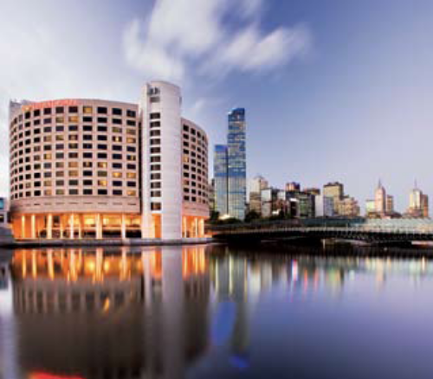
Crowne Plaza Melbourne, a participant in the
City of Melbourne – Savings in the City initiative.

1 Commonwealth Department of Infrastructure, Transport, Regional Development and Local Government 2008 Winners: National Awards for Local Government 2008, City of Melbourne website

Minister’s Foreword

The emergency relief response to the Victorian bushfires is an excellent example of what can be achieved when governments and the community work together.

Governments in Australia face challenging times in 2009.

In these circumstances, it is important that governments involve the community in their efforts and demonstrate that their actions are effective.

The emergency relief response to the Victorian bushfires is an excellent example of what can be achieved when governments and the community work together.

On a longer term scale, there are examples, such as the City of Melbourne’s Savings in the City – Green Hotels Program and the Warrnambool Maremma project. These initiatives which are profiled in this report, show how councils are working with communities and business stakeholders to tackle difficult challenges whether they address environmental issues or economic sustainability.

I am pleased to present the 2008 Local Government in Victoria Report. The report brings together a range of information to show how councils are performing and how their communities are responding.

The report focuses on Key Performance Indicators for local government – indicators agreed by the Victorian Government and councils. The key indicators on overall financial performance and asset management show pleasing trends of improving performance by councils.

It is also encouraging that over the longer term, councils have improved the satisfaction ratings given by their community. Whilst there has been some plateauing of satisfaction ratings in recent years with slight declines for some service areas, the overall results continue to be positive.

The report presents trends in the sector over the last seven years, providing the reader with a snapshot of the sector’s direction and giving context to the numbers.

I encourage you to visit the Local Government Victoria website for more comprehensive council data. On the website you will find time series spreadsheets of the indicators for individual councils. This will provide councils in particular with a benchmarking tool for performance comparisons.

I envisage that as this resource continues to build over time, it will become even more useful for council analysis of trends and performance. This will benefit the sector by helping to drive continuous improvement.

This report and the data can serve as a starting point for communities, other levels of governments and councils to conduct analysis, express views and inform the debate.

I recommend this report as a valuable resource for all with an interest in local government performance.

Richard Wynne MP
Minister for Local Government

Table of Contents

Measuring Performance

Minister’s Foreword

Council Expenditure Patterns

Revenue Patterns

Trends since 2002

Expenditure
Revenues
Maintaining Community Assets
Residents’ Views on Council Performance
Overall Results

Assisting Councils to Improve Performance

National Measures
Victorian Initiatives

Further Information

Council Expenditure Patterns

Victoria has 79 local councils which represent and serve very different communities.

In looking at the different contexts in which councils operate, a key influence across the state is the balance between roads and resident population. Victorian councils are responsible for 130,000 kilometres of road, and provide services to 5.2 million people. Yet councils differ widely in the extent of their local road networks – Buloke in north west Victoria has 5,168 kilometres of road for its 7,038 people, while densely populated Port Phillip in inner Melbourne has only 211 kilometres for a population of 91,931.

How councils differ

There are other considerable variations between councils within Victoria, such as²:

- Land area, ranging from Queenscliffe (8 sq km) to Mildura (22,000 sq km);
- Population size, ranging from 3,200 people (Queenscliffe) to 229,000 (Casey);
- Population change, ranging from small declines in some rural shires to annual growth of 12 per cent in the City of Melbourne; and
- Residents with poor English proficiency and recent arrivals in Australia: virtually nil in many farming areas, but 16 per cent in Maribyrnong and Brimbank, and 25% in Greater Dandenong.

Chart 1 shows the relationship between council population and road kilometres for all councils.

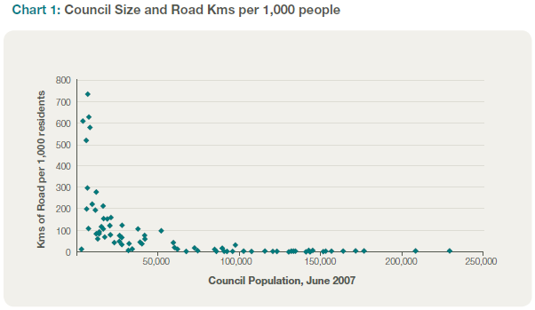

Victorian councils are responsible for 130,000 kilometres of road, and provide services to 5.2 million people. Buloke in north west Victoria has 5,168 kilometres of road for its 7,038 people, while densely populated Port Phillip in inner Melbourne has only 211 kilometres for a population of 91,931.

2 Data from Victoria Grants Commission (VGC) Annual Report 2007-08, roads p97, 99; English proficiency p49, 54; population and growth p50, 55

These variations contribute to differing challenges for councils across the state. In response, council expenditure patterns differ. Key features are shown in the following charts:

- In Melbourne’s central business area, the four inner Melbourne councils (Melbourne, Port Phillip, Stonnington and Yarra) provide services to a greater concentration of business ratepayers. Chart 2a³ shows that these councils spend 40 per cent of their budgets on business services (such as building control, tourism and area promotion and markets) and traffic and street management.

- All other metropolitan councils (excluding the inner four) have a focus on people services. Chart 2b indicates 43 per cent of these budgets are allocated to Family and Community, Aged Services and Recreation and Culture. Within such services, older suburbs closer to the centre of Melbourne have larger numbers of older people (often 15 per cent of the population) and spend more on aged services, while community services are more significant in the new outer suburbs, where around 15 per cent of the population is children aged less than 10.

- Consistent with the roads emphasis shown in Chart 1, regional and rural councils dedicate more funding to roads. Compared with 9 per cent across all Melbourne councils, these councils spend an average of 23 per cent of expenditure on roads – and this emphasis increases the more rural the council is, reaching 45 per cent for some small shires. Many of these councils, especially in the more rural areas, have ageing populations, some with 20 per cent aged over 65.

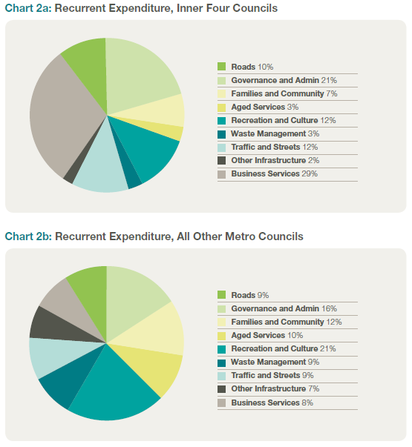

3 Chart 2 and Chart 4 are based on unpublished VGC data for the 2007-08 financial year. Chart 2 uses ‘recurrent expenditure’, which is expenditure as reported in council operating statements. It includes depreciation, but excludes capital expenditure.

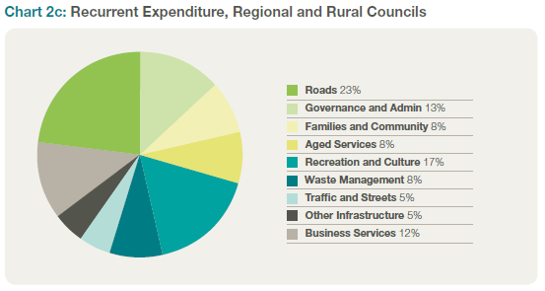

Council expenditure differs not only in its allocation between service areas, but also its sheer size. As Chart 3 shows, a typical council of 10,000 residents spends in total twice as much per resident as a council with a population of 100,000.4

Chart 3 also shows that the extent of the difference between councils varies in the three expenditure areas: recurrent road expenses, depreciation and other expenses.

- In expenses other than depreciation and recurrent roads, a council of 10,000 residents spends on average $1,044 per head, 66 per cent higher than the $630 spent by a council of 100,000 residents. This reflects both economies of scale in delivering services, and the fact that most smaller councils are in remote rural areas, with associated cost disabilities.

- In depreciation, the expenditure gap is bigger, with the council of 10,000 residents ($388 per head) spending 2.5 times that of the council of 100,000 residents ($142 per head). This difference is primarily due to the much greater road length per head in the smaller rural councils – although the asset base for depreciation also includes drainage assets and council offices and built facilities, which are more extensive in urban areas.

- In recurrent road expenses, the expenditure gap is even bigger again, with a council of 10,000 residents ($200 per head) spending six times as much as the council of 100,000 residents ($32 per head).

These differences in expenditure present varying challenges for councils in raising revenues. However, the extent of the problem is also affected by differences in the sources of councils’ revenues.

4 The typical expenditure figures are calculated from the trend lines for each of the three expenditure areas, per head, compared with council population size. Due to the unusual expenditure patterns of the four inner Melbourne councils, these are excluded from this exercise.

A typical council of 10,000 residents spends in total twice as much per resident as a council with a population of 100,000.

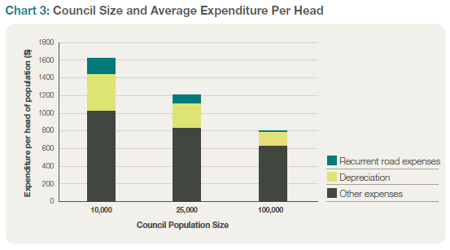

Revenue Patterns

Across Victoria, rates contribute almost half of revenues, with grants from Commonwealth and State governments providing another 20 per cent. Service fees and developer contributions are also significant.

There are also differences between the council groups in where their revenues come from, as shown in Charts 4a, 4b and 4c. Across Victoria, rates contribute almost half of revenues, with grants from Commonwealth and State governments providing another 20 per cent. Service fees and developer contributions are also significant. Within these overall patterns, emphases differ for the three broad groups of councils:

- The four councils in inner Melbourne raise significant revenues from car parking and other charges, and receive a relatively low proportion of recurrent revenue from Commonwealth or State government grants. At 45 per cent, their reliance on rate revenues is slightly less than the state average.

- All other metropolitan councils have the highest reliance on rates in their revenue base (60 per cent), although some councils in outer Melbourne also receive significant revenue from developer contributions.

- Regional, and especially rural, councils receive the highest proportion of revenue grants from Commonwealth and State governments (29 per cent of income comes from government grants). Their contribution from rates, at 49 per cent, is on the state average, although the figure is much less than this for some smaller councils. As recently noted by the Productivity Commission⁵, councils with a high reliance on Commonwealth and State government grants generally have a lower fiscal capacity to address challenges by themselves.

The discussion of expenditure, and Chart 3, noted that smaller councils have much higher average expenditures per head than larger councils, with a council of 10,000 residents spending twice as much per head as a council of 100,000 residents. To fund this expenditure, the smaller councils have to raise significantly higher revenues per head.

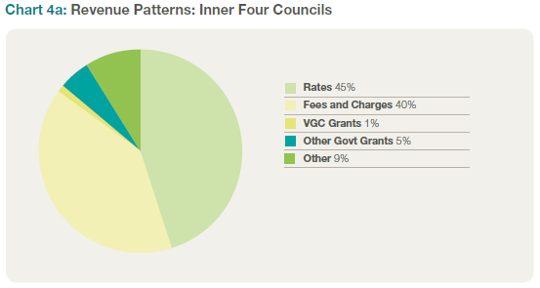

5 Productivity Commission Assessing Local Government Revenue Raising Capacity April 2008

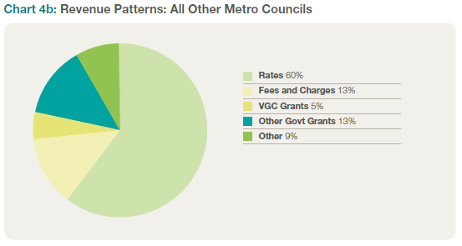

Regional, and especially rural, councils receive the highest proportion of government grants at 29 per cent.

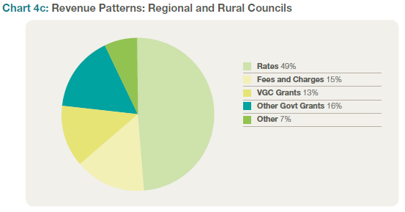 .

The impost on the community from this necessity is lessened somewhat by the pattern of government grants. A typical council of 10,000 residents receives some $672 per head in government grants: 3.5 times the $189 per head grants received by a council of 100,000 residents.⁶ When this is taken into account, the smaller council has to raise an average of some $1,154 in revenues from its own sources – 60 per cent more than the $733 raised by the council of 100,000.⁷

The impact of this impost is reinforced by the fact that rural and regional areas (where most smaller councils are located) typically have lower resident incomes than most metropolitan councils. Local Government Victoria figures compare the revenues raised by the smallest 25 councils with those raised by the largest 25. The smallest 25 councils raise an average of $880 per year in own-source revenues per head of population – from communities that have average disposable incomes of $18,500 per head. The largest 25 councils raise less per head, at $540, from better-off communities with average disposable incomes of $24,300 per head. Council own-source income is therefore 4.7 per cent of disposable income for the smallest councils: more than twice the impost of 2.2 per cent for the largest councils.

6 This demonstrates for Victoria a point the Productivity Commission report found across Australia – the weighting of grants to the smaller and more remote councils. See Commission finding 3.4, p xxxvi
7 As with Chart 3, the typical revenue figures are calculated from the trend lines for each revenue source. As before, the four inner Melbourne councils with unusual revenue patterns are excluded from this exercise.

Trends since 2002

Expenditure

The Key Indicators collected by councils and published in this report use two measures of council expenditure: operating expenditure (Opex) and capital expenditure (Capex).

Chart 5 shows the growth in both council operating and capital expenditure since 2002. To provide easy comparison between councils, these and the following figures are expressed per rateable property (or ‘assessment’). The chart shows the council median value across Victoria.⁸

Between 2002 and 2008, median council operating expenditure has grown by 39 per cent, or by 5.6 per cent each year.

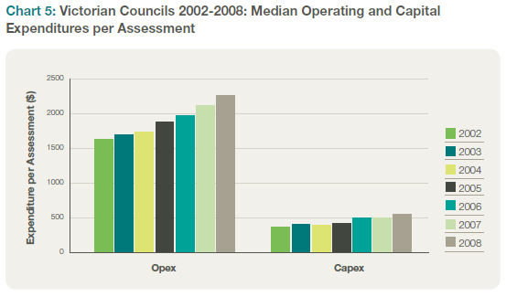

Between 2002 and 2008, median council operating expenditure has grown by 39 per cent, or by 5.6 per cent each year. Operating expenditure has grown the fastest in large shires, with inner metro, regional centres and small shires all seeing slightly slower growth over these years, around 28 per cent. Reporting recently on the overall financial strength of the sector, the State Auditor-General noted that operating expenditure in 2007-08 increased by more than operating revenues did, and expressed concern that “the long-term financial sustainability of councils may be at risk if these trends are sustained.”⁹

Capital expenditure has recently grown faster than operating expenditure (a trend welcomed in the Auditor-General’s report). Councils have responsibility for a range of community assets, including roads, drainage, parks and gardens and community buildings. In recent years, councils have been placing an increased emphasis on these assets. Median capital expenditure is up by 48 per cent since 2002, an annual average of 6.7 per cent. Inner metro and small shires have seen the biggest expansion of capital spending, while regional centres, which already had the largest capital expenditure in 2002, have experienced slightly slower growth.

8 The median value is the midpoint of each group. For this analysis, it is a more accurate measure of ‘typical’ experience than a mean or average value as the latter can be influenced more by unusual movements in the figures for one or more councils.
9 Auditor-General’s Report Local Government: Results of the 2007-08 Audits November 2008 p38

Revenues

The Key Indicators examine three measures of council revenues: overall rates, residential rates, and changes in debt levels.

To fund the expenditures shown in Chart 5, Victorian councils have been increasing rate levels over the past six years – and have also drawn on slightly more debt. Chart 6 shows median overall rates, residential rates and debt levels per assessment.

Since 2002, councils have increased median rates by 54 per cent, or 7.4 per cent per year (residential rates have increased by a very similar 55 per cent). Increases have been similar across the state, with outer metropolitan councils at 57 per cent and only inner metropolitan councils at 52 per cent is much less than the state median increase. As noted, the four inner Melbourne councils have the greatest scope to increase fees and charges, which may explain the slightly lower level of rate increases for the inner group.

Victorian councils have been increasing rate levels over the past six years – and have also drawn on slightly more debt.

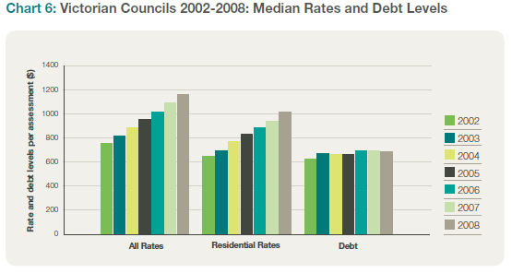

Maintaining Community Assets

Chart 5 indicated that councils have been strongly increasing their capital expenditure in recent years. Chart 7 compares this expenditure with council estimates of what is necessary to renew and maintain their assets. The Key Indicators measure this in two ways:

- Expenditure on asset renewal – as a percentage of the desired expenditure considered necessary to sustain the assets; and

- Expenditure on renewal together with maintenance – again as a percentage of the desired level of expenditure on renewal and maintenance.

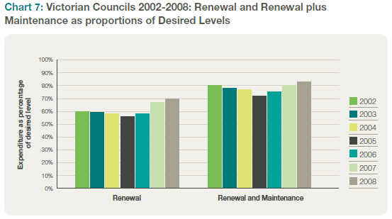

Chart 7 does not show the same strong growth as the capital expenditure figures – indeed, both these measures experienced declines in the ratios from 2002 to 2005. The key reason for these patterns is that a council’s view of what is necessary to sustain assets changes as asset management information improves. It can both increase as councils include additional assets or decrease as ways of sustaining assets improve.

Early this decade, councils put considerable effort into improving asset management information. Chart 7 indicates that this reassessment led to increases in estimates of the size of the renewal task. However, since 2005 both measures have seen strong increases, linked to the further expansion of capital expenditure.

All five council groups (inner metro, outer metro, regional cities, large and small shires) experienced similar patterns to these figures: a stable or slightly falling renewal figure between 2002 and 2005, and then good growth in expenditure as a percentage of the desired level after 2005. Comparing the groups, outer metropolitan councils and small shires have renewal percentages slightly above average, while regional centres have the lowest figure, at 58 per cent compared with the state-wide 71 per cent.

Residents’ Views on Council Performance

Since 1998, councils across Victoria, working with the government, have conducted annual resident satisfaction surveys to assess the community’s views on how well local government is performing. From 2002, three measures from this annual survey have been used in the Key Performance Indicators: overall satisfaction with council performance, satisfaction with council advocacy and councils’ engagement with the community

Trends in satisfaction ratings for all councils are shown in Chart 8.

Councils have consistently been rated above average on overall satisfaction and advocacy across these years with results for engagement showing considerable improvement.

Councils have consistently been rated above average on overall satisfaction and advocacy across these years with results for engagement showing considerable improvement.

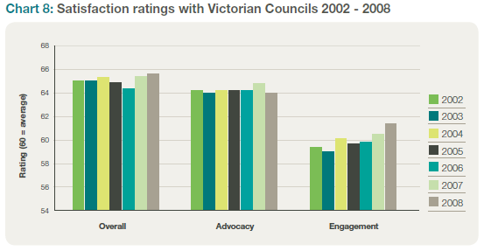

The satisfaction ratings shown in Chart 8 are based on a scale from 20 to 100, with 60 an overall ‘average’ rating. The figures indicate:

- While there are some minor year-to-year variations, overall community satisfaction with councils shows a positive slight upwards trend over the past six years. Across the council groups, the metropolitan councils saw slight declines in satisfaction, while both large and small shires, which had lower than average ratings in 2002, have seen slight upward trends;

- Ratings for council advocacy have been stable for several years, although inner metro, and large and small shires have seen slight declines on this measure; and

- In contrast, ratings for community engagement have been climbing over this period, with a further slight increase in 2008. Regional centres and small shires have seen the strongest increases in this measure.

As well as measuring overall satisfaction, the survey asks for opinions on specific areas of council performance, and how these impact on overall ratings.¹⁰

10 Wallis Consulting Group Local Government Community Satisfaction Survey 2008: Statewide Research Results Summary May 2008, for the Department of Planning and Community Development and local governments

In 2008, while the overall results show a continuing positive trend, residents reported some dissatisfaction in some service areas. The four services which had the strongest impact on resident satisfaction were (in order of priority) –

- Town planning, policy and approvals. While many people (most notably in outer metropolitan councils) still report satisfaction with council performance, this area has seen the strongest growth in dissatisfaction over the past five years. Across the state, one third of residents say they want improved performance, especially in inner metropolitan councils and in large shires.

- Economic development. This is especially seen as important in regional and rural areas, with residents in large and small shires wanting the most improvement in performance. Overall satisfaction with council performance has improved slightly over the past six years.

- Local roads and footpaths. This is the area where improvement is wanted by 40 per cent of residents across the state, and almost half of residents in large and small shires. Inner metropolitan residents are the most satisfied. However, consistent with the trends of increases in council capital expenditure, satisfaction has improved in rural areas in recent years.

- Appearance of public areas. A consistent one fifth of residents report room for improvement in this area, which is seen as especially important in metropolitan areas. Residents in regional centres are the most satisfied with their councils’ performance on this measure.

Engaging the Community: Community, penguins and shaggy dogs

Middle Island, on the coast near Warrnambool, is home to seabird colonies including little penguins and short-tailed shearwaters. Over the past decade, the penguin colony was decimated by fox predation, with numbers falling from more than 600 in 1999 to only 10 in 2005.

Warrnambool City Council’s measures to protect this part of its natural environment have attracted international attention. Working together with 60 local volunteers, businesses, and government agencies; the City established around-the-clock protection using a Maremma sheep dog at the entry point to the island. These steps were immediately successful in stopping fox predation.

A local newspaper poll in March 2007 showed strong community support for the project. The council expanded the project to two guard dogs, and despite some setbacks, has won additional support from the community and in business sponsorship.¹¹

By December 2008, penguin numbers had dramatically recovered. Coastcare volunteers counted 80 penguins and 26 chicks on the island.¹² Community interest also continued – there were several hundred bookings for a “Meet the Maremmas Weekend” as part of Coastcare’s Summer by the Sea program.

In September 2008, the success in building community involvement to restore the penguin colony earned the council a commendation in the National Awards for Local Government, Natural Resource Management.

Warrnambool Council’s success in involving the community in the Maremma project appears to have won friends in community views of the council’s engagement. As resident satisfaction ratings are influenced by many factors, it is often difficult to attribute changes in ratings to one specific event. However, changes in Warrnambool’s ratings are at least suggestive. In 2006, there was a significant increase in the rating for engagement, followed by a further increase in 2007. The 2007 increase was also reflected in a higher rating for overall satisfaction.

11 Warrnambool Council media release 13 March 2007, Warrnambool Standard 16/12/2008
12 Tina Liptai “Penguin colony keeps growing” Warrnambool Standard 19/12/2008

Since 2002, the overall operating result has shown a strong positive trend, with the median operating surplus growing from $168 to $188 per assessment.

Overall Results

The Key Indicators include the overall operating result for each council as an indicator of overall financial strength. Since 2002, the overall operating result has shown a strong positive trend, with the median operating surplus growing from $168 to $188 per assessment.

Since 2003-04, the State Auditor- General has also reported on councils’ annual performance on five key financial indicators for short and long-term viability. Two of the key measures used are:

- Whether the underlying operating result, excluding the large one-off revenue items, indicates enough revenue from all sources to cover operating costs (including the cost of replacing assets reflected in depreciation); and

- Whether an investment gap exists: if the council has been replacing assets at a rate consistent with the rate at which they are being consumed.¹³

In recent reports, the Auditor-General described broadly positive trends, with most councils showing improving financial results. The number of councils with underlying financial deficits in the operating result fell from 50 in 2002-03 to 36 in 2004-05, further to 20 in 2006-07 and then to 14 in 2007-08.¹⁴

A key feature of this improvement has been the strong growth in capital expenditure by Victorian councils. However, as Chart 9 shows, there is considerable variation between councils on their operating results.

There is considerable variation between councils on their operating results.

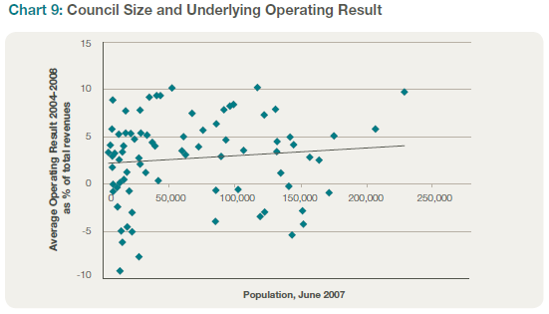

13 Auditor-General’s Report on Local Government: Results of the 2007-08 Audits November 2008 p33. The other three measures are: liquidity (sufficient working capital to meet short-term commitments); the self-financing ratio (sufficient free operating cash flows); and indebtedness (being not overly reliant on debt to fund capital programs)
14 Auditor-General’s Report on Public Sector Agencies December 2005 Chapter 14, 2006-07 data from Auditor General Local Government: Results of the 2006-07 Audits February 2008 Appendix D, 2007-08 data from Auditor-General Local Government: Results of the 2007-08 Audits November 2008 Appendix D

The Auditor-General calculates an average underlying operating result over five years, expressed as a percentage of the total revenues for each council. This average five-year figure is shown in Chart 9, compared with each council’s size.

The chart shows some relationship between a council’s size and its operating result. More than half the councils with underlying deficits have fewer than 30,000 residents. However, both the shallow slope of the trend line and the considerable variation above and below that trend line indicate that the relationship is not strong. Some small councils, despite the large asset commitments and small populations, produce very strong financial results. On the other hand, some larger councils, despite the advantages that size brings, still have operating deficits.

This suggests two areas for government and council action:

- Assistance for the smaller councils facing particular difficulties in maintaining services and assets with limited population bases; and

- Assistance in developing skills so councils can manage their situations better.

Assisting Councils to Improve Performance

This report has outlined some key performance dimensions of local government in Victoria in 2008. Overall, there are strong positive trends, with good performance especially in asset management and in community responses. However, the report has also highlighted some of the challenges that councils face. There is still some way to go in achieving full renewal of assets – and the achievements thus far have been underpinned by rate increases substantially above the rate of inflation.

Both national and state governments, working together with local government, have moved during the year to assist in improving local government sustainability.

National measures

A range of studies, at a state level and across Australia, have looked at the financial situation of local government. The issues have been most recently discussed by the Productivity Commission in its April 2008 report Assessing Local Government Revenue Raising Capacity, and in a paper prepared by Victoria for the Local Government and Planning Ministers’ Council in August 2008, and subsequently referred to the Council of Australian Governments.

To support the sustainability of local government, and as part of its measures to tackle the economic downturn, the Federal Government announced in November 2008 a $300 million program to build local community infrastructure in all of Australia’s 565 local council areas. This $300 million Regional and Local Community Infrastructure Program was expanded in 2009 with an additional $500 million to boost local economic development and support jobs in communities around the country.

Victorian initiatives

As discussed in this report, improving local government performance requires both

- addressing structural issues (such as the inherent financial pressures on small councils with extensive road networks); and

- supporting local government’s own capacity to respond to their challenges.

This section outlines four initiatives that Victoria is implementing to support local councils and improve governance.

Assessing Council Sustainability

This initiative is providing direct support to councils identified as ‘at risk’. The analysis takes two steps:

- Identifying a number of demographic and income related factors, beyond the control of councils, that affect sustainability. These factors include the revenue capacity of the council, the level of government grants, and adverse cost pressures stemming from population size, dispersion and remoteness.

- Measuring key financial performance indicators, including many discussed in this report, which indicate how well a council itself is performing. These include underlying operating result, extent of infrastructure renewal, and debt and financial management.

Asset Management Initiatives

Over the past decade, the government and local councils have worked on a number of initiatives to improve council management of infrastructure. These have included:

- The Step Program, developed by the Municipal Association of Victoria (MAV), which sets out several steps in understanding the current and desired performance of assets, the financial implications, and the development of an asset strategy.

- The Asset Management Performance Measures Project, a data collection and reporting tool developed by Local Government Victoria to enable councils to measure their own performance in the management of infrastructure assets. The methodology enables councils to collect data on asset conditions and usage, using current replacement cost and economic lives. This will provide information, for council’s purposes, about the rate at which assets are being consumed, renewed and expanded.

- A five year project managed by the MAV and Australian Road Research Board which monitors more than 160 roads across Victoria to assess conditions and rates of deterioration. New models will better reflect the performance of local roads in various environments, different traffic volumes and road pavements, covering both sealed and unsealed roads.

Councils Reforming Business

The State Government allocated $4.7 million in funding for the Councils Reforming Business project in the 2007-2008 State Budget for two years until June 2009. It has concentrated on:

- Smarter procurement practices;
- Greater use of shared services;
- Reduced cost to business through best practice local law making; and
- Improved processes for affordable housing.

The projects have also documented the scope for significant improvements in local government performance. As part of the procurement stream, a detailed study concluded that savings of $180- 350 million a year are possible from better procurement practices. The best practice law making stream released a discussion paper in April 2008, and this has been followed by a draft strategy (September 2008) and a report on consultation (November 2008).

The current projects have generated strong council participation in a number of pilot projects. For example, the Collaborative Procurement Program projects announced on 16 December 2008 involve 53 councils, 27 in rural Victoria and 26 in metropolitan Melbourne. Nearly all councils have participated in the workshops and consultation processes as part of specific projects.

Improving Council Governance

The government introduced reforms to governance arrangements during 2008 to support councillors in their roles and to ensure improved public accountability. These included changes to the laws about councillor conduct and greater resources for councillors.

The Local Government Act 1989 now defines standards of conduct that councillors are expected to uphold and establishes procedures where a councillor fails in this task.

Minor misbehaviour can be addressed through Councillor Conduct Panels that have the power to reprimand a councillor, require him or her to make an apology or place a councillor on leave for up to two months. More serious misconduct is subject to VCAT hearings and can result in suspension or dismissal.

New rules for meetings provide greater transparency, particularly in regard to the disclosure of conflicts of interest. Conflicts of interest must now be disclosed in more detail and at a wider range of meetings. In addition, notices of meetings must be published on council web pages.

In order to better support councillors, an independent local government panel conducted a review of councillor remuneration. This resulted in allowances being updated in line with inflation and clearer requirements for the reimbursement of councillor expenses.

Further Information

Do you want to see how your council is performing against the 11 Local Government Indicators?

The indicator data for each council, and for council groups, from 2005 are available on the Local Government Victoria website www.localgovernment.vic.gov.au by following the links to ‘Publications and Resources’ and then ‘Data, Directories and Surveys’. You can also find out more here about the indicators and how they are calculated.

Other reports referred to in this publication are also available on line:

The Wallis Consulting Group’s report Local Government Community Satisfaction Survey 2008 can also be found at www.localgovernment.vic.gov.au, following the links to ‘Publications and Resources’ and then ‘Data, Directories and Surveys’.

The Productivity Commission’s report Assessing Local Government Revenue Raising Capacity is available from www.pc.gov.au

The Auditor-General’s report Local Government: Results of the 2007-08 Audits is available from
www.audit.vic.gov.au

Information about the Councils Reforming Business initiative is available on the Local Government Victoria website at www.localgovernment.vic.gov.au

April 2009

Published by Local Government Victoria
Department of Planning and Community Development
Level 8, 55 Collins Street, Melbourne Victoria 3000
Tel (03) 9651 7026
Fax (03) 9651 7269

Authorised by the Victorian Government, Melbourne
Printed by Croxton Printing
Designed by The Designery
Printed on 100% recycled paper

Accessibility
If you would like to receive this publication in an
accessible format such as large print or audio, please
telephone Local Government Victoria on (03) 9651 7026,
or email local.government@dpcd.vic.gov.au
This publication is also published in PDF and Word
formats on www.localgovernment.vic.gov.au

ISBN 978-1-921607-16-5

Copyright & Disclaimer
The materials presented in this report are for information purposes only. The information
is provided solely on the basis that readers will be responsible for making their own
assessments of the matters discussed and are advised to verify all relevant
representations, statements and information and obtain independent advice before acting
on any information contained in or in connection with this report. While every effort has
been made to ensure that the information is accurate, the Department of Planning and
Community Development will not accept any liability for any loss or damage which may be
incurred by any person acting in reliance upon the information.
Copyright © State of Victoria 2009
This publication is copyright. No part may be reproduced by any process except in
accordance with the provisions of the Copyright Act 1968.

