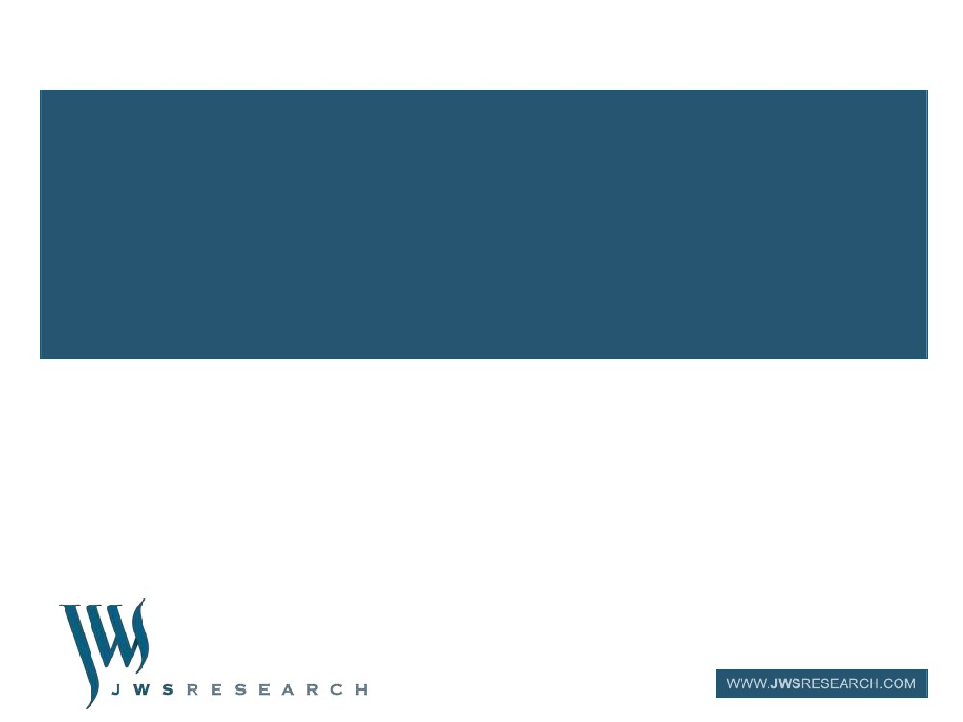
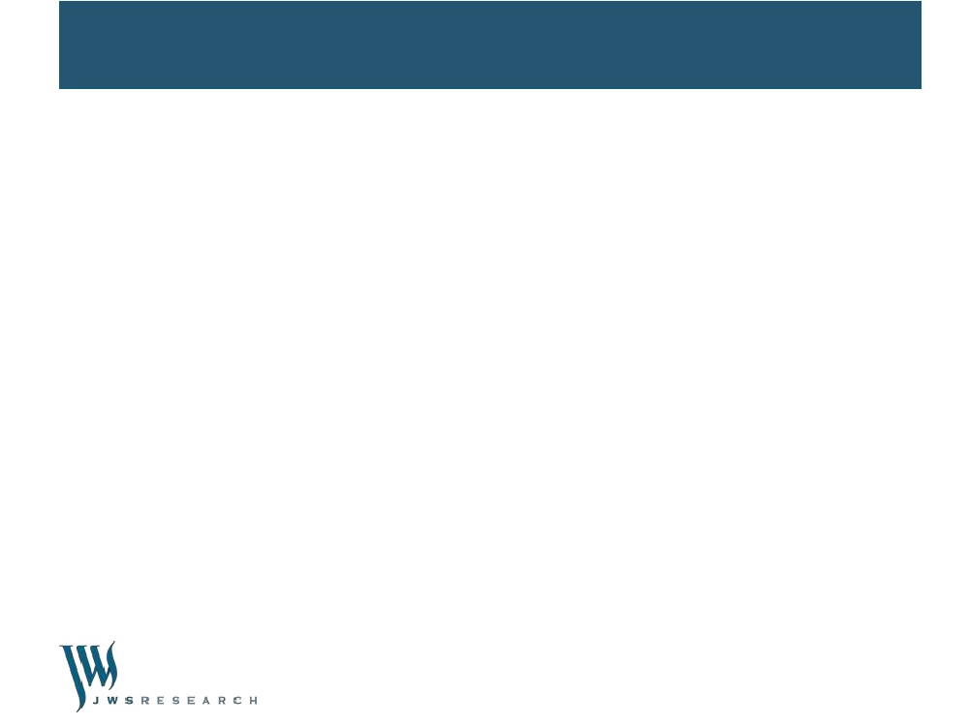
STATEWIDE LOCAL GOVERNMENT
SERVICES REPORT
JUNE 2012
Coordinated by the
Department of Planning and Community Development
on behalf of Victorian councils
1
Contents
•
•
•
•
•
•
•
•
Background & Objectives
Survey Methodology & Sampling
Margins of Error
Analysis & Reporting
Glossary of Terms
Observations & Recommendations
Key Results Summary
Detailed Results – including Section Findings Summaries
APPENDIX A: List of Participating Councils
2
Statewide Local Government Services Report 2012
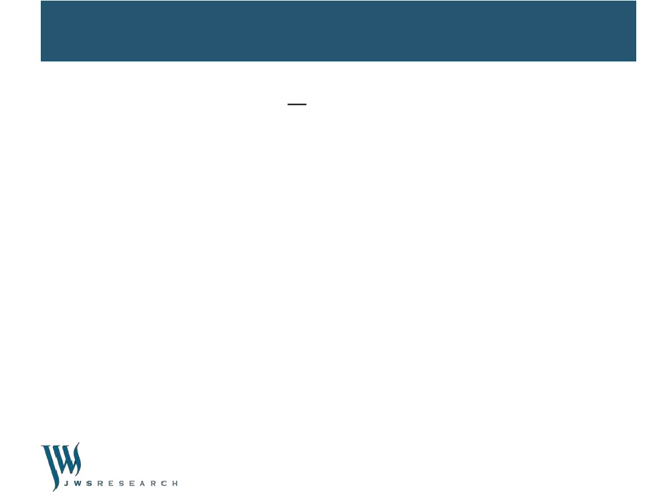
Background & Objectives
•
Welcome to the state-wide report of results and recommendations for the 2012 community satisfaction
survey.
Each year the Department of Community Planning and Development (DCPD) coordinates and auspices
this community satisfaction survey throughout Victorian Local Government areas. This coordinated
approach allows for far more cost effective surveying than would be possible if Councils commissioned
surveys individually.
•
•
Participation in the community satisfaction survey is optional and participating Councils have a range of
choices as to the content of the questionnaire and the sample size to be surveyed, depending on their
individual strategic, financial and other considerations.
The main objectives of the survey are to assess the performance of Victorian Councils across a range of
measures and to seek insight into ways to provide improved or more effective service delivery. The
survey also provides Councils with a means to fulfil some of their statutory reporting requirements as well
as acting as a feedback mechanism to DCPD.
•
3
Statewide Local Government Services Report 2012
Background & Objectives (Cont‟d)
•
Please note that comparisons should not be made with community satisfaction survey results
from 2011 and prior. As a result of feedback from extensive consultations with Councils, in 2012
there have been necessary and significant changes to the methodology and content of the
survey which make comparisons invalid, including:
–
The survey is now conducted as a representative random probability survey of residents aged 18 years or
over in local Councils, whereas previously it was conducted as a „head of household‟ survey.
As part of the change to a representative resident survey, results are now weighted post survey to the known
population distribution of Victorian Councils according to the most recently available Australian Bureau of
Statistics population estimates, whereas the results were previously not weighted.
The service responsibility area performance measures have changed significantly and the rating scale used
to assess performance has also changed.
–
–
•
As such, the results of the 2012 community satisfaction survey should be considered as a benchmark.
Tracking comparisons will be possible in future years.
Detailed explanations of the „Survey Methodology & Sampling‟ and „Analysis & Reporting‟ approaches
are provided in the following sections.
•
4
Statewide Local Government Services Report 2012
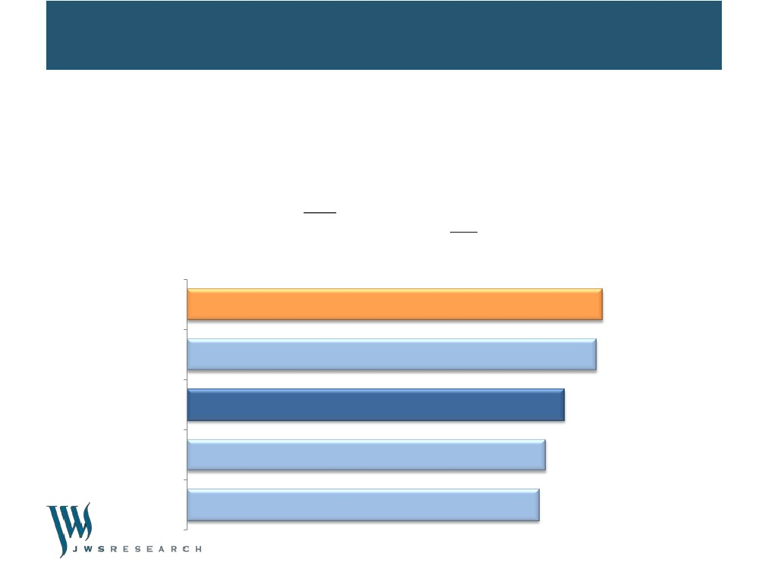
Survey Methodology & Sampling
•
This survey was conducted by Computer Assisted Telephone Interviewing (CATI) as a representative
random probability survey of residents aged 18+ years in the Overall.
Survey sample matched to Victorian Councils was purchased from an accredited supplier of publicly
available phone records, including up to 10% mobile phone numbers to cater to the diversity of
residents in the Council, particularly younger people.
A total of n=29,384 completed interviews were achieved based on a survey of an estimated average
length of between 4 and 15 minutes dependent on individual Council question selection. Survey
fieldwork was conducted in the period of 18th May – 30 June 2012.
Minimum quotas of gender within age groups were applied during the fieldwork phase. Post survey
weighting was then conducted to ensure accurate representation of the age and gender profile of the
Overall area.
Any variation of +/-1% between individual results and NET scores in this report or the detailed survey
tabulations is due to rounding.
“NET” scores refer to two or more response categories being combined into one category for simplicity
of reporting.
•
•
•
•
•
5
Statewide Local Government Services Report 2012
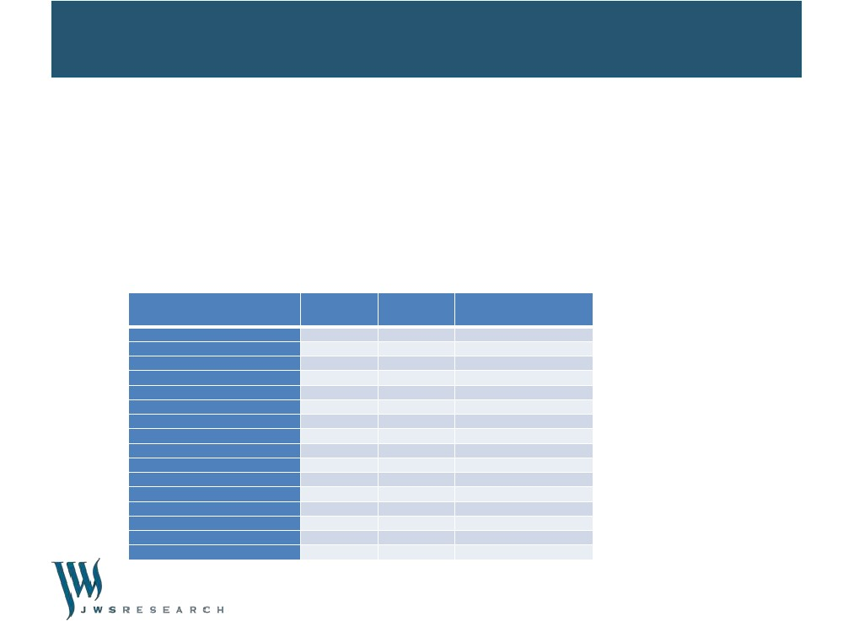
Survey Methodology & Sampling (Cont‟d)
•
Within tables and index score charts throughout this report, statistically significant differences at the
95% confidence level are represented by upward directing blue and downward directing red arrows.
Significance when noted indicates a significantly higher or lower result for the analysis group in
comparison to the „Total‟ result for the Council for that survey question. Therefore in the following
example:
–
–
The State-wide result is significantly higher than the overall result for the Council.
The result amongst 50-64 year olds in the Council is significantly lower than for the overall result for the Council.
Overall Performance – Index Score (example extract only)
State-wide
66⬆
18-34
65
Council
60
Men 50+
57
50-64
56⬇
6
Statewide Local Government Services Report 2012
Margins of Error
•
•
•
The sample size for the 2012 community satisfaction survey for Overall was 29,384. Unless otherwise
noted, this is the total sample base for all reported charts and tables.
The maximum margin of error on a sample of approximately 29,000 interviews is +/-0.6% at the 95%
confidence level for results around 50%. Margins of error will be larger for any sub-samples.
As an example, a result of 50% can be read confidently as falling midway in the range 49.4% - 50.6%.
•
Maximum margins of error are listed in the table below, based on a population of 4,300,000 people
aged 18 years or over State-wide according to ABS estimates.
Table 2: Survey sub-samples and margins or error
Demographic
Overall
Inner Melbourne Metro
Outer Melbourne Metro
Regional Centres
Large Rural Shires
Small Rural Shires
Men
Women
18-34 years
35-49 years
50-64 years
65+ years
Men 18-49 years
Men 50+ years
Women 18-49 years
Women 50+ years
Actual survey
sample size
29384
6002
4901
4403
6913
7165
12924
16460
3933
6270
9707
9474
4547
8377
5656
10804
Weighted
base
28400
6001
4400
4400
6400
7200
14005
14395
7809
7570
6575
6445
7725
6279
7654
6741
Maximum margin of error
at 95% confidence interval
+/-0.6%
+/-1.3%
+/-1.4%
+/-1.5%
+/-1.2%
+/-1.2%
+/-0.9%
+/-0.8%
+/-1.6%
+/-1.2%
+/-1.0%
+/-1.0%
+/-1.5%
+/-1.1%
+/-1.3%
+/-0.9%
7
Statewide Local Government Services Report 2012
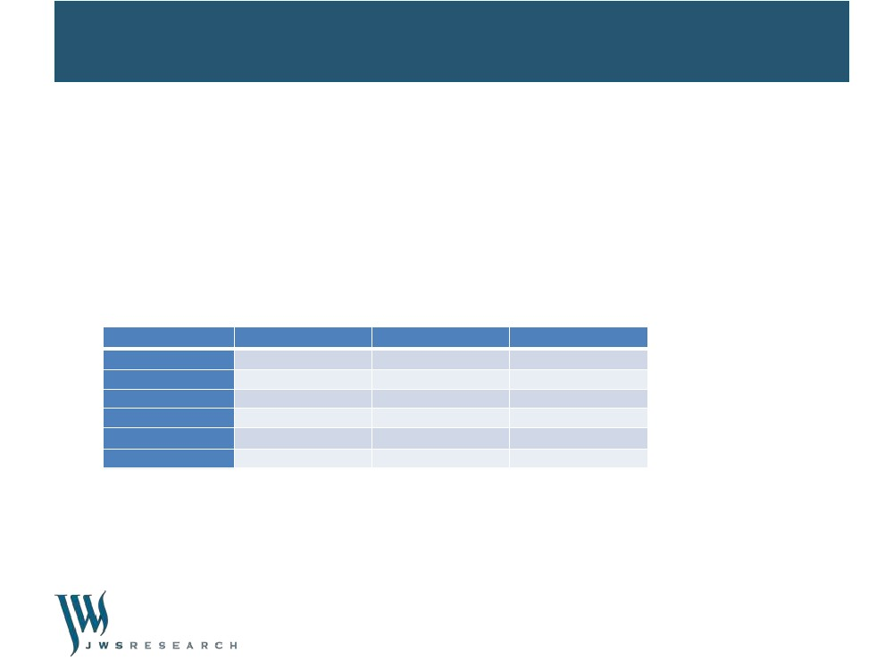
Analysis & Reporting
Council Groups
•
Overall results for this 2012 community satisfaction survey include an overall state-wide result which is
an average of all participating Councils, as well as results by the 5 self-classification groups that each
Council was part of and measured against:
–
–
–
–
–
•
Inner metropolitan councils
Outer metropolitan councils
Rural cities and regional centres
Large rural shires
Small rural shires
All participating Councils are listed in the State-wide report published on the DPCD website. In 2012, 71
of the 79 Councils throughout Victoria participated in this survey.
8
Statewide Local Government Services Report 2012

Analysis & Reporting (Cont‟d)
Index Scores
•Many questions ask respondents to rate Council performance on a five-point scale, for example, from
"Very good" to "Very poor", with “Can‟t say” also a possible response category. To facilitate ease of
reporting and comparison of results over time (after this initial 2012 benchmark) and against the State-
wide result and the Council group, an „Index Score‟ has been calculated for such measures.
•
The „Index Score‟ is calculated and represented as a score out of 100 (on a 0 to 100 scale), with “Can‟t
say” responses excluded from the analysis. The „% RESULT‟ for each scale category is multiplied by the
„INDEX FACTOR‟. This produces an „INDEX VALUE‟ for each category, which are then summed to
produce the „INDEX SCORE‟, equating to „60‟ in the following example.
SCALE CATEGORIES
Very good
Good
Average
Poor
Very poor
Can’t say
% RESULT
9%
40%
37%
9%
4%
1%
INDEX FACTOR
100
75
50
25
0
--
INDEX VALUE
9
30
19
2
0
INDEX SCORE 60
•
Similarly, an Index Score has been calculated for the Core question „Performance direction in the last
12 months‟, based on the following scale for each performance measure category, with „Can‟t say‟
responses excluded from the calculation:
–
–
–
„Improved‟ = 100
„Stayed about the same‟ = 50
„Deteriorated‟ = 0
9
Statewide Local Government Services Report 2012
Analysis & Reporting (Cont‟d)
Reporting
•
Every Council that participated in the 2012 Victorian Local Government community satisfaction survey
receives a customized report. In addition, DPCD is supplied with a State-wide summary report of the
aggregate results of „Core‟ and „Optional‟ questions asked across all Council areas surveyed.
Tailored questions commissioned by individual Councils are reported only to the commissioning Council
and not otherwise shared with DPCD or others unless by express written approval of the
commissioning Council.
The State-wide Research Results Summary Report is available on the Department's website at
www.localgovernment.vic.gov.au.
•
•
Contacts
•
For further queries about the conduct and reporting of this community satisfaction survey, please
contact JWS Research as follows:
–
–
John Scales – jscales@jwsresearch.com - 0409 244412
Mark Zuker – mzuker@jwsresearch.com - 0418 364009
10
Statewide Local Government Services Report 2012
Analysis & Reporting (Cont‟d)
Core, Optional and Tailored Questions
•
Over and above necessary geographic and demographic questions required to ensure sample
representativeness, a base set of questions for the 2012 community satisfaction survey were
designated as „Core‟ and therefore compulsory inclusions for all participating Councils. These Core
questions comprised:
–
–
–
–
–
–
•
Overall performance last 12 months (Overall performance)
Lobbying on behalf of community (Advocacy)
Community consultation and engagement (Consultation)
Contact in last 12 months (Contact)
Rating of contact (Contact rating)
Overall council direction last 12 months (Council direction)
Reporting of results for these Core questions can always be compared against other Councils in the
Council group and against all participating Councils State-wide. Alternatively, some questions in the
2012 community satisfaction survey were optional. If comparisons for Overall for some questions
cannot be made against all other Councils in the Regional centres group and/or all Councils on a State-
wide basis, this is noted for those results by noting the number of Councils the comparison is made
against.
Councils also had the ability to ask tailored questions specific only to their Council. Results for these
tailored questions are only reported to the commissioning Council.
11
Statewide Local Government Services Report 2012
•
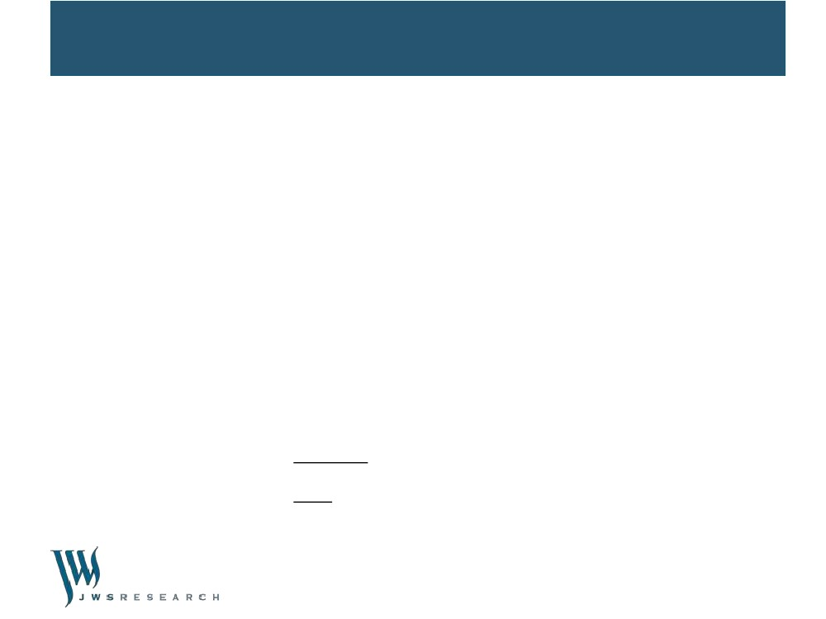
Glossary of Terms
•
•
•
•
•
Core questions: Compulsory inclusion questions for all Councils participating in the CSS.
CSS: 2012 Victorian Local Government community satisfaction survey.
Council group: One of five self-classified groups, comprising: inner metropolitan councils, outer metropolitan
councils, rural cities and regional centres, large rural shires and small rural shires.
Council group average: The average result for all participating Councils in the Council group.
Highest / Lowest: The result described is the highest or lowest result across a particular demographic sub-
group e.g. Men, for the specific question being reported. Reference to the result for a demographic sub-group
being the highest or lowest does not imply that it is significantly higher or lower, unless this is specifically
mentioned.
Index Score: A score calculated and represented as a score out of 100 (on a 0 to 100 scale). This score is
sometimes reported as a figure in brackets next to the category being described, e.g. men 50+ (60).
Net Differential: The difference between net importance and performance ratings.
Optional questions: Questions which Councils had an option to include or not.
Percentages: Also referred to as „detailed results‟, meaning the proportion of responses, expressed as a
percentage.
Sample: The number of completed interviews, e.g. for a Council or within a demographic sub-group.
Significantly higher / lower: The result described is significantly higher or lower than the comparison result
based on a statistical significance test at the 95% confidence limit. If the result referenced is statistically higher or
lower then this will be specifically mentioned, however not all significantly higher or lower results are referenced
in summary reporting, especially in this State-wide report where differences of just one percentage point or more
are often significant due to the large sample sizes involved.
State-wide average: The average result for all participating Councils in the State.
Tailored questions: Individual questions tailored by and only reported to the commissioning Council.
Weighting: Weighting factors are applied to the sample for each Council based on available age and gender
proportions from ABS census information to ensure reported results are proportionate to the actual population of
the Council, rather than the achieved survey sample.
12
Statewide Local Government Services Report 2012
•
•
•
•
•
•
•
•
•
Observations & Recommendations
•
Victorian Councils tend to score lower than their Overall Performance rating on Community
Consultation and Engagement, Advocacy and Council Direction, so these are obvious areas for
improvement for most Councils over the next 12 months.
Personal or household experience of Council Consultation and Advocacy typically extends the
gap between rated importance and performance. On both counts, Advocacy especially, personal
or household experience actually does very little to improve rated performance.
To improve performance on Consultation and Advocacy, the recommended approach is not simply
to engage more residents in these services, but to improve service content and for Council‟s to
better communicate their efforts to the broader community, targeting information to those
demographic groups which rate these services lowest – this is typically 50-64 year olds, for whom
the preferred communication method is hard copy not electronic mail outs and newsletters.
Councils obviously need to make their own assessment on what constitutes acceptable levels of
performance on core and individual service responsibilities and similarly for the level of
improvement required. Our recommended approach by way of a guiding principle for action is:
–
•
Where Councils are rating at or above the State-wide or Council group average, target
improvement at underperforming demographic groups.
Where Councils are rating below the State-wide or Council group average, review delivery of the
service – including with reference to other Councils if performance is particularly poor or
unacceptable. In some instances further consultation or research may be required.
•
•
•
13
Statewide Local Government Services Report 2012
Observations & Recommendations
•
We recommend a more detailed analysis of Council service delivery areas, particularly those with
the highest net negative differentials between importance and performance, with a focus on
identifying the demographic groups driving higher and lower results.
Councils should focus on services (and demographics) where rated importance is higher than
performance by 10 points or more. Such services and demographics will typically be negative
drivers on Overall Performance.
For arts centres and libraries and for community and cultural activities, the importance-
performance net differentials are typically lower amongst personal and household user groups
than for the overall result. To rectify this disparity and to reduce the apparent over-servicing to the
broader community, we recommend more of a focus on improving performance delivery to these
personal and household user groups.
For those Councils who included the coded open ended questions, analysis of the verbatim
responses provides depth and insight into Council‟s performance and service delivery, both from a
positive as well as a negative perspective. The category descriptions for the coded open ended
responses are generic summaries only. We recommend further analysis of the detailed cross
tabulations and the actual verbatim responses, with a view to understanding the responses in
more detail and by their demographic profile, especially for any over or under performing target
groups identified for individual Councils.
•
•
•
14
Statewide Local Government Services Report 2012
Observations & Recommendations
•
Despite 92% of Victorian Council residents stating there is room for improvement for their Council,
the right / wrong direction results indicate that the improvements required should be moderate
rather than substantial in nature and that most Councils have their „macro‟ settings set
appropriately.
•
Additionally, the rate rises versus service cuts results indicate that ratepayers expect most
Councils to live within their current means.
For Councils with the available data, it will be important to understand the demographic profile of
contact and service ratings by various methods, such as by telephone, in-person, via the Council
website, etc. Understandably, contact in writing is rated lower for customer service than other
forms of contact, so extra attention needs to be made in this area. Social media does not yet have
wide currency or preference.
An approach we have recommended to all Councils is to further mine the survey data and any
verbatim (open-ended responses) to better understand the profile of any over and under-
performing demographic groups. This can be achieved via additional consultation and data
interrogation, or self-mining the SPSS data provided or via the dashboard portal available to
Councils.
•
•
15
Statewide Local Government Services Report 2012
KEY RESULTS SUMMARY
16
Summary of Findings
•
In 2012 in response to the core performance measure question of, “On balance, for the last twelve
months, how do you feel about the performance of your Council, not just on one or two issues, but
overall across all responsibility areas?”, Victorian Councils State-wide recorded an Overall
Performance Index Score of 60.
•
On the other core performance measures the State-wide Index Scores were as follows:
– 71 for Customer Service
– 57 for Community Consultation and Engagement
– 55 for Advocacy
– 52 for Overall Council Direction
All core performance measures can be compared by Council group and for key gender and age
demographics for all Councils State-wide.
•
17
Statewide Local Government Services Report 2012
Summary of Findings
•
On Overall Performance, among the different Council groups, the Inner Melbourne Metropolitan
group achieved the highest rating of 66, which is significantly above the State-wide average Index
Score of 60. The Large Rural Shires group rated the lowest, at 56, which is significantly below the
State-wide average.
•
Small Rural Shires (59) rated below average, whilst Regional Centres (60) were on par with the
State-wide result and the Outer Melbourne Metropolitan group at 61 was above the State-wide
average.
Analysis by key gender and age groups shows that on Overall Performance, 18-34 year olds
(rating 65), women aged 18-49 (62), women generally (61) and 65+ year olds all rated above
average.
By contrast, 50-64 year olds (57) rated lowest, below 35-49 year olds and men aged 50+ (both
rated 58) and men generally (59). Men aged 18-49 and women aged 50+ rated equal to the
Statewide average of 60.
Although 18-34 year olds were the most likely to rate their Council‟s Overall Performance as
„good‟ or „very good‟, at 61% combined, 65+ year olds were the most likely to rate their Council‟s
Overall Performance as „very good‟, at 13%.
→ CONT’D
•
•
•
18
Statewide Local Government Services Report 2012
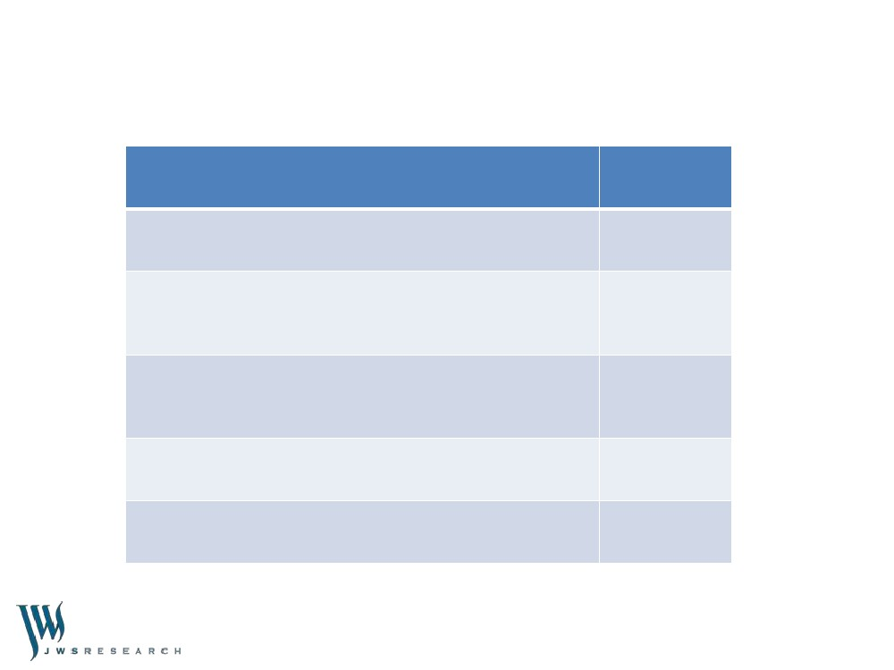
Summary of Findings
•
On the other core performance measures, the Inner and Outer Melbourne Metropolitan groups
generally record the highest results, while the Large Rural Shires and Small Rural Shires groups
record the lowest results and the Regional Centres group is consistently equal to the average.
More specifically:
–
Across all Victorian Councils, 61% of residents have had contact with their Council in the last
12 months. Index Scores for Customer Service across the Council groups did not vary
greatly from the State-wide average, with the Inner Metropolitan group the highest at 73,
ahead of the Outer Metropolitan and Regional Centres groups at 72, with the Large Rural
Shires (68) and Small Rural Shires (70) groups rated lowest.
On Community Consultation and Engagement, a service area consistently underperforming
relative to perceived importance, the Inner and Outer Metropolitan groups, both at 58, rated
their Council‟s Consultation efforts above the State-wide Index Score of 57. Conversely,
Large Rural Shires (54) and Regional Centres (56) rated below average, whilst Small Rural
Shires were on par.
On Advocacy, the Inner Metropolitan group at 57 and the Small Rural Shires and Outer
Metropolitan group, both at 56, rated their Council‟s efforts above the State-wide Index Score
of 55. Regional Centres also rated 55 and Large Rural Shires at 53 performed below the
State-wide average for their advocacy efforts.
Council Direction over the last 12 months was a particular issue of concern for many
Victorian Councils. The Large and Small Rural Shires groups at 48 and 50 respectively rated
the lowest and Regional Centres were on par with the State-wide average of 52, while the
Outer and Inner Metropolitan groups (55 and 54 respectively) rated above average.
19
Statewide Local Government Services Report 2012
–
–
–
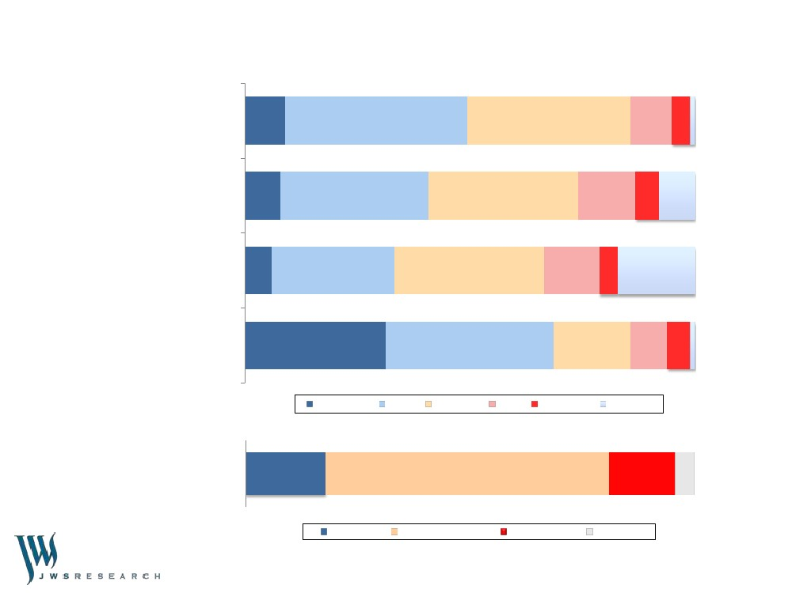
Summary of Key Community Satisfaction Results
Core Performance Measure
OVERALL PERFORMANCE
COMMUNITY CONSULTATION
(Community consultation and engagement)
Index Score
60
57
ADVOCACY
(Lobbying on behalf of the community)
55
CUSTOMER SERVICE
71
OVERALL COUNCIL DIRECTION
52
20
Statewide Local Government Services Report 2012
Summary of Key Community Satisfaction Results
Overall Performance
9
40
36
9
41
Community
Consultation
8
33
33
13
5
8
Advocacy
6
27
33
12
4
17
Customer Service
%
31
37
17
8
51
Very Good
Good
Average
Poor
Very Poor
Can't Say
Overall Council Direction
%
18
64
15
4
Improved
Stayed the Same
Deteriorated
Can't Say
21
Statewide Local Government Services Report 2012

