

delwp.vic.gov.au

|  |
| --- |
| Report on 2018-19 Council Budgets  Local Government Victoria |

|  |  |
| --- | --- |
|  |  |

Author

Local Government Victoria

|  |
| --- |
| Acknowledgment  We acknowledge and respect Victorian Traditional Owners as the original custodians of Victoria's land and waters, their unique ability to care for Country and deep spiritual connection to it. We honour Elders past and present whose knowledge and wisdom has ensured the continuation of culture and traditional practices.  We are committed to genuinely partner, and meaningfully engage, with Victoria's Traditional Owners and Aboriginal communities to support the protection of Country, the maintenance of spiritual and cultural practices and their broader aspirations in the 21st century and beyond. |
| © The State of Victoria Department of Environment, Land, Water and Planning 2019  LogoThis work is licensed under a Creative Commons Attribution 4.0 International licence. You are free to re-use the work under that licence, on the condition that you credit the State of Victoria as author. The licence does not apply to any images, photographs or branding, including the Victorian Coat of Arms, the Victorian Government logo and the Department of Environment, Land, Water and Planning (DELWP) logo. To view a copy of this licence, visit <http://creativecommons.org/licenses/by/4.0/>  ISBN 978-1-76077-907-8 (pdf/online/MS Word)  Disclaimer  This publication may be of assistance to you but the State of Victoria and its employees do not guarantee that the publication is without flaw of any kind or is wholly appropriate for your particular purposes and therefore disclaims all liability for any error, loss or other consequence which may arise from you relying on any information in this publication.  Accessibility  If you would like to receive this publication in an alternative format, please telephone the DELWP Customer Service Centre on 136186, email [customer.service@delwp.vic.gov.au](mailto:customer.service@delwp.vic.gov.au), or via the National Relay Service on 133 677 [www.relayservice.com.au](http://www.relayservice.com.au). This document is also available on the internet at [www.delwp.vic.gov.au](http://www.delwp.vic.gov.au). |

Contents

Contents

Report on 2018-19 Council Budgets 2

Executive summary 2

Analysis 3

Revenue 3

Rates and Charges 4

Grants 10

Expenditure 12

Capital Works 13

Staff expenditure 15

Financial performance and position 16

Cash and debt 17

Appendices 19

Appendix A Council Cohorts 20

Report on 2018-19 Council Budgets

Section 127 of *the Local Government Act 1989* (the Act)requires that councils prepare a budget for each financial year that contains financial statements, a description of the services and initiatives to be funded, and information about rates and charges.[1] The budget is council’s key resource planning document for the next financial year (short term), and commonly includes forecasts for the next four financial years from the strategic resource plan (medium term).

## Executive summary

Each year Victorian councils must develop a proposed budget for consideration by their community.[2] After complying with the relevant legislative requirements, including giving public notice and considering any submissions on the proposed budget, a council may adopt their budget.[3]

Local Government Victoria (LGV) have reviewed and analysed the information available in the 79 adopted council budgets for 2018-19. Collectively, these documents set out the budgeted financial performance and position of the sector for the next financial year. Key points are:

* Collectively, Victorian councils are budgeting to generate an operating surplus of $1.5 billion in 2018-19;
* The sector is budgeting to hold cash and investments worth $3.8 billion and have borrowings of $1.29 billion as at 30 June 2019;
* Sector-wide capital works expenditure of $3.12 billion is budgeted for 2018-19;
* Councils are budgeting to employ 36,944 full time equivalent staff members at 30 June 2019;
* The average general rate increase publicised by councils for the 2018-19 year is 2.24% (2.1% in 2017-18); and
* Several councils sought to restructure their rates and charges revenue for 2018-19. This included the removal of a municipal charge by three councils and the introduction of waste charges by three councils.
* At the beginning of 2018 China stopped the import of low quality mixed recyclable materials, including plastic, paper and cardboard. This policy change significantly impacted the cost to Victorian councils of providing kerbside recycling services and as a result most councils increased their waste charges for the 2018-19 year.

The analysis presented separates the 79 councils into groupings based on size and geographic location. These cohort groups are as follows: Metropolitan Councils, Interface Councils, Regional Cities, Large Shires and Small Shires. These groupings are consistent with the Know Your Council website groupings.

A list of council cohorts and their membership is attached at **Appendix A**.

# Analysis

The analysis contained in this report is based on data extracted from the 2018-19 Council Adopted Budgets. At times, the analysis has been supplemented with data from the 2018-19 Strategic Resource Plans (SRP), which contain medium term (four year) budget intentions of councils.

## Revenue

Councils are budgeting for total revenue of $10.12 billion in 2018-19. This consists mostly of rates and charges ($5.98 billion or 59.1%) and grants ($1.51 billion or 14.9%). User fees and contributions are also key sources of income for councils, accounting for 9.6% and 9.3% of forecast total income, respectively.

The composition of revenue varies significantly between cohorts. For example, interface councils receive 23% of their income through developer contributions which significantly increases the sector result. Under the Australian Accounting Standards these contributions must be recognised as revenue upon receipt.

Within council cohorts there can be significant variability in the amount of total income forecast by each individual council. The small shire with the highest forecast income is Buloke Shire Council ($36.4 million), almost 2.5 times the size of Hindmarsh Shire Council ($15.1 million), the small shire with the lowest forecast income.

The variability of forecast income between interface councils is also significant. Wyndham City Council’s forecast income ($517 million) is more than five times the lowest forecast income within the cohort, belonging to Nillumbik Shire Council ($96.8 million). Developer contributions (monetary) and gifted assets are a significant revenue stream for interface councils. For Wyndham City Council, combined developer contributions of $181 million represents 35% of total income.

More than half of interface councils are expecting more income than every metropolitan council in the 2018-19 financial year, except for Melbourne City Council. Despite the relatively higher income of these interface councils, there are also interface councils that have a similar amount of income to large shires and regional cities.

There is also significant variability within the Regional City Council cohort.

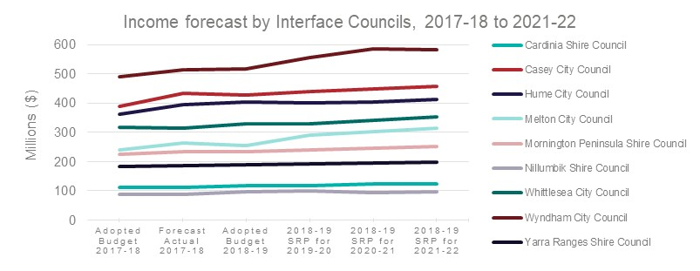

The graph above shows the variability in size and growth of forecast income by individual interface councils. It highlights the rapid growth and change in outer suburban Melbourne.

The graph below shows that 65% of metropolitan council revenue is raised through rates and charges, while rates and charges only make up 52% of interface council revenue. Interface councils however have relatively greater opportunities to raise revenue through developer contributions (cash and infrastructure), accounting for 23% of their total revenue. Small shires raise the least rates and charges by amount per council and this represents 54 per cent of their total revenue. However, they receive 34% of their revenue through grant funding, the largest percentage of grant revenue forecast to be received by a council cohort. This highlights the fewer revenue raising options for small rural councils and their significant dependence upon external grant funding.

The graph also highlights the relatively lower proportion of income that user fees make up for small shires, accounting for just 6% of their revenue. This suggests that charging for council services on a user pays basis is less of an option for this cohort. By contrast user fees represent 12% of total revenue in the Regional City cohort.

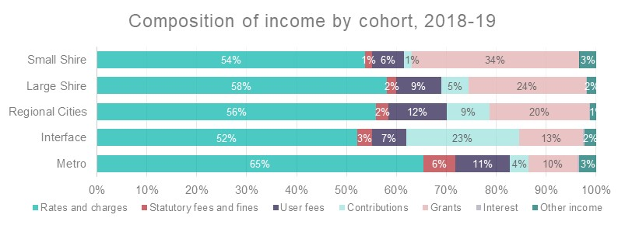

### Rates and Charges

Rates and charges are the primary source of revenue for councils, representing approximately $5.98 billion or 59% of total budgeted revenue in 2018-19. 86% or $5.09 billion of rates and charges revenue is raised through rates, while the rest is raised through waste, municipal and other charges.

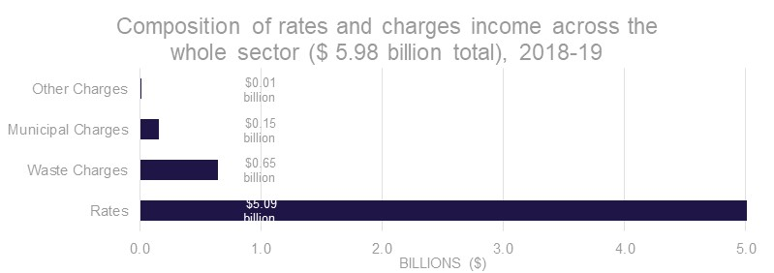

#### Growth in rateable assessments

Local governments continue to experience year on year growth in the number of assessments (i.e. rated properties). The growth has averaged around 1.81% per annum over the past ten years.

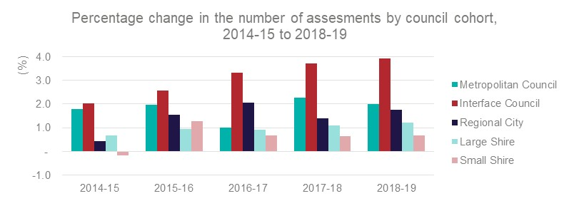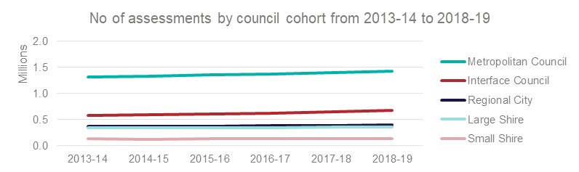

In 2018-19, councils have budgeted for an additional 65,522 rateable properties which represents an increase of 2.2% taking the total number of assessments to 2,994,555 (2,928,583 in 2017-18 adopted budgets).

The average growth in local government assessments is broadly consistent with Victoria’s population growth between 2008 and 2017, which averaged an increase of 1.96% per annum.

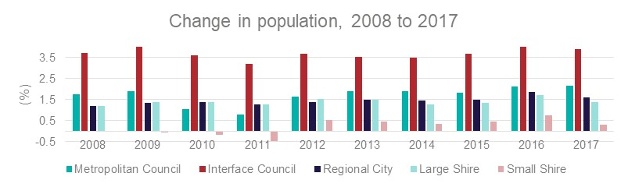

Interface councils have consistently experienced the largest growth in their population during the last ten years, while small shires are the only council cohort to see a decline in population over the same period. This demonstrates how the rate of population growth in the past decade has been most concentrated in the interface councils, and the challenge of declining and aging populations for small rural shires.

#### Total rates and charges increases

The increase in the total rates and charges income for the 79 Council’s is 5.6% (4.1% in 2017-18), for a budgeted total amount of $5.98 billion. The combined pool includes general rates, municipal charges, waste charges, supplementary rates and revenue in lieu of rates.

Over the past three years the difference between the increase in the rate cap and the increase in the total rates and charges income pool has varied between 2.0% and 3.35% This variance is caused by the natural growth in the rate base (driven by population growth) and the increase in charges not subject to the rate cap, mainly waste charges, which have been higher than both the rate cap increases *and* the equivalent CPI increases.

In 2018-19 the increase of 5.6% in total rates and charges income is 3.35% greater than the rate cap of 2.25%. In 2017-18 the increase in total rates and charges income was 4.1% which was 2.1% greater than the rate cap of 2.0%. The higher rate of increase in 2018-19 is largely attributable to the impact on recycling costs arising from the National Sword Policy introduced by China on 1 January 2018.

#### Fair Go Rates System and publicised rate rises

The average general rate increase by councils for the 2018-19 year is 2.24% (2.1% in 2017-18). This is marginally below the rate cap of 2.25%. The lower average amount below the 2018-19 rate cap is caused by the four rate cap variations approved by the Essential Services Commission (ESC) offset by other councils who chose to declare rate increases lower than the cap amount.

For the 2018-19 financial year, the Monash City Council was the only council that applied to the ESC for a variation to the rate cap, seeking a higher cap of 3.53%. The ESC approved an alternative higher cap of 2.57%. Ultimately Monash City Council resolved not to accept this increase and instead introduced a limited recycling levy. Three other councils had their rate cap variations approved for multiple years in the prior year. The approved variations to the rate cap for the 2018-19 financial year were as follows:

* Monash City Council (**2018-19:** 2.57%);
* Pyrenees Shire Council (**2018-19:** 3.5%);
* Towong Shire Council (**2018-19:** 5.55%, **2019-20:** 5.55%, **2020-21:** 5.55%); and
* West Wimmera Shire Council (**2018-19:** 3.5%, **2019-20:** 3.5%, **2020-21:** 3.5%).

Ararat Rural City Council (0.00%), Buloke Shire Council (2.00%), Colac Otway Shire Council (2.00%), Glenelg Shire Council (1.00%), Hindmarsh Shire Council (2.00%), Moorabool Shire Council (2.11%), Murrindindi Shire Council (2.15%), Nillumbik Shire Council (1.95%), South Gippsland Shire Council (2.00%), Strathbogie Shire Council (1.90%) and Swan Hill Rural City Council (2.05%) chose to declare rate increases lower than the 2.25% rate cap in 2018-19.

The remaining 65 councils declared a rate rise of 2.25%, in line with the rate cap.

The Corangamite Shire Council, Hobsons Bay City Council and Swan Hill Rural City Council were found to be immaterially non-compliant with the Fair Go Rates System (FGRS) rate cap by the ESC in 2018-19. The Yarriambiack Shire Council was found to be materially non-compliant in 2018-19. The ESC has published the explanations provided by each council and is required to report on council compliance with the rate cap on an annual basis.

#### Average assessment

The average amount ($) per assessment includes all rates and charges and has risen steadily in all council cohorts over the last five years.

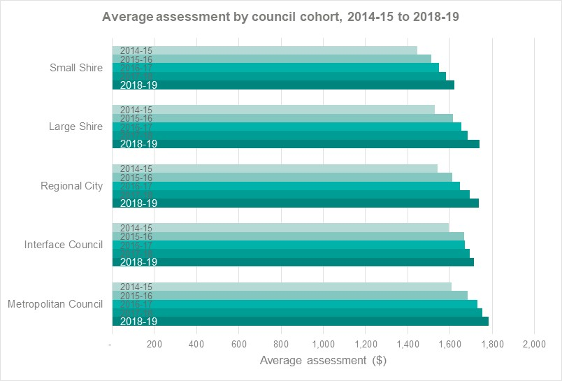

In 2018-19, the Metropolitan Council’s average assessment was the largest at $1,782, $161 higher than the small shire average assessment of $1,621.

While there may not seem to be a large difference between the average assessments of council cohorts, the average assessments of small shires and large shires are significantly distorted because larger proportions of their rates revenue, (37% and 19% respectively) are raised through farm rates. The amounts paid in rates for farms are typically higher than most residential rate assessments due to the much larger land holdings and therefore greater values compared to residential assessments, notwithstanding the widespread use of differential rates to affect a discount for farm assessments.

It is also important to note that the average assessment is impacted by population. For example, the relatively high average assessment for rural and regional councils highlights the smaller population (and number of assessments) base in rural and regional areas and a limited range of income sources. By comparison, the average assessments in metropolitan and interface cohorts are positively impacted by total rates being distributed across a larger population base and often access to revenue streams other than rates.

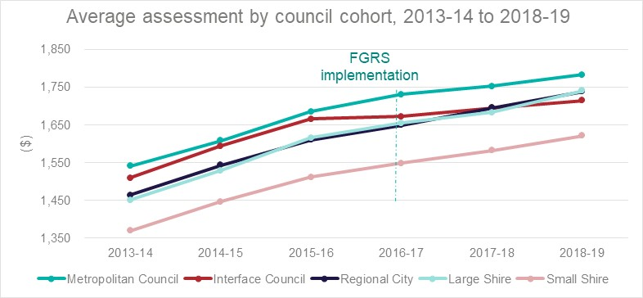

The above graph shows the impact on average assessments of the Fair Go Rates System (FGRS).

Post implementation of the FGRS, the year on year increase of the average assessment has decreased for all council cohorts, reflecting the constraint on rates and charges revenue.

The following graph demonstrates that in the forward projections of councils since implementation of the FGRS there is a trend of lower growth in forecast income from rates and charges. The 2015-16 (prior to cap) projections are shown to show the difference.

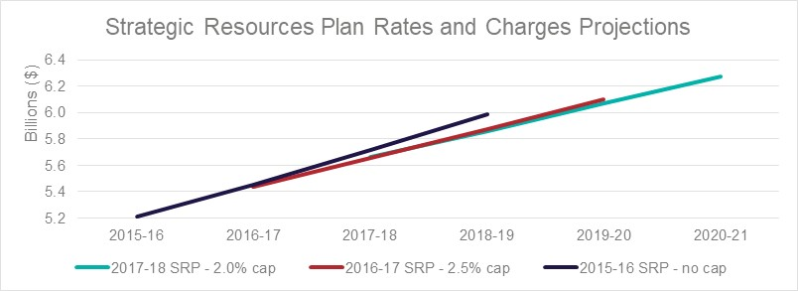

In the 2015-16 Strategic Resource Plans (SRPs), the forecast year-on-year growth of rates and charges averaged 4.7%, while in 2016-17 SRPs, post the implementation of the FGRS cap, the predicted average growth decreased to 3.9%. The SRPs also give a broad indication of future expectations of councils in respect of FGRS.

Over this period, there is no discernible evidence of any widespread reduction in council service levels although several councils have flagged this as possible in the future. The Victorian Auditor-General’s Office have noted this potential risk and highlighted the importance of longer term service planning in consultation with local communities.[4]

**Mix of rates and charges revenue**

Under the *Local Government Act 1989*, councils have discretion to determine what rates and charges will be levied and how this burden will be distributed. The 2018-19 adopted budgets of six councils foreshadowed changes to their mix of rates and charges revenue. Nillumbik Shire Council, Banyule City Council and Mount Alexander Shire Council have removed municipal charges while the Whittlesea City Council, Monash City Council and Hindmarsh Shire Council all introduced some form of waste charges.

**Municipal charges**

Pursuant to section 159 of the Act, councils may declare a municipal charge to cover some of the administrative costs of the council. In 2018-19 the budgeted total to be collected is $151.2 million, a decrease of $7.2 million or 4.57% on 2017-18 levels.

In 2018-19 municipal charges are being levied by 39 councils including only five metropolitan councils.

**Waste charges**

|  |
| --- |
| Councils that do not levy a separate waste charge:   * Banyule City Council; * Maribyrnong City Council; * Melbourne City Council; * Port Phillip City Council[5]; * Whitehorse City Council; and * Yarra City Council. |

Section 162 of the Act allows councils to raise service rates and charges. Service charges are most commonly raised in relation to waste services. Service charges are not currently subject to the rate cap. Across the sector there is a great diversity in waste service charges. Councils commonly provide services to individual properties such as garbage, recycling and green waste collection.

Separate waste charges are levied by 73 of the 79 Councils. This effectively means that the waste services provided by the remaining six councils are funded by general rates.

The increase in budgeted waste charges revenue over the last three years has been substantially higher than both budgeted general rates revenue and consumer price index increases, with a 9.6% increase in 2016-17, 5.7% in 2017-18 and 11.0% in 2018-19.

The main driver for the larger than normal increases in 2018-19 is reaction to cost increases as a result of China’s policy to stop the import of low quality mixed recyclable materials.

An emerging feature of waste services provided by councils is the capacity to select from a range of service options. Due to the multiple combinations available, any analysis of year on year increases must recognise that additional revenue can also be the result of a request for additional services.

### Grants

Councils are budgeting to receive $1.51 billion in grant funding during 2018-19.

$1.04 billion (or 65.5%) of grant funding is expected to be recurrent operating funding, and a third (or $343.6 million) of this funding is expected to go to metropolitan councils. Another $316 million or 20% of grant funding is expected to be non-recurrent capital grants. The chart below provides a breakdown of grants.

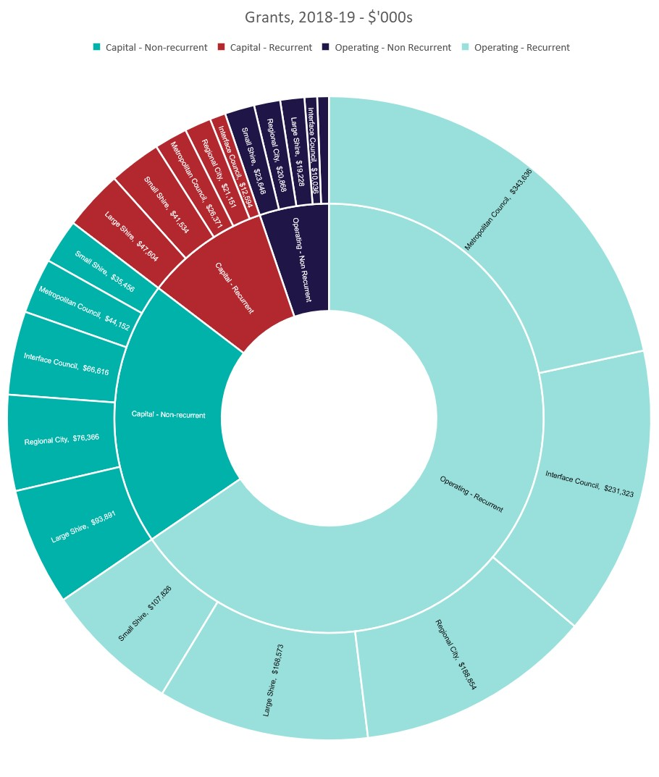

**$ 83,178**

**$ 149,254**

**$ 316,481**

**$ 1,040,212**

## Expenditure

Councils are budgeting for total expenditure of $8.58 billion in 2018-19. This consists mostly of employee costs ($3.61 billion or 42%) and materials and services ($3.11 billion or 36%). The graph below shows the main expenditure budgeted by councils.

Another significant expenditure item is depreciation. Depreciation is the allocation of the cost of an asset over its useful life and reflects the pattern of consumption of the asset (i.e. wear and tear) over time. Depreciation is a significant expense of local government due to the asset intensive nature of the sector, particularly in relation to the management of fixed assets such as roads, bridges, drains and buildings.

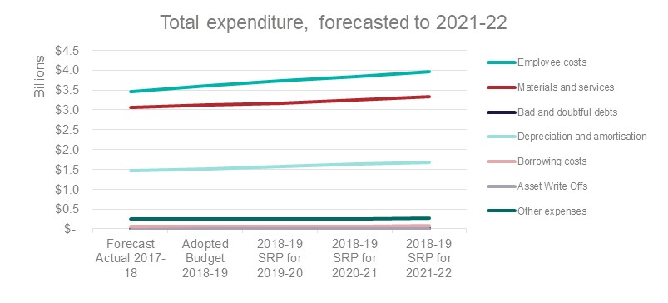

Expenditure is forecast to increase at a steady rate over the next four years, with the highest increases being depreciation and amortisation, growing at an average of 3.52% per year over the next four years, and employee costs, growing at an average of 3.45% per year over the next four years.

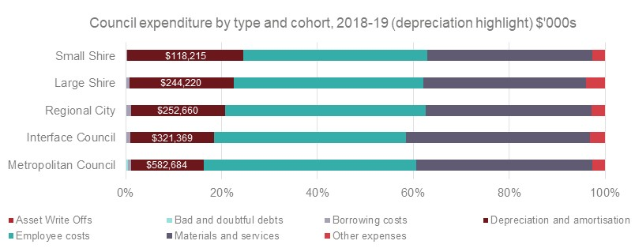

The composition of council expenditure by cohort is illustrated in the graph above, specifically identifying depreciation and the challenge for rural and regional councils. While rural council spend on depreciation and amortisation is a significantly lower figure than that in metropolitan councils, it accounts for a significantly larger *proportion* of their total expenditure. This can be primarily attributed to small shires having much larger road networks relative to their overall asset maintenance responsibilities. To illustrate this disparity, the Shire of Buloke has a road network totalling 5,313 kilometres. This contrasts with the City of Stonnington, which has a road network of just 309 kilometres but enjoys significantly greater revenue.

### Capital Works

Combined capital expenditure for the sector is budgeted to be $3.12 billion in 2018-19. This is an 11% increase over the previous year. Over the next three years, 45% of these capital works are expected to be delivered by metropolitan councils, while only 18% are expected to be delivered by large and small shire councils. These figures include road construction and maintenance, which constitute a significant responsibility for rural and regional councils. Metropolitan, interface and regional cities together account for 82% of capital works while their combined population comprises of 87.9% of the Victorian total. In contrast, the 38 large and small shire councils with 12.1% of the population cover a geographically larger area with relatively larger road networks and higher costs.

The adopted budget documents reveal that of the $3.12 billion of works budgeted, $412 million of these works are carried over from the previous year. In most instances, this occurs because of construction delays that were unforeseen at budget time.

The graph below shows the forecast changes to council capital expenditure over the next four years by council cohort. Both small and large shires are forecasting significant decreases in capital expenditure over the next four years, however this can be attributed to decreased forecasts in capital grant funding, which is not in line with historical trends. It is important to note that interface councils receive large developer contributions including gifted assets. These are not reflected in the capital expenditure forecasts shown below.

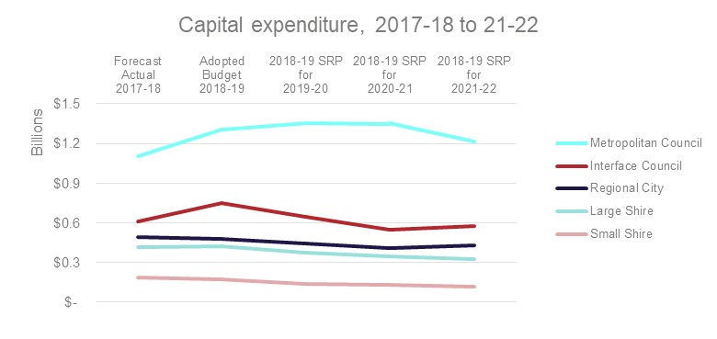

The following charts show the composition of capital works expenditure and capital works funding in 2018-19. The bar chart below shows that interface councils and regional cities spend a much larger proportion of their budget on new assets compared to the other council cohorts, and significantly less on asset renewal. As the interface council populations stabilise and their asset base matures, it is likely they will decrease their expenditure on new assets and increase expenditure on renewal.

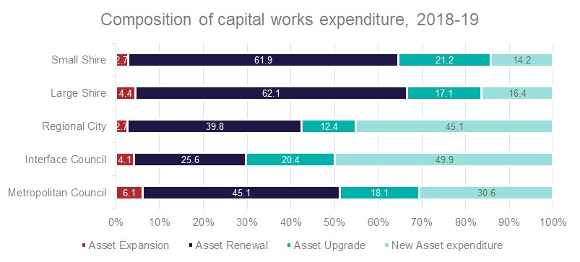

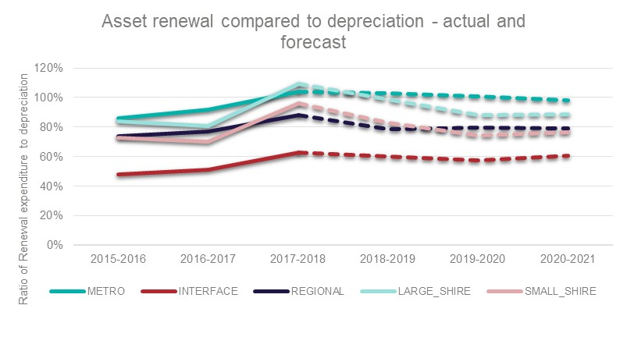

The chart above is based on data from Know Your Council and shows the actual and forecast asset renewal ratio (sometimes referred to as the ‘renewal gap’) which is the potential gap between planned expenditure on asset renewal compared to the forecast cost of depreciation. The ratio is an indicator of whether council spending on asset renewal is keeping pace with the rate of consumption of those assets and a ratio of 100% or greater is desirable. The chart shows that interface councils have lower levels of asset renewal spending due to their asset expenditure typically focusing on new rather than established assets due to recent growth. According to this indicator Metropolitan and Large shire council cohorts reach a level of 1:1 renewal spend against depreciation as per the 2018/19 budget.

It is important to note that the renewal ‘gap’ is hypothetical but does highlight the possibility that many councils are not planning to invest sufficiently to maintain assets at their current levels. This can be due to planned service level reductions, financial constraints or both.

The graph below shows that a significantly larger proportion of capital works in rural and regional council areas are reliant on grant funding, while most metropolitan and interface council capital works are funded by own source revenue.

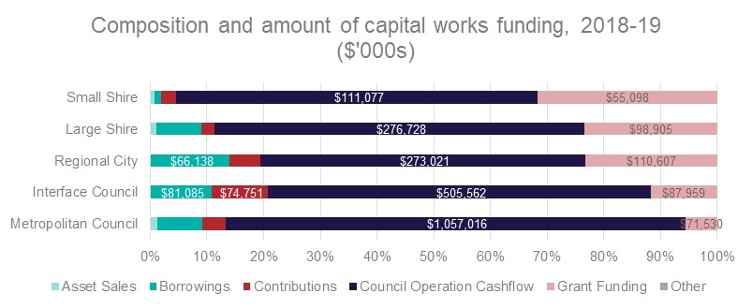

### Staff expenditure

Adopted budgets forecast that employment expenses will cost councils $3.61 billion in 2018-19, and that it will increase by 9.5% to $3.96 billion by 2021-22. The largest growth in staff expenditure over the next four years will be experienced by the interface council cohort, at 15.0%, due to increasing service requirements.

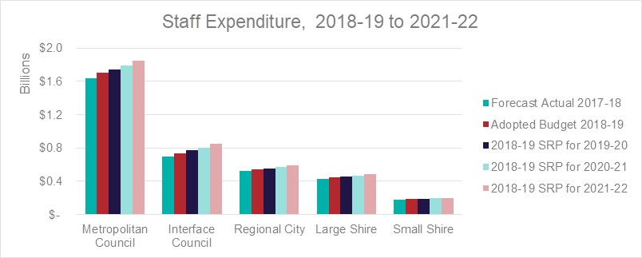

Metropolitan Councils are projecting an average increase of 3.1% per year over four years in their Staff expenditure, whereas staff expenditure for Small Shires are increasing at an average rate of 2.4% per year for the same period.

The council adopted budgets forecast that 36,944 full time equivalent staff members will be employed in the Victorian local government sector at 30 June 2019. Budgets forecast that this will decrease by 0.2% to 36,871 by 30 June 2022.

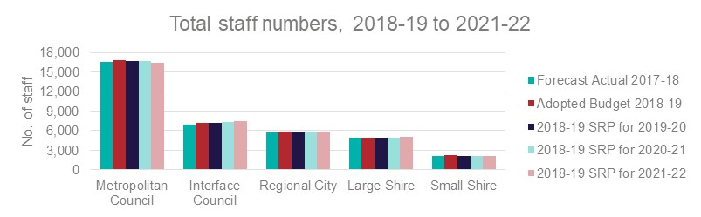

The above graph shows a breakdown of budgeted council staff numbers by cohort and highlights the relative stability of employee numbers across the sector.

## Financial performance and position

Collectively, Victorian councils are budgeting to generate an operating surplus of $1.5 billion in 2018-19. The sector’s actual operating surplus for 2017-18 was $2.17 billion[6]. Both the budgeted and actual surpluses have been impacted by the advance receipt of Commonwealth grant funds. The Victoria Grants Commission (VGC) paid councils approximately 50% of their 2018-19 allocation in June 2018. Under Australian Accounting Standards these funds must be recognised as revenue upon receipt and therefore inflate the 2017-18 surplus. Consequentially, most councils have also adjusted their budgeted 2018-19 grant income, reducing the 2018-19 surplus.

Overall, the financial position of the sector is strong, with low overall debt levels and significant cash reserves. The following two charts show the net result indicator by cohort and the adjusted underlying result indicator by cohort. These indicators are important ways to ascertain the financial health of local governments.

The net result indicator shows the operating result (e.g. surplus or deficit) as a percentage of total revenue, and is derived from the comprehensive income statement of each council. A positive result indicates a surplus, and the larger the percentage, the stronger the result. A negative result indicates a deficit.[7] The below chart shows that rural and regional councils generally have lower net results, and that small shires in particular are forecasting their net results to decline over the next four years. The financial sustainability challenges of small shires were identified in VAGO’s November 2016 report *Local Government: 2015-16 Audit Snapshot*.

The chart also highlights that the interface cohort have consistently had the highest net results over the past five years, however this is mostly due to the significant value of developer contributed assets they receive and the requirement of the Australian Accounting Standards that these be recognised as revenue upon receipt.

The volatility in the chart largely reflects the timing of payment of financial assistance grants.

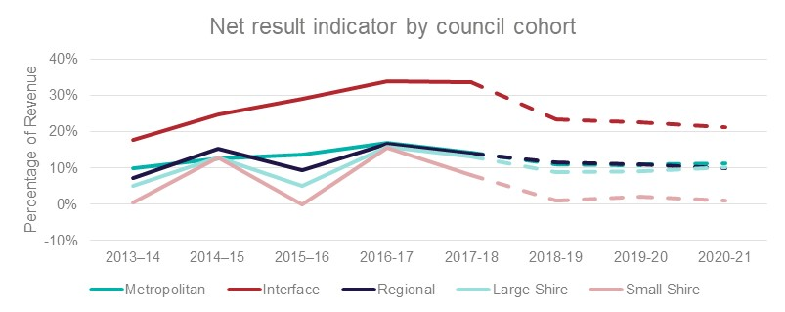

The *adjusted* underlying result indicator adjusts the council’s revenue and operating result to exclude items considered non-recurrent or capital in nature. This allows the indicator to measure the underlying operating performance of council in the ordinary course of business. To remain financially sustainable a council should ideally generate an underlying operating surplus, as operating deficits cannot be sustained in the longer term.

The chart below again highlights the volatility caused by the different timing of payments of financial assistance grants over recent years. It also shows the deficit operating performance, both actual and forecast, of small shire councils whereas Regional City and Large Shire Councils are projecting a dip in 2018-19 results before slight improvements in 2019-20 and 2020-21 results. This is impacted by the removal of capital grants for this indicator. The other two cohorts are forecasting break-even, or better, operating performance over the next four years. The operating surpluses of the metropolitan and interface council cohorts have generally remained 5% or above and are forecast to continue to do so.

These two indicators are used by the Victorian Auditor General to assess financial sustainability in their annual audits of local government finances and are replicated here by cohort group.

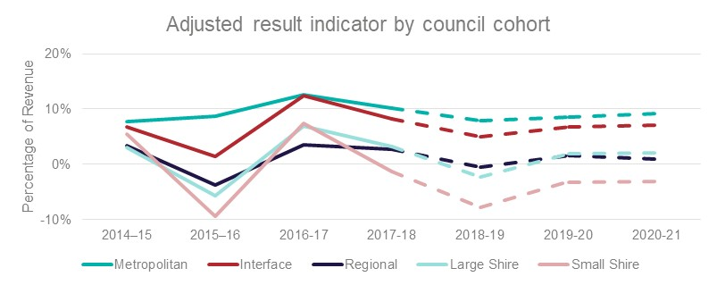

## Cash and debt

The sector is budgeting to hold cash and investments of approximately $3.8 billion at 30 June 2019. The sector’s actual cash and investments at 30 June 2018 was $3.3 billion. These actual levels of cash and investments have been positively impacted by the advance receipt of Commonwealth grant funds ($297 million).

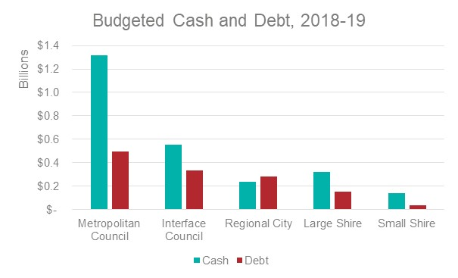

Councils are budgeting collective borrowings of $1.29 billion by 30 June 2019. The actual level of debt at 30 June 2018 was $1.1 billion[8]. The forward forecast for the next three years sees total borrowings increase to $1.64 billion by 30 June 2022. The increase in borrowings over the next three years is predominantly because of an increase in the use of loan funds by the City of Melbourne. They forecast their borrowings to increase from $30 million at 30 June 2018 to $250 million by 30 June 2021, primarily in relation to the redevelopment of the Queen Victoria Market (as highlighted by the chart below).

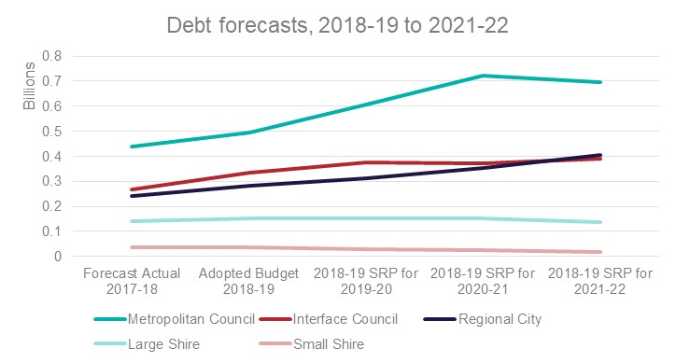

Appendices

Appendix A Council Cohorts

|  |  |
| --- | --- |
| **COUNCIL** | **VLGCG GROUPING** |
| Banyule City Council | Metropolitan |
| Bayside City Council | Metropolitan |
| Boroondara City Council | Metropolitan |
| Brimbank City Council | Metropolitan |
| Darebin City Council | Metropolitan |
| Frankston City Council | Metropolitan |
| Glen Eira City Council | Metropolitan |
| Greater Dandenong City Council | Metropolitan |
| Hobsons Bay City Council | Metropolitan |
| Kingston City Council | Metropolitan |
| Knox City Council | Metropolitan |
| Manningham City Council | Metropolitan |
| Maribyrnong City Council | Metropolitan |
| Maroondah City Council | Metropolitan |
| Melbourne City Council | Metropolitan |
| Monash City Council | Metropolitan |
| Moonee Valley City Council | Metropolitan |
| Moreland City Council | Metropolitan |
| Port Phillip City Council | Metropolitan |
| Stonnington City Council | Metropolitan |
| Whitehorse City Council | Metropolitan |
| Yarra City Council | Metropolitan |

|  |  |
| --- | --- |
| **COUNCIL** | **VLGCG GROUPING** |
| Cardinia Shire Council | Interface |
| Casey City Council | Interface |
| Hume City Council | Interface |
| Melton Shire Council | Interface |
| Mornington Peninsula Shire Council | Interface |
| Nillumbik Shire Council | Interface |
| Whittlesea City Council | Interface |
| Wyndham City Council | Interface |
| Yarra Ranges Shire Council | Interface |

|  |  |
| --- | --- |
| **COUNCIL** | **VLGCG GROUPING** |
| Ballarat City Council | Regional City |
| Greater Bendigo City Council | Regional City |
| Greater Geelong City Council | Regional City |
| Greater Shepparton City Council | Regional City |
| Horsham Rural City Council | Regional City |
| Latrobe City Council | Regional City |
| Mildura Rural City Council | Regional City |
| Wangaratta Rural City Council | Regional City |
| Warrnambool City Council | Regional City |
| Wodonga City Council | Regional City |

|  |  |
| --- | --- |
| **COUNCIL** | **VLGCG GROUPING** |
| Bass Coast Shire Council | Large Shire |
| Baw Baw Shire Council | Large Shire |
| Campaspe Shire Council | Large Shire |
| Colac Otway Shire Council | Large Shire |
| Corangamite Shire Council | Large Shire |
| East Gippsland Shire Council | Large Shire |
| Glenelg Shire Council | Large Shire |
| Golden Plains Shire Council | Large Shire |
| Macedon Ranges Shire Council | Large Shire |
| Mitchell Shire Council | Large Shire |
| Moira Shire Council | Large Shire |
| Moorabool Shire Council | Large Shire |
| Mount Alexander Shire Council | Large Shire |
| Moyne Shire Council | Large Shire |
| South Gippsland Shire Council | Large Shire |
| Southern Grampians Shire Council | Large Shire |
| Surf Coast Shire Council | Large Shire |
| Swan Hill Rural City Council | Large Shire |
| Wellington Shire Council | Large Shire |

|  |  |
| --- | --- |
| **COUNCIL** | **VLGCG GROUPING** |
| Alpine Shire Council | Small Shire |
| Ararat Rural City Council | Small Shire |
| Benalla Rural City Council | Small Shire |
| Buloke Shire Council | Small Shire |
| Central Goldfields Shire Council | Small Shire |
| Gannawarra Shire Council | Small Shire |
| Hepburn Shire Council | Small Shire |
| Hindmarsh Shire Council | Small Shire |
| Indigo Shire Council | Small Shire |
| Loddon Shire Council | Small Shire |
| Mansfield Shire Council | Small Shire |
| Murrindindi Shire Council | Small Shire |
| Northern Grampians Shire Council | Small Shire |
| Pyrenees Shire Council | Small Shire |
| Borough of Queenscliffe | Small Shire |
| Strathbogie Shire Council | Small Shire |
| Towong Shire Council | Small Shire |
| West Wimmera Shire Council | Small Shire |
| Yarriambiack Shire Council | Small Shire |

1. . Sections 127(2)(a), (b) and (e) of the *Local Government Act 1989*. Section 130 of the *Local Government Act 1989* requires all councils to submit a copy of the budget, or revised budget, to the Minister for Local Government within 28 days of adopting the budget.
2. . Section 127(1) and 129(1) of the *Local Government Act 1989*
3. . Section 130(1) of the *Local Government Act 1989*
4. . Results of 2016-17 Audits: Local Government, Victorian Auditor-General’s Office, November 2017
5. . Port Phillip City Council includes a nominal amount as service charges revenue in its 2018-19 adopted budget, mainly in relation to discretionary waste services provided by council.
6. . Results of 2017-18 Audits: Local Government ,Victorian Auditor-General’s Office, December 2018
7. . Results of 2017-18 Audits: Local Government ,Victorian Auditor-General’s Office, December 2018
8. . Results of 2017-18 Audits: Local Government ,Victorian Auditor-General’s Office, December 2018