Local Government Victoria and Collaborative Councils
Solar Rates Program
Continuing the success of the Darebin City Council Solar $avers project, the Eastern Alliance for Greenhouse Action (EAGA) partnered with the Northern Alliance for Greenhouse Action (NAGA) to complete ‘an independent and objective analysis of the costs and benefits of a state-wide solar finance program’.
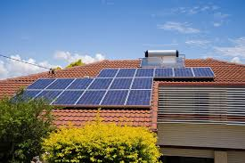
In 2015 the Maroondah City Council received $60,700 from the Victorian Government’s Collaborative Council-Sustainability Fund Partnership (then Sustainable Business Capacity Program) for the development of a business case for a regional group of councils to utilise rates charges to facilitate the uptake of solar power in lower socio-economic segments of the community (Phase II).

Led by the Eastern Alliance for Greenhouse Action (EAGA) and the Maroondah City Council, the project was undertaken in partnership with:

Boroondara City Council Stonnington City Council Knox City Council
Whitehorse City Council Monash City Council Yarra Ranges Shire Council

Urban Elements & Practice Pty Ltd (Urban EP) were engaged to complete the second phase of the business case and provided a comprehensive investigation of the options available to provide solar panels to low income households within the region and across the state. The project analysed the economic, regulatory and technical viability of council rates charges and other low income solar finance options, developed a recommended program model, and established its business case. This process included comprehensive discussions between the councils involved, Victorian Government business units, financial institutions and social welfare organisations.

The investigation revealed that the deployment of 2kW Solar PV systems to the 52,000 identified low income owner occupier households in Victoria could represent an annual generation of 114,557 to 139,360 MWh of clean energy and greenhouse gas savings of 143,197 to 174,811 tonnes of CO2 equivalent.

The Phase II report quantified the benefits of an integrated approach for the Victorian Government and local governments to work together with private sector financiers to overcome the barriers faced by low-income households in accessing the benefits of Solar PV.
As a result of Phase II, a consortium of 20 councils and four Greenhouse Alliances were successful in receiving an allocation of $764,589 from the Victorian Government’s New Energy Jobs Fund. The project will install up to 1,000 solar PV on low-income and vulnerable households across 20 municipalities in Victoria.

The project will be led by EAGA & Maroondah City Council
and coordinated by the Victorian Greenhouse Alliances.
It will be delivered over two-and-a-half years and will:

- test a model for scaling-up the use of council rates to provide individual loans to households and recover costs through the rates system;
- catalyse private investment within a community segment traditionally viewed as high risk to investors, by establishing and evaluating partnership finance models with the banking sector;
- establish a shared services approach to project implementation to enable access to dedicated capability and reduce resource requirements and risks to councils. This will leverage scale economies in administration, procurement and governance, and enable participation by councils not otherwise able to offer this service to their residents.
To consolidate an integrated approach to the project, a forum was held at the conclusion of Phase II which involved an open discussion between all project partners including metropolitan and rural councils, Victorian Government business units, Bank Australia, the Brotherhood of St Lawrence and the Municipal Association of Victoria. Participants discussed:

- benefits to households, governments (through concession savings) and the environment
- procurement process of solar panels
- cutting red tape and legislative requirements
- communication of information to stakeholders.
The forum reiterated the commitment of each of the project partners to rolling out the Solar Rates program and ensuring its success. The strength of the partnership between the organisations will ensure prioritisation of enabling all community members to take steps towards gaining energy independence.
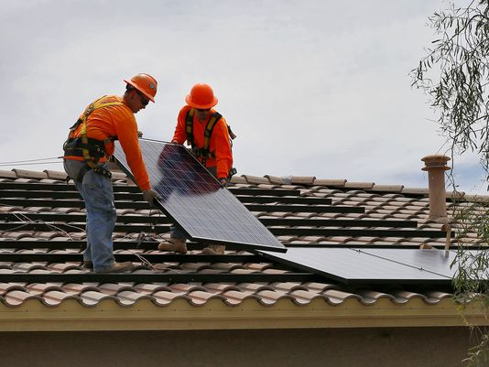

For more information regarding this project and others like it please contact Local Government Victoria on 03 9948 8537 or our webpage.

