Local Government Community
Satisfaction Survey

2010

Adamsville City Council .

Research Results .
May 2010 .

A project sponsored by the
Department of Planning and
Community Development
and local governments

Prepared by





MINISTER’S FOREWORD

I am pleased to present the 2010 Community Satisfaction Survey results, which provide a valuable overview of how the Victorian local government sector is performing according to its communities.

The sector can proudly claim a 10 per cent improvement in overall performance since the survey began in 1998. In 2010, 79 per cent of respondents rated their councils’ overall performance as excellent, good or adequate, compared with 69 per cent in 1998. At 83 per cent, metropolitan councils continue to report higher satisfaction for overall performance than country councils at 77 per cent.

The vast majority of councils continue to participate in the survey each year, which allows us to monitor trends and supports the survey’s value as a powerful benchmarking tool for councils.

The survey also allows us to consider the community drivers of satisfaction, which have moved beyond the traditional Rs of ‘rates, roads and rubbish’. The three key drivers of residents’ satisfaction state-wide are town planning policy and approvals; economic development; and local roads and footpaths. These priorities further highlight the strategic role of today’s councils in meeting the needs of Victorian communities as our state’s population grows and changes.

The survey questions refer to the broad areas of governance and service delivery. Governance is covered by overall council performance, advocacy, council contact and community. Service delivery is captured by nine key service areas ranging from town planning and economic development to local laws and waste management.

The Community Satisfaction Survey, together with the financial and asset management measures reported in the Local Government in Victoria Report, provide a complete overview of the sector’s performance each year.

Councils receive individual Community Satisfaction Survey results which are communicated in part in their annual reports or may be utilised by councils for other purposes. The survey allows councils to assess performance and monitor areas for both celebration and improvement.

It is important that councils continue to review and strengthen their individual performance measurement systems to complement the Community Satisfaction Survey. The work being undertaken by the Essential Services Commission in developing a performance monitoring framework for local government will support this process.

I would like to thank all councils that participated in this year’s survey as well as the independent research company, Wallis Consulting Group, for conducting the survey.

The aggregate state-wide report will be available on the department’s website at www.localgovernment.vic.gov.au

RICHARD WYNNE MP
Minister for Local Government

CONTENTS

1. INTRODUCTION 1
2. HOW THE SURVEY IS DONE 1
3. KEY RESULTS IN SUMMARY 2
4. SUMMARY RESULTS BY MEASURE 2010 5
5. RELATIVE PERFORMANCE WITHIN LGA GROUP 6
6. CUSTOMER WINDOW: KEY AREAS FOR IMPROVEMENT 2010 8
7. RESULTS IN DETAIL: OVERALL PERFORMANCE 10
8. RESULTS IN DETAIL: ADVOCACY 11
9. RESULTS IN DETAIL: COMMUNITY ENGAGEMENT 12
10. RESULTS IN DETAIL: CUSTOMER CONTACT 13
11. RESULTS IN DETAIL: RESPONSIBILITY AREAS 14

APPENDIX 1: QUESTIONNAIRE
APPENDIX 2: LIST OF COUNCILS
APPENDIX 3: RESPONSES TO OPEN ENDED QUESTIONS

1. INTRODUCTION

This is the thirteenth year in which the Local Government Community Satisfaction Survey has been conducted. It is also the thirteenth year in which Adamsville City Council has participated in the survey.

Hence, using this report, Adamsville City Council is able to track residents' views on its performance over time. The survey focussed on nine service areas and four governance measures. Each of these is reported to show progress and improvements in performance.

The report also identifies some key areas for improvement and for increasing resident satisfaction in the coming year.

In this report, Adamsville can monitor its performance on key measures with other councils in its like council group, that is 'outer metropolitan areas'.

In the section showing results in detail, beginning on page 10, results are provided for the last seven years. Councils requiring historical results from earlier years, should consult their previous reports, or contact Wallis Consulting Group.

2. HOW THE SURVEY IS DONE

The 2010 survey was undertaken by an independent market research consultancy, Wallis Consulting

The 2010 survey was undertaken by an independent market research consultancy, Wallis Consulting Group. The questionnaire used was identical to that of 2009 (and very similar to previous years) to allow for comparisons over time.

The survey was conducted by telephone. In order to complete the survey, a random sample of telephone numbers was selected from postcodes known to be in the Adamsville area. These numbers were called and a 'head of household' was selected for interview at that dwelling. Average interview length was 10 minutes.

Seventy-eight of the total seventy-nine Victorian local councils took part in the 2010 survey. Using a sample size of 350 interviews per council area, over 27,000 interviews were conducted across the State. The Statewide Research Results Summary Report is available on the Department's website at www.localgovernment.vic.gov.au

If you have further queries about the conduct of the survey, please contact either Pam Millwood at Wallis Consulting Group (pamm@wallisgroup.com.au / 03 8620 5614) or Eveline Kane at the Department of Planning and Community Development (eveline.kane@dpcd.vic.gov.au).

3. KEY RESULTS IN SUMMARY

EXPLANATION: INDEXED MEAN SCORES

Many of the survey questions ask respondents to rate their Council's performance on a five-point scale from "Excellent" to "Needs a lot of Improvement".

To facilitate comparisons over time, and between different measures, or between Councils, the scales are scored as shown below:

INDEXED
SCALE RESULTS SCORE SCORE

Excellent - outstanding performance 5 100
Good - a high standard 4 80
Adequate - an acceptable standard 3 60
Needs some improvement 2 40
Needs a lot of improvement 1 20

The "Indexed Mean" is calculated by taking the mean value for all respondents on the five point scale and multiplying by twenty to convert this mean to an index of up to 100. In the Figures and Tables on the following pages, the scale for the "Indexed Mean" is used, which ranges from a minimum of 20 to a maximum of 100 a maximum of 100.

It should be noted that the indexed mean, as described above, is a quite separate measure from the 'Excellent/Good/Adequate' totals which are shown alongside the performance over time data on pages 10 to 22. The 'Excellent/Good/Adequate' results relate to the proportions of respondents giving these ratings, and are not mean scores.

3. KEY RESULTS: SUMMARY OF RESULTS FOR 2009

Indexed Mean

1 * Community satisfaction rating for overall performance 67 .
generally of the council

2 * Community satisfaction rating for council's advocacy 64 .
and community representation on key local issues
(Advocacy)

3 * Community satisfaction rating for council's 63 .
engagement in decision making on key local issues
(Community Engagement)

4 Community satisfaction rating for council's interaction 76 .
and responsiveness in dealing with the public
(Customer Contact)

5 Community satisfaction rating for overall performance 66 .
in key service areas and responsibilities (individual
service group ratings shown below)

5a Local Roads and Footpaths 63 .

5b Health and Human Services 74 .

5c Recreational Facilities 71 .

5d Appearance of Public Areas 68 .

5e Traffic Management and Parking Facilities 62 .

5f Waste Management 76 .

5g Enforcement of By Laws 64 .

5h Economic Development 62 .

5i Town Planning Policy and Approvals 58 .

* These results form part of the Victorian Local Government Indicators which councils include in their annual reports.

3. KEY RESULTS: SUMMARY AT A GLANCE

How the City of Adamsville performed in 2009/2010

 |  |  |  |  |  | Comparison of results to:
 | 2009 |  | 2010 |  | Change in performance in the Last Year | All Councils in Group | All Councils
 | Mean | Indexed Mean | Mean | Indexed Mean | Change in performance in the Last Year | 2010 | 2011
a. Local Government Indicators
Overall Performance | 3.5 | 70 | 3.4 | 67 | Unchanged | Similar | Higher
Advocacy | 3.3 | 66 | 3.2 | 64 | Unchanged | Similar | Similar
Community Engagement | 3.2 | 64 | 3.1 | 63 | Unchanged | Similar | Similar
Customer Contact | 3.9 | 77 | 3.8 | 76 | Unchanged | Similar | Higher
b. Specific Performance Areas
Local Roads and Footpaths | 3.2 | 64 | 3.2 | 63 | Unchanged | Higher | Higher
Health and Human Services | 3.6 | 72 | 3.7 | 74 | Unchanged | Similar | Similar
Recreational Facilities | 3.6 | 72 | 3.5 | 71 | Unchanged | Similar | Similar
Appearance of Public Areas | 3.4 | 69 | 3.4 | 68 | Unchanged | Higher | Similar
Traffic Management and Parking | 3.1 | 61 | 3.1 | 62 | Unchanged | Higher | Higher
Waste Management | 3.9 | 77 | 3.8 | 76 | Unchanged | Higher | Higher
Enforcement of Local Laws | 3.3 | 66 | 3.2 | 64 | Unchanged | Similar | Similar
Economic Development | 3.2 | 65 | 3.1 | 62 | Unchanged | Similar | Similar
Town Planning Policy and Approvals | 2.8 | 63 | 2.9 | 58 | Declined | Similar | Similar

* Improved/declined indicates a significantly different result from 2009.
** Higher/lower indicates a significantly different result from the 2010 mean score for others in the group/total.

Has any particular issue strongly influenced residents' overall rating?

%
Yes -positive 11
Yes -negative 24
No 60
Don't Know 1

Q6a In giving your overall rating, has any particular issue strongly influenced your view, either in a positive or negative way?

If yes, Was it a positive or negative influence?
Residents' view of change in this Council's performance since 2009.

%
Improved 19
Stayed the same 65
Deteriorated 7
Don't Know 9

Q7 Over the last 12 months, what is your view of the direction of Council's overall performance?

Has it improved, stayed the same or deteriorated?

4. SUMMARY RESULTS BY MEASURE: 2010

Results for Adamsville City Council

 | Percentage of respondents saying performance was ……
MEASURE | Excellent | Good | Adequate | Needs some improvement | Needs a lot of improvement | RELEVANCY | MEAN | INDEXED MEAN
 | % | % | % | % | %
Overall Performance | 6 | 42 | 37 | 10 | 5 | 96% | 3.4 | 67
Advocacy and community representation | 5 | 40 | 31 | 15 | 9 | 53% | 3.2 | 64
Community Engagement | 7 | 36 | 31 | 16 | 10 | 75% | 3.1 | 63
Customer Contact  (interaction & responsiveness) | 30 | 44 | 9 | 11 | 6 | 44% | 3.8 | 76
Specific responsibility areas:
1. Local Roads and Footpaths | 6 | 43 | 23 | 19 | 9 | 99% | 3.2 | 63
2. Health and Human Services | 16 | 50 | 23 | 10 | 2 | 50% | 3.7 | 74
2. Recreational Facilities | 11 | 51 | 22 | 11 | 5 | 88% | 3.5 | 71
4. Appearance of Public Areas | 12 | 46 | 21 | 14 | 8 | 99% | 3.4 | 68
5. Traffic Management and Parking | 4 | 39 | 28 | 18 | 10 | 96% | 3.1 | 62
6. Waste Management | 22 | 53 | 11 | 10 | 3 | 100% | 3.8 | 76
7. Enforcement of By-Laws | 5 | 44 | 27 | 15 | 10 | 82% | 3.2 | 64
8. Economic Development | 3 | 36 | 36 | 17 | 8 | 56% | 3.1 | 62
9. Town Planning Policy and Approvals | 4 | 30 | 33 | 22 | 11 | 67% | 2.9 | 58

Explanation: Relevancy is the % of residents who could rate the Council on this measure,
i.e. did not give a "Don't know" rating.

5. RELATIVE PERFORMANCE WITHIN LGA GROUP FOR 2009

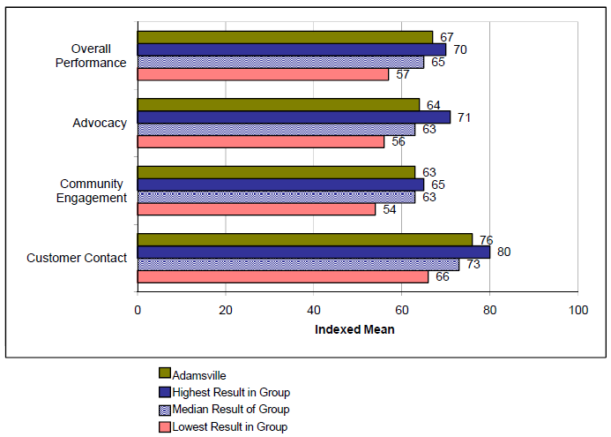

5. RELATIVE PERFORMANCE WITHIN LGA GROUP FOR 2009

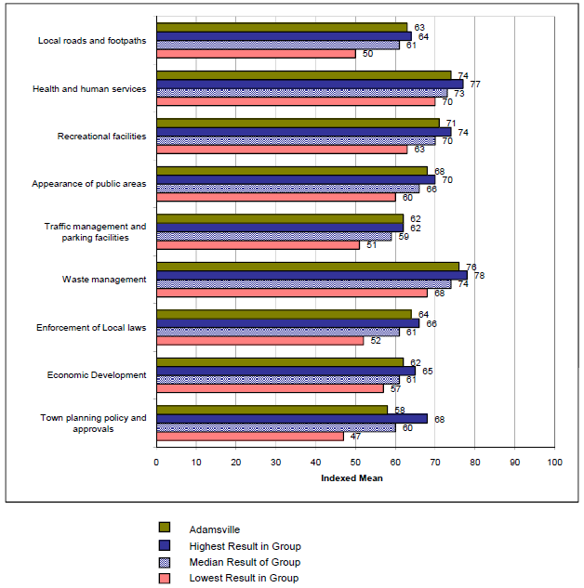

6. CUSTOMER WINDOW: AN EXPLANATION

In allocating resources to improve services, Councils need to consider two factors:

1. The relative importance of each service area to the community, and
2. The current level of performance in service provision.

The improvement window (page 9) graphically identifies the 4 possible combinations of these two factors. The highest priority for improvement is indicated where current performance is low in a service area that the community views as of high importance.

The importance dimension uses a correlation coefficient. The correlation coefficient shows the relationship between each responsibility area rating and the overall performance rating – the extent to which a change in one influences a change in the other. Correlation coefficients range from 0 to 1.0 indicates that there is no relationship while 1 shows a positive association (that an improvement in one rating will lead to an improvement in the other). A good level of correlation for survey measures of this kind is 0.5.

Another figure used to derive relative importance is the percentage of people who were able to rate Council’s performance on the service area concerned. This is used because people generally do not rate services when they have not experienced them, or have no opinion about them. Relative importance for each area surveyed is achieved by multiplying the square of the correlation coefficient by the percentage of people who gave a satisfaction rating.

The performance measure is based on the percentage of people who gave a rating of excellent, good or adequate.

The four quadrants of the improvement window inform service improvement decisions as follows:

1) Bottom right quadrant: Key areas for improvement. Identifies those services that are relatively important to the community in which the Council underperformed. These are the first areas for improvement.

2) Bottom left quadrant: Secondary areas for improvement. Identifies service areas in which the Council has performed poorly which are of relatively lower importance to the community.

3) Top right quadrant: Strengthen and consolidate. Indicates those service areas that are relatively important to the community and for which they expressed a high level of satisfaction.

4) Top left quadrant: Maintain existing performance. Identifies services in which the Council has performed well, but which are of little relative importance to the Community. Although these areas don’t contribute greatly to overall satisfaction, it may be that if Council allows standards to drop then the community may attribute them with a higher level of importance in the future.

The visual display on the next page shows the improvement window for Adamsville City Council.

6. CUSTOMER WINDOW: KEY AREAS FOR IMPROVEMENT 2009

Customer Window for Adamsville City Council
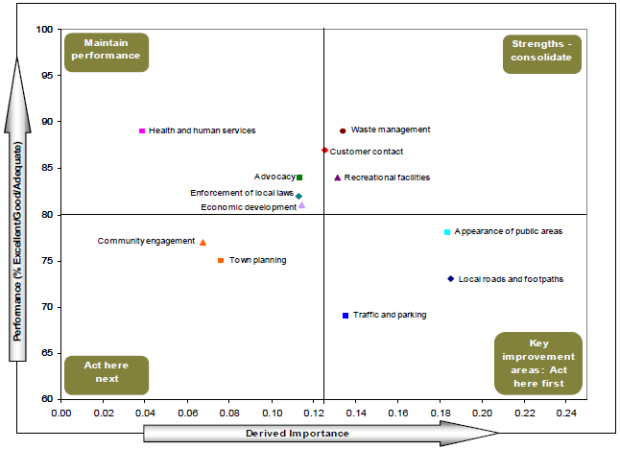
Adamsville's key areas for improvement are:

1. Traffic Management and Parking Facilities
- An important issue for residents, but this has the lowest percentage of "Excellent/
Good/ Adequate" ratings, and some 31% of residents would like to see improvement.

2. Local Roads and Footpaths
- This has the strongest connection to overall satisfaction, but
- 27% of residents consider this to be a key area for improvement.

3. Appearance of Public Areas
- Very similar in relative importance to Local Roads and Footpaths
- 22% say improvement is needed.

Other areas requiring attention are:
- Town Planning Policy and Approvals, and Community Engagement - Of lesser importance, but these areas have low performance ratings, with percentages of 25% and 23% respectively, seeking improvement.

What Adamsville does well
Although residents desire further improvement in the areas of local roads and footpaths, the appearance of public areas, traffic management and parking, and town planning policy and approvals, Adamsville does relatively well compared to other councils in its group on these measures. Enforcement of local laws, waste management, recreational facilities, and customer contact are also areas on which it performs better than its comparable group. Overall performance is also comparatively higher.

7. RESULTS IN DETAIL: OVERALL PERFORMANCE

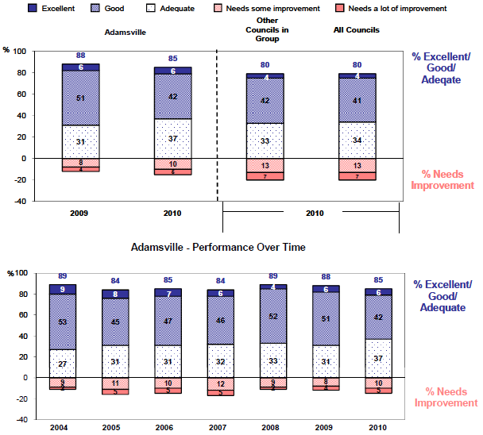

Reasons Needs Improvement (2010) Number of Respondents: 87
%
- Traffic management and parking facilities 22
- Make decisions despite community consultation/ don't listen to community 20
- Appearance of public areas including foreshore 15
- Town planning policy and approvals 14
- Communicating/leading discussion with community 13
- Favour certain areas in Shire/ local government area over others 11
- Rates are not giving value for money 9
- Local roads and footpaths 9
- Council too focused on internal politics/ don't achieve outcomes 9
- Recreational facilities 8

Note: Only the most frequently mentioned reasons shown. Some respondents may have given more than one reason for needing improvement.

8. RESULTS IN DETAIL: ADVOCACY

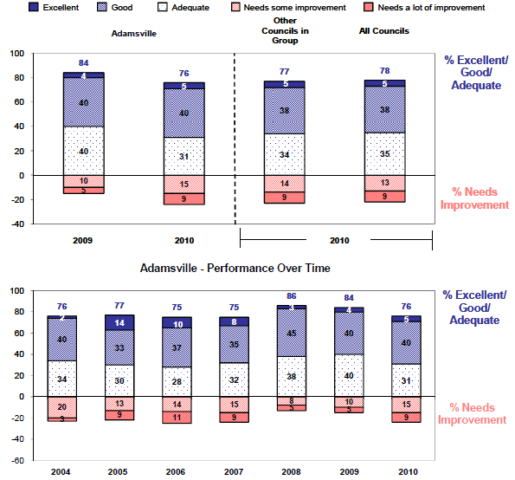

Reasons Needs Improvement (2010) Number of Respondents: 88
%
- Don't represent the interests of the community 32
- Not doing enough/ need to lobby harder on key local issues 19
- Not sure what the council does/ need to promote/ communicate effectively 17
- Council does not make sufficient effort 16
- Don't consult to gauge community views 15
- Lobbying skills need improvement/ more professional/ effective lobbying 14
- Town planning issues/ inappropriate development 13
- Council represents some areas/services/interests but neglect others 8
- Council more interested in politics/themselves than community interests 8
- Division within council/infighting/need to be more cohesive 3

Note: Only the most frequently mentioned reasons shown. Some respondents may have given more than one reason for needing improvement.

9. RESULTS IN DETAIL: COMMUNITY ENGAGEMENT

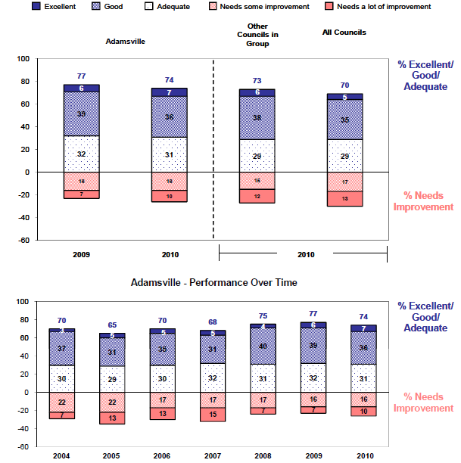

Reasons Needs Improvement (2010) Number of Respondents: 210
%
- Need to keep community better informed/communicate more 59
- Don't consult sufficiently/effectively/with entire community 42
- More community consultation/ use consultants less/more public meetings 23
- Communicate more regularly via newsletter/ local paper etc 12
- Don't listen/ need to take more notice of community's wishes 11
- Need to publicise/promote consultation sessions and inform us of results 10
- Only pay lip service to issues/need to follow through 9
- More attention on other particular local issues 4
- Need to consult with all areas in the council/ district 3
- Councillors/ incompetent/ uninterested/ dishonest/ self-serving 2

Note: Only the most frequently mentioned reasons shown. Some respondents may have given more than one reason for needing improvement.

10. RESULTS IN DETAIL: CUSTOMER CONTACT

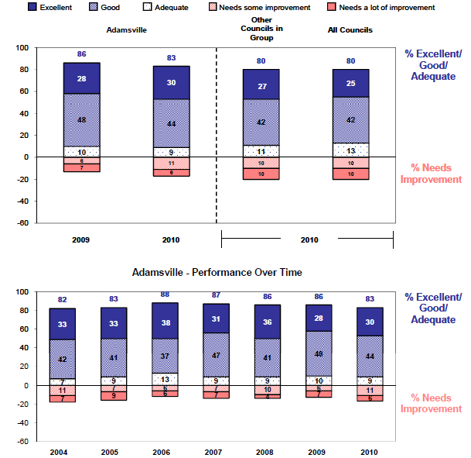

Reasons Needs Improvement (2010) Number of Respondents: 64
%
- Lack of follow up 33
- Took too long to respond 30
- Poor customer service/ need better communication skills/personal service 27
- Not interested in helping/didn't take an interest/responsibility 22
- Passed around departments/not clear who to speak to 22
- Impolite/rude manner/tone 14
- Issue not resolved in a satisfactory manner 13
- Did not achieve outcome I wanted 13
- Not knowledgeable 6
- Too hard to get through to anyone/kept getting machine 6

Note: Only the most frequently mentioned reasons shown. Some respondents may have given more than one reason for needing improvement.

11. RESULTS IN DETAIL: RESPONSIBILITY AREAS
A) Local Roads and Footpaths

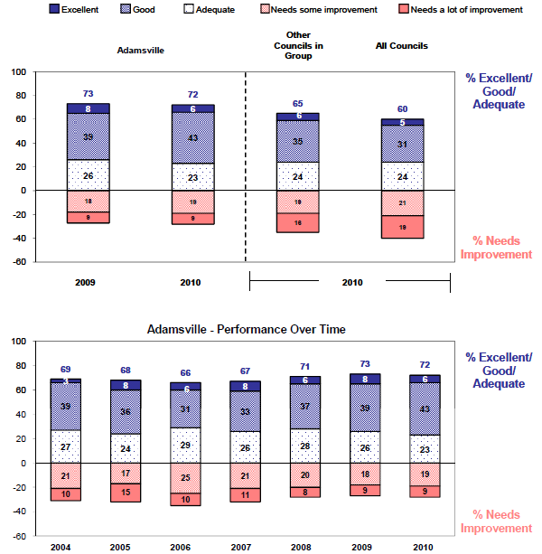

Reasons Needs Improvement (2010) Number of Respondents: 138
%
- Improve/ Fix/ Repair uneven surface of footpaths 54
- More frequent/ better re-surfacing of roads 22
- Improve the quality of maintenance on roads and footpaths 20
- Quicker response for repairs to roads, footpaths or gutters 11
- Fix/ improve unsafe sections of roads 7
- Improve/More frequent grading etc of unsealed roads 3
- Increase number of footpaths/ widen footpaths 3
- More frequent maintenance/ cleaning of roadside drains and culverts 3
- More/ better roadside drains and culverts 3
- Traffic management issues 3

Note: Only the most frequently mentioned reasons shown. Some respondents may have given more than one reason for needing improvement.

12. RESULTS IN DETAIL: RESPONSIBILITY AREAS
B) Health & Human Services

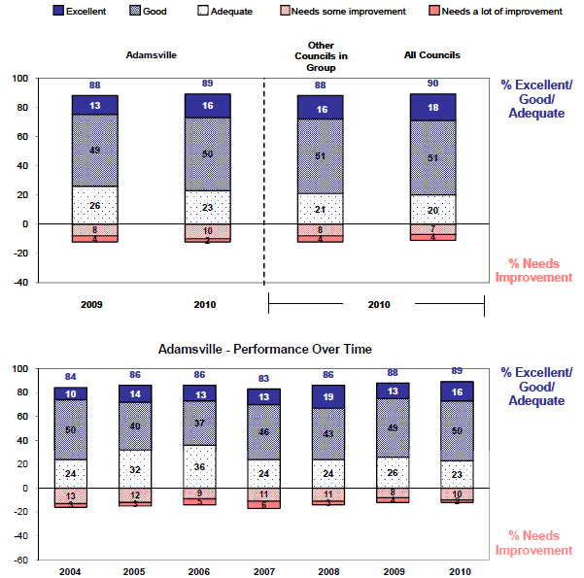

Reasons Needs Improvement (2010) Number of Respondents: 57
%
- Improved/More childcare facilities/after school/holiday care 35
- More resources/longer hours for Maternal & Child Health Facilities 18
- More/better support/services for minority/disadvantaged groups 18
- More facilities/resources for Aged Care/better nursing homes 16
- Increase resources for/availability of home help /meals on wheels 16
- More funds/resources to reduce waiting lists for services 9
- Services need to be improved in all areas/council needs to do more 9
- More/better premises for health or community facilities 9
- Improve quality/variety of food in meals on wheels program 5
- Improve quality of home help 5

Note: Only the most frequently mentioned reasons shown. Some respondents may have given more than one reason for needing improvement.

12. RESULTS IN DETAIL: RESPONSIBILITY AREAS
C) Recreational Facilities

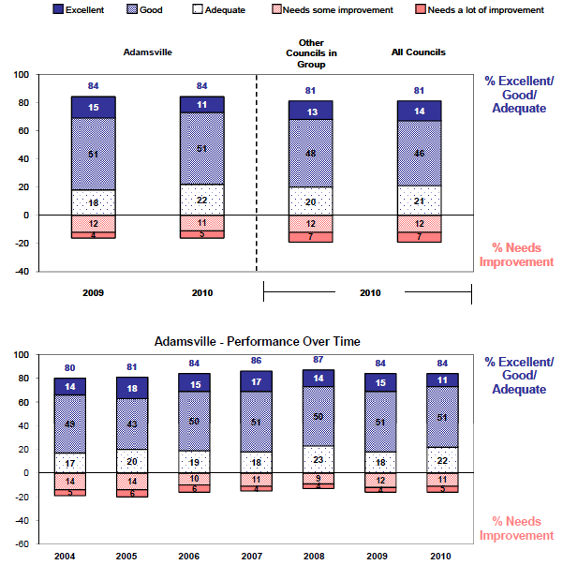

Reasons Needs Improvement (2010) Number of Respondents: 84
%
- More/better Sporting Complexes (including pools) 18
- Better maintenance of Sporting facilities (including pools) 17
- More support/funding needed for recreational/sporting facilities 12
- More/better recreational activities/programs 10
- More facilities/activities for young people/teenagers 8
- More/better library buildings/no library service/closing /moving library 8
- More/better/safer Playgrounds and/or equipment/with sun shade 8
- More/better facilities and resources at libraries (incl funding) 7
- Should allocate funds better in more important areas 7
- Longer opening hours for Sporting Complexes (including pools) 5

Note: Only the most frequently mentioned reasons shown. Some respondents may have given more than one reason for needing improvement.

12. RESULTS IN DETAIL: RESPONSIBILITY AREAS
D) Appearance of Public Areas

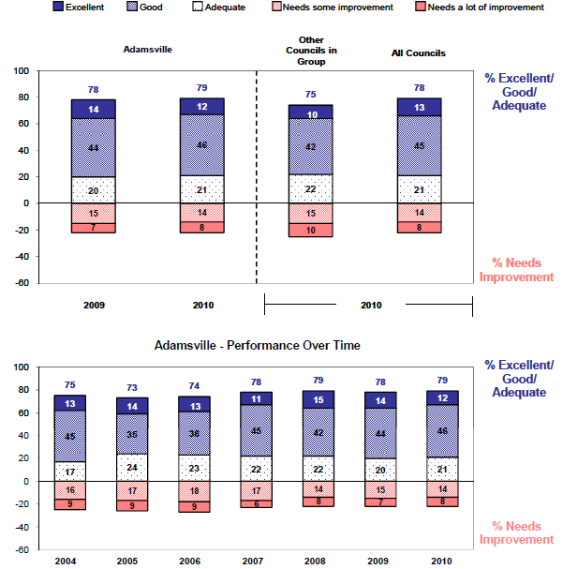

Reasons Needs Improvement (2010) Number of Respondents: 121
%
- More frequent/better street cleaning 40
- Better care of street trees -watering, staking, removal etc 18
- More frequent/better removal of litter in parks and gardens 12
- Better maintenance of parks and gardens 12
- More frequent/better pruning of street trees/plants 7
- More street trees 5
- More frequent sweeping of leaves 5
- Cleaning of public areas/generally untidy 5
- Better landscaping/design (eg. more colour, more shady trees) 4
- Some areas favoured over others/some areas are neglected 4

Note: Only the most frequently mentioned reasons shown. Some respondents may have given more than one reason for needing improvement.

12. RESULTS IN DETAIL: RESPONSIBILITY AREAS
E) Traffic Management & Parking Facilities

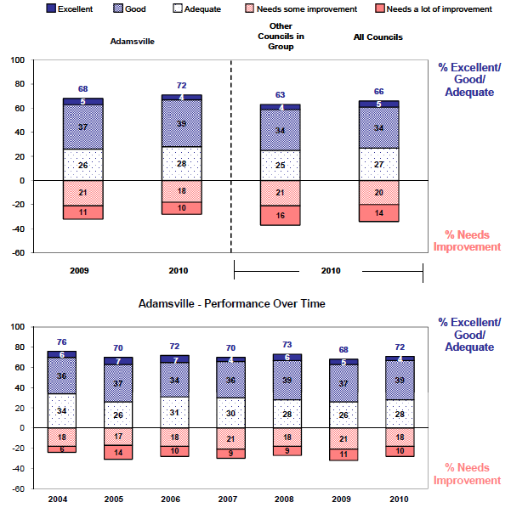

Reasons Needs Improvement (2010) Number of Respondents: 318
%
- More parking facilities/capacity 39
- More parking specifically allocated for residents 29
- More parking facilities adjacent to shopping and business centres 19
- More free parking/cheaper parking 14
- Poor traffic/parking management 13
- Improve traffic flow/congestion 12
- Less parking restrictions 11
- Longer parking times/more long-term parking 6
- Improve traffic management at intersections 5
- Improve road signage -general (parking/speed/road works) 4

Note: Only the most frequently mentioned reasons shown. Some respondents may have given more than one reason for needing improvement.

12. RESULTS IN DETAIL: RESPONSIBILITY AREAS
F) Waste Management

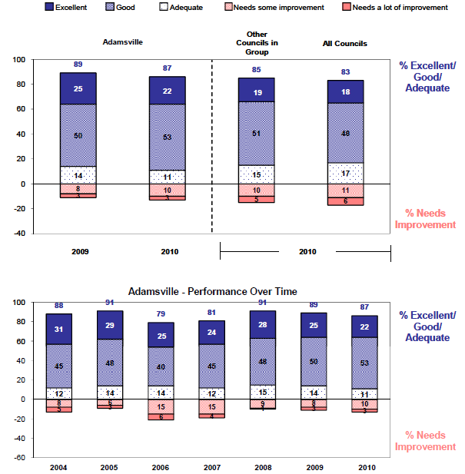

Reasons Needs Improvement (2010) Number of Respondents: 105
%
- Any/more frequent hard waste collection 19
- More comprehensive recycling program/no recycling program 14
- More reliable Collections 10
- Any/More frequent collection of green waste/vegetation 10
- Inconvenient time of day for pick-ups (too early/late/too noisy) 10
- More frequent rubbish collection 8
- Any/Better containers for collection of recyclable /green materials 8
- More frequent collection of recyclable materials 5
- Spilling garbage on footpath/ road during garbage collection/rubbish blows out of truck 4
- Bins should be returned upright to curbside/in same place/with lids closed 4

Note: Only the most frequently mentioned reasons shown. Some respondents may have given more than one reason for needing improvement.

12. RESULTS IN DETAIL: RESPONSIBILITY AREAS
G) Enforcement of Local Laws

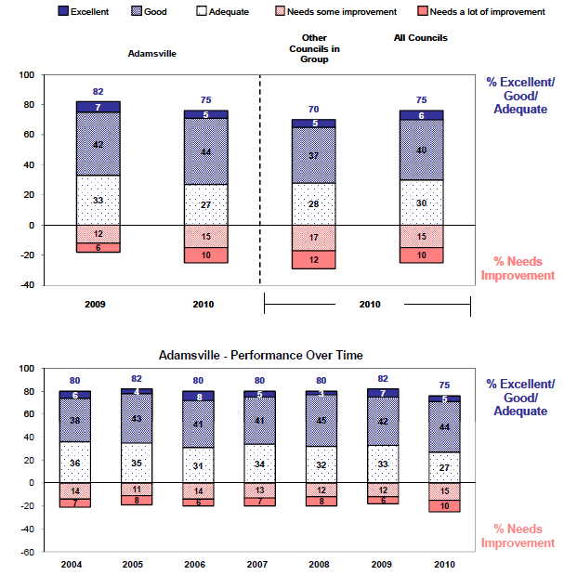

Reasons Needs Improvement (2010) Number of Respondents: 180
%
- Greater enforcement of noise Local Laws (domestic, industrial, traffic) 43
- Greater enforcement of parking restrictions/more officers/rangers 19
- Greater enforcement of animal Local Laws 15
- Less enforcement of parking restrictions 9
- Local Laws are too stringent 4
- Greater enforcement of health/food handling Local Laws 4
- Greater enforcement of Local Laws generally/more Local Law officers 4
- Greater enforcement of littering Local Laws 4
- Better attitude for Local Law enforcement officers/rangers 4
- Quicker response to reports of Local Law infringements 2

Note: Only the most frequently mentioned reasons shown. Some respondents may have given more than one reason for needing improvement.

12. RESULTS IN DETAIL: RESPONSIBILITY AREAS
H) Economic Development

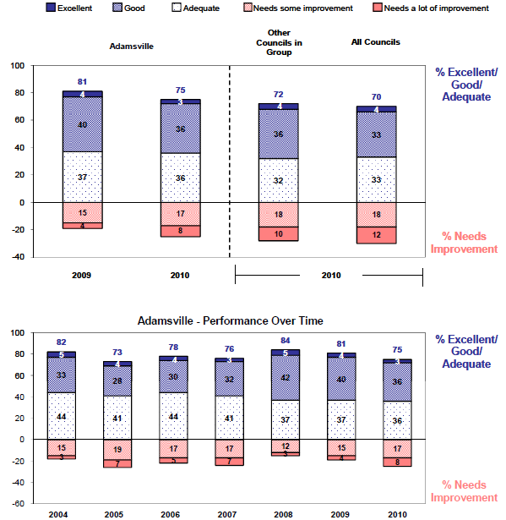

Reasons Needs Improvement (2010) Number of Respondents: 56
%
- More/better job creation programs/employment opportunities 34
- Too little support for local businesses/ new business/many closing down 20
- Encourage more tourism 13
- Better financial planning/management of Council budget/money wasted 7
- Too much emphasis on tourism 7
- Greater emphasis on Economic Development in general 5
- Not enough promotion of local businesses 5
- Need to publicise/inform the community of Council activities 5
- More community consultation/consultation with business 5
- Encourage more companies/industries to re-locate to the area 5

Note: Only the most frequently mentioned reasons shown. Some respondents may have given more than one reason for needing improvement.

12. RESULTS IN DETAIL: RESPONSIBILITY AREAS
I) Town Planning Policy & Approvals

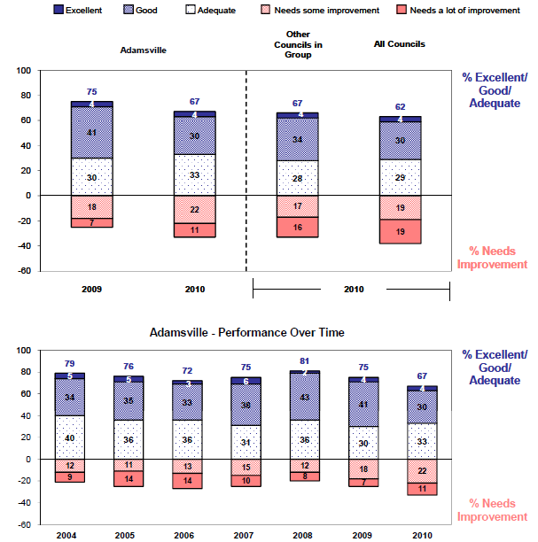

Reasons Needs Improvement (2010) Number of Respondents: 165
%
- Better planning policies 23
- Ugly/inappropriate design/development/out of character with area 22
- Too little regulation in heritage areas/knocking down old houses 20
- More consultation with community 16
- Take better account of environmental issues 11
- Council should be stronger in representing community opinion 11
- Less high density dwellings 10
- More consistent decisions 9
- More efficient/faster approval processes 9
- Greater enforcement of/adherence to planning policies 9

Note: Only the most frequently mentioned reasons shown. Some respondents may have given more than one reason for needing improvement.

APPENDIX 1

Survey Questionnaire

DPCD Community Satisfaction Survey 2009 Page 1

WALLIS CONSULTING GROUP

Department for Planning & Community Development
Community Satisfaction Survey 2010
WG3699
January 2010

INTRODUCTION

IF IN COUNCIL AREA:

Good morning/afternoon/evening. My name is ………from Wallis Consulting Group. We are conducting research on behalf of Victorian Local Government. The survey aims to find out how residents feel about the PERFORMANCE of local Government in your area. Can you confirm that you live in (NAME OF COUNCIL)?

IF NON-RESIDENT RATE-PAYER:

Good morning/afternoon/evening. My name is ………from Wallis Consulting Group. We are conducting research on behalf of Victorian Local Government. The survey aims to find out how residents feel about the PERFORMANCE of local Government in the (NAME OF COUNCIL).
Council records indicate that you are a rate-payer in that area.

1 Yes GO TO S1
2 In different Council area GO TO PRE S1
3 Not available/callback (make appt) RETURN TO SMS
4 Household refusal RETURN TO SMS
5 Selected resident refusal RETURN TO SMS
6 Language Difficulties RETURN TO SMS

PRE S1

LIST ALL COUNCILS IN SAME GROUP

What Local Government Area do you live in?

1 Correct Council can be selected CONTINUE
2 Council not listed – cannot select RETURN TO SMS
3 Don’t know RETURN TO SMS

DPCD Community Satisfaction Survey 2009 Page 2

SCREENING

S1: Firstly, have you or anyone in your household worked in a market research organisation or local government anywhere in the last three years?

1 No (continue) CONTINUE
2 Yes - Market Research RETURN TO SMS
3 Yes - Local Government RETURN TO SMS

S2: Also, we just wish to speak to residents, not businesses, of (NAME OF COUNCIL). Are you a residential household (IF GROUPS 3-5: or a farming household)?

1 Yes - Residential Household
2 Yes - Farming Household
3 No RETURN TO SMS

S3: Can I please speak to a head of your household (either male or female) that is 18 years or older?

1 Yes – available Continue
2 Not available/callback (make appt) RETURN TO SMS
3 Household refusal RETURN TO SMS
4 Selected resident refusal RETURN TO SMS
5 Not in Council area RETURN TO SMS
6 Language Difficulties RETURN TO SMS

ONCE HAVE CORRECT PERSON: Thank-you for your participation. The survey will only take about 8 or 9 minutes AND THE INFORMATION YOU PROVIDE WILL BE USED TO HELP COUNCILS IMPROVE THEIR SERVICES. No information that you provide will be linked to your name.

IF A FARMING HOUSEHOLD: Please note, we would like you to participate in the survey thinking of your needs as a resident, rather than specific farm management issues.

S5: My supervisor may be monitoring the interview for quality control purposes. If you do not wish this to occur, please let me know.

1 Monitoring allowed
2 Monitoring NOT allowed

DPCD Community Satisfaction Survey 2009 Page 3

MAIN SURVEY

Q1 I’m going to read out a list of nine areas which are the responsibility of local government. For each area of responsibility, I would like to establish your ASSESSMENT OF THE PERFORMANCE of (NAME OF COUNCIL) over the last twelve months. Please keep in mind that the focus is on local government only.

NOW ASK (a) AND (b) WHERE NECESSARY FOR EACH RESPONSIBILITY AREA, BEFORE
PROCEEDING TO NEXT SERVICE AREA. RANDOMISE.

Q1ax) In the last twelve months, how has (NAME OF COUNCIL) performed on (RESPONSIBILITY AREA)? Was it … ?

READ OUT 1-5 INCLUDING DEFINITIONS THE FIRST TIME AND THEREAFTER ONLY THE KEY WORDS.

5 Excellent - outstanding performance
4 Good - a high standard
3 Adequate - an acceptable standard
2 Needs some improvement
1 Needs a lot of improvement
0 Don’t Know / Can’t Say

ASK Q1b IF CODES 4 OR 5 IN Q1a. OTHERWISE CONTINUE WITH THE NEXT RESPONSIBILITY AREA.

Q1bx) Why do you say that? PROBE FULLY. DO NOT READ OUT.

USE ATTACHED PRE-CODES FOR EACH RESPONSIBILITY AREA.

ASK Q1c FOR THE SECOND RESPONSIBILITY AREA ONLY.

Q1c) Have you or any member of your household used any of the HEALTH AND HUMAN SERVICES provided by the (NAME OF COUNCIL) in the last 12 months?

1 Yes
2 No

RESPONSIBILITY AREAS:

1. LOCAL ROADS AND FOOTPATHS, excluding highways and main roads (IF GROUPS 2-5: but INCLUDING roadside slashing / maintenance)
2. HEALTH AND HUMAN SERVICES; this includes Meals on Wheels, home help, maternal and child health, immunisation, child care, and support for disadvantaged and minority groups, but EXCLUDES hospitals.
3. RECREATIONAL FACILITIES; this includes sporting facilities, swimming pools, sports fields and playgrounds, arts centres and festivals, and library services.
4. APPEARANCE OF PUBLIC AREAS; this includes local parks and gardens, street cleaning and litter collection, and street trees.
5. TRAFFIC MANAGEMENT AND PARKING FACILITIES; this includes council provision of street and off street parking, and local road safety.

DPCD Community Satisfaction Survey 2009 Page 4

6. WASTE MANAGEMENT; this includes garbage and recyclable collection, and operation of tips / transfer stations.
7. ENFORCEMENT OF LOCAL LAWS; this includes food and health, noise, animal control, parking, and fire prevention.
8. ECONOMIC DEVELOPMENT; this includes business and tourism, and jobs creation.
9. TOWN PLANNING POLICY AND APPROVALS, including heritage and environmental issues.

Q2a In the last twelve months, have you had any contact with (NAME OF COUNCIL)? This may have been in person, by telephone, in writing, email or by fax.

1 Yes
2 No SKIP TO Q3

Q2b Thinking of the most recent contact, how well did (NAME OF COUNCIL) perform in the WAY you were treated - things like the ease of contact, helpfulness and ability of staff, speed of response, and their attitude towards you. We do NOT mean the ACTUAL OUTCOME. Was it … READ OUT 1-5 … ?

5 Excellent - outstanding performance
4 Good - a high standard
3 Adequate - an acceptable standard
2 Needs some improvement
1 Needs a lot of improvement
0 Don’t Know / Can’t Say

ASK Q2c IF OPTION 2 AND CODES 4 OR 5 IN Q2b. OTHERWISE SKIP TO Q3a

Q2c Why do you say that? PROBE FULLY. DO NOT READ OUT.

(USE ATTACHED PRE-CODES)

ASK ALL

Q3a Over the last 12 months, how would you rate the performance of (NAME OF COUNCIL) on consulting with the community and leading discussion on key social, economic and environmental issues which could impact on the local area, and may require decisions by Council? Would you say it was… READ OUT PERFORMANCE SCALE 1-5… ?

5 Excellent - outstanding performance
4 Good - a high standard
3 Adequate - an acceptable standard
2 Needs some improvement
1 Needs a lot of improvement
0 Don’t Know / Can’t Say

ASK Q3b IF OPTION 2 AND CODES 4 OR 5 IN Q3a. OTHERWISE SKIP TO Q4a

Q3b Why do you say that? PROBE FULLY. DO NOT READ OUT.

(USE ATTACHED PRE-CODES)

DPCD Community Satisfaction Survey 2009 Page 5

Q4a In the last twelve months, how well has (NAME OF COUNCIL) represented and lobbied on behalf of the community with other levels of government and private organisations, on key local issues? Was it … READ OUT 1-5 … ?

5 Excellent - outstanding performance
4 Good - a high standard
3 Adequate - an acceptable standard
2 Needs some improvement
1 Needs a lot of improvement
0 Don’t Know / Can’t Say

ASK Q4b IF OPTION 2 AND CODES 4 OR 5 IN Q4a. OTHERWISE SKIP TO Q5

Q4b Why do you say that? PROBE FULLY. DO NOT READ OUT.

(USE ATTACHED PRE-CODES)

Q5 ON BALANCE, for the last twelve months, how do you feel about the performance of (NAME OF COUNCIL), not just on one or two issues, BUT OVERALL across all responsibility areas. Was it … READ OUT PERFORMANCE SCALE 1-5 … ?

5 Excellent - outstanding performance
4 Good - a high standard
3 Adequate - an acceptable standard
2 Needs some improvement
1 Needs a lot of improvement
0 Don’t Know / Can’t Say SKIP TO Q7

Q6a In giving your answer to the previous question, has any particular issue STRONGLY influenced your view, either in a positive or negative way? IF YES: Was it a positive or negative influence? MULTICODE IF NECESSARY

1 Yes - Positive
2 Yes - Negative
3 No
4 Don’t Know / No Response

ASK Q6b IF OPTION 2 AND CODES 4 OR 5 IN Q5. OTHERWISE SKIP TO Q7

Q6b Why do you say that on balance the council’s overall performance is in need of improvement? PROBE FULLY. DO NOT READ OUT.

(USE ATTACHED PRE-CODES)

Q7 Over the last 12 months, what is your view of the direction of (NAME OF COUNCIL)’s overall performance? Has it IMPROVED, STAYED THE SAME or DETERIORATED?

1 Improved
2 Stayed the Same
3 Deteriorated
4 Don’t Know / Can’t Say

DPCD Community Satisfaction Survey 2009 Page 6

DEMOGRAPHICS

Q8a Now I have just three final questions …To which one of the following age groups do you belong? (READ OUT 1-5)
1 18 - 24
2 25 - 34
3 35 - 49
4 50 - 64
5 65 +
6 Refused
7 Under 18 GO TO Q8b

NOW GO TO Q9

Q8b I originally asked to speak to someone who is 18 years or older. Can you please confirm that you are under 18 years old?
1 Yes, confirm
2 No GO BACK TO Q8a

Q9 Thinking of the property you live in, do you OWN it or are you RENTING?
1 Own (includes purchasing)
2 Renting

IF CALLING PROPERTY IN COUNCIL AREA ASK Q10a, IF CALLING PROPERTY OUTSIDE
COUNCIL AREA ASK Q10b

Q10a Is the property WE HAVE CALLED YOU AT your main permanent residence or a secondary residence such as a holiday home?

Q10b Is the property in the (NAME OF COUNCIL) area your main permanent residence or a secondary residence such as a holiday home?
1 Permanent residence
2 Secondary residence

Q11 Record gender:
1 Male
2 Female

Q12 Record language interview conducted in:
1 English
2 Other SPECIFY (including home translator)

CLOSE: Thank you for taking part in this research. Your views count and we’re very glad you made them known to us. This research is being carried out in accordance with the Privacy Act and the information you provided will be used for research purposes only. Once the survey is complete, any information that could identify you will be removed from the computer records.

Just in case you missed it, my name is …….. and I'm from the Wallis Group. If you have any questions about this survey you may contact the Australian Market and Social Research Society on 1300 364 830.

DPCD Community Satisfaction Survey 2009 Page 7

RESPONSIBILITY AREA PRE-CODES

RA 1 – Local Roads and Footpaths Pre-codes

ON SCREEN:

1. Improve/ Fix/ Repair uneven surface of footpaths
2. More frequent/ better re-surfacing of roads
3. More frequent / better slashing of roadside verges
4. Improve standard of unsealed roads (loose gravel, dust, corrugations)
5. Improve/More frequent grading etc of unsealed roads
6. Quicker response for repairs to roads, footpaths or gutters
7. Increase number of footpaths/ widen footpaths
8. Fix/ improve unsafe sections of roads
9. Improve the quality of maintenance on roads and footpaths
10. More frequent maintenance/ cleaning of roadside drains and culverts
11. Fix/ improve edges and shoulders of roads
12. More/ better roadside drains and culverts
13. Prune/trim trees/shrubs overhanging footpaths/roads
14. Other (SPECIFY)

CODING:

15. Widen roads/roads too narrow
16. More/better street/road signs (including position/visibility)
17. More/better street lighting
18. Need improved/more frequent weed control
19. Increase number of sealed roads - outside town limits
20. Increase number of sealed roads - inside town limits
21. Tree roots causing damage to footpaths/roads/drains
22. Council favours/focuses on certain areas over others
23. Traffic management issues

DPCD Community Satisfaction Survey 2009 Page 8

RA 2 – Health and Human Services Pre-codes

ON SCREEN:

1. More funds/resources to reduce waiting lists for services
2. More facilities/resources for Aged Care/better nursing homes
3. More/better support/services for minority/disadvantaged groups
4. Increase resources for/availability of home help /meals on wheels
5. More resources/longer hours for Maternal & Child Health Facilities
6. Improved/More childcare facilities/after school/holiday care
7. Improve quality of home help
8. More/better centres/facilities generally in more remote towns/areas
9. Services need to be improved in all areas/council needs to do more
10. Improve quality/variety of food in meals on wheels program
11. More/better publicity/information about available services
12. More/better premises for health or community facilities
13. Better transport to/from health or community centres/facilities
14. Other (SPECIFY)

CODING:

15. More/better activities/programs for young people
16. More information/resources to immunisation programs
17. Improve services for children with special needs/ disability services
18. More facilities/services for mental health
19. Improve/increased dental program/services
20. Better management of services/organisations

DPCD Community Satisfaction Survey 2009 Page 9

RA 3 – Recreational Facilities Pre-codes

ON SCREEN:

1. More/better Sporting Complexes (including pools)
2. Better maintenance of Sporting facilities (including pools)
3. More facilities/activities for young people/teenagers
4. More/better/safer Playgrounds and/or equipment/with sun shade
5. More/better sporting complexes and/or facilities in smaller towns
6. More/better recreational activities/programs
7. More/better library buildings/no library service/closing /moving library
8. More/better facilities and resources at libraries (incl funding)
9. More community consultation about recreational facilities etc
10. More/better arts/cultural facilities/events in smaller towns
11. More/better bike paths/ walking tracks/ skate board facilities
12. Longer opening hours for Sporting Complexes (including pools)
13. More support/funding needed for recreational/sporting facilities
14. Other (SPECIFY)

CODING:

15. More/better amenities in recreation areas (eg. seats, picnic tables, barbeques etc)
16. Less expensive recreational facilities and activities/more consistent fees
17. Better/More maintenance of Parks/Playgrounds-syringes/ lighting/ trees/ equipment etc
18. More support for local sporting clubs in smaller towns
19. Council favours certain areas over others in regard to recreational facilities
20. More publicity/information on facilities and activities/programs
21. More/better performing arts facilities
22. More/better events and festivals
23. Not enough money spent on cultural events and festivals
24. Not enough support for local community groups/clubs
25. Larger range/greater availability of books
26. Pool/baths closing/moving/closed/should be open more months a year
27. Need more parks/open space
28. Everything takes too long/upgrading of facilities/decision making i.e. facilities
29. Improved management of facilities/sports/recreation/library etc (incl food management)

DPCD Community Satisfaction Survey 2009 Page 10

RA 4 – Appearance of Public Areas Pre-codes

ON SCREEN:

1. Better maintenance of parks and gardens
2. More frequent/better street cleaning
3. More frequent/better pruning of street trees/plants
4. More frequent slashing/mowing of public areas/fire hazard
5. More frequent/better removal of litter in parks and gardens
6. Better care of street trees - watering, staking, removal etc
7. Better landscaping/design (eg. more colour, more shady trees)
8. More street trees
9. Better maintenance of beaches, lakes, rivers and surrounding areas
10. Some areas favoured over others/some areas are neglected
11. Better maintenance of amenities in parks (BBQ's, tables, toilets etc)
12. More frequent sweeping of leaves
13. More emphasis on smaller towns
14. Other (SPECIFY)

CODING:

15. More frequent spraying of weeds in open spaces/better weed management
16. Retain/More parks and gardens/open spaces
17. Better amenities within parks/gardens (eg. BBQ's, Picnic tables, toilets, play equipment etc.)
18. Better/different types/mix of trees/vegetation/more appropriate trees
19. Cleaning of public areas/generally untidy
20. More frequent clearing of public litter bins
21. More/better cleaning up of condoms, syringes etc. in parks, beaches, alleys
22. Clear drains regularly/stormwater drains often blocked/gutters
23. Improve streetscapes with landscape or architectural features
24. More public litter bins
25. Quicker/more frequent removal of graffiti/attention to vandalism
26. Cutting down too many trees
27. More maintenance of nature strips/median strips
28. Improve/better maintenance of entrances to town
29. Not responsive to maintenance requests/takes too long

DPCD Community Satisfaction Survey 2009 Page 11

RA 5 – Traffic Management and Parking Facilities Pre-codes

ON SCREEN:

1. More parking facilities adjacent to shopping and business centres
2. More parking facilities/capacity
3. Poor traffic/parking management
4. Improve traffic flow/congestion
5. Improve traffic management at intersections
6. More free parking/cheaper parking
7. Improve road signage – general (parking/speed/road works)
8. More parking specifically allocated for residents
9. Longer parking times/more long-term parking
10. More speed inhibitors (humps, barriers, traffic islands etc)
11. Improved parking management /more parking around schools
12. Less parking restrictions
13. Fewer parking meters
14. Other (SPECIFY)

CODING:

15. More parking enforcement/traffic officers
16. More disabled parking needed
17. Reduce speed limits in residential areas
18. More pedestrian crossings
19. Streets/roads too narrow/need widening/cars parked on sides
20. Improve blind spots, dangerous curves etc. on country roads (excluding highways)
21. More community consultation
22. Greater restriction of non-resident parking
23. More parking restrictions
24. More parking around specific areas, eg train stations, hospitals, etc
25. Fewer speed inhibitors (humps, barriers traffic islands etc)
26. Install more traffic lights at dangerous intersections
27. Less Roundabouts
28. Restrict/discourage traffic on residential roads
29. Restrict truck traffic in streets
30. Parking spaces too small/need to be widened
31. Greater enforcement of speed limits

DPCD Community Satisfaction Survey 2009 Page 12

RA 6 – Waste Management Pre-codes

ON SCREEN:

1. More consistent/ lower fees for tips etc (reintroduce vouchers)
2. Any/more frequent hard waste collection
3. More comprehensive recycling program/no recycling program
4. More consistent/convenient/Longer opening times/days for Tips etc.
5. No garbage collection
6. More reliable Collections
7. Bigger bins
8. Any/More frequent collection of green waste/vegetation
9. Better location of tip/transfer station/rubbish dump/no tip/closed tip
10. No collection of recyclable materials
11. Any/Better containers for collection of recyclable /green materials
12. More frequent collection of recyclable materials
13. Tip/transfer stations in poor condition/badly managed
14. Other (SPECIFY)

CODING:

15. Spilling garbage on footpath/ road during garbage collection/rubbish blows out of truck
16. Bins should be returned upright to curbside/in same place/with lids closed
17. More frequent rubbish collection
18. Cost of garbage/waste collection too much (including bins)
19. Extend areas covered by garbage collection in areas outside townships
20. Provide more info/keep residents informed about waste management procedures
21. More community consultation
22. Less damage to garbage bins
23. More education/promotion for recycling
24. Recyclable material goes into garbage truck/Doubt recycling occurs
25. Inconvenient time of day for pick-ups (too early/late/too noisy)
26. Collection of rubbish left on streets/footpaths/gutters/public areas
27. Quicker response to requests i.e., for new bins/bin lids

DPCD Community Satisfaction Survey 2009 Page 13

RA 7 – Enforcement of Local Laws Pre-codes

ON SCREEN:

1. Greater enforcement of animal Local Laws
2. Greater enforcement of noise Local Laws (domestic, industrial, traffic)
3. Greater enforcement of parking restrictions/more officers/rangers
4. Greater enforcement of Local Laws generally/more Local Laws officers
5. Greater enforcement of fire prevention Local Laws to clean up properties
6. Greater enforcement of fire prevention Local Laws
7. Greater enforcement of health/food handling Local Laws
8. Greater enforcement of littering Local Laws
9. Local Laws are too stringent
10. Less enforcement of parking restrictions
11. Quicker response to reports of Local Law infringements
12. Better attitude for Local Laws enforcement officers/rangers
13. Local Laws are too lenient
14. Other (SPECIFY)

CODING:

15. Greater enforcement of pollution Local Laws (domestic, industrial, traffic etc)
16. More publicity/information to residents
17. Local Laws purely revenue raising
18. Animal Local Laws are too stringent
19. Greater enforcement of traffic/road laws (including footpaths)
20. More consistent application of Local Laws/enforcement
21. Create access to/more free parking/unrestricted parking/dislike parking meters

DPCD Community Satisfaction Survey 2009 Page 14

RA 8 – Economic Development Pre-codes

ON SCREEN:

1. More/better job creation programs/employment opportunities
2. Encourage more tourism
3. Too little support for local businesses/ new business/many closing down
4. Greater emphasis on Economic Development in general
5. Encourage more companies/industries to re-locate to the area
6. Unaware of any economic development/improvement needed
7. Better financial planning/management of Council budget/ money wasted
8. Too much focus on major towns/need more focus on rural & regional areas
9. Not enough promotion of local businesses
10. Encourage more desirable industries to locate to the area
11. Need to publicise/inform the community of Council activities
12. More community consultation/consultation with business
13. Too much emphasis on tourism
14. Other (SPECIFY)

CODING:

15. Some areas of local govt are neglected
16. Stop rate increases/rates too high for businesses
17. Attract/encourage better/more diverse shops/businesses i.e. Target/ Spotlight/ newsagents
18. Takes too long to get things done/complete projects
19. Infrastructure in the area needs to be improved/keep up with new developments

DPCD Community Satisfaction Survey 2009 Page 15

RA 9 – Town Planning Policy and Approvals Pre-codes

ON SCREEN:

1. Better planning policies
2. More efficient/faster approval processes
3. More consultation with community
4. More consistent decisions
5. Too little regulation in heritage areas/knocking down old houses
6. Council should be stronger in representing community opinion
7. Take better account of environmental issues
8. Less high density dwellings
9. Too much residential sub-division
10. Ugly/inappropriate design/development/out of character with area
11. Greater enforcement of/adherence to planning policies
12. Take better account of impact on neighbouring properties
13. Too much regulation in heritage areas
14. Other (SPECIFY)

CODING:

15. Less development/too much overdevelopment
16. Greater clarity/information on guidelines and process for building application
17. Too much highrise development/high rise apartments
18. More helpful Town planning staff
19. Not enough infrastructure to support new developments i.e.lack of water/ parking/ roads
20. Process is too bureaucratic/needs to be flexible/too many regulations/in exports
21. Council not very professional in this area/poor management
22. Could do better in this area/some areas favoured over others
23. Better planning for development of shopping areas
24. Decisions overridden by State Government/VCAT/the Tribunal

DPCD Community Satisfaction Survey 2009 Page 16

VALUE-ADD QUESTIONS PRE-CODES

Customer Contact: Q2c Why do you say that?

ON SCREEN (ALL):

1. Lack of follow up
2. Took too long to respond
3. Not interested in helping/didn't take an interest/responsibility
4. Poor customer service/ need better communication skills/personal service
5. Impolite/rude manner/tone
6. Issue not resolved in a satisfactory manner
7. Passed around departments/not clear who to speak to
8. Not knowledgeable
9. Did not achieve outcome I wanted
10. Too hard to get through to anyone/kept getting machine
11. Need longer opening hours/after hours contacts
12. Understaffed/spent too long waiting in queue/on phone
13. Not enough information/keep community informed
14. Other (SPECIFY)

DPCD Community Satisfaction Survey 2009 Page 17

Advocacy: Q3b Why do you say that?

ON SCREEN:

1. Don't represent the interests of the community
2. Not sure what the council does/ need to promote/ communicate effectively
3. Council does not make sufficient effort
4. Council represents some areas/services/interests but neglect others
5. Council more interested in politics/themselves than community interests
6. Don't consult to gauge community views
7. Not doing enough/ need to lobby harder on key local issues
8. Lobbying skills need improvement/ more professional/ effective lobbying
9. Didn't lobby effectively on freeway/toll issues etc
10. Division within council/infighting/need to be more cohesive
11. Need to assist/protect/encourage local business/industry
12. Town planning issues/ inappropriate development
13. Need more/improved public transport
14. Other (SPECIFY)

CODING:

15. Time taken for action to take place is too long
16. Could generally improve/do better
17. Rates are too high/unjustified increases
18. Councillors seem incompetent/naive/inexperienced
19. Waste money/spending money in the wrong areas

DPCD Community Satisfaction Survey 2009 Page 20

Overall Performance:

Q5b Why do you say that on balance the council’s overall performance is in need of improvement?

ON SCREEN:

1. Favour certain areas in Shire/ local government area over others
2. Council too focused on internal politics/ don't achieve outcomes
3. Make decisions despite community consultation/ don't listen to community
4. Rates are not giving value for money
5. Local roads and footpaths
6. Town planning policy and approvals
7. Decline in standard of service generally provided by council
8. Waste/spend too much money/poor financial management/in debt
9. Communicating/leading discussion with community
10. Appearance of public areas including foreshore
11. Traffic management and parking facilities
12. Recreational facilities
13. Economic development
14. Other (SPECIFY)

CODING:

15. More resources/better handling of environmental issues
16. Service not as good as other councils
17. Health and human services
18. Waste management
19. Customer contact
20. Enforcement of Local laws
21. Too slow to act/respond/make decisions
22. Advocacy - representation to other levels of govt
23. Crime/drug related problems/violence
24. Wasted money on plastic cows/moving art/public sculpture

DPCD Community Satisfaction Survey 2009 Page 20

Community Engagement:

Q7b Why do you say that?

ON SCREEN:

1. Need to keep community better informed/communicate more
2. Don't consult sufficiently/effectively/with entire community
3. Don't listen/ need to take more notice of community's wishes
4. More community consultation/ use consultants less/more public meetings
5. Need to publicise/promote consultation sessions and inform us of results
6. Only pay lip service to issues/need to follow through
7. Don't take a role in leading discussion/aren't proactive
8. Communicate more regularly via newsletter/ local paper etc
9. Only talk to the same people
10. Need to consult with all areas of the LGD
11. Inconsistent/ pick and choose which issues it leads discussion on
12. Too much council in-fighting/get politics out of it
13. Takes too long to get things done/ not enough action
14. Other (SPECIFY)

CODING:

15. Should explain/justify/consult more on rates and fees
16. Rates are too high
17. More knowledgeable people/senior management on council
18. People don't get opportunity to speak at council meetings
19. Too concerned with lobby groups/minority groups
20. Could generally improve
21. Inappropriate developments/poor town planning decisions
22. Need to focus more on environmental issues

APPENDIX 2

List of participating councils

Annual Community Satisfaction Survey 2010
Participating Councils

1. Inner Melbourne Metropolitan Councils
Banyule City Council
Bayside City Council
Boroondara City Council
Darebin City Council
Glen Eira City Council
Hobsons Bay City Council
Kingston City Council
Maroondah City Council
Melbourne City Council
Monash City Council
Moonee Valley City Council
Moreland City Council
Port Phillip City Council
Stonnington City Council
Whitehorse City Council
Yarra City Council

2. Outer Melbourne Metropolitan Councils
Brimbank City Council
Cardinia Shire Council
Casey City Council
Frankston City Council
Greater Dandenong City Council
Hume City Council
Knox City Council
Manningham City Council
Melton Shire Council
Mornington Peninsula Shire Council
Nillumbik Shire Council
Whittlesea City Council
Wyndham City Council
Yarra Ranges Shire Council

3. Rural Cities and Regional Centres
Ballarat City Council
Greater Bendigo City Council
Greater Geelong City Council
Greater Shepparton City Council
Horsham Rural City Council
Latrobe City Council
Mildura Rural City Council
Swan Hill Rural City Council
Wangaratta Rural City Council
Warrnambool City Council
Wodonga City Council
4. Large Rural Shires
Bass Coast Shire Council
Baw Baw Shire Council
Campaspe Shire Council
Colac-Otway Shire Council
Corangamite Shire Council
East Gippsland Shire Council
Glenelg Shire Council
Macedon Ranges Shire Council
Mitchell Shire Council
Moira Shire Council
Moorabool Shire Council
Moyne Shire Council
South Gippsland Shire Council
Southern Grampians Shire Council
Surf Coast Shire Council
Wellington Shire Council

5. Small Rural Shires
Alpine Shire Council
Ararat Rural City Council
Benalla Rural City Council
Buloke Shire Council
Central Goldfields Shire Council
Gannawarra Shire Council
Golden Plains Shire Council
Hepburn Shire Council
Hindmarsh Shire Council
Indigo Shire Council
Loddon Shire Council
Mansfield Shire Council
Mount Alexander Shire Council
Murrindindi Shire Council
Northern Grampians Shire Council
Pyrenees Shire Council
Borough of Queenscliffe
Strathbogie Shire Council
Towong Shire Council
West Wimmera Shire Council
Yarriambiack Shire Council

