

Victorian Local Government
Grants Commission

Annual Allocation Report
2026-27

September 2026

Victorian Local Government
Grants Commission

Annual Allocation Report
2026-27

This Report is available from
https://www.localgovernment.vic.gov.au/funding-programs/victoria-grants-commission/publications

ISSN 0155-1418 (Print) &
ISSN 1447-5286 (Online)

Authorised by the
Victorian Local Government Grants Commission
Department of Government Services
1 Spring Street Melbourne Victoria 3000

© Copyright State of Victoria 2026
Department of Government Services
Except for any logos, emblems, trademarks, artwork and photography this document is made available under the terms of the Creative Commons Attribution 3.0 Australia license.

Disclaimer
This publication may be of assistance to you but the State of Victoria and its employees do not guarantee that the publication is without flaw of any kind or is wholly appropriate for your particular purposes and therefore disclaims all liability for any error, loss or other consequence which may arise from you relying on any information in this publication.

Victorian Local Government Grants Commission

Annual Allocation Report

2026-27

August 2026

The Hon Tim Richardson MP
Minister for Local Government
Level 1, 2 Treasury Place
MELBOURNE VIC 3000

Dear Minister

On behalf of the Victorian Local Government Grants Commission, we have pleasure in presenting the Annual Allocation Report of the Commission’s operations for the year to 31 August 2026, in accordance with Section 17 of the Victorian Local Government Grants Commission Act 1976.

This report provides a summary of the Commission’s activities for the year and details the methodology used by the Commission in preparing recommendations to the Commonwealth Government for the allocation of financial assistance grants to Victorian councils for 2026-27.

Steven Kingshott
Chair

Michael Ulbrick
Member

Marg Allan PSM
Member

Contents

1 | The Commission 1
2 | Summary of 2026-27 5
3 | Consultation 9
4 | General Purpose Grants 11
5 | Local Roads Grants 27
6 | Trends in Outcomes 33
Appendices 37
1. 2025-26 Final Grant Allocations
2. 2026-27 Allocations
3. 2026-27 Comparative Grant Outcomes
4. 2026-27 General Purpose Grants
5. 2026-27 Local Roads Grants

1. The Commission

Role |  | The role of the Victorian Local Government Grants Commission is to make recommendations for the allocation of financial assistance grants (general purpose grants and local roads grants) provided by the Commonwealth Government to Victorian councils.  The Commonwealth Government’s Financial Assistance Grant Program provides annual funding to councils to support the delivery of services to their communities. The grants are untied, allowing councils to spend the funds according to local priorities.
Legislation |  | The Victorian Local Government Grants Commission Act 1976 is the State legislation that governs the operation of the Victorian Local Government Grants Commission. The Act establishes the Commission for the purpose of making recommendations for the allocation of financial assistance grants to councils, provides for the appointment and remuneration of Commission members and specifies the general operations of the Commission, including meetings of the Commission and the annual reporting requirements.  The Local Government (Financial Assistance) Act 1995 is the Commonwealth legislation that sets out the basis for the allocation of financial assistance grants by each Local Government Grants Commission to its respective local governing bodies in each State and the Northern Territory.  This legislation also requires that a set of national principles be formulated in writing between the Commonwealth and each jurisdiction. The purpose of the principles is to guide the respective Local Government Grants Commissions in the allocation of funds to councils within their own jurisdiction.  The number of national principles currently stands at seven - six applying to the allocation of general purpose grants and one applying to the allocation of local roads grants. The national principles are detailed in Sections 4 (page 12) and 5 (page 25).
Membership |  | As required by the Victorian Local Government Grants Commission Act 1976 the Commission is to comprise a Chairperson and two other Members appointed by the Governor in Council. At least two of the members of the Commission are required to have had an association with local government. All current Commission members have extensive local government experience.  The present membership of the Commission is as follows:
   |  | Initial  Appointment | Current Term  Expires
  Chair | Steven Kingshott | 28 March 2024 | 31 October 2027
  Sessional Member | Michael Ulbrick | 1 November 2013 | 31 October 2027
  Sessional Member | Marg Allan PSM | 1 November 2021 | 31 October 2029
Steven Kingshott (Chair)

Mr Steven Kingshott joined the Victorian Local Government Grants Commission as Chair in March 2024.

Mr Kingshott has a depth of experience in Human Resources, business planning, organisational risk and change management from his extensive career in the public and private sectors. Mr Kingshott was a Councillor and Mayor at the former City of Williamstown and Hobsons Bay City Council. More recently, he worked in senior roles in one of the world’s largest corporations within Australia and overseas, managing complex project implementation and workforce change. Mr Kingshott was one of two monitors appointed to Glenelg Shire Council, until August 2024. Following this he was appointed as monitor to Horsham Rural City Council, which concluded on 30 June 2025. In October 2025, he was appointed as a monitor at Whittlesea City Council.

Michael Ulbrick (Member)

Mr Michael Ulbrick has been a Member of the Victorian Local Government Grants Commission since 2013.

Mr Ulbrick has considerable State and local government, public policy and consultation experience. He has held several executive positions in local government, including as Chief Executive Officer of Surf Coast Shire Council (2002) and Darebin City Council (2005-2010). His Victorian Government experience includes periods as Executive Director of the Workcover Authority and Executive Officer of the Victorian Local Government Grants Commission and, more recently, as consultant with Local Government Victoria in developing the Performance Management Framework (2012-14). Mr Ulbrick has established his own management consulting business and holds various Board and local government audit committee positions.

Marg Allan PSM (Member)

Ms Marg Allan has been a Member of the Victorian Local Government Grants Commission since November 2021.

Ms Allan has had an extensive career in local government, commencing in 1980. Throughout her career she has specialised in governance and strategy, corporate services, people and policy development and program delivery. Ms Allan has worked with a number of councils in executive roles including Greater Bendigo City Council 2007-2015, Loddon (interim CEO), and Mount Alexander and Gannawarra Shire Councils. Ms Allan joined the Victorian Public Service from 2016-21 as Regional Director Loddon Mallee with the Department of Environment, Land, Water and Planning. She is a member of Zoos Victoria Board and was the municipal monitor appointed to Moira Shire Council. She was also appointed as monitor to Strathbogie Shire Council, with a term concluding on 6 November 2025. Ms Allan was awarded the Public Service Medal in 2022.

Obituaries |  | The Victorian Local Government Grants Commission notes with sadness the passing of Mr John Lester who served as Chairperson of the then Victoria Grants Commission from January 1996 to January 2005. Mr Lester led the Commission during a period of significant reform in local government across Victoria. He was widely regarded for his integrity, professionalism and commitment to ensuring fair, equitable and transparent grant allocations for councils throughout the state.  Under Mr Lester’s stewardship, the Commission’s consultation processes and funding methodologies were strengthened, leaving a lasting impact on Victorian local government. He will be remembered for his thoughtful leadership, sound judgment and enduring contribution to councils across Victoria.  The Commission also acknowledges with sadness the passing of Ms Julie Eisenbise, who served as a Commission Member from November 2013 to October 2021. Ms Eisenbise made a significant contribution to the Commission through her professionalism and commitment to local government.  Ms Eisenbise was respected by colleagues for her commitment to public service and her understanding of the vital role local councils play in communities. Her dedication to supporting fair outcomes for Victorian councils was highly valued by fellow Commissioners, councillors and council staff alike. She will be remembered with gratitude and respect for her service and contribution to local government in Victoria.
Commission Meetings  2025-26 |  | The Commission and staff generally meet on a monthly basis, and other times as required, throughout the year.  During 2025-26 (Sept 2025 - Aug 2026), the Commission conducted  10 meetings.
   | Member | Number of  Meetings Attended
   | Steven Kingshott | 10
   | Michael Ulbrick | 10
   | Marg Allan | 9
National Forum |  | The National Forum of Local Government Grants Commissions is held every two years.  The 2025 forum was held in September 2025 and was hosted by the Northern Territory Grants Commission in Alice Springs.
Staff |  | The Commission’s staff is drawn from Local Government Victoria, which forms part of the Department of Government Services.  Staff members during 2025-26 were as follows:
   | Colin Morrison | Executive Officer
   | Julia Keeble | Manager, Recurrent Programs
   | Nada Bagaric | Senior Program Officer
Funding |  | All funds allocated by the Commonwealth are distributed to councils, with all of the Commission’s operating costs being met by the Victorian Government. These costs include staff salaries, accommodation, members’ sessional fees, travel and consultancies.
Acknowledgements |  | The Commission acknowledges the continued and valuable contributions from Victorian councils particularly in response to information requests, including the annual data return, providing submissions and participating in Commission information sessions.  The Commission would also like to thank the following organisations for their assistance and guidance throughout the year:  - Local Government Victoria, Department of Government Services  - Commonwealth Department of Infrastructure, Transport, Regional Development, Communications and the Arts  - Commonwealth Grants Commission  - Municipal Association of Victoria  - Office of the Valuer-General  - Australian Bureau of Statistics  - Commonwealth Department of Human Services (Centrelink)  - Tourism Research Australia  - Department of Transport and Planning (Vicmap Spatial Services)  - Our counterparts in other states and the Northern Territory

2. Summary of 2026-27

This section provides a summary of the Victorian Local Government Grants Commission’s key activities for 2026-27.

Estimated Grant Allocations for  2026-27 |  | The 2026 Federal Budget, which was handed down on 12 May 2026, contained an initial estimate of the total allocations to Victorian councils for 2026-27.  Consequently, on 25 May 2026, the Commission was able to provide all councils with an indicative estimate of their general purpose and local roads grants allocations for 2026-27, based on the Federal Budget estimates.
Early Payment |  | The Federal Budget also indicated that an “early payment” of financial assistance grants for 2026-27 would be paid.  On 16 June 2026, formal advice was provided by the Federal Minister for Regional Development, Local Government and Territories confirming an early payment. This was equivalent to 80% of the estimated financial assistance grant allocation for 2026-27 as detailed in the 2026 Federal Budget.  The total amount paid for Victorian councils was $698.250 million, comprising general purpose grants of $514.658 million and local roads grants of $183.592 million.  These amounts were paid to councils on 19 June 2026.
Allocation |  | The 2026-27 estimated allocations for Victorian councils are:  The Commonwealth Government announced that an amount of  $3.017 million would be added to the 2026-27 cash payments to Victorian councils due to an under-estimation of the 2025-26 grants.  This is the result of an adjustment made by the Commonwealth Government at the end of each financial year to reflect updated population estimates and inflation forecasts.  In aggregate, the estimated allocation for 2026-27 represents an increase in funding of:  - $41.983 million (5.1%) compared to the total estimated financial assistance grants for 2025-26; or  - $38.966 million (4.7%) compared to the total final financial assistance grants allocation for 2025-26.  Further details about the allocation of general purpose grants and local roads grants are contained in Sections 4 and 5, respectively.
   | General Purpose Grants | $ 642,905,952
   | Local Roads Grants | $ 229,381,379
   | 2026-27 Financial Assistance Grants | $ 872,287,331
Annual Data  Questionnaire |  | The Commission’s allocation methodology relies on data provided by councils in an annual data questionnaire. Much of this data is also shared with third parties, including the Australian Bureau of Statistics, Essential Services Commission, etc.  A lodgement date of the first Wednesday in November is set for the receipt of the annual questionnaire from councils.  Many councils provided their questionnaires well before the due date, assisting in expediting the data processing that is the first stage of the grant allocation process.
Consultation |  | All Victorian councils have the opportunity to provide written submissions to the Commission. The views presented in these submissions provide valuable input on aspects of both the general purpose and local roads grants allocation methodologies, including the construction and application of the cost adjustors and cost modifiers used to reflect the local characteristics of individual councils. This, in turn, allows the Commission to consider modification of the methodologies to ensure that they continue to be relevant to the needs of councils.  Regular statewide information sessions are conducted by the Commission to provide an overview of the methodology used in preparing its recommended allocations were conducted.  Two statewide information sessions were held on 21 and 29 August 2025.  A further session was held virtually on 6 March 2026. These were conducted virtually and were attended by 334 individuals, including 88 councillors, from 63 councils.  The Commission also held a stand-alone information session for councils on its Local Roads Data Reconciliation Project in June 2026. This was attended by 270 people from 40 councils.  A further series of statewide information sessions is scheduled for late  August 2026.  The Commission also visits and meets with Victorian councils individually over a four-year cycle. The Commission strives to meet councils in person where possible. During 2025-26, the Commission held individual meetings with 16 councils.  For more details about the Commission’s consultation program for  2025-26 refer to Section 3 of this Allocation Report.
Commonwealth Allocation Summary |  | The Commonwealth Government formally advises the Victorian Local Government Grants Commission in each July of the allocations to be provided for the forthcoming financial year. These allocations are adjusted by the Commonwealth in the following year if they are deemed to have been “underpaid” or “overpaid” once revised population growth and inflation data is taken into account.
  General Purpose Grants *
  2025-26 Allocation | $ 611,975,150
  2025-26 Underpayment | $ 1,837,229
  2025-26 Adjusted Allocation | $ 613,812,379
  2026-27 Allocation | $ 642,905,952
  $ Change (compared to 2025-26 allocation) | $ 30,930,802
  $ Change (compared to adjusted allocation) | $ 29,093,573
  % Change (compared to 2025-26 allocation) | 5.1%
  % Change (compared to adjusted allocation) | 4.7%
  Local Roads Grants
  2025-26 Allocation | $ 218,329,295
  2025-26 Underpayment | $ 1,179,424
  2025-26 Adjusted Allocation | $ 219,508,719
  2026-27 Allocation | $ 229,381,379
  $ Change (compared to 2025-26 allocation) | $ 11,052,084
  $ Change (compared to adjusted allocation) | $ 9,872,660
  % Change (compared to 2025-26 allocation) | 5.1%
  % Change (compared to adjusted allocation) | 4.5%
  Total Financial Assistance Grants
  2025-26 Allocation | $ 830,304,445
  2025-26 Underpayment | $ 3,016,653
  2025-26 Adjusted Allocation | $ 833,321,098
  2026-27 Allocation | $ 872,287,331
  $ Change (compared to 2025-26 allocation) | $ 41,982,886
  $ Change (compared to adjusted allocation) | $ 38,966,233
  % Change (compared to 2025-26 allocation) | 5.1%
  % Change (compared to adjusted allocation) | 4.7%
  2026-27 Cash Payments
  2026-27 Allocation | $ 872,287,331
  2025-26 Underpayment | $ 3,016,653
   | $ 875,303,984
  * Includes natural disaster assistance grants
Methodology Changes |  | The Commission has a continuous program of reviewing and adjusting its allocation methodology in consultation with councils.  Prior to determining its recommendations for the 2026-27 allocations, the Commission reviewed a number of key aspects of the formula.  In addition to incorporating revised data sets, the Commission made two changes to its allocation methodology.  - Following an internal review, changes were made to the data used to construct the Environmental Risk cost adjustor. This is used in the general purpose grant allocation model to reflect relative risk from natural disaster events, including bushfire and floods. For the 2026-27 allocation, the Department of Transport and Planning (DTP) Spatial Services provided updated datasets based on rateable properties subject to bushfire management overlays (which reflect properties with the potential to be affected by extreme bushfires) and flood extent data.  - Following devastating bushfires in Victoria in January 2026, the Commission made the decision to make an adjustment to the valuation base for the 12 councils reporting a loss of more than 10 properties each – Colac Otway, Corangamite, Golden Plains, Horsham, Mansfield, Mitchell, Moira, Mount Alexander, Murrindindi, Pyrenees, Strathbogie and Towong. In line with previous practice following major natural disaster events, the Commission has made an adjustment equivalent to 50% of the estimated capital improved valuation of impacted properties. This reduces the assessed revenue raising capacity of those councils and reflects their immediate loss of rate income following the fires.
Local Roads Allocation Formula and Data |  | As noted in Section 5, the Commission is progressing the transition from the current formula used to allocate local road grants, which is based on traffic volumes carried on local roads as reported by councils, to a formula based on road-purpose hierarchy data as captured on Vicmap through the Local Roads Data Reconciliation Project.  This project will enable the Commission and other users of the Vicmap system, including emergency services, to access local roads data on a statewide basis.  To advance this work, the Commission once again allocated 1% of the local roads grants pool for 2026-27 to continue to support councils in reporting road purpose hierarchy data and the transition process to Vicmap.

3. Consultation

The Victorian Local Government Grants Commission undertakes consultation with councils and other interested parties. A number of forums are provided annually by the Commission for communication of the methodology it uses to develop its recommendations, making opportunities available for councils to provide input into the grant allocation process, as well as for the Commission to listen and respond to councils’ issues and concerns. The Commission strongly encourages as many elected councillors as possible to attend these meetings as a way of broadening their knowledge of the wider local government sector.

Council Meetings |  | The Commission holds a number of individual meetings with councils each year. The purpose of these meetings is to provide councils with a detailed overview of the Commission’s role and methodology, and how the grant outcomes are determined. The meetings also enable the Commission to gain a greater understanding of the issues facing individual councils.  In 2025-26, the Commission continued its program of individual meetings with councils as part of its commitment to meet with every Victorian council on a four-year cycle.  During the year to 31 August 2026, approximately 150 individuals attended the 16 meetings that were held with individual councils. Attendance comprised councillors (49%), administrators, chief executive officers and other council staff (51%).
  Individual Council Meeting | Venue | Date
  Brimbank (C) | Sunshine | 19 August 2025
  Wyndham (C) | Werribee | 19 August 2025
  Hume (C) | Broadmeadows | 21 August 2025
  Moorabool (S) | Darley | 22 October 2025
  Melton (C) | Melton | 22 October 2025
  Hepburn (S) | Daylesford | 23 October 2025
  Pyrenees (S) | Beaufort | 23 October 2025
  Ararat (RC) | Ararat | 24 October 2025
  Ballarat (C) | Ballarat | 24 October 2025
  Corangamite (S) | Camperdown | 15 April 2026
  Warrnambool (C) | Warrnambool | 15 April 2026
  Glenelg (S) | Portland | 16 April 2026
  Moyne (S) | Port Fairy | 16 April 2026
  Colac Otway (S) | Colac | 17 April 2026
  Golden Plains (S) | Bannockburn | 17 April 2026
  Murrindindi (S) | Yea | 28 April 2026
Statewide Information Sessions |  | The Commission also held statewide information sessions to provide an overview of the methodology in developing its recommendations for the allocations and the Commission’s work program.  Statewide information sessions were held.  During 2025-26, approximately 330 individuals attended the virtual information sessions. Attendance comprised councillors (34%), administrators, chief executive officers and other council staff.  The Commission also held a stand-alone information session for councils on its Local Roads Data Reconciliation Project in June 2026. This was attended by 270 people from 40 councils.
  Information Sessions |  | Date
  Session 1 | Virtual | 21 August 2025
  Session 2 | Virtual | 29 August 2025
  Session 3 | Virtual | 6 March 2025
  Session 4 | Virtual | 21 August 2026
  Session 5 | Virtual | 27 August 2026
Public Meetings |  | In accordance with section 11 (2) (c) of the Local Government (Financial Assistance Act) 1995, the Commission’s meetings with councils and regional information sessions are conducted as public meetings.
Submissions |  | Councils were invited to provide the Commission with written submissions by the end of February 2026 in relation to the 2026-27 allocations.  Submissions were received from:  - Murrindindi (S)  - Warrnambool (C)  - Wimmera Southern Mallee Council Alliance.
Other Information |  | Information about the Victorian Local Government Grants Commission, including key reports, information papers and submissions received, is published on the Commission’s webpages:  https://www.localgovernment.vic.gov.au/funding-programs/victoria-grants-commission

4. General Purpose Grants

This section provides details the allocation of general purpose grants to Victorian councils for 2026-27. The recommendations of the Victorian Local Government Grants Commission for the allocation of these funds were approved by the Federal Assistant Minister for Local Government in August 2025.

Background |  | General purpose grants are one of the two components of the financial assistance grants (along with local roads grants) provided by the Commonwealth Government to local government. The Local Government (Financial Assistance) Act 1995 provides that the grants are untied; that is, the Victorian Local Government Grants Commission is unable to direct councils as to how the grants are to be spent.  General purpose grants are allocated between Australian states and territories on a population basis. In 2026-27, Victoria will receive 25.6% of the total funds made available by the Commonwealth Government for this purpose, in line with its share of national population.  Figure 4.1: Share of General Purpose Grants  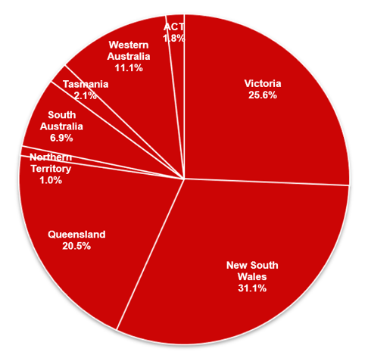  % figures have been rounded
National Principles |  | The Victorian Local Government Grants Commission is required to make recommendations for the allocation of financial assistance grants to councils in accordance with a set of nationally agreed principles. There are currently six principles that apply to the allocation of general purpose grants.

National Principles

The Commonwealth Local Government (Financial Assistance) Act 1995 requires that the allocation of general purpose grants to local government bodies (councils) conforms with the relevant national distribution principles:

(i) Horizontal Equalisation | General purpose grants are to be allocated to councils, as far as practicable, on a full horizontal equalisation basis. This aims to ensure that each council is able to function, by reasonable effort, at a standard not lower than the average standard of other councils in the State/Territory.
(ii) Effort Neutrality | In allocating general purpose grants, an effort or policy neutral approach is to be used in assessing the expenditure requirements and revenue raising capacity of each council. This means as far as practicable, the policies of individual councils in terms of expenditure and revenue efforts will not affect the grant determination.
(iii) Minimum Grant | The minimum general purpose grant for a council is to be not less than the amount to which it would be entitled if 30 per cent of the total amount of general purpose grants were allocated on a per capita basis.
(iv) Other Grant Support | In allocating general purpose grants, other relevant grant support provided to local governing bodies to meet any of the expenditure needs assessed is to be taken into account.
(v) Aboriginal Peoples & Torres Strait Islanders | Financial assistance is to be allocated to councils in a way which recognises the needs of Aboriginal peoples and Torres Strait Islanders within their boundaries.
(vi) Council Amalgamation | Where two or more local governing bodies are amalgamated into a single body, the general purpose grant provided to the new body for each of the four years following amalgamation should be the total of the amounts that would have been provided to the former bodies in each of those years if they had remained separate entities.

 | Final Allocations 2025-26 |  | In July 2025, the Commonwealth Government provided the Victorian Local Government Grants Commission with an estimate of total general purpose grants for 2025-26 of $611.975 million. This formed the basis of the Commission’s recommended general purpose grant allocations to each council for 2025-26, which were announced in August 2025 and are detailed in Appendix 2A of this Report.  The final (or actual) amount to be allocated for 2025-26 was determined by the Commonwealth Government in July 2026, based on revised population growth and inflation estimates. The final allocation of general purpose grants is $613.812 million, an increase of $1.837 million compared with the earlier estimate.  Councils’ final allocations for 2025-26 are shown in Appendix 2B.
Estimated  Allocations  2026-27 |  |  |  | The national general purpose grants pool for 2026-27 is $2.507 billion. Victoria’s share of this estimated allocation is $642.906 million. This represents an increase of:  - $30.931 million (5.1%) compared to the estimated general purpose grants allocation for 2025-26, or  - $29.094 million (4.7%) compared to the final general purpose grants allocation for 2025-26.  Figure 4.2: General Purpose Grants - Victoria  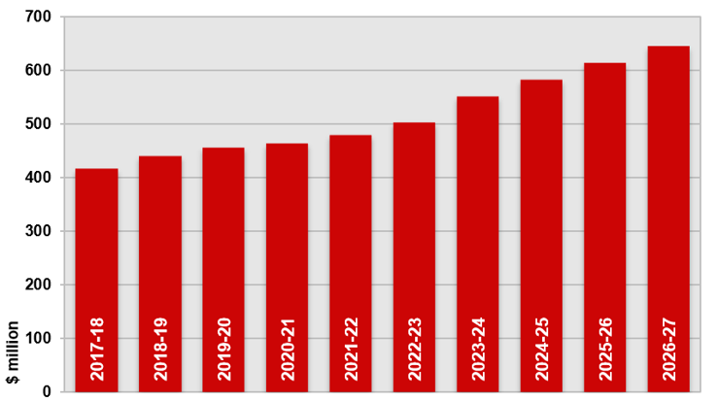  Estimated allocation 2026-27, actual allocation all other years
Methodology |  |  |  | The Victorian Local Government Grants Commission’s methodology for allocating general purpose grants takes into account each council’s assessed relative expenditure needs and relative capacity to raise revenue.  For each council, a raw grant is obtained which is calculated by subtracting the council’s standardised revenue from its standardised expenditure.  The available general purpose grants pool is then allocated in proportion to each council’s raw grant, taking into account the requirement in the Commonwealth legislation and associated national distribution principles to provide a minimum grant to each council. As outlined below, increases and decreases in general purpose grant outcomes have also been limited in movement which, in turn, affects the relationship between raw grants and actual grants.
In preparing its estimates of general purpose grants, the Commission gave careful consideration to specific issues raised by councils through written submissions and the individual and regional meetings held with councils throughout the year.

Specific grants, up to a maximum of $35,000 per declared event, are made to a small number of councils each year in the form of natural disaster assistance. These grants are drawn from the general purpose grants pool and so reduce the amount allocated on a formula basis.

Details of natural disaster assistance grants allocated for 2026-27 are provided on page 24.

Standardised Expenditure |  |  |  | Under the Commission’s general purpose grants methodology, standardised expenditure is calculated for each council on the basis of nine expenditure functions. Between them, these expenditure functions include all council recurrent expenditure.  The structure of the model ensures that the gross standardised expenditure for each function equals aggregate actual expenditure by councils, thus ensuring that the relative importance of each of the nine expenditure functions in the Commission’s model matches the pattern of actual council expenditure.  The total recurrent expenditure across all Victorian councils in 2025-26 equalled $12.179 billion. Under the Commission’s methodology, the gross standardised expenditure in the allocation model for 2026-27 therefore also equals $12.179 billion, with each of the nine expenditure functions assuming the same share of both actual expenditure and standardised expenditure.  Figure 4.3: Functional shares of recurrent expenditure 2025-26  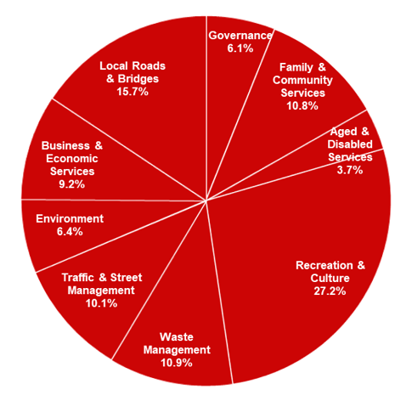
For each function, with the exception of Local Roads and Bridges, gross standardised expenditure is obtained by multiplying the relevant major cost driver by:
- the average Victorian council expenditure on that function, per unit of need; and
- a composite cost adjustor which takes account of factors that make service provision cost more or less for individual councils than the State average.

This can be demonstrated diagrammatically as follows:

Figure 4.4: Calculation of gross standardised expenditure
Gross Standardised Expenditure
(for each function)
Major Cost Driver
Gross Standardised Expenditure
Average Expenditure
per Unit
Cost Adjustors

The calculation of standardised expenditure for the Local Roads and Bridges expenditure function is described at the end of this section.

The major cost drivers and average expenditures per unit for each expenditure function, with the exception of Local Roads and Bridges, are shown below:
Expenditure Function | Major Cost Driver | Average Expend  Per Unit
Governance | Modified Population * | $ 94.40
Family & Community Services | Population | $ 173.91
Aged & Disabled Services | Pop >60 +Disability Pensioners +Carer’s Allowance Recipients | $ 216.68
Recreation & Culture | Modified Population * | $ 433.10
Waste Management | No. of Dwellings | $ 417.47
Traffic & Street Management | Modified Population * | $ 161.36
Environment | Modified Population * | $ 100.70
Business & Economic Services | Modified Population * | $ 144.13
* Modified Population - adjusted by two-thirds of the vacancy rate above the state average to take account of part-time residents.

For each expenditure function a major cost driver (or unit of need) is used, which is seen by the Commission to be the most significant determinant of a council’s expenditure need on a particular function.

Several different major cost drivers are used:

Major Cost Driver | Expenditure Functions
Population | - Family & Community Services
Modified Population*  (minimum population: 20,000) | - Governance
Modified Population *  (minimum population: 17,500) | - Environment  - Business & Economic Services
Modified Population *  (no minimum) | - Recreation and Culture  - Traffic & Street Management
Population Aged >60 + Recipients  of Disability Support Pensions  or Carer’s Allowance | - Aged & Disabled Services
Number of Dwellings | - Waste Management
* Modified Population - adjusted by two-thirds of the vacancy rate above the state average to take account of part-time residents.

 |  |  |  | For five expenditure functions, a modified population is used as the major cost driver to recognise the fixed costs associated with certain functional areas.
The major cost drivers used in assessing relative expenditure needs for these functions take account of high rates of vacant dwellings at the time the census is taken. Councils with a vacancy rate above the State average are assumed to have a population higher than the census-based estimate as a result of their part-time resident population:
- For the Governance expenditure function, actual populations are adjusted upwards to reflect two-thirds of the “excess” vacant dwellings on census night and councils with a population of less than 25,000 are deemed to have a population of 25,000. The population for any individual council is capped at 300,000 for this expenditure function.
- For the Recreation & Culture and Traffic & Street Management functions actual populations are adjusted upwards to reflect two-thirds of the “excess” vacant dwellings on census night.
- For the Environment and Business & Economic Services functions actual populations are adjusted upwards to reflect two-thirds of the “excess” vacant dwellings on census night. Councils with a population of less than 17,500 are deemed to have a base population of 17,500.

Cost Adjustors |  |  |  | Cost adjustors are measures designed to reflect differences between councils and allow the Commission to take account of the particular characteristics of individual councils which impact on the cost of service provision on a comparable basis. A number of cost adjustors are used in various combinations against each expenditure function.  Each cost adjustor has been based around a State weighted average of 1.00 with a ratio of 1:2 between the minimum and maximum values, to ensure that the relative importance of each expenditure function in the model is maintained.
The 12 cost adjustors used in the calculation of the 2026-27 general purpose grants are:

Aged Pensioners | Population Growth
Economies of Scale | Population less than 6 Years
Environmental Risk (Fire & Flood) | Regional Services
Indigenous Population | Remoteness
Language | Socio-Economic
Population Dispersion | Tourism

Further information on each cost adjustor is contained at the end of this section on page 25.

Because some factors represented by cost adjustors impact more on costs than others, different weightings have been used for the cost adjustors applied to each expenditure function.

The cost adjustors and weightings applied to each expenditure function in the calculation of the 2026-27 general purpose grants are shown in Figure 4.5.

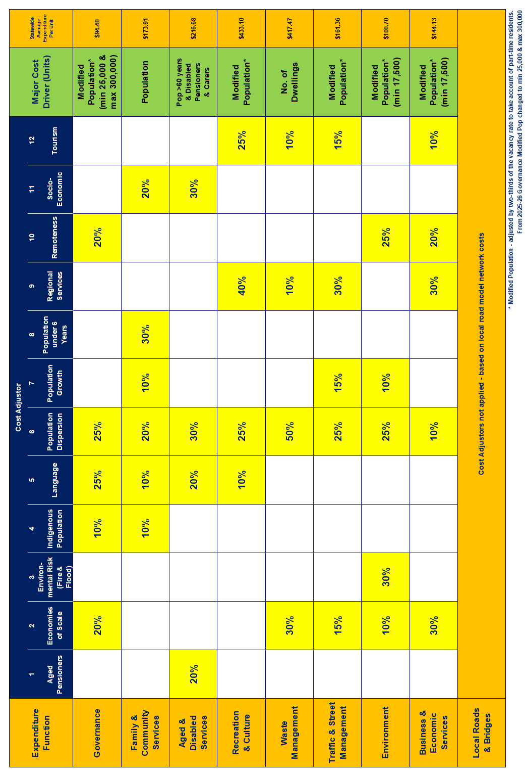 |  |  |  | Figure 4.5: Application of cost adjustors: 2026-27 allocations
Treatment of  Other Grants |  |  |  | Net standardised expenditure has been obtained for each function by subtracting standardised grant support (calculated on an average per unit basis) from gross standardised expenditure. This ensures that other grant support is treated on an “inclusion” basis.  Average grant revenue on a per unit basis (based on actual grants received by local government in 2025-26) is shown below:  Diagrammatically, the calculation of net standardised expenditure for each expenditure function is as shown in Figure 4.6:  Figure 4.6: Calculation of net standardised expenditure  Net Standardised Expenditure  (for each function)  Less  Major  Cost Driver  Major  Cost Driver  Gross Standardised Expenditure  Equals  Cost Adjustors  Average Grant Revenue per Unit  Average Expenditure per Unit  Standardised Grant  Revenue  Net Standardised Expenditure
  Function | Major Cost Driver | Average  Grants  Per Unit
  Governance | Modified Population | $ 2.79
  Family & Community Services | Population | $ 55.81
  Aged & Disabled Services | Pop > 60 + Disability Pensioners + Carer’s Allowance Recipients | $ 93.98
  Recreation & Culture | Modified Population | $ 5.23
  Waste Management | No. of Dwellings | $ 0.24
  Traffic & Street Management | Modified Population | $ 4.44
  Environment | Modified Population | $ 1.41
  Business & Economic Services | Modified Population | $ 0.89
Standardised expenditure for the Local Roads and Bridges expenditure function within the general purpose grants model is based on the grant outcomes for each council under the Commission’s local roads grants model. As outlined in Section 5, this incorporates a number of cost modifiers (similar to cost adjustors) to take account of differences between councils.

Net standardised expenditure for this function for each council is calculated by subtracting other grant support (based on actual identified local roads grants and a proportion of Roads to Recovery grants) from gross standardised expenditure.

The total standardised expenditure for each council is the sum of the standardised expenditure calculated for each of the nine expenditure functions.

Standardised  Revenue |  |  |  | A council’s standardised revenue is intended to reflect its capacity to raise revenue from its community.  Relative capacity to raise rate revenue, or standardised rate revenue, is calculated for each council by multiplying its valuation base (on a capital improved value basis) by the average rate across all Victorian councils. The payments in lieu of rates received by some councils for major facilities such as power generating plants and airports have been added to their standardised revenue to ensure that all councils are treated on an equitable basis.  Rate revenue raising capacity is calculated separately for each of the three major property classes (residential, commercial/industrial/other and farm), with data averaged over a three-year period.  The derivation of the average rates for each of the property classes is shown below:  The Commission constrains increases in each council’s assessed revenue capacity to improve stability in grant outcomes. The constraint for each council has been set at the statewide average increase in standardised revenue adjusted by the council’s own rate of population growth to reflect growth in the property base.  A council’s relative capacity to raise revenue from user fees and charges, or standardised fees and charges revenue, also forms part of the calculation of standardised revenue.  For each council, for each of the nine functional areas, the relevant driver (such as population) is multiplied by the adjusted State median revenue from user fees and charges (adjusted to remove the skewing effect of large outliers in the data). For some functions, this is then modified by a series of “revenue adjustors” to take account of differences between municipalities in their capacity to generate fees and charges, due to their characteristics.  The actual revenue from user fees and charges from the three years to June 2025 has been used as the basis for calculating standardised fees and charges revenue for the recommended allocations for  2026-27. These amounts are shown below, along with the revenue adjustors applied:
  Category | Total Average  Valuations | Total Rate Revenue | Average  Rate
  Residential | $ 2,536.395 b | $ 5.839 b | $ 0.00230
  Commercial/  Industrial/Other | $ 423.479 b | $ 1.198 b | $ 0.00283
  Farm | $ 186.974 b | $ 0.383 b | $ 0.00205
Expenditure  Function | Major Driver (Units) | Standard Fees & Charges Per Unit | Revenue Adjustors
Governance | Population | $ 21.02 | Nil
Family &  Community Services | Population | $ 6.26 | Socio-Economic
Aged &  Disabled Services | Pop. > 60  +Disability  +Carer’s Allowance | $ 10.49 | Household Income
Recreation & Culture | Population | $ 24.33 | Nil
Waste Management | No. Dwellings | $ 39.39 | Nil
Traffic & Street Management | Population | $ 6.58 | Valuations  (% Commercial)
Environment | Population | $ 1.25 | Nil
Business &  Economic Services | Population | $ 36.51 | Tourism + Value of Development
Local Roads  & Bridges | Population | $ 2.35 | Nil

The assessed capacity to generate user fees and charges for each council is added to its standardised rate revenue to produce total standardised revenue.

Further information about the revenue adjustors used in assessing standardised fees and charges revenue is contained at the end of this section on page 26.
Data and Methodology Changes |  |  |  | In preparing its recommendations for general purpose grants for  2026-27, the Commission gave consideration to issues raised by councils through written submissions and the individual and statewide meetings held with councils throughout the year.  All data used by the Commission in allocating general purpose grants has been updated where possible. Major inputs for the 2026-27 allocation include Australian Bureau of Statistics’ population estimates, valuations data and the most recent information on council expenditure and revenue.  The Commission made two changes to its allocation methodology.  - Changes were made to the data used to construct the Environmental Risk cost adjustor. This is used to reflect relative risk from natural disaster events, including bushfire and floods. For the 2026-27 allocation, the Department of Transport and Planning (DTP) Spatial Services provided updated datasets based on rateable properties subject to bushfire management overlays (which reflect properties with the potential to be affected by extreme bushfires) and flood extent data.  - Following devastating bushfires in Victoria in January 2026, the Commission made the decision to make an adjustment to the valuation base for the 12 councils reporting a loss of more than 10 properties each – Colac Otway, Corangamite, Golden Plains, Horsham, Mansfield, Mitchell, Moira, Mount Alexander, Murrindindi, Pyrenees, Strathbogie and Towong. In line with previous practice following major natural disaster events, the Commission has made an adjustment equivalent to 50% of the estimated capital improved valuation of impacted properties. This reduces the assessed revenue raising capacity of those councils and reflects their immediate loss of rate income following the fires.
Minimum Grants |  |  |  | The available general purpose grants pool for Victorian councils represents, on average, $90.89 per head of population (using ABS population estimates as at 30 June 2025). The minimum grant national distribution principle requires that no council may receive a general purpose grant that is less than 30% of the per capita average  (or $27.27 for 2026-27).  Without the application of this principle, general purpose grants for  2026-27 for 17 councils – Banyule, Bayside, Boroondara, Darebin, Glen Eira, Hobsons Bay, Kingston, Manningham, Melbourne, Monash, Moreland, Mornington Peninsula, Moonee Valley, Port Phillip, Stonnington, Whitehorse and Yarra - would have been below the equivalent of $27.27 per capita. The minimum grant principle has resulted in the general purpose grants to these councils being increased to that level.
Limits on Grant Movements |  |  |  | The Commission applied the following limits to movements in the general purpose grant outcomes for 2026-27:  - no limits were applied to councils assessed as being at the minimum grant level;  - grant increases were limited to no more than 10.0%; and  - grants increased for all councils by a minimum of 2.0%.
Estimated Allocations  2026-27 |  |  |  | The general purpose grant allocations for each Victorian council for 2026-27 are shown in Appendix 2A.  A summary of the changes in general purpose grants from 2025-26 to 2026-27 is shown below:
  Change in General Purpose Grant | No. of Councils
  Limit set at no more than 10% | 3
  Increase from 5 to 10% | 33
  Increase from 2 to 5% | 42
  Limit set at minimum 2% | 1
   | 79
Comparative  Grant Outcomes  2026-27 |  |  |  | The largest general purpose grant allocations for 2026-27 are for Melton City Council ($27.125 million), Wyndham City Council ($26.905 million), Casey City Council ($26.803 million) and Greater Geelong City Council ($25.907 million).  The smallest grant has been provided to the Borough of Queenscliffe ($0.517 million).  On a per capita basis, the largest general purpose grant has been allocated to West Wimmera Shire Council, where the grant allocation of $4.980 million represents $1,271.97 per head of population.  This compares to the outcome for the 17 councils receiving a minimum general purpose grant where the grant represents $27.27 per head of population.  A comparison of general purpose grant outcomes on a per capita basis is illustrated in Figure 4.7:
Figure 4.7: 2026-27 General Purpose Grants (per capita)

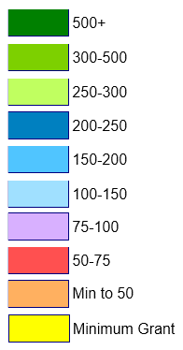
Natural Disaster Assistance |  |  |  | As outlined on page 15 of this report, the Commission provides funds from the general purpose grants pool to councils which have incurred expenditure resulting from natural disasters. Grants of up to $35,000 per council per eligible event are provided to assist with repairs and restoration work.  For 2026-27, a total of $777,816 has been allocated to 17 councils in relation to 28 events as follows:  2026-27 Natural Disaster Assistance Grants
  Baw Baw (S) | Eastern Vic Storms & Floods | $ 46,124
  Cardinia (S) | Victorian Storms (2) | $ 55,788
  Colac Otway (S) | Victorian Storms (x2) & Floods | $ 105,000
  East Gippsland (S) | Floods | $ 22,475
  Golden Plains (S) | Victorian Floods | $ 7,031
  Greater Bendigo (C) | Floods & Storms | $ 35,000
  Hepburn (S) | Vic Floods & Storms | $ 24,219
  Indigo (S) | Vic Floods & Storms | $ 35,000
  Mitchell (S) | Floods & Storms | $ 35,000
  Murrindindi (S) | Floods & Storms | $ 18,203
  Nillumbik (S) | Floods & Storms | $ 35,000
  Northern Grampians (S) | Floods & Storms | $ 35,000
  Pyrenees (S) | Bushfires and Storms (2) | $ 52,930
  South Gippsland (S) | Storms & Floods (x5) | $ 110,676
  Warrnambool (C) | Victorian Storms | $ 35,000
  Wellington (S) | Earthquake | $ 35,000
  Yarra Ranges (S) | Floods & Storms (x3) | $ 90,370
  17 | 28 | $ 777,816

Allocation of General Purpose Grants
Cost Adjustors
A set of cost adjustors is used in the Victorian Local Government Grants Commission’s formula for allocating general purpose grants to Victorian councils. These are designed to reflect differences between councils and take account of factors that make service provision cost more or less for individual councils than the State average.
Individual cost adjustment index values are calculated for each of the cost adjustors for each council. These are shown in Appendix 4D.
The 12 cost adjustors used by the Commission for the 2026-27 allocations are listed below.
Data sources for these cost adjustors are detailed in Appendix 4L.
Aged Pensioners | Recognises that councils with high numbers of aged pensioners, relative to the number of people aged over 60 years, are likely to have additional expenditure requirements.
Economies of Scale | Recognises the economies of scale inherent in providing some local government services to larger populations.
Environmental Risk (Fire & Flood) | Recognises that councils face differing levels of risk from floods and bushfires leading to varying impacts on council expenditure.
Indigenous Population | Recognises the impact on council expenditure of providing services to people of Aboriginal or Torres Strait Islander descent.
Language | Recognises the impact on council expenditure of providing services to residents, particularly newly arrived migrants, with a low level of proficiency in English.
Population Dispersion | Recognises the impact on council expenditure of having to provide infrastructure and services to more than one population centre.
Population Growth | Recognises that areas of higher population growth require relatively greater council effort in providing some services.
Population <6 Years | Recognises the impact on council expenditure of providing services to children less than 6 years of age.
Regional Services | Recognises that some municipalities provide a range of services to a larger than average catchment area, increasing the demand on some council services.
Remoteness | Recognises the impact on council expenditure caused by remoteness from major service centres.
Socio-Economic | Recognises that residents of areas of relative socio-economic disadvantage are likely to make a greater call on certain council services.
Tourism | Recognises that councils in areas attracting significant numbers of tourists have additional expenditure requirements.

Allocation of General Purpose Grants
Revenue Adjustors
A set of revenue adjustors is used in the Victorian Local Government Grants Commission’s formula for allocating general purpose grants to Victorian councils. These are designed to reflect differences between councils and take account of factors that impact on a council’s relative capacity to raise revenue from user fees and charges.
Individual revenue adjustment index values are calculated for each of the revenue adjustors for each council. These are shown in Appendix 4H.
The five revenue adjustors used by the Commission for the 2026-27 allocations are listed below.
Data sources for these revenue adjustors are detailed in Appendix 4L.

Household Income | Recognises the impact that household income has on the level of fees and charges that a council can raise.
Socio-Economic | Recognises that residents of areas of relative socio-economic disadvantage are likely to have a lower capacity to pay fees and charges than residents of areas of relative socio-economic advantage.
Tourism | Recognises the impact that tourism has on the level of fees and charges that a council can raise, particularly in relation to tourist facilities.
Value of Development | Recognises that municipalities that have a high value of development, as represented by building approvals, have a greater capacity to raise fees and charges, particularly in relation to planning and building services.
Valuations (Commercial) | Recognises that municipalities that have a high proportion of commercial activity have a greater capacity to raise fees and charges, particularly in relation to parking fees and fines.

5. Local Roads Grants

This section provides details the allocation of local roads grants to Victorian councils for 2026-27. The recommendations of the Victorian Local Government Grants Commission for the allocation of these funds were approved by the Federal Assistant Minister for Local Government in August 2025.

Background |  | Local roads grants are the second of the two components of the financial assistance grants provided by the Commonwealth Government to local government. Although local roads grants are allocated on the basis of the relative needs of each council for roads expenditure, the Local Government (Financial Assistance) Act 1995 provides that the grants are untied.  Victoria receives a fixed proportion of 20.6% of the total funds made available each year by the Commonwealth Government for this purpose.  Figure 5.1: Share of Local Roads Grants  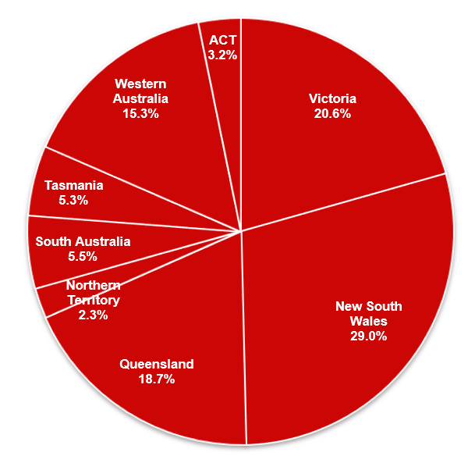  % figures have been rounded
National Principles |  | The Victorian Local Government Grants Commission is required to make recommendations for the allocation of financial assistance grants to councils in accordance with a set of nationally agreed principles. These currently require that local roads grants be ‘allocated to councils as far as practicable on the basis of the relative needs of each council for roads expenditure and to preserve its road assets.’
Final Allocations 2025-26 |  | In July 2025 the Commonwealth Government provided the Victorian Local Government Grants Commission with an estimate of total local roads grants for 2025-26 of $216.146 million. This formed the basis of the Commission’s recommended local roads allocation to each council for 2025-26, which were announced in August 2025 and are shown in Appendix 2A of the Commission’s 2025-26 Annual Report.  The Commonwealth Department of Infrastructure, Transport, Regional Development, Communications and the Arts advised the Commission in July 2026 of the final (or actual) amount to be allocated for 2025-26.  The final allocation of total local roads grants is $217.325 million, an increase of $1.179 million compared with the earlier estimate.  Councils’ final allocations for 2025-26 are shown in Appendix 2B.
Estimated Allocations  2026-27 |  | The estimated national local roads grants pool for 2026-27 is $1.113 billion. Victoria’s share of this estimated allocation is  $229.381 million. This represents an increase of $11.052 million or 5.1% compared with the estimated allocation for 2025-26.  Figure 5.2: Local Roads Grants - Victoria  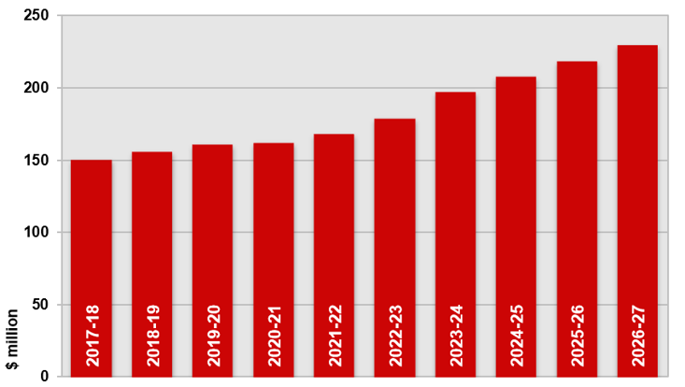  Estimated allocation 2026-27, actual allocation all other years.
Methodology |  | The Commission’s formula for allocating local roads grants is based on each council’s road length (for all surface types) and traffic volumes, using average annual preservation costs for given traffic volume ranges.  The methodology also includes a series of cost modifiers for freight loading, climate, materials, sub-grade conditions and strategic routes and takes account of the deck area of bridges on local roads.  This formula is designed to reflect the relative needs of Victorian councils in relation to local roads grants in accordance with the national principle relating to the allocation of local roads grants.  In 2024, Commission signalled its intention to councils to transition from the current allocation formula, which is based on traffic volumes carried on a local road as reported by councils, to a formula based on road-purpose hierarchy data as captured on Vicmap. This will enable the Commission and other Vicmap users, including emergency services, to access local roads data on a statewide basis.  To advance this work, the Commission has again allocated 1% of the local roads grants pool for 2026-27 to support councils in collecting and reporting road purpose hierarchy data. The allocation has been made on the basis of a flat amount of $10,000 per council, with the remainder distributed in proportion to the total length of local roads in each council.  The balance of the funding pool for 2026-27 has been allocated in line with the Commission’s current formula.
Road Length & Traffic Volume Data |  | The recommended allocation of local roads grants for 2026-27 was based on road length and traffic volume data reported by all councils for the 12 months to June 2025.  Similar to previous years, councils were asked to categorise their local road networks according to nine broad traffic volume ranges  – four for urban roads and five for rural roads.  Victorian councils reported a total of 133,861 kilometres of local roads as at 30 June 2025, a decrease of 369 kilometres, or 0.3% compared to the length reported 12 months earlier.  Where significant changes were made to the data previously provided, councils were asked to verify those data changes and, in some instances, provide additional supporting documentation.  Variations were as follows:  Road lengths reported by each council for each traffic volume range as at June 2024 are detailed in Appendix 5A.
  Change in Length of Local Roads | No. of Councils
  Increase of 1.0% to 5.0% | 12
  Increase of up to 1.0% | 26
  No change | 25
  Decreases of up to -1.0% | 12
  Decreases of 1.0% to 5.0% | 4
   | 79
Asset  Preservation  Costs |  | Average annual preservation costs for each traffic volume range are used in the allocation model to reflect the cost of local road maintenance and renewal.  The asset preservation costs were altered for the 2018-19 allocations to better reflect councils’ aggregate actual expenditure on road maintenance. However, this change had no impact on the distribution of local roads grants.  The asset preservation costs used in the 2026-27 allocations were as follows:
  Local Road Type | Daily Traffic  Volume Range | Annual Asset  Preservation Cost  $/km
  Urban | < 500 | $ 8,640
   | 500 - <1000 | $ 11,760
   | 1000 - <5000 | $ 15,840
   | 5000 + | $ 25,680
  Rural | Natural Surface | $ 840
   | < 100 | $ 6,000
   | 100 - <500 | $ 12,480
   | 500 - < 1,000 | $ 13,920
   | 1,000 + | $ 15,840
  Timber Bridge |  | $ 240 / sq m
  Concrete Bridge |  | $ 144 / sq m
Cost Modifiers |  | The allocation model uses a series of five cost modifiers to reflect differences in circumstances between councils in relation to:  - the relative volume of freight carried on local roads in each council  - climate  - the availability of road-making materials  - sub-grade conditions  - strategic routes  Cost modifiers are applied to the average annual preservation costs for each traffic volume range for each council to reflect the level of need of the council relative to others. Relatively high cost modifiers add to the network cost calculated for each council and so increase its local roads grant outcome.  Additional information on the cost modifiers used in the local roads allocation model is provided at the end of this section on page 31.  No changes were made to the cost modifiers for the recommended  2026-27 allocations.
Grant Calculation |  | The Commission calculates a total network cost for each council’s local roads. This represents the relative annual costs faced by the council in maintaining its local road and bridge networks, based on average annual preservation costs and taking account of local conditions, using cost modifiers.  The network cost is calculated using traffic volume data for each council, standard asset preservation costs for each traffic volume range and cost modifiers for freight carriage, climate, materials availability, sub-grade conditions and strategic route lengths. The deck area of bridges on local roads is included in the network cost at a rate of $144 per square metre for concrete bridges and $240 per square metre for timber bridges.  Mathematically, the calculation of the network cost for a single traffic volume range for a council can be illustrated as follows:  Figure 5.3: Calculation of network cost  X X =  Network  Cost  Length of local roads in category  Asset preservation cost for category  Overall  cost  modifier *  * Overall cost modifier is calculated by multiplying the cost modifier for freight, climate, materials, reactive sub-grades and strategic routes.  The actual local roads grants are then determined by applying the available funds in proportion to each council’s calculated network cost.
Limits on Grants Movements |  | The Commission applied the following limits to movements in the local roads grant outcomes for 2026-27:  - grant increases were limited to no more than 10.0%; and  - grants have increased for all councils by a minimum of 2.0%.
Estimated Allocations  2026-27 |  | The estimated local roads grant allocation for each Victorian council for 2026-27 is shown in Appendix 2A.  In general, where a significant change has occurred in a council’s local roads grant for 2026-27, this is due to significant changes in local roads data supplied by the council to the Commission.  A summary of the changes in estimated local roads grants from 2025-26 to 2026-27 is shown below:
  Change in Local Roads Grants | No. of Councils
  Limit set at no more than 10% | 4
  Ranging from 5-10% | 21
  Ranging from 2-5% | 50
  Limit set at minimum 2% | 4
   | 79
Comparative  Grant Outcomes  2026-27 |  | The largest local roads grants for 2026-27 have been allocated to Wellington Shire Council ($6.755 million) and East Gippsland Shire Council ($6.661 million).  The smallest grant has been allocated to the Borough of Queenscliffe ($0.083 million).

Allocation of Local Roads Grants
Cost Modifiers
A series of five cost modifiers is used in the Victorian Local Government Grants Commission’s formula for allocating local roads grants to Victorian councils. These are designed to take account of differences between councils that may make local road maintenance more or less costly than the State average, which is reflected in average annual preservation costs.
Individual cost factors are calculated for each of the five cost modifiers for each council. Their application to the average annual preservation costs is shown in Appendix 5C.
The five cost modifiers used by the Commission in allocating local roads grants to councils for 2026-27 were:
Freight | The freight cost modifier recognises that local roads in some municipalities carry relatively high volumes of heavy vehicles compared to others, which impacts on the cost of asset preservation. A freight loading ratio has been calculated for each municipality, based on the level of employment in freight-intensive industries within that municipality. The cost modifier index infers that a higher level of employment in such industries will see relatively higher levels of freight carriage on their local roads network, leading to more rapid road surface deterioration and relatively higher road maintenance costs.
Climate | The climate cost modifier recognises that certain climatic conditions have an adverse impact on road durability and increase the costs to affected councils of asset preservation. The climate index identifies the length of urban and rural roads that fall within the five climatic zones utilised by Standards Australia to produce an average climate rating for both rural and urban roads within each municipality. These ratings are then spread across index ranges, the larger being for rural roads to reflect the relatively greater influence of climate on such surfaces.
Materials | The cost of maintaining local roads can be impacted by the local availability of suitable pavement materials. The materials availability index has identified the distance between the nearest quarry location containing high quality road making material and the council headquarters. All metropolitan councils have had their indexes set at the minimum value, reflecting the availability of materials from a variety of sources.
Sub-grades | The performance life of road pavements is affected by seasonal swelling and shrinkage of the sub-grade, which accelerates the deterioration of the pavement and adds to asset preservation costs. In Victoria, this is a particular issue in areas with expansive clay sub-grades, which occur predominantly in the western suburbs of Melbourne and western Victoria. The Commission has identified the total length of urban and rural roads in each of the eight sub-grade categories utilised by Standards Australia and has constructed an index reflecting the relative road maintenance costs associated with having lengths of road built on relatively reactive soils.
Strategic Routes | The strategic route cost modifier recognises that certain local roads must be maintained to a higher standard than would normally be the case because of certain characteristics or functions they perform. For all road categories, local roads that are tram or bus routes, including school bus routes, are considered to be strategic routes. In addition, rural local roads that carry less than 100 vehicles a day, but carry at least 10 trucks, or carry less than 100 but more than 50 vehicles per day and are in steep terrain or irrigated areas, are considered strategic routes requiring higher annual levels of expenditure. Details on strategic routes are provided to the Commission by individual councils as part of their annual information returns.

6. Trends in Outcomes

This section provides a summary of movements in financial assistance grants over time for Victorian councils. This information is provided to emphasise the importance of financial assistance grants to Victorian councils and to assist councils and other stakeholders in understanding how the allocation of these funds has altered over time.

Several of the charts in this section place councils in different broad groupings (interface councils, small rural councils, etc). This categorisation is only for the purpose of summarising the results – it is not used in the grant allocation process and has no influence on grant outcomes.

Grants as a proportion of recurrent revenue |  | Figure 6.1 shows the relative importance of financial assistance grants to all Victorian councils, and highlights that these grants represent a higher proportion of the recurrent revenue of rural councils compared to metropolitan councils.  In the 2025-26 financial year, financial assistance grants represented, on average, 6.3% of the recurrent revenue of Victorian councils. For most metropolitan councils, these grants comprised less than 5% of their recurrent revenue. However, for eight rural councils (Loddon, Towong, West Wimmera, Buloke, Pyrenees, Ararat, Hindmarsh, and Yarriambiack), more than 25% of their revenue was derived from financial assistance grants.  Figure 6.1: Financial assistance grants as % of recurrent revenue  Financial assistance grants  as % of recurrent revenue  Victoria Average: 6.2%  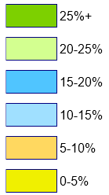  Data for 2024-25 financial year.
Total grants  over time |  | Figure 6.2 shows the change over time in the total pool of financial assistance grants allocated by the Commonwealth Government to Victorian councils.  The total funding pool increased steadily from $394.9 million in 2005-06 to $538.2 million in 2013-14, an average of 4.5% per annum. This reflected strong growth in Australia’s population across that period, and an increase in Victoria’s share of the national population. However, a three-year “pause” on indexation imposed by the Commonwealth Government meant that grant levels were then largely unchanged for three years through to 2016-17.  The resumption of indexation in 2017-18 meant that growth then resumed through to 2026-27 and has averaged 3.8% per annum over that time.  The 2026-27 Federal Budget estimated that the aggregate pool of funds for Victorian councils will increase by 3.9% in 2027-28, 4.1% in 2028-29 and 4.1% in 2029-30.  Figure 6.2: Total financial assistance grants to Victorian councils  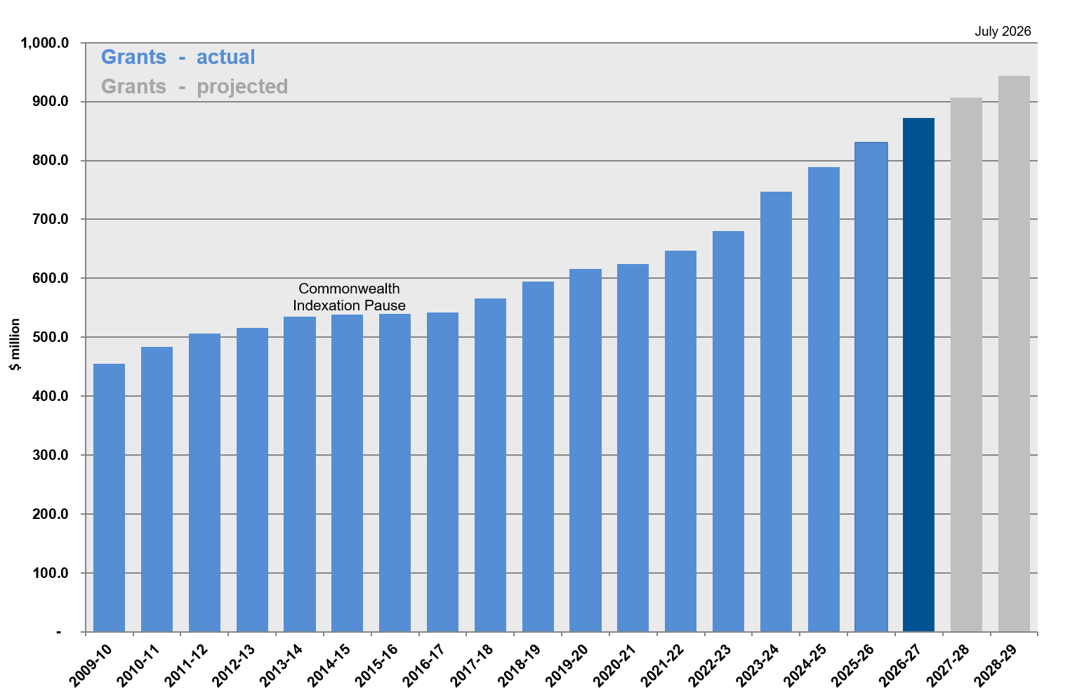
Total grants per capita by council group |  | Figure 6.3 shows the movement in total financial assistance grants on a per capita basis to each council group since 2017-18.  This shows that average grants per capita have increased strongly for both the small rural and large rural groups of councils and, to a lesser extent, regional cities. In contrast, average grants per capita have remained relatively constant across that period for the interface and metropolitan-other groups.  Figure 6.3: Total financial assistance grants per capita by council group  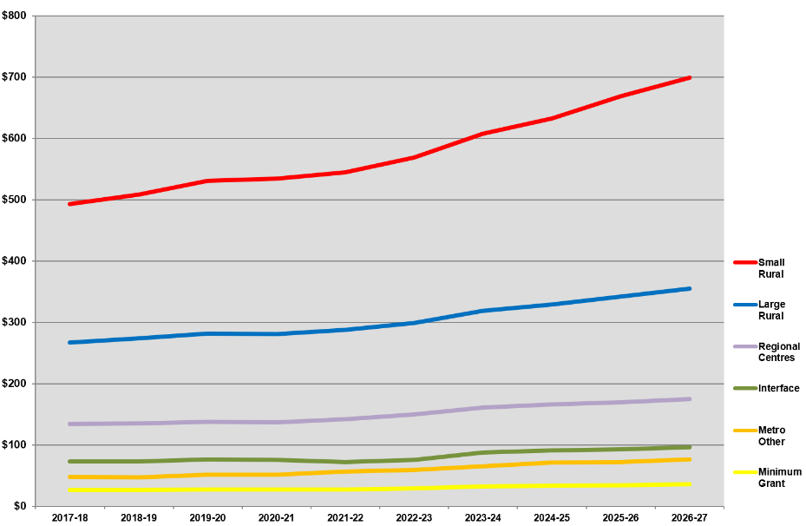
Average increases in grants by council group |  | Figure 6.4 shows the overall average rate of increase in financial assistance grants for each of the council groups in 2026-27.  Compared to a state average increase of 5.1%, aggregate financial assistance grants to the inner metropolitan group of councils (those receiving the minimum general purpose grant) will increase by 5.0%, whereas grants for the metropolitan-other group will increase by 5.7% and those to the interface councils group will increase by 6.4%. This reflects above-average population growth in those areas. Grants to the regional cities group will increase by 4.0% on average, while grants to the large and small rural councils’ groups will both increase by 4.8% and 4.7% on average respectively.  Figure 6.4: Average increases in financial assistance grants  by council group: 2026-27  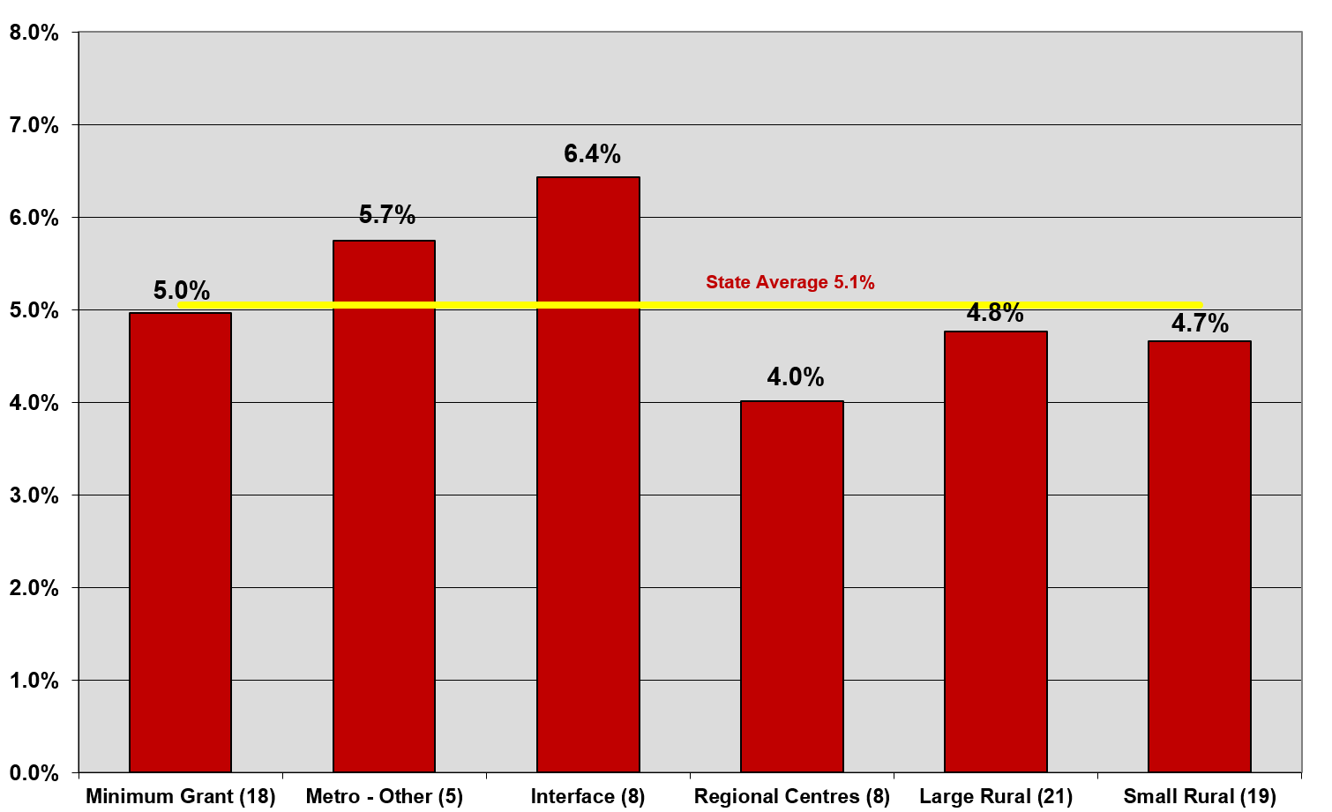
Share of grants pool by council group |  | Figure 6.5 shows the share of the Victorian financial assistance grants pool allocated to each council group in 2026-27 compared to that group’s share of Victorian population.  This shows that, while rural councils comprise 12.8% of Victoria’s population, they will receive 44.5% of the total financial assistance grants pool in 2026-27.  Figure 6.5: Share of financial assistance grants pool  by council group: 2026-27  

