Local Government in Victoria Report

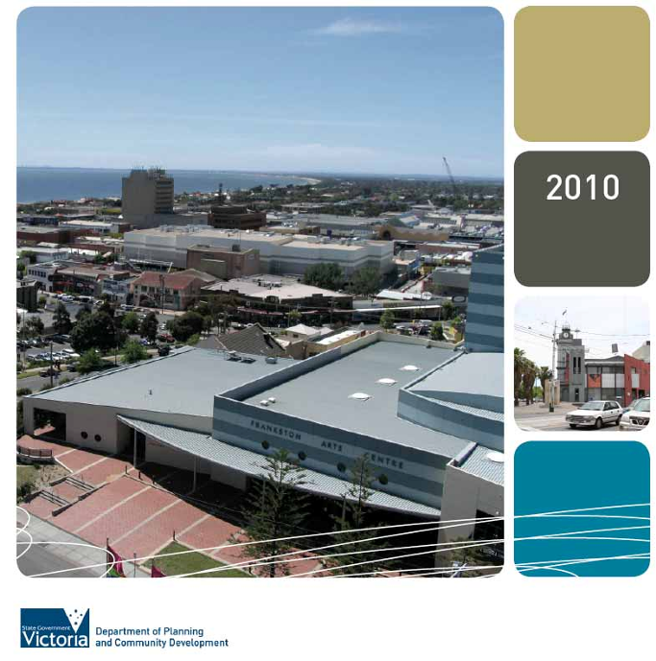
Map of Victorian local government areas

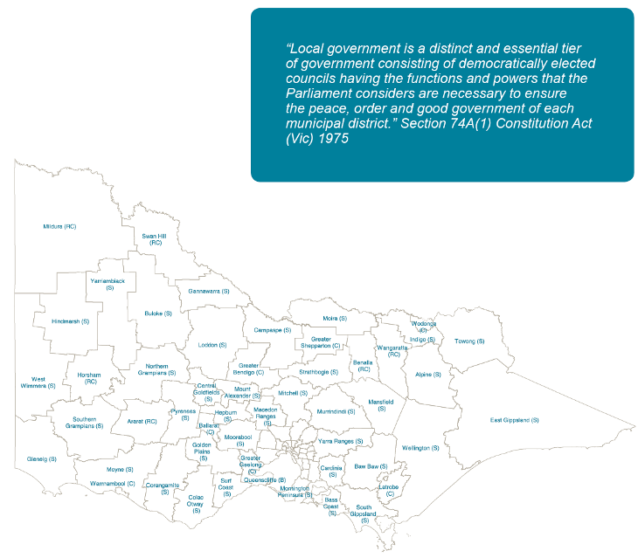

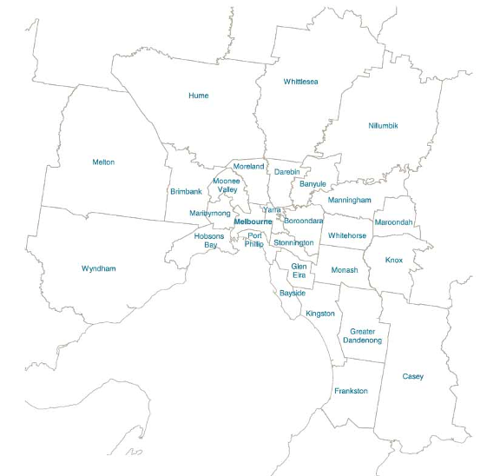
Measuring Performance

The Local Government in Victoria Report
is prepared annually by Local Government
Victoria to provide readers with a
snapshot of the local government sector’s performance and trends over time. The information included in this Report presents an overview of councils’ performance in the areas of finance, community satisfaction and asset management.

As with all levels of government, local councils are accountable to the communities they represent and serve. A key part of accountability is letting the community know how each council is
performing – and what they are doing with the community’s fees and charges.

Ten years ago, local government in
Victoria agreed on eleven key performance indicators (KPIs), concentrating on
finance, community satisfaction and asset management performance. Since 2002, each council has reported against these key performance indicators in its Annual Report.

This report discusses average performance for all councils and for five council groups (inner and outer metropolitan councils,
Local Government in Victoria Report 2010
rural cities and regional centres, large and small shire councils). In addition, the Local Government Victoria website provides detailed historical data for each council
across the eleven performance indicators.
Good data on performance helps councils communicate their achievements to the community. This report also includes two successful initiatives recognised in recent National Local Government Awards: the Pure Towong Energy Project and the Casey Fields leisure precinct.

Other data is also available for local government performance in Victoria. Each year, the Victorian Auditor General’s Office provides summary information on some
key financial measures – and some detail from these assessments is included in this Report.

Local Government Victoria, the peak local government bodies and other agencies
have been undertaking a range of initiatives in consultation with the sector which
will support councils in their financial, asset management and performance measurement work. These projects are
discussed in a later section of this report.

1

Pure Towong Energy Project: Measurable Energy Savings

The systems have the potential to generate
28,000kW of energy, resulting in a saving of 31.5 tonnes of
greenhouse emissions.
Towong Shire Council has encouraged the installation of solar power systems for both its own buildings and in the community more generally.

By June 2010, Towong Council had installed nine 2.1kW solar energy systems across a range of community owned buildings, including the Berringa Community Centre, the Corryong
Man from Snowy River Museum and
Dartmouth Hall. The systems have
the potential to generate 28,000kW of energy, resulting in a saving of 31.5 tonnes of greenhouse emissions.


Towong Shire Council also encouraged local home owners to install solar panels. Local project partners helped reduce expenses through the bulk- buying of solar panels and the negotiation of low interest loans. The project was taken up by 153 Towong households. The Towong area, with 0.1 per cent of Victoria’s population, now
produces almost 6 per cent of the state’s domestic renewable energy.

Towong is now moving to Stage 2
of the project, with $52,000 from the Victorian Sustainability Fund. The second phase of the project provides residents opportunities to install solar power and hot water systems and also include in-home energy audits and water harvesting technologies.

Pure Towong Energy won several awards in 2009. It received the National Local Government Award for excellence in a small council leading greenhouse action, and the Economic Development Australia Award for Environmental Economic innovation. At the state level, Pure Towong Energy won the Local Government Professionals award for excellence in a sustainability initiative.

2

Table of Contents

Measuring Performance | 1
Pure Towong Energy Project | 2
Community Views | 4
Financial Sustainability | 8
Casey Fields Development Project | 13
Council Expenditure | 14
Maintaining Community Assets | 18
Variations in Council Expenditure Patterns | 20
Revenue Patterns | 25
Key Revenue Measures | 29
Assisting Councils to Improve Performance | 31
Victorian Local Government Indicators | 34

3
Local Government in Victoria Report 2010
Community Views

4

Community Views

Since 1998, nearly all councils in Victoria have participated in annual resident satisfaction surveys. From 2002, three measures from these surveys have been used in the Key Performance Indicators: overall satisfaction with council performance, satisfaction with council advocacy and councils’ engagement with the community.

Trends in satisfaction ratings for all councils are shown in Chart 1.

The results in Chart 1 are based on annual surveys of some 350 people in each local government area. The scale uses a centre point of 60 – a result above this level indicates that the number of people happy (or very happy) with their council’s performance is greater than the number dissatisfied.

As with any survey of this size, there can be some minor movements up or down each year, and it can be difficult to immediately identify trends. The 2010 data confirms trends over the past three years, with slight falls in both overall satisfaction and for advocacy, albeit starting from above average ratings.
The ratings for engagement showed improvement in the early 2000s, and have been stable about the average rating for the last four years.

5
Local Government in Victoria Report 2010
A key point about these movements is that, like many other measures, they vary between councils. The average of the overall satisfaction rating with council performance peaked in 2007, and has since fallen by 1.4 points. However, it
still remains at an above average rating. Across the seventy eight councils taking part in the survey:

• seven councils had major falls in satisfaction, dropping by - 6 points or more;

• twelve fell by - 4 or -5 points;

• another twenty councils had marginal falls, by - 2 or - 3 points;

• twenty three councils saw little movement in their ratings, with
changes between - 1 and +1 point; and

• only sixteen councils enjoyed increased satisfaction, of 2 or more points.

The most important aspects of local government influencing community satisfaction were:

• Town planning, policy and approval;

• Economic development;

• Local roads and footpaths;

• Recreational facilities; and

• Appearance of public areas.

The overall satisfaction rating with council performance peaked
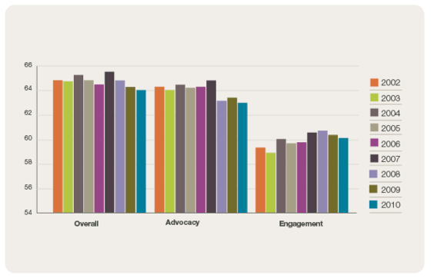

in 2007, and has since fallen by 1.4 points. However, it still remains at an above average
rating.
Chart 1: Satisfaction Ratings with Victorian councils 2002–2010

These patterns of variation occurred across all council groups, and in consequence there was little difference between the groups in the overall slight decline in satisfaction. The regional cities group had the largest fall in its overall average, by -2.6 points, while the small shires group had the smallest fall, down by -0.8 points.
Some influence on the satisfaction ratings was seen in the most recent council elections, which are held every four years in Victoria. The November
2008 Council elections across Victoria saw mixed fortunes for councillors seeking re-election. In some councils, all sitting councillors were re-elected:
in others half or more of the sitting
councillors were defeated.

6

Elections are always affected by a range of issues. One predictor of results in the 2008 elections came from recent changes in the overall levels of community satisfaction, as measured in annual surveys. At the two ends of the spectrum:

• Five councils saw drops in their satisfaction rating by -6 points or more between 2005 and 2008. In four of those councils, some 60 per
cent of councillors seeking re-election were defeated.

• Another five councils had increases in their satisfaction ratings between
2005 and 2008 of +5 points or more. In four of these, only 20 per cent
of councillors seeking re-election were defeated – and in the fifth, all councillors seeking re-election were
successful.
The influence of other factors can be seen in the results for 11 councils which had no change in their satisfaction ratings between 2005 and 2008. The rejection rate for councillors seeking reelection in these councils varied from nil (all re- elected) to 50 per cent. In these councils (and, indeed, in councils generally), there was some influence from the absolute level of satisfaction with the council. However, this influence was not a strong one.

The trends since 2007 suggest that many councils need to consider the factors behind declines in their satisfaction ratings.

7
Local Government in Victoria Report 2010

Financial Sustainability

8

Financial Sustainability

From the mid 2000s, many reports noted that councils across Australia were
facing financial challenges, especially
in funding community infrastructure. As well as documenting the physical need for infrastructure investment, the reports also recommended that councils should improve their information bases. Over the past four years, both the former national Local Government and Planning Ministers’ Council and the Australian Council of Local Government have encouraged councils to adopt national frameworks for asset management and financial planning.

The third meeting of the Australian Council of Local Government occurred in Canberra on 18 June 2010.1 The council, Australia’s largest gathering of mayors and shire presidents, agreed
with the national government on a range of measures. These included goals to:

• contribute to dialogue on issues of national significance that affect local government and local communities;

• encourage innovation and best practice in local government; and
• improve the provision of information and data to support the long term development of local government.

In 2010 most Victorian councils implemented projects funded through the Federal Government’s $1.1 billion Regional and Local Community Infrastructure Program. One of these projects is the Casey Fields leisure precinct, discussed later in this report.

Victorian councils are well placed to deliver on the national requirements, and have made substantial progress towards the agreed frameworks by the end of 2010. Indeed, both financial performance and asset management have improved considerably over the
past decade. The Auditor-General audits each council’s accounts each year.
Since 2003-04, the Auditor-General has reported the major trends noted in Chart
2.
Six years ago, councils were, on
average, just breaking even on their operating result. Almost half of the councils had operating deficits. As Chart
2 shows, by 2010, only 13 councils had underlying deficits, and the average operating result was a surplus of 5.0 per cent of revenues. Within this significant improving trend, there was some deterioration since 2009 (when only
six councils had deficits and the overall result was a surplus of 8.4 per cent).

1 See http://www.aclg.gov.au/index.aspx

9
Local Government in Victoria Report 2010

By 2010, only
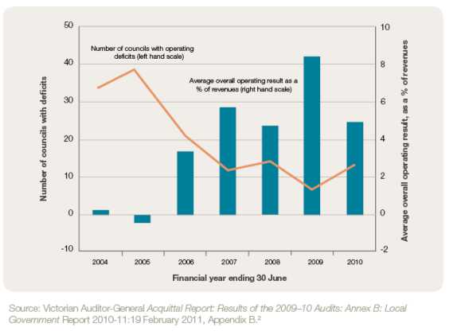

13 councils had underlying deficits, and the average
operating result was a surplus of 5.0 per cent of revenues.
Chart 2: Overall Operating Result

2 Note that the average operating result figures in this chart differ slightly from those reported by the
Auditor General in previous years (e.g. Auditor General Local Government: Results of the 2008-
09 Audits November 2008 p29). The reason is that this chart takes the average of the % results for each council, while the previous Auditor General figures took the total operating result for all councils, compared with total revenues for all councils.

10

As the Auditor General’s report explained3, this pattern was primarily due to a temporary change in the timing of grants. Following the disastrous bushfires of February 2009, the Commonwealth agreed to a State Government request to assist councils by bringing forward grant payments
from August to May 2009. As a consequence, councils received five grant payments in 2008–09, instead of the usual four payments, and grant payments formed 22 per cent of total
revenue that year. With a return to four grant payments in 2009–10, total grants decreased by $33.7 million and formed
20 per cent of total revenues.
Looking forward into 2010-11, the financial results will be adversely affected by two factors:

- As part of returning to the usual timing pattern for grants, the Federal Government currently proposes three grant payments in 2010-11, with the full four payments to be received in
2011-12.

- Vision Super, the Local Authorities Superannuation board, advised members in late 2010 that the Global Financial Crisis has resulted in an unfunded liability of $71 million as
at 31 December 2008 in the defined benefits fund. Councils have to recognise this liability in their 2010-11 accounts.

Despite such setbacks, the longer term trends show a strong improvement
in councils’ financial situations. The average underlying operating result is now 5 per cent of revenues, compared with a break-even result five years ago. The number of councils with operating deficits has dropped by two thirds, from just under 40 in 2004-05 and 2005-06 to
13 now.

3 Victorian Auditor-General Acquittal Report: Results of the 2009–10 Audits: Annex B: Local
Government Report 2010-11:19 February 2011, p14

11
Local Government in Victoria Report 2010

The major reason for this improvement in council financial performance has been large increases in rates over the past ten years. The median rate per assessment has increased from $705 in 2000-01 to
$1,283 in 2009-10 – an increase of 82 per cent in nine years, averaging 6.9 per cent each year. For comparison, the Consumer Price Index increased by 29 percent between June 2001 and June
2010 – an average of 2.9 per cent per
year.
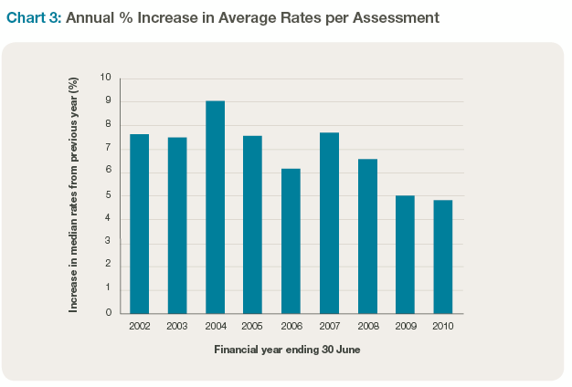

As Chart 3 shows, the annual rate of increase was highest in early years, and has diminished in recent years.

The improvements in overall financial position are only one of the outcomes from these increases in rates over the past ten years. Councils have also used their increasing income to fund both operating expenditure and capital projects.

The annual rate of increase was highest
in early years, and has diminished in recent years.

12

Casey Fields Development Project

The Casey Fields Development Project is an $11 million project to develop Casey’s premier sporting precinct. It received funding from the Federal Government’s Regional Local Community Infrastructure Program and the State Government’s Community Support Fund.

The project’s key feature is the development of a $6 million Regional Athletics Centre to support local
and senior athletic, school and Little Athletics programs. Completed in February 2011, the Centre includes a synthetic athletics track, almost 1,000 undercover spectator seats, lighting
for night competition and an extensive pavilion with multi-purpose room overlooking the main straight.

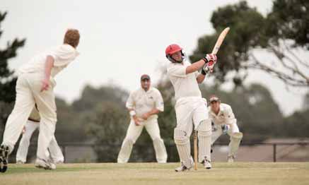

13
Local Government in Victoria Report 2010
The regional athletics centre will be home to both Little Athletics and senior athletic clubs. The Centre will also play host to major regional athletics events as well as a multitude of school athletic carnivals.

The Casey City Council opened a three hectare regional playground in December 2010 with a variety of
recreational features. Adventure options include a six metre high climbing net and rope bridge, an adventure hill featuring
a birds nest swing, climbing areas and large slide, and a large pirate ship
play structure. Visitors can also enjoy various walking paths around a lake. An irrigation system using Class A recycled water ensures the entire site remains lush and green year round.

The complex also contains the Shed, an undercover skate park catering for skate, BMX, in-line and scooters.

The Casey Fields Development Project won the Infrastructure Development Award in the 2010 National Local Government Awards.

The Casey Fields Development Project is an $11 million project to develop Casey’s premier sporting precinct.

Council Expenditure

14
Council Expenditure

The Key Indicators collected by councils and published in this report use two measures of council expenditure: operating expenditure and capital expenditure.
The data displayed in Chart 4 shows the growth in both council operating and capital expenditure since 2002. To provide easy comparison between
councils, these and other indicators are expressed per rateable property (or
‘assessment’4). The chart shows the
council median value across Victoria.5

Chart 4: Victorian Councils 2002–2010: Median Operating and Capital
Expenditures per Assessment

4 As discussed in Local Government in Victoria 2007, the comparison between councils changes somewhat if other comparators are used: for example, results per head of population rather than per assessment. No indicator can give the full picture, and council patterns differ across the state. The per assessment figures are used here as they have been agreed by the sector, and give the best overall basis for comparison.
Local Government in Victoria Report 2010
5 The median value is the midpoint of each group. For this analysis, it is a more accurate measure of ‘typical’ experience than a mean or average value, as the latter can be influenced more by
15 unusual movements in the figures for one or more councils.

Between 2002 and 2010, median council operating expenditure has grown by half, or by 5.1 per cent each year. Operating expenditure has grown the fastest
in large and small shires, with Inner Metropolitan and Regional Centres both seeing slightly slower growth over these years, of around 40 percent.
Capital expenditure (Capex) has recently grown faster than operating, a trend welcomed in the Auditor-General’s reports discussed earlier. Councils have responsibility for a range of community assets, including roads, drainage, parks and gardens and community buildings.
In recent years, councils have been placing an increased emphasis on these assets. From 2002, capital expenditure has almost doubled, from $377 to $699 per assessment. The figures for the different council groups are shown in
Chart 5.

Regional and rural councils have seen the strongest increase in capital expenditure.
Chart 5: Median Capital Expenditure per Assessment for Councils

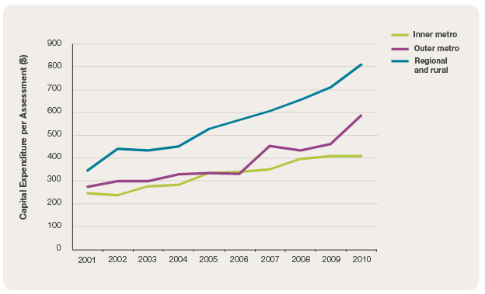
16

This graph shows the capital expenditure per assessment from 2001 to 2010 for
the groupings of councils (the three non- metropolitan groups are combined here as their median expenditures, and the trends, are similar):

• Regional and rural councils have seen the strongest increase in capital expenditure. From $350 per
assessment in 2000-01, expenditure doubled to $711 in 2009. A further strong increase occurred in the last year, encouraged by the Federal Government’s capital project funding, and the level is now 133 per cent
higher than in 2001.
• Outer metropolitan councils
also benefitted from the Federal Government funding in 2010. On top of good growth in the earlier years, expenditure per assessment is now just over double what it was in 2001.

• Inner metropolitan councils, as discussed later in this report, have the smallest road lengths per capita, and saw less funding from the Federal stimulus package. While these councils had comparatively
the smallest growth, it was still an impressive increase of two-thirds above the 2001 results.

17
Local Government in Victoria Report 2010

There has been good growth in renewal expenditure as a percentage of the desired level since
2005.
Maintaining Community Assets

As evidenced in Chart 5, councils have been strongly increasing their capital expenditure in recent years. Chart 6 compares this expenditure with council estimates of what is necessary to renew and maintain their assets. The Key Indicators measure this in two ways:

• expenditure on asset renewal – as a percentage of the desired expenditure considered necessary to sustain the assets; and

• expenditure on renewal together with maintenance – again as a percentage of the desired level of expenditure on renewal and maintenance.
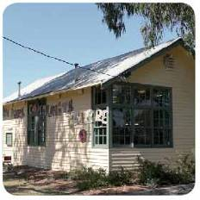

Chart 6: Victorian Councils 2002–2010: Renewal and Renewal plus
Maintenance as Proportions of Desired Levels

18
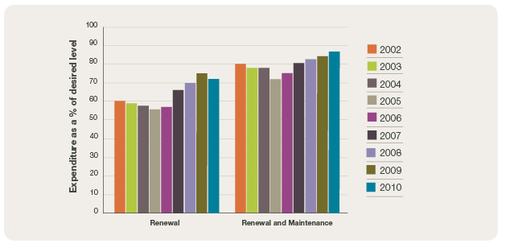

The results in Chart 6 do not show
the same strong growth as the capital expenditure figures – indeed, both these measures experienced declines in the ratios from 2002 to 2005. The key reason for these patterns is that
a council’s view of what is necessary to sustain assets changes as asset management information improves.
It can both increase as councils include additional assets or decrease as ways of sustaining assets improve.

Early this decade, councils put considerable effort into improving asset management information. The
information shown in Chart 6 indicates that this reassessment led to increases in estimates of the size of the renewal task. However, since 2005 both measures have seen strong increases, linked to the further expansion of capital
expenditure discussed above.
All five council groups experienced similar patterns to the above figures: a stable or slightly falling renewal figure between 2002 and 2005, and then good growth in expenditure as a percentage of the desired level after
2005. Comparing the groups, Outer Metropolitan councils have below average figures for both renewal and renewal plus maintenance. Many of these councils are growing quickly,
so more of their capital expenditure is focused on securing new assets rather than renewing older ones. In contrast, large and small Shires, which typically have little population growth, have fewer new projects and slightly above average figures for renewal expenditure.

19
Local Government in Victoria Report 2010

Variations in Council Expenditure Patterns

Victoria has 79 local councils which represent and serve very different communities. The considerable variations between councils within Victoria include6:

• land area, ranging from Queenscliffe
(8 sq km) to Mildura (22,000 sq km);

• road lengths, with Buloke in the north west having 5,330 kms for 7,078 people, while Port Phillip in inner Melbourne has 211 kms for 96,110 people;

• population size, ranging from 3,300 people (Queenscliffe) to 247,000 (Casey);

• population change, ranging from small declines in two rural shires to annual growth of 8% in the metropolitan fringes of Melton and Wyndham; and

• residents with poor English proficiency and recent arrivals in Australia:
virtually nil in many farming areas, but
15-17 per cent in Maribyrnong and Brimbank, and 25 per cent in Greater Dandenong.

These variations contribute to differing challenges for councils across the
state. In response, council expenditure patterns differ. Key features, which are reasonably stable from year to year, are shown in the following charts:

• The four inner Melbourne councils in Melbourne’s central business area, have larger than average numbers
of business ratepayers. The data in Chart 7a7 shows that these councils spend 34 per cent of their budgets on business services (such as building control, tourism and area promotion and markets) and traffic and street management.

• The other metropolitan councils (excluding the inner four) are dominated by residential areas and consequently have a focus on people services. The information found
in Chart 7b indicates 47 per cent of these budgets are allocated to family and community, aged services and recreation and culture. The
demographics vary a little across

6 Data from Victoria Grants Commission (VGC) Annual Report 2009-10. Murrindindi had a significant drop in population in 2008-09, but this was due to temporary relocations following the disastrous bushfires of February 2009.
7 Chart 7 is based on unpublished VGC data for the 2009-10 financial year. Chart 4 uses ‘recurrent expenditure’, which is expenditure as reported in council operating statements. It includes depreciation, but excludes capital expenditure.
20

Melbourne: older suburbs closer to the centre of Melbourne have larger numbers of older people (often 15 per cent of the population) and councils spend more on aged services, while family and community services are more significant in the newer outer suburbs, where around 15 per cent of the population are children under the age of 10 years.

• Regional and rural councils as indicated in Buloke Shire Council’s figures above, have greater road lengths. They consequently
spend an average of 24 per cent of expenditure on roads – and
this emphasis increases the more
rural the council is, reaching 45 per cent for some small shires. These expenditures compare with an 11 per cent average for Melbourne councils.

• Many regional and rural councils, especially those in the more rural areas, and in retiree locations, have ageing populations, some with 20 per cent of the population over the age of
65 years.

Chart 7a: Recurrent Expenditure: Inner Four Councils
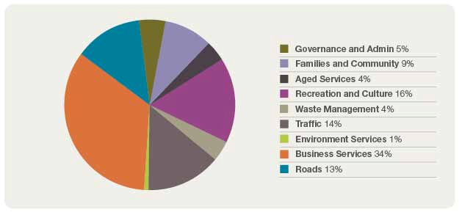
21
Local Government in Victoria Report 2010

These councils spend a significant 47 per
cent of their budgets on family and community, aged services, and recreation and culture.

These councils spend an average of 24 per cent of expenditure on roads compared with 10 per cent in metropolitan councils.

22
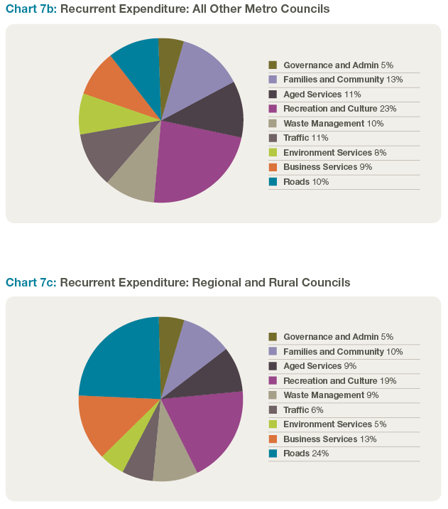

Council expenditure differs not only in its allocation between service areas, but also its sheer size. As Chart 8 shows, a typical council of 10,000 residents spends in total twice as much per resident as a council with a population of 100,000.8

Chart 8: Council Population and Expenses per head 2009–2010
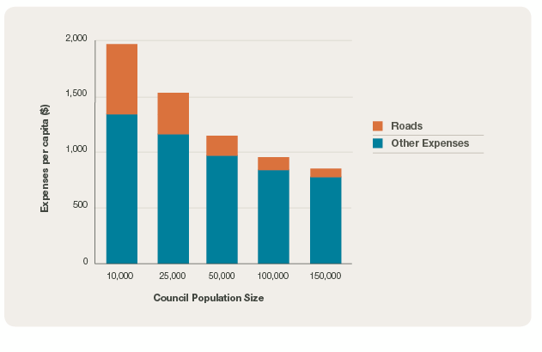

8 The typical expenditure figures are calculated from the trend lines for each of the three expenditure areas, per head, compared with council population size. Due to the unusual expenditure patterns of the inner four Melbourne councils, these are excluded from this exercise.

23
Local Government in Victoria Report 2010

What Chart 8 also shows is the extent of the difference between councils varies between road expenses (including depreciation on roads) and other expenses.

• A council of 10,000 residents averages $1,344 per person on expenses other than roads, 60 per cent more than the $840 spent by a council of 100,000 residents. This reflects both economies of scale in delivering services, and the fact that most smaller councils are in remote
rural areas, often facing higher service costs.

• The expenditure gap is bigger in roads (including depreciation), with the council of 10,000 residents spending $618 per resident, almost
six times that of the council of 100,000 residents ($108 per person). This difference is primarily due to the much greater road length per resident in the
smaller rural councils.
Overall, the council of 10,000 spends almost $2,000 per resident, twice as
much as the $950 spent by a council with
100,000 people. These differences in expenditure mean that smaller councils have to raise more revenues per person. However, the scale of the problem is lessened by differences in the sources
of councils’ revenues – especially the pattern of government grants.

24

Revenue Patterns
Local Government in Victoria Report 2010

25
Revenue Patterns

The data captured in Chart 99 shows the differences between the council groups in revenue sources. Across Victoria, rates contribute just over half of revenues, with grants from
Commonwealth and State governments providing another quarter.10 Service fees and developer contributions are also significant. Within these overall patterns, emphases differ for the three broad groups of councils:

• The four councils in inner Melbourne raise some 39 per cent of their revenues from car parking and other charges – a proportion that has increased slightly over the past ten years.11 These councils receive a relatively low proportion of recurrent revenue from Commonwealth and State Government grants. At 47 per cent, their reliance on rate revenues
is slightly less than the State average.
• All other metropolitan councils have the highest reliance on rates in their revenue base. Rates now contribute 58 per cent of the total,
up significantly from 48 per cent ten years ago. Some councils in outer Melbourne also receive significant revenue from developer contributions.

• Regional and especially rural councils receive the highest proportion of revenue grants, with 34 per cent of income received from Government grants. This figure has grown from
29 per cent ten years ago. The contribution from rates has also grown for this group, from 41 per cent to 46 per cent now – both figures lower than the state average.

9 Chart 9 is based on unpublished VGC data for the 2008-09 financial year. Some problems were identified with the initial data for 2009-10, and so the data for the previous year is used here. Generally, there is little change in the proportions from year to year.
10 This proportion is higher than usual in 2008-09. As noted above, some Government grants were paid earlier than usual in June 2009, and hence were included in the revenue figures for 2008-09
11 This and following comparisons are based on the results for 1999-2000 reported in Local
Government in Victoria 2002, p8

26

Chart 9a: Revenue Patterns: Inner Four Councils

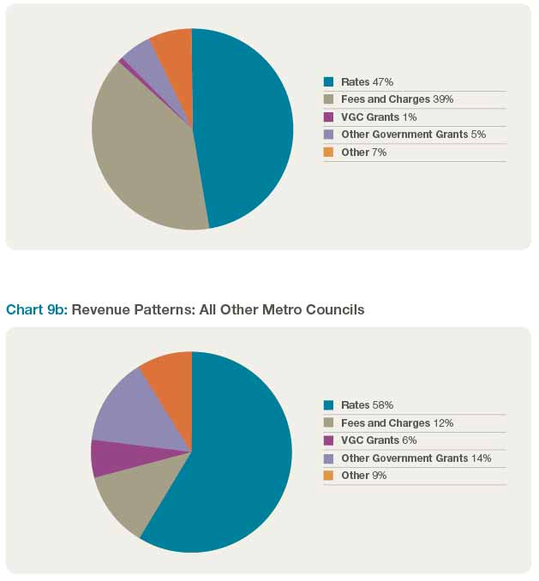

27
Local Government in Victoria Report 2010

Regional and especially rural councils receive the highest proportion of revenue grants,
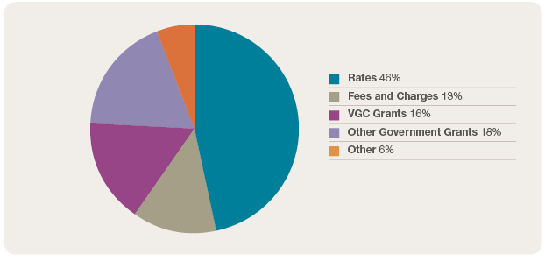

with 34 per cent of income received from
Government grants.
Chart 9c: Revenue Patterns: Regional and Rural Councils

The discussion of expenditure and
Chart 8, noted that smaller councils
have much higher average expenditures per resident than larger councils, with
a council of 10,000 residents spending twice as much per person as a council of 100,000 residents. To fund this expenditure, the smaller councils
have to raise commensurately higher revenues per individual.

The impact on the community from this necessity is lessened somewhat by the pattern of government grants. A typical council of 10,000 residents receives
some $670 per resident in government grants: 3.5 times the $190 per person grants received by a council of 100,000 residents.12 When this is taken into account, the smaller council has to raise an average of some $1,300 in revenues from its own sources – 70 per cent more than the $760 raised by the council of
100,000.13 However, as recently noted by the Productivity Commission14, councils with a high reliance on Commonwealth and State Government grants generally have a lower fiscal capacity to address challenges by
themselves.

12 This demonstrates for Victoria a point the Productivity Commission report found across Australia
– the weighting of grants to the smaller and more remote councils. See Commission Assessing
Local Government Revenue Raising Capacity April 2008, finding 3.4, p xxxvi
13 As with Chart 8 above, the typical revenue figures are calculated from the trend lines for each revenue source. As before, the inner four Melbourne councils, with unusual revenue patterns, are excluded from this exercise.
14 Productivity Commission Assessing Local Government Revenue Raising Capacity April 2008
28

Key Revenue Measures

The Key Indicators examine three measures of council revenues: overall rates, residential rates, and changes in debt levels.

To fund the expenditures shown in
Chart 4 (on page 15), Victorian councils have been increasing rate levels over the past seven years – and have also drawn on slightly more debt. The median overall rates, residential rates and debt levels per assessment are indicated in Chart 10.

Chart 10: Victorian Councils 2002–2010: Median Rates and Debt Levels

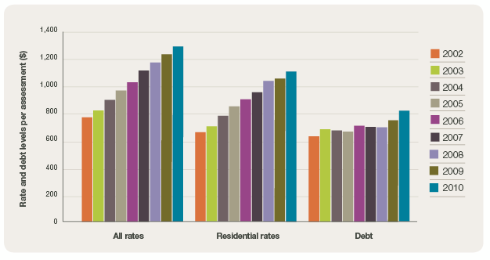

29
Local Government in Victoria Report 2010

Since 2002, councils have increased median rates by 61 per cent, or 7.1 per cent per year (residential rates have also increased by 61 per cent). Increases have been similar across
the State, with little difference between the council groups. As with the pattern for operating expenditure, the rate
of growth has slowed recently, with increases averaging some six per cent in 2008 and 2009.
After several years of stability, the median debt level15 for councils increased a little in 2010. Once again, the pattern varies between councils, with some repaying debts. For those councils increasing debt levels, the primary driver appears to be major capital projects that require additional funding.

As well as looking at general satisfaction ratings, the survey also assesses the influence of particular council services
on resident satisfaction.16

15 The accounting term for this measure is ‘liabilities’, which extends beyond debts to obligations councils have to fund in future years. However, for most councils the vast majority of these liabilities are indeed debts owed, and this term is used for ease of reference.
16 Further discussion of these trends is available in Appendix D Community Satisfaction Survey, pp73-81 in Essential Services Commission Local Government Performance Monitoring Framework – Issues Paper, October 2009
30

Assisting Councils to
Improve Performance

31
Assisting Councils to Improve Performance

This section outlines initiatives that Victoria is implementing to support local councils and improve governance:

Local Government Ministerial-Mayors
Advisory Panel
A Local Government Ministerial-Mayors
Advisory Panel has been established to consult with local government and provide high level advice on the impact of state government decisions and legislation. In addition, the annual Local Government Ministerial Forum involving all mayors and chief executive officers provides a mechanism for consultation and sharing of ideas on key issues impacting on the local government sector.

Asset Management Initiatives
Research and projects to address the impact of councils’ asset management requirements on their overall financial viability are underway. These efforts promote the successful integration
of asset management into service planning and resource allocation. Access to financial and asset management capacity and expertise by particularly small and regional councils is an important component of this work.
The Step Program, developed by the Municipal Association of Victoria, which provides a framework for understanding the current and desired performance of assets, the financial implications and
the development of asset strategy and plans.

The Asset Management Performance
Measures Project which collects data from councils on their asset management performance in particular the size of the infrastructure renewal funding gap and methods councils
are using to measure and report the condition of their infrastructure assets such as roads, bridges, buildings and drains.

Local governments face significant challenges in managing their infrastructure. A number of programs have been established to address
this issue. They include the Regional Growth Fund where local governments are eligible for grants funding over four years through the $100 million Local Government Infrastructure Account to support a range of council initiatives including roads projects, bridges, new community assets such as sporting grounds and libraries and upgrading existing facilities. Forty rural councils will also be able to apply for a share of
$160 million of funding from a Country
Roads and Bridges Fund over the next
32

four years to ensure regional roads and bridges are renewed and maintained.

The Public Libraries Capital Works Program will further improve Victoria’s public library infrastructure, delivering new or upgraded library facilities. This will significantly improve community access to public libraries, which are
one of the most highly-used and valued services in Victoria.

This initiative will help build new libraries where one does not already exist, replace libraries that are too small or no longer meet the needs of the community, refurbish and modernise library buildings, and allow the replacement or refurbishment of mobile libraries.

Legislative changes
The State Government continues
to reform legislation to support local government elections. Legislation has been presented to Parliament to bring forward the date of council elections from November to October to allow incoming councillors adequate time
to familiarise themselves with local government processes prior to setting of council budgets and plans. Legislation will also be introduced to give the voters of the Greater Geelong City Council the opportunity to directly elect their Mayor for a four year term.
33
Local Government in Victoria Report 2010
Council Business Reforms
Local Government Victoria is working closely with Victoria’s 79 councils to help them achieve best practice and greater value for money through collaborative, economic, environmental and social initiatives. Local Government Victoria focussed on improving council efficiency and reducing costs by improving council procurement practices; better practice local law making; and encouraging wider use of online and shared services.

The Victorian Competition and Efficiency Commission’s report into streamlining local government regulation identified opportunities to strengthen economic, financial and resource management
at local government level. The
State Government is considering the recommendations of VCEC. The Government is also considering other reform opportunities identified by the VCEC including harmonisation of
building site requirements and enhanced state-local government consultation.

Victorian Local Government Indicators

34
Victorian Local Government Indicators

Term Description Definition

Overall performance

Community satisfaction rating for overall performance generally of the council

Council result from the Annual Community Satisfaction Survey for Local Governments (Chart One: Summary of Results - Result No. 1), coordinated by Local Government Victoria.

Advocacy Community satisfaction rating for Council’s advocacy and community representation on key local issues

Engagement Community satisfaction rating for Council’s engagement in decision making on key local issues

All rates Average rates and charges per assessment

Council result from the Annual Community Satisfaction Survey for Local Governments (Chart One: Summary of Results - Result No. 4), coordinated by Local Government Victoria.

Council result from the Annual Community Satisfaction Survey for Local Governments (Chart One: Summary of Results - Result No. 5), coordinated by Local Government Victoria.

Rates and charges declared as being receivable, in the calculations for the adopted rates, at the beginning of the year, including:
• general rates and charges declared under ss. 160,
161,161A of the Local Government Act 1989
• municipal charges and service rates and charges (that is, garbage services) levied under ss. 159, 162 respectively
• supplementary rates declared, divided by the number of assessments used in the calculation of the adopted rate (that is, when the rate was struck).

35

Term Description Definition

3036
Residential rates

Operating costs

Capital expenditure

Average residential rates and charges per assessment

Average operating expenditure per assessment

Average capital expenditure per assessment

Rates and charges declared for all residential assessments (including vacant residential assessments) as defined in “All rates”, except for residential assessments only divided by the number of residential assessments used in the calculation of the adopted rate (that is, when the rate was struck).

Total expenses per the Income Statement (previously known as the statement of financial performance) plus net gain (loss) on disposal of property, plant and equipment infrastructure.
divided by the number of assessments used in the calculation of the adopted rate (that is, when the rate was struck).
Note: Where major factors of expenditure such as devaluations or transfers of assets are excluded, councils should provide a note explaining what has been excluded.

Amount of council’s expenditure capitalised to the Balance Sheet (previously known as the statement of financial position) and contributions by a local government to major assets not owned by the local government, including expenditure on:
• capital renewal of existing assets which returns the service potential or the life of the asset up to that which it had originally
• capital expansion which extends an existing asset at the same standard as currently enjoyed by residents to a new group of users
• capital upgrade which enhances an existing asset to provide a higher level of service or expenditure that will increase the life of the asset beyond that which it had originally divided by the number of assessments used in the calculation of the adopted rate (that is, when the rate was struck).

NB Exactly what is included as capital expenditure will vary according to the local government’s policy in defining the
‘asset’ and its ‘life’.

36

Term Description Definition

Infrastructure Renewal

Renewal and maintenance

Debts Average liabilities per assessment

Ratio of current spending on capital renewal of existing infrastructure assets which returns the service potential or the life of the asset up to that which it had originally to the
AAAC totalled for each and every infrastructure asset to give one ratio.

Ratio of current spending on capital renewal of existing infrastructure assets which returns the service potential or the life of the asset up to that which it had originally plus current spending on maintenance:
• to AAAC plus all anticipated planned and unplanned maintenance (that is, the expected level of maintenance which was used in the calculation of the useful life of the asset)
• totalled for each and every infrastructure asset to give one ratio.
The Average Annual Asset Consumption (AAAC) is the amount of a local government’s asset base consumed during a year. It is based on the current replacement cost ‘as new’ divided by useful life.

Total liabilities as per the Balance Sheet (previously known as the statement of financial position) less items held in
trust (reflected in assets also held) divided by the number of assessments used in the calculation of the adopted rate (that is, when the rate was struck).

NB Items held in trust does not include employee leave entitlements such as long service leave.

2010
Report ictoria
V
in

Government

Local
Operating result

37

Operating result per assessment

Surplus (deficit) for the period per the Income Statement (previously known as the Bottom line per statement of financial performance) divided by the number of assessments used in the calculation of the adopted rate (that is when the rate was struck).

A note should be provided to this indicator explaining any major factors including their dollar amount, which have contributed to the result. For example, capital grants, developers contributions, revaluations of non current assets and what the result would be excluding these major factors.

NB Surpluses should be shown as positive and losses or deficits as negatives.

Further Information

Do you want to see how your council is performing against the 11 Local Government Indicators?

The indicator data for each council, and for council groups, from 2005 are available on the Local Government Victoria website www.localgovernment. vic.gov.au by following the links to “Publications and Resources” and then “Data, Directories and Surveys”.

October 2011

Published by Local Government Victoria
Department of Planning and Community Development
Level 9, 8 Nicholson Street, East Melbourne Victoria 3002

Tel (03) 9937 0527
Fax (03) 9937 0598

Authorised by the Victorian Government, Melbourne

Designed by The Designery

Accessibility

If you would like to receive this publication in an accessible format such as large print or audio, please telephone Local Government Victoria on (03) 9937 0527 or email local.government@dpcd.vic.gov.au This publication is also published in PDF and Word formats on www.localgovernment.vic.gov.au

ISBN 978-1-921607-63-9

Copyright & Disclaimer
The materials presented in this report are for information purposes only. The information is provided solely on the basis that readers will be responsible for making their own assessments of the matters discussed and are advised to verify all relevant representations, statements and information and obtain independent advice before acting on any information contained in or in connection with this report. While every
effort has been made to ensure that the information is accurate, the Department of Planning and Community Development will not accept any liability for any loss or damage which may be incurred by any person acting in reliance upon the information. Copyright © State of Victoria 2011
This publication is copyright. No part may be reproduced by any process except in accordance with the provisions of the Copyright Act 1968.

