Local Government

Better Practice Guide

Financial Plan 2023-24

Table of Contents
Acronyms 3
Integrated Strategic Planning and Reporting Framework 4
Statutory and regulatory requirements 5
Local Government Act 2020 5
Strategic planning 5
Financial management principles 6
Service performance principles 6
Community engagement and public transparency 7
Local Government (Planning and Reporting) Regulations 2020 8
Long-term financial planning better practice guide 10
Engagement Principles 11
Asset Plan Integration 11
Financial Policy Statements 13
Strategic Actions 13
Assumptions to the Comprehensive Income Statement 14
Financial Plan Statements 16
Financial Performance Indicators 16
Borrowing Strategy 17
Reserves Strategy 17
Appendices 19
Glossary 46
References 48

Acronyms

AAS Australian Accounting Standards
BPG Better Practice Guide
COVID-19 Coronavirus (COVID-19) Pandemic
DGS Department of Government Services
FinPro Local Government Finance Professionals
FTE Full Time Equivalent
FY Financial Year
FGRS Fair Go Rates System
ISPRF Integrated Strategic Planning and Reporting Framework
LGMFR Local Government Model Financial Report
LGPRF Local Government Performance Reporting Framework
LGV Local Government Victoria
VAGO Victorian Auditor‐General’s Office

Integrated Strategic Planning and Reporting Framework
Introduction
The Local Government Act 2020 (the Act) received Royal Asset on 24 March 2020 with proclamation occurring in stages. Part 4 of the Act addresses planning and financial management. The legislative requirements to develop strategic planning, budgeting and annual reporting documents in Part 4 came into operation on 24 October 2020.
The Act introduces strategic planning principles for Victorian councils which include an integrated approach to planning, monitoring and performance reporting. The Act is a principles-based Act, removing unnecessary regulatory and legislative prescription.
A component of the Integrated Strategic Planning and Reporting Framework (ISPRF) is the Financial Plan. The Financial Plan is a rolling plan with a scope of at least the next 10 financial years.
This better practice guide sets out the key legislative and regulatory provisions relevant to the Financial Plan. It also considers technical and better practice aspects of long-term financial planning and provides support and guidance regarding the Financial Plan. The first iteration of this guide was co-designed by the Local Government Finance Professionals (FinPro) and Local Government Victoria, and this edition has been updated for the period 2023-24 to 2032-33.
This guide should be read in conjunction with the Model Financial Plan 2023-24 to 2032-33 template (Microsoft Excel) and the example Model Financial Plan 2023-24 to 2032-33 (Appendix A).

Statutory and regulatory requirements

Local Government Act 2020

Strategic planning
Part 4 of the Local Government Act 2020 addresses planning and financial management and Division 1 covers strategic planning. The Financial Plan is one of the strategic plans subject to the Strategic planning principles. Section 89 of the Act sets out the Strategic planning principles as follows:
89 Strategic planning principles
(1) A Council must undertake the preparation of its Council Plan and other strategic plans in accordance with the strategic planning principles.
(2) The following are the strategic planning principles —
a) an integrated approach to planning, monitoring and performance reporting is to be adopted;
(b) strategic planning must address the Community Vision;
(c) strategic planning must take into account the resources needed for effective implementation;
(d) strategic planning must identify and address the risks to effective implementation;
(e) strategic planning must provide for ongoing monitoring of progress and regular reviews to identify and address changing circumstances.
The Local Government Act 2020 introduced a requirement for Victorian councils to develop, adopt and keep in force a Financial Plan covering at least the next 10 financial years. Many councils already prepare long-term financial plans for internal management purposes. The requirements under the Act mean councils must develop a Financial Plan that is publicly accessible.
The specific legislative requirements for a Financial Plan are set out in section 91 of the Act as follows:
91 Financial Plan
(1) A Council must develop, adopt and keep in force a Financial Plan in accordance with its deliberative engagement practices.
(2) The scope of a Financial Plan is a period of at least the next 10 financial years.
(3) A Financial Plan must include the following in the manner and form prescribed by the regulations—
(a) statements describing the financial resources required to give effect to the Council Plan and other strategic plans of the Council;
(b) information about the decisions and assumptions that underpin the forecasts in the statements specified in paragraph (a);
(c) statements describing any other resource requirements that the Council considers appropriate to include in the Financial Plan;
(d) any other matters prescribed by the regulations.
(4) A Council must develop or review the Financial Plan in accordance with its deliberative engagement practices and adopt the Financial Plan by 31 October in the year following a general election.
(5) The Financial Plan adopted under subsection (4) has effect from 1 July in the year following a general election.
Section 91(1) and section 91(4) refer to deliberative engagement practices. The Act requires deliberative engagement practices to be incorporated into a council’s community engagement policy.

Financial management principles
Division 4 of Part 4 of the Local Government Act 2020 addresses financial management. Section 101 of the Act sets out the financial management principles as follows:
101 Financial management principles
(1) The following are the financial management principles—
(a) revenue, expenses, assets, liabilities, investments and financial transactions must be managed in accordance with a Council's financial policies and strategic plans;
(b) financial risks must be monitored and managed prudently having regard to economic circumstances;
(c) financial policies and strategic plans, including the Revenue and Rating Plan, must seek to provide stability and predictability in the financial impact on the municipal community;
(d) accounts and records that explain the financial operations and financial position of the Council must be kept.
(2) For the purposes of the financial management principles, financial risk includes any risk relating to the following—
(a) the financial viability of the Council;
(b) the management of current and future liabilities of the Council;
(c) the beneficial enterprises of the Council.

Service performance principles
The Local Government Act 2020 requires Victorian councils to plan and deliver services in accordance with the service performance principles. Part 5 of the Act addresses council operations. Section 106 of the Act sets out the service performance principles as follows:
106 Service performance principles
(1) A Council must plan and deliver services to the municipal community in accordance with the service performance principles.
(2) The following are the service performance principles—
(a) services should be provided in an equitable manner and be responsive to the diverse needs of the municipal community;
(b) services should be accessible to the members of the municipal community for whom the services are intended;
(c) quality and costs standards for services set by the Council should provide good value to the municipal community;
(d) a Council should seek to continuously improve service delivery to the municipal community in response to performance monitoring;
(e) service delivery must include a fair and effective process for considering and responding to complaints about service provision.

Community engagement and public transparency
The Local Government Act 2020 includes community engagement principles (section 56) and public transparency principles (section 58). The Act requires Victorian councils to adopt and maintain a public transparency policy (section 57) and to adopt and maintain a community engagement policy (section 55).
The Financial Plan is specifically referenced in section 55(2)(g) of the Act which requires (amongst other provisions) that a community engagement policy must:
(g) include deliberative engagement practices which must include and address any matters prescribed by the regulations for the purposes of this paragraph and be capable of being applied to the development of the Community Vision, Council Plan, Financial Plan and Asset Plan…

Local Government (Planning and Reporting) Regulations 2020
The Local Government (Planning and Reporting) Regulations 2020 (the regulations) came into operation on 24 October 2020. Part 2 of the regulations prescribe the information to be included in a Financial Plan as follows:
5 Statements describing financial resources
(1) For the purposes of section 91(3)(a) of the Act, the statements describing the financial resources must be in the form set out in the Local Government Model Financial Report.
(2) For the purposes of section 91(3)(d) of the Act, the prescribed matters include a statement of capital works for the financial years to which the statements describing the financial resources referred to in section 91(3)(a) of the Act relate.
6 Statements describing other resource requirements
For the purposes of section 91(3)(d) of the Act, the prescribed matters include the following—
(a) a statement of human resources;
(b) a summary of planned expenditure in relation to the human resources referred to in the statement of human resources, categorised according to the organisational structure of the Council and classified separately as—
(i) permanent full time who are—
(A) women; or
(B) men; or
(C) persons of self-described gender;
or
(ii) permanent part time staff who are—
(A) women; or
(B) men; or
(C) persons of self-described gender;
(c) a summary of the planned number of full time equivalent Council staff referred to in the statement of human resources, categorised according to the organisational structure of the Council and classified separately as—
(i) permanent full time staff who are—
(A) women; or
(B) men; or
(C) persons of self-described gender;
or
(ii) permanent part time staff who are—
(A) women; or
(B) men; or
(C) persons of self-described gender.

Long-term financial planning better practice guide
The Financial Plan provides a 10 year financially sustainable projection regarding how the actions of the Council Plan may be funded to achieve the Community Vision.
At a minimum the Financial Plan is to include:
- financial statements for next the ten years that includes Comprehensive Income Statement, Balance Sheet, Statement of Changes in Equity, Statement of Cash Flows and Statement of Capital Works.

- statement of capital works is to include ten-year expenditure in relation to non-current assets, classified in accordance with the asset classes and asset expenditure types specified in the Local Government Model Financial Report and a summary of funding sources in relation to the planned capital works expenditure.

- a statement of human resources that includes a summary of planned expenditure for the next ten years in relation to permanent human resources and a summary of the planned number of permanent full time equivalent staff by organisational structure split between male, female and self-described gender.
The Model Financial Plan includes a number of examples, in numeric form, designed to disclose future year financial projections. Individual councils may choose to also report this information in graphic format to assist report users and particularly those users with a non-accounting background.

Engagement Principles
The level of engagement will depend on each council’s appetite for community input and the extent this input will impact the decision-making process. The table below describes the community engagement spectrum from a low level engagement (inform) to a high level engagement (empower).

Community Engagement Framework
Inform – 1 | Consult – 2 | Involve - 3 | Collaborate - 4 | Empower - 5
Low Level High Level
Provide community awareness and keep them informed of the completion of the Financial Plan | Ask the community for feedback then inform them of how their input affected decision making. | Work directly with the community to ensure their views and aspirations are considered in developing the Financial Plan. | Partner with the community to develop joint solutions and incorporate their advice into the Financial Plan. | Community decides what is implemented and included into the Financial Plan.

Each Council will be required to describe a level of engagement in the development of the Financial Plan.

Asset Plan Integration
It is essential that any approach towards strategic financial planning be integrated to the Asset Plan. This will ensure that future funding is allocated in a manner that supports service delivery in terms of the plans and the effective management of Council’s assets into the future.
The Asset Plan is designed to identify the operational and strategic practices which will ensure that Council manages assets across their life cycle in a financially sustainable manner.
The objective is for each council to confidently forecast its infrastructure investment needs and costs to ensure it can sustainably provide for current and future communities and ensure they are cost effectively managing asset associated risks and opportunities over the long term. Key considerations include:
- Decisions about assets have significant financial consequences.

- Asset related expenditure and risk form a significant proportion of the financial statements and overall performance of each council.

- Service delivery is often highly dependent upon the assets owned and controlled by each council.

- Council assets are long lived, commonly built to last for 50 – 100 years and as they age there is an increase in maintenance costs.

Financial Policy Statements
A list of policy statements designed to demonstrate councils financial sustainability over the life of the next ten years. The policy statements are to include:
- an explanation of the financial measure that underpins each financial policy statement.
- an agreed financial target that is assigned to each financial measure.
- Ten-year calculations of each financial measure that may be compared to the respective target in order to demonstrate financial sustainability.
- The Model Financial Plan includes target performance measures that are indicative only. Each Council may choose to amend the target performance measures to suit their individual circumstances.

Strategic Actions
A list of strategic actions that disclose councils key funding priorities over the next ten years. By adopting the strategic actions in conjunction with the annual adoption of the Financial Plan, council is demonstrating its key financial strategies in order to ensure ongoing financial sustainability.
The strategic actions are included to the 10-year financial plan and, where appropriate, referenced in the commentary associated with the 10-year Comprehensive Income Statement and the 10-year Statement of Capital Works.
Examples of key strategic actions:
- That council adopt the budgeted statement of financial performance (Comprehensive Income Statement) as an integral part of the budget setting process for current and future budgets.

- That Council targets to achieve a breakeven operating result in the statement of financial performance within x years.

- That Council adopt the budgeted statement of financial position (balance sheet) as being an integral part of the budget setting process for current and future budgets.

- That the working capital ratio be targeted to remain above a ratio of 1.5.

- That budgeted transfers to reserves be matched by an equivalent budgeted surplus in the statement of financial performance so as to preserve the accumulated surplus position of the Council.

- That Council adopt the budgeted statement of cash flows as being an integral part of the budget setting process for current and future budgets.

- That the budgeted ‘cash at the end of year’ position be targeted to be within the range of $1.0 million to $1.5 million in annual and forward financial plans pending further detailed analysis of budgeted cash inflows and outflows.

- That capital expenditure on asset renewal projects (and upgrades that have a significant renewal component) be given priority over capital expenditure on new assets until the sustainability index consistently exceeds 95%.

- That any new projects that require loan funding be considered only if the projects will have proven cash flows in future periods to ‘repay’ the cash outlays required in the initial periods and / or that the capital evaluation guidelines be used to evaluate costing impacts on the forward budgets.

- That Council consider the most appropriate fees and charges strategy so that adequate funds are recovered to offset operational expenses in annual and future budgets.

Assumptions to the Comprehensive Income Statement
In order to inform the ten-year view of projected income and expenditure the Financial Plan should include:
- a table of annual percentage escalations for the next ten years comprising:

  - the major line items included to the ten-year Comprehensive Income Statement
  - the estimated annual CPI increases
  - the estimated annual percentage growth rate for the municipality

- an explanation of the reasons for the ten-year escalations for each major income and expense line item particularly where the annual escalations exceed the estimated annual CPI increase.

- Major income and expense line items are to comprise:

  - Rates and charges
  - Statutory fees and fines
  - User fees
  - Grants – operating
  - Grants – capital
  - Contributions
  - Other income
  - Employee costs
  - Materials and services
  - Depreciation and amortisation
  - Borrowing costs
  - Other expenses
CPI and wage inflation - individual councils may choose to source CPI and wage inflation rates from the Victorian budget or budget update published by the Department of Treasury and Finance (DTF).
Rate cap projections - it is preferable that each council applies consistent rate cap projections, based on available DTF projections or advice from LGV, unless there is a proposal to seek a variation from the rate cap.
For consistency the assumptions should align with the assumptions and escalation factors published in the 4-year budget document.

Financial Plan Statements
The Financial Plan Statements comprise the following statements for the ensuing 10 years:
• Comprehensive Income Statement
• Balance Sheet
• Statement of Changes in Equity
• Statement of Cash Flows
• Statement of Capital Works
• Statement of Human Resources
Where possible the first 4 years of the 10-year Financial Plan Statements should align to the Budget as it relates to the same financial years. Alignment will ensure consistent financial year projections for both the Financial Plan and the Budget.

Financial Performance Indicators
A range of financial indicators should be used to demonstrate the financial sustainability of the ten-year Financial Plan and allow the reader to gain a better understanding of key measures such as indebtedness and liquidity which are often hidden when financial information is presented in financial statement format. The use of indicators over a ten-year horizon also allows trends to be assessed helping the reader to confirm the council’s service delivery, infrastructure renewal, rating and debt strategies.
The financial performance indicators are also included in the Model Budget and are the prescribed financial performance indicators contained in the Regulations. Results against these indicators are also reported in council’s performance statement included in the annual report.
The Act and regulations require councils to report actual results against these indicators, together with the other prescribed indicators contained in the regulations.
The Model Financial Plan includes a table of indicative performance indicators that are designed to align with the Model Budget. Individual councils may consider the inclusion of additional sustainable capacity indicators, such as indicators included in the Local Government Performance Reporting Framework (LGPRF).

Borrowing Strategy
A schedule and commentary of existing borrowings that comprise the current loan balance.
An explanation of the current debt position and a ten-year projection that discloses the debt position at the end of each financial year comprising:
- new loan borrowings
- the amount of loan repayment
- the amount of interest payments
- the opening and closing debt balance
Financial performance indicators that disclose for each year of the ten-year Financial Plan:
- the total borrowings divided by rate revenue
- total debt servicing (interest payments) divided by rate revenue
- total debt commitment (interest and principle repayments) divided by rate revenue
- total indebtedness divided by own source revenue
An explanation of the performance of each indicator over the life of the ten-year plan. The Model Financial Plan includes target performance measures that are indicative only. Each Council may choose to amend the target performance measures to suit their individual circumstances.

Reserves Strategy
Reserves are allocations set aside for specific purposes in later years. Ideally reserves will be cash backed in order to form an important source of funding for the Financial Plan. The following disclosures are recommended.
A list of each reserve indicating if restricted or discretionary in nature.
A table that discloses the ten-year reserve movements comprising:
- the opening balance of each reserve
- the value transferred into each reserve per annum
- the value transferred from each reserve per annum
- the closing balance of each reserve
Transfers into each reserve should include a description of the source and frequency of funding that may include either receipt of income from external sources or appropriation from council’s existing cash funds.
Transfers out of each reserve should include an explanation of how each reserve is used to fund operating and capital expenditure within the Financial Plan.
The Reserves Strategy is to include a description of the nature and purpose of each reserve including any usage restrictions.
The total reserves are required to balance to the Other Reserves within the Statement of Changes in Equity.
The Model Financial Plan includes examples, by individual reserves, for both restricted and discretionary. Each council may choose to disclose reserves either by individual items or in aggregate. Aggregation would result in a single disclosure for the total of restricted (non-discretionary) reserves plus a single disclosure for the total of discretionary reserves.

Appendices
Appendix A: Model Financial Plan 2023-24 to 2032-2033

CONTENTS

Legislative Requirements XX
Financial Plan Context XX
Financial Plan Statements XX
Financial Performance Indicators XX
Strategies and Plans XX

Legislative Requirements

This section describes how the Financial Plan links to the achievement of the Community Vision and the Council Plan within the Integrated Strategic Planning & Reporting framework. This framework guides the Council in identifying community needs and aspirations over the long term (Community Vision), medium term (Council Plan) and short term (Annual Budget) and then holding itself accountable (Annual Report).
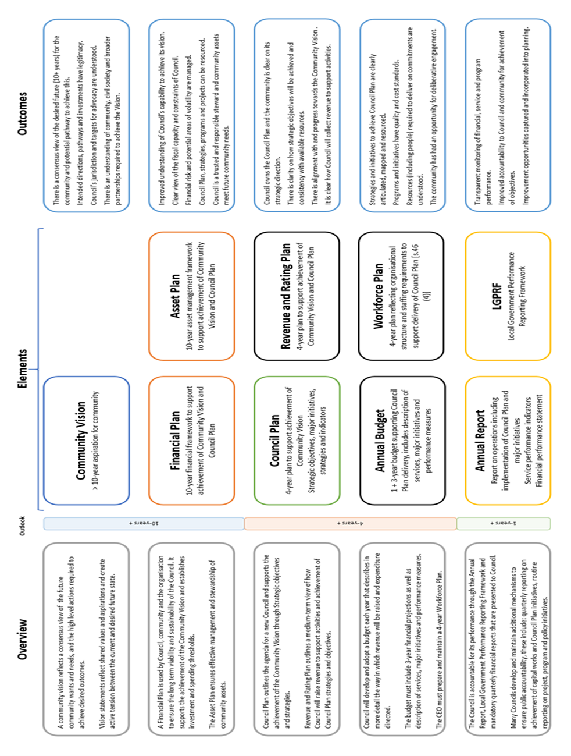
The following diagram provides an overview of the core legislated elements of an integrated strategic planning and reporting framework and outcomes.

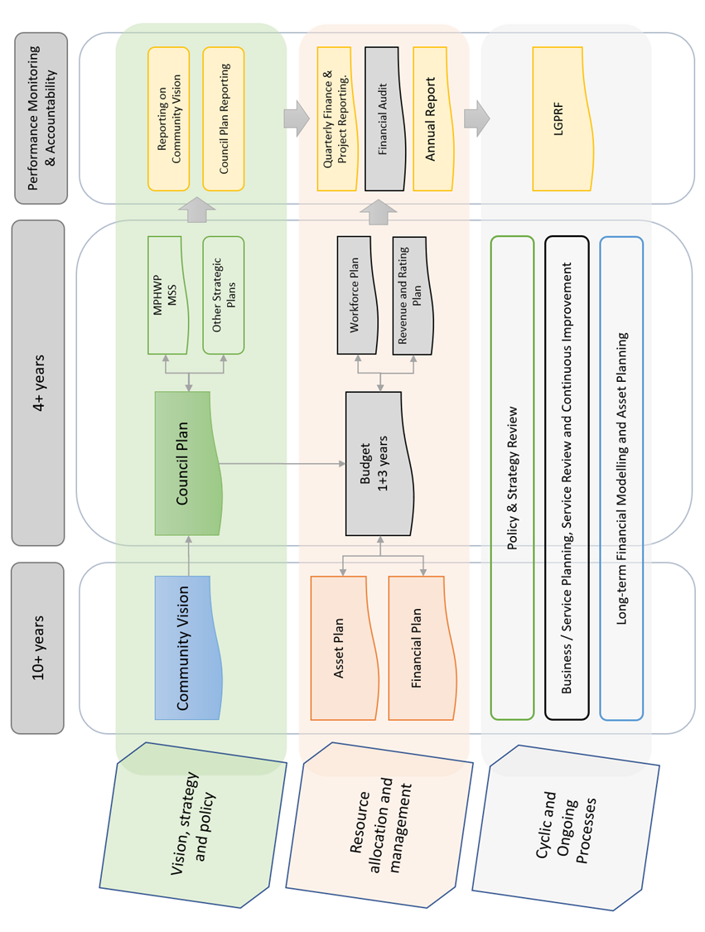
The following figure demonstrates how each element might inform or be informed by other parts of the integrated framework.

1.1 Strategic Planning Principles
The Financial Plan provides a 10 year financially sustainable projection regarding how the actions of the Council Plan may be funded to achieve the Community Vision. The Financial Plan is developed in the context of the following strategic planning principles:
- Council has an integrated approach to planning, monitoring and performance reporting.

- Council financial plan addresses the Community Vision by funding the aspirations of the Council Plan. The Council Plan aspirations and actions are formulated in the context of the Community Vision.

- The Financial Plan statements articulate the 10-year financial resources necessary to implement the goals and aspirations of the Council Plan to achieve the Community Vision.

- Council's strategic planning principles identify and address the risks to effective implementation of the Financial Plan. The financial risks are included at section 1.2.2 below.

- The Financial Plan provides for the strategic planning principles of progress monitoring of progress and reviews to identify and adapt to changing circumstances.

1.2 Financial Management Principles
The Financial Plan demonstrates the following financial management principles:
    - Revenue, expenses, assets, liabilities, investments and financial transactions are managed in accordance with Council's financial policies and strategic plans.

    - Management of the following financial risks:

- the financial viability of the Council (refer to section 2.1 Financial Policy Statements).

- the management of current and future liabilities of the Council. The estimated 10 year-liabilities are disclosed in section 3.2 Balance Sheet projections.
- the beneficial enterprises of Council (where appropriate).

    - Financial policies and strategic plans are designed to provide financial stability and predictability to the community.

    - Council maintains accounts and records that explain its financial operations and financial position (refer section 3 Financial Statements)

1.3 Engagement Principles
Council is in the process of developing a comprehensive community engagement framework. In the interim, Council has implemented the following consultation process to ensure due consideration and feedback is received from relevant stakeholders.

- Draft Financial Plan prepared by management;
- Draft Financial Plan placed on public exhibition at (April) Council meeting for a period of 28 day and calling for public submissions;
- Community engagement is conducted using local news outlets and social media;
- Hearing of public submissions to the Financial Plan (June);
- Draft Financial Plan, including any revisions, presented to (June) Council meeting for adoption.

1.4 Service Performance Principles
Council services are designed to be purposeful, targeted to community needs and value for money. The service performance principles are listed below:
- Services are provided in an equitable manner and are responsive to the diverse needs of the community. The Council Plan is designed to identify the key services and projects to be delivered to the community. The Financial Plan provides the mechanism to demonstrate how the service aspirations within the Council Plan may be funded.

- Services are accessible to the relevant users within the community.

- Council provides quality services that provide value for money to the community. The Local Government Performance Reporting Framework (LGPRF) is designed to communicate council’s performance regarding the provision of quality and efficient services.

- Council is developing a performance monitoring framework to continuously improve its service delivery standards.

- Council is developing a service delivery framework that considers and responds to community feedback and complaints regarding service provision.

1.5 Asset Plan Integration
Integration to the Asset Plan is a key principle of the Council’s strategic financial planning principles. The purpose of this integration is designed to ensure that future funding is allocated in a manner that supports service delivery in terms of the plans and the effective management of Council’s assets into the future.
The Asset Plan identifies the operational and strategic practices which will ensure that Council manages assets across their life cycle in a financially sustainable manner. The Asset Plan, and associated asset management policies, provide council with a sound base to understand the risk associated with managing its assets for the community’s benefit.
The Asset Plan is designed to inform the 10-year Financial Plan by identifying the amount of capital renewal, backlog and maintenance funding that is required over the life of each asset category. The level of funding will incorporate knowledge of asset condition, the risk assessment issues as well as the impact of reviewing and setting intervention and service levels for each asset class.
In addition to identifying the operational and strategic practices that ensure that Council manages assets across their life cycle in a financially sustainable manner, the Asset Plan quantifies the asset portfolio and the financial implications of those practices. Together the Financial Plan and Asset Plan seek to balance projected investment requirements against projected budgets.

2. Financial Plan Context
This section describes the context and external / internal environment and consideration in determining the 10-year financial projections and assumptions.

2.1 Financial Policy Statements
This section defines the policy statements, and associated measures, that demonstrates Council's financial sustainability to fund the aspirations of the Community Vision and the Council Plan.
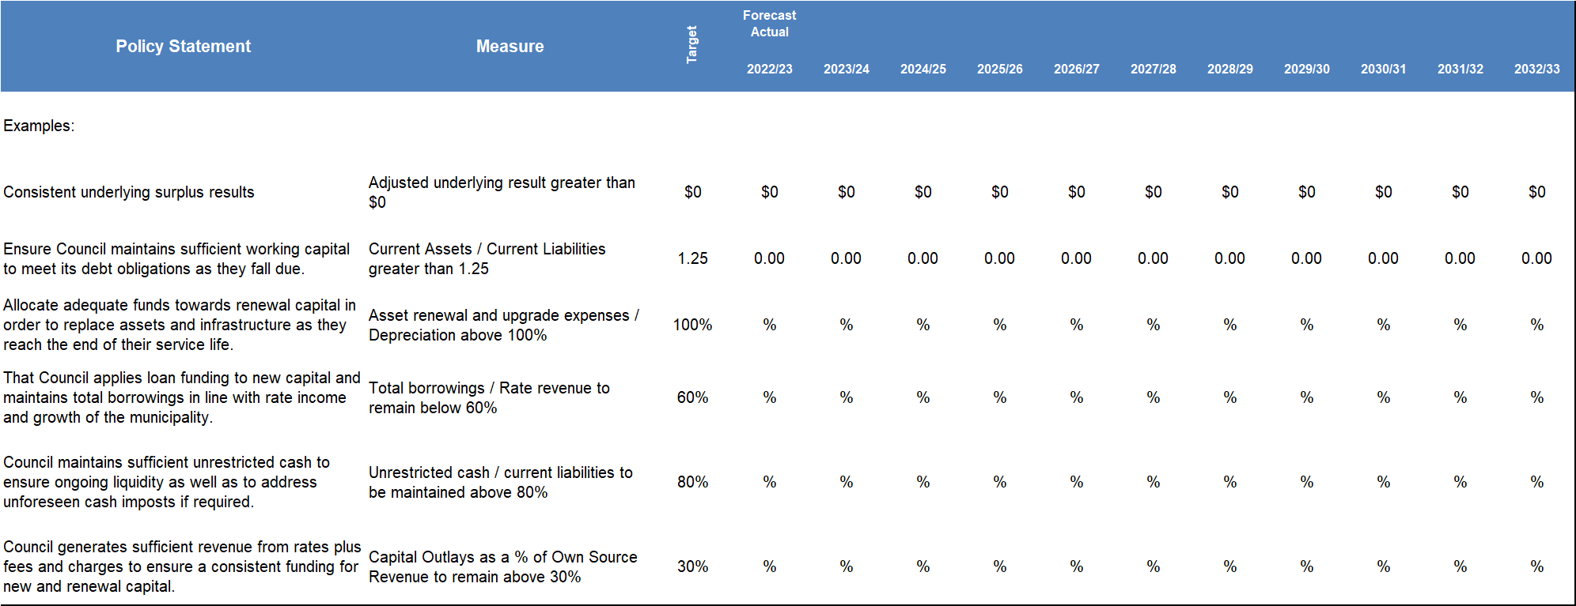
Examples:

2.2 Strategic Actions
Following a series of community engagement activities, Council has identified the following strategic actions that will support the aspirations of the Council Plan.
The strategic actions are included to the 10-year financial plan and, where appropriate, referenced in the commentary associated with the 10-year Comprehensive Income Statement and the 10-year Statement of Capital Works.
Examples:
- Increase investment in renewal capital to reduce the escalating risk and maintenance of aging infrastructure.
- Additional funding to address climate change.
- Debt funding to be applied to growth infrastructure where necessary.
- Maintaining current service levels for the next 4 years to enable Council sufficient time to complete a full review of its service delivery programs.

2.3 Assumptions to the financial plan statements
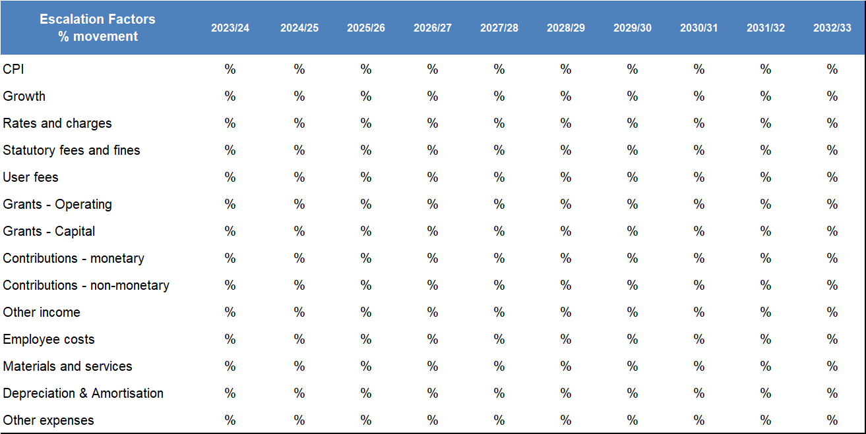
This section presents information regarding the assumptions to the Comprehensive Income Statement for the 10 years from 2023/24 to 2032/33. The assumptions comprise the annual escalations / movement for each line item of the Comprehensive Income Statement.

2.3.1 Rates and charges
Example only:
Base rate revenue will increase by 3.50% for the 2023/24 year, based on the state government rate cap, with estimated future annual increases of x.x% per annum for the ensuing years of the long term financial plan. In addition, it is expected that during the 2023/24 year a further increase of y.y% per annum will be received for growth (additional properties) as a result of supplementary rates.
Waste charges are proposed to increase by z.z% compared to 2022/23 levels in order to defray the total costs of waste management incurred across the municipal district. Future years waste charges are estimated to increase in line with the growth % increase to ensure Council continues to recover the full costs of providing waste services.

2.3.2 Statutory fees and fines
Example only:
The Financial Plan indexes statutory fees, set by legislation, according to the estimated annual rate of CPI. This is often a best case scenario given some fees are outside of the control of Council and therefore may be subject to increases less than CPI.

2.3.3 User fees
Example only:
Revenue from user fees is expected to increase by x.x% for the 2023/24 year. Details of user fees for the 2023/24 budget year can be found in Council’s schedule of Fees and Charges that is adopted in conjunction with the budget.
Revenue increases for the ensuing years are based on a conservative annual rate of increase of x.x% to reflect, as a minimum, annual increases in line with the state government rate cap.

2.3.4 Grants
Example only:
Council currently receives grants for tied (specific purpose grants) and un-tied Financial Assistance grant funding received via the Victorian Local Government Grants Commission (VLGGC). Operating grants are expected to increase on an annual basis by approximately x.x%.

2.3.5 Contributions
Example only:
Council receives contributions from developers. These contributions represent funds to enable council to provide the necessary infrastructure and infrastructure improvements to accommodate development growth. The contributions are for specific purposes and often require Council to outlay funds for infrastructure works often before receipt of this income source. These contributions are statutory contributions and are transferred to a restricted reserve until utilised for a specific purpose through the capital works program or delivered as works in kind by developers.

2.3.6 Other income
Example only:
Revenue from other income mainly comprises investment income plus the recovery income from a variety of sources and rental income received from the hire of Council buildings.

2.3.7 Employee costs
Example only:
The 2023/24 year includes a x.x% increase for employee costs that mainly reflects the salary increase for all staff pursuant to the Enterprise Bargaining Agreement as well as a further y.y% to fund increased staff resources in the areas of planning and customer service due to service demands.
The ensuing years, from 2024/25 to 2032/33, reflect annual increases of z.z% per annum to provide for annual EBA increases, some required increases to staff salaries as well as a marginal increase to the delivery of existing services.
2.3.8 Materials and services
Example only:
Material costs include items required for the maintenance and repairs of Council buildings, roads, drains and footpaths which are more governed by market forces based on availability than CPI. Council’s payments to family day carers are also included under this category. Other associated costs included under this category are utilities, materials for the supply of meals on wheels and consumable items for a range of services. Council also utilises external expertise on a range of matters, including legal services and audit. These costs are kept to within CPI levels year on year.

2.3.9 Depreciation & amortisation
Example only:
Depreciation estimates have been based on the projected capital spending contained within this LTFS document. Depreciation has been further increased by the indexing of the replacement cost of Council’s fixed assets.

2.3.10 Borrowing costs
Borrowing costs comprise the interest expense to service Council's loan portfolio that is described in Section 5.1 Borrowing Plan.

2.3.11 Other expenses
Example only:
Other expenses include administration costs such as Councillor allowances, election costs, sponsorships, partnerships, community grants, lease expenditure, fire services property levy, audit costs and other costs associated with the day to day running of Council.

2.4 Other Matters impacting the 10-year financial projections
Description of the current challenges and expected future events likely to impact the Financial Plan projections.

3. Financial Plan Statements

This section presents information regarding the Financial Plan Statements for the 10 years from 2023/24 to 2032/33.
- Comprehensive Income Statement
- Balance Sheet
- Statement of Changes in Equity
- Statement of Cash Flows
- Statement of Capital Works
- Statement of Human Resources

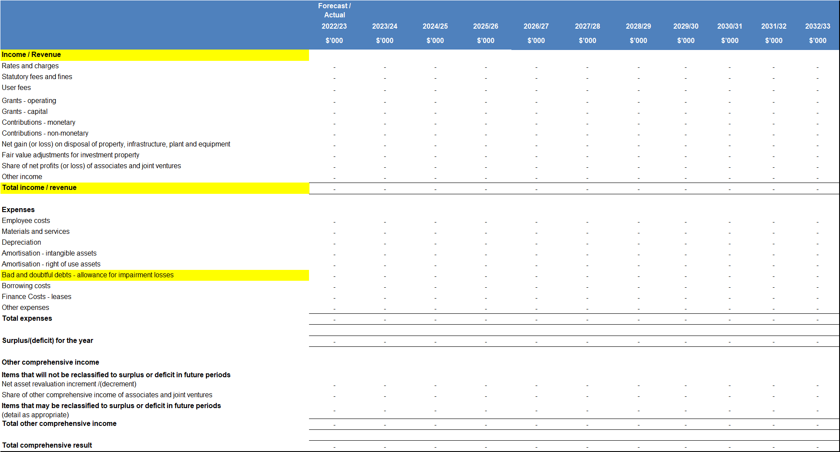
3.1 Comprehensive Income Statement

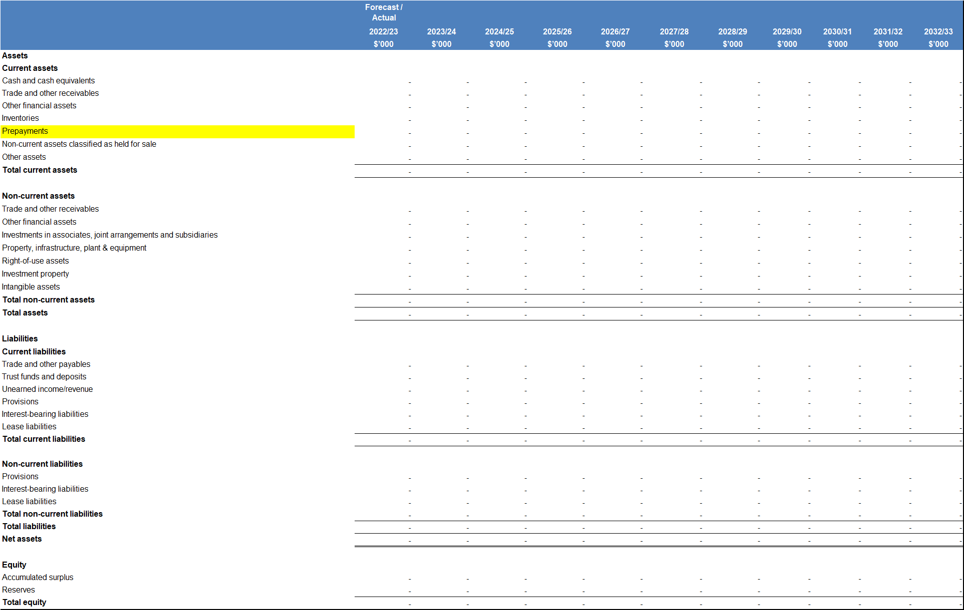
3.2 Balance Sheet

3.3 Statement of Changes in Equity
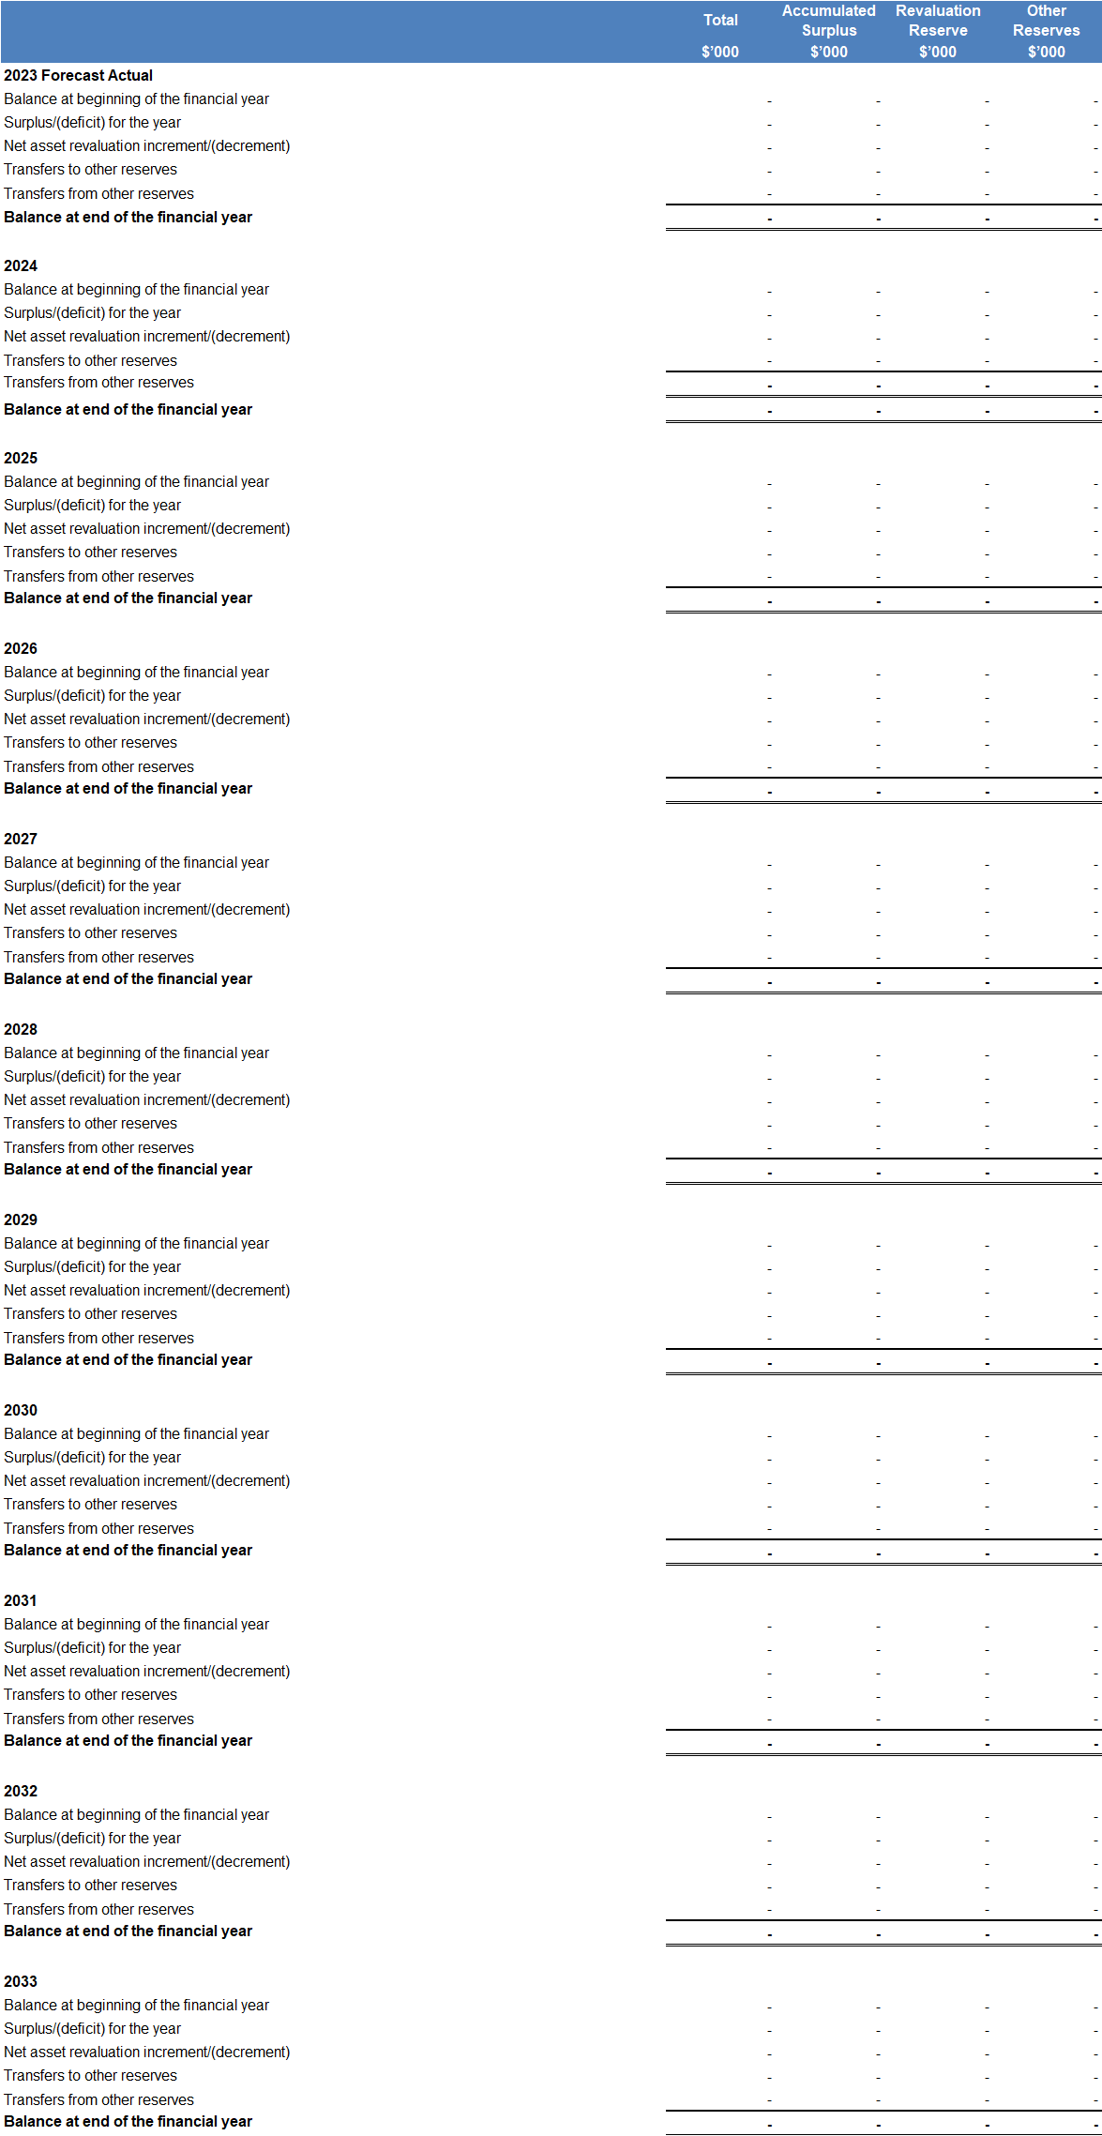

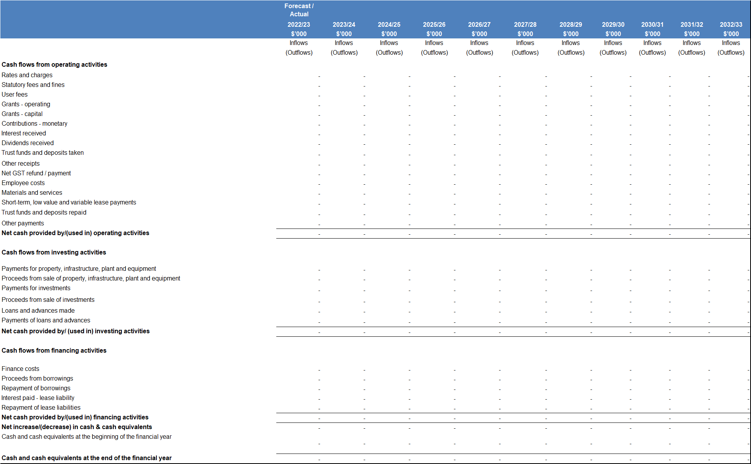
3.4 Statement of Cash Flows

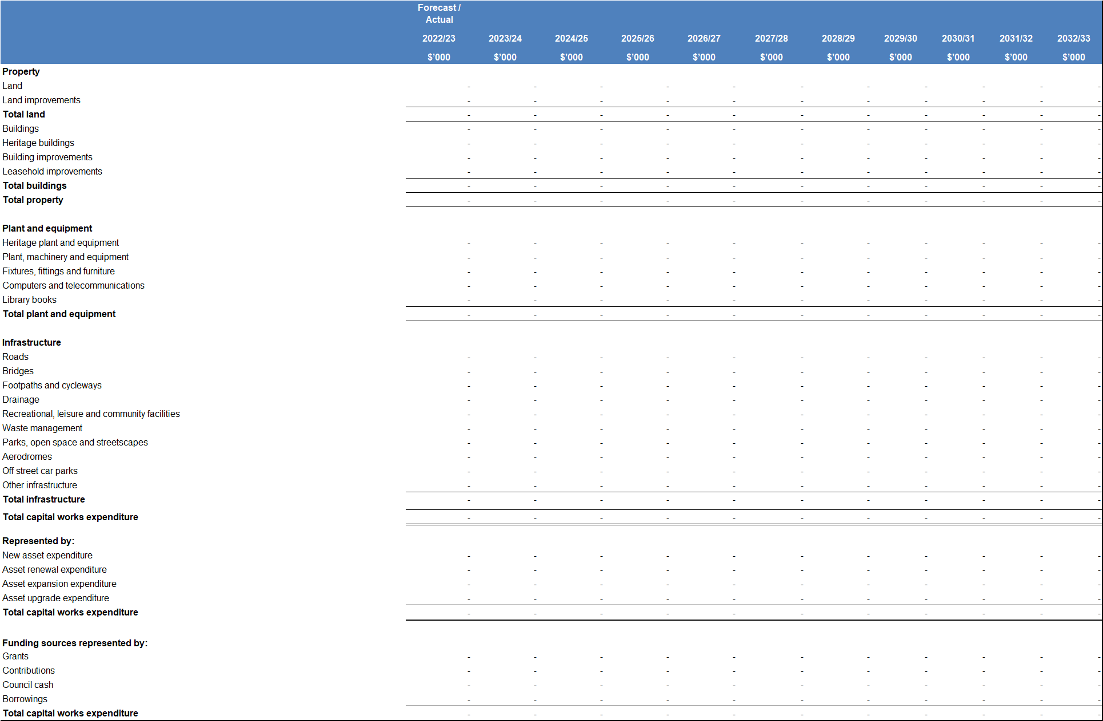
3.5 Statement of Capital Works

3.6 Statement of Human Resources
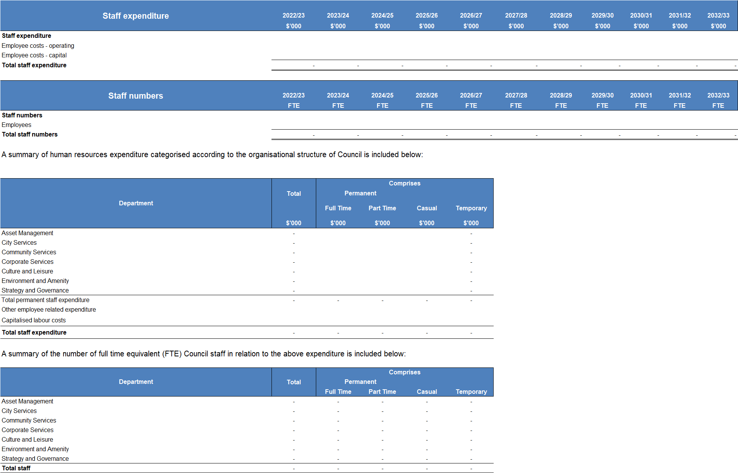
One City Council – to be dissected within the categories of the organisation structure.

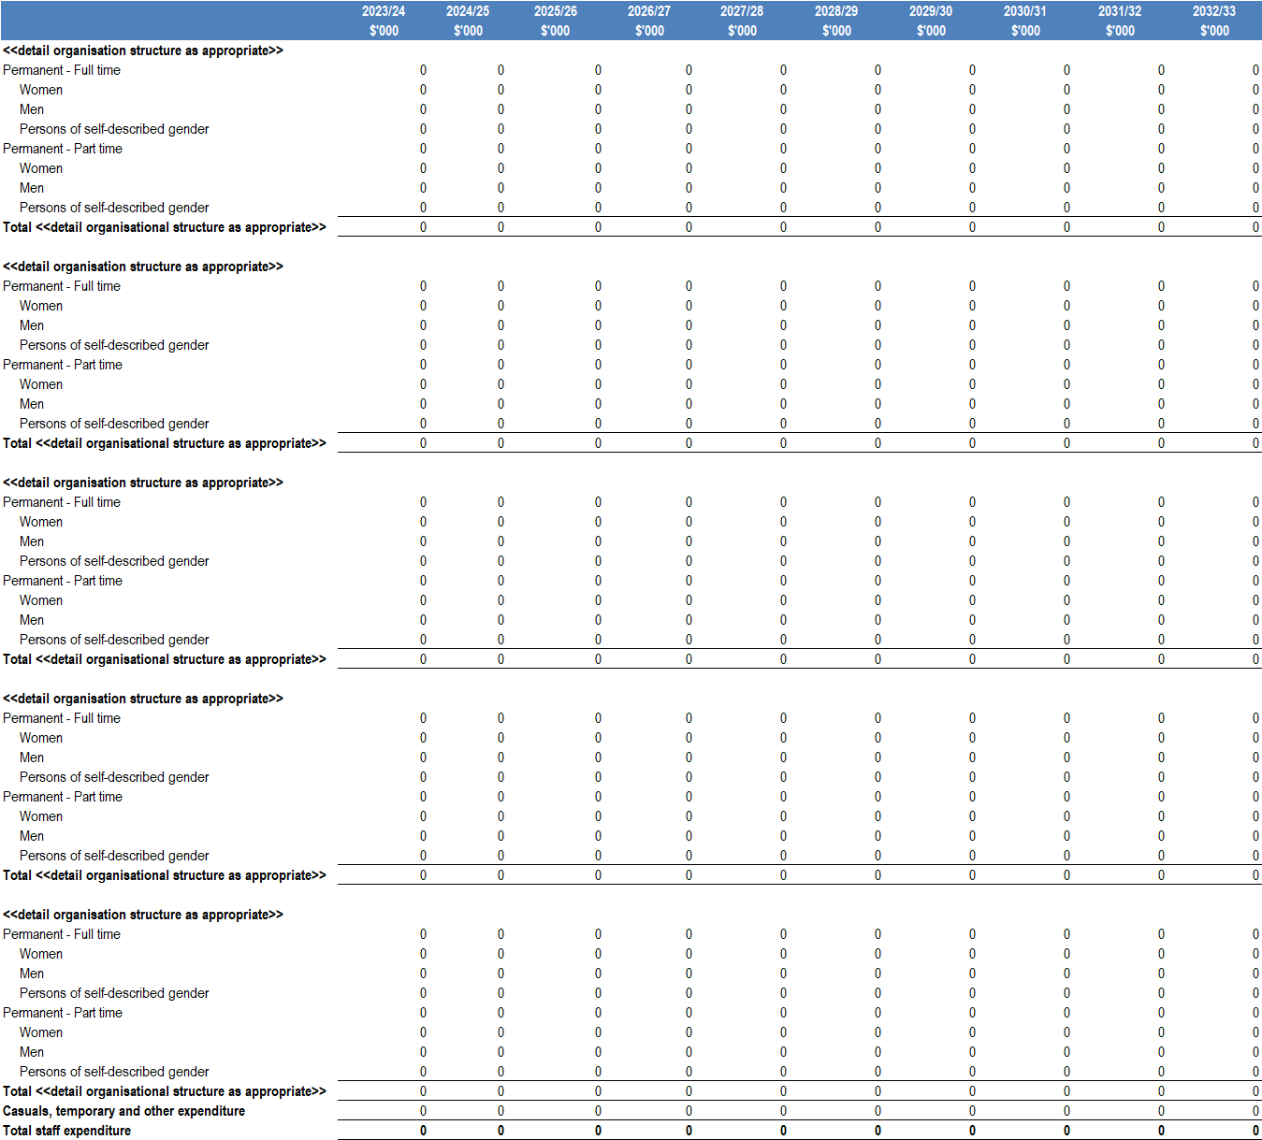
3.7 Planned Human Resource Expenditure

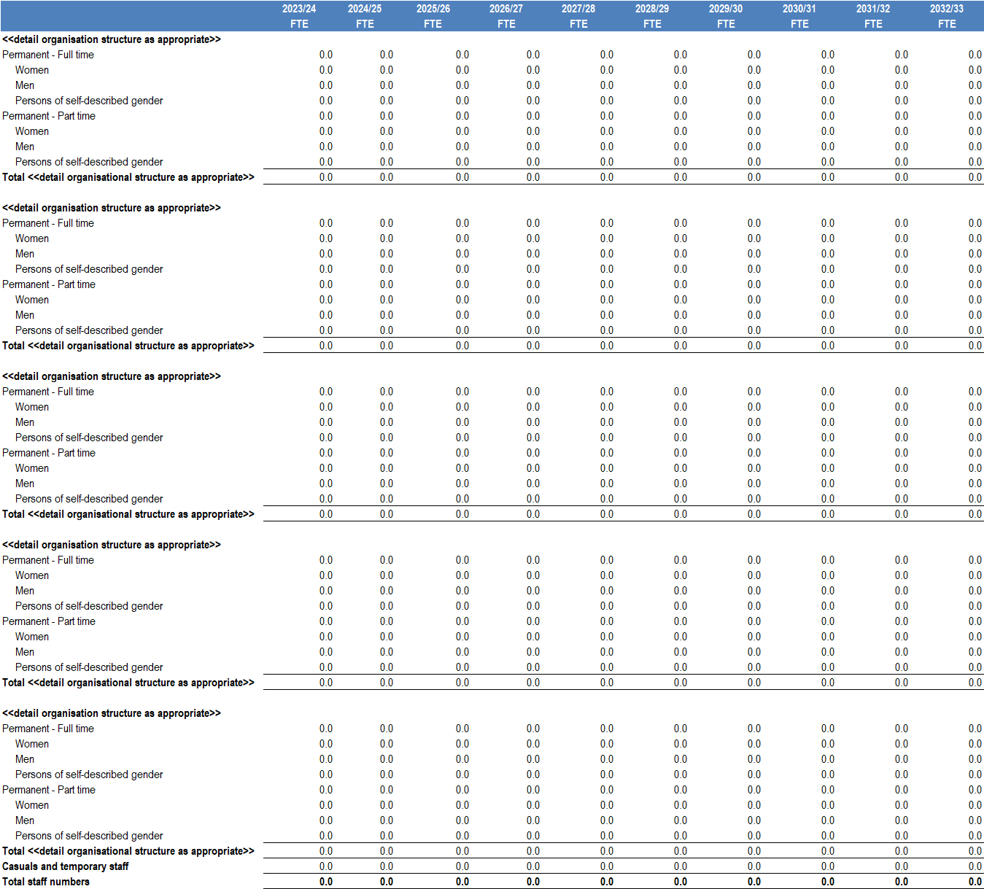

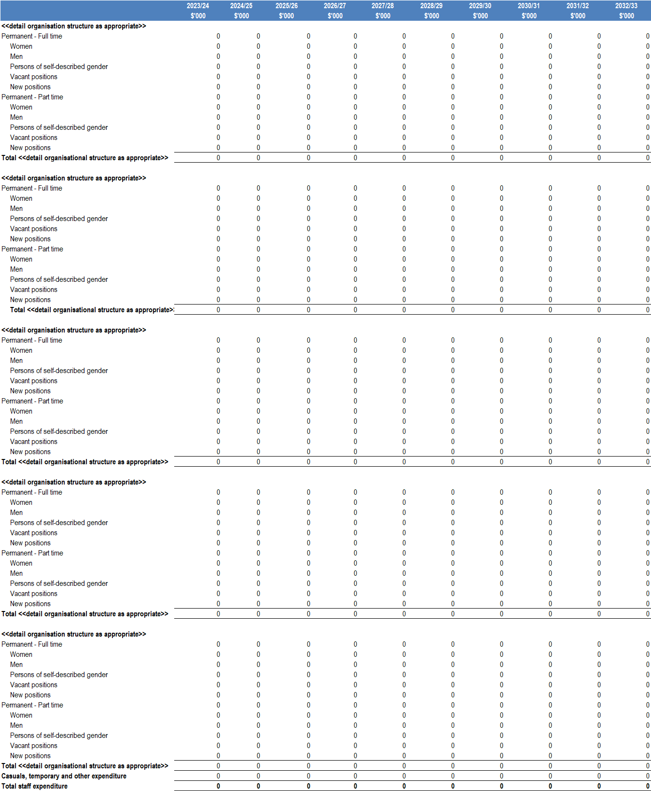
3.7 Planned Human Resource Expenditure (Optional)

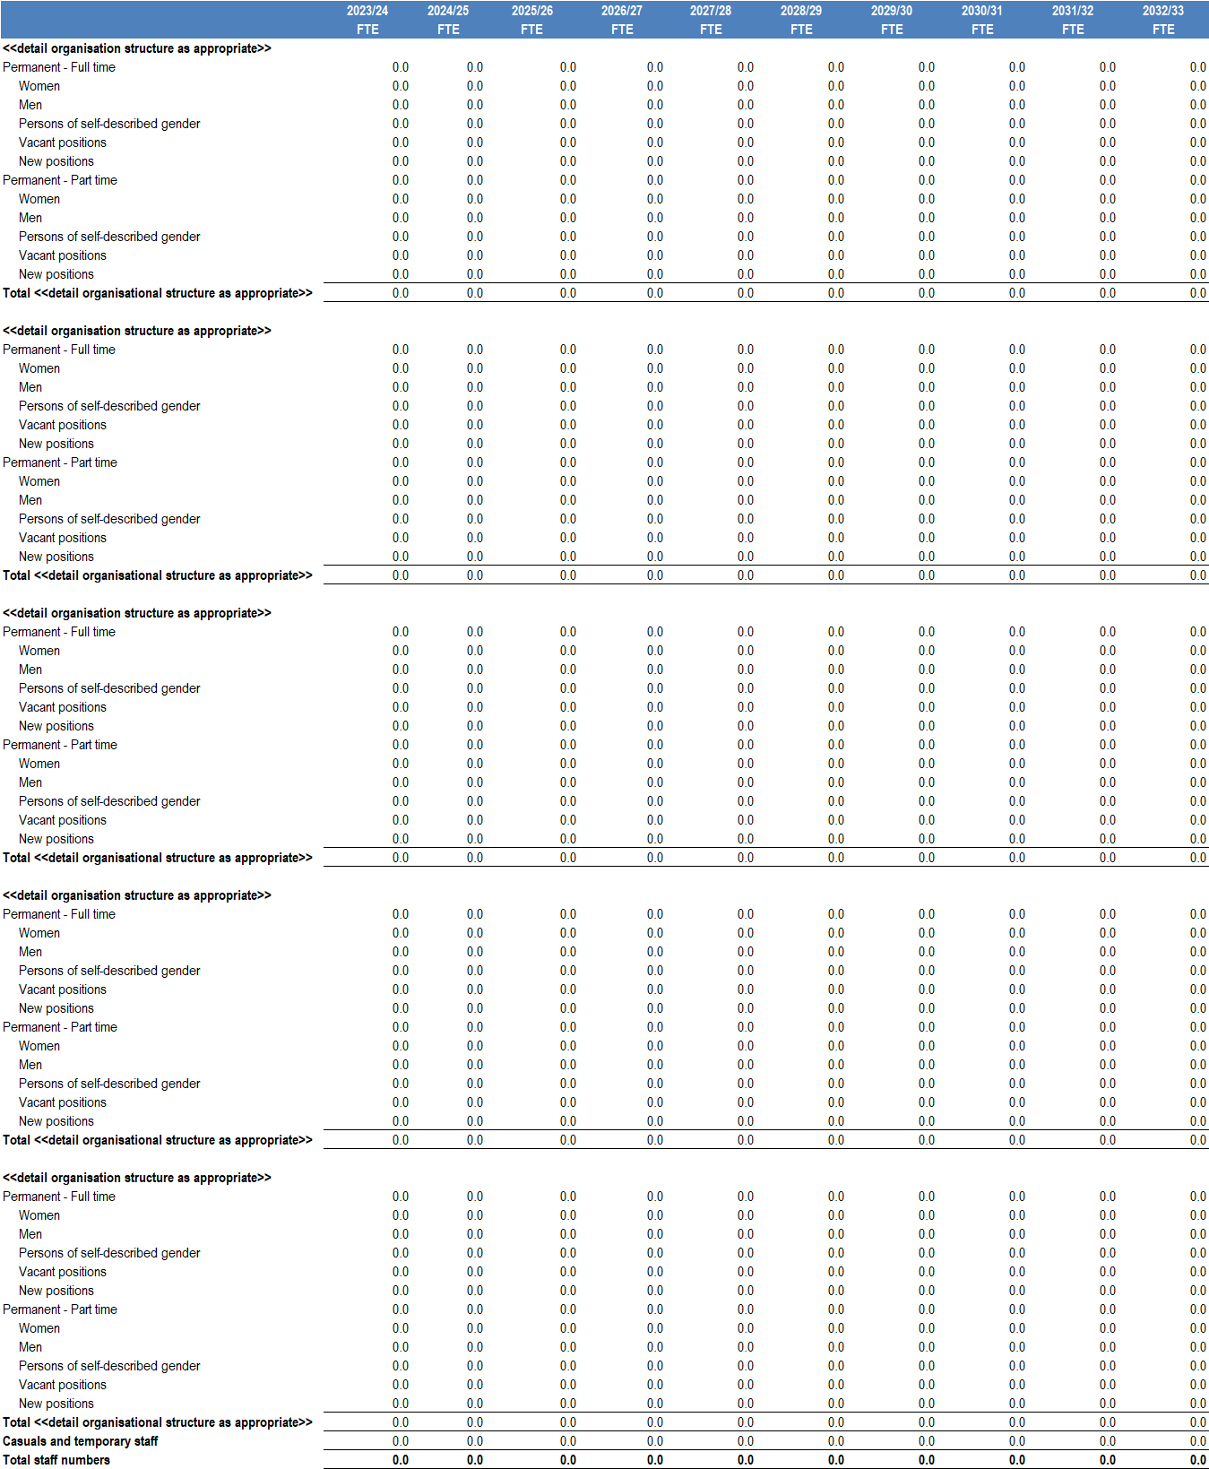
4. Financial Performance Indicators
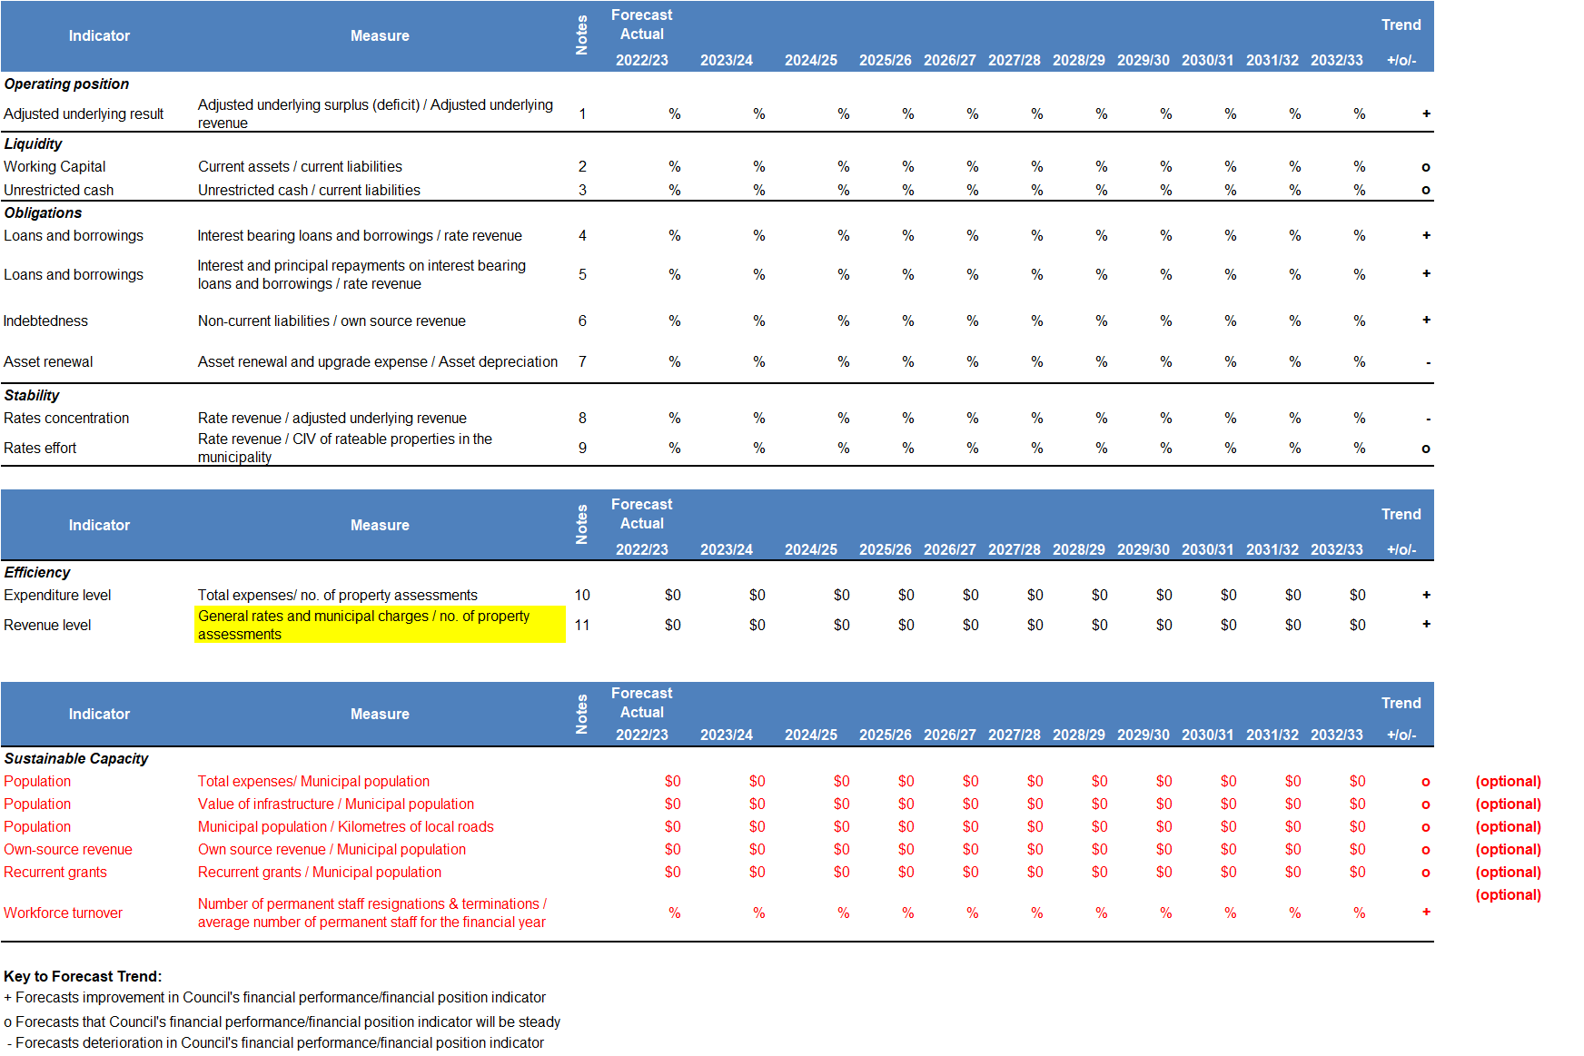
The following table highlights Council’s projected performance across a range of key financial performance indicators. These indicators provide an analysis of Council’s 10-year financial projections and should be interpreted in the context of the organisation’s objectives and financial management principles.

5. Strategies and Plans
This section describes the strategies and plans that support the 10-year financial projections included to the Financial Plan.
5.1 Borrowing Strategy
5.1.1 Current Debt Position
Example:
The total amount borrowed as at 30 June 20XX is $x.x million. Council has accessed debt funding to complete a range of major infrastructure projects including the construction of the ABC Community Hub (due for completion mid 2024), the XYZ Civic Centre and Library, as well as redevelopment of the One City Theatre, Market and Aquatic Centre.
5.1.2 Future Borrowing Requirements
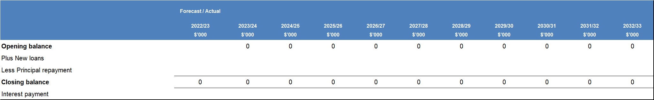
The following table highlights Council’s projected loan balance, including new loans and loan repayments for the 10 years of the Financial Plan

5.1.3 Performance Indicators
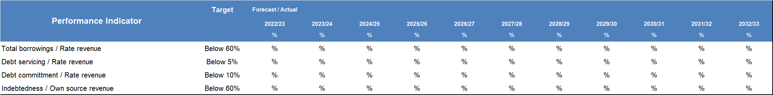
The following table highlights Council’s projected performance across a range of debt management performance indicators.

Council maintains its loan borrowing within prudent and management limits as demonstrated by the following performance indicators.
Total borrowings / Rate revenue
Performance – describe how the ratio performs against the target over the life of the Financial Plan.
Debt servicing / Rate revenue
Performance – describe how the ratio performs against the target over the life of the Financial Plan.
Debt commitment / Rate revenue
Performance – describe how the ratio performs against the target over the life of the Financial Plan.
Indebtedness / Own source revenue
Performance – describe how the ratio performs against the target over the life of the Financial Plan.

5.2 Reserves Strategy
5.2.1 Current Reserves
Examples:
Public Open Space Reserve
- Purpose - The Open Space Reserve holds funds contributed by developers for works associated with developing and improved public open space and recreational facilities within Council. Funds are contributed in accordance with Section 18 of the Subdivision Act and transfers are restricted to the purpose of creating open space such as parks, playgrounds, pavilions and other such items where it is deemed that these works should occur at a later point than the initial development.

- Movements - transfers to the reserve (inflows) comprise contribution income from subdividers in lieu of the 5.0% Public Open Space requirement. Transfers from the reserve (outflows) are applied to fund Open Space capital projects on an annual basis.

Development Contributions Reserve
- Purpose – This reserve retains funds received from developers for infrastructure provision related to Council’s Development Contributions Plans. Council has two (2) Development Contribution Plans with currently two reserves established to manage levy income contributed by developers. Development Contribution Plan reserves were introduced to manage proceeds from the recently adopted Precinct Structure Plans within the district A and district B within the municipality.

- Movements – Transfers from this reserve will be for nominated capital works for Development Infrastructure projects and Community Infrastructure projects. These funds are tied directly to the income received or cash funds refunded to developers for capital works completed directly by the developer.

Plant Replacement Reserve
- Purpose – This reserve is to set aside funds to replace Council’s heavy plant and equipment at the end of the service life.

- Movements – Inflows to the reserve are mainly sourced from budget savings in depot maintenance and operations. Transfers from the reserve are aligned to Councill’s replacement schedule to fund plant acquisitions on an annual basis.

Loan Repayment Reserve
- Purpose – The Loan Repayment reserve is discretionary in nature and designed to hold funds for the repayment of interest only loans.

- Movements – The annual contributions are equal to the deemed principle repayment so sufficient funds will be available to fund the future repayment of interest only loans.

5.2.2 Reserve Usage Projections
The table below discloses the balance and annual movement for each reserve over the 10-year life of the Financial Plan. Total amount of reserves, for each year, is to align with the Statement of Changes in Equity.
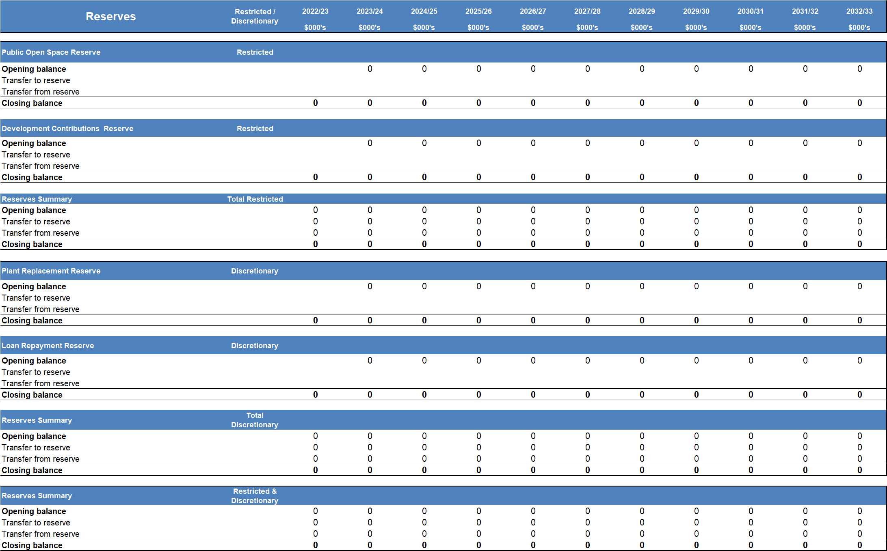
Example:

Glossary
Act | means the Local Government Act 2020
Annual report | means a report of the council’s operations of the previous financial year and contains a report of operations, audited financial statements and an audited performance statement
Australian Accounting Standards (AAS) | means the accounting standards published by the Australian Accounting Standards Board
Better practice | means that in the absence of legislation or a relevant Australian Accounting Standard this commentary is considered by Local Government Victoria to reflect better practice reporting
Budget | means a plan setting out the services and initiatives to be funded for the financial year and the subsequent three financial years and how they will contribute to achieving the strategic objectives specified in the council plan. It is to be a ‘rolling’ budget with an outlook of at least 4-years.
Council plan | means a plan setting out the medium-term strategic objectives, strategies, strategic indicators and resources reflecting vision and aspirations of the community for the next four years
Asset Plan | a plan which has an outlook of at least ten years setting out information about maintenance, renewal, acquisition, expansion, upgrade, disposal and decommissioning of each class of infrastructure under Council’s control
Revenue and Rating Plan | provides a medium-term plan for how Council will generate income to deliver on the Council Plan, program and services and capital works commitments over a 4-year period
Workforce plan | a plan which describes the organisational structure of the Council, specifies the projected staffing requirements for a period of at least 4-years, and sets out measures to seek to ensure gender equality, diversity, and inclusiveness
Community Vision | Council must develop, maintain, and review a Community Vision with its municipal community using deliberative engagement practices which has an outlook of at least 10-years and describes the municipal community’s social, economic, cultural and environmental aspirations for the future.
Financial statements | means the financial statements and notes prepared in accordance with the Local Government Model Financial Report, Australian Accounting Standards and other applicable standards as they apply to the general purpose financial reports and statement of capital works, included in the annual report
Financial year | means the period of 12 months ending on 30 June each year
Heritage asset | means an asset with historic, artistic, scientific, technological, geographical or environmental qualities that is held and maintained principally for its contribution to knowledge and culture and this purpose is central to the objectives of the entity holding it
Minister | means the Minister for Local Government
Performance statement | means a statement including the results of the prescribed service outcome indicators, financial performance indicators and sustainable capacity indicators for the financial year and included in the annual report
Integrated Strategic Planning and Reporting framework | means the key statutory planning and reporting documents that are required to be prepared by councils to support strategic decision making and ensure accountability to local communities in the performance of functions and exercise of powers under the Act
Principal accounting officer | means the person designated by a council to be responsible for the financial management of the council
Regulations | means the Local Government (Planning and Reporting) Regulations 2020
Report of operations  Specialised assets | means a report containing a description of the operations of the council during the financial year and included in the annual report  means assets designed for a specific limited purpose. Specialised assets include buildings such as schools, hospitals, court houses, emergency services buildings (police, fire, ambulance and emergency services), specialised buildings to house infrastructure (pump stations, etc.), some heritage properties and most infrastructure assets
Financial Plan | means a plan of the financial and non-financial resources for at least the next ten years required to achieve the Council Plan and other strategic plans of Council. The Financial Plan defines the broad fiscal boundaries for the Council Plan, Asset Plan, other subordinate policies and strategies and budget processes

References
Department of Jobs, Precincts and Regions (2022), Local Government Model Financial Report, State of Victoria
https://www.localgovernment.vic.gov.au/strengthening-councils/sector-guidance-planning-and-reporting
Department of Jobs, Precincts and Regions (2022), Local Government Model Financial Report Better Practice Guide, State of Victoria
https://www.localgovernment.vic.gov.au/strengthening-councils/sector-guidance-planning-and-reporting
Department of Jobs, Precincts and Regions (2022), Local Government Better Practice Guide Performance Statement 2021-22, State of Victoria
https://www.localgovernment.vic.gov.au/strengthening-councils/sector-guidance-planning-and-reporting

Section 89(2)(a) of the Local Government Act 2020

