Local Government

Better Practice Guide

Model Financial Report 2022-23

Table of Contents

1 Acronyms 3

2 A message from Local Government Victoria 4

3 Introduction 6

Local Government Act 2020 6

About this guide 8

4 Integrated Strategic Planning and Reporting Framework 10

5 Local Government Model Financial Report (Overview) 13

Statutory and regulatory requirements 13

6 Local Government Model Financial Report (Guidance) 15

Context and development of guidance 15

7 Glossary 17

8 References 19

# 1 Acronyms

AAS Australian Accounting Standards

BPG Better Practice Guide

COVID-19 Coronavirus (COVID-19) Pandemic

DGS Department of Government Services

FinPro Local Government Finance Professionals

FTE Full Time Equivalent

FY Financial Year

FGRS Fair Go Rates System

ISPRF Integrated Strategic Planning and Reporting Framework

LGMFR Local Government Model Financial Report

LGPRF Local Government Performance Reporting Framework

LGV Local Government Victoria

VAGO Victorian Auditor‐General’s Office

# 2 A message from Local Government Victoria

Welcome to the 2022-23 version of this Better Practice Guide (BPG) which accompanies the Local Government Model Financial Report (LGMFR).

Council annual reports are prepared under the provisions of the *Local Government Act 2020* and the Local Government (Planning and Reporting) Regulations 2020.

This BPG sets out the broader Integrated Strategic Planning and Reporting Framework (ISPRF) to better contextualise the place of the annual report within the ISPRF.

The annual reporting responsibilities for Victorian councils also reflect the requirements of Australian Accounting Standards and the Local Government Performance Reporting Framework (LGPRF). The regulations continue to require the financial statements in annual reports to be prepared in accordance with the LGMFR. The LGMFR and BPG are developed to assist councils in the preparation of financial statements for inclusion in their annual report.

Local Government Victoria (LGV) again convened a working group to guide the development of this year’s LGMFR and BPG. LGV would like to take this opportunity to acknowledge the contributions of the Local Government Finance Professionals (FinPro), CPA Australia, Crowe Australasia and the Victorian Auditor-General’s Office (VAGO) in an observer capacity, to the update of this year’s edition of the BPG and LGMFR.

The key changes to the LGMFR for 2022-23 include:

* A reference column (column A) has been added to the LGMFR to identify the specific Australian Accounting Standard requirements, or legislative or regulatory requirements, that require particular disclosures or inclusions in the model accounts;
* Additional discretion has been given to councils to determine whether to include certain notes (3.7, 4.4, 4.5,4.6, 4.7, 4.8, 5.2,5.8,6.1 and 6.4) based on materiality;
* The sub-heading and sub-total in the Statement of Comprehensive Income have been amended to “Income / Revenue” and “Total income / revenue” respectively to better reflect the Australian Accounting Standards distinction between Income under *AASB 1058 Income of Not-for-Profit Entities* and Revenue under *AASB 15 Revenue from Contracts with Customers*.
* A new line item has been added to the Balance Sheet for prepayments;
* Additional information on accounting policy selection and the GST has been added to Note 1;
* Note 2 has been given a new heading, “Analysis of our results”, and been amended throughout to match the changed Statement of Comprehensive Income language of “Income / Revenue”.
* Concept of intended allocations, restricted and unrestricted cash removed from the LGMFR;
* Guidance supporting Note 5.6 Financing Arrangements has been updated to clarify the expectation that councils disclose all financing arrangements at this note.
* Additional disclosures regarding the date and type of the current valuations has been added to Note 6 Property, Infrastructure, Plant and Equipment.
* Senior officer disclosures replaced with ‘other senior staff’ disclosures, threshold increased to $160k and must also report directly to a member of Key Management Personnel; and
* The superannuation contribution rate has been updated to 10.5 per cent.

A more detailed *summary* of the changes made to both the LGMFR and BPG is available in the ‘changes’ tab in the model accounts excel workbook on the Department’s website at [www.localgovernment.vic.gov.au](http://www.localgovernment.vic.gov.au).

We trust that you find the LGMFR and this associated BPG very practical tools to assist in the preparation of your financial statements for the 2022-23 financial year.

Local Government Victoria

# 3 Introduction

Local government in Victoria manages approximately $114.07 billion of community assets and infrastructure and spends around $9.8 billion on the provision of services annually.[1] Local government, in partnership with other levels of government, is responsible for aspects of everyday life that people care about deeply – from vibrant and safe public spaces, to accessible libraries, to strong local business and employment opportunities. Effective planning and reporting by councils is essential for ensuring transparency and accountability to the community and other levels of government as to how public money is being spent and the quality of services delivered.

## Local Government Act 2020

### Objectives and purpose

The *Local Government Act 2020* (the Act) received Royal Assent on 24 March 2020 with proclamation occurring in stages. The Act is a principles-based Act, removing unnecessary regulatory and legislative prescription.

The objectives of the Act are as follows:

*The objectives of this Act are to ensure that –*

1. *local government continues to be constituted as a democratically elected tier of Government in Victoria; and*
2. *Councils are constituted as representative bodies that are accountable, transparent, collaborative, efficient and engaged with their communities; and*
3. *Councils have the functions and powers necessary to enable Councils to perform their role.[2]*

The purpose of the Act is as follows:

*The purpose of this Act is to give effect to section 74A(1) of the* ***Constitution Act 1975*** *which provides that local government is a distinct and essential tier of government consisting of democratically elected Councils having the functions and powers that the Parliament considers are necessary to ensure the peace, order and good government of each municipal district.[3]*

### Role of a council

The Act specifies the role of a council is:

*“…to provide good governance in its municipal district for the benefit and wellbeing of the municipal community.”[4]*

The provision of good governance includes a council performing its role in accordance with the overarching governance principles. The overarching governance principles are set out in section 9(2) of the Act. The overarching governance principles include (amongst other principles) that:

* Council decisions are to be made and actions taken in accordance with the relevant law;
* The economic, social and environmental sustainability of the municipal district, including mitigation and planning for climate change risks, is to be promoted;
* The ongoing financial viability of the Council is to be ensured; and
* The transparency of Council decisions, actions and information is to be ensured. [5]

The overarching governance principles are supplemented by the supporting principles. Section 9(3) requires councils to take into account the supporting principles in giving effect to the overarching governance principles. The supporting principles are:

* The community engagement principles;
* The public transparency principles;
* The strategic planning principles;
* The financial management principles; and
* The service performance principles.[6]

It is a statutory requirement under the Act that councils prepare and report on long, medium and short-term plans to discharge their duties of accountability and transparency to their communities.

## About this guide

Councils are required to prepare an annual report in respect of each financial year[7] consisting of three parts:

* **Report of operations:** information about the operations of the council
* **Performance statement:** audited results achieved against the prescribed performance indicators and measures
* **Financial statements:** audited financial statements prepared in accordance with the Australian Accounting Standards.

This guide has been developed to help local government in meeting statutory requirements relating to the preparation of their annual financial statements. Guidance on the preparation of the report of operations and audited performance statement can be found at the website of Local Government Victoria (www.localgovernment.vic.gov.au).

This guide is presented in three sections.

* **Integrated Strategic Planning and Reporting Framework** provides an overview of the relationship between the key planning and reporting documents.
* **Local Government Model Financial Report (overview)** provides an overview of statutory and other requirements in relation to annual financial statements.
* **Local Government Model Financial Report (guidance)** provides context for the detailed guidance included in the LGMFR on the preparation and format of the annual financial statements.

The guide is intended for use by local government finance professionals. Each council retains the responsibility for preparing its annual financial statements, including the format and the disclosures made. This guide, along with the LGMFR, represents the annual financial statements presentation required by LGV. The guidance in the LGMFR directs users to related information and further guidance, including Australian Accounting Standards (AAS). Footnotes are used to reference legislative provisions and other relevant information.

### Preparation of this better practice guide

LGV is responsible for the development of this BPG and will update and reissue it on an annual basis. LGV convened a working group to guide the development of both the 2022-23 LGMFR and this guide.

The working group is comprised of representatives from the accounting profession, the local government finance professionals (FinPro), CPA Australia and LGV. Technical advice and assistance in preparing the LGMFR and BPG was provided by the working group. Representatives of VAGO also attended working group meetings in an observer capacity. LGV would like to take this opportunity to acknowledge the contribution of each of the members of the working group towards the development of the LGMFR and this guide.

Model Accounts 2022-23 working group membership

|  |  |
| --- | --- |
| **Accounting profession** | |
| Martin Thompson, CPA | Crowe |
| Cassandra Gravenall, CPA | Crowe |
| Ram Subramanian, CPA | CPA Australia |
| **Local government finance professionals (FinPro)** | |
| Danny Wain, CPA | Monash City Council |
| Tony Rocca, CA | Maroondah City Council |
| Fiona Rae, CPA | Golden Plains Shire Council |
| Alan Wilson, CPA | Melbourne City Council |
| **Department of Government Services** | |
| Daniel O’Shea, CPA | Local Government Victoria |
| Sadiq Hussaini, CA | Local Government Victoria |
| **Attendance in observer capacity** | |
| Travis Derricott, CPA | Victorian Auditor-General’s Office (VAGO) |
| Jung Yau, CA | Victorian Auditor-General’s Office (VAGO) |

# 4 Integrated Strategic Planning and Reporting Framework

Part 4 of the *Local Government Act 2020* addresses planning and financial management. The legislative requirements to develop strategic planning, budgeting and annual reporting documents in Part 4 came into operation on 24 October 2020.

The Act introduces strategic planning principles for Victorian councils which include an integrated approach to planning, monitoring and performance reporting.[8] This is an important shift from a more prescriptive form of legislation to an Act that is principles-based.

Part 4 of the *Local Government Act 2020* requires councils to prepare the following:

* A Community Vision (for at least the next 10 financial years);[9]
* A Council Plan (for at least the next 4 financial years);[10]
* A Financial Plan (for at least the next 10 financial years);[11]
* An Asset Plan (for at least the next 10 financial years);[12]
* A Revenue and Rating Plan (for at least the next 4 financial years);[13]
* A Budget (for the next 4 financial years);[14]
* A Quarterly Budget Report;[15]
* An Annual Report (for each financial year);[16] and
* Financial Policies.[17]

The Act also requires councils to prepare:

* A Workforce Plan (including projected staffing requirements for at least 4 years);[18]

The legislative timeframes for development, review and adoption of the elements of the Integrated Strategic Planning and Reporting Framework (ISPRF) and the time horizons for each element vary. However there are also many linkages, including the central importance of community engagement. It is therefore vital to recognise the relationships and degrees of integration between different elements. To aid this process, visual representations of the ISPRF have been developed.

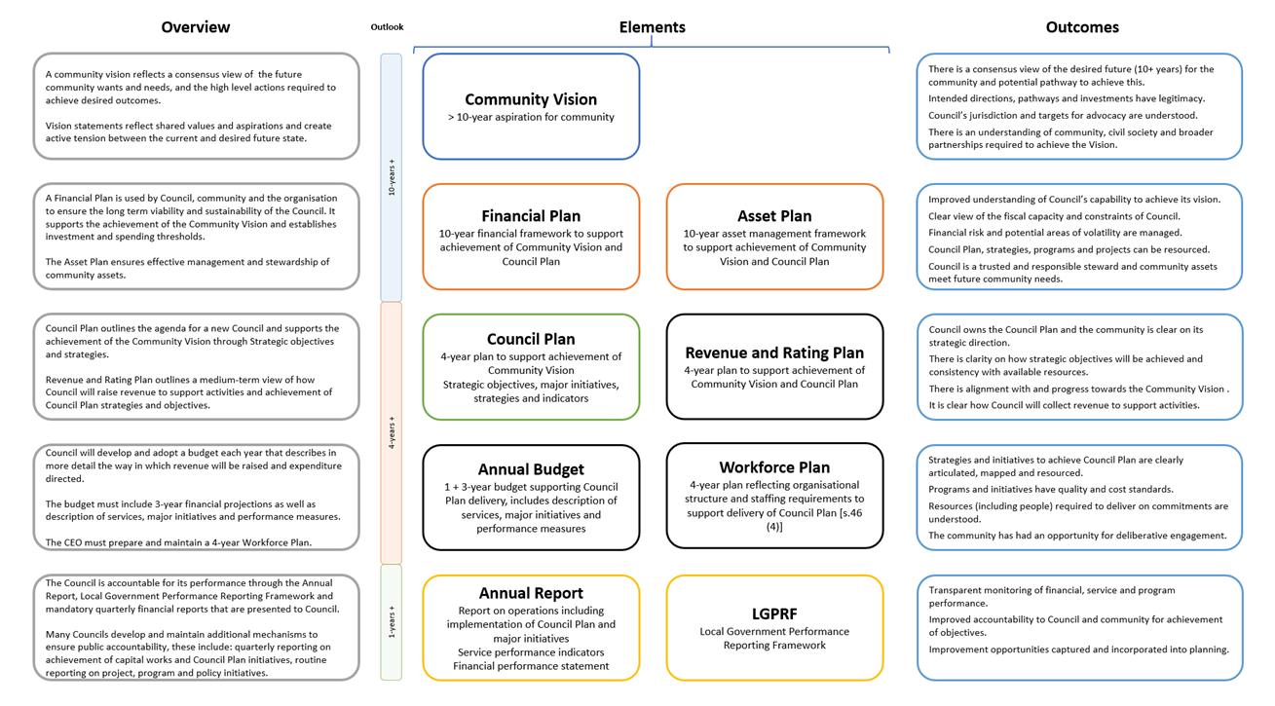The following diagram provides an overview of the core legislated elements of an integrated strategic planning and reporting framework and outcomes.

Figure 1: Department of Jobs, Precincts and Regions 2020

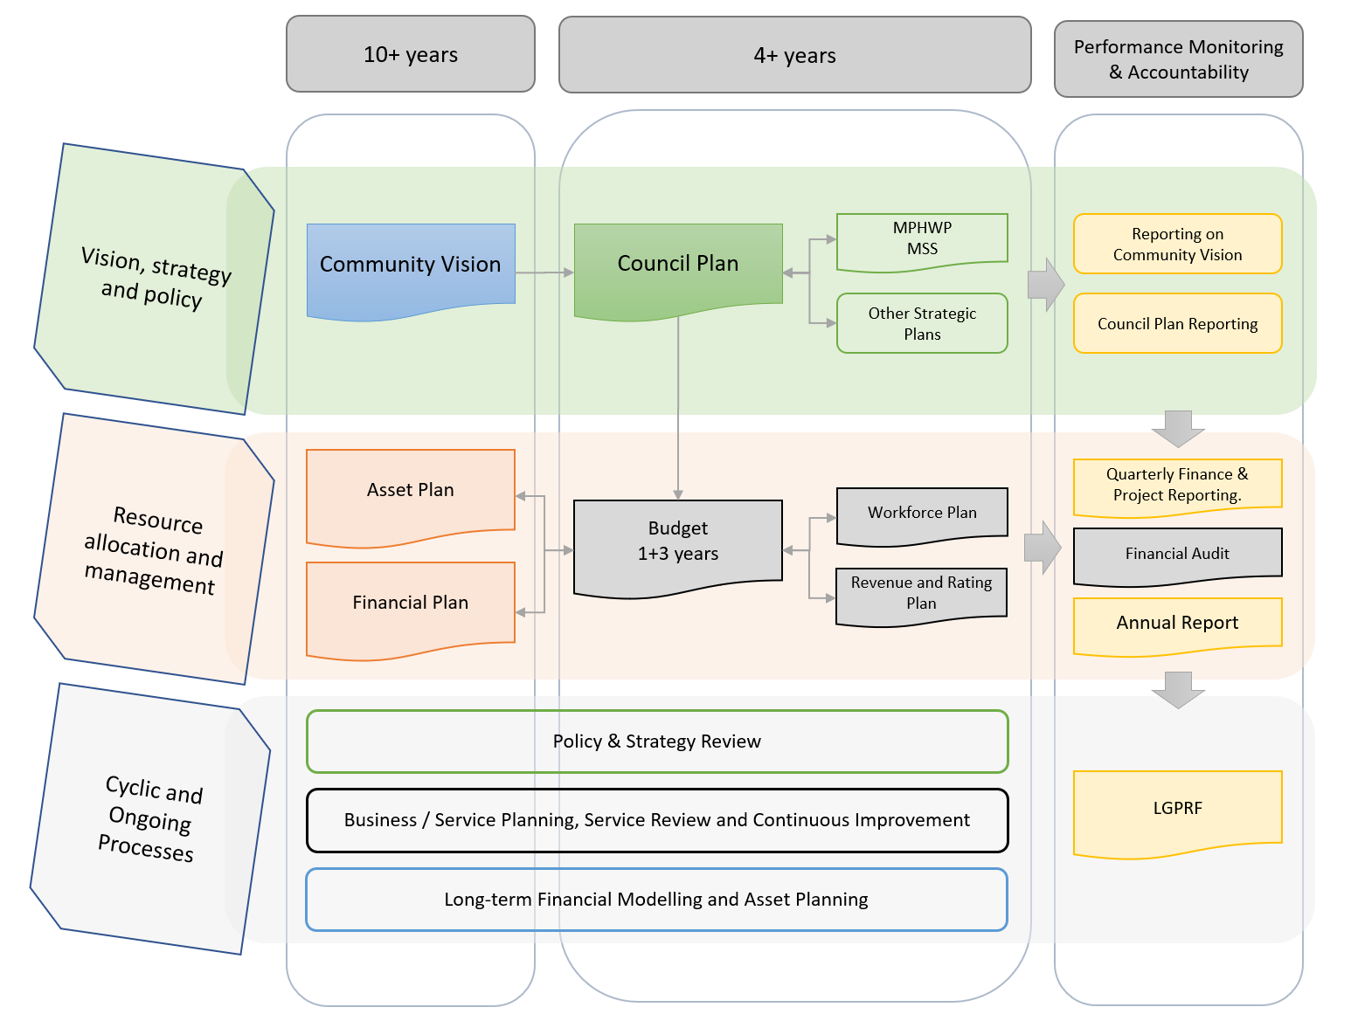The following figure demonstrates how each element might inform or be informed by other parts of the integrated framework.

Note: this shape denotes mandated plans and strategies. 

Figure 2: Department of Jobs, Precincts and Regions 2020

While this guide is focused on one element of the ISPRF – the financial statements within an Annual Report – it is important to recognise the broader framework within which this reporting occurs.

# 5 Local Government Model Financial Report (Overview)

## Statutory and regulatory requirements

### The Act requires a council’s annual report to contain audited financial statements

Sections 98, 99 and 100 of the *Local Government Act 2020* state that:

* the financial statements must be prepared in accordance with the regulations and include any other information prescribed by the regulations[19]
* the financial statements must be prepared by a Council as soon as practicable after the end of the financial year[20]
* the financial statements must be submitted to the auditor for reporting on the audit after the Council has passed a resolution giving its approval in principle to the performance statement and financial statements[21]
* the financial statements must be certified in their final form by two councillors, the CEO and Principal Accounting Officer[22]
* the annual report must contain a copy of the auditor’s report on the financial statements[23]

In addition to sections 98, 99 and 100 of the Act, councils should review part four of the regulations for further information required in the financial statements.

### The regulations require a council’s financial statements to be prepared in accordance with the Local Government Model Financial Report

Regulation 14 in part four of the *Local Government (Planning and Reporting) Regulations 2020* states that:

* the financial statements must be prepared in accordance with the Local Government Model Financial Report[24]
* the financial statements must contain a statement of capital works[25]
* the financial statements must include specified other information as notes.[26]

### Checklist

The financial statements must:

* be prepared in accordance with the Local Government Model Financial Report including a statement of capital works; and
* include other information required by the regulations.

# 6 Local Government Model Financial Report (Guidance)

## Context and development of guidance

Under the *Local Government (Planning and Reporting) Regulations 2020*, Local Government Model Financial Report *means the Local Government Model Financial Report published by the Department from time to time including on the Department’s Internet site*.[27] The LGMFR refers to the Microsoft excel workbook available on the website of Local Government Victoria. This LGMFR Better Practice Guide is separate and is provided to assist preparers.

The LGMFR has been developed to illustrate as widely as possible the minimum disclosure requirements for councils. It is expected that councils will follow the format, presentation and disclosures in the LGMFR. In certain limited circumstances additional disclosures and presentation formats may be required in order to meet the requirements of AAS or report on specific local issues. The guidance in the LGMFR provides some examples of when additional disclosures and presentation formats may be required. Where disclosures illustrated in the LGMFR are not relevant to an individual council they may be omitted as appropriate.

It is expected that local government finance professionals exercise professional judgement in preparing their financial statements in accordance with the LGMFR.

The LGMFR is underpinned by seven guiding principles.

1. The presentation of the financial statements should promote transparency and accountability of local government to stakeholders.
2. The pursuit of consistency in local government financial statements is important but the primary role is to recognise and report responsibly on relevant local issues.
3. By law the financial statements must be prepared in accordance with the LGMFR which has been developed to illustrate as widely as possible the minimum disclosure requirements for councils.
4. While the LGMFR is used as a basis for preparing the financial statements, subject to each council’s individual circumstances, the statements must also be an accurate and transparent representation of local issues.
5. Local government finance professionals are in the best position to make informed decisions about the appropriateness or otherwise of relevant disclosures and the exercise of professional judgement, in excess of the minimum requirements, in preparing the financial statements.
6. In the event of any conflict between the requirements of the LGMFR and the requirements of the AAS, the requirements of the AAS take precedence.
7. When preparing financial statements, local government finance professionals should have regard to the financial management principles set out in section 101 of the *Local Government Act 2020*.

**Guiding Principles**

For the 2022-23 reporting year the detailed guidance supporting the model accounts is located as a tab within the LGMFR itself. This allows users to quickly access any relevant guidance from within the LGMFR template and includes hyperlinks for ease of use.

The detailed guidance in the LGMFR is provided to assist local government finance professionals in preparing the council’s annual financial statements. For ease of referencing each piece of guidance has been assigned a unique number. Where applicable, references to the *Local Government Act 2020*, the Local Government (Planning and Reporting) Regulations 2020, the *Local Government Act 1989*, the Local Government (Planning and Reporting) Regulations 2014, Australian Accounting Standards and other authoritative pronouncements are also included.

# 7 Glossary

|  |  |
| --- | --- |
| **Act** | means the Local Government Act 2020 |
| **Annual report** | means a report of the council’s operations of the previous financial year and contains a report of operations, audited financial statements and an audited performance statement |
| **Australian Accounting Standards (AAS)** | means the accounting standards published by the Australian Accounting Standards Board |
| **Better practice** | means that in the absence of legislation or a relevant Australian Accounting Standard this commentary is considered by Local Government Victoria to reflect better practice reporting |
| **Budget** | means a plan setting out the services and initiatives to be funded for the financial year and the subsequent 3 financial years and how they will contribute to achieving the strategic objectives specified in the council plan |
| **Council plan** | means a plan setting out the medium-term strategic objectives, strategies, strategic indicators and resources reflecting the vision and aspirations of the community for the next four years |
| **Financial statements** | means the financial statements and notes prepared in accordance with the Local Government Model Financial Report, Australian Accounting Standards and other applicable standards as they apply to the general purpose financial reports and statement of capital works, included in the annual report |
| **Financial year** | means the period of 12 months ending on 30 June each year |
| **Heritage asset** | means an asset with historic, artistic, scientific, technological, geographical or environmental qualities that is held and maintained principally for its contribution to knowledge and culture and this purpose is central to the objectives of the entity holding it |
| **Minister** | means the Minister for Local Government |
| **Performance statement** | means a statement including the results of the prescribed service performance indicators, financial performance indicators and sustainable capacity performance indicators for the financial year and included in the annual report |
| **Integrated Strategic Planning and Reporting Framework** | means the integrated approach to planning and reporting set out in the Act and Regulations. The framework includes documents that are required to be prepared by Councils to ensure transparency and accountability to local communities in the performance of functions and exercise of powers under the Act. Community engagement is a key aspect of the ISPRF. |
| **Principal accounting officer** | means the person designated by the Chief Executive Officer of a Council as the officer responsible for managing the Council’s finances |
| **Regulations** | means the Local Government (Planning and Reporting) Regulations 2020 |
| **Report of operations**  **Specialised assets** | means a report containing a description of the operations of the council during the financial year and included in the annual report  means assets designed for a specific limited purpose. Specialised assets include buildings such as schools, hospitals, court houses, emergency services buildings (police, fire, ambulance and emergency services), specialised buildings to house infrastructure (pump stations, etc.), some heritage properties and most infrastructure assets |
|  |  |

# 8 References

Australian Accounting Standards Board, AASB Standards, <https://www.aasb.gov.au/pronouncements/accounting-standards/>

Department of Environment, Land, Water & Planning (2017), *Accounting for Landfills*, State of Victoria, <https://www.localgovernment.vic.gov.au/strengthening-councils/sector-guidance-planning-and-reporting>

Department of Environment, Land, Water & Planning (2017), *Accounting for Natural Disasters*, State of Victoria, <https://www.localgovernment.vic.gov.au/strengthening-councils/sector-guidance-planning-and-reporting>

Department of Environment, Land, Water & Planning (2017), *Accounting for Related Party Disclosures*, State of Victoria, <https://www.localgovernment.vic.gov.au/strengthening-councils/sector-guidance-planning-and-reporting>

Department of Environment, Land, Water & Planning (2018), *Guidance on transition to new accounting standards 2018-19*, State of Victoria, <https://www.localgovernment.vic.gov.au/strengthening-councils/sector-guidance-planning-and-reporting>

Department of Jobs, Precincts and Regions (2022), *Local Government Model Financial Report*, State of Victoria, <https://www.localgovernment.vic.gov.au/strengthening-councils/sector-guidance-planning-and-reporting>

Department of Jobs, Precincts and Regions (2022), *Local Government Better Practice Guide Performance Statement 2021-22*, State of Victoria, <https://www.localgovernment.vic.gov.au/strengthening-councils/sector-guidance-planning-and-reporting>

Department of Treasury and Finance (2022), *2021-22 Model Report for Victorian Government Departments*, State of Victoria, <https://www.dtf.vic.gov.au/model-report/2021-22-model-report>

Institute of Public Works Engineering Australasia (2015), *Australian Infrastructure Financial Management Manual*, Australian Edition

Victorian Auditor-General’s Office (2021), *Results of 2020-21 Audits: Local Government*, <https://www.audit.vic.gov.au/report/results-2020-21-audits-local-government>

1. Victorian Auditor-General’s Office (2021), *Results of 2020-21 Audits: Local Government*
2. Section 4(a),4(b) and 4(c) of the *Local Government Act 2020*
3. Section 1 of the *Local Government Act 2020*
4. Section 8(1) of the *Local Government Act 2020*
5. Section 9(2) of the *Local Government Act 2020*
6. Section 9(3) of the *Local Government Act 2020*
7. Section 98(1) of the *Local Government Act 2020*
8. Section 89(2)(a) of the *Local Government Act 2020*
9. Section 88 of the *Local Government Act 2020*
10. Section 90 of the *Local Government Act 2020*
11. Section 91 of the *Local Government Act 2020*
12. Section 92 of the *Local Government Act 2020*
13. Section 93 of the *Local Government Act 2020*
14. Section 94 of the *Local Government Act 2020*
15. Section 97 of the *Local Government Act 2020*
16. Section 98 of the *Local Government Act 2020*
17. Section 102 of the *Local Government Act 2020*
18. Section 46(4)(a) of the *Local Government Act 2020*
19. Section 98(5)(a) and (b) of the *Local Government Act 2020*
20. Section 99(1) of the *Local Government Act 2020*
21. Section 99(2) of the *Local Government Act 2020*
22. Section 99(3) of the *Local Government Act 2020*
23. Section 98(2)(e) of the *Local Government Act 2020*
24. Regulation 14(2)(a) of the Local Government (Planning and Reporting) Regulations 2020
25. Regulation 14(1)(a) of the Local Government (Planning and Reporting) Regulations 2020
26. Regulation 14(2)(b) of the Local Government (Planning and Reporting) Regulations 2020
27. Regulation 4 of the Local Government (Planning and Reporting) Regulations 2020