C U B E
G R O U P"

Making public value happen.

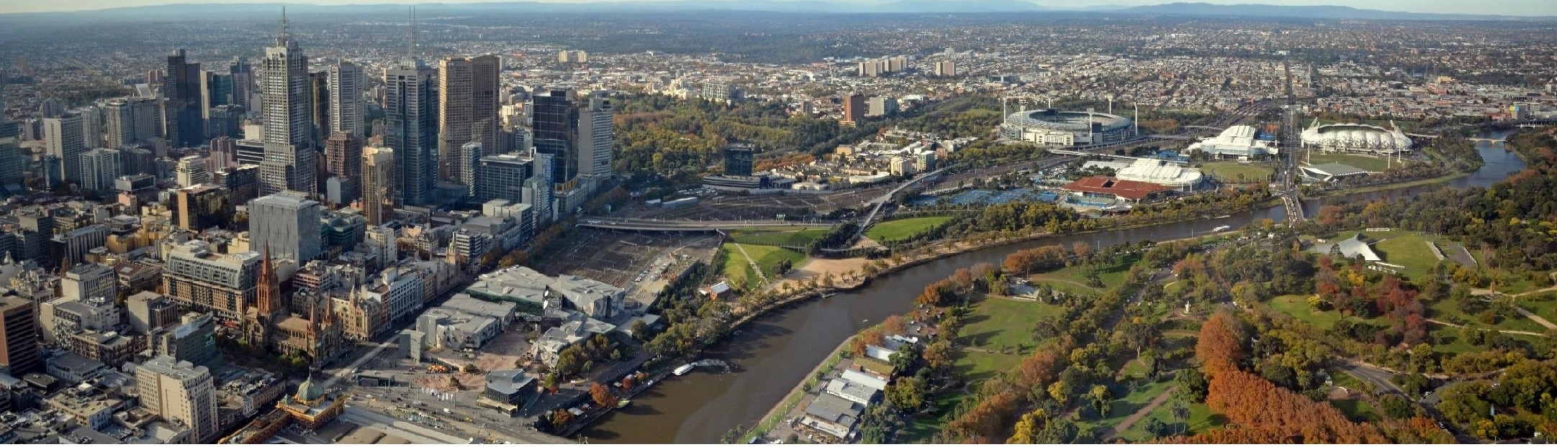

Municipal Emergency Management Collaborations Learnings Report
Final Report (July 2017)

Executive Summary Introduction

Context, scope and study participants Methodology

Findings

Benefits of collaborative models Collaboration objectives
Current practice in Victoria 2017 Findings across key focus areas
Observations, ideas in action, insights from Collaboration members, good practice

Appendices

Appendix A: Map of current Collaborations ac ross Victoria 2

AV | Ambulance Victoria
CFA | Country Fire Authority
EMC | Emergency Management Commissioner
EMCOP | Emergency Management Common Operating Picture
EMV | Emergency Management Victoria
ERC | Emergency Relief Centre
DELWP | Department of Environment, Land, Water and Planning
ICC | Incident Control Centre
IMT | Incident Management Team
LGV | Local Government Victoria
MAV | Municipal Association of Victoria
MEMEG | Municipal Emergency Management Enhancement Group
MERO/ MRM | Municipal Emergency Management Officer / Municipal Recovery Manager
MFB | Metropolitan Fire Brigade
RCC | Regional Control Centre
REMPC/ MEMPC | Regional Emergency Management Planning Committee / Municipal Emergency Management Planning Committee
SOG/ SOP | Standard Operating Guideline / Standard Operating Procedure
VMIA | Victorian Managed Insurance Authority
VicPol | Victoria Police
VicSES | Victorian State Emergency Service

3

•

•

•

•

•
•
•

EM Collaborations and partnerships, including Municipal Emergency Management Enhancement Groups (MEMEG s), are regional committees linking councils with their neighbours and emergency management agencies. Collectively, they strengthen EM capability and capacity, by working together to improve individual council's EM outcomes.

Regional MEMEGs, and other Collaborations are represented on a State MEMEG committee.

Councils acknowledge a limited capacity to individually respond to major emergencies for extended periods of time. The development of the Collaborative groups or committees at a municipal level addresses an identified practical need by the local government sector to improve arrangements between councils to support each other and deliver a more consistent, effective and sustainable service response- in supporting Victorian communities during major emergencies. Using the limited resources available, councils often work together in planning, response, as well as in relief and recovery activities.

LGV (Local Government Victoria) and the Victorian Managed Insurance Authority (VMIA) have partnered with Emergency Management Victoria (EMV) to undertake a study of municipal collaborative models across the state. This study provides an opportunity to contribute and inform broader EM system reforms under way across Victoria.

EMV provided oversight of the study and was supported by a Project Steering Committee with representatives from LGV, VMIA. MAY and State MEMEG.

5

•

•

•

•

The study IS about | The study IS NOT about
Identifying challenges, needs and opportunities for 12 Municipal EM Collaborations | Reviewing EM Committees other than the 12 identified Collaborations
Identifying how the state can better support collaborations | Benchmarking Victorian or interstate Collaborations (beyond the literature review)
Recognising how 12 identified Collaborations work with other EM Committees and other stakeholders | Operations deployment of municipal resources
Influencing the future design of an integrated EM service delivery model for the state that maximises the effectiveness of municipal EM service delivery | Reviewing existing legislative obligations
 | Reviewing planning guidelines process
 | Advising councils on how to collaborate and implement a prescriptive collaborative model

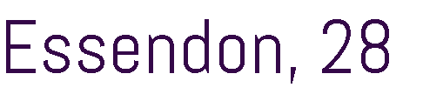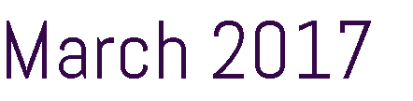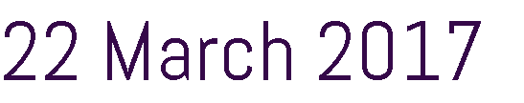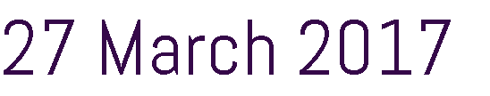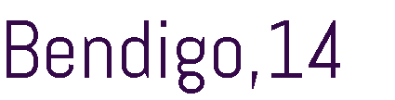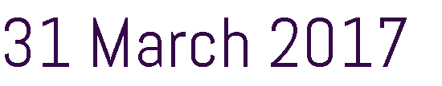
Collaboration | Consultation Format | Consultation details
State MEMEG | Workshop | Essendon, 28 March 2017
Hume Region MEMEG | Workshop | Benalla, 23 March 2017
South West Region MEMEG | Telephone | 22 March 2017
Central Victoria MEMEG | Telephone | 27 March 2017
Gippsland MEMEG | Workshop | Traralgon, 10 April 2017
Southern Metro Region MEMEG | Telephone | 4 April 2017
Wimmera EM Group | Workshop | Horsham, 30 March 2017
North West Metro Region Collaboration | Workshop | Melton, 1 March 2017
Eastern Metro Emergency Management Partnership | Workshop | Box Hill, 31 March 2017
Northern Victoria Emergency Management Cluster | Workshop | Bendigo, 14 February 2017
Murray River Group of Councils | Telephone | 31 March 2017
Grampians MEMEG | Telephone | 20 April 2017

•

•

•

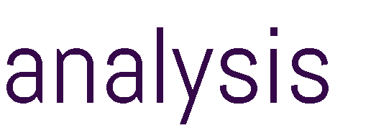

•

•

•

•

•

•

•

•

•

•

•

•

•

•

Focus Areas

Communication & Engagement
The communication, community engagement and stakeholder management activities the Collaboration undertakes, in emergency and non­ emergency contexts
The methodology for consultation had five key focus areas.

They were chosen to provide a consistent and clear approach to understand the Collaboration's operating environments, inputs, outputs, products and community based outcomes.

Organisation
Haw the Collaboration is structured, including the participating local government authorities, chair arrangements and use of sub-committees and working groups

Systems and Technical
The systems and mechanisms in place to support the effective operation of the Collaboration, including training, online systems and portals

10

Community Impact
How Collaborations contribute to community outcomes for emergency management
0
Process
The processes by which the Collaboration achieves its objectives and undertakes it's functions

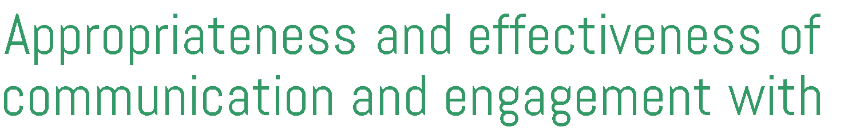

•
•
•
•
•
•
•
•
•
•
•
•

•
•
•
•
•
•
•
•
•
•

•

•

Facilitates enhanced coordination of relief and recovery services
by local government Allows agencies to consult and engage
Creates

Given limited capacity and resources Collaborative Models share resources, knowledge and support for EM
across a number of Local Governments
- one consistent message
Advocacy for efficiencieS
municipal EM issues

Encourages the productive sharing

Builds trust and relationships across the sector

of resources across government Sharing of best Imparts
Generates ideas practiC8 expertise

Transfer of knowledge across
Local Government
Consistent services and response to

InnOvatiO n emergencies
I

Lower organisational risk

Source: Terms of reference, insights tram consultations and workshop
Access to surge capacity if needed
12

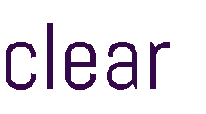

•
•
•
•
•
•
•
•
•

•
•
•
•
•

State MEMEG

To support and advise local government EM practitioners, builds: capability and advocates
on behalf of the local government sector on EM

Gippsland MEMEG Hume MEMEG

Resource, information sharing and coordination Resource, information sharing and in the Gippsland Region. coordination in the Hume Regio
To discuss changes in EM sector

South West Regional MEMEG

To support resource-sharing including staff, and buildings tor relief centers or machinery to assist with clean-up efforts.

Building capacity & knowledge sharing

Participants: State-wide committee including councils, regional MEMEGs, DHHS, EMV, LGV, MFB, MAY, Red Cross, Victoria Police and VicSES.
Participants: South Gippslanc.t, Bass Coast. Latrobe, Wellington, Baw Baw, East Gippsland

Formal MOUs govern practice
Participants: Hume, Wangaratta, Benalla , Mansfield, Wodonga, Towong, Moira, Strathbogie, Mitchell, Murrindindi, Greater Shepparton, Indigo.
Participants: Colac Otway, Corangamite and Surf Coast shires: have formalised an MOU tor collaboration.

The MEMEG includes the above councils

Shire of Nillumbik has just assumed the role of There is funding uncertainty into the chair for the next 12 months future

MAV provides policy guidance

LGV provides administrative support
Formed in December 2012

Hume Region is unique for its seasonal variability, and that it has four alpine Resort Management Boards. which also have EM responsibilities

Hume Region MEMEG does not receive funding and therefore does not have project staff
as well as Warrnambool, Moyne, Glenelg and Southern Grampians:, Moorabool, Golden Plains, Queenscliffe and Greater Geelong

Municipal EM Handbook Municipal EM Orientation Kit
Inter-council Resource Sharing Protocol MECC Practice Note
Annual Forum

Designed and commissioned Standard Operating Procedures which have proven to be effective in Emergency Relief Centres

MEMEG's current project is EM Volunteer, in partnership with Volunteer Victoria, to recruit. train, support, deploy and debrief a workforce of emergency volunteer managers to manage emergency
volunteers during disaster recovery and relief

The MQU enables the member councils to request extra resources tor emergency relief and recovery services it required
EM training modules tor staff of all member councils

14

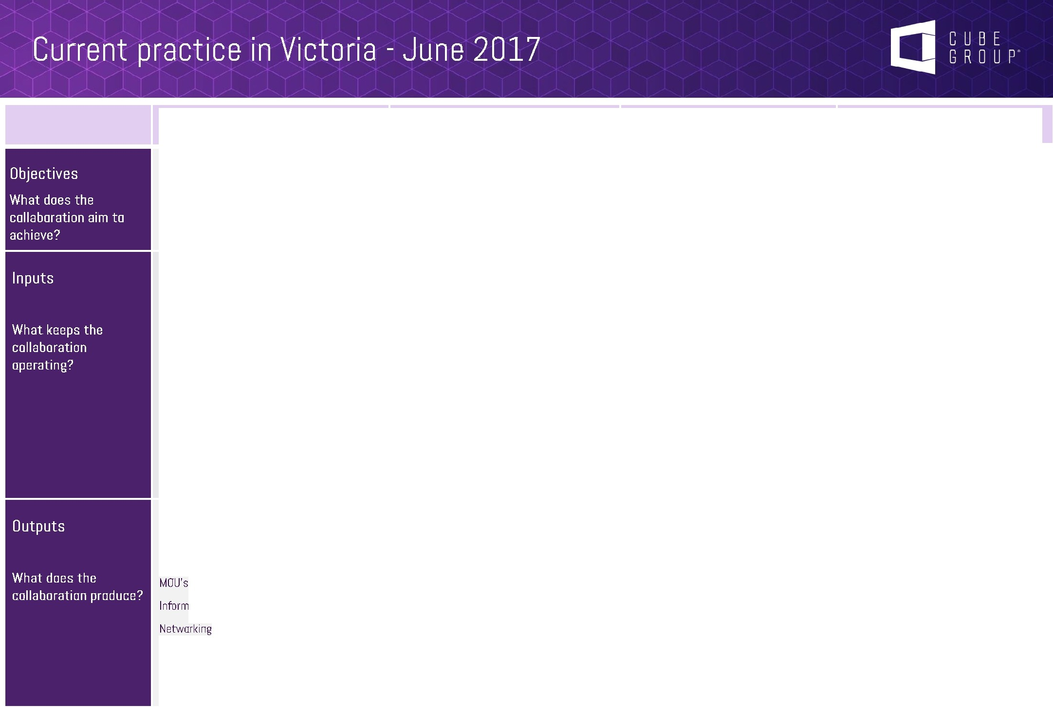
Central Victoria MEMEG

Building and strengthening local relationships, formalising a network in the event of emergencies, building capability and capacity at participating local governments

Participants.: Macedon Ranges., Hume, Wyndham, Melton Hepburn, Moorabool, Mitchell, and Mount Alexander
The group was initially established through funding from the 2011 LG Grants Program, funded by DOJ. The group is administered by the Macedon Ranges Shire Council who provides a small amount of annual funding.
Member councils also provide funding when required e.g. exercises.
The group is predominantly supported by a MERO. The group has also successfully applied fur other grants - Regional Relief Centre Project.

Communication frameworks Relief centre guidelines Annual Exercises

Information Sharing - processes, submissions

Guest Speakers i.e. response and recovery agencies or key EM topics

Eastern Metro EM Partnership

Advocating for the region, working with others, building capacity, improving common ways. of working, strengthening communities.

Participants.: Boroondara, Knox, Monash, Manningham, Maroondah, Nillumbik, Whitehorse, and Yarra Ranges.
Model of self-sufficiency, although some of the officers a-re funded through the MERP.
Councils contribute an agreed amount annually in addition to the in-kind
contributions.

2014 Strategic Plan outlines six working groups, outcomes and initiatives
Training module matrix (compulsory, recommended, optional) and training calendar
EM induction.
Role specific training packages Common recruitment processes MOUs
Regionalised sub-plans
Southern Metro Region Collaboration
To be determined

At the time of writing, Southern Metro Region Collaboration is planning to commence operations in late 20 17.

At the time of writing, Southern Metro Region Collaboration is planning to commence operations in late 2017
North West Metro Collaboration
Enhancing our common ways of working, working with others, building capability, building capacity, advocating for the region and community resilience

Participants.: Banyule, Brimbank, Darebin, Hobsons Bay, Hume, Maribyrnong, Melbourne. Melton, Moonee Valley, Moreland, Nilumbik, Whittlesea, Wyndham and Yarra City
Formal MOU

Collaboration Activation Protocol
Developed and annually review governance structure and sub groups, piloted over the last two years which has proven to be successful in its operation.
Full time regional Support Qffic.er 12 month secondment funded by 14 councils matched funding
Development of training packages and workbooks
More than 1,100 staff trained since the collaboration commenced
Standardised regional documentation Strategic Plan 2016-2019
Regular forums
Inter-c ouncil resource sharing protocol (MOU)
15

Developing programs, processes and tools to enable shared planning and resourcing.
Resource sharing, partnerships, practices and resilience.

Participants: Greater Bendigo, Mount Alexander, Loddon. Campaspe, Central Goldfields
A Shared Ownership Collaboration.
Formation of Project Control Board (CEOs) and Senior Reference Group with Directors from each.
councils contribute an agreed amount annually in addition to the in-kind
contributions (pro-rata according to population)

Integrated Plan

Training programs Integrated Committee Cluster Crisisworks

Murray River Group of Councils

Sharing information, networking, enhancing communication and providing support.

Participants: Mildura, Swan Hill, Gannawarra. Buloke
Links in with Horsham

Th& Murray River Group of councils is wholly self-sufficient and does. not rely on any funding from State or Federal Government to sustain its operations.
As a result of this, the Collaboration only meets. when a need arises.

As the Murray River Group of Councils. is. a relatively new collaboration at the time of writing they have not produced any outputs.

Wimmera Resource Sharing Program
Promote, facilitate and advocate for continuous improvement in EM & council's obligations.
Oversee implementation of standardised processes.

Participants: Horsham, Hindmarsh, West Wimmera-. Yarriambiack.
Each of the Partner councils have appointed a­ MERO. MRM and MFPO. These roles are in addition t o the employee-'s core role and are- supported by the Wimmera EM Team (established by the program) which includes: a Coordinator and
Project Officer.
Th& Wimmera- EM Tea-m is funded by LGV - MERP funding and council co -contributions. There is no Commonwealth funding from the NORG scheme. councils provide monetary or in-kind co-
contributions

The- WEMT supports the EM governance of each council and has oversight on the delivery of their outputs in this area
Joint training between the four partner councils and other neighbouring councils is actively facilitated by the WEMT as training needs and opportunities are identified
Resource Sharing across. four councils

Grampians MEMEG

To better understand diverse issue-s across municipalities, and improve our processes.

Participants: Moorabool Shire, Ararat, Ballarat. Golden Pia-ins. Northern Grampians, Pyrenees (and delegate from Wimmera Project)

Committee is un-funded - rather input is based on the goodwill of participating member organisations

Current acting chair only 50% funded - part of his normal role

Shared training packages have been developed for consistency
Developing a numb.er of task based groups

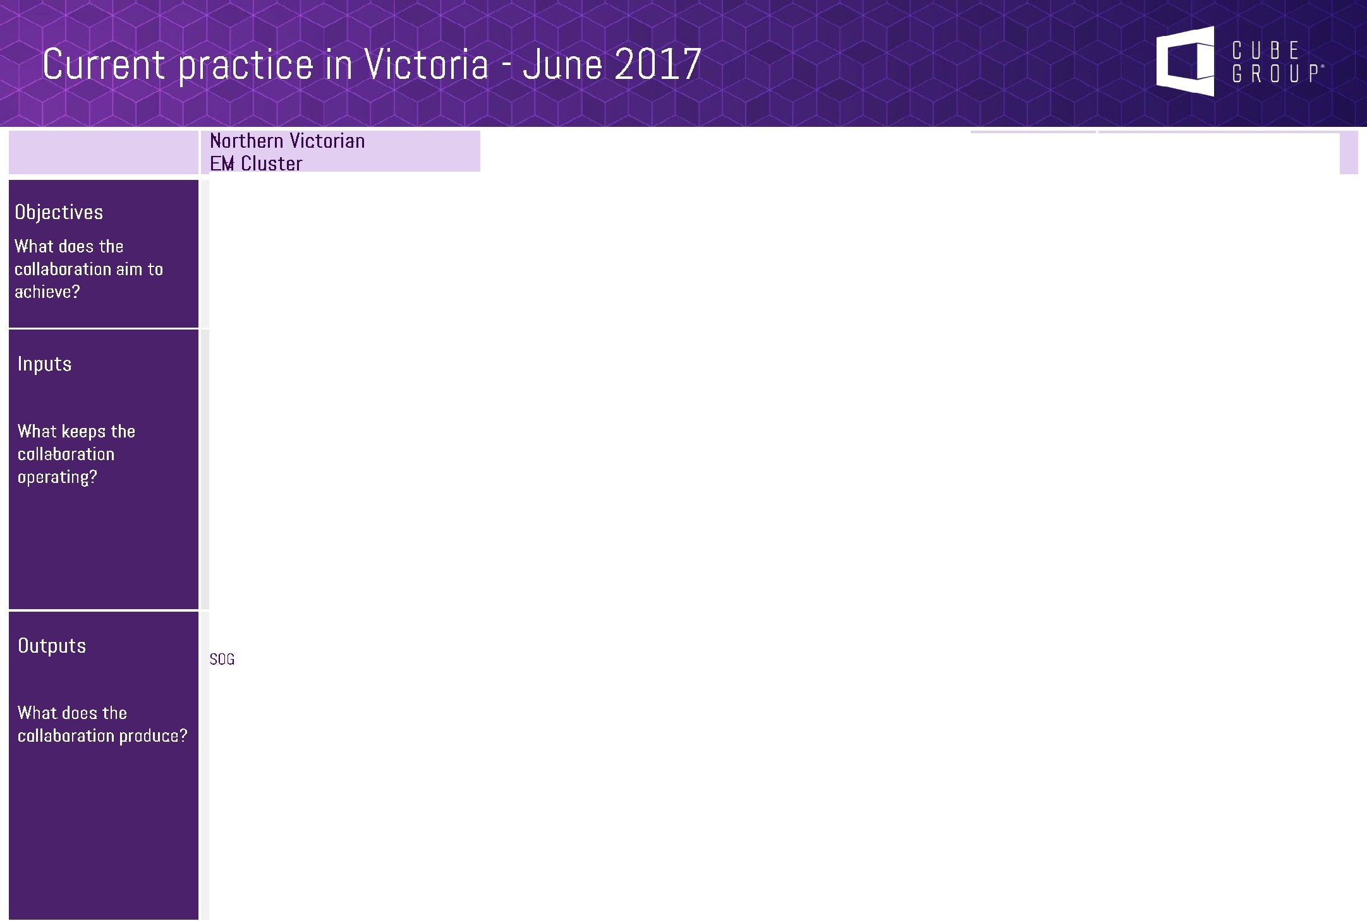
Planning
Capacity and Capability Development

Communication and Engagement
Agency engagement and relationships 16

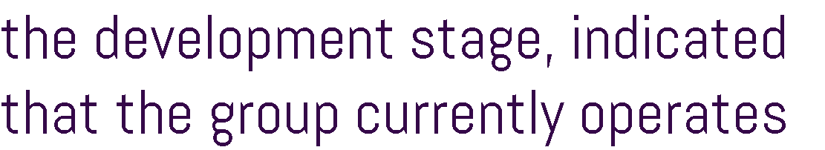

 | •  • | •  •  •  •
 | • The size and composition of Collaborative models varied greatly, and had no evident link to critical success factors or maturity  • The study observed that more mature collaborative models created sub-working groups which focused on specific requirements or provided surge capacity. The focus of the working sub groups ranged from progressing specific strategic project components (such as training exercises, or standard operating procedures) | • There are opportunities to enhance the sharing of good practice ideas generated from working groups.  • This may include State MEMEG taking a more active role in supporting project delivery in areas of strategic importance i.e. training, communication or advocacy projects.  • Depending on the strategic objectives of the Collaboration, many found that a dedicated working group for advocacy helped to better articulate regional/location based issues and represent them at other forums, for example State MEMEG, regional planning groups

FINDING 1

The majority of Collaborative models adapt good governance and practices, operating across a range of organisational structures and sizes

Ideas in action
0

State MEMEG could provide a forum (an annual event, or standing agenda item at meetings) for collaborative models to share 'good practice' governance practices as this w ill assist groups who are still developing their internal organisational processes.
0

There is an opportunity to create 'governance standards' - a baseline for governance practices which would best support Collaborative models.

Some Collaborative models may benefit from adopting a consistent approach in how they demonstrate and communicate their achievements and benefits of the group. This may include newsletter templates, or sending articles to MAV, for example, for profiling in their newsletter. This would assist to build support from stakeholders (including local agencies, local government CEOs, other parts of local government, other stakeholders).
0

Many of the regional and rural Collaboration members acknowledged that distance is a significant and timely barrier to their involvement. Consideration may be given to test new technological practices (teleconference, Skype) ta better support participation and organisation. Equally there are a number of low cost technology platforms available which may also better support co-ordination and communication within Collaborations (interactive internet communication platforms such as 'Yammer').
0

Insights from Collaboration Workshops I Interviews
"We have learnt how to work better together but it has taken time."
"We needed time to improve our work products. We now have a consistent approach to SOG and training guidelines."
Good practice example
The North West Metro Region Collaboration have a well documented approach to MOU development and sign off. This also extends to meeting management processes to ensure all members have the opportunity to contribute and agenda items are provided equitable discussion time. It benefited by having dedicated resources to support governance activities and project delivery.

ltl

Organisation
Review theme | Observations | Additional Findings
 | •  •  •  •  •  • | •  •  •  •
State MEMEG | •There are mixed views of the functionality and success of State MEMEG.  •Some participants have more experience in how and when to engage with State MEMEG – e.g. can depend on existing relationships.  •The consultation indicated that engagement with State MEMEG can be challenging for new participants to the sector. | •There was a strong view that there is an opportunity to review and refocus State MEMEG to better respond to challenges and opportunities faced by local government in EM. By improving role clarity and strengthening the focus on local government priorities, State MEMEG should improve the links between Municipal Collaborations to the State MEMEG, and improve delivery at a state level. Some groups expressed the view that at the moment State MEMEG is quite task focused.

0
The roles, responsibilities and relationships between State MEMEG, MAV, LGV and EMV should be clarified at a state level
and communicated consistently to all stakeholders.

It is important that engagement continues with CEOs and Councillors to build greater understanding and buy-in far emergency management at senior levels and includes local government EM practitioners.
0

This is a timely opportunity far groups ta clarify and test the expectations of stakeholders (agencies, State Government, local government, members) for each Municipal Collaboration (clarify what they want out of Collaborations/ MEMEGs).
0

In the context of significant reform in the local government and EM sectors, the role of Collaborations could be better
0
recognised and supported in business continuity planning, municipal EM planning and policy development.

It is important to clarify the role and strengthen the capacity for State MEMEG to better support delivery of innovative solutions. This may include improving the sharing of best practice ac ross the state, improving co-ordination at a state level
0
(e.g. training requirements), developing guidelines and minimum standards for key documents used by collaborative models.

Insights from Collaboration Workshops I Interviews
Good practice example
It was reported that the CEOs and Mayors in Gippsland understand and respect the role of the MEMEG and seek its advice on issues. EMV and LGV recently engaged the CEOs to discuss EM and there are further opportunities to build on this engagement through the Collaborations (as subject matter experts).
20
'We are doing well but we need more horse power to take things further." "MEMEG has been created to fill the void - LGV has a very different focus." "CEOs are an important link from the partnership ta MAV and Government."

• •

•
•

•
•

•

• •

•

•
• •
•
•

•

Ideas in action
0

While acknowledging the autonomy and localised needs of collaborative groups, consideration may be given to developing a baseline or principles-based approach for key documents or templates (MSIA, SOP, SOG) to improve consistency and reduce duplication of effort.
0

Standard templates could also be supported by the sharing of good practice examples (and an explanation of what 'good practice' is in the context of collaborative models) to increase awareness and capability on what people are doing, and how it can be shared and adapted to meet local needs.
0

Following an event, a review of lessons learnt is always valuable. Consideration could be given to improving the capture and sharing of lessons learnt through existing audits processes relating to EM planning.

A formal induction process for new members to the Collaborative groups is seen as a valuable process. This may involve new members meeting with the chair, clarifying roles, expectations and protocols, such as, how best to engage with State MEMEG.
0

Insights from Collaboration Workshops / Interviews

Good practice example
Eastern Metro Councils Emergency Management Partnership has a formal process for 'induction' at new members. This involves the chair providing each new memb.er with an introductory meeting on the collaboration operating model, current issues and unique operating challenges. This is reported to lead to stronger member
engagement, better knowledge. transfer and positive long term collaboration outcomes.
11As a Committee we are continually reviewing and improving our documentation."

1'Sharing of training tool - if someone develops material they email to group -may not be good practice but good to share."
22

• •

•
•
•

•
•

•

• •

In a time when there is increasing
more consistent and
FINDING 4

benefit from a

Ideas in action
 | ccommunication ac ross t he sector, Collaborations would b
c o |  | -o | rdinated engagement approach to improve outcomes

There was strong support for the development of an 'Engagement Charter' that provides guidance on how to consult with local government and Collaborations - with standard timeframes relevant to local government (lead times for briefing CEO,
0
Council Iors, reporting cycles).

Consideration may be given to creating a new Collaborative Committee (involving EMV, LGV, DHHS, MAV, State MEMEG) which could meet every 6 months to review and consider upcoming consultation. The group could then communicate the proposed pipeline of consultation and engagement.
0
0

A common theme arising throughout the review was the appetite to share good practice and lessons learnt. Communication platforms such as YouTube or Facebook may offer an interesting and innovative way in which to share information between Collaboration members across regions and at a state lev el ta share their insights and views in a dynamic environment.

Examples include YouTube videos, closed Facebook groups fo r discussion or raising questions, or sharing documents or discussion in Slack or Yammer portals.
Internet forums may also support greater participation for those members who have to travel significant distances to attend meetings or forums.

Insights from Collaboration Workshops I Interviews

Good practice example
Northern West Metro Collaboration has established a shared calendar to enable a more efficient and ca-ordinated approach to engagement. The shared calendar ensures the Collaboration is appropriately engaged and Collaboration members are not attending meetings on the same day.
"Some people in focal government are overwhelmed by EM information." "We use the broader EM network to email questions (across Victoria) -
don't limit network ta region."

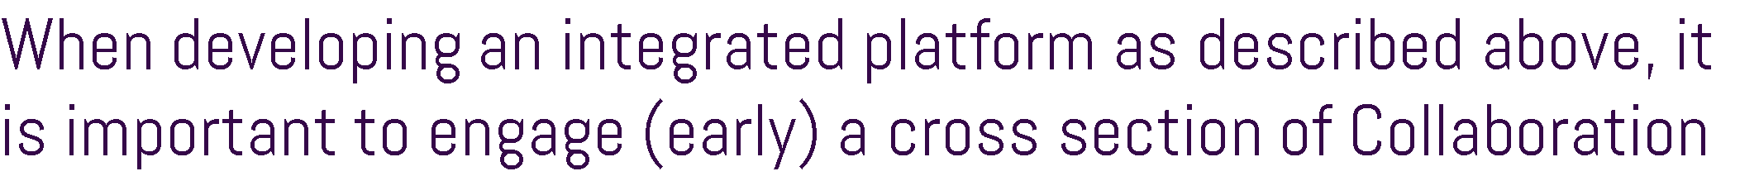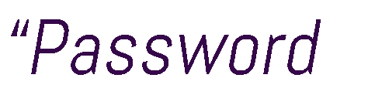

• •

•
•

•
•

•

• •

•
•

•

•

• •

•
•

•
•

• •

Acknowledgements
Thank you to all those who participated in this study.

Cube Group gratefully acknowledges the cooperation of municipal stakeholders for making themselves available to discuss insights into EM collaborations in Victoria. Included in this acknowledgement are members of State MEMEG, Grampians MEMEG, Hume MEMEG, Gippsland MEMEG, South West Regional MEMEG, Central Victoria MEMEG, Eastern Metro Councils EM Partnership, Southern Metro Region Collaboration , North West Metro Collaboration, Northern Victorian EM Cluster, Murray River Group of Councils and the Wimmera Resource Sharing Program.

Cube Group also acknowledge the valuable input of key emergency management stakeholders including, Country Fire Authorit y, Victoria State Emergency Service, Victoria Police, Department of Health and Human Services, Municipal Association of Victoria, Department of Environment, Land, Water, and Planning and the Metropolitan Fire Brigade.

Project Sponsors

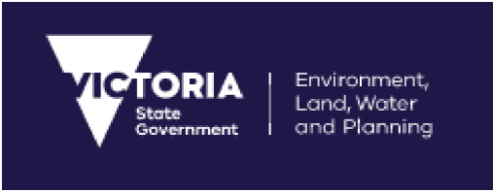EMV
EM ERGENCY MANAG EM ENT VICTORIA
vm,ia4...>

Disclaimer

This Review Report ('deliverable') has been prepared by Cube Management Solutions Pty Ltd ('Cube') for Emergency Management Victoria ('Client'). The content and extent of this deliverable is limited ta the Terms of Reference agreed between Cube and the Client. The deliverable is far the sale use of the Client for the purposes for which it was commissioned, and no third party may rely an or use any part of this deliverable.

Cube has relied an the information provided ta it by the Client and its employee s and agents, and has not (except where noted otherwise) checked the veracity, accuracy or completeness of such information. Except ta the extent that copyright in any part of this deliverable vests in the Client, Cube retains all copyright in this deliverable, no part of which may be used or reproduced in any form except as expressly permitted by the Copyright Act 1868.

For further information:

For more information on LGV's role in supporting local councils in emergency management: Phone: 03 8948 8511
Email: LGV.emergenci es@delwp.vi c. gov.au

For more information about Victoria's emergency management arrangements, visit www.emv.vic.gov.au

EMERGENCY MANAGEMENT COLLABORATIONS IN VICTORIA

-

LEGEND

Centra/VictorianMEMEG Ecmem Metro Councils
=Mallll9ffll"III

-Gippsland MEMEG
- ropo/irialliegion
-HumeMEMEG
ergmcy

- ,:g:roion
- =Re>oorceSl>omg
-Soulh Wes! Regional MEMEG
Grompiom M£MEG

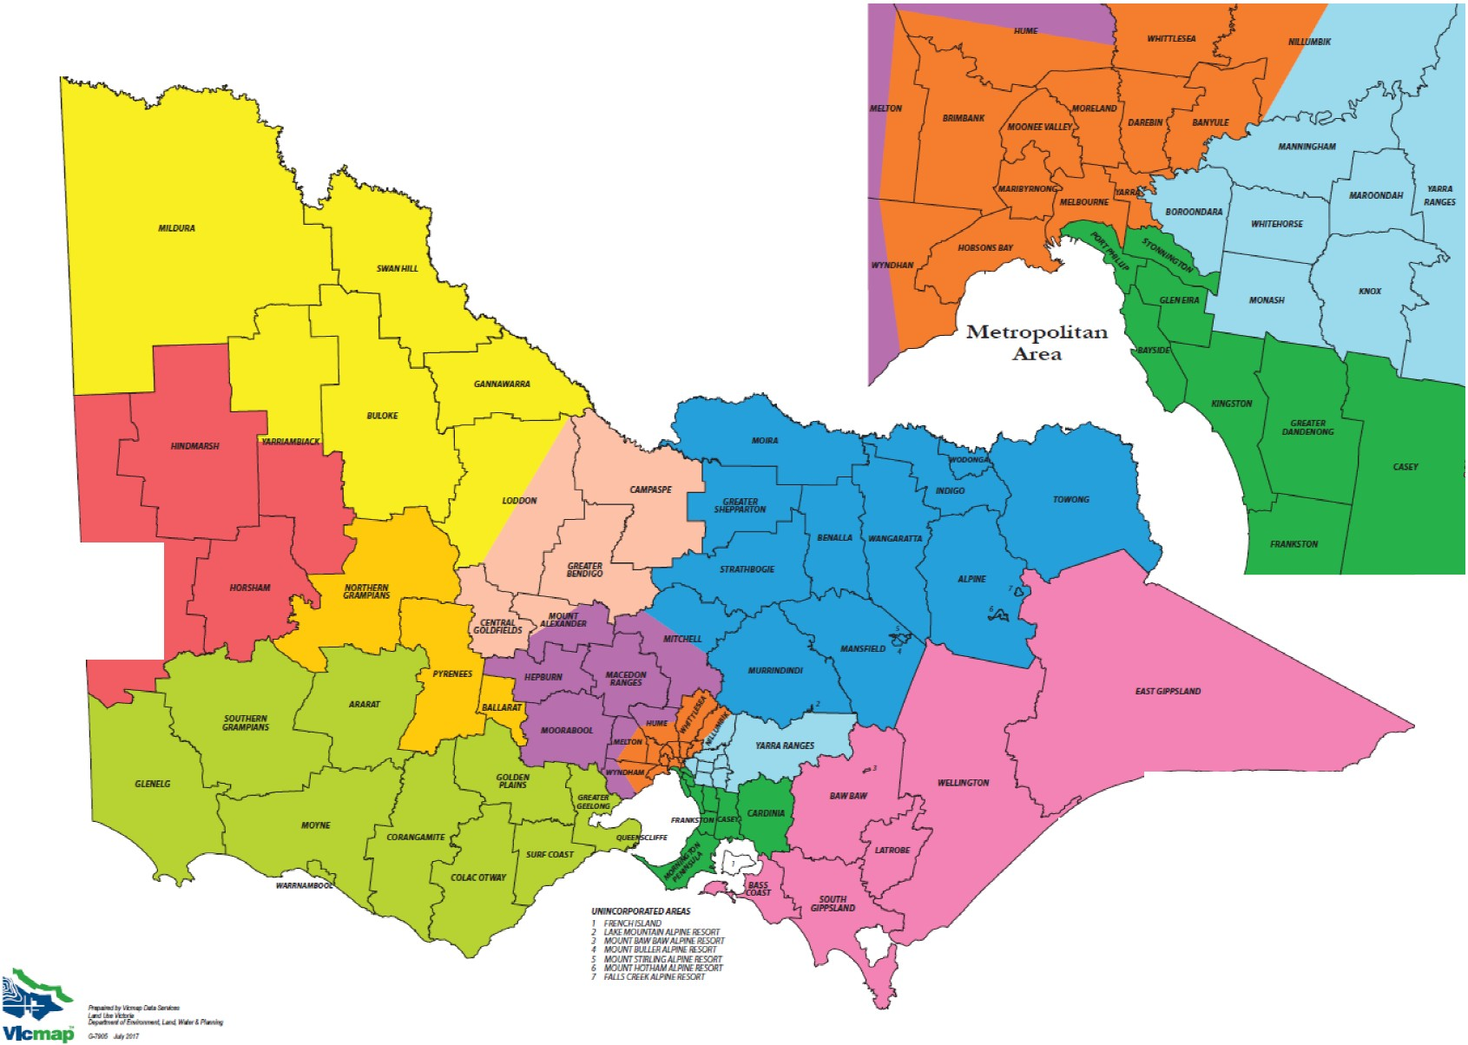
30
Source: Department of Environment, Land, Water and Planning

