Local Government

Better Practice Guide

Annual REport

REPORT OF OPERATIONS 2021-22

Table of contents

Acronyms and Abbreviations 2

Introduction 3

The Local Government Act 2020 3

Objectives and purpose 3

Role of a council 3

About this guide 4

1 Integrated Strategic Planning and Reporting 6

2 Report of operations (Overview) 9

Statutory requirements 9

2.1 The Report of Operations 9

2.2 Better practice guidance 9

3 Report of operations (guidance) 10

Quality and integrity of information 10

Preparation of the report of operations 15

**4.** Materiality guidelines 19

5 Glossary 20

6 References 22

To update Table of Contents:  
> right click in contents area > select ‘Update Field’ > ‘Update entire table’.  
This is automated from styles: Heading 1, 2, 3.

# Acronyms and Abbreviations

|  |  |
| --- | --- |
| AAS | Australian Accounting Standards |
| CEO | Chief Executive Officer |
| EMT | Executive Management Team |
| LGV | Local Government Victoria |
| VAGO | Victorian Auditor-General’s Office |
| VCAT | Victorian Civil and Administrative Tribunal |

# Introduction

Local government in Victoria manages approximately $114.07 billion of community assets and infrastructure and spends around $9.8 billion on the provision of services annually.[1] Local government, in partnership with other levels of government, is responsible for aspects of everyday life that people care about deeply – from vibrant and safe public spaces to accessible libraries, to strong local business and employment opportunities. Effective planning and reporting by councils are essential for ensuring transparency and accountability to the community and other levels of government as to how public money is being spent and the quality of services delivered.

## The *Local Government Act 2020*

Objectives and purpose

The *Local Government Act 2020* (the Act) received Royal Asset on 24 March 2020 with proclamation to occur in stages. The Act is a principles-based Act, removing unnecessary regulatory and legislative prescription.

The objectives of the Act are as follows:

*The objectives of this Act are to ensure that –*

1. *local government continues to be constituted as a democratically elected tier of Government in Victoria; and*
2. *Councils are constituted as representative bodies that are accountable, transparent, collaborative, efficient and engaged with their communities; and*
3. *Councils have the functions and powers necessary to enable Councils to perform their role.[2]*

The purpose of the Act is as follows:

*The purpose of this Act is to give effect to section 74A(1) of the* ***Constitution Act 1975*** *which provides that local government is a distinct and essential tier of government consisting of democratically elected Councils having the functions and powers that the Parliament considers are necessary to ensure the peace, order and good government of each municipal district.[3]*

Role of a council

The Act specifies the role of a council is:

*“…to provide good governance in its municipal district for the benefit and wellbeing of the municipal community.”[4]*

The provision of good governance includes a council performing its role in accordance with the overarching governance principles. The overarching governance principles are set out in section 9(2) of the Act. The overarching governance principles include (amongst other principles) that:

* Council decisions are to be made and actions taken in accordance with the relevant law
* The economic, social and environmental sustainability of the municipal district, including mitigation and planning for climate change risks, is to be promoted
* The ongoing financial viability of the Council is to be ensured, and
* The transparency of Council decisions, actions and information is to be ensured. [5]

The overarching governance principles are supplemented by the supporting principles. Section 9(3) requires councils to take into account the supporting principles in giving effect to the overarching governance principles. The supporting principles are:

* The community engagement principles
* The public transparency principles
* The strategic planning principles
* The financial management principles, and
* The service performance principles.[6]

It is a statutory requirement under the Act that councils prepare and report on long, medium and short-term plans to discharge their duties of accountability and transparency to their communities.

## 

## About this guide

Councils are required to prepare an annual report in respect of each financial year consisting of three parts:

* **Report of operations:** information about the operations of the council
* **Performance statement:** audited results achieved against the prescribed performance indicators and measures
* **Financial statements:** audited financial statements prepared in accordance with the Australian Accounting Standards.

This guide has been developed to help local government in meeting the statutory requirements relating to the preparation of report of operations. Guidance on the preparation of the audited performance statement and audited financial statements can be found at the Local Government website <https://www.localgovernment.vic.gov.au/council-innovation-and-performance/sector-guidance-planning-and-reporting>. The guide is presented in four sections.

1. **Integrated Strategic Planning and Reporting Framework** provides an overview of the relationship between the key planning and reporting documents
2. **Report of operations (overview)** provides an overview of the statutory requirements and best practice guidance for preparing a report of operations
3. **Report of operations (guidance)** provides detailed guidance on the preparation of a report of operations, including guidance on the quality and integrity of information and the inclusion of information required by other legislation applicable to local government

This guide is intended for use by specialists in the field of local government planning and reporting. It will also be instructive for senior officers including chief executive officers (CEOs) and councillors. Each council retains the responsibility for preparing their report of operations, including the format and the disclosures made. This guide represents the required presentation of LGV.

Within this guide there are references to related information and further guidance. A full list of resources can be found in the reference section. Footnotes are used to reference legislative provisions and other information. Illustrative information and examples are provided in tables and boxed text.

A full sample of the report of operations has been produced and is available as the Local Government Model Report of operations.

# Integrated Strategic Planning and Reporting

Part 4 of the *Local Government Act 2020* addresses planning and financial management. The legislative requirements to develop strategic planning, budgeting and annual reporting documents in Part 4 came into operation on 24 October 2020.

The Act introduces strategic planning principles for Victorian councils which include an integrated approach to planning, monitoring and performance reporting.[7] This important shift from a more prescriptive form of legislation to a new Act that is principles-based is explored further in the *Integrated Strategic Planning and Reporting Discussion Paper* which is available at <https://engage.vic.gov.au/local-government-act-2020>.

Part 4 of the *Local Government Act 2020* requires councils to prepare the following:

* A Community Vision (for at least the next 10 financial years)[8]
* A Council Plan (for at least the next 4 financial years)[9]
* A Financial Plan (for at least the next 10 financial years)[10]
* An Asset Plan (for at least the next 10 financial years)[11]
* A Revenue and Rating Plan (for at least the next 4 financial years)[12]
* An Annual Budget (for the next 4 financial years)[13]
* A Quarterly Budget Report[14]
* An Annual Report (for each financial year),[15] and
* Financial Policies.[16]

The Act also requires councils to prepare:

* A Workforce Plan (including projected staffing requirements for at least 4 years).[17]

The legislative timeframes for development, review and adoption of the elements of the Integrated Strategic Planning and Reporting Framework (ISPRF) and the time horizons for each element vary. However, there are also many linkages, including the central importance of community engagement. It is therefore vital to recognise the relationships and degrees of integration between different elements. To aid this process, visual representations of the ISPRF have been developed.

The following diagram provides an overview of the core legislated elements of an integrated strategic planning and reporting framework and outcomes.

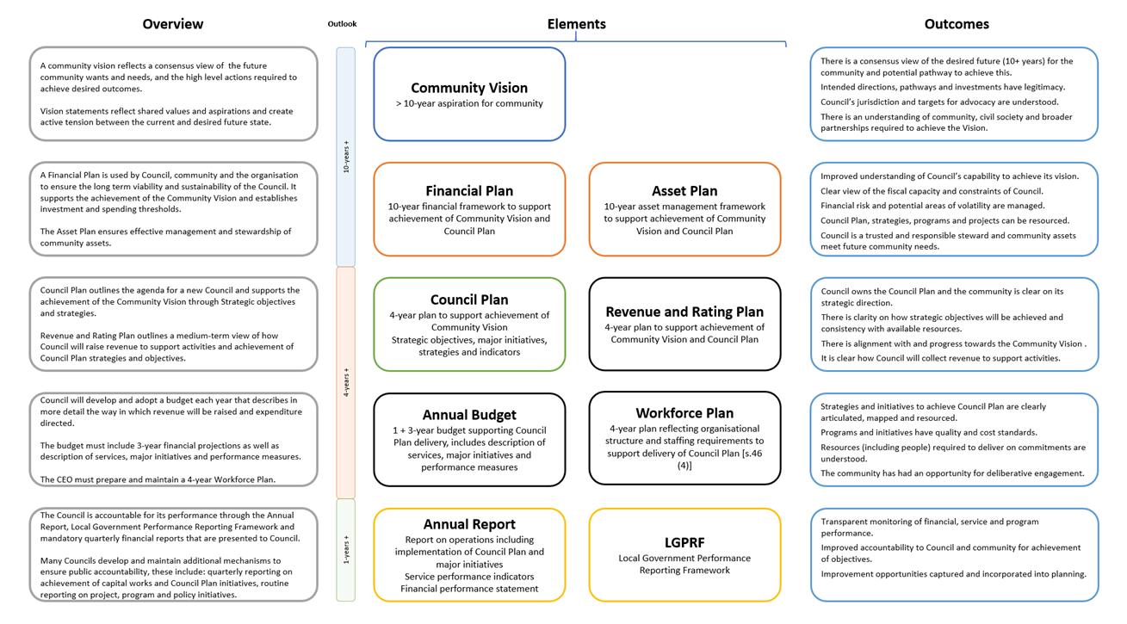

*Figure 1: Department of Jobs, Precincts and Regions 2020*

The following figure demonstrates how each element might inform or be informed by other parts of the integrated framework.

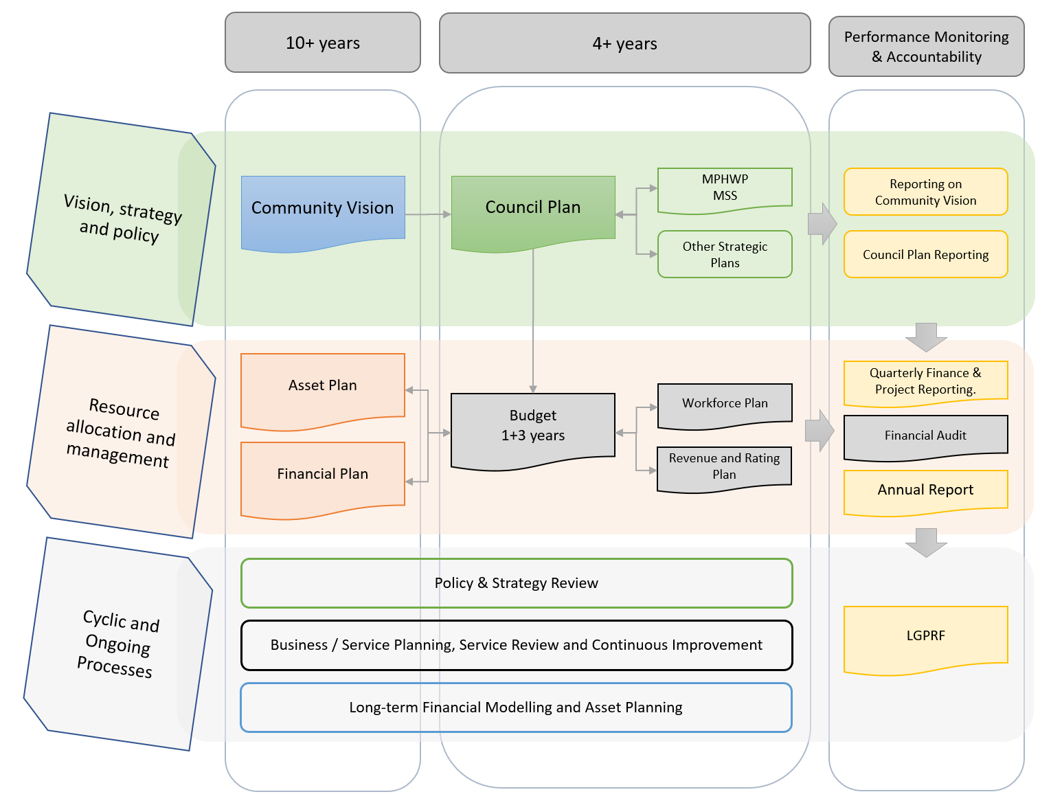

Note: this shape denotes mandated plans and strategies. 

*Figure 2: Department of Jobs, Precincts and Regions 2020*

While this guide is focused on one element of the ISPRF – the financial statements within an Annual Report – it is important to recognise the broader framework within which this reporting occurs.

# Report of operations (Overview)

## Statutory requirements

***“The Act requires a council’s annual report to contain a report of operations.”***

The report of operations provides a vital interface for demonstrating the operational efficiency, effectiveness and overall performance of the council organisation to its residents and ratepayers.

Distinct from the performance statement which has a financial focus, the report of operations is the key mechanism for presenting how a council is achieving its operational and strategic goals.

The statutory requirements for the report of operations are set out in section 98 of the Act. Section 98(2) outlines that annual report must contain a report of operations for the council.

Section 98 of the Act states that a “council must prepare an annual report in respect to each financial year”. Within that annual report, the Act requires the council to include a ‘report of operations’.

## The Report of Operations

The Report of Operations is a statutory requirement under section 98(2) of the Local Government Act 2020.

Section 98(3) of the Act states that the report of operations must contain:

* + a statement of progress on the implementation of the Council Plan
  + a statement of progress in relation to the major initiatives identified in the budget
  + the results of council’s assessment against the governance and management checklist, service performance indicator results (as detailed in Schedule 1 and 2 of the Local Government (Planning and Reporting) Regulations 2020, and
  + and general information on the activities of the council

In addition to section 98 of the Act, councils should review part four of the regulations for further information required in the performance statement.

## Better practice guidance

The report of operations is a key section of the annual report whereby council makes itself accountable to the community and contains information about the performance of the council for the financial year.

In 2012, the then Victorian Auditor-General’s Office (VAGO) recommended that all councils should critically review the performance information in their annual reports to ensure it is relevant, balanced, appropriate and clearly aligned with their council plan strategic objectives to ensure performance reporting is meaningful to the community.[18] In response, the Victorian Government introduced a mandatory system of performance reporting (Local Government Performance Reporting Framework – LGPRF) in 2014-15 which prescribes performance information to be included in council annual reports. Further guidance to assist councils report against the prescribed performance indicators and measures can be found in the *Local Government Performance Reporting Framework Indicator Guide*.

# Report of operations (guidance)

## Quality and integrity of information

**Internal control environment**

All performance information reported by a council to the community, ratepayers and other stakeholders should be subjected to a robust review to ensure the factual accuracy and integrity of the information. Internal control environment in this context refers to:

* + - * a council’s tone and attitude towards transparent performance reporting
      * the level of commitment to high quality internal and external reporting
      * the policies, procedures and quality assurance protocols implemented to provide reasonable assurance regarding the accuracy of performance measures reported
      * the level of oversight by a council’s Executive Management Team (EMT), audit committee and the councillors themselves.

In plain language, what the organisation does to provide councillors with assurance about the performance information the council reports to the community.

Councillors take ultimate responsibility for the performance of a council and are accountable to the ratepayers and community of the municipality. As councillors are not involved in the day-to-day operations of the council, they rely on the organisation’s policies, procedures and quality assurance protocols to provide assurance about the information reported to them and that they in turn report to the community and other stakeholders.

Performance reporting by a council in the annual report, whether it is in the report of operations or the performance statement, can often be more readily understood by members of the community than the financial reports. While councils have an extensive and mature environment in place to provide assurance around financial performance information, the environment for reporting non-financial performance information about services and outcomes has not historically been as developed.

**Policy**

To support the need to have a strong internal control environment around performance reporting, a council should adopt a performance reporting policy providing an overview of a council’s attitude and commitment to performance reporting. Suggested content for a performance reporting policy is outlined below.

|  |
| --- |
| **A performance reporting policy should include:**   * the council’s objectives in reporting performance (i.e. is it a compliance exercise, or does council seek internal focus and motivation from performance reporting?) * identification of the council’s stakeholders (i.e. does compliance with the regulations through the annual report disclosures meet stakeholders’ information requirements?) * the protocols for the dissemination of performance information by the council in circumstances other than formal published performance reports (i.e. are performance measures reported to the audit committee and councillors throughout the year and how rigorous is the process of verifying the performance measures reported?) * whether the council considers the prescribed indicators of service performance, financial performance and sustainable capacity to be a relevant, appropriate and comprehensive set of indicators of the council’s performance against its stated strategic objectives (i.e. has council identified a need to provide additional information, indicators and measures to communicate performance?) * the level of assurance that the CEO and principal accounting officer require to enable them to certify the performance statement (i.e. is the assurance provided by a direct review of the supporting evidence by the CEO and principal accounting officer or is assurance provided by the responsible directors for each relevant service area?) * the role of the audit committee in advising the council of the adequacy of the council’s performance reporting to external stakeholders * the level of assurance the councillors require to enable adoption of the performance statement. |

**Procedures**

The council should also document the procedures involved in preparing performance reporting information to build and retain the organisation’s knowledge. Formalised procedures can provide efficiency and enhance planning to ensure timeframes are met where performance reporting is prepared infrequently throughout the year or in circumstances of staff transition. Standardised procedures for performance reporting can also enhance consistency of the information reporting, particularly where the measures are reported across a time span of several years. Suggested content for performance reporting procedures is outlined below.

|  |
| --- |
| **Performance reporting procedures should include:**   * specific sources of data for each indicator (i.e. software, report name, report fields selected, any filters applied and supported with screen captures or hard copy examples) * contact details for relevant personnel both internally and where data is provided to the council by third parties (e.g. Department of Health or operators of outsourced services) * nomination of officers responsible for the collation and verification of data collected * the frequency at which data needs to be collected (i.e. daily, weekly, monthly, quarterly or annually) and the lead time on collecting the data * identification of other controls that may exist in the collection and verification of indicator data to ensure it is complete and accurate (e.g. is the data monitored on a regular basis to identify unusual or unexplained variances?) * nomination of the council officer responsible for ensuring performance reporting data is centrally collated in time for: * internal reporting * preparation of the performance statement * audit of the performance statement * the timing and frequency with which performance indicators and measures are reviewed by the EMT * the actions to be taken by the audit committee when reviewing the draft performance statement * the format of any formal statements provided by responsible officers to the CEO, principal accounting officer and councillors. |

**Third party information**

Some of the prescribed indicators require the collection of supporting data from sources external to the council. These include:

* annual community satisfaction survey results from LGV
* municipal population and socio-economic disadvantage data from the Australian Bureau of Statistics
* statutory planning results from the Planning Permit Activity Reporting System (PPARS)
* maternal and child health results from the Child Development Information System (CDIS)
* notice of decisions from VCAT hearings.

The planning process for the preparation of performance reporting should separately identify data required from external sources and the reporting timetable and data format requirements should be communicated to the third party data providers to ensure the council receives the correct data at the required time.

The format and content of the data received from third parties should be sufficiently robust to support the level of assurance required by councillors, the CEO and the principal accounting officer in certifying the performance statement. As a number of the indicators will be subject to audit, council officers should request supporting evidence at a level that enables a critical review and assessment of the reliability of the data provided. For example, an email advising a numeric input for a measure’s numerator or denominator does not provide the same level of assurance as a copy of the source report from that third party’s operational software.

It is not uncommon for a council to outsource the operation of some service areas such as the operation of swimming pools or the kerbside garbage and recycling collections. While a council can outsource some day-to-day operational activities, it still retains responsibility for the oversight of the provision of the service to the community and ultimate risk in the management of facilities and operations.

Councils may need to review and revise service level agreements with contracted service providers to ensure the data required for performance reporting is provided within the council’s required timeframe.

**Operational control**

In some instances, a council that has outsourced the provision of services or transferred the functional operation of facilities through formalised contracts, leases or funding agreements may believe that it no longer has operational control of the service. If a council does not believe it has operational control of one of the prescribed services and does not collect data to facilitate performance reporting, it will need to obtain and document an understanding of the background of the original outsourcing decision and why it does not believe it can influence the outcome of the service delivered. Suggested tests for determining operational control of a service are outlined below.

|  |
| --- |
| **Tests for operational control of a service:**   1. If the service is asset dependent such as in the case of a pool then the first test will be whether all the risks and rewards associated with owning the asset have been transferred away from the council (e.g. this could be done through a lease agreement) 2. The second test relates to whether the council has significant influence over the service outcomes (i.e. does the council have the capacity [ability or power] to substantially affect the outcomes of the service. For example, this might be the case if, despite the council making a financial contribution, decisions over the service outcomes rest with the funding agency). |

In many instances a council retains a sufficient level of responsibility and obligation under the formal agreement that would suggest the service is still ultimately under the control of council.

**Audit committee**

The audit committee is an advisory committee to the council and its membership is usually a combination of councillors and independent advisors. This provides a balance between in-depth understanding of the council’s strategic objectives and operations and the independence required to challenge the information presented to the council for consideration. The audit committee should review the service performance indicators and other performance information disclosures in the draft report of operations and consider the results in the context of any interim reports received throughout the year as well as challenge any unusual or unexpected results. The audit committee’s review should include an assessment of the materiality thresholds applied for each service performance indicator and the resulting explanations of material variations to ensure the explanations are adequate and consistent with their understanding of the council’s performance. It should also review the report of operations as part of the internal control environment to ensure that it is consistent with the audited financial statements and performance statement.

The audit committee’s assessment of the quality of the assurance provided to support the performance information will be enhanced if the audit committee receives reports on the service performance indicators and other performance information on at least a quarterly basis throughout the year enabling the members to establish a level of normalised and expected results. The audit committee’s charter should include its roles and responsibilities in regard to the council’s reporting of performance as part of an overall performance reporting framework.

**Events after year end**

Occasionally an event will occur after the end of the reporting year that could impact on the manner in which the performance indicators and measures are reported or interpreted (e.g. a particular service provided by the council could cease after 30 June).

The council’s framework for performance reporting should include procedures to ensure any events that occur after year end that could impact on the results are identified and brought to the attention of the council, CEO and principal accounting officer prior to adoption of the annual report.

A mechanism for this procedure could be to seek a formal certification from each of the responsible managers/directors dated as close as possible to the date of certification.

**Roles and responsibilities**

In order to meet the reporting timelines for preparation of the report of operations a council should formally allocate roles and responsibilities across the council. The following table provides a summary of the responsibilities for each of the key parties in regard to the following performance information disclosed in the report of operations in the annual report:

* governance and management checklist[19]
* prescribed indicators and measures of service performance and the results achieved[20]
* a statement that reviews the performance of the council against the council plan including results achieved in relation to the strategic indicators included in the council plan.[21]

|  |  |
| --- | --- |
| **Role** | **Responsibilities** |
| **Service area officer** | * extract /collate data to calculate results * request and obtain data from third parties (if applicable) * critically review data to ensure the data is accurate and complete * provide supporting evidence in preparation for management review |
| **Service area manager/director** | * review results * review the supporting source data to verify the calculation of the results * investigate unusual or unexpected results * monitor negative or unanticipated trends and recommend options for an appropriate response * provide explanations for material variations * provide assurance representations to EMT as to the accuracy and completeness of the results and the adequacy of the supporting source data |
| **Performance reporting officer[22]** | * prepare the performance reporting workplan and timetable * communicate requirements to responsible service areas * collate quarterly and final results to be reported * provide quarterly performance reports to the EMT, audit committee and Council * prepare the governance and management checklist, service performance indicators and other performance information disclosures for review |
| **Executive Management Team (EMT)** | * receive and consider quarterly performance reports * consider recommendations for intervention where unfavourable or unanticipated trends are identified * review the draft governance and management checklist, service performance indicators and other performance information disclosures and consider the results in the context of the quarterly reports received throughout the year * identify material variations at the council level for explanation (i.e. in the context of the council’s priorities) * review the assurance representations provided by service area managers/directors * provide a recommendation to the CEO and principal accounting officer |
| **Chief Executive Officer (CEO)** | * review and approve the draft governance and management checklist * review the materiality levels adopted in identifying the variations requiring explanations for the service performance indicators * review and approve the draft explanations for material variations for the service performance indicators * review the recommendation provided by EMT for the draft service performance indicators and other performance information disclosures * provide a recommendation to the audit committee * provide a recommendation to the council * certify the governance and management checklist |
| **Audit committee** | * receive and consider quarterly performance reports * review the draft governance and management checklist, service performance indicator and other performance information disclosures and consider the results in the context of the quarterly reports received throughout the year challenging any unusual or unexpected results * enquire as to the internal control framework and level of assurance received around the accuracy and completeness of the information reported * review the report of operations to ensure that it is consistent with the audited financial statements and performance statement * review the recommendation provided by the CEO for the draft governance and management checklist, service performance indicators and other performance information disclosures |
| **Council** | * receive and consider quarterly performance reports * have the mayor certify the governance and management checklist * submit the annual report to the Minister * consider the annual report at a meeting of the council. |

In addition to the above key parties, it is recommended that councils establish a performance reporting team to improve the coordination and integration of the performance reporting process. The team should be made up of the performance reporting officer, service area officers and principal accounting officer.

Each of the parties in the above table also has similar responsibilities in regard to performance information disclosed in the **performance statement** in the annual report including the prescribed indicators and measures of service performance outcome, financial performance and sustainable capacity and the results for each indicator.[23]

For **further information** refer to:

* Department of Jobs, Precincts and Regions (2021), *Local Government Better Practice Guide Performance Statement,* State of Victoria
* Department of Jobs, Precincts and Regions (2021), *Local Government Model Performance Statement*, State of Victoria

## Preparation of the report of operations

**Form and content**

The Act requires a council to include a report of operations in its annual report. While the format of the report of operations is not prescribed, the Act and regulations require the report of operations to contain:

* + - * a statement of progress in relation to the major initiatives identified in the budget
      * the results of council’s assessment against the governance and management checklist
      * the results against the prescribed service performance indicators and measures for the financial year and three preceding years along with an explanation of material variances
      * a statement which reviews the performance of the council against the council plan including outcomes in relation to the strategic indicators in the council plan
      * economic or other factors which have had an impact on the council’s performance
      * major capital works expenditure
      * major changes which have taken place during the financial year and the reasons for those changes
      * other major achievements
      * the services funded in the budget and the persons or sections of the community who are provided the services
      * information about the councillors, senior management, organisational structure and contact details
      * details of current allowances fixed for the mayor and councillors
      * details of the expenses including reimbursements of expenses for each councillor and member of a council committee paid by the council
      * a list of any delegated committees established by the council including their purpose
      * a summary of the number, gender (women, men or persons of self-described gender) and employment classification of council staff including details of any equal opportunity program
      * a list of any prescribed documents to be made available for public inspection and the ways in which they are available to the public.[24]

In addition, for councils who have adopted a Procurement Policy (consistent with section 108 of the 2020 Act) from 1 July 2021 or for any period during the financial year where council had a policy that complied with the 2020 Act, council must:

* include a list of contracts entered into with a value above Council’s Procurement Policy contract value (threshold) for invitation to tender or expression of interest, and
* identify any contract as listed above where the Council did not invite a tender or seek an expression of interest and which did not meet the conditions to purchase goods or services without a inviting a public tender or expression of interest[25].

For councils that did not have a Procurement Policy consistent with section 108 of the 2020 Act for any period during the financial year, council must:

* include a list of contracts entered into with a value of $100,000 or more where the Council did not engage in a competitive process.[26]

Additional service performance indicators can be included by councils in the report of operations, but they should be consistent in design with the performance reporting framework.

Councils are also required to disclose other performance related information in the **performance statement** in the annual report including the prescribed indicators and measures of service performance outcome, financial performance and sustainable capacity and the results for each indicator.[27]

The performance information in the report of operations along with that in the performance statement should form part of an overall council performance reporting framework with quarterly reporting of performance results to senior management, the audit committee and councillors. Taking an integrated approach to performance reporting can assist councils understand how well their organisations are performing in meeting the needs of their communities as well as achieving the strategic objectives in their council plan.

**Materiality**

The regulations require the report of operations to contain an explanation of any material variations in the results against the prescribed service performance indicators and measures. Materiality, in the context of performance reporting is the threshold at which omission or misstatement of information could influence the decisions made and expectations formed by reference to the data reported. For example:

* a significant change in a service performance result that does not have an explanation could give the reader the impression that the service is not important to the council
* a significant misstatement in a sustainable capacity result could result in incorrect strategic planning decisions being made by the council in the future.

The decision about what is material has both qualitative and quantitative factors. The qualitative factors include:

* the council’s overall strategic objectives and priorities as identified in the council plan
* the relative importance of the service to the council in the context of its whole operations
* what is important to the stakeholders and readers of the performance statement
* the relevance and appropriateness of the indicator in accurately reporting performance
* the drivers underlying the calculation of the measure.

An indicator that is more important to a council or its stakeholders will be more sensitive and therefore will have a lower materiality threshold and require more expansive explanations. Conversely a less sensitive indicator can bear a higher materiality threshold and will require less or no explanation of variations.

Quantitative factors are easier to define as indications of materiality, however councils should be aware that even though a variation may not be significantly different when quantified the variation may be important and warrant explanation when assessed against the qualitative materiality factors. The results of the prescribed indicators and measures consist of absolute numbers, percentages, ratios and dollars and accordingly the materiality threshold decision will be different for each indicator.

Section 4 of this guide contains quantitative materiality guidance for explaining material variations in the results of the prescribed performance indicators and measures in the report of operations for the following comparisons:

* current year versus the prior year results
* current year versus the three preceding year results.

Each council will need to make their own assessment of the appropriate materiality threshold taking account both qualitative and quantitative factors and circumstances specific to themselves. While the explanations of material variations will not be subject to audit, they should be capable of substantiation and supported by adequate source documentation.

**Material Variations**

There is only a minor difference between material variation statements (or ‘material variations’) and comments. Comments, while not mandatory, are strongly encouraged to allow councils to provide context around their results, especially in cases of particularly high or low results. Material variations on the other hand, are mandatory, and explain a year on year variation exceeding the materiality threshold (which is either set by council or taken from *Local Government Victoria’s Report of Operations and Performance Statement Better Practice Guidance*).

Material variation explanations should be provided in the following circumstances:

* material variations between the current year and prior years’ results (as explained under ‘Materiality’). For the Financial Performance indicators, this will also include material variations between the current year and forecast results.
* zero results. This includes where the Council has operational control over the service but did not provide the service during the reporting period or is unable to report any data for the service.
* major changes. This includes changes to services or unplanned financial or other events which have impacted the result(s).
* differing figures to annual report. This includes figures published in the annual report and later amended on the Know Your Council website, and figures amended from prior years.

Where results sit inside the materiality threshold, councils are encouraged to provide a qualitative statement.In the case of Council not wishing to make a comment, the material variations section should simply be left blank in the Performance Reporting template. Councils may wish to publish the term ‘no material variations’ in the Annual Report, however comments with regard to the expected or permissible range should be avoided in both the template and Annual Report**.** It is recommended that Council consider providing commentary around all indicators where possible, to provide context to readers, even in cases where year on year variances may be immaterial.

The nature of the Know Your Council website is to ensure council performance is accessible to the public, and as such, councils should consider their audience when drafting comments or material variations. LGV allows comments and material variations to differ on the Know Your Council website from the Annual Report, to address different audiences. These comments and material variations should convey the same message and must be careful not to contradict each other. In the case of website comments, for example, councils may wish to include a URL link to corresponding documents or council where relevant. The link will then appear as a hyperlink on the *Know Your Council* website, however, may not be useful in the context of the Annual Report.

In 2016, it was agreed with VAGO that for 2015-16 and 2016-17 previous year results, if incorrect, could be changed by councils to ensure comparable year on year data. In 2018 it was agreed that from 2017-18 onwards there would be no further changes to data from previous years. If information has come to light which changes the result for a previous year following the data being published on the Know Your Council website, councils should reference this in the current year commentary, particularly where it results in a significant year on year variation.

Councils are also required to identify whether data is to be reported for each measure using the DATA APPLICABLE column in the Performance Reporting Template. For each measure, councils must select from the drop-down box either APPLICABLE or NO DATA.

Material variations should be provided in some of these examples, as explained in the following table:

|  |  |
| --- | --- |
| APPLICABLE | Council provides and has operational control of the service, and data will be reported in the template. |
| NO DATA | Council either provides the service but is unable to report data in the template for the reporting period or does not have operational control of the service. If council provides the service, but is unable to report data, a material variation/comment must be provided in Input 5 of the template. |

In the cases of and ‘No Data’, this should be reflected accordingly in the Annual Report.

For further information refer to:

* Department of Jobs, Precincts and Regions (2021), *Local Government Better Practice Guide Performance Statement,* State of Victoria

4. Materiality guidelines

This section is provided as a guide to establish quantitative materiality thresholds for explaining material variations in results for the following comparisons:

* Current year result versus the prior year results
* Current year result versus the three preceding year results

**The example materiality thresholds in the table below are based on +/- 10% of the state average results. Councils will need to make their own assessment of the appropriate materiality threshold, using their actual 2020-21 results and taking account both quantitative and qualitative factors and circumstances specific to their council.**

| 1. SERVICE PERFORMANCE (EXAMPLES) | | |
| --- | --- | --- |
| **Service */ indicator* /** measure | **Measure expressed as:** | **Materiality threshold:** |
| **Aquatic Facilities**  ***Utilisation***  Utilisation of aquatic facilities | Number of visits to aquatic facilities per head of municipal population | Movement of +/- 0.5 visits  (Based on the state average of 5.02 visits multiplied by +/-10%) |
| **Food Safety**  ***Health and safety***  Critical and major non-compliance outcome notifications | % of critical and major non-compliance outcome notifications that are followed up by council | Movement of +/- 9%  (Based on the state average of 89.90% multiplied by +/-10%) |
| **Governance**  ***Satisfaction***  Satisfaction with council decisions | Community satisfaction rating out of 100 | Movement of +/- 5  (Based on the state average of 55 multiplied by +/-10%) |

# Glossary

|  |  |
| --- | --- |
| Act | means the *Local Government Act 2020* |
| Annual report | means a report of the council’s operations of the previous financial year and contains a report of operations, audited financial statements and an audited performance statement |
| Appropriateness | means indicators or measures that provide users with sufficient information to assess the extent to which an entity has achieved a pre-determined target, goal or outcome |
| Budget | means a plan setting out the services and initiatives to be funded for the financial year and how they will contribute to achieving the strategic objectives specified in the council plan |
| Council plan | means a plan setting out the medium-term strategic objectives, strategies, strategic indicators and resources reflecting vision and aspirations of the community for the next four year |
| Financial performance indicators | means a prescribed set of indicators and measures that assess the effectiveness of financial management in a council covering operating position, liquidity, obligations, stability and efficiency |
| Financial statements | means the financial statements and notes prepared in accordance with the Local Government Model Financial Report, Australian Accounting Standards and other applicable standards as they apply to the general purpose financial reports and a statement of capital works and included in the annual report |
| Financial year | means the period of 12 months ending on 30 June each year |
| Governance and management checklist | means a prescribed checklist of policies, plans and documents that councils must report the status of in the report of operations, covering engagement, planning, monitoring, reporting and decision making |
| Indicator | means what will be measured to assess performance |
| Initiatives | means actions that are one-off in nature and/or lead to improvements in service |
| Major initiative | means significant initiatives that will directly contribute to the achievement of the council plan during the current year and have a major focus in the budget |
| Measure | means how an indicator will be measured and takes the form of a computation, typically including a numerator and denominator |
| Minister | means the Minister for Local Government |
| Performance statement | means a statement including the results of the prescribed service outcome indicators, financial performance indicators and sustainable capacity indicators for the financial year and included in the annual report |
| Planning and accountability framework | means the key statutory planning and reporting documents that are required to be prepared by councils to ensure accountability to local communities in the performance of functions and exercise of powers under the Act |
| Regulations | means theLocal Government (Planning and Reporting) Regulations 2020 |
| Relevance | means indicators or measures that have a logical and consistent relationship to an entity's objectives and are linked to the outcomes to be achieved |
| Report of operations | means a report containing a description of the operations of the council during the financial year and included in the annual report |
| Services | means assistance, support, advice and other actions undertaken by a council for the benefit of the local community |
| Service outcome indicators | means the prescribed service performance indicators to be included in the performance statement which measure whether the stated service objective has been achieved |
| Service performance indicators | means a prescribed set of indicators measuring the effectiveness and efficiency of council services covering appropriateness, quality, cost and service outcomes |
| Strategic objectives | means the outcomes a council is seeking to achieve over the next four years and included in the council plan |
| Financial plan | means a plan of the financial and non-financial resources for at least the next ten years required to achieve the strategic objectives in the council plan |
| Strategies | means high level actions directed at achieving the strategic objectives in the council plan |
| Sustainable capacity indicators | means a prescribed set of indicators measuring whether councils have the capacity to meet the agreed service and infrastructure needs of the local community and absorb foreseeable changes and unexpected shocks into the future covering financial performance, capacity and governance and management |

# References

Department of Jobs, Precincts and Regions (2022), *Local Government Performance Reporting Framework Indicator Guide,* State of Victoria, <https://www.localgovernment.vic.gov.au/council-innovation-and-performance/sector-guidance-planning-and-reporting>

Department of Jobs, Precincts and Regions (2022), *Local Government Model Report of operations*, State of Victoria, <https://www.localgovernment.vic.gov.au/council-innovation-and-performance/sector-guidance-planning-and-reporting>

Department of Jobs, Precincts and Regions (2022), *Local Government Better Practice Guide, Performance Statement*, State of Victoria, <https://www.localgovernment.vic.gov.au/council-innovation-and-performance/sector-guidance-planning-and-reporting>

Department of Jobs, Precincts and Regions (2022), *Local Government Model Performance Statement*, State of Victoria, <https://www.localgovernment.vic.gov.au/council-innovation-and-performance/sector-guidance-planning-and-reporting>

Department of Jobs, Precincts and Regions (2022), *Local Government Better Practice Guide, Model Financial Report*, State of Victoria, <https://www.localgovernment.vic.gov.au/council-innovation-and-performance/sector-guidance-planning-and-reporting>

1. Victorian Auditor-General’s Office (2021), *Results of 2020-21 Audits: Local Government*
2. Section 4(a),4(b) and 4(c) of the *Local Government Act 2020*
3. Section 1 of the *Local Government Act 2020*
4. Section 8(1) of the *Local Government Act 2020*
5. Section 9(2) of the *Local Government Act 2020*
6. Section 9(3) of the *Local Government Act 2020*
7. Section 89(2)(a) of the *Local Government Act 2020*
8. Section 88 of the *Local Government Act 2020*
9. Section 90 of the *Local Government Act 2020*
10. Section 91 of the *Local Government Act 2020*
11. Section 92 of the *Local Government Act 2020*
12. Section 93 of the *Local Government Act 2020*
13. Section 94 of the *Local Government Act 2020*
14. Section 97 of the *Local Government Act 2020*
15. Section 98 of the *Local Government Act 2020*
16. Section 102 of the *Local Government Act 2020*
17. Section 46(4)(a) of the *Local Government Act 2020*
18. . Victorian Auditor-General's Office (2012), Performance Reporting by Local Government
19. . Regulation 9(2)(c) of the Local Government (Planning and Reporting) Regulations 2020
20. . Section 98(3)(c) of the Local Government Act 2020
21. . Section 98(3)(a) of the Local Government Act 2020
22. . The officer responsible for centrally collating the performance reporting data
23. . Section 98(4) of the Local Government Act 2020
24. Regulations 9 and 10 of the Local Government (Planning and Reporting) Regulations 2020
25. Regulations 10(c)(ii)(A) and (B) of the Local Government (Planning and Reporting) Regulations 2020
26. Regulations 10(c)(i)(A) and (B) of the Local Government (Planning and Reporting) Regulations 2020
27. Section 98(4) of the Local Government Act 2020