LOCAL GOVERNMENT
BETTER PRACTICE GUIDE

Performance Target Guide
For the Local Government Performance Reporting Framework

2024-25 Edition

Table of contents
1 Introduction 3
1.1 Background 3
1.2 Related guidance 3
2 Setting targets 4
2.1 Measures requiring targets 4
2.2 Budget process 5
2.3 Principles for setting targets 5
2.4 Presentation of targets within the budget 6
2.5 Using the Target Setting Calculator 7
3 Reporting actuals against targets 9
3.1 Target thresholds 9
3.2 Commentary on results against targets 11
3.3 Presentation of targets and results 11
Appendix A: Performance Target Reporting Cycle 13

1 Introduction

1.1 Background
The Local Government Performance Reporting Framework (LGPRF) consists of 59 measures across key financial deliverables and common service areas in Victoria. Enabled through the Local Government (Planning and Reporting) Regulations 2020 and the Local Government Act 2020, Councils are required to present their individual council results via the Performance Statement and the Report of Operations in their Annual Report. Local Government Victoria, as the stewards of the LGPRF, also collate and present the data for benchmarking across the sector.
Contextually, the annual budget is fundamentally a target setting process, i.e., a public statement of a council’s intentions. Expanding on this, target setting against standardised performance measures (as per the LGPRF) would allow the public and stakeholders to view the council’s intentions through the Council’s Budget and assess how council has performed against its intentions via the Council’s Annual Report.
After development work with the sector (including technical working groups and target setting trials) and with the support of the Local Government Performance Reporting Steering Committee, the Minister for Local Government approved a target setting component within the LGPRF.
In October 2022, the Local Government (Planning and Reporting) Regulations were amended to include a requirement for target setting against measures within the Budget and for reporting targets against results in the Council’s Performance Statement (Annual Report).
This step will form a link between the council budget and annual report. Councils will be required to set targets against eight performance indicators. Through consultation with the sector, these indicators were selected because of their relative stability and their appropriateness for the setting of targets. Through investment, staffing, management, or process improvement, council could influence the outcome of these measures.
This phase will provide councils with the opportunity to develop their own internal processes and trial their own methodology for developing targets.
A Technical Working Group has been assembled for 2024 to review future additions to the targeted indicators. For more information, visit the 2024 Review of the LGPRF website.

1.2 Related guidance
This guide should be read in conjunction with the Local Government Better Practice Guide for Preparing Council’s Annual Report and the Local Government Performance Indicator Guide 2024-25.

2 Setting targets

2.1 Measures requiring targets
As part of the 2024-25 budget process, councils will be required to set targets for the following eight prescribed service and financial measures as per Section 5 of the Local Government Model Budget.
These measures are:
Service measures |  | Financial measures
G2 - Governance – Consultation and engagement  Satisfaction with community consultation and engagement (community satisfaction rating out of 100 with the consultation and engagement efforts of Council) |  | E2 - Financial efficiency – Expenditure  Expenses per property assessment (total expenses per property assessment)
SP2 - Statutory Planning – Service standard  Planning applications decided within the relevant required time (percentage of planning application decisions made within the relevant required time) |  | S1 - Financial stability – Rates concentration  Rates compared to adjusted underlying revenue (rate revenue as a percentage of adjusted underlying revenue)
R2 - Roads - Condition  Sealed local roads below the intervention level (percentage of sealed local roads that are below the renewal intervention level set by Council and not requiring renewal) |  | L1 - Financial liquidity – Working capital  Current assets compared to current liabilities (current assets as a percentage of current liabilities)
WC5 - Waste management – Waste diversion  Kerbside collection waste diverted from landfill (percentage of recyclables and green organics collected from kerbside bins that is diverted from landfill) |  | O5 - Financial obligations – Asset renewal  Asset renewal compared to depreciation (asset renewal and upgrade expense as a percentage of depreciation)

2.2 Budget process

2.2.1 Setting targets
Councils are required to consider and set targets during the 2024-25 budget preparation period with the respective targets being included in the Annual Budget adopted by 30 June. (See Appendix A for the cycle).
Each of the targeted indicators will require a target for the budgeted year and subsequent three financial years. The Local Government Model Budget has been updated to reflect this requirement.
.

2.2.2 Revising targets
As part of the council’s budget, targets can be reviewed and updated (if required) in line with the development of a revised budget.
Revised budgets must meet the requirements as detailed in sections 95 and 96 of the Local Government Act (2020).

2.3 Principles for setting targets
Council has autonomy in setting its own targets, however, the council may wish to consider the following when developing targets.

2.3.1 Informed
When setting targets, Council should make an informed decision on the target, using available data and their strategic plans such as the Council Plan, Financial Plan and Asset Plan.
Council may choose to:
- consider annual trends in previous results for these indicators (where available) or any previous projected forecasts for the financial measures
- review any former, current or future budget commitments which may influence the outcome of these measures
- check with service delivery areas as to whether there are any risks to achieving the target and ascertain a likely expected outcome; and,
- assess any former or current plans or programs which may influence the outcome of these indicators.
Local Government Victoria has built a LGPRF target setting calculator that may assist in reviewing previous results.
Council may wish to consider internal levers that may drive improvement within the measure, such as investing in the service or function, improving staffing levels or reviewing processes and systems.

2.3.2 Transparent
Targets make council’s intentions in relation to service delivery and financial management more transparent to council’s stakeholders, including the community.
Targets will be made public through the Council’s budget documents. As such, council may wish to consider the potential impact the target may have on the community’s expectations.

2.3.3 Achievable
Targets should be achievable within the current or future scope of the council.
Aspirational or stretched targets - while suitable for internal motivation - may be less suited for a public audience, where there may be risk of not achieving the target owing to external factors outside of a council’s control.
Thresholds have been developed (see Section 3.1) to assist in providing a range for the interpretation of the result and council may wish to consider the range when determining the target.

2.3.4 Supported
Once a target is determined, Council should finalise the target, including gaining internal agreement and approval before inclusion in the Council budget documentation. This may include engaging with the elected Council as part of the budget process.

2.4 Presentation of targets within the budget
Councils are required to present their targets publicly as part of the Annual Budget process.

2.4.1 Budget
The indicators with their respective targets (for the budgeted year and future) are required to be presented within the council’s budget documents. They should be clearly presented with rationale for the target (if required) recorded in the notes section.
For an example of the layout, please refer to the Local Government Model Budget 2024-25.

2.4.2 Local Government Sector Performance
While councils are required to provide their targets to Local Government Victoria for sector analysis, the targets will not be published for comparison purposes until the release of the 2024-25 results in late 2025.

2.5 Using the Target Setting Calculator
Council may choose to use the LGPRF target setting calculator to assist in setting their targets and reporting within the Model Budget. The excel document has been produced to provide an easy tool for Council to review previous results, test targets against thresholds and populate the necessary Budget insert.
To complete the calculator, Councils are encouraged to:
- Review the targeted measures on the Measures tab, including the calculation of the measure, the data inputs, data type and indicator guide page reference.
- Enter the following data into the Input tab:
  - Step 1: Select your council from the dropdown list
  - Step 2: Determine your forecast actual for the current reporting year. This may include using any existing quarterly or six-monthly results to make an estimate of the likely result for the current reporting year.
  - Step 3: Enter the anticipated percentage change to the measure for the budgeted year. To assist, Council may refer to the Percentage change to state-wide averages table or Percentage change to similar council average table at the bottom of the tab.
Once a percentage change is entered, the calculator will provide a potential target. This target is based on the anticipated change on the result of the last complete year (for example, 2022-23). Councils may use this potential target in determining their target.
  - Step 4: Enter Council’s target for the budgeted year. This may be based on the available data, the potential target and other factors not included within the calculator. For more considerations, please refer to section 2.3 of this guide.
  - Step 5: Enter any rationale for the target. This field is for internal purposes only. This may include adding direct references to the Council Plan Annual initiatives for the budgeted year.
  - Step 6: Enter the Public Comment. This explains the reasoning for the target for a public audience. These comments should be included as notes within Council’s budget.
  - Steps 7, 8, 9: As per Step 3, Council can enter the anticipated percentage change to the targeted measure for the future years. Council may review the potential trend line and changes to the trends in the last two columns.
- On the target thresholds tab, Council can review the target thresholds applied to each measure based on the data entered via the Input tab. For more information on the use of target thresholds, please refer to section 3.1.
- Council may use the Model Budget insert tab to produce the required insert for the Council’s budget. This tab provides the detail and potential layout for the Council’s budget to meet the legislated requirements as per the Local Government Planning and Reporting Regulations 2020.

3 Reporting actuals against
targets
The reporting of actual results against the set targets, provides the public with the ability to assess how successful the council has been in achieving its intentions. The LGPRF will make use of target thresholds to present the outcome.

3.1 Target thresholds
A range is used across targeted results to better express the outcome. The variance outcome between the target and the result can be represented in three categories:
- Meets target;
- Within range; and
- Missed target.
Depending on the nature of the measure (development or reduction) will determine how the range applies to the result.

3.1.1 Development focussed measures
Development focussed measures are metrics where the general expected outcome across the sector is for the measure to increase in result. As such, Council is seen to be improving when the result is higher than last year or the target.
This does not prevent Council from setting targets below the previous year’s result if they are expecting a downturn or decrease in result, however the measure maintains its focus on improving through an increase.
The target threshold applied to a development focussed measure would:
- Meet the target where the result is higher than the target or within 2.5% variance below the target.
- Be within the range of the target where the result is within 2.5% to 10% variance below the target.
- Miss the target where the result is below 10% or more of the target.
This is represented in Graph 3.1.
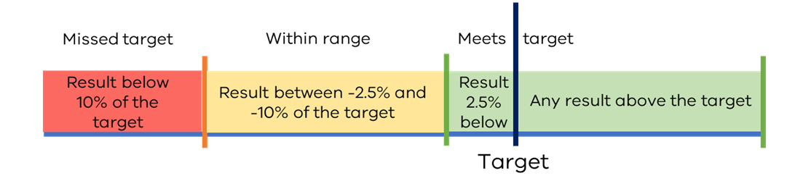
Graph 3.1 – Threshold range applied to development focussed measures.

The list of targeted development focussed measures are:
- G2 - Satisfaction with community consultation and engagement
- R2 - (Percentage of) Sealed local roads maintained to condition standards
- SP2 - (Percentage of) Planning applications decided within required timeframes
- WC5 - (Percentage of) Kerbside collection waste diverted from landfill
- L1 - (Percentage of) Current assets compared to current liabilities
- O5 - (Percentage of) Asset renewal and upgrade compared to depreciation

3.1.2 Reduction focussed measures
In contrast to development focussed measures, reduction focussed measures are metrics where the general expected outcome across the sector is for the measure to decrease or maintain in result. In this instance, Council is seen to be improving when the result is equal to or lower than the last year result or the target.

This does not prevent Council from setting targets above the previous year’s result if they are expecting a “blow-out” or increase in result, however the measure maintains its focus on improving through a decrease.

Therefore, the target threshold applied to a reduction focussed measure would:
- Meet the target where the result is lower than the target or within 2.5% variance above the target.
- Be within the range of the target where the result is within 2.5% to 10% variance above the target.
- Miss the target where the result is above 10% or more of the target.
This is represented in Graph 3.2.

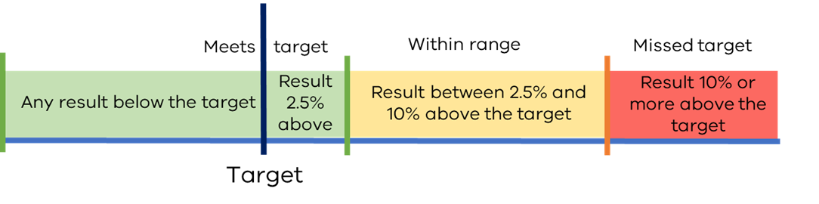
Graph 3.2 – Threshold range applied to reduction focussed measures.

The list of targeted reduction focussed measures are:
- E2 - Expenses per property assessment
- S1 - (Percentage of) Rates compared to adjusted underlying revenue

3.2 Commentary on results against targets
Where the actual performance result varies from the target by more than 10 per cent, an explanatory public comment should be included to outline the factors contributing to the variance.

The comment should explain why performance was over/under the target, regardless of whether these factors were within the council’s scope of influence or not.

Examples of commentary to explain the result against target:

“Council's primary strategy remains focused on community safety, communication, education, and promotion of responsible pet ownership.” | “The 2023-24 expected outcome is lower than the 2023-24 target due to changes in Commonwealth Government guidelines that resulted in reduced service demand.” | “Effort is being made to deliver organisational efficiencies and cost savings as a future dividend to ratepayers.”

3.3 Presentation of targets and results
Following the public release of the targets through Council’s budget and the conclusion of the financial year, the comparison between the targets set and the actual results are required to be released publicly in line with the Annual Reporting process. (See Appendix A for the cycle.)

3.3.1 Performance statement (Annual Report)
Within Council’s Performance Statement, the eight measures with the targets from the 2023-24 budget must be presented along with their actual results. Council must provide commentary to explain the result where necessary.

For an example of the layout, please refer to the Local Government Model Performance Statement 2023-24 (due for release in February 2024).

3.3.2 Sector Performance Reporting
While councils are required to provide their targets to Local Government Victoria for sector analysis, the targets will not be released publicly until the release of the 2024-25 results in late 2025.

From the 2023-24 financial year onwards, Local Government Victoria will present the targets (as provided by council through their budget or revised budget) alongside the results for the eight targeted indicators. In addition, Local Government Victoria will use the three outcomes (meets target, within range of target, missed target) within the presentation of the actuals, along with the numerical value of the target.

As with all results released through this reporting, council will have the opportunity to provide context to the result and target through the commentary function.

The future or anticipated targets will be updated with the most recent budget release based on forward estimate principles.

Appendix A: Performance Target Reporting Cycle
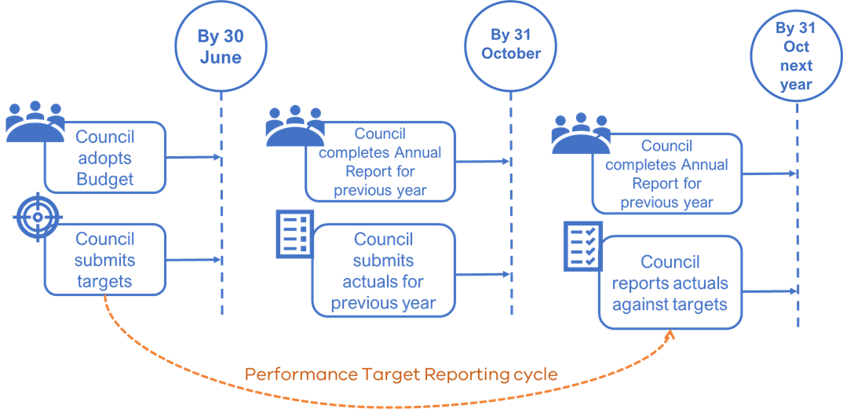

APPENDIX B – Summary of Changes
The following updates were made to this document between the 2023-24 edition and the current 2024-25 edition:
Section Ref | Change
All | References to the current and budgeted year have been updated along with updates to the names of supporting guidance.
1.1 | Including information on the Technical Working Group review for 2024
2.2.1 | Removing content around the embargoed period for the first year
2.4.2 | Removing content around the embargoed period for the first year

