Department of Jobs,
Precincts and Regions
Local Government Act 2020
FOUNDATIONAL Workforce Plan Guide

Table of contents
1 Introduction 2
1.1 Foundational workforce plan 3
1.2 Integrated Strategic Planning and Reporting Framework 3
1.3 Development of this guide 3
1.4 Initiating a workforce plan 3
2 Foundational workforce plan checklist 4
3 Foundational workforce plan checklist details 5
3.1 Organisational chart 5
3.2 Workforce profile 6
3.3 Projected staff requirements 6
3.4 Workforce analytics 6
3.5 Gender equality measures 7
3.6 Summary of key actions 7
4 Further reading 8
5 Appendices 9

Introduction
This simple guide has been designed to assist councils in meeting the foundational requirements necessary to produce a workforce plan that meets legislative and fundamental business requirements.
An integral part of human resources management for any organisation is the workforce plan. Workforce planning is defined as:
“‘The systematic identification, analysis and planning of organisational needs in terms of people’. It is an active and continuous process used to generate business intelligence to inform organisations about the current and future impact of the external and internal environment on their business, and in the process, to become resilient to structural and cultural changes and better positioned for the future.”
Within the scope of the Local Government Act 2020, the Council’s Chief Executive Officer is responsible for developing and maintaining a workforce plan. This plan available to the Mayor, councillors and all council employees, outlines the current and future workforce requirements for the organisation. This includes the organisation’s intended aims to ensure gender equality, diversity and inclusiveness across the workforce.
Typically, a workforce plan can be influenced by multiple factors, including the size of the organisation, the number of employees, the services provided to the community or customer, the demographic makeup of the community itself, and even geographical aspects of the local government area. As such the needs and requirements for a workforce plan can vary significantly across councils.
Based on this, this guide outlines the differing needs of a workforce plan in a hierarchy (see Graph 1), where the highest form of workforce plan is defined as a strategic workforce plan through to the simplest form defined as a foundational workforce plan.
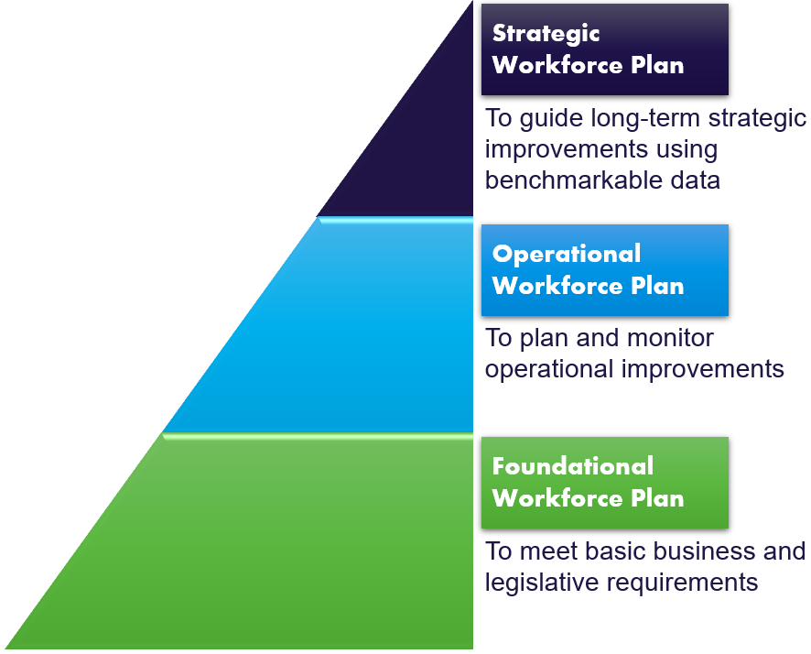
Graph 1 – Workforce documentation hierarchy

The focus on this guide is on what Council could include to prepare a foundational workforce plan.

Foundational workforce plan
A foundational workforce plan describes the basic or foundational plan required in order to meet the minimum needs of an organisation in mapping their workforce needs. Councils are encouraged to use this foundational workforce plan as their base and build upon it as needed. It serves as the starting point for councils to develop their own operational or strategic workforce plan based on the unique requirements of their organisation or community.
The Foundational workforce plan is examined in more detail in Sections 2 and 3.

Integrated Strategic Planning and Reporting Framework
The Local Government Act 2020 introduced strategic planning principles for Victorian councils which include an integrated approach to planning, monitoring and performance reporting. This important shift from a more prescriptive form of legislation to a new Act that is principles-based is explored further in the Integrated Strategic Planning and Reporting Discussion Paper (see Section 4 – Further reading).
The Council’s Workforce Plan is an integral part of the Local Government Integrated Strategic Planning and Reporting Framework (ISPRF) (See Appendix A). As such, the plan should align and complement other council planning and reporting documentation, including the Council Plan, Council Budget and Annual Report.

Development of this guide
This guide was developed through consultation with the sector as part of the Local Government Act 2020 Implementation work.
This guide was developed to provide the core elements for inclusion in a foundational workforce plan. Council may choose to incorporate elements and produce their own layout when drafting their plan.
This is not a best practice guide. This guide has been developed to assist in foundational workforce planning only and councils would be encouraged to seek additional advice in determining their needs for a comprehensive operational or strategic workforce plan (see Graph 1). Section 4 – Further reading, provides links to further content to assist in developing operational or strategic workforce plans.

Initiating a workforce plan
While Section 46(4) of the LG Act 2020 imposes a statutory obligation on the council CEO to develop and maintain a workforce plan, there is no requirement for the workforce plan to be subject to a community engagement process, nor to be formally adopted by the council. A CEO must ensure that the Mayor, Deputy Mayor, councillors and members of council staff have access to the workforce plan once it is finalised.
There is a requirement, however, for the CEO to inform the council before implementing an organisational restructure that will affect the capacity of the council to deliver the Council Plan.

Foundational workforce plan checklist
To meet legislative requirements and minimum business requirements, a foundational workforce plan should include the following:
An Organisational chart which describes the organisational structure of the Council.
A workforce profile which outlines the current organisation such as a breakdown by:
- Full-time equivalent (FTE)
- Employment type (including permanent, temporary, part-time, casual and contingency staff)
- Band or salary level
- Age (broken into age brackets)

A statement of the projected staffing requirements for the next four years.

A summary of any appropriate workforce analytics, such as:
- Monitoring of skill shortages; or
- Hours worked
A statement of the measures in place to seek to ensure gender equality, diversity and inclusiveness, such as the development of a Gender Equality Action Plan.
A summary of any key actions Council intends to implement or address and the associated timelines.

Foundational workforce plan checklist details
This section expands the requirements of the Foundational workforce plan checklist items and presents them in the broader context of legislative and business practices. For further detailed information on these requirements and the process of developing your workforce plan, refer to Section 4 – Further reading.

Organisational chart
The foundational workforce plan must include an organisational chart setting out the structure of the council.
Graph 3.1.1. Example of an organisational chart
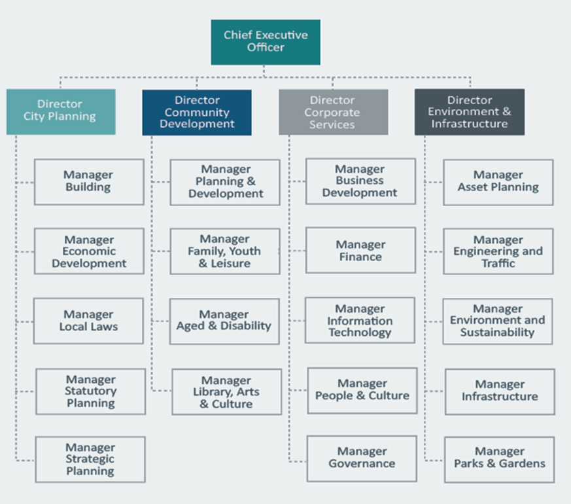
Detail in the chart may include the employee’s name, job title, their areas of responsibility, number of reports or employee photograph. This chart should correspond with the organisational chart in Council’s planning and reporting documents.

Workforce profile
The workforce profile should include the planned number of full-time equivalent Council staff categorised by the organisational structure and employment type.
Employment types may include:
- Permanent full-time
- Permanent part-time
- Fixed term or temporary council employee (greater than six months)
- Fixed term or temporary council employee (less than six months)
- Casual
- Senior officer or Executive contract
- Graduate
- Trainee
- Apprentice
- Cadet
- Volunteer
- Agency staff
- Or flexible arrangement.
In addition, council may wish to categorise by banded or salary level such as apprentices, cadets, trainees, Bands 1 to 8 and Executive contract.
Council may also wish to categorise by employee age bracket. Such as:
- Under 20 years
- 20 – 29 years
- 30 – 39 years
- 40 – 49 years
- 50 – 59 years
- 60 – 65 years
- Over 65 years

Projected staff requirements
In addition to the workforce profile above, the workforce plan must include a statement which shows the number of full-time equivalent Council staff for the current year and three subsequent financial years. This should correspond with the planned human resources expenditure and planned number of full-time equivalent staff in the council’s Annual Budget document.
This may include commentary on potential changes to the organisational structure and links to Council’s strategic priorities.

Workforce analytics
Council may wish to include any metrics, indicators, results or analysis of data conducted to demonstrate Council’s commitment to meeting the current and future workforce needs of the organisation and its community.
Examples may include:
- Data and analytics of skill shortages;
- Analysis of hours worked.

Gender equality measures
Council must include a statement of measures to seek to ensure gender equality, diversity and inclusiveness. This data may include:
- gender-disaggregated data; and
- if available, data about Aboriginality, age, disability, ethnicity, gender identity, race, religion and sexual orientation.
This statement should complement any workplace gender audit or workplace gender equity plan developed by Council under the Gender Equality Act 2020.
This data can be integrated into Council’s workforce profile as required, with gender equality measures being incorporated into workforce analytics as required.
In the absence of available data or the measures, council should outline the steps they are taking to develop measures.
Targeted advice to support local councils to comply with the Gender Equality Act is available here: https://www.genderequalitycommission.vic.gov.au/advice-local-government

Summary of key actions
Council should include a summary of any key actions that will be implemented either:
- in response to issues, they have identified in their data,
- resulting from structural or technological changes that will require new or different work profiles or capabilities, or
- as a result of delivering on the Council’s commitment to residents.
The timeframe for each action should be included.
Overall, Council should also specify the timeline for the Workforce Plan, including dates for review and renewal.

Further reading
Authorised by Local Government Victoria
Department of Jobs, Precincts and Regions
1 Spring Street Melbourne Victoria 3000
Telephone (03) 9651 9999
© Copyright State of Victoria,
Department of Jobs, Precincts and Regions 2021
Except for any logos, emblems, trademarks, artwork and photography this document is made available under the terms of the Creative Commons Attribution 3.0 Australia license.
This document is also available in an accessible format at djpr.vic.gov.au
Government resources:
- LGPro Future Ready – Workforce Planning Handbook and Guide
- Local Government Act 2020 – Part 2 – Division 7 – Section 46 – Functions of the Chief Executive Officer
- Local Government (Planning and Reporting) Regulations 2020 –
  - Part 2 Financial Plans – Section 6 Statements describing other resource requirements
  - Part 3 Budget – Section 8 Other information to be included – (4(c)(d))
  - Part 4 Annual Report – Section 10 General Information – (1(i))
- Gender Equality Act 2020 – Part 4 – Workplace gender equality
- Integrated Strategic Planning and Reporting Discussion Paper
Non-government specific resources:
- Australian Human Resources Institute (AHRI) – Workforce Planning
- Australian Human Resources Institute (AHRI) – Diversity and Inclusion
- Australian Human Resources Institute (AHRI) – HR Metrics

Appendices
Appendix A – Workforce Plan in the Integrated Strategic and Planning Reporting Framework
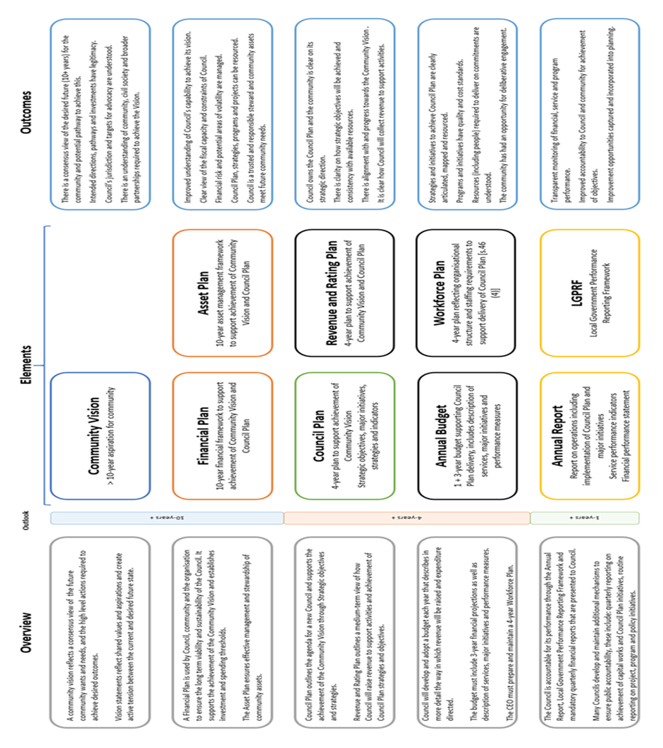

LGPro Future Ready – Workforce Planning Handbook and Guide, page 6
Section 46(6) of the Local Government Act 2020
Section 89(2)(a) of the Local Government Act 2020
Section 46(4)(b) of the Local Government Act 2020
Section 46(4) of the Local Government Act 2020
Part 4, Division 1, Section 11(c) of the Gender Equality Act 2020

