Report

Collaborative Emergency Management

Costs and benefits for Local Government

Municipal Association of Victoria and  
Department of Environment, Land, Water and Planning

October 2015

****Report** **Disclaimer****

This report has been prepared for the Municipal Association of Victorian and Department of Environment, Land, Water and Planning as outlined in the Proposal and scope of works. The services provided in connection with this engagement comprise an advisory engagement, which is not subject to Australian Auditing Standards or Australian Standards on Review or Assurance Engagements, and consequently no opinions or conclusions intended to convey assurance have been expressed.

Point Advisory acts in a professional manner and exercises all reasonable skill and care in the provision of its professional services. The reports are commissioned by and prepared for the exclusive use of the Client. They are subject to and issued in accordance with the agreement between the Client and Point Advisory. Point Advisory is not responsible for any liability and accepts no responsibility whatsoever arising from the misapplication or misinterpretation by third parties of the contents of its reports.

Where site inspections, testing or fieldwork have taken place, the report is based on the information made available by the client or their nominees during the visit, visual observations and any subsequent discussions with regulatory authorities. It is further assumed that normal activities were being undertaken at the site on the day of the site

Except where expressly stated, Point Advisory does not attempt to verify the accuracy, validity or comprehensiveness of any information supplied to Point Advisory for its reports. We have indicated within this report the sources of the information provided. We are under no obligation in any circumstance to update this report, in either oral or written form, for events occurring after the report has been issued in final form.

The findings in this report have been formed on the above basis.

Third Party Reliance

This report is solely for the purpose of the Client, and is not to be used for any other purpose or distributed to any other party without Point Advisory’s prior written consent.

This report has been prepared at the request of our Client in accordance with the terms of the contract. Other than our responsibility to the Client, we (Point Advisory or its employees) take no responsibility arising in any way from reliance placed by a third party on this report. Any reliance placed is that party’s sole responsibility.

****Version Control****

|  |  |  |  |
| --- | --- | --- | --- |
| Version | Date | Author(s) | Project Director |
| DRAFT | 10/07/2015 | Christophe Brulliard | Christophe Brulliard |
| DRAFT | 21/07/2015 | Christophe Brulliard, Patrick Gilmour | Christophe Brulliard |
| DRAFT | 17/09/2015 | Christophe Brulliard, Patrick Gilmour | Christophe Brulliard |
| FINAL | 14/10/2015 | Christophe Brulliard, Patrick Gilmour | Christophe Brulliard |
| FINAL | 18/11/2015 | Christophe Brulliard, Patrick Gilmour | Christophe Brulliard |

Executive Summary

This report reviews and outlines the costs and benefits of collaborative approaches to Emergency Management (EM) from the perspective of Local Governments. This is based on a financial cost-benefit analysis of the Northern Victorian EM Cluster Pilot and on a qualitative analysis of the Wimmera EM collaboration and the Eastern Metropolitan Councils Emergency Management Partnership.

**The main driver for collaboration between councils appears to be the need to do more with less.** This includes:

* An interest in efficiency – avoiding duplication between councils in planning and preparing for emergencies.
* An interest in effectiveness – a recognition that this collaboration can leverage their often scarce resources and skills to create meaningful improvements in planning for and managing emergencies.

Key differences between collaborative approaches to EM and councils working independently are:

* **Coordination of the collaboration**: collaborative approaches need some sort of coordination of their activities. This can occur internally, or through a dedicated coordinator. Coordination represents the key additional cost of collaboration over working independently—both for the coordinator and for the additional time required for discussion and agreement among councils.
* **Planning and other documentation**: much of the documentation in planning for emergencies requires similar materials and thinking. Councils can share document production to either produce sub-regional documents, more consistent documents, or templates for tailoring to local conditions.
* **Training and other support**: neighbouring councils can form a network through which they can share expertise, skills and resources.
* **EM response, relief and recovery support**: standalone councils can draw on assistance from central agencies and other councils under agreements organised by MAV. When collaborating with neighbours, resource-sharing agreements and procedures can be in place prior to emergencies.
* **Representation**: councils working collaboratively can be represented jointly at forums.

In turn, the key benefits from collaboration relate to:

* **Avoided duplication** in: 1) developing and updating documents; 2) being represented jointly on relevant forums.
* **Better plans**, realised through having access to a broader pool of expertise across a group of councils as well as through having more resources (on a council by council basis) to put into the breadth and detail of plans.
* **Consistency and depth of resources:** standardised processes, documentation and the experience of working together helps partner councils support each other more effectively in emergencies as they are familiar with each other’s processes. This additional pool of capacity should also help reduce “burn out” in an emergency.
* **Consistency and communication with agencies**: reducing the burden on agencies in their planning and improving overall collaboration between councils and agencies.
* **Councils having a unified voice** in their representations at State and regional levels.
* **Support for EM staff**, who have a broader network of people with whom they can ask questions of, share experiences with or call on for support. This has implications for the ability of councils to retain and share knowledge and expertise.

Ultimately, and most importantly, these benefits should **contribute to better outcomes for the community** during and after emergencies.

A reasonably narrow assessment of the financial costs and benefits of administering a collaboration suggests the Northern Victorian EM Cluster Pilot was likely to yield between a $2,250 benefit and $14,000 cost per annum.

This effectively cost-neutral result takes into account the additional costs of managing the collaboration and the administrative savings from reduced duplication. It does not take into account any of the additional, unquantifiable benefits to councils, other organisations or the community thorough the improvements to planning, preparation and communication.

**Key success factors for collaboration between councils appear to include**:

* Interest in and a commitment to collaboration - collaboration emerges from a strong recognition of a need for mutual support.
* Trust from strong interpersonal relationships is essential, as well as a willingness to share information and material freely without thinking of reciprocity.
* Dedicated and enthused EM staff, together with a high-level desire for better outcomes for the community – there may be some administrative savings from collaboration, but the vast majority of the benefits accrue to the community through improvements in quality of EM planning and preparation.
* A facilitator or dedicated coordinator is essential to maintaining momentum.

**Other relevant lessons from existing collaborations are that**:

* It takes time to build trust relationships and shared understanding between participating members. Hence there is an initial set-up time investment (i.e. cost) required before a collaboration becomes operational.
* The optimal size for collaboration is determined mainly by geography, as councils need to be close enough to allow frequent meetings and travel between locations to lend assistance in case of an emergency.
* The longest running of the three case studies specifically highlighted the value of:
  + explicitly focusing on the greater good of the community as the ultimate outcome (as above)—making sure that egos and self-interest are “left at the door”
  + having clear conflict resolution mechanism accepted by all
  + having a commitment to ongoing improvement and changing the structure to match evolving needs.

Table of contents

1 Introduction 5

1.1 Overview 5

1.2 Objectives, scope and structure of this report 5

2 Methodology 6

3 Collaboration in Emergency Management 7

3.1 Drivers of collaboration in EM 7

3.2 Cases of collaborative EM examined here 7

3.2.1 EM Cluster Pilot (Northern Victoria) 7

3.2.2 Wimmera EM Collaboration 9

3.2.3 Eastern Metropolitan Councils Emergency Management Partnership 10

3.3 Collaborative versus standalone models of EM 12

4 Benefits, costs and lessons from collaborative EM 13

4.1 Conceptual map of costs and benefits to different stakeholders 13

4.2 Understanding what makes a collaboration work 16

5 Cost-benefit analysis of the EM Cluster Pilot 19

5.1 Overview 19

5.2 EM under the Cluster Pilot versus councils working independently 19

5.3 Costs and benefits of the EM Cluster Pilot 21

5.4 Quantifiable financial costs and benefits to participating councils 25

5.4.1 Content and approach 25

5.4.2 Recurring Costs (yearly basis) 25

5.4.3 Recurring Benefits (yearly basis) 27

5.5 Summary of the costs and benefits of the EM Cluster Pilot in the context of EM 29

6 Appendix A: reviewed documents 31

7 Appendix B: EM Cluster responsibilities 32

8 Appendix C: Assumptions underpinning the Benefit Cost Analysis of recurring benefits 33

# Introduction

## Overview

Local Governments throughout Victoria, alongside specialised Emergency Management (EM) agencies, have had to manage a range of dramatic emergency incidents in the last decade. This has put Local Governments’ capabilities in this field to the test and has led to a number of regulatory changes at the State level.

In this evolving space, a range of councils have begun collaborating with their neighbours around various aspects of the EM cycle (planning, response, relief and recovery). The broad aim of these initiatives has been to increase EM capacity and capabilities, particularly in regional areas. While broad-reaching and potentially significant, these improvements come at a cost to the councils involved.

This report reviews the various costs and benefits of collaborative approaches to EM. This includes a financial cost-benefit analysis of the Northern Victorian EM Cluster Pilot, for which external support is due to cease in September 2015.

## Objectives, scope and structure of this report

This report was commissioned by the Municipal Association of Victoria (MAV) and the Victorian Department of Environment, Land, Water and Planning (DELWP). It draws from and builds on an aligned evaluation of the Northern Victorian EM Cluster Pilot, the results of which are detailed in a separate report.

The overarching objectives of this report are to:

* capture the broad costs and benefits of collaborative approaches to emergency management in local government
* help inform council staff’s decision making around Emergency Management collaborations.

In turn, the scope of the report is to:

* Document how collaborative approaches to EM in council can differ from standalone approaches, drawing on three cases across Victoria (the Northern Victorian Emergency Management Cluster Pilot Project, the Eastern Metropolitan Collaboration and the Wimmera EM Collaboration).
* Identify and document the general benefits and costs of these sorts of collaborations, as well as lessons learned and factors for success.
* Provide a detailed review of the benefits and costs for the Northern Victorian Emergency Management Cluster Pilot Project, with particular focus on the financial benefits and costs to participating councils.

The remainder of this report is structured as such:

* a summary of the methodology and data sources used in generating this report
* an overview of the three cases of EM collaboration, together with a summary of how collaborative approaches to EM can differ from EM done by standalone councils
* a conceptual map of the costs and benefits to councils from taking a collaborative approach to EM, together with a summary of lessons drawn from the three cases
* a detailed analysis of the costs and benefits of the EM Cluster Pilot in broad terms, followed by a specific assessment of the financial costs and benefits to participating councils.

# Methodology

Our approach in this project was broadly to:

* **Review three cases of collaborative EM** to identify costs, benefits, challenges and enablers to effective EM across councils. The purpose of this component was to establish general conditions, lessons and benefits/costs that could be expected from collaborative approaches.
* **Examine one of these collaborations in more detail** (the EM Cluster Pilot). This involved identifying and documenting the specific costs and benefits for that collaboration, including the quantifiable financial costs and benefits.

In reviewing the benefits and costs in each case, it was important to consider how those benefits and costs differed from what would have been required otherwise—i.e. how did the collaboration differ from the status quo (or the ‘base case’ or counterfactual). These comparisons are detailed at various points throughout this report to identify just how collaborative efforts differ from EM done in isolation.

We collected data through:

* **Reviewing key documents across the cases**, particularly for the EM Cluster Pilot. This included project plans, business cases, governance structures, report, etc. (see Appendix A).
* **Semi-structured interviews with 21 key stakeholders** (Table 1).

These data were analysis and integrated into a draft report. Preliminary results were presented to EM Cluster Pilot stakeholders and the resulting input and suggestions used to refine the final report.

Table 1. Stakeholders interviewed for this project.

|  |  |  |
| --- | --- | --- |
| Stakeholder group | Description | Number |
| EM Cluster Pilot | EM Coordinators (4), Cluster Manager, council Directors and CEOs (6) | 11 |
| Wimmera | Collaboration Project Coordinator | 1 |
| Eastern Metro | 4 council stakeholders across 3 participating councils | 4 |
| EM and other agencies | Representatives from:   * + MAV (Manager, EM Policy)   + DHHS (EM Manager, Northern Region)   + VicPol (Regional Emergency Management Response Coordinator of Loddon Mallee)   + EMV (EM Planning Facilitator)   + SES ( Manager Regional Operations-Emergency Management | North West Region (Loddon Mallee)) | 5 |

# Collaboration in Emergency Management

## Drivers of collaboration in EM

Councils’ EM obligations have been shifting and changing over the past decade, most notably since the Victorian Bushfire Royal Commission that followed the Black Saturday fires of February 2009. The trend in this evolving process has been a rising set of expectations about the level and quality of emergency planning and preparation within councils. There has thus been a need for greater EM capability and capacity within councils across the State.

To address this need, various councils around Victoria have begun to work in planning for and responding to emergencies. These collaborations include:

* the eastern metropolitan region collaboration project involving ten councils in Melbourne’s east
* the north-west Metropolitan Relief and Recovery Project, which involves 14 local governments in the CBD and northern and western suburbs of Melbourne
* the Wimmera Emergency Management Cluster Program, with four local governments in the western district of regional Victoria
* the southern metropolitan region collaboration
* Municipal Emergency Management Enhancement Groups (MEMEGs) operating at the state and regional level.

These collaborations are in addition to more informal collaborations between councils, such as those councils that share EM staff under the Municipal Emergency Resourcing Program.

Interviews across the EM Cluster Pilot, the Wimmera EM Cluster and the Eastern Metro Collaboration indicated that the key drivers underpinning collaboration appear to be, essentially, **doing more with less** (i.e. improving cost-effectiveness). This includes:

* **An interest in efficiency** – avoidingduplication between councils in planning and preparing for emergencies; “that’s where there’ll be benefit and there will be significant cost savings” (council interviewee).
* **An interest in effectiveness** – a recognition that collaboration between councils can leverage often scarce resources and skills, leading to better management of emergencies. As one executive-level interviewee noted, “emergency management obviously stretched us here in past events. We know that we can’t do it alone so the cluster approach has potential value”.

This interest in cost-effectiveness is unsurprising given both the heightened expectations about how council should be performing in emergencies (noted earlier), as well as the increasingly tight budgets available to local government. Interviewees also noted that despite the obligations on and expectations of councils in this space, there is a strong perception among some councils that EM is ‘non-core business’. This can make it difficult, especially for smaller councils, to adequately resource EM planning and operations.

With these high-level drivers in mind, the following sub-sections outlines three cases of collaborative EM in more detail. We then contrast these collaborative efforts with ‘stand-alone’ approaches to EM, before unpacking the various benefits, costs and lessons from these collaborations in Section 4.

## Cases of collaborative EM examined here

### EM Cluster Pilot (Northern Victoria)

**The EM Cluster Pilot** initially brought together four neighbouring councils: Loddon Shire, City of Greater Bendigo, Shire of Campaspe and Mount Alexander Shire. In August 2015, Central Goldfields Shire also joined the cluster.

The pilot itself commenced in March 2013 and is expected to conclude in October 2015. A Shared Local Government Emergency Management Services Memorandum of Understanding (the EM Cluster MOU) was developed to facilitate the EM Cluster and was last updated in December 2014.

**Funding** for the EM Cluster Pilot was provided through:

* The commonwealth Natural Disaster and Resilience Grants Scheme (NDRGS), which funded project operations and a project manager.
* In-kind funding of project operations by participant councils.
* Indirect support through the state-based Municipal Emergency Resourcing Program (MERP), which whole- or part-funded Emergency Management Coordinator (EMC) roles in participating councils.

**The objectives** of the EM Cluster Pilot were to:

* Build community resilience through standardised emergency management planning processes relating to prevention, preparedness, response, relief and recovery.
* Establish a consistent emergency management risk assessment process.
* Adopt an agreed framework and associated terms for the sharing of human and capital resources between participating Councils.
* Seek and act on opportunities to avoid duplication, reduce costs and improve the efficiency and effectiveness of emergency management activities.

In working towards these objectives, the EM Cluster Pilot project team expect to deliver:

* A formal agreement for cooperation in emergency management between the municipalities that is efficient, effective and sustainable without external funding.
* A cluster Municipal Emergency Management Plan, sub-plans and planning processes
* Shared risk assessment process
* Standard operating procedures, guidelines, facility standards and role descriptions for municipal readiness, response, relief and recovery activities.
* Standard contact lists.
* Shared training and exercising strategies and guidelines.
* Shared communication and engagement strategies.
* Sharing of resources and EM roles.

**In terms of governance**, overall responsibility for the EM Cluster Pilot resides with the Project Control Board (PCB), also referred to as the Emergency Management Board in some documentation, consisting of the four participant council CEOs (Figure 1). The Pilot Project Manager reports directly the PCB with input from the Senior Reference Group (SRG), comprised of the responsible director from each participant council.

The Pilot Project Manager oversees works undertaken by four workgroups, chaired by each council’s Emergency Management Coordinator and focusing on one of the four elements of emergency management (Rankin, M., 2015):

* Prevention - City of Greater Bendigo.
* Response – Loddon Shire Council.
* Relief – Mt Alexander Shire Council.
* Recovery – Campaspe Shire Council.

A representation of the governance model, valid for the EM Cluster Pilot and subsequently proposed Northern Victorian Cluster (Shared Local Government Emergency Management Services), and as presented in the EM Cluster MOU (EMC Pilot Councils, 2014) is provided below.

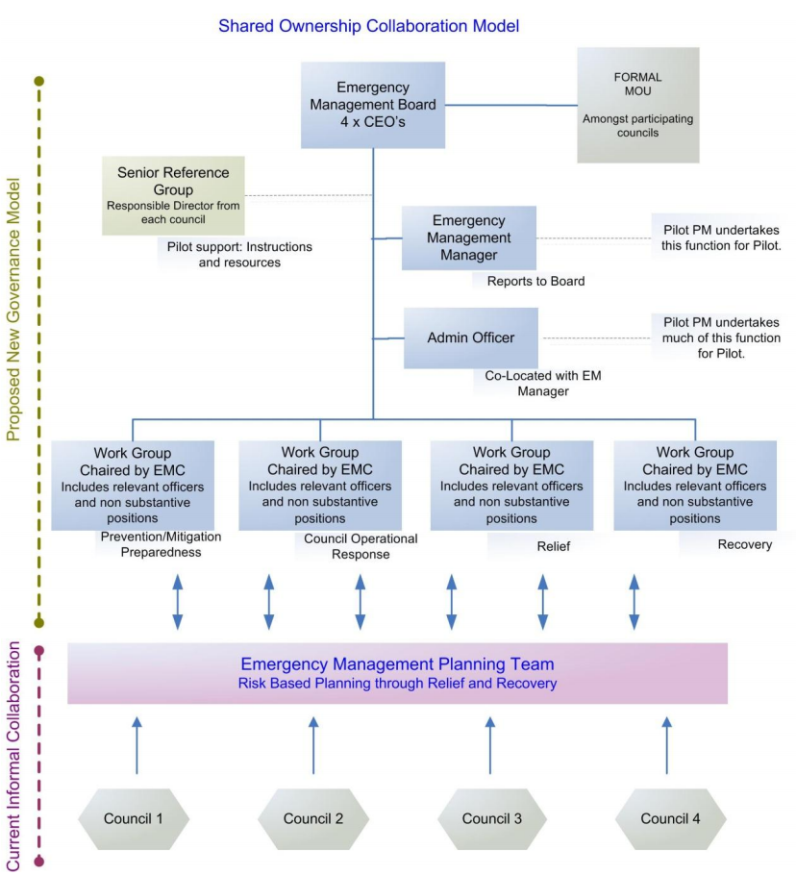

Figure 1. Shared ownership collaboration model (adapted from EM Cluster Pilot MOU).

### Wimmera EM Collaboration

**The Wimmera EM Collaboration** began in August 2011 and involves four councils in the north west of Victoria:

* Horsham Rural City Council
* West Wimmera Shire Council
* Yarriambiack Shire Council
* Hindmarsh Shire Council

The collaboration was initiated on receipt of **funding** for two separate roles:

* state-based MERP funding, which was allocated to a shared EM Coordinator position (originally an EM Fire Coordinator role)
* NDRGS funding, which supported a EM Project Officer position.

All four councils matched the NDRGS funding 1:1. While the funding and positions were secured separately, they have, since the start of their tenure, worked together to coordinate EM across the four councils.

**The objectives** of this coordinated effort and of the collaboration were to:

* To promote, facilitate and advocate for continuous improvement in emergency Management across Horsham Rural city Council, Hindmarsh Shire, Yarriambiack and West Wimmera Shire.
* To oversee the implementation of standardised processes for the sharing of common services, resources and planning activities across the four local government areas” (Wimmera EM Evaluation Report, 2014).

The EM Collaboration team and the partner councils first began working towards these objectives through a thorough audit of EM documentation across the councils. Since then, the collaboration has worked towards developing a shared understanding across the councils of the objectives of emergency management, councils’ roles and responsibilities in relation to EM and a standardised approach to practices, procedures and documentation.

One of the key principles of the collaboration has been to support the work done within councils—“the doing remains with [council] staff” (Wimmera Emergency Management Program 2011-2014, p.1). This model seeks to provide support, advice and mutual assistance but not an out-sourcing of councils’ responsibilities. In some cases, the collaboration can act as a shared resource, as a research facility or as a representative at regional or state forums.

The collaboration’s **governance structure** is outlined in Figure 2. The Wimmera EM Steering Group oversees the project, facilitating communication between the councils and identifying and guiding activities that address the collaboration’s objectives. The Steering Group comprises individuals that are also involved in the Working Group, thus providing a direct and natural link between the two groups (the “overseers” and the “doers”). The EM Working Groups operate in each of the partner councils. They are responsible for most of the operational elements of the collaboration—i.e. coordinating and standardising EM practices and procedures.



Figure 2. Structure of Wimmera EM Cluster based on information in the Cluster Partnership Agreement and interviews.

### Eastern Metropolitan Councils Emergency Management Partnership

The **Eastern Metropolitan Councils Emergency Management Partnership** brings together eight urban and interface councils from Melbourne’s outer east:

* Boroondara City Council
* Knox City Council
* Manningham City Council
* Maroondah City Council
* Monash City Council
* Nillumbik Shire Council
* Whitehorse City Council
* Yarra Ranges Council.

The partnership has been in operation for over six years, being established in the wake of the 2009 bushfires. This links with one of the key drivers for the collaboration—the value of and need for councils to support each other during extended emergencies. It is **funded internally** through financial and in-kind contributions of partner councils. Statewide MERP funding indirectly supports these contributions.

The overall vision of the collaboration is “Excellence in emergency management arrangements in Eastern Metropolitan Councils” (Strategic Plan 2014). **Six goals**, also articulated in the strategic plan, align with this vision:

* Working with others - We will effectively collaborate amongst Councils, with existing partners and any new groups identified.
* Advocating for the region – We will advocate on relevant emergency management matters.
* Building capacity – We will seek appropriate funding and resources as enablers to support to the Partnership.
* Improving our common ways of working - We will continue to seek a consistency of approach (where relevant) amongst the participating Councils in the planning and delivery of emergency management
* Strengthening communities – We will encourage and support our communities in activities that increase disaster resilience.
* Building capability – We will further our emergency management capability through training, exercises and other forms of professional development.

Each of these goals forms the basis of a Working Group as part of the overall **governance structure** of the partnership (Figure 3). The Partnerships group essentially steers the activities. EM Coordinators or equivalent roles within each council sit in the Partnership Group and recruit appropriate participants in the working groups, depending on the topics.

The Regional Administrative team supports this through organising and facilitating meetings, documentation and finances; a role that rotates annually among the participating councils.



Figure 3. Structure of Easter Metro EM Partnership based on Terms of Reference (2014).

## Collaborative versus standalone models of EM

The three examples of collaborative EM above point to the variety in how such collaborations are formed and structured. In all cases, however, **the participating councils share elements of EM planning and preparation and have arrangements for sharing resources during the response, relief and recovery phases of emergencies.**

Key points of difference between these collaborative approaches to EM and cases in which councils work independently relate to

* **Coordination of the collaboration:** collaborative approaches need some sort of coordination of their activities. This can occur internally using staff from the participating councils (such as on a rotational basis), or through a dedicated coordinator. Coordination represents the key additional cost of collaboration over working independently—both for the coordinator and for the additional time required for discussion and agreement among councils.
* **Planning and other documentation:** much of the documentation in planning and preparing for emergencies requires similar material and thinking. Councils can share document production to either produce sub-regional documents, more consistent documents or documents templates that are tailored to local conditions.
* **Training and other support:** neighbouring councils form a network through which they can share expertise, skills and resources that, in cases where councils are ‘standalone’, may have to be sourced externally. This includes collaborations having the opportunity to train people internally or to organise joint exercises so that staff are familiar with processes and locations in neighbouring councils.
* **EM response, relief and recovery support:** standalone councils can draw on assistance from central agencies and other councils under agreements organised by MAV. When collaborating with neighbours, resource-sharing agreements and procedures can be in place prior to emergencies and councils can call on resources from other councils with the confidence that they will be familiar with their processes and the local conditions.
* **Representation:** councils working collaboratively can be represented jointly at various EM forums and meetings, both at State and regional levels.

These differences entail a range of both costs and benefits, which are outlined in the next section.

# Benefits, costs and lessons from collaborative EM

## Conceptual map of costs and benefits to different stakeholders

Given the above section deals with how collaborative approaches to EM differ from standalone approaches, this section outlines the relative benefits, costs and lessons from such an approach. Again, the key point of comparison is how collaborative approaches differ from the base case or the status quo (i.e. councils working independently).

Figure 4 below maps out the benefits and costs of a typical collaborative arrangement. These are the generic costs and benefits that have emerged across the Wimmera, EM Cluster Pilot and Eastern Metro EM Partnership cases (see Section 3.2).

**Costs** are essentially the time needed for staff to collaborate—i.e. attending steering group meetings, workgroup meetings, corresponding with other partners and so on. All three cases also had some sort of costs of administering and coordinating the collaboration—either by an administrative team or a separate coordinator/manager role. Together with the operational costs of these activities (largely transport), these costs are additional to what would be required if councils were working independently.

**Benefits** are categorised according to stakeholder group:

* participating councils
* state-level government/organisations
* EM agencies/charities
* the community.

In turn, these benefits are also organised according to whether they are:

* Administrative. The principal benefit here is the cost savings to councils because of the reduced time: 1) developing and updating documents that are largely similar between councils (e.g. MEM Plans and sub-plans, Standard Operating Procedures); 2) being represented jointly on forums that are relevant across all the councils.
* Operational. For councils, this relates largely to the ability of partners to rely on each other during extended emergencies, drawing of a broader pool of staff from across the collaboration.
* Risk management. Again, the principal benefit here is to councils reducing their risks of inadequately dealing with an emergency (either in the planning, response, relief or recovery phases).

Ultimately, and most importantly, **collaborative approaches should contribute to better outcomes for the community** during and after emergencies. This is expected to happen through three main mechanisms:

* **Better plans:** Collaboration allows partners to draw on a broader pool of experience and expertise across the participating councils. Efficiencies in document production should also mean that, on a council-by-council basis, more resources are put into EM plans and sub-plans. The result is improvements in the comprehensiveness (e.g. the breadth of sub-plans) and quality of planning and preparation. In turn, these improvements in planning and preparation should lead to improved response to and recovery from emergencies.
* **Consistency and depth of resources:** Collaboration promotes consistency in documentation and in training. This promotes a shared understanding among participating councils of each other’s circumstances and clarity around their procedures. During emergencies, this will mean there is a pool of support for councils to draw on—support that is familiar with and understands the needs of that council’s EM operations. This should result in smoother management of emergencies and a lower impact on councils’ business-as-usual activities.
* **Consistency and communication with agencies**: the shared, consistent planning among collaborating councils results in improved communication with EM agencies. As one agency interviewee noted “it is not just about the quality of what councils do but sometimes it’s about consistency”. This consistency and communication reduces the burden on agencies in planning and preparing for emergencies, but should also result in more effective communication between councils and agencies during emergencies.

Outside of the overarching benefits to the community and potential for reduced administrative duplication, one key benefit of collaboration is **the importance of the councils having a unified voice**. Two of the three cases suggested this to be of key strategic value in discussions about EM at state or regional levels. It is also something that flows through to time savings on behalf of state and regional-level agencies and organisations as less time is needed for engaging with multiple individual councils.

There are also benefits to the staff involved in EM roles. Collaboration provides these staff with **a broader network of people with whom they can ask questions of, share experiences with or call on for support**. Given these roles tend to be relatively isolated within councils, this broader base of support was noted by in all three cases to be an important motivating factor for staff. This has implications not only for the quality of EM (noted above), but the wellbeing of staff and, potentially, their retention in those roles (in turn, leading to savings in training costs and the benefits accumulated experience).

Two further benefits not captured in Figure 4, but apparent in at least one of the cases, were:

* Improved understanding of councils’ EM obligations –operational and executive-level staff noted the effort of and cross-council learnings from the collaboration helped to clarify council’s obligations in this space, one noting “[we] have discovered all the things that we have to do … [it’s] been a success just for that”.
* Improved understanding of and trust in partner councils. The working relationships forged through the EM collaboration, again at both an operational and executive level, were noted to have led to collaboration and knowledge sharing in other areas of council operations.

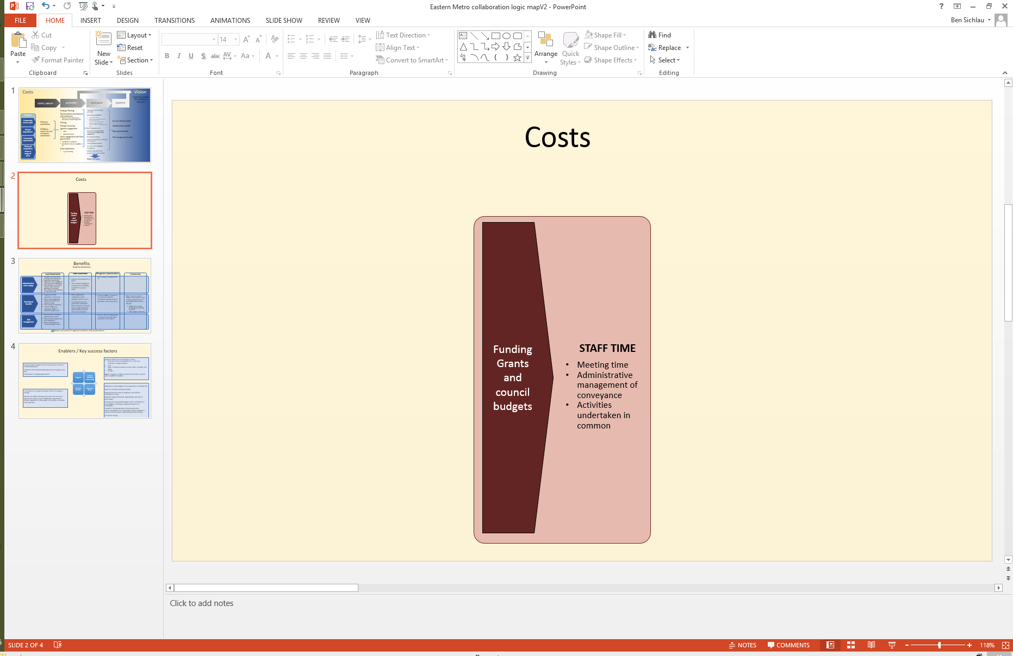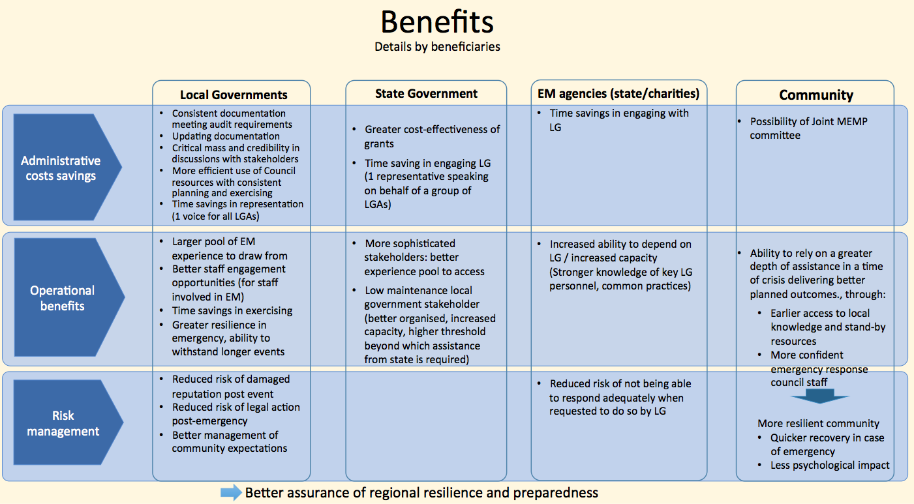

Figure 4. Benefits and costs of EM collaborative approaches – in general

## Understanding what makes a collaboration work

This section deals with two interrelated issues:

* the conditions for successful EM collaboration, including when they are most appropriate and beneficial
* potential strategies to overcome barriers and manage risks.

In terms of the **conditions for success**, key findings from the three cases are:

* **Interest in and a commitment to collaboration**. Collaboration cannot be ‘forced’ upon its members. Rather, it appears to need those members to embrace the concept and take the initiative. This only happens where participants can see the benefits and rationale of the approach. However, even when participants have a clear vision of how collaboration can benefit them, coming to a shared vision and common expectations among a group can take time. In this context, stakeholders from all three cases of collaboration emphasised the importance of executive-level staff buying-in to the concept.
* **A willingness to share.** The costs of collaboration are reasonably predictable, while the benefits across a group may vary substantially, depending on the size of councils and the emergencies they experience. Stakeholders from one collaboration explicitly noted the importance of accepting that costs and benefits may not be equal across members and that this should not hamper cooperative efforts.
* **Trust**. Building working relationships and trust between members was seen as a critical, but time-consuming step in each of the three cases. Trust underpins the shared expectations and goals (see points above and below) needed for collaboration to occur. Importantly, it also frees up participants to discuss, negotiate and come to agreement without needing every detail to be formalised—resource sharing in Wimmera, for example, was noted to be based on “goodwill”. Once established, this trust allows faster or more efficient progress to be made—something that was evident in the EM Cluster Pilot. The balance, of course, is that trust exists between people and people move on. All of the cases here did formalise their arrangements to some extent in Memorandums of Understanding or Agreements between councils.
* **A shared desire for better outcomes for the community**. While there may be some administrative savings from collaboration (see Section 5 below), the vast majority of the benefits accrue to the community through improvements in the quality of EM planning and preparation. These improvements should, in turn, flow through to reduced impacts on the community during and after emergencies. All groups had this as a shared ‘end goal’. Observations of negotiations of a proposed expansion of one collaboration highlighted how important it is to have this as the focus—focusing on cost-savings alone risks eroding a willingness to share and the common interest and working relationships on which these collaborations depend.
* **Having a facilitator or dedicated coordinator**. This was apparent across all of the cases, with stakeholders in each emphasising the importance of having someone—either administratively or strategically—driving the collaboration forward. Having such an ‘energy centre’ is also an observation from the broader academic literature on cooperation and collaboration in small groups. This coordinator does not necessarily do the work, but facilitates interaction, drives the process and acts as a knowledge hub and sounding board. A change to a proactive coordinator for the EM Cluster Pilot, for example, appeared to spur action and make substantial progress.
* **Dedicated and enthused EM staff.** All of the cases were about local government delivering on their EM responsibilities, accessing a pool of knowledge as assistance. As noted earlier for the Wimmera collaboration, “the doing remains with [council] staff”. None of the collaborations were about delegation, except in the case of joint representation at meetings. For this reason, the personality and motivation of key staff—MEROs, MRMs and other EM staff, whom cluster organisations are essentially supporting—is key to the success of collaborations; they are the ones doing the work. In the absence of such staff—as observed during a gap in staffing in the EM Cluster Pilot—progress of the entire collaboration can falter.

**There are also a range of characteristics that may have implications for how collaborations are managed. However, the link between these characteristics and the benefits to flow from collaboration are not clear** and preclude definitive conclusions. They are, nevertheless, worth highlighting and considering. Characteristics include:

* **Number of collaborators.** The three cases here had groups ranging from four to eight members. Other collaborations around Victoria range up to 14 members (the North West Metropolitan Relief and Recovery project). The more councils involved, the more that economies of scale can be harnessed (reducing the marginal financial costs of administration) and the greater the pool of experience and expertise on which to draw. However, as groups become larger they also become unwieldy, with additional time required for discussion and agreement. Larger numbers also means a broader geographical spread, which can impinge on resource sharing benefits during emergencies.

The maximum size of a collaboration would thus depend on the tasks involved. For example, keeping abreast of regulatory changes at the State level might be able to be done by a relatively larger group. For the activities done as part of the cases here, the group sizes appeared to be a good balance between being worthwhile and being manageable. Interviewees from Eastern Metropolitan EM Partnership suggested that eight councils was the maximum they would recommend in their circumstances.

* **Diversity of collaborators.** Diversity among collaborators brings with it potential advantages and disadvantages. On the one hand, councils with grossly different capacities and capabilities raise potential issues in agreeing to equitable cost- and resource-sharing. Diversity in council risk profiles also has the potential to also skew the perceived costs and benefits of collaboration. However, stakeholders in one collaboration noted that diversity in risk profiles means that councils are less likely to be impacted by the same event, meaning the collaboration would be more able to provide support. They also noted that diversity helps bring different experiences and expertise to the group.
* **Size of collaborating councils.** The Victorian Emergency Management Reform White Paper suggests that collaboration “has principal advantages for ‘small’ councils in pooling resources and expertise”. However, this does not mean that ‘larger’ councils may not also benefit from collaboration. Even within municipalities with regional centres, EM teams are still relatively small. City of Greater Bendigo, for example, has only two dedicated EM staff spread over less than two fulltime positions. This means that there are still clear benefits to sharing knowledge and resources among a broader group of EM stakeholders—having this support network was noted to be a key outcome of collaboration in all three cases.

Looking across the case studies of collaboration here, a range of **potential strategies emerge for overcoming the challenges and risks of EM collaborations:**

* Acknowledging that it will take time to develop the trust, working relationships and shared vision that are important for collaborations to be effective. This is particularly important in the early stages of a collaboration when the tangible outputs may be relatively meagre.
* As the early stages of collaboration require time and energy and higher levels of coordination, external funding support can be advantageous in ‘kick-starting’ a collaboration and getting over this period of high transaction costs. This should not come at the expense, however, of participants having a clear commitment to collaboration, including funding it in the long-term.
* There are advantages in sharing and reducing the duplication of documents. However, local content remains crucial and many of the advantages of collaboration are realised through the consistency of documents, if not the outright replication.
* The longest running of the three case studies highlighted key approaches they have found effective in managing their collaborative activities over time:
  + explicitly focusing on the greater good of the community as the ultimate outcome (as above)—making sure that egos and self-interest are “left at the door”
  + there is a clear conflict resolution mechanism accepted by all
  + there is a commitment to ongoing improvement and changing the structure to match evolving needs.
* Avoiding burn out of operational staff (MEROs, MRMs and other staff) through rotational arrangements and ensuring these people know that they have a pool of expertise they can readily access in case of an emergency. As an interviewee from the Wimmera region noted, “one of the biggest benefits [of the collaboration] is that these isolated part-time individuals have a network to talk to”.
* Stakeholders from all three case studies noted that the streamlining of documentation or processes across councils required an enabling environment to be created by state agencies and regulation. There has been uncertainty in relation to legislative changes, for example in relation to combined CERA processes and combined MEMP for groups of councils. Greater clarity here would provide councils with a clearer framework for guiding the scope of their collaborative activities and the potential benefits therein.
* When collaborations have the opportunity to expand, it is important for the partners to ensure that a new member council ‘fits in’ with the existing collaborative culture. This includes buying into the objectives set for the collaboration and being ready to adopt the same working ethics. It is also important to emphasise that involvement means contributing to, as well as leveraging from, existing processes, recognising that the new member may bring in knowledge and experience that is valuable for the whole group.

# Cost-benefit analysis of the EM Cluster Pilot

## Overview

Sections 3 and 4 above provide a high-level review of collaborative approaches to EM. The section below complements this by presenting a more detailed analysis of the costs and benefits of one of the cases of collaboration—the Northern Victoria EM Cluster Pilot. This includes:

* Comparing the **activities done under the EM Cluster Pilot** as compared to what would have happened had each of the councils worked in isolation.
* Mapping out **how these activities are expected to flow through to various benefits**, which is then expanded in a more **detailed conceptual diagram of the costs and benefits** to various stakeholders at different stages of the EM process (planning, response, relief and recovery).
* Analysing the **quantifiable financial costs and benefits** to councils from the collaboration. This is distinct from the complete set of costs and benefits above and deals only with those financial costs/benefits that can be readily and reliably estimated. In this way it provides a highly conservative estimate of the net costs to councils of running the cluster, without taking into account the range of broader benefits.
* a **summary of the overall costs and benefits** in the contexts of EM.

## EM under the Cluster Pilot versus councils working independently

Table 2 (below) compares the activities done under the EM Cluster Pilot with how EM would have occurred without collaboration—i.e. if the councils were working independently. Looking across the elements of Table 2, key points to note are:

* There is no change to the legislated EM roles within councils (MEROs, MRMs, etc.), though the way in which these roles are organised varies between councils. Similarly, all councils have EM Coordinators, though the tenure of these positions (on-going versus contract) also varies.
* The EM Cluster Pilot currently has a dedicated, fulltime coordinator. With an extensive background in EM, the coordinator works across the councils to organise and support collaborative EM processes (meetings, development of shared documents, etc.). The coordinator position is currently funded externally. At the time of this report, EM Cluster members were negotiating how to fund the position internally into the future—likely at a 0.5 FTE to reflect an expected decrease in workload.
* One of the key areas of collaboration is in shared document production, though as noted, there are arrange of other opportunities that have yet to be realised, including the potential for joint training and exercises.
* Another key area that the cluster has established is agreement about how they can share resources during an emergency. The consistency in documentation and their understanding of each other’s regions also provides confidence that this support will work smoothly and effectively.
* Similarly, EM staff within each of the participating councils are now part of a broader network of people working in EM, opening opportunities for sharing knowledge and expertise.

Note that Table 2 (below) systematically compares all elements of EM to ensure that any cost and benefit is identified and can be qualitatively explored or quantified in the next sections.

Collaborating in this way entails a range of costs and benefits for member councils and other stakeholders. These are detailed in the following section.

Table 2. Comparison between how the EM Cluster Pilot councils operated under the pilot and how they would have operated working independently.

|  |  |  |
| --- | --- | --- |
| **EM element** | **Approach to EM** | |
| **Councils working independently** | **EM Cluster Pilot** |
| EM legislated functions | Each council has EM roles assigned to specific people, as per legislative requirements (MERO, MRM, MFPO; not typically occupied by EM specialists). Organisation varies among council, e.g.: Campaspe has roster of 5 MEROs and 5 MRMs, other typically have one MERO and MRM, each with a deputy. | Same as if councils were working independently |
| EM coordination | Campaspe and City of Greater Bendigo have permanent positions for experienced EM coordinators. Mount Alexander and Loddon rely essentially on MERP funding to fill in these positions | Same as if councils were working independently |
| Coordinator for the collaboration | N/A | Separately funded as part of the EM Cluster Pilot (1 FTE position). Proposed to reduce the role to 0.5 FTE for the ongoing management of the Cluster, to be funded by participating councils |
| EM planning documentation (MEMP, CERA, etc.) | Each council needs to assign time and responsibilities for developing and / or maintaining these documents and incorporate legislative changes as they arise. | Document development and updates are undertaken collaboratively, with a common core document and appendices (e.g. 80% of the document). |
| MEMP Committees | MEMP Committees are organised at the local level. | MEMP Committees remain local at the moment, but there is an opportunity for merging MEMP committees into one as agencies are essentially operating on a regional basis. |
| Legislative requirements audits | Audits on a council by council basis (by the SES, etc.). Opportunity for moving to a single audit for the Cluster participants, subject to regulatory approval. | Same as if councils were working independently |
| Staff training | Training is offered to staff (for a small fee) by EM agencies, each council organising time for their own staff | Opportunity to train people jointly and increase number of training sessions internal to the cluster, using available expertise |
| Operationalisation of MEMP | Exercises and plan implementation is the responsibility of each council. Each council participates at exercises organised by EM agencies | Opportunity to organise joint exercises more often and to ensure that staff is familiar with processes and locations in neighbouring councils. |
| EM response, relief and recovery support | Each council draws on its own resources and can call for assistance from central agencies and from other councils state-wide (under assistance agreements organised by MAV) | Councils can call on resources from other councils involved in the collaboration with the confidence that they will be familiar with their processes and the local conditions. |
| Representation / advocacy | Each council represents itself | Councils have a common position and can have single representation at various meetings and forums |
| Supporting networks | Councils may have access to MEMEGs, informal collaboration networks and have the support of MAV as a provider of knowledge and assistance relevant to all councils | Same as if councils were working independently |
| N/A | Councils can rely on each other’s support to carry out all their functions through the EM cycle (planning, response, relief, recovery) |

## Costs and benefits of the EM Cluster Pilot

Figure 5 below summarises the key inputs to and activities of the EM Cluster Pilot, linking them to the expected outputs and outcomes. In turn, Figure 6 details the range of benefits the EM Cluster Pilot is expected to deliver.

As with the more general review of collaborative approaches in Section 4.1, the benefits of collaboration through the EM Cluster Pilot should be realised not just by participating councils. Benefits should also be realised by state-level organisations, regional-level agencies and the broader community (Figure 6).

**The quantifiable financial costs and benefits** for councils are examined in more detail in Section 5.4. Importantly, the only area where financial benefits can be reliably estimated is in:

* **Reduced duplication of effort** in documentation and in representation of councils at EM planning forums/meetings (see Section 5.4).

Beyond these quantifiable financial benefits, there are also a range of **broader benefits to councils** from the EM Cluster Pilot. These reflect much of the earlier discussion of the costs and benefits to be expected of collaborations in general (Section 4.1):

* **Improvements in plan consistency and quality** due to the efficiencies in document production across the group and the broader pool of expertise available. As documents and processes are improved, the risk of non-compliance is reduced and time required to deal with audit recommendation is consequently reduced.
* **Greater ability to inform and influence state level EM discussions** by speaking as “one voice” with greater weight and credibility (by virtue of greater representability and ability to deal with more strategic issues).
* **Improvements to staff capability**, flowing from the networks of expertise and support that the collaboration makes available. The training and development effort across the cluster can also be increased at no additional cost using internal resources (in addition to booking time with relevant agencies for formally recognised training).
* **Improvements to staff wellbeing** through the support networks available and their ability to deal with emergencies. This is crucial to reducing the stress these staff members are subjected to, leading to less burn out or potential psychological trauma. From a financial benefits perspective, a saving of five days absence represents around $2,500 per MRM/MERO.
* **Knowledge retention**: although this has not been tested, the EM Cluster Pilot was considered by some interviewees to be more resilient to changes in personnel, as staff will be less likely to change at the same time, allowing knowledge to be transferred to new staff as they join the group.
* **An increase in the capacity to respond to longer emergencies** (beyond the first “shift”), with the confidence that people called in to help are familiar with the processes to apply and the local context. This can increase the efficiency of the response and the effectiveness of the relief and recovery. Time saving benefits cannot be readily quantified, but the time input from MEROs and MRMs in time of emergency is a good proxy, and can be estimated at $500 per day per MRM/MERO.

Again, as noted in Section 4.1, **these benefits flow through to the community**, who, during emergencies, benefit from improvements in response (through better planning and links with EM agencies), relief and recovery.

Interviews with councils and agencies suggest **the principal benefits of the EM Cluster for EM agencies** are both:

* Administrative:
  + Coordinated and joint training can save time.
  + Smaller number of participants in meeting and consistent messages from local government reduce discussion time at coordination / engagement meetings.
  + Reduced number of MEMP committees, risk analysis and audits (if approved) would save time.
  + Joint exercises can save time (but would most likely increase effectiveness or the exercise)
* Operational:
  + Better trained and prepared EM staff leads to more effective communication.
  + More consistent plans and procedures leads to more effective communication and coordination between councils and agencies.

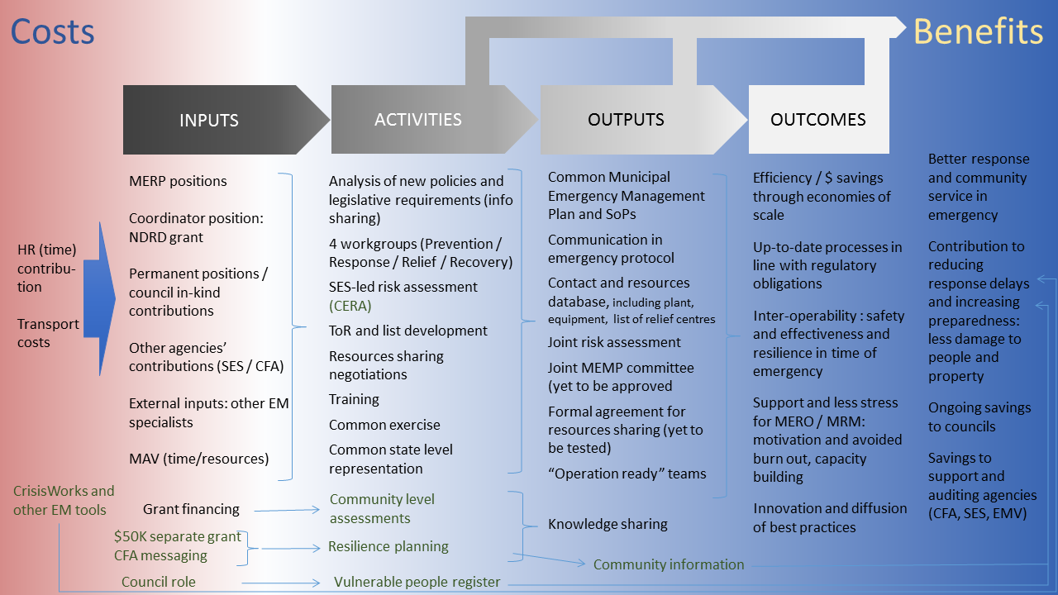

Figure 5. Logic map showing the links between the EM Cluster inputs (costs), its activities and the expected outputs and outcomes from those activities.

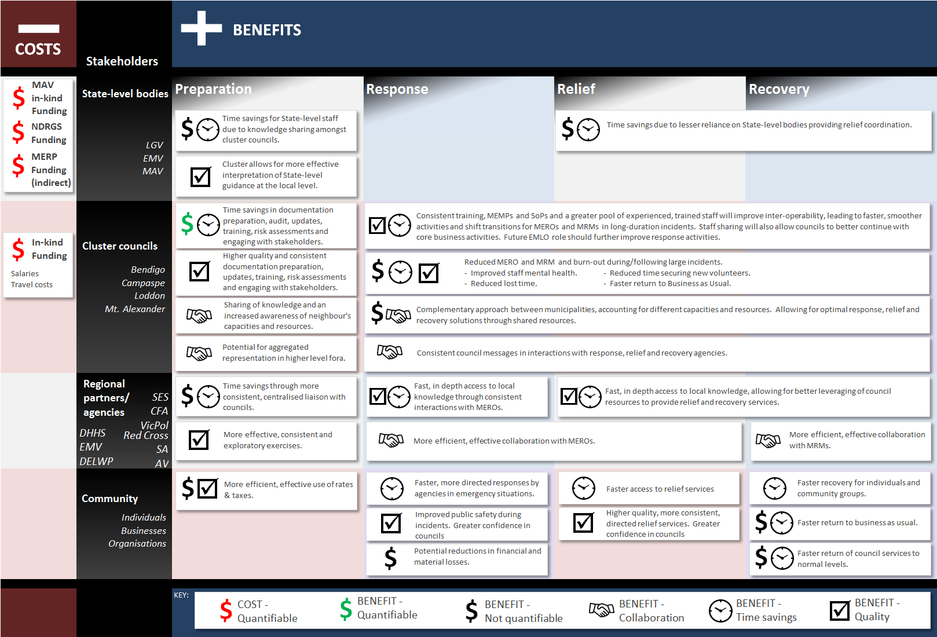

Figure 6. Summary of the costs and benefits of the EM Cluster Pilot.

## Quantifiable financial costs and benefits to participating councils

### Content and approach

The quantifiable financial costs and benefits to councils of the EM Cluster Pilot are a small piece in the overall matrix of outcomes from the collaboration (Figure 7). They are significant, however, in that they are one of the key numbers that resource-constrained and budget-conscious councils may have to provide context to potential investment in this area.

**The key quantifiable financial benefits from the EM Cluster are the time savings from document production and joint representation** (see Figure 6). There are other benefits that are technically ‘financial’, but because we have not been able to quantify them robustly, we have, instead, discussed them in Section 5.3 above.[1]

**The result below is thus a small window into the direct, recurring financial costs/benefits of the approach, on top of which the additional benefits of collaboration (Section 5.3) can be added).**

The analysis, presented below, has two key elements:

* an assessment of the annual financial costs (including in-kind support) of running the EM Cluster each year
* an assessment of the net financial benefits from the EM Cluster, specifically relating to:
  + time savings from joint document production
  + time savings from joint representation at meetings.

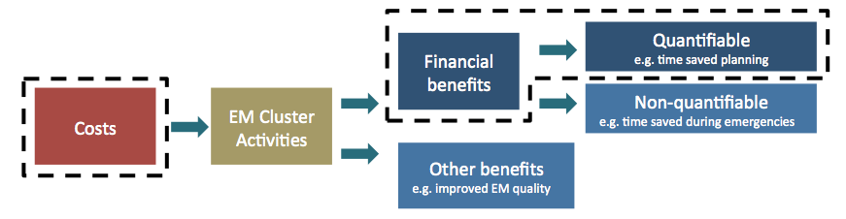

Figure 7. Elements that this section assesses (within the dashed squares) in the context of the broader benefits from the EM Cluster (see Section 5.3).

### Recurring Costs (yearly basis)

The cost of running the Cluster has been estimated by participating councils and is detailed in Table 3 below.

It is important to note for this analysis that the estimates are for the annual costs/benefits for the EM Cluster into the future. They do not consider the establishment costs (i.e. those incurred during the pilot phase). The ongoing costs are expected to be lower because less time will be required to:

* Explain and present the cluster to stakeholders (it was estimated that this took up to 30% of the coordinator’s time during the Pilot).
* Coordinate meetings and plan for deliverables (administration of joint tasks), once key documents are finalised by the four workgroups.
* Work on MoU and “structuring” document, once these have been agreed upon by participating councils.

The following tasks are however expected to remain the same as during the pilot phase:

* Management of joint projects (e.g. Contact database).
* Information gathering and distribution, in particular in relation to legislative changes: it is expected that these changes will eventually become less frequent, but in the short- to medium-term (3-5 years), more changes are expected.
* Knowledge management and retention, ensuring resilience of learnings and progress made.
* Governance: costs follow up and reporting to SRG and PCB.

Finally, some tasks are likely to take more prominence:

* Representation of the EM Cluster councils at regional and state EM meetings.
* Coordination of exercises and other joint activities.

The full list of Cluster EM Manager’s proposed tasks and responsibility is provided in Appendix B.

Overall, the costs summarised in Table 3 are considered adequate to ensure enough commitment and availability of the coordinator and enough secretarial support.

It should be however noted that salary costs will depend on the level of experience of staff employed. We have not attempted to question this for the EM Coordinator, though present a more- and less-conservative estimate for the administration officer.

Table 3. EM Cluster management costs. Note the overall cost per annum shows a range, based on a more- and less-conservative estimate of the costs of the administration officer.

|  |  |  |
| --- | --- | --- |
| Cost description | Estimated budget (p.a.) | Possible variations / Comments |
| Emergency Management Coordinator  (0.5 FTE - Salary plus on costs) | $50,000 | Standard cost deemed adequate based on current EM Manager’s advice.  There have been suggestions that the role could be reduced to 0.2FTEs (1 day / week).  Our opinion is that the 0.2FTE would significantly hamper the EM Manager’s ability to represent the cluster and coordinate special projects and would therefore curtail some of the anticipated benefits. |
| 0.15 FTE admin. officer | $15,000 | Cost of admin officer is likely to be significantly less than EM Manager, probably by 30% (this would bring this item to $10,000). |
| Ancillary costs: contractors, vehicle, IT | $10,000 | The capacity to commission external contractors will be limited by this budget and is likely to require ad hoc funding. |
| **Total cluster cost per annum** | **$70,000-75,000** | |

In addition to the resources solely dedicated to the management of the cluster, the time input of EM coordinators and other resources within each council when undertaking cluster-related activities is also considered as a cost (Table 4).

Importantly, only differential costs should be considered, i.e. time inputs into cluster activities should be netted off against time saved thanks to cluster deliverables being undertaken jointly under the cluster. For clarity, this time saving has been presented under the “benefit” section below.

Table 4. EM Cluster participation costs (in kind council resources costs)

|  |  |  |
| --- | --- | --- |
| Cost description | Estimated  budget (p.a.) | Possible variations / Comments |
| Council based EM resources (for all councils) | $120,000 | Standard cost deemed adequate based on current EM Manager’s advice.  It is our view that, while 0.3 FTE (EM coordination role) per council may be required to carry out joint cluster activities when developing new documentation or organising major exercise, it is likely to be less once the cluster’s structures and documentations are all in place.  We do not however propose to revise down this number, as it is our opinion that this cost is effectively offset by the benefits received back from the cluster (see below - benefits). |
| MERO, MRM, other council roles 0.8 FTE | $0 | We consider that MEROs, MRMs and other council participants’ roles in EM can be enhanced through cluster activities. This may require additional time away from BAU activities for these people, but this should not be considered as additional costs. |
| **Total cluster management cost per annum** | **$120,000** |  |

### Recurring Benefits (yearly basis)

Ongoing financial benefits for councils from participating in the Cluster (Table 5) can be primary linked to time savings by staff in relation to:

* Reduced workload required to achieve compliance, as some of the **work is undertaken collectively** through workgroups.
* Time savings from **delegation of tasks and representation role to EM Cluster coordinator** for specific tasks, in particular project management of joint projects (e.g. contract databases, information management), coordination of training / exercises (when those are organised jointly) and representation of Cluster councils at regional and state meetings.

Estimating ongoing time savings from these activities is complex, as activities are bound to vary significantly over time. In addition, the capacity of the EM Cluster manager to take on representation and project management activities will greatly depend on his / her level of experience and comfort with the specific nature of the tasks (and their complexity).

Obviously, costs (presented in the sub-section above) and benefits (presented here) are intimately linked: if EM resources in each council input less time into cluster-based activities, they may still get benefits from the work of others, but overall the benefits will decrease proportionally. Similarly, if the EM manager’s time allocation for the cluster is reduced, then corresponding benefits will decrease. The table below therefore only present a possible scenario for the production of benefits aligned with the input assumed based on the costs listed above.

Also note that benefits would increase if more councils were involved.

Table 5. EM Cluster estimated financial benefits.

|  |  |  |
| --- | --- | --- |
| Benefit description | Estimate (p.a.) | Assumptions / Comments |
| Time saving for council based EM resources from collective work (workgroup participation, other joint activities) | $120,000 - $180,000 | Assumes 2-3 hours “benefit” for 1 hour input  The assumed input is:  0.3 FTE (see Table 4), less the time needed for non-productive meetings etc. (0.15 FTE) = 0.15 input into productive collective work. |
| Time saving for council based EM resources from delegation of responsibilities to EM manager | $19,000 | Assumes that the EM manager can represent council at 16 meetings a year (i.e. avoiding 16 meetings for each councils), assumes half a day to a day for each meeting, including transport (see additional explanation below) |
| **Total estimated benefit per annum** | **$139,000 - $199,000** | |

Note the estimated benefit for time savings from collective work shows a range, based on a more- and less-conservative set of assumptions.

Additional assumptions underpinning the numbers provided above are provided in Appendix C.

Table 6 below summarises these costs and benefits with the result being the cluster yielding between a $9,000 benefit per annum and a $56,000 cost.

Table 6. Summary of estimated EM Cluster benefits and costs under less- and more-conservative assumptions (see above).

|  |  |  |
| --- | --- | --- |
| Description (all costs and benefits are per annum for 4 councils) | Less-conservative estimate (p.a.) | More-conservative estimate (p.a.) |
| **Costs** |  |  |
| Costs - Cluster management | *$70,000* | *$75,000* |
| Costs - Council based EM resources (0.3 FTEs per council) | *$120,000* | *$120,000* |
| **sub-total (costs)** | **$190,000** | **$195,000** |
| **Benefits** |  |  |
| From collective work | *$180,000* | *$120,000* |
| From delegation to EM manager | *$19,000* | *$19,000* |
| **sub-total (benefits)** | **$199,000** | **$139,000** |
|  |  |  |
| **Net result** | **$9,000 benefit** | **$56,000 cost** |

## Summary of the costs and benefits of the EM Cluster Pilot in the context of EM

As outlined in Sections 5.2 to 5.4 above, there are a broad range of benefits from the EM Cluster for participating councils, agencies and the community.

Section 5.4 deals specifically with the quantifiable financial costs and benefits of the collaboration; the costs relating to having an EM Cluster Coordinator and the time invested by EM staff, the benefits relating to time saved in producing documents and attending meetings. When offset against each other, the overall outcome is that the EM Cluster:

* costs each council $14,000 per annum (under more conservative assumptions)
* provides a net benefit to each councils of $2,250 per annum (under less conservative assumptions).

Importantly, these net figures do not account for the broad range of other benefits delivered by the EM Collaboration (Figure 8). These non-quantifiable financial and other benefits are detailed in Section 5.3. **At their core, these benefits relate having better EM planning and preparation, which, in turn, will benefit the community through a better response to and recovery from future emergencies.**

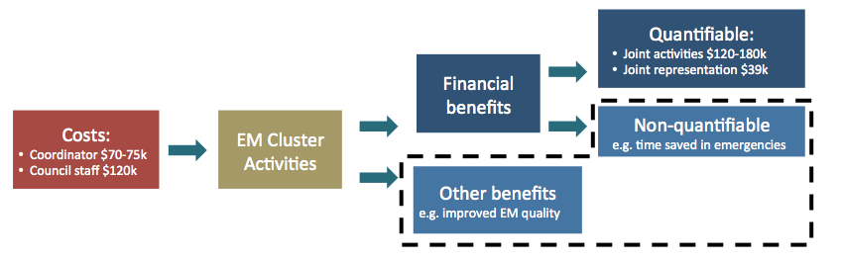

Figure 8. Financial costs and benefits as compared to the other benefits expected to flow from the EM Cluster (those within the dashed lines, detailed in Section 5.3).

The final point in this review of the costs and benefits of collaboration is to put these costs and benefits in context with the risks from various emergencies. Based on Community Emergency Risk Management documents, Table 7 shows the range of risks that are rated as high or extreme within the four EM Cluster councils. Importantly, in all cases, councils had also rated these risks as ‘almost certain’.

The very high likelihood and consequences of these emergencies indicates just how significant a threat various emergencies are within municipalities. This points, in turn, to the substantial potential for collaboration to provide meaningful benefits.

Collaborative approaches are expected to reduce the long-term consequences of these risks through improved planning and through improved response, relief and recovery efforts (as discussed for each type of risk in Table 7). Given the frequency and magnitude of the risks, even small improvements in any of the emergency planning and management elements above has the potential for significant flow on benefits.

Thus, even with the more conservative assumptions in Section 5.5, **the net financial cost to councils of collaborations such as the EM Cluster should be seen as a marginal cost with the potential to deliver substantial long-term benefits to councils, communities and other stakeholders.**

Table 7. EM risks assessment by councils. In terms of likelihood, all have been rated as “almost certain” by those councils

|  |  |  |
| --- | --- | --- |
| Risk ranked as high / extreme by councils | No of councils [2] | Possible benefits of collaboration (in addition to enhanced planning) |
| Wildfire | 4 | A fire can go on for several days and threat can remain high long after the main fire is under control. Relief and recovery for affected communities can be very long lasting. This is a major area where inter-council support can provide benefit. |
| Storm | 3 | Depending on the type of storm, the impact can be similar to that of a flood, although damages can be more diversified. They can also tax councils’ EM resources quite dramatically and assistance is beneficial. |
| Road crashes | 3 | These are likely to be frequent, but also likely to be within the coping capacity of a single council (dramatic consequence but limited in time and in space), without needing to draw on other councils. |
| Drought | 2 | The consequences of a drought take longer to eventuate than other emergencies, but are long lasting, requiring specific relief and recovery measures. Access to a pool of knowledge could be beneficial. |
| Flood | 2 | As for wildfires, consequences of floods can be dramatic, costly and the relief and recovery effort is likely to be beyond the resources of one single council. Collaboration can therefore be invaluable. |
| Fire (structures) | 1 | Such emergencies are usually managed locally without much difficulty. Only in case of a dramatic fire affecting communities (such as the 2014 mine fire in Morwell) is collaboration between councils likely to have a significant impact |
| Human disease (pandemic) | 1 | While considered as “almost certain” by only one council, consequences could be catastrophic and create unknown / difficult to manage situations for councils. The ability to call on neighbouring councils for support (to relocate vulnerable people for example) could be very valuable. |

# Appendix A: reviewed documents

Our team reviewed and analysed a range of documents related to the EM Cluster Pilot, including documents available through the EM Cluster Pilot’s online document repository (‘Basecamp’). Documents included:

* DELWP. (2015). Request for Quotation and Project Specification - Evaluation of the Emergency Management Cluster Pilot Project for Councils and the Municipal Emergency Resourcing Program. DELWP.
* EMC Pilot Councils. (2014). Shared Local Government Emergency Management Services - Memorandum of Understanding. Campaspe, Bendigo, Loddon & Mount Alexander.
* EMC Pilot Councils. (2015). Shared Local Government Emergency Management Services - Northern Victorian Cluster - Business Case DRAFT V4.1.
* EMC Pilot Councils. (2015). Shared Local Government Emergency Management Services - Northern Victorian Cluster - Framework.
* EMC Pilot Councils. (2015). Shared Local Government Emergency Management Services - Northern Victorian Cluster - Implementation Plan.
* EMC Pilot Councils. (205). Agency Meeting 16/3/15.
* MAV. (2013). Project Management Plan - Emergency Management Cluster Pilot Project for Councils V1.9. MAV.
* MAV. (2014). Municipal Association of Victoria - Submission to the Productivity Commission inquiry into natural disaster funding arrangements.
* MEMEG & MAV. (2015). Local Government Emergency Management Handbook. The Victorian Government. Cite:
  + Parliament of Victoria. (1958). The Country Fire Authority Act. Parliament of Victoria.
  + Parliament of Victoria. (1986). Emergency Management Act. Parliament of Victoria.
  + Parliament of Victoria. (2010). 2009 Victorian Bushfires Royal Commission. Parliament of Victoria.
* Rankin, M. (2015). Cluster Emergency Management Discussion Paper - Confirmation of Work Packages.
* Victorian Government. (2011). Review of the 201-11 Flood Warnings & Response. Melbourne: Victorian Government.

In addition, the following documents have been reviewed in relation to the Wimmera collaboration:

* Wimmera Cluster (2014): Wimmera Emergency Management Cluster Program (presentation package)
* Development Impacts Pty Ltd (2014): Wimmera Emergency Management Cluster Program, Measuring for Results – Final report
* Wimmera Emergency Management – Cluster Partnership Agreement (Draft – undated)

The following documents have been reviewed in relation to the Eastern Metropolitan collaboration:

* EMC EMP (2014): Presentation to Eastern CEOs
* EMC EMP group (October 2014 V4): MOU 2014
* EMC EMP group (2014): TOR
* EMC EMP (July 2014): Strategic Plan
* Application to the Australian Community Safety Awards (2010)
* Eastern Metro Region (2014?): Local Government Achievements in Emergency Management

# Appendix B: EM Cluster responsibilities

The following proposed responsibilities have been extracted from the “Business Case Cluster EM V5” document (Draft).

**Emergency Management Coordinator Tasks and Accountabilities:**

* Manage the Municipal Emergency Management Planning process, including the maintenance and distribution of contact lists and databases
* Identify sufficient resources to fill all the required emergency response, relief, recovery and resilience roles within the cluster
* Coordinate the training and development of staff to fill emergency roles, ensuring there is sufficient but not excess capacity for an extended emergency
* Coordinate the development and implementation of staff rosters for cluster activities
* Coordinate the activities of workgroups, defined in the governance arrangements in the four key areas of coordination: preparedness, response, relief and recovery
* Coordinate delivery of information on changes in legislation and policy development.
* Develop and maintain standard operating procedures, forms and position descriptions for response, relief, recovery and resilience.
* Manager document storage and availability through EM Knowledge and other appropriate portals.
* Continue to seek efficiencies in emergency management delivery by streamlining resources, processes and facilities
* Represent cluster councils at state, regional and sub-regional forums and seasonal briefings
* Provide cluster councils with feedback on their internal EM activities and up-to-date information on best practice emergency management.

**EM Responsibilities Remaining with Councils:**

* Community engagement and consultation on emergency management planning additional to levels required for development of the Cluster MEMP
* Development of municipal or community resilience plans
* Development of community protection plans
* EM roles within council e.g. MERO, MRM, Recovery Centre Manager, Relief Centre Manager, MECC manager,
* Disaster Assistance grant applications
* Community Recovery Committees
* Engagement with local agencies and organisations on emergency preparedness.

# Appendix C: Assumptions underpinning the Benefit Cost Analysis of recurring benefits

**Assumptions for work done collectively:**

Common activities undertaken through the workgroups has been significant over the last six months of 2014/15 financial year as the workgroups were producing documents. It is difficult to predict the ongoing workload that can be undertaken by these workgroups on behalf of the cluster participants as the cluster moves into the next phase. However, based on interviews across council staff, we assume the following rule would adequately account for the input/benefit relationship for work undertaken jointly:

* For each hour input into the workgroup within the cluster, the EM Coordinators (or, if not them, MEROs etc.) gain four hours in overall benefit: one from their own efforts, and three from the efforts of the other three councils in the workgroup.
* However, they still need to spend the time integrating some of the knowledge / benefit, or tailoring those documents to their own needs:
  + Conservatively, we assume this equates to half of the overall effort (two hours)
  + More optimistically, we estimate this equates to 25% of the overall effort (one hour)[3]
* The result is a benefit of:
  + two hours for every one hour invested (conservatively)
  + three hours for every one hour invested (optimistically).

In terms of time invested: Table 4 indicates the overall time spent by council EM staff in the Cluster is approximately 0.3FTE. Interviews suggest approximately half of this time is dedicated to non-productive Cluster activities (meetings, communication or coordination that would not have occurred without the cluster). The other half (0.15FTE per council), is invested in productive, collaborative work that benefits the group. This equates to:

* 0.15 FTE x 2 = 0.3 FTE benefit (conservatively) = ~$30,000 x 4 councils = $120,000
* 0.15 FTE x 3 = 0.45 FT benefit (optimistically) = ~$45,000 x 4 councils = $180,000

**Assumptions for delegation of responsibility to EM Cluster coordinator:**

When a joint representation can be organised for the four councils in the cluster, local EM coordinators’ time can be saved. Based on interviews and conservative estimates, this might involve:

* 16 meetings a year is based on the assumption that 4 agencies (EMV, SES, CFA, Red Cross) organise 4 planning meeting a year either at regional or state levels, to which each council is invited, but where a joint representation is possible.
* For each meeting, time saved is assumed to be ½ day for 75% of the meetings, assuming they are organised regionally, and 1 day for 25% of the meetings, assuming they take place in Melbourne or another location requiring significant travel time.
* This translates into a time involvement of 10 days for the EM Cluster Coordinator and a corresponding time saving for each of the 4 EM coordinators (or other representatives from councils).
* Assuming a full time equivalent of 210 working days a year (excluding holidays), 10 days represent a saving of 4.75% of a FTE for each council, or 0.19 FTEs for the 4 councils.

1. These unquantifiable financial benefits require assumptions as to the nature, probability and magnitude of emergency events, which is beyond the scope of this assessment.
2. Number of councils reporting the risk under these categories. This risk is considered by other councils, but with a lower ranking.
3. For example: each council invests ten hours producing four different documents they can all share. Overall each council is getting forty hours of work from this investment. However, each of the documents needs to be tailored to local needs. Conservatively, this might take as much as five hours per document, equating to half the overall effort (20 hours). Optimistically, it may take only 25%, or 2.5 hours per document (10 hours overall). Importantly, this ‘optimistic’ case remains a reasonably conservative assumption.