LOCAL GOVERNMENT
BETTER PRACTICE GUIDE

Performance Target Guide
For the Local Government Performance Reporting Framework

2026-27 Edition

Table of contents
1 Introduction 3
1.1 Background 3
1.2 Related guidance 3
2 Setting targets 4
2.1 Measures requiring targets 4
2.2 Budget process 6
2.3 Principles for choosing council-selected measures 6
2.4 Principles for setting targets 7
2.5 Presentation of targets within the budget 8
2.6 Using the Target Setting Calculator 9
3 Reporting actuals against targets 11
3.1 Target thresholds 11
3.2 Commentary on results against targets 13
3.3 Presentation of targets and results 14
Appendix A: Performance Target Reporting Cycle 15
APPENDIX B – Summary of Changes 16

1 Introduction

1.1 Background
The Local Government Performance Reporting Framework (LGPRF) comprises 63 performance measures across key financial indicators and common service areas in Victoria. Enabled through the Local Government Act 2020 and the Local Government (Planning and Reporting) Regulations 2020, councils are required to report their individual results through the Performance Statement and Report of Operations in their Annual Report. Local Government Victoria, as the steward of the LGPRF, also collates and publishes this data to enable sector-wide benchmarking through the Know Your Council website.
The annual budget is fundamentally a target-setting instrument, representing a public statement of a council’s intended performance. Setting targets against standardised LGPRF measures enables the community and stakeholders to clearly understand a council’s intentions through the Budget, and subsequently assess performance against those intentions through the Annual Report.
After development work with the sector (including technical working groups and target setting trials) and with the support of the Local Government Performance Reporting Steering Committee, the Minister for Local Government approved the introduction of an initial target-setting component within the LGPRF in 2022, followed by its subsequent expansion in 2025.
Amendments to the Local Government (Planning and Reporting) Regulations in October 2022 introduced a requirement for councils to:
- set performance targets against specified LGPRF measures in their Budget, and
- report actual results against those targets in the Performance Statement.
These requirements strengthen the link between a council’s Budget and its Annual Report.
Further amendments in November 2025 expanded the target-setting requirements. Based on feedback from the technical working groups of 2024, the expanded target setting model gives councils the opportunity to select eight applicable measures from the framework for the setting, monitoring and reporting of targets.

1.2 Related guidance
This guide should be read in conjunction with the Local Government Better Practice Guide for Preparing Council’s Annual Report and the Local Government Performance Indicator Guide 2026-27.

2 Setting targets

2.1 Measures requiring targets

2.1.1 Measures requiring mandatory targets
As part of the 2026-27 budget process, councils are required to set targets for the following eight prescribed measures as per Section 5 of the Local Government Model Budget.
These measures are:
Service measures |  | Financial measures
GOV-G2 - Consultation and engagement  Satisfaction with the opportunities offered by Council to be consulted or engaged in Council decisions (community satisfaction rating out of 100 with the consultation and engagement efforts of Council) |  | FIM-E2 – Expenditure and revenue level Expenses per property assessment (total expenses per property assessment)
RSP-SP2 - Statutory Planning  Planning applications decided within the relevant required time (percentage of planning application decisions made within the relevant required time) |  | FIM-S1 – Rates concentration  Rates compared to adjusted underlying revenue (rate revenue as a percentage of adjusted underlying revenue)
ENV-R2 - Roads  Sealed local roads below the intervention level (percentage of sealed local roads that are below the renewal intervention level set by Council and not requiring renewal) |  | FIM-L1 - Liquidity  Current assets compared to current liabilities (current assets as a percentage of current liabilities)
ENV-WM8 - Waste management  Kerbside collection waste to landfill (amount of waste collected from kerbside waste collection services that is sent to landfill per serviced property) |  | FIF-O5 - Asset renewal and upgrade  Asset renewal compared to depreciation (asset renewal and upgrade expense as a percentage of depreciation)

2.1.2 Measures for Council-selected targets
In addition to the measures requiring mandatory targets, councils must select eight additional measures for the setting of targets from the LGPRF.

These eight council-selected measures for target setting can be any of the remaining Local Government Performance Reporting Framework measures as outlined in the Indicator Guide 2026-27 or Schedule 2 or 3 of the Local Government (Planning and Reporting) Regulations 2020.

FIF-O4 Non-current liabilities compared to own-source revenue  FIF-O6 Loans and borrowings compared to own-source revenue  FIF-O7 Loans and borrowings repayments compared to own-source revenue  FIF-C1 Expenses per head of population  FIF-C2 Infrastructure per head of population  FIF-C4 Own-source revenue per head of population  FIF-C5 Recurrent grants per head of population  FIM-E4 Average rate per property assessment  FIM-L3 Cash compared to current liabilities  FIM-OP1 Adjusted underlying surplus (or deficit)  FIF-O4 Non-current liabilities compared to own-source revenue  FIF-O6 Loans and borrowings compared to own-source revenue  FIF-O7 Loans and borrowings repayments compared to own-source revenue  FIF-C1 Expenses per head of population  FIF-C2 Infrastructure per head of population  FIF-C4 Own-source revenue per head of population  FIF-C5 Recurrent grants per head of population  FIM-E4 Average rate per property assessment | FIM-L3 Cash compared to current liabilities  FIM-OP1 Adjusted underlying surplus (or deficit)  FIM-S2 Rates compared to property value  FIM-S3 Rates and charges debt  GOV-G9 Total unpaid rates and charges  COM-LB7 Library membership  COM-MC4 Participation in the MCH service  COM-MC5 Participation in the MCH service by Aboriginal children  RSP-FS4 Critical and major non-compliance outcome notifications  CST-LB5 Cost of library services  CST-WM6 Cost of kerbside waste collection services  GOV-G1 Council resolutions made at meetings closed to the public  GOV-G3 Councillor attendance at council meetings  GOV-G6 Councillor attendance at councillor briefings  GOV-G7 Council meeting duration  GOV-G10 Permanent staff turnover  GOV-G11 Executive management staff turnover  GOV-G4 Cost of elected representation  GOV-G8 Capital works planning  GOV-G5 Satisfaction with Council decisions | COM-AF2 Utilisation of aquatic facilities  COM-LB6 Library loans per head of population  COM-LB8 Library visits per head of population  COM-MC2 Infant enrolments in the MCH service  COM-MC6 Participation in 4-week key age and stage visit  COM-R6 Active travel infrastructure  ENV-AF8 Health inspections of council registered aquatic facilities  ENV-AM2 Animals reclaimed  ENV-EC1 Water usage  ENV-EC2 Electricity usage  ENV-EC3 Gas usage  ENV-FS7 Food safety assessments  ENV-FS5 Food safety samples  ENV-R5 Satisfaction with sealed local roads  ENV-R7 Population density per length of road  RSP-AM8 Time taken to action animal management requests  RSP-FS6 Time taken to action food complaints  RSP-SP1 Time taken to decide planning applications  RSP-SP4 Council planning decisions upheld at VCAT  RSP-WM9 Kerbside collection bins missed  CST-AF7 Cost of aquatic facilities  CST-FS3 Cost of food safety service
CST-LB2 Recently purchased library collection  CST-MC3 Cost of the MCH service | CST-SP3 Cost of statutory planning service  CST-R3 Cost of sealed local road reconstruction | CST-R4 Cost of sealed local road resealing

2.2 Budget process

2.2.1 Setting targets
Councils are required to consider and set targets during the 2026-27 budget preparation period with the respective targets being included in the Annual Budget adopted by 30 June. (See Appendix A for the cycle).
Each of the targeted indicators will require a target for the budgeted year and subsequent three financial years. The Local Government Model Budget has been updated to reflect this requirement.

2.2.2 Revising targets
As part of the council’s budget, targets can be reviewed and updated (if required) in line with the development of a revised budget.
Revised budgets must meet the requirements as detailed in sections 95 and 96 of the Local Government Act (2020).

2.2.3 Changing council-selected measures
During the budget development process, council may choose to change the council-selected measures from previous years.
Council cannot remove or change the mandatory measures.

2.3 Principles for choosing council-selected measures
As part of the 2025 amendments to the regulations, councils are now required to select eight LGPRF measures for the purpose of setting targets and reporting performance against those targets.
In selecting appropriate measures for target setting, councils may wish to consider the following principles.

2.3.1 Alignment with council objectives, strategy and funding
Measures selected for target setting should align with the council’s strategic objectives, statutory obligations, and service priorities. Councils should be able to clearly link performance outcomes to their commitments through funding decisions, resource allocation, or service delivery improvements.
Achievement against a selected measure should therefore reflect the effectiveness of council actions and investment.

2.3.2 Comparability and benchmarking potential
Measures that are stable and not subject to year-on-year volatility will be better suited for target setting. The ability to conduct comparisons over time and against peers or benchmarks will assist in assessing relative performance and informing evidence-based decision-making.

2.3.3 Balanced across performance dimensions
With the framework’s transition to seven performance dimensions, councils can select a balanced suite of measures that reflect performance across financial management, financial forecasting, responsiveness, cost, governance, environment, and community outcomes.
As a starting point, the Performance Statement has been updated to identify key measures across each of the seven performance dimensions. Councils may choose to adopt measures already included in the Performance Statement when selecting measures for target setting.

2.3.4 Auditable
Measures selected for target setting will be subject to annual audit from the Victorian Auditor General’s Office as part of the Performance Statement.
When selecting measures, council may wish to consider the required audit evidence to support the measure.
Measures currently included in the Performance Statement are already subject to audit and requirements are well documented and tested. Measures as part of the Report of Operations do not have supporting audit requirements and council will need to consider potential audit evidence and discuss with their audit provider.

2.4 Principles for setting targets
Council has autonomy in setting its own targets, however, the council may wish to consider the following when developing targets.

2.4.1 Informed
When setting targets, Council should make an informed decision on the target, using available data and their strategic plans such as the Council Plan, Financial Plan and Asset Plan.
Council may choose to:
- consider annual trends in previous results for these indicators (where available) or any previous projected forecasts for the financial measures
- review any former, current or future budget commitments which may influence the outcome of these measures
- check with service delivery areas as to whether there are any risks to achieving the target and ascertain a likely expected outcome; and,
- assess any former or current plans or programs which may influence the outcome of these indicators.
Local Government Victoria has built a LGPRF target setting calculator that may assist in reviewing previous results.
Council may wish to consider internal levers that may drive improvement within the measure, such as investing in the service or function, improving staffing levels or reviewing processes and systems.

2.4.2 Transparent
Targets make council’s intentions in relation to service delivery and financial management more transparent to council’s stakeholders, including the community.
Targets will be made public through the Council’s budget documents. As such, council may wish to consider the potential impact the target may have on the community’s expectations.

2.4.3 Achievable
Targets should be achievable within the current or future scope of the council.
Aspirational or stretch targets - while suitable for internal motivation - may be less suited for a public audience, where there may be risk of not achieving the target owing to external factors outside of a council’s control.
Thresholds have been developed (see Section 3.1) to assist in providing a range for the interpretation of the result and council may wish to consider the range when determining the target.

2.4.4 Supported
Once a target is determined, Council should finalise the target, including gaining internal agreement and approval before inclusion in the Council budget documentation. This may include engaging with the elected Council as part of the budget process.

2.5 Presentation of targets within the budget
Councils are required to present their targets publicly as part of the Annual Budget process.

2.5.1 Budget
The indicators with their respective targets (for the budgeted year and future) are required to be presented within the council’s budget documents. They should be clearly presented with rationale for the target (if required) recorded in the notes section.
For an example of the layout, please refer to the Local Government Model Budget 2026-27.

2.5.2 Local Government Sector Performance
While councils are required to provide their targets to Local Government Victoria for sector analysis, the targets will not be published for comparison purposes until the release of the 2026-27 results in late 2027.

2.6 Using the Target Setting Calculator
Council may choose to use the LGPRF target setting calculator to assist in setting their targets and reporting within the Model Budget. The excel document has been produced to provide an easy tool for Council to review previous results, test targets against thresholds and populate the necessary Budget insert.
To complete the calculator, Councils are encouraged to:
- Action 1 – Review the measures for mandatory targeting setting.
Review the targeted measures on the 1 Review mandatory measures tab, including the calculation of the measure, the data inputs, data type and indicator guide page reference.
- Action 2 – Select the eight council specific measures for target setting. Each measure will be displayed along with the relevant domain, associated indicator, the measure ID, the value format (e.g., dollar, percentage), the data inputs, data type and the linked page number from the 2026-27 Indicator Guide for further reference.
- Action 3 – Set the targets for the eight mandatory measures and the eight council specific measures.
  - Step 1: Select your council from the dropdown list
  - Step 2: Determine your forecast actual for the current reporting year. This may include using any existing quarterly or six-monthly results to make an estimate of the likely result for the current reporting year.
  - Step 3: Enter the anticipated percentage change to the measure for the budgeted year. To assist, Council may refer to the Percentage change to state-wide averages table or Percentage change to similar council average table at the bottom of the tab.
Once a percentage change is entered, the calculator will provide a potential target. This target is based on the anticipated change on the result of the last complete year (for example, 2024-25). Councils may use this potential target in determining their target.
  - Step 4: Enter Council’s target for the budgeted year. This may be based on the available data, the potential target and other factors not included within the calculator. For more considerations, please refer to section 2.4 of this guide.
  - Step 5: Enter any rationale for the target. This field is for internal purposes only. This may include adding direct references to the Council Plan Annual initiatives for the budgeted year.
  - Step 6: Enter the Public Comment. This explains the reasoning for the target for a public audience. These comments should be included as notes within Council’s budget.
  - Steps 7, 8, 9: As per Step 3, Council can enter the anticipated percentage change to the targeted measure for the future years. Council may review the potential trend line and changes to the trends in the last two columns.
- On the target thresholds tab, Council can review the target thresholds applied to each measure based on the data entered via the Input tab. For more information on the use of target thresholds, please refer to section 3.1.
- Council may use the Model Budget insert tab to produce the required insert for the Council’s budget. This tab provides the detail and potential layout for the Council’s budget to meet the legislated requirements as per the Local Government Planning and Reporting Regulations 2020.

3 Reporting actuals against
targets
The reporting of actual results against the set targets, provides the public with the ability to assess how successful the council has been in achieving its intentions. The LGPRF will make use of target thresholds to present the outcome.

3.1 Target thresholds
A range is used across targeted results to better express the outcome. The variance outcome between the target and the result can be represented in three categories:
- Meets target;
- Within range; and
- Missed target.
Depending on the nature of the measure (development, reduction or open) will determine how the range applies to the result.

3.1.1 Development focussed measures
Development focussed measures are metrics where the general expected outcome across the sector is for the measure to increase in result. As such, Council is seen to be improving when the result is higher than last year or the target.
This does not prevent Council from setting targets below the previous year’s result if they are expecting a downturn or decrease in result, however the measure maintains its focus on improving through an increase.
The target threshold applied to a development focussed measure would:
- Meet the target where the result is higher than the target or within 2.5% variance below the target.
- Be within the range of the target where the result is within 2.5% to 10% variance below the target.
- Miss the target where the result is below 10% or more of the target.
This is represented in Graph 3.1.
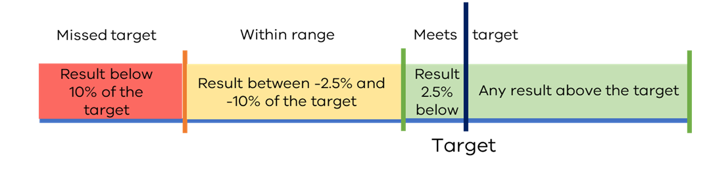
Graph 3.1 – Threshold range applied to development focussed measures.

Examples of targeted development focussed measures are:
- GOV-G2 - Satisfaction with the opportunities offered by Council to be consuted community consultation and engagement
- ENV-R2 - Sealed local roads below the intervention level
- RSP-SP2 - Planning applications decided within required timeframes
- FIM-L1 - Current assets compared to current liabilities
- FIF-O5 - Asset renewal and upgrade compared to depreciation

3.1.2 Reduction focussed measures
In contrast to development focussed measures, reduction focussed measures are metrics where the general expected outcome across the sector is for the measure to decrease or maintain in result. In this instance, Council is seen to be improving when the result is equal to or lower than the last year result or the target.

This does not prevent Council from setting targets above the previous year’s result if they are expecting a “blow-out” or increase in result, however the measure maintains its focus on improving through a decrease.

Therefore, the target threshold applied to a reduction focussed measure would:
- Meet the target where the result is lower than the target or within 2.5% variance above the target.
- Be within the range of the target where the result is within 2.5% to 10% variance above the target.
- Miss the target where the result is above 10% or more of the target.
This is represented in Graph 3.2.

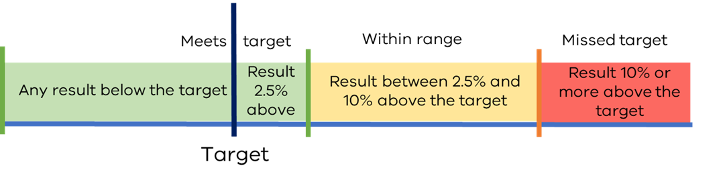
Graph 3.2 – Threshold range applied to reduction focussed measures.

The list of targeted reduction focussed measures include:
- FIM-E2 - Expenses per property assessment
- FIM-S1 - Rates compared to adjusted underlying revenue

3.1.3 Open focus measure
Open focus measures are metrics where a general expected outcome could be an increase or a decrease depending on the intentions of council. In this instance, council sets a target and the result must fall within the range to meet the target.

Therefore, the target threshold applied to a open focussed measure would:
- Meet the target where the result is within 2.5% variance above or below the target.
- Be within the range of the target where the result is within 2.5% to 10% variance above or below the target.
- Miss the target where the result is above or below by 10% of the target.
This is represented in Graph 3.3.

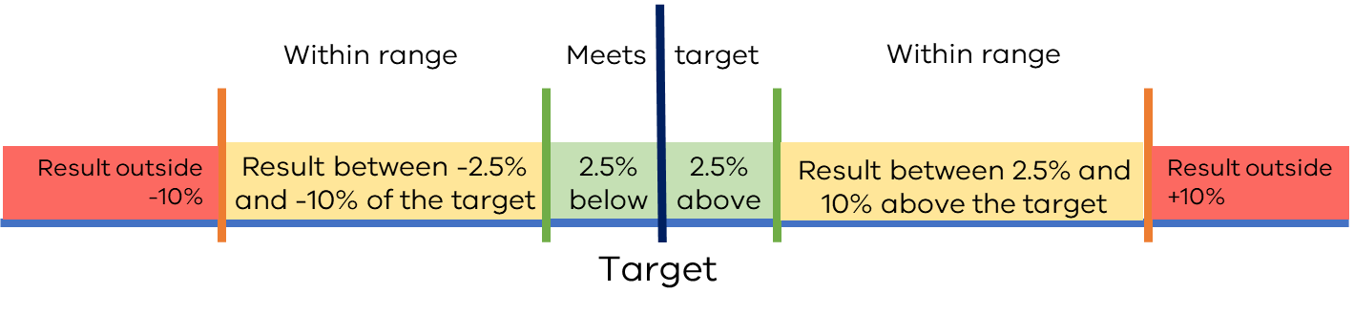
Graph 3.3 – Threshold range applied to open focussed measures.

The list of targeted open focussed measures include:
- FIF-O6 – Loans and borrowings compared to own-source revenue
- GOV-G7 – Council meeting duration
- GOV-G8 – Capital works planning

3.2 Commentary on results against targets
Where the actual performance result varies from the target by more than 10 per cent, an explanatory public comment should be included to outline the factors contributing to the variance.

The comment should explain why performance was over/under the target, regardless of whether these factors were within the council’s scope of influence or not.

Examples of commentary to explain the result against target:

“Council's primary strategy remains focused on community safety, communication, education, and promotion of responsible pet ownership.” | “The 2024-25 expected outcome is lower than the 2024-25 target due to changes in Commonwealth Government guidelines that resulted in reduced service demand.” | “Effort is being made to deliver organisational efficiencies and cost savings as a future dividend to ratepayers.”

3.3 Presentation of targets and results
Following the public release of the targets through Council’s budget and the conclusion of the financial year, the comparison between the targets set and the actual results are required to be released publicly in line with the Annual Reporting process. (See Appendix A for the cycle.)

3.3.1 Performance statement (Annual Report)
Within Council’s Performance Statement, the eight mandatory and eight council selected measures with the targets from the 2026-27 budget must be presented along with their actual results. Council must provide commentary to explain the result where necessary.

For an example of the layout, please refer to the Local Government Model Performance Statement 2026-27 (due for release in February 2027).

3.3.2 Sector Performance Reporting
From the 2023-24 financial year onwards, Local Government Victoria will present the targets (as provided by council through their budget or revised budget) alongside the results for the eight targeted indicators. In addition, Local Government Victoria will use the three outcomes (meets target, within range of target, missed target) within the presentation of the actuals, along with the numerical value of the target.

As with all results released through this reporting, council will have the opportunity to provide context to the result and target through the commentary function.

The future or anticipated targets will be updated with the most recent budget release based on forward estimate principles.

The target, result and council comment are featured on the Your Council Dashboard section of Know Your Council.

Appendix A: Performance Target Reporting Cycle
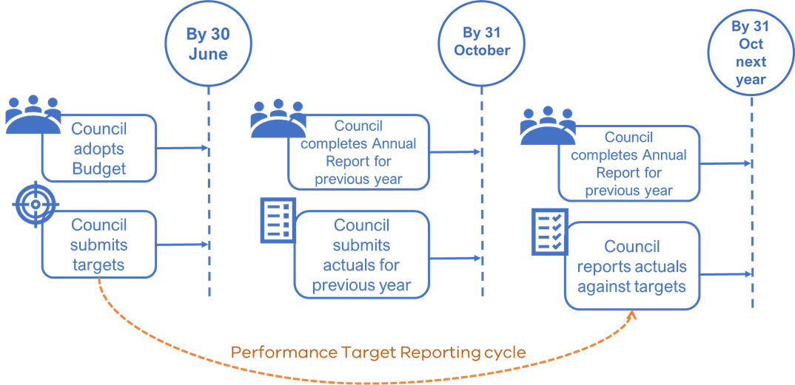

APPENDIX B – Summary of Changes
The following updates were made to this document between the 2025-26 edition and the current 2026-27 edition:

Section Ref | Change
All | References to the current and budgeted year have been updated along with updates to the names of supporting guidance.
1.1 | Updated to reflect the 2025 amendments to the Local Government (Planning and Reporting) Regulations 2020 and the expansion of eight council selected measures for target setting.
2.1.1 | Prefixes and names (where required) updated of the measures requiring mandatory targets.
2.1.2 | Insertion of new subsection detailing requirements of targets for council-selected measures.
2.2.3 | Subsection detailing options to change council-selected measures between reporting years.
2.3 | New section focussing on the principles for choosing council-selected measures.
2.6 | Section updated to reflect additional steps and improvements to the Target Setting Calculator 2026/27.
3.1.1 | Measure prefixes and names updated.
3.1.2 | Measure prefixes and names updated.
3.1.3 | New subsection explaining open focussed measures for target setting.

