LOCAL GOVERNMENT
BETTER PRACTICE GUIDE

Submitting performance data
For the Local Government Performance Reporting Framework

2025-26 Edition

OFFICIAL
Table of contents
1. Introduction 3
1.1 Purpose of the guide 3
1.2 Changes since 2022-23 3
2. Local Government Model Sector Performance Report template 4
2.1 The template 4
2.2 Opening and saving the template 4
2.3 Navigating the sections 5
2.4 Input sheets 5
2.5 Previous years’ data 11
2.6 Output sheets 11
2.7 Export sheets 12
2.8 Interim reporting 12
2.9 Broken formula detection 13
3. How to submit data 14
3.1 Monitoring the timeframe 14
3.2 Data review 14
3.3 Submitting the data 14
APPENDIX A – Troubleshooting the Template 16
APPENDIX B – Summary of Changes 17

Introduction

1.1 Purpose of the guide
As part of the Local Government Performance Reporting Framework, councils are required to prepare and present their performance data annually.
This loading guide has been developed to support users in the submission of data to Local Government Victoria (LGV) for the publication of the Sector Performance Reporting on the Know Your Council website. It contains:
- an overview of the Local Government Model Sector Performance Reporting template to be used for calculating measures and submitting data.
This information is provided for council’s use, to ensure the consistency, quality and accuracy of data provided as part of reporting against the LGPRF.
For detailed information on the indicators, measures and associated calculation, please refer to the Local Government Performance Reporting Indicator Guide 2025-26.
For more information on Performance reporting requirements, please refer to the Local Government Better Practice Guide - Preparing Council’s Annual Report 2025-26.
Both documents can be found at:
https://www.localgovernment.vic.gov.au/strengthening-councils/sector-guidance-planning-and-reporting

1.2 Changes since 2022-23
As an overview of the requirements, councils are no longer required to load their data via the Know Your Council website interface. Councils can now submit their data directly by emailing their completed template to the Local Government Performance team. See section 3 for further information.

In addition, as part of the 2022 amendments to the Local Government (Planning and Reporting) Regulations 2020, the Performance Reporting template has now been renamed the Local Government Model Sector Performance Report template to bring the document in alignment with similar budget documents.

A summary of other changes between the current edition of this document and the former edition (2024-25) can be found in Appendix B.

Local Government Model Sector Performance Report template

2.1 The template
This part of the Reporting Guide has been created to assist with the completion of the Local Government Model Sector Performance Report template (the template).
The template is an excel spreadsheet that has been developed to assist councils to:
- calculate and report the results for the performance indicators and measures in the Report of Operations and Performance Statement in council’s annual report
- submit data to Local Government Victoria for online publication through the Know Your Council website.
Use of the template will assist councils to meet the statutory reporting requirements in accordance with the Local Government Act 2020 (the Act) and Local Government (Planning and Reporting) Regulations 2020 (the Regulations).
As with previous years, the template has been pre-loaded with council’s results from prior reporting periods and targets from council’s budget. To activate this pre-load, simply select your council’s name on Input 1.

2.2 Opening and saving the template
Unlike previous versions, the Local Government Model Sector Performance Report template does not contain macros and councils should be able to save the spreadsheet for sharing in a document management system.

Locked areas
The spreadsheet has been locked to protect the formulas and feeds, ensuring that the correct data is picked up for analysis, calculations, and upload. Please do not add, remove or move fields as this affects how your template operates. If you wish to modify any of the locked content for your internal reporting, you can simply copy and paste the sheets into a new document. You will however need to ensure you are using the provided reporting template when finalising data for submission to LGV.
Colours – these are used to indicate where information should be entered.
White / clear | Cells to be completed by Council
Shaded | Protected cells, no input required
Filled cells | Conditional cells not requiring data

2.3 Navigating the sections

Councils are required to complete each of the input sheets. Each required step is highlighted with a golden step, e.g., - -

2.4 Input sheets
The template contains seven (7) input sheets.

Input 1: Operational control
This sheet is where councils select:
- their council, and
- the services they fund and over which they have operational control.

Councils should select their council from the drop-down box at the top of the table, which will allow additional data to populate in the template (e.g., index of relative socio-economic disadvantage by decile, ABS population estimates and previous data and targets) and update the headings throughout the template.
The current financial year is set in the template.

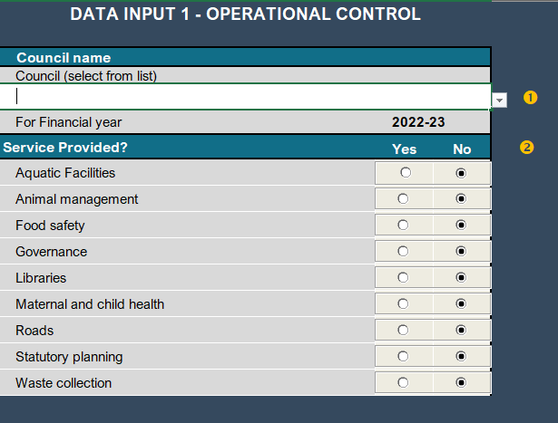

For more information on Operational control, please refer to the Local Government Better Practice Guide – Preparing Council’s Annual Report – 2025-26.
In the template, the default position for all services is ‘NO’ and councils are required to select ‘Yes’ and provide data for each relevant service. Councils can leave the service as ‘NO’ if they do not provide or have operational control of the service.

Input 2: Service performance
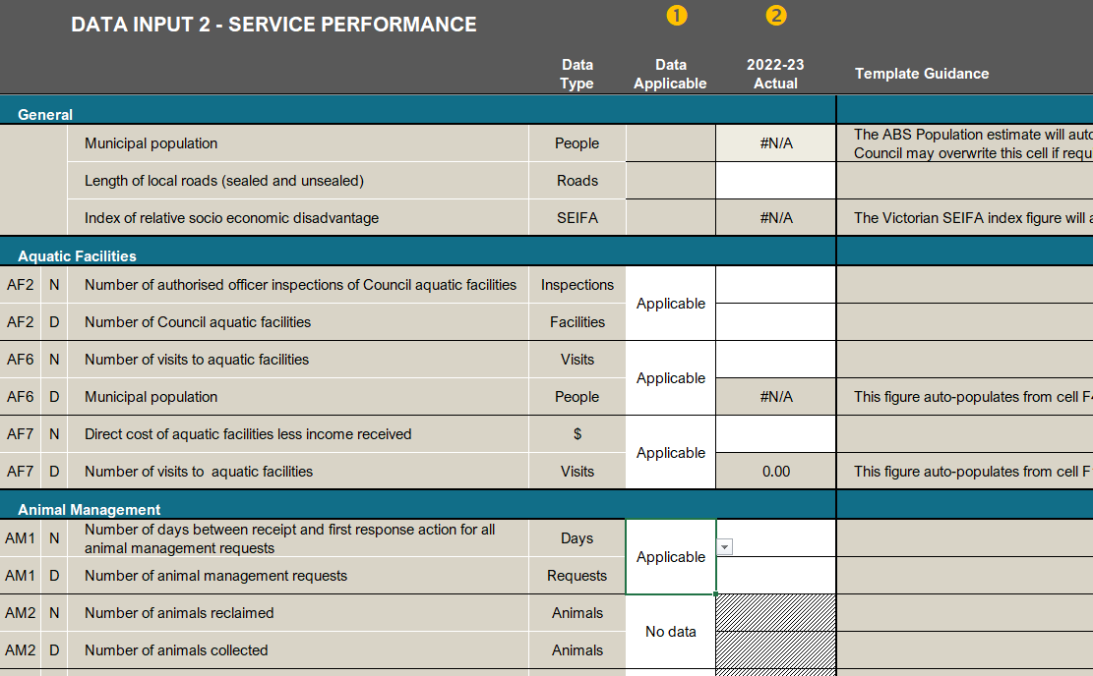

This sheet is where the data is entered for the Service Performance indicators and measures. Councils are required to enter the inputs (numerator and denominator) for each measure. Some inputs will be pre-populated in the template based on previously submitted data.
The data entered in this sheet will allow the results to be calculated in the output sheets. The results will populate the sheets Output 1 (Report of Operations), and Output 2 (Performance Statement).
Councils are required to identify whether data is to be reported for each measure using the DATA APPLICABLE column. For each measure, councils must select from the drop-down box either APPLICABLE or NO DATA. The default position is ‘No data’; Councils should select ‘Applicable’ for each service indicator it will provide data for.
These are explained in the following table:
APPLICABLE | Council provides and has operational control of the service, and data will be reported in the template.
NO DATA | Council either provides the service but is unable to report data in the template for the reporting period, or does not have operational control of the service. If council provides the service, but is unable to report data, a public comment must be provided in Input 4 of the template.

In some instances, council may need to record a genuine zero result for their measure. Council should select ‘Applicable’ with a result of zero.
Template guidance provides details on the input fields, including suggestions and error messages when data entered does not meet the requirements. The Guidance reference column provides the corresponding reference page number in the Local Government Better Practice - Performance Reporting Indicator Guide.

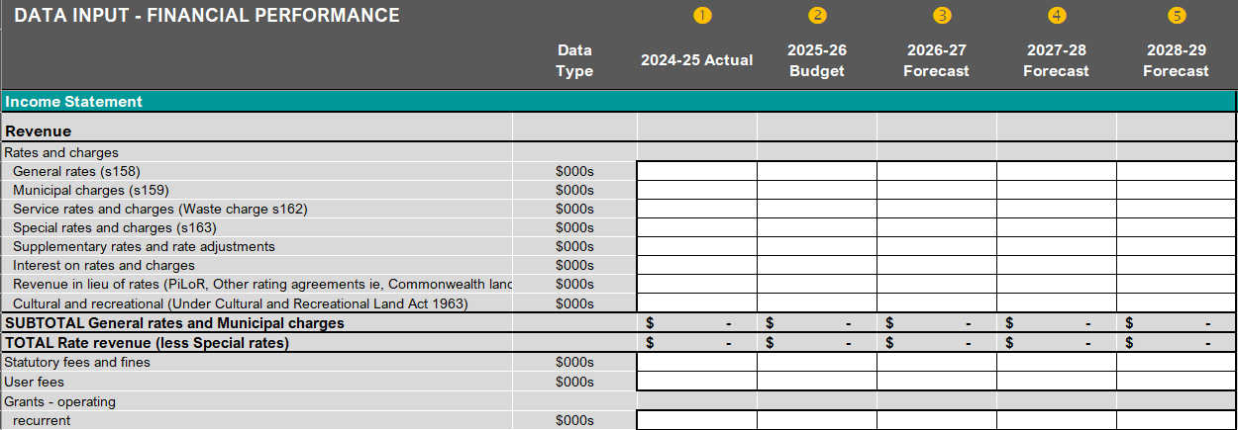
Input 3: Finance indicators

This sheet is where the data is entered for the Financial Performance indicators and measures. It requires councils to enter the actual year’s data, the budget and the three forecast years. The data entered in this sheet will then be calculated in the Output 2 - Performance Statement sheet. A copy of the financial statement is included in the Export 3 – Staff FTE and Fin Stat tab for analysis.
Template guidance provides details on the input fields, including suggestions and error messages when data entered does not meet the requirements. The Guidance reference column provides the corresponding reference page number in the Local Government Better Practice - Performance Reporting Indicator Guide.

Input 3 changes from 2024-25
Since 2024-25, the following minor changes have been applied to the Input 3 – Financial statement sheet.
- Under the Rates and Charges section of Revenue, the previous line items for Waste management charge and Service rates and charges have been combined into the line item: Service rates and charges (Waste charge).
- Descriptors for rates and charges have been added, including the relevant section under the Local Government Act 2020.
- Number of assessments have been updated to request the number of total assessments as a whole number rather than assessments in their thousands.

Input 4: Council comments and material variations
This sheet is where council comments on results, trends, and variations. Comments entered in this sheet will populate the Output 1 (Report of Operations) and Output 2 (Performance Statement) sheets.
Comments allow councils to provide context around their results, especially in cases of particularly high or low results. For audit purposes, where there is material variation, Council must explain the year-on-year variation exceeding the materiality threshold. For more information on materiality, please refer to the Local Government Better Practice Guide – Preparing Council’s Annual Report.
For the targets for prescribed indicators in the Council’s annual budget, Input 4 will show if the council’s actual result has met the target. This is based on preset target thresholds as outlined in the Local Government Better Practice Guide – Performance Target Guide and Target Setting Calculator.
Councils should perform a spell check on their comments by pressing the ‘F7’ key. Please note that LGV will not correct any spelling errors. Text will appear unaltered on the public website, regardless of spelling or grammar mistakes.
This sheet is unprotected to allow Council to conduct the spelling check of their comments. Only the council comment and target sections are used to populate the Output tabs. Councils may include targets for any non-prescribed indicators to form part of Output 2 – Performance Statement.
Note: Targets for prescribed indicators, cannot be altered in Input 4. These targets are populated from Council’s adopted budget data. Any amendments made to prescribed targets in Input 4 will not be reflected in Output 2.
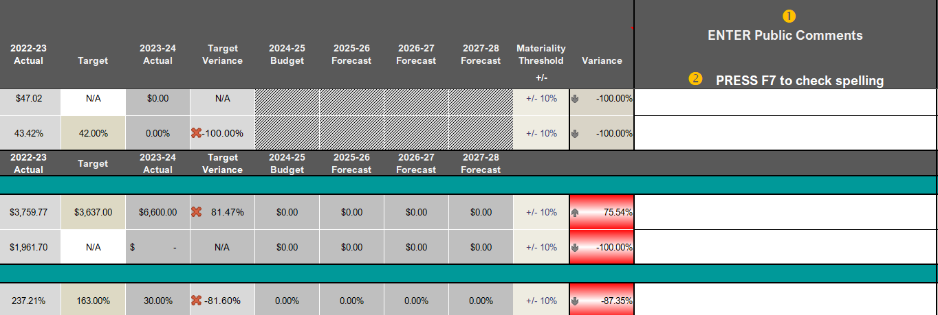

Material variation explanations must be provided for the following:
- material variations between the current year and all three previous years’ results. For the Financial Performance indicators, this will also include material variations between the current year and forecast results
- material variations between the current actual and targets as provided through the council budget
- zero results. This includes where the Council has operational control over the service but did not provide the service during the reporting period, or is unable to report any data for the service
- major changes. This includes changes to services or unplanned financial or other events which have impacted on the result(s).
Councils are able to include a URL link to corresponding documents or council pages in their commentary or material variations where relevant. The link will then appear on the Know Your Council website.
Where there are no material variations, Council should provide a qualitative statement. Council should not comment in regard to the expected range.
If information has come to light which changes the result for a previous year following the data being published, council should reference this in the current year commentary, particularly where it results in a significant year on year variation.
To assist councils to utilise the template internally, an ‘Internal Council Notes’ text only column is provided on each of the input sheets. Any notes in this column will not appear in the Performance Indicators sheet, and therefore will not be released to the public. Cutting content from this cell to other cells within the template may cause the template to break.
Please note, only the comment and target fields on this spreadsheet will be transferred to the export and output sheets, changes or updates to the remaining cells will not affect the data loaded to the system.
Where the change between the current result and the previous result is greater or less than 10%, the template will prompt the council to include a comment by highlighting the cell in the Variance column as Red and provide a message in the template guidance.

Input 5: Governance and management checklist
This sheet is where the responses to the Governance and Management Checklist are to be entered. Councils should select from the YES/NO drop down in column ‘D’ for each item and enter the applicable date in column ‘E’ in the following format: DD/MM/YYYY. These dates may revert to the American date format if Excel is set to the default settings.
For some items (e.g., GC20 Council Plan reporting, GC21 Quarterly budget reports , GC22 Risk Reports and GC23 Performance Reports) there may be multiple dates of operation. Where this is the case, Council should enter the name of the items and applicable date in column ‘F’ in the following format: [name of item]: DD/MM/YYYY, [name of item]: DD/MM/YYYY. An example is provided below.
Example: items with multiple dates
Road Management Plan: 24/07/2013, Building Management Plan: 22/04/2010, Bridge Management Plan: 06/05/2013

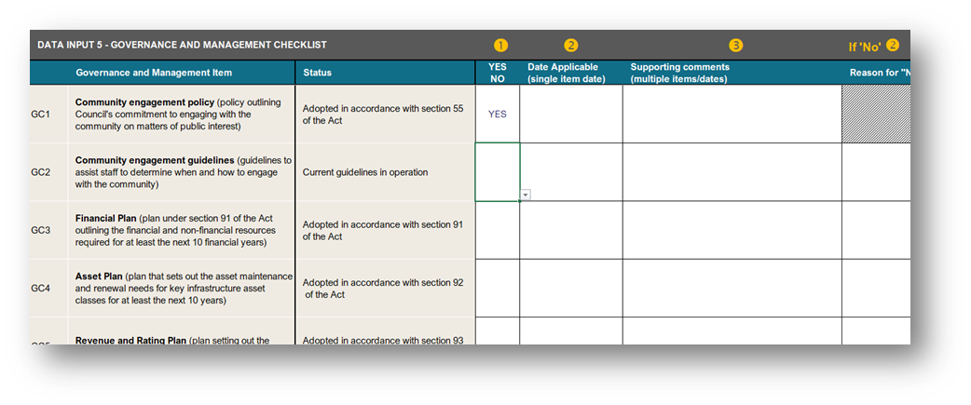

Councils are encouraged to include a URL link to corresponding documents for checklist items where relevant (e.g., annual report, road management plan). The link will then appear in the published data.
The data entered here will populate the Export 2 - ‘Gov and Mgt Checklist’ sheet and the Output 3 – GM Checklist tab.
Please note the format of the Governance and Management Checklist reported in the annual report must be presented in the format prescribed by Schedule 1 to the Local Government (Planning and Reporting) Regulations 2020. Refer to Output 3 – GM Checklist tab in the Model Sector Performance Reporting template for a downloadable version of the checklist.

Input 6: Workforce data
This sheet is where the Workforce data from the Report of Operations prepared in accordance with Regulation 10(l) and (m) is to be entered. The data entered here will populate the Export 3 - Staff FTE and Fin Stat sheet.

Input 7: Approve data for release
This sheet is where the Council authorises the release of the data.
Council should only complete this input once it has been approved by the Chief Executive Officer or their delegated authority.
Once Council has completed this input, the completed template should be sent to Local Government Victoria for compiling into the Sector Performance report and Know Your Council dashboards for release to the public.
Local Government Victoria has provided the final date for submission in Practice Note 23.
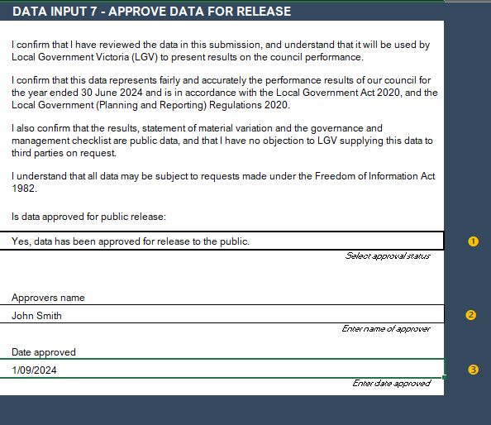

2.5 Previous years’ data
The template contains three (3) previous years’ data.
Data from 3, 2 and 1 years ago
Data from the last three years is included in the template and will show in Input 4, as well as Output 1 and Output 2.
Targets from the current budget
The targets for the prescribed indicators as per the Local Government (Planning and Reporting) Regulations 2020 are included from Council’s current budget and will show in Input 4 and Output 2.
All data has been pre-loaded from previous LGPRF submissions and councils do not need to load any additional data.

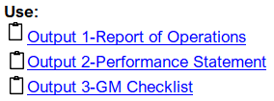
2.6 Output sheets
The template contains three (3) output sheets.
Output 1: Report of Operations
This output sheet is where the service indicator results and the explanation of material variations is provided as an insert for the Report of Operations in the annual report. The results and material variations have been populated from the Input 2 (Service Indicators), Input 4 (Public Comments) and Data from 3, 2 and 1 years ago sheets.
Output 2: Performance Statement
This output sheet is where the results and targets for the service, financial and sustainability indicators and the material variations are provided as an insert for the Performance Statement in the annual report. The results and material variations have been populated from the Input 2 (Service Indicators), Input 3 (Finance Indicators), Input 4 (Sustainability Indicators and Material Variations) and Data from 3, 2 and 1 years ago sheets. Target data for the prescribed targeted measures will populate here from Council’s budget data.
Output 3: GM Checklist
This output sheet is where the items, results and comments for the Governance and management checklist are presented and is populated from Input 5.

2.7 Export sheets
The template contains three (3) export sheets. These sheets are used to summarise the data for loading to a sector wide database and presented in public reports at the end of the reporting period.
Councils are not required to do anything with these sheets and are primarily for LGV use.
Performance
This export sheet is where the numerator, denominator, results and comments for the service, financial, sustainability indicators and non-prescribed Targets are reported (inputs 1-4). Prescribed Targets are populated here from Council’s budget data.
Gov and Mgt checklist
This export sheet is where the results of the Governance and Management checklist (Input 5) are reported.
FTE Fin Statement
This export sheet is where the results of the Input 6 (Workforce Data) and an overview of Input 3 (Financial Performance) are reported.
Please note, the financial statement data is collated and used to produce sector wide analysis and reporting.

2.8 Interim reporting
Councils may use this template to calculate the performance measures throughout the year for monitoring and evaluation purposes. Care should be taken when doing this, as some measures (numerators and denominators) will need to be annualised and this template does not undertake this function.
Annualised measures should be interpreted with caution as uneven reporting will occur due to seasonal variations and availability of some data elements. Therefore, results will not be uniform throughout the year.

2.9 Broken formula detection
Please note that the key input sections within the Service, Financial, Governance and Management Checklist are protected with formula controls designed to detect breaks in embedded calculations. These errors most commonly occur when cells are moved or cut and pasted.
If a formula is disrupted, the affected input area will automatically be shaded red to alert you.
Example:
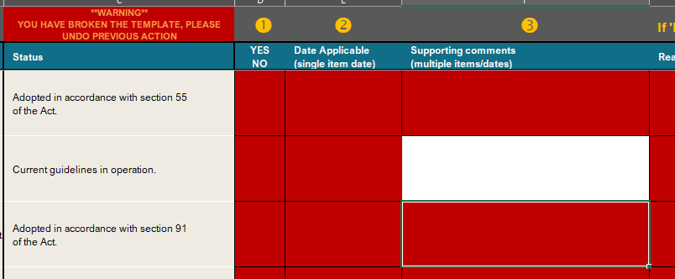

To resolve the error:
- Select Undo to reverse the previous action and restore the formula.
- If data has been entered incorrectly, either re-type the value directly into the correct cell or use copy and paste (not cut and paste) to transfer the value.
Please note that using cut and paste within the input areas will break the formula and trigger an error.

How to submit data

3.1 Monitoring the timeframe
Each reporting period involves crucial milestones that councils must fulfill. Local Government Victoria has issued Practice Note 23, outlining the key milestones and associated dates for the 2025-26 reporting period. It is essential for councils to carefully review these dates and develop an internal plan to ensure timely completion of the milestones.
To see all current practice notes, please refer to the Practice Notes section on the Performance Reporting Framework page. For assistance on roles and responsibilities, please refer to the Local Government Better Practice Guide – Preparing Council’s Annual Report 2025-26.

3.2 Data review
While 28 of the 59 indicators are audited by the Victorian Auditor General’s Office (VAGO) as part of the audited Performance Statement, the remaining 31 indicators are not directly subject to an independent audit and are reliant on council to ensure their data integrity.
Local Government Victoria (LGV), as the stewards of the LGPRF, offer an independent review of the template to check all measures for missing data, common errors and misinterpretations of the reporting requirements.
Councils will be invited to book a review with Local Government Victoria during the reporting period and prior to the final submission of the council performance data. Depending on Council’s needs, LGV can review before the data is provided to the auditors or as a final check after the data has been audited.
LGV will conduct only one review per council and only on a complete dataset.
Once the review is completed, LGV will provide feedback back to council.
If council does not require a review, they may elect to complete the template, approve the release of the data (see Input 7) and submit the template to LGV for final publication.
Once published, the data is a public record and cannot be altered.

3.3 Submitting the data
To submit the data for a review or for final submission for publication, council can email the template directly to performance@ecodev.vic.gov.au
Local Government Victoria (LGV) will provide a receipt email to confirm the template has been received.
Please note, LGV cannot accept the template for final submission unless the council has completed Input 7 – Approve data for release.
Any issues or questions, can be raised with the LGV Sector Performance team at performance@ecodev.vic.gov.au
Failure to submit all approved data before the final closing date may result in Council’s data not being included in the public release of data through the Know Your Council website.

APPENDIX A – Troubleshooting the Template
Some common issues which councils encounter when using the template are listed below, along with how to avoid them and how to fix them when they occur.
Issue | Cause | Preventative measures | Solution
Cells have gone RED | Formulas have been broken due to data or comments being cut between cells in the template. | Follow these steps when cutting or copying data into the template or between cells in the template, as Excel is quite sensitive to these sorts of changes.  1. Always copy as cutting may affect the formulas and cell references throughout the template (this particularly affects the Output and Upload sheets)  2. When copying, paste into the template using 'Paste Special' then 'Paste Values' | Undo previous changes or contact LGV via email to request fixing affected cells.
Cells become locked and cannot be edited | The formatting of the cells has been overwritten and locked due to data or comments being pasted into the template |  | Contact LGV via email to request the affected cells are fixed
Cells are returning #REF! | Formulas have been broken due to data or comments being cut or copied between cells in the template
Data or comments are displaying in the wrong cells
Can’t read the full commentary in the Output sheets | The default size of the cells is not big enough to display the commentary | n/a | Save and close Excel, then reopen and the cells will have resized
A strange figure (ï¿½;) is displaying in the place of punctuation | This type of text appears when the comment was originally written in a Word document and then copied and pasted into the Excel spreadsheet | - Type commentary directly into Excel, OR  2 When copying from Word into Excel, double click in the cell in Excel and then paste the text | This character can be overwritten in the template

APPENDIX B – Summary of Changes
The document has been updated throughout to reflect the current reporting period dates.
More specific changes are:
Section Ref | Change
2.4 | Removed outdated references to changes from 2023-24 for the Governance and management checklist.
2.9 | New section on error detection in the template.

