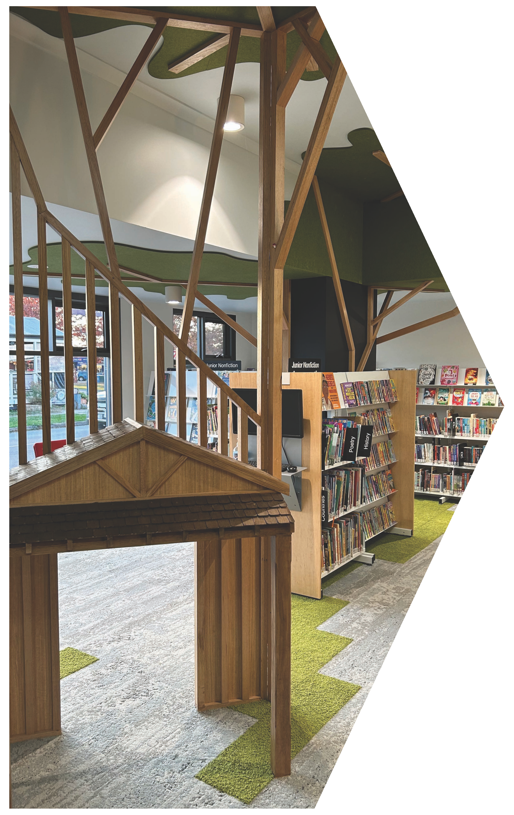Living Libraries Infrastructure Program 2023-24
Grant Guidelines

Authorised by the Victorian Government, Melbourne. Department of Government Services

1 Spring Street, Melbourne, Victoria 3000
Telephone 1300 366 356
© Copyright State of Victoria 2024
Department of Government Services, January 2024
ISBN 978-1-925551-85-3 (pdf/online/MS word)
This publication is copyright. No part may be reproduced by any process except in accordance with provisions of the Copyright Act 1968.

Except for any logos, emblems, trademarks, artwork and photography this document is made available under the terms of the Creative Commons Attribution 3.0 Australia license.

Disclaimer
This publication may be of assistance to you but the State of Victoria and its employees do not guarantee that the publication is without ﬂaw of any kind or is wholly appropriate for your particular purposes and therefore disclaims all liability for any error, loss or other consequence which may arise from you relying on any information in this publication. While every effort has been made to ensure the currency, accuracy or completeness
of the content, we endeavor to keep the content relevant and up to date and reserve the right to make changes as required.

The Victorian Government, authors and presenters do not accept any liability to any person for the information (or the use of the information) which is provided or referred to in the publication.

To receive this publication in an accessible format, please contact the Victorian Government Contact Centre on 1300 366 356, using the National Relay Service 133 677 if required.

Available at Local Government Victoria’s website:
https://www.localgovernment.vic.gov.au/public-libraries/public-library- programs/living-libraries-infrastructure-program

Acknowledgement
We acknowledge and respect the Traditional Owners of Country throughout Victoria, their ongoing connection to lands and waterways upon which we depend, and we pay respects to their culture and their Elders past, present, and future.

We acknowledge that Aboriginal self-determination is a human right enshrined in the United Nations Declaration on the Rights of Indigenous Peoples, and we are committed to working towards social, economic, and cultural equity for Aboriginal Victorians.

We acknowledge the diversity of Aboriginal Victorians, and we acknowledge all other people of Aboriginal and Torres Strait Islander descent living in Victoria.

Foreword
These past few years have shown us the importance
of community connection and the vital role that public
libraries play as community hubs.

Public libraries are about much more than books.
They deliver increasingly important services like digital
and cyber safe education and free internet access.
These programs support members of the community
to work, study and keep in touch with loved ones.

Then there’s the libraries that support creative, entrepreneurial communities through recording studios and 3D printing – supporting hobbies and launching careers. But beyond books, free facilities
and services, libraries have and will always offer a safe and inclusive space for everyone in the community.

We love our public libraries, and through the Victorian Government’s Living Libraries Infrastructure Program, we are proud to offer funding to support library upgrades in communities across Victoria. In the
2023-24 funding round, grants of between $10,000 and
$200,000 are available under the Minor Works stream.

The Victorian Government has invested more than
$47.1 million dollars over the last eight years into 120
library infrastructure projects with a total project cost
of $345.8 million, supporting libraries in metropolitan,
regional and rural Victoria and enriching their
communities.

Please take the time to read through these guidelines and find out how your library could be eligible for a grant. I encourage you to think about how your project can support your community and provide access for learning opportunities and programs.

I look forward to announcing the successful projects.

The Hon Melissa Horne
Minister for Local Government

Contents

What is the Living Libraries Infrastructure Program? | 5
Why is the Victorian Government funding this program? | 5
Who can apply for funding? | 5
What types of projects will be funded? | 6
Minor works | 6
What will not be funded? | 6
What are the funding details? | 7
Assessment criteria | 8
What supporting documentation needs to be provided? | 9
What are the conditions of funding? | 9
What are the monitoring and reporting requirements? | 9
Acknowledgement and Publicity Requirements | 10
Capital Works Signage Requirements | 10
How to apply | 10
Frequently Asked Questions | 11
Is funding available for shelving and library furniture? | 11
Is funding available for staff amenities? | 11
Which components of a mobile library will the LLIP fund? | 11
What documentation is required if a Regional Library Corporation or Myli applies for a minor grant for a static library? | 11

Living Libraries Infrastructure Program 2023-24

What is the Living Libraries
Infrastructure Program?
The 2023-24 round of the Living Libraries Infrastructure Program (LLIP) will enable councils, regional library corporations, Vision Australia (Victoria), Your Library and My Community Library (Myli) to deliver minor works for library infrastructure for their communities.

The program supports the provision of library facilities that meet the needs of communities and, in doing so, enhances the role of libraries
in strengthening communities and encouraging opportunities for community participation.

Funding is provided to support projects that deliver and demonstrate benefits for the community and/or aim to improve engagement and access to learning opportunities.

To achieve this, projects must:

• be accessible and meet appropriate standards for people of all abilities

• demonstrate ﬂexibility in meeting the long-term needs of the community

• provide space to increase access to learning opportunities and programs

• incorporate principles of environmental sustainability design, such as the use
of recycled/renewable materials, and improved energy and water efficiency.
Why is the Victorian Government funding this program?

The Victorian Government recognises the important role of public libraries in fostering lifelong learning, facilitating access to information - both print and digital, and providing a safe, supported community space for local people to engage in a wide range of activities. Libraries provide free public access
to information and technology, literacy support, and training and skills development that
engage communities and enrich community life.

Who can apply for funding?
Victorian councils, regional library corporations, Vision Australia (Victoria), Your Library and Myli are eligible to apply for funding.

Councils, regional library corporations, Vision Australia (Victoria), Your Library and Myli that have not previously received funding through the Living Libraries Infrastructure Program or have received limited funding from the program are strongly encouraged to apply.

Regional library corporations, Your Library and Myli may submit an application relating directly to mobile library services, or on behalf of a council under the minor works category for static libraries. (Refer FAQs).

Applicants must consult the LLIP team by
22 March 2024 on 0411 752 071 to discuss their
project proposal prior to submission. Project
proposals that have not been discussed will not
be considered.

The LLIP website can be found at:

https://www.localgovernment.vic.gov.au/public- libraries/public-library-programs/living- libraries-infrastructure-program

What types of projects will be funded?

In 2023-24 funding is available under the Minor Works stream only. One application can be submitted in the 2023-24 funding round.

 | Grant Available*
Minor | $10,000 – $200,000

* dependent on funding co-contributions as outlined in Table 1

All projects must clearly articulate the exact elements that the LLIP funding will be used for.

Projects eligible under the minor works category will generally be cosmetic in nature, but may include small remodeling elements or upgrades of a mobile library service.

Funding from the LLIP of between $10,000 and
$200,000 can be used to:

• deliver creative, innovative spaces that support different programming and learning activities

• improve access to facilities for communities that may not have access to a
library service
• remodel or refurbish an existing facility
to improve the facility for community use,
accessibility and program deliverability.
This may also include mobile libraries and
the purchase of a mobile van including fit-
out (Refer to FAQs)
• upgrade permanent fixtures and fittings critical to the efficient, effective and ﬂexible delivery of library services.

Works must commence within 6 months from the grant being announced, and construction must be completed within 12 months
of commencement.
What will not be funded?

• Projects that have already commenced construction prior to funding agreements being executed

• Freestanding IT equipment and electronic resources

• Shelving or library furniture as a standalone project (Refer to FAQs).

• Funding from LLIP cannot be used for non- public areas (e.g. exclusive staff amenities, work rooms, offices etc.) (Refer to FAQs)

• Purchase of land or established buildings
• Ongoing or routine maintenance activities
• Duplication of services already in operation

• Repair of facilities where the damage can be or should have been covered by insurance

• Purchase of a mobile library van that does not include the cost of a fit-out and does not take into consideration OH&S practices e.g. hydraulic lift, trolleys on wheels etc.

What are the funding details?

Table 1 outlines the required funding contribution from councils.

Other contributions can be sourced from council funding, Commonwealth Government funding and other non-state government sources. In-kind contributions of up to 25 per cent can be considered towards the total council contribution. In-kind contributions cannot be aspects of the project that are an
actual cost to council. This includes any project management costs associated with the delivery of the project or ongoing costs of operation.
In-kind contributions that can be considered are the re-purposing of equipment that is included in council’s asset register, donation of materials, or volunteer time that is directly related to the project.

Where there are multiple sources of funding, the application must clearly articulate what the
LLIP funding will deliver.
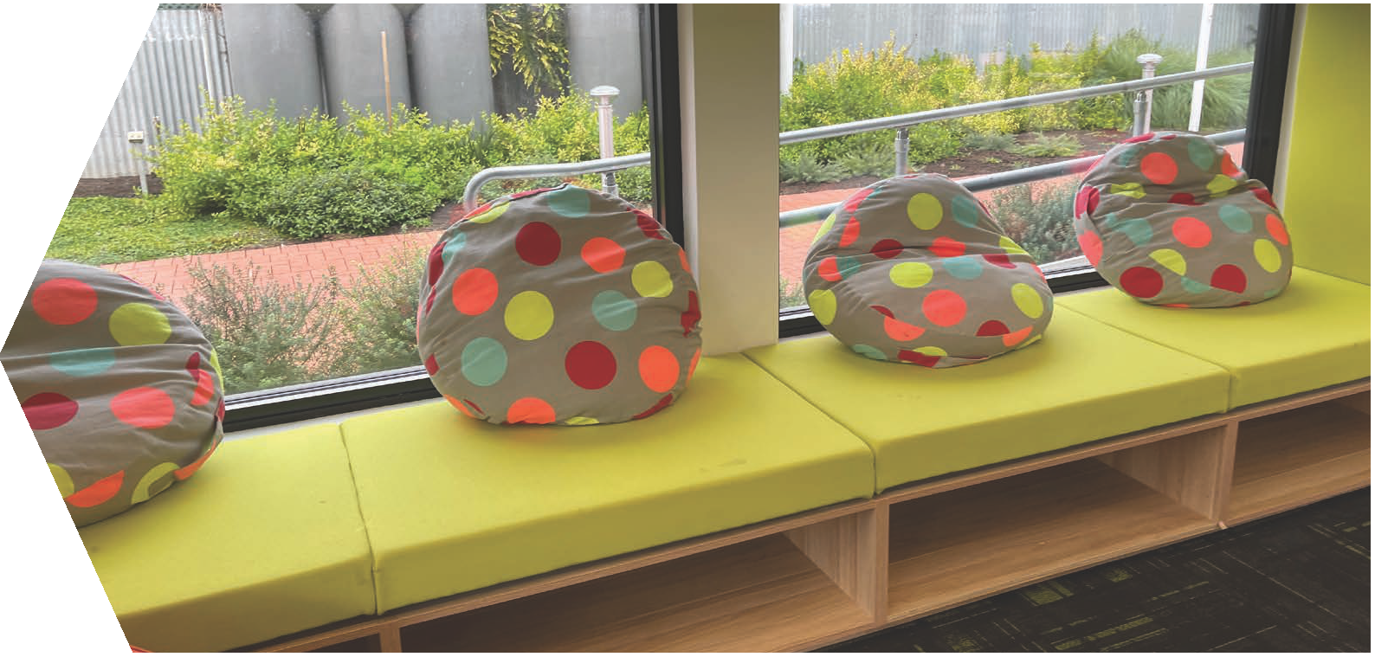
Table 1: Co-contributions required

Area | Ratio | Council
Libraries for | LLIP $1 : $1 Local | Banyule, Bayside, Boroondara, Brimbank, Darebin, Frankston, Glen Eira, Greater Dandenong, Hobsons Bay, Kingston, Knox, Manningham, Maribyrnong, Maroondah, Melbourne, Merri-bek, Monash, Moonee Valley, Port Phillip, Stonnington, Vision Australia (Victoria), Whitehorse, Yarra
metropolitan
councils
Libraries for | LLIP $1.5 : $1 Local | Cardinia, Casey, Hume, Melton, Mornington Peninsula, Nillumbik, Whittlesea, Wyndham, Yarra Ranges
interface
councils
Libraries for | LLIP $2 : $1 Local | Ballarat, Bendigo, Geelong, Horsham, Latrobe, Mildura, Shepparton, Wangaratta, Warrnambool, Wodonga
regional cities
Libraries for | LLIP $3 : $1 Local | Bass Coast, Baw Baw, Campaspe, Colac Otway, Corangamite, East Gippsland, Glenelg, Golden Plains, Macedon Ranges, Mitchell, Moira, Moorabool, Mount Alexander, Moyne, South Gippsland, Southern Grampians, Surf Coast, Swan Hill, Wellington
regional and
rural councils
Libraries for small | No contribution | Alpine, Ararat, Benalla, Buloke, Central Goldfields, Gannawarra, Hepburn, Hindmarsh, Indigo, Loddon, Mansfield, Murrindindi, Northern Grampians, Pyrenees, Queenscliffe, Strathbogie, Towong, West Wimmera, Yarriambiack
rural councils | required

** Note: Regional Library Corporations, Your Library and Myli are required to meet the appropriate councils co-contribution requirements (where applicable) if applying for a minor grant for static libraries.

Assessment criteria

Applications will be assessed against the criteria set out below. Percentage weightings are provided as a guide to the relative importance of different criteria in the
assessment process. The level of detail provided in the application should be commensurate
with the value of the project.
Confirmation of other funding sources and funding from previous LLIP rounds will be taken into consideration during the assessment process. If applications for other funding sources are unsuccessful, applicants must identify how the shortfall will be funded.

Why? | Applications will be required to demonstrate the extent to which the project addresses an identified need in the community by:  • Clearly identifying why the project is a priority  • Demonstrating why the project is important to the community  • Demonstrating how the project will provide increased access to learning opportunities and programs.
(30%)
Who? | Applications must clearly demonstrate the extent to which the project will deliver benefits to the local community and must:  • Identify the communities that will directly benefit from the project  • Articulate current library user statistics that support the project, including changes in use and/or need  • Identify the benefits that the project will deliver for library users  • Identify who else is involved in the planning/design or implementation of the project, including an outline of their roles and contributions and, where applicable, details of shared use agreements.
(30%)
What? | Applications must clearly articulate or demonstrate:  • What the LLIP funding will be used for  • Details of the overall project and what will be delivered  • What services will change as a result of the project.
(25%)
How? | Applications must demonstrate:  • A sound approach to deliver the project, providing realistic timeframes for delivery and demonstrate the project represents value for money  • Capacity to implement the project, including details of specific resource allocations  (staff, time and funding) to deliver the project on time and within budget  • Capacity to financially support the ongoing library operations and the ability to service the community within the opening hours specified in the application  • Council’s performance in delivering previously funded state government projects.
(15%)

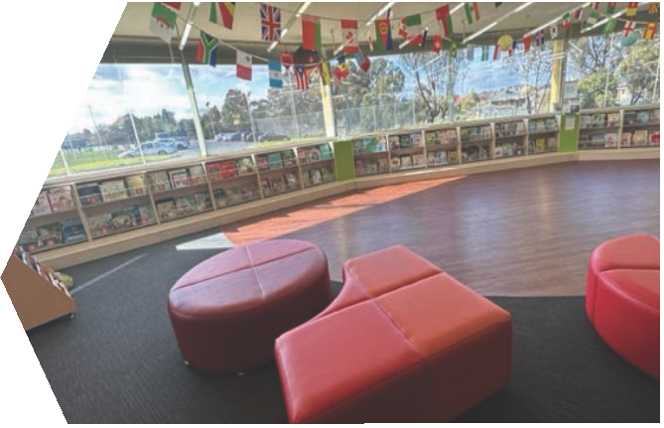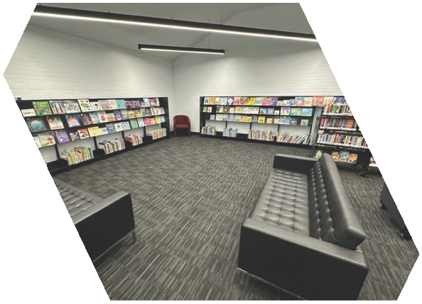What supporting documentation needs to be provided?

Supporting documents can be submitted through the online grants system, so long as the file size does not exceed 5MB.

Supporting documents that may be relevant to the project are:

• a project plan and project budget (mandatory)

• confirmation of other funding sources where appropriate

• relevant costings/supplier quotations
• concept designs and/or detailed ﬂoor plans (mandatory)

• applicable permits if available.

What are the conditions of funding?

Successful applicants must enter into a funding agreement with Department of Government Services (DGS). Funding agreements establish the parties and outline their commitments and obligations to each other, as well as setting out the general funding terms and conditions.

Applicants should review the Victorian Common Funding Agreement standard terms and conditions before applying.

No funding will be released until the Department and the applicant have executed the funding agreement and the appropriate milestone evidence identified in the funding agreement has been met.

DGS reserves the right to withhold payments in cases where evidence has been provided but DGS deems that there are concerns relating to the delivery of the project. In this instance, DGS will release funding when appropriate actions have been taken to ensure the funded project is being delivered within the agreed timeframes.
In the event of a project being delivered for less than the budget stated in the funding agreement, two alternatives will be available to councils:

• return the unspent funds on a pro rata basis
• opportunity to put forward a case to have any unspent funds used to expand the scope of the underspent project.

Any reallocation request to Local Government Victoria must include information about why there was an underspend on a LLIP project and how increasing the scope of the underspent project will further benefit the community.

Local Government Victoria will use this information in making recommendations
to the Minister for Local Government on the reallocation of any unspent funding.

What are the monitoring and reporting requirements?

Funded recipients are required to comply with project monitoring and reporting requirements outlined in the funding agreement. This includes participating in project and program evaluation activities implemented by DGS.

An outcomes report is required to be completed
12 months post construction. This will need to
include information and data about:

• increased usability
• increased activities and programs
• visitation rates
• new initiatives that have been implemented as a direct result of funding from the LLIP.

Funded recipients are responsible for project delivery, including any project cost overruns should they occur. Funded recipients must take full responsibility for the cost of ongoing
operation and maintenance of facilities through their asset management processes.

In cases where a project is delayed for an unreasonable length of time, where substantive changes of scope are made after funding has been approved, or where a project fails to be delivered, DGS reserves the right to cancel the grant and recoup any funds that have already been provided.

Acknowledgement and
Publicity Requirements

Successful applicants must acknowledge the Victorian Government’s support through the LLIP. Promotional guidelines form part of the funding agreement and include the requirement that all activities acknowledge Victorian Government support through logo presentation on any activity-related publications, media releases and promotional material. Successful applicants must liaise with the Department’s program area to coordinate any public events or announcements related
to the project.

Plaque proofs MUST be submitted to DGS’s program area for approval before being displayed at any public event. This includes signage for mobile library vans and must contain the Victorian Government logo.

Successful applicants may be required to provide information on activity outcomes for use in program evaluation or in the Department’s communication material.

Capital Works Signage
Requirements

Successful applicants need to acknowledge the State Government’s support for the project through appropriate signage consistent with the Victorian Government’s Capital Works Signage Requirements (available at https://www.vic.gov. au/capital-works-signage-guidelines) or as otherwise specified by DGS.
How to apply

Applicants must consult the LLIP team on
0411 752 071 by 22 March 2024 to discuss their
project proposal prior to submission. Project
proposals that have not been discussed will not
be considered.

To submit an application for minor and major works, please visit:

https://www.localgovernment.vic.gov.au/
public-libraries/public-library-programs/living-
libraries-infrastructure-program

Hard copy or emailed applications will not
be accepted.

Applications open
12 February 2024
Applications close
28 March 2024 at 2.00pm
Assessment & decision making
April 2024
Announcements
From May 2024
Funding Agreements executed

By June 2024

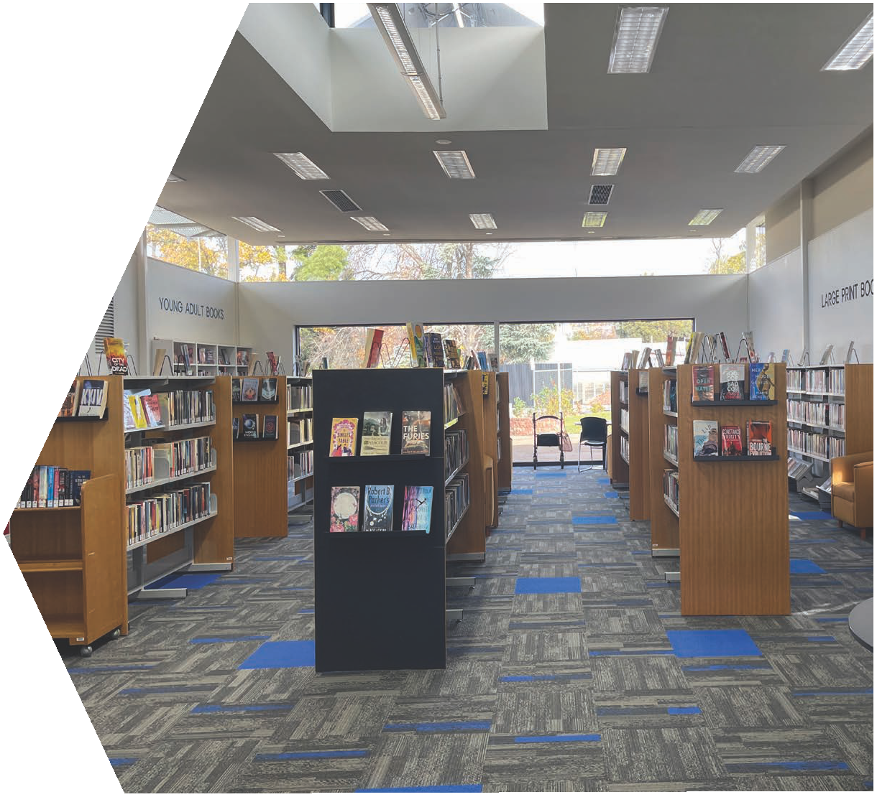Frequently Asked Questions

Is funding available for shelving and library furniture?

Funding for shelving and library furniture is not eligible as a standalone project as the primary purpose of this program is to support the upgrading of library buildings and mobile library facilities.

However, if new shelving or library furniture is to be provided as part of a broader project, and it can be demonstrated that the project supports innovation and increased ﬂexibility and deliverability of programs and activities, the application will be considered. A maximum of
30 percent of the total project cost can contribute to the cost of shelving and library furniture.

Is funding available for staff amenities?

Staff amenities will not be eligible for funding. To be eligible, amenities must be available and accessible for community use e.g. kitchenette, toilets etc.
Which components of a mobile library will the LLIP fund?

The components of a mobile library eligible for funding must be integral to the functionality and deliverability of a mobile library service, and can include power supply infrastructure and necessary communications equipment, such as antennas.

The LLIP will only fund the purchase of a mobile library van if it includes a fit-out incorporating OH&S practices, e.g. hydraulic lift, trolleys on wheels etc.

Equipment such as PCs, iPads, RFID, scanners etc, remain ineligible.

What documentation is required if a Regional Library Corporation, Your Library or Myli applies for a minor grant for a static library?

A letter from the relevant council’s CEO is mandatory and must demonstrate support for the project and meet the co-contribution ratio as per the co-contribution table.
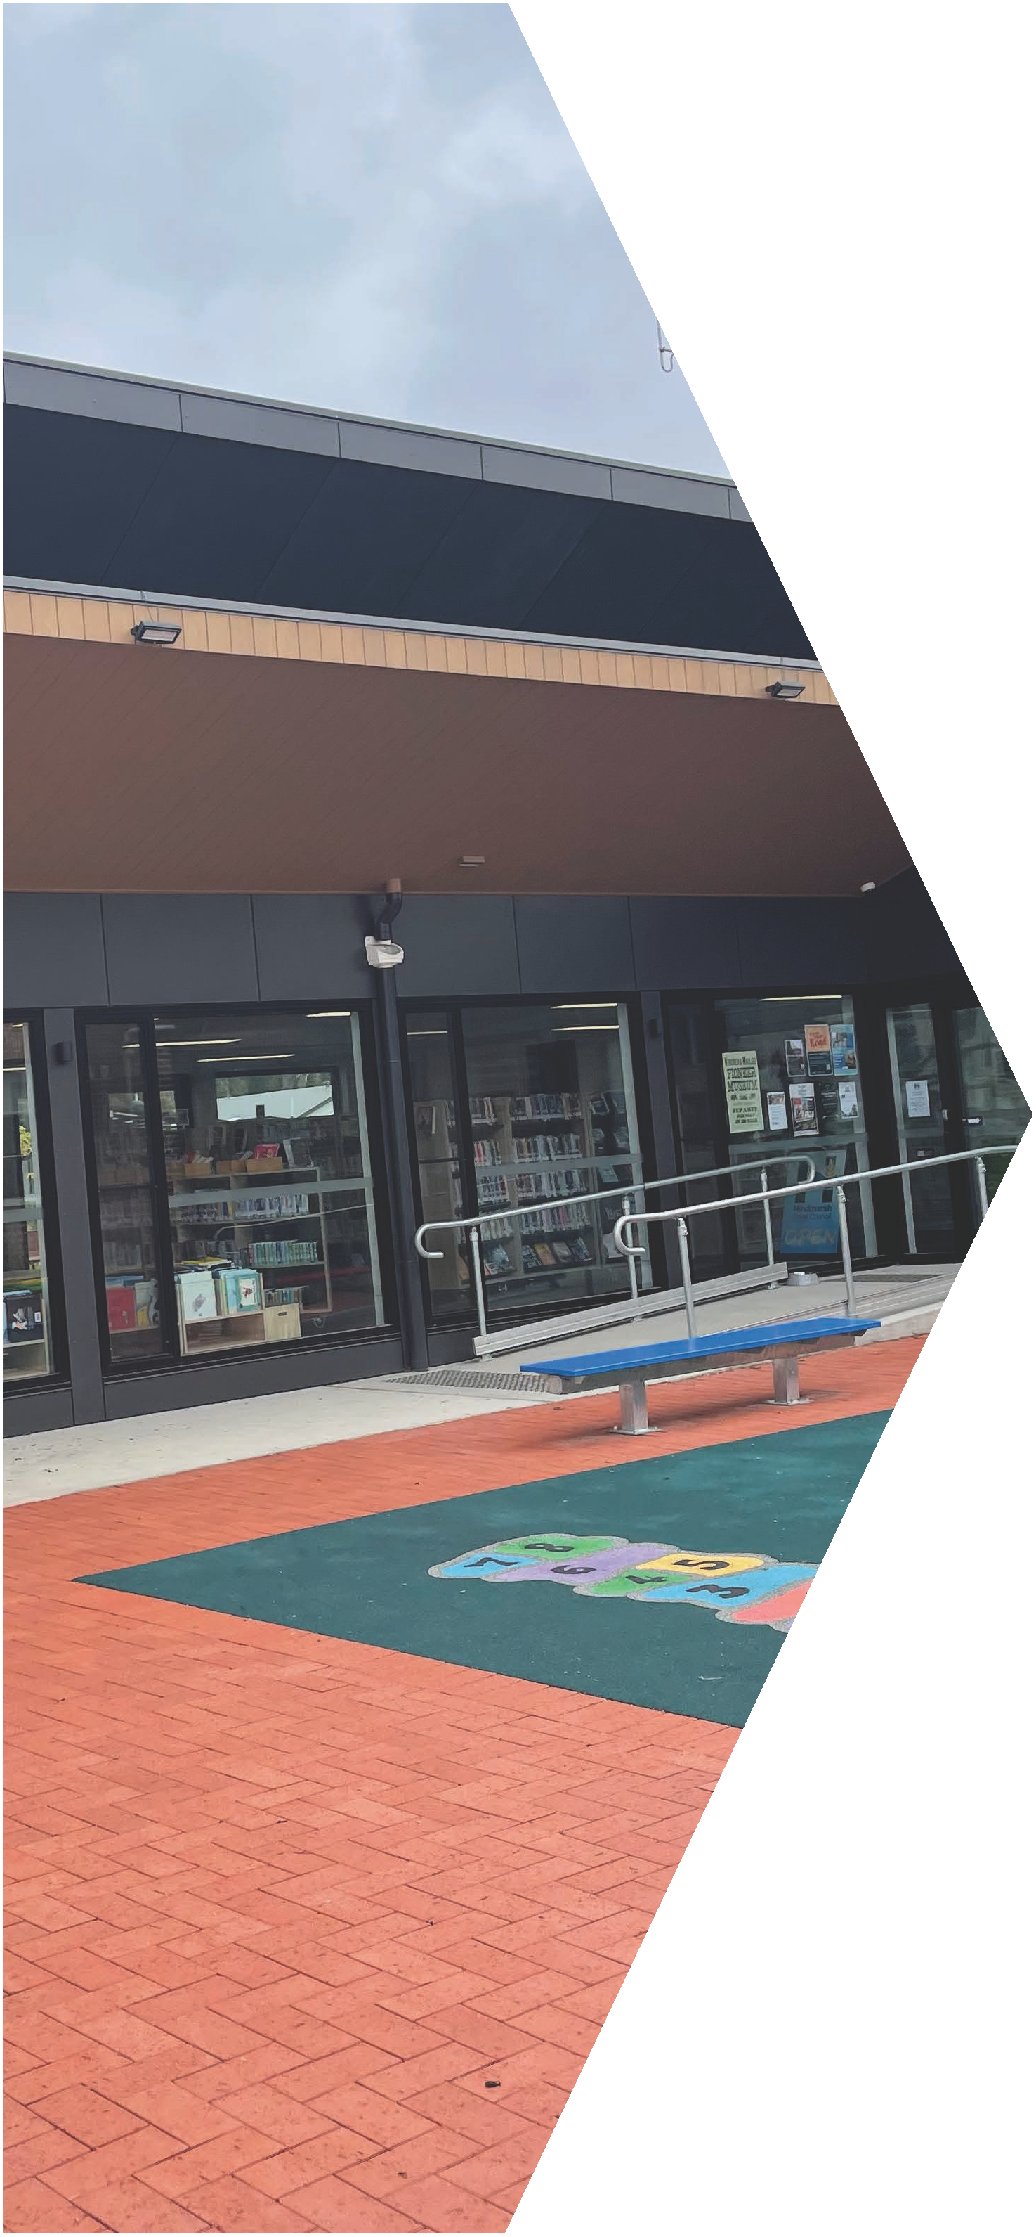

www.dgs.

vic.gov.au

