LOCAL GOVERNMENT
BETTER PRACTICE GUIDE
Model Performance Statement

2025–2026 Edition

Performance statement (full model)
 | 

This document provides a model performance statement for inclusion in the annual report that complies with the Local Government Act 2020, the Local Government Planning and Reporting Regulations 2020 and the transitional provisions in the Act and regulations (i.e., the financial year commencing on 1 July 2025).
This section outlines an example of a performance statement. In addition to the content, the guide will provide suggestions and mandatory inclusions.

Guiding symbols have been included to assist in understanding which content is required and which content is optional. For example:

 | This symbol denotes content or a feature that is required to be included within the performance statement to meet statutory, legislative, or VAGO operational audit requirements. Council may customise the look or layout, but the content must be included in some form.
 | This symbol denotes content or a feature that represents good practice. Councils may choose to customise according to their own needs. Content may be removed or changed.

This model should be read in conjunction with the Local Government Better Practice Guide – Preparing Council’s Annual Report 2025-26.

Summary of changes - 2025-26

This section summarises the changes between the previous edition (2025-26) of the Local Government Better Practice Guide – Model Performance Statement and the current edition.
Please note that there are no material changes to this document for 2025-26.
Councils are encouraged to read this document in its entirety.


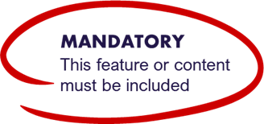
Table of Contents
Victorian City Council
Performance Statement
For the year ended 30 June 202X

Certification of the performance statement | 5
Victorian Auditor-General’s Office audit report | 6
Section 1. Description of municipality | 8
Section 2. Service performance indicators | 9
Section 3. Financial performance indicators | 12
Section 4. Sustainable capacity indicators | 16
Section 5. Notes to the accounts | 19
5.1. Basis of preparation | 19
5.2. Definitions | 20
5.3. Other matters | 21

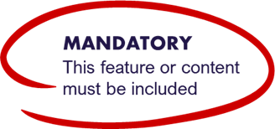
Certification of the Performance Statement
In my opinion, the accompanying performance statement has been prepared in accordance with the Local Government Act 2020 and the Local Government (Planning and Reporting) Regulations 2020.
__________________
(Principal Accounting Officer Name and Qualifications (if any))
Principal Accounting Officer
Dated: (Date)
In our opinion, the accompanying performance statement of the (council name) for the year ended 30 June 202X presents fairly the results of council’s performance in accordance with the Local Government Act 2020 and the Local Government (Planning and Reporting) Regulations 2020.
The performance statement contains the relevant performance indicators, measures and results in relation to service performance, financial performance and sustainable capacity.
At the date of signing, we are not aware of any circumstances that would render any particulars in the performance statement to be misleading or inaccurate.
We have been authorised by the council and by the Local Government (Planning and Reporting) Regulations 2020 to certify this performance statement in its final form.
__________________
(Councillor 1 Name)
Councillor
Dated: (Date)
__________________
(Councillor 2 Name)
Councillor
Dated: (Date)
__________________
(Chief Executive Officer Name)
Chief Executive Officer
Dated: (Date)

Victorian Auditor – General’s Office Audit Report

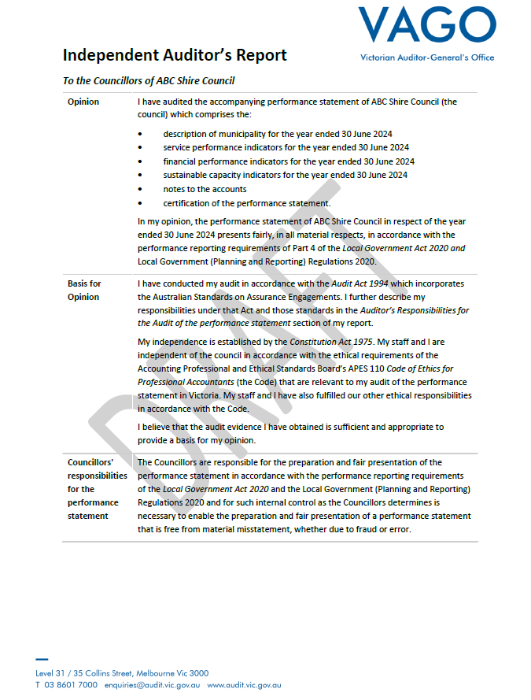
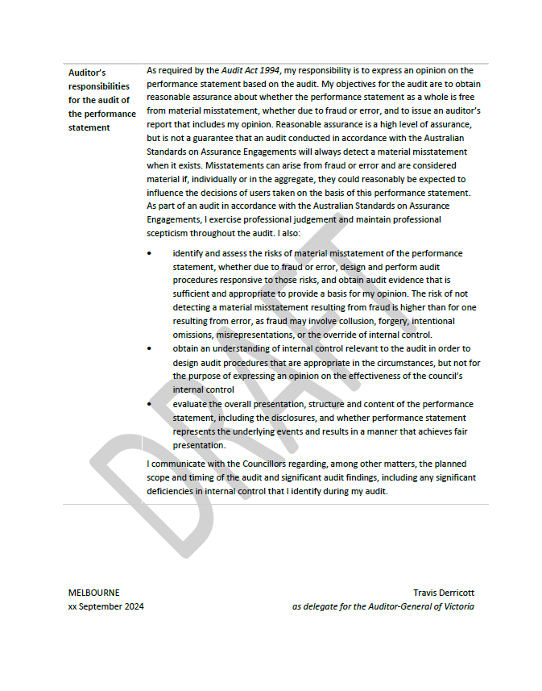
Section 1. Description of municipality
delwp.vic.gov.au

The Victorian City Council (the council) is situated on the south-eastern fringe of the Melbourne metropolitan area and has a significant rural and horticultural hinterland. It includes more than 30 communities stretching from the foothills of the Dandenong ranges in the north to the shores of Western Port Bay in the south. The council is at the ‘front’ of Melbourne’s growth corridor which stretches in a narrow band along the Princes Highway. The main industries include food manufacturing, agriculture, meat and meat product manufacturing, motor vehicle and part manufacturing. The council covers an area of 1281 square kilometres and has a population of 82,000 which is expected to grow to 142,000 over the next 20 years.

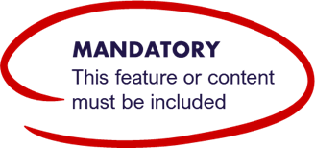
Section 2. Service performance indicators
For the year ended 30 June 202X

 | Results
 | 2023 | 2024 | 2025 | 2026 |  | Comments
 | Actual | Actual | Actual | Target as per budget | Actual | Comments
Aquatic Facilities  Utilisation |  |  |  |  |  | The result for this measure increased by 5 visits per capita to 12 visits in the 20X4 year and has increased by 6 visits over the 4 year period from 20X1.
Utilisation of aquatic facilities  [Number of visits to aquatic facilities / Municipal population] | 6.23 | 7.45 | 7.56 | N/A | 12.81
Animal Management
Health and safety
Animal management prosecutions  [Number of successful animal management prosecutions / Number of animal management prosecutions] x 100 | 24.56 | 18.02 | 17 | N/A | 10 | The result for this measure has decreased by 8 prosecutions to 16 over the 4 year period. This was mainly due to a change in council policy in 20X2 in relation to dog attacks from legal action to mediation
Food Safety
Health and safety
Critical and major non-compliance outcome notifications  [Number of critical non-compliance outcome notifications and major non-compliance notifications about a food premises followed up / Number of critical non-compliance outcome notifications and major non-compliance notifications about a food premises] x100 | 98.98% | 100.12% | 98.65% | N/A | 100.00%
Governance
Satisfaction
Satisfaction with community consultation and engagement (community satisfaction rating out of 100 with the consultation and engagement efforts of Council) | 55 | 55 | 57 | 58 | 60 | The result for this measure has increased by 5 points to 60 over the 4 year period from 20X1. This was mainly due to the introduction of a new Community Engagement Policy and Guidelines in 20X2.Council's result for this measure has exceeded the target.
Libraries
Participation
Library membership  [percentage of the population that are registered library members] x100 | N/A | N/A | N/A | N/A | 15.52%
Maternal and Child Health (MCH)
Participation
Participation in the MCH service  [Number of children who attend the MCH service at least once (in the year) / Number of children enrolled in the MCH service] x100 | 80.23% | 79.56% | 78.98% | N/A | 81.42%
Participation
Participation in the MCH service by Aboriginal children  [Number of Aboriginal children who attend the MCH service at least once (in the year) / Number of Aboriginal children enrolled in the MCH service] x100 | 48.89% | 50.23% | 57.73% | N/A | 64.19% | The result for this measure has increased by 16 percentage points to 64% over the 4 year period from 20X1. This was mainly due to a 4 year campaign funded by the Commonwealth Government.
Roads
Condition
Sealed local roads below the intervention level  (percentage of sealed local roads that are below the renewal intervention level set by Council and not requiring renewal) | 52 | 50 | 49 | 49 | 48 | The result for this measure decreased by 1 points to 48 in the 20X4 year. This was mainly due to the significant rainfall and subsequent flooding of major local roads.
Statutory Planning
Service standard
Planning applications decided within the relevant required time  (percentage of planning application decisions made within the relevant required time) | 72.56% | 85.37% | 90.43% | 90.00% | 90.43% | In 20x4 council allocated additional resources in the budget to address a backlog in planning applications in 2023-24. Council's result is in line with the target set for this financial year.
Waste Management
Waste diversion
Kerbside collection waste diverted from landfill  [Weight of recyclables and green organics collected from kerbside bins / Weight of garbage, recyclables and green organics collected from kerbside bins] x100 | 76.64% | 78.12% | 79.54% | 82.00% | 82.27% | Council has seen an improvement in the kerbside waste diverted from landfill, demonstrating council’s commitment to a clean and green municipality.

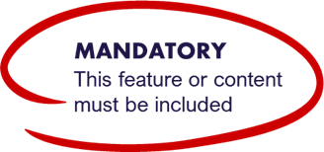
Section 3. Financial performance indicators
For the year ended 30 June 202X
Dimension/indicator/ measure | 2023 |  | 2024 |  | 2025 | 2026 |  | 2027 | 2028 |  | 2029 |  | 2030 |  | Material Variations and Comments
Dimension/indicator/ measure | Actual | Actual |  | Actual |  | Target As per budget | Actual | Forecast |  | Forecast |  | Forecast |  | Forecast | Material Variations and Comments
Efficiency
Expenditure level
Expenses per property assessment  [Total expenses / Number of property assessments] | $2,650.65 | $2,710.52 |  | $2,780.54 |  | $2,800.00 | $2,830.71 | $2,870.65 |  | $2,950.12 |  | $3,005.89 |  | $3,012.14 | The result for this measure has increased by $180 per assessment over the 4 year period from 20X1 to $2,830 and expected to increase by a further $182 per assessment by 20X8.
Revenue level
Average rate per property assessment  [Sum of all general rates and municipal charges / Number of property assessments] | $1,408.21 | $1,434.14 |  | $1,478.23 |  | N/A | $1,630.54 | $1,712.19 |  | $1,755.87 |  | $1,799.65 |  | $1,844.87 | The result for this measure has increased by $222 per assessment over the 4 year period from 20X1 to $1,630 and expected to increase by a further $214 per assessment by 20X8.
Liquidity
Working capital
Current assets compared to current liabilities  [Current assets / Current liabilities] x100 | 185.54% | 187.85% |  | 184.87% |  | 220.00% | 225.16% | 185.78% |  | 187.64% |  | 184.87% |  | 190.98% | The result for this measure increased by 41 percentage points to 225% in the 20XX year. It has also increased by 40 percentage points over the 4 year period from 20X1 and expected to decrease by 40 percentage points in 2015-16.
Unrestricted cash
Unrestricted cash compared to current liabilities | 55.35% | 57.01% |  | 54.45% |  | N/A | 55.87% | 45.98% |  | 47.45% |  | 44.78% |  | 60.31%
[Unrestricted cash / Current liabilities] x100
Obligations
Loans and borrowings
Loans and borrowings compared to rates  [Interest bearing loans and borrowings / Rate revenue] x100 | 35.52% | 34.18% |  | 62.78% |  | N/A | 61.21% | 55.32% |  | 49.34% |  | 43.74% |  | 37.19% | The result for this measure has increased by 26 percentage points over the 4 year period to 61% from 20X1 but is expected to decrease by 24 percentage points over the four year period to 20X8.
Loans and borrowings repayments compared to rates  [Interest and principal repayments on interest bearing loans and borrowings / Rate revenue] x100 | 4.32% | 4.51% |  | 8.37% |  | N/A | 8.87% | 7.81% |  | 6.28% |  | 5.31% |  | 4.09% | The result for this measure has increased by 4 percentage points to 8% over the 4 year period to 20X4 but is expected to decrease by 4 percentage points over the 4 year period to 20X8.
Indebtedness
Non-current liabilities compared to own source revenue | 55.35% | 55.78% |  | 56.07% |  | N/A | 56.81% | 57.89% |  | 57.45% |  | 58.19% |  | 58.01%
[Non-current liabilities / Own source revenue] x100
Asset renewal and upgrade
Asset renewal and upgrade compared to depreciation  [Asset renewal and asset upgrade expense / Asset depreciation] x100 | 55.35% | 55.78% |  | 56.07% |  | 56.50% | 56.81% | 57.89% |  | 57.45% |  | 58.19% |  | 58.01% | The result for this measure has increased by 7 percentage points over the 4 year period from 20X1 to 82% and expected to increase by a further 18 percentage points by 20X6.
Operating position
Adjusted underlying result
Adjusted underlying surplus (or deficit)  [Adjusted underlying surplus (deficit)/ Adjusted underlying revenue] x100 | -10.38% | -8.29% |  | -6.23% |  | N/A | 2.19% | 5.78% |  | 8.59% |  | 12.71% |  | 15.92% | The result for this measure increased by 8 percentage points to 2% in the 20X4 year moving from a deficit to surplus. It has also increased by 12 percentage points over the 4 year period from 20X4 and expected to increase by a further 13 percentage points by 20X8.
Stability
Rates concentration
Rates compared to adjusted underlying revenue | 59.16% | 59.28% |  | 59.45% |  | 60.00% | 60.98% | 61.56% |  | 61.45% |  | 62.91% |  | 62.05%
[Rate revenue / Adjusted underlying revenue] x100
Rates effort
Rates compared to property values | 0.43% | 0.45% |  | 0.46% |  | N/A | 0.49% | 0.40% |  | 0.43% |  | 0.42% |  | 0.46%
[Rate revenue / Capital improved value of rateable properties in the municipality] x100

Section 4. Sustainable capacity indicators
For the year ended 30 June 202X
 | Results
Indicator / measure  [formula] | 2023 | 2024 | 2025 | 2026 | Comments
Indicator / measure  [formula] | Actual | Actual | Actual | Actual | Comments
Population
Expenses per head of municipal population | $950.54 | $1,090.37 | $1,120.56 | $1,190.54 | The result for this measure has increased by $240 per capita over the 4 year period from 20X1 to $1,190 per capita in 20X4. The slowing upward trend from 20X2 reflects cost containment measures taken by council since 20X3
Infrastructure per head of municipal population  [Value of infrastructure / Municipal population] | $5,390.14 | $5,410.02 | $6,102.25 | $6,390.14 | The result for this measure increased by $1,000 per capita over the 4 year period from 20X1 to $1,190 per capita in 20X4. The significant increase in the 20X3 year was mainly due to the construction of a new indoor aquatic facility in 20X2 to service the population growth being experienced in the west of the municipality
Population density per length of road  [Municipal population / Kilometres of local roads] | 160.78 | 168.32 | 178.89 | 180.12 | The result for this measure increased by 20 people per kilometre of road over the 4 year period from 20X1 to 180 people per kilometre in 20X4. This increasing trend reflects the significant population growth being experienced in the west of the municipality
Own-source revenue
Own-source revenue per head of municipal population  [Own-source revenue / Municipal population] | $850.71 | $845.23 | $975.45 | $990.14 | The result for this measure has increased by $140 per capita over the 4 year period from 20X1 to $990 in 20X4. The increasing trend reflects measures taken by council since 20X3 to address the asset renewal gap through rate increases above CPI
Recurrent grants
Recurrent grants per head of municipal population  [Recurrent grants / Municipal population] | $168.45 | $170.08 | $175.78 | $198.32 | The result for this measure increased by $30 per capita over the 4 year period to $198 per capita in 20X4. The significant increase in the current year was mainly due to an increase in Commonwealth Financial Assistance Grants following a period of strong population growth. The increasing trend is consistent with the increase in the current year
Disadvantage
Relative Socio-Economic Disadvantage  [Index of Relative Socio-Economic Disadvantage by decile] | 8 | 8 | 8 | 8 | Council is ranked in the top 20% in the SEIFA index suggesting low levels of disadvantage, but at a more localised level, there are several pockets of high levels of disadvantage.
Workforce turnover
Percentage of staff turnover
[Number of permanent staff resignations and terminations / Average number of permanent staff for the financial year] x100 | 10.19% | 11.98% | 11.65% | 15.18% | The result for this measure increased by 4 percentage points to 15% in the 20X4 year. It has also increased by 5 percentage points over the 4 year period from 20X1 but is expected to decrease by 4 percentage points back to pre 20X4 levels in 20X5.

Section 5. Notes to the accounts

5.1. Basis of preparation
Council is required to prepare and include a performance statement within its annual report. The performance statement includes the results of the prescribed, service performance, financial performance and sustainable capacity indicators and measures together with a description of the municipal district, an explanation of material variations in the results and notes to the accounts. This statement has been prepared to meet the requirements of the Local Government Act 2020 and Local Government (Planning and Reporting) Regulations 2020.
Where applicable the results in the performance statement have been prepared on accounting bases consistent with those reported in the Financial Statements. The other results are based on information drawn from council information systems or from third parties (e.g., Australian Bureau of Statistics or the Council’s satisfaction survey provider).
The performance statement presents the actual results for the current year and the previous three years, along with the current year's target, if mandated by the Local Government (Planning and Reporting) Regulations 2020. Additionally, for the prescribed financial performance indicators and measures, the performance statement includes the target budget for the current year and the results forecast for the period 2026-27 to 2029-30 by the council's financial plan.
The Local Government (Planning and Reporting) Regulations 2020 requires explanation of any material variations in the results contained in the performance statement. Council has adopted materiality thresholds relevant to each indicator and measure and explanations have not been provided for variations below the materiality thresholds unless the variance is considered to be material because of its nature.

5.2. Definitions
Key term | Definition
Aboriginal children | means a child who is an Aboriginal person
Aboriginal person | has the same meaning as in the Aboriginal Heritage Act 2006
adjusted underlying revenue | means total income other than:  - non-recurrent grants used to fund capital expenditure; and  - non-monetary asset contributions; and  - contributions to fund capital expenditure from sources other than those referred to above
adjusted underlying surplus (or deficit) | means adjusted underlying revenue less total expenditure
annual report | means an annual report prepared by a council under section 98 of the Act
asset renewal expenditure | means expenditure on an existing asset or on replacing an existing asset that returns the service capability of the asset to its original capability
asset upgrade expenditure | means expenditure that— (a) enhances an existing asset to provide a higher level of service; or (b) extends the life of the asset beyond its original life
critical non-compliance outcome notification | means a notification received by council under section 19N(3) or (4) of the Food Act 1984 , or advice given to council by an authorized officer under that Act, of a deficiency that poses an immediate serious threat to public health
current assets | has the same meaning as in the Australian Accounting Standards
current liabilities | has the same meaning as in the Australian Accounting Standards
food premises | has the same meaning as in the Food Act 1984
intervention level | means the level set for the condition of a road beyond which a council will not allow the road to deteriorate and will need to intervene
local road | means a sealed or unsealed road for which the council is the responsible road authority under the Road Management Act 2004
major non-compliance outcome notification | means a notification received by a council under section 19N(3) or (4) of the Food Act 1984, or advice given to council by an authorized officer under that Act, of a deficiency that does not pose an immediate serious threat to public health but may do so if no remedial action is taken
MCH | means the Maternal and Child Health Service provided by a council to support the health and development of children within the municipality from birth until school age
non-current liabilities | means all liabilities other than current liabilities
own-source revenue | means adjusted underlying revenue other than revenue that is not under the control of council (including government grants)
population | means the resident population estimated by council
rate revenue | means revenue from general rates, municipal charges, service rates and service charges
relative socio-economic disadvantage | in relation to a municipal district, means the relative socio-economic disadvantage, expressed as a decile for the relevant financial year, of the area in which the municipal district is located according to the Index of Relative Socio-Economic Disadvantage of SEIFA
restricted cash | means cash, cash equivalents and financial assets, within the meaning of the Australian Accounting Standards, not available for use other than for a purpose for which it is restricted, and includes cash to be used to fund capital works expenditure from the previous financial year
SEIFA | means the Socio-Economic Indexes for Areas published from time to time by the Australian Bureau of Statistics on its Internet site
unrestricted cash | means all cash and cash equivalents other than restricted cash



5.3. Other Matters
Overview of 202X
During the financial year council experienced growth in residents and demand for services. Extensive capital works were undertaken to improve infrastructure.

Notes for draft preparation (delete in final version)
- Section 5.3. Other Matters is for council to provide details of additional matters that impacted the performance outcomes as considered necessary.
- This may include where the performance was impacted by severe weather conditions, bushfires or increases in demand for services.

