LOCAL GOVERNMENT
BETTER PRACTICE GUIDE

Report of Operations - Example

2025-26 Edition

OFFICIAL

Report of operations (full guide)
This section provides an example of a Report of Operations. In addition to the content, the guide will provide good practice suggestions and mandatory inclusions.
Guiding symbols have been included to assist in understanding which content is required and which content is optional. For example:

 | This symbol denotes content or a feature that is required to be included within the report of operations to meet statutory or legislative requirements. Council may customise the look or layout, but the content must be included in some form.
 | This symbol denotes content or a feature that represents good practice. Councils may choose to customise according to their own needs. Content may be removed or changed.

This example should be read in conjunction with the Local Government Better Practice Guide – Performance reporting for Council’s Annual Report 2025-26.


[TITLE PAGE]
Victorian City Council
Report of Operations
For the year ended 30 June 202X


Report of Operations
For the year ended 30 June 202X
 | Table of contents
 | - Introduction
 | Snapshot of council | 5
 | Highlights of the year | 5
 | Challenges and future outlook | 5
 | - The year in review
 | Mayor’s message | 5
 | CEO’s message | 5
 | Financial summary | 5
 | Description of operations | 6
 | - Our council
 | City profile | 6
 | Council offices | 6
 | Councillors | 7
 | - Our people
 | Organisational structure | 8
 | Council staff | 9
 | Other staff matters | 10
 | - Our performance
 | Planning and accountability framework | 10
 | Council plan | 11
 | Performance | 11
 | - Governance, management and other information
 | Governance | 14
 | Management | 16
 | Governance and management checklist | 16
 |  | 16
  - Statutory information
  Other Statutory information | 14


Section 1 - Introduction
Council may wish to provide a snapshot of its financial year and could include an explanation of some of the highlights, significant events or headlines from the year, such as:
- Demographic profile: Include an explanation of council localities, population, age and cultural demographics
- Purpose: Include Council Vision, Mission and Values
- Fast Facts: attendees at leisure and aquatic centres. kilometres of footpaths maintained, rateable properties and tonnes of waste collected

Highlights of council’s year
Council may include an outline of the achievements for each council strategic objective, as per the Council Plan.
Challenges and future outlook
Council could identify some of the challenging factors it faced throughout the year and highlight its focus areas for the future. For example:
- Challenges: emergency management, aging infrastructure, dwindling or expanding population
- The future: Completing key community projects, undertaking enhanced service planning and Investigating opportunities for cost saving and service improvements

Notes
- The introduction is not required for the purposes of the legislation; however, it is considered better practice to provide the reader with contextual information about the purpose of the Report of Operations and an overview of council’s operations and performance for the year.

Section 2 - The year in review
For better practice purposes, Council is advised to include both the Mayor and CEO messages for the reporting year.

Financial summary
Council may wish to provide a summary of its financial position for the reporting year. Examples may include:
- Operating position
- Liquidity
- Obligations
- Stability and efficiency
Council is free to include financial tables or graphs where applicable.

Description of operations
Council is required to provide a description of its operations for the reporting year, including an explanation of the following items:
- Economic factors
- Major Capital works
- Major changes
- Major achievements
Notes
- The Mayor’s Message and CEO’s Message are not required for the purposes of the legislation however it is considered better practice to provide the reader with information from the Mayor and CEO about the council’s operations and performance for the year.
- A financial summary is not required for the purposes of the legislation however it is considered better practice to provide an overview of the council’s financial performance for the year in plain English to assist readers.
- Economic factors faced are mandatory under the Planning and Reporting Regulations 2020, regulation 10(a)(i).
- Major Capital Works are mandatory under the Planning and Reporting Regulations 2020, regulation 10(a)(ii).
- Major changes to council are mandatory under the Planning and Reporting Regulations 2020, regulation 10(a)(iii).
- Major Achievements are mandatory under the Planning and Reporting Regulations 2020, regulation 10(a)(iv).


Section 3 - Our council

City Profile
Council may wish to provide an outline of its municipal profile, including an explanation of the following:
- Suburbs
- Resident population
- Population demographics
- Socio economic status
Councils can include a municipal boundary map where applicable.
Council offices
Council is required to provide information details relating to the following:
- Business address
- Telephone number
- Email address
- Internet site address of each council office
Councillors
Councils are required to provide the details of all elected Councillors, their ward, the dates of their election, and retirement where applicable.

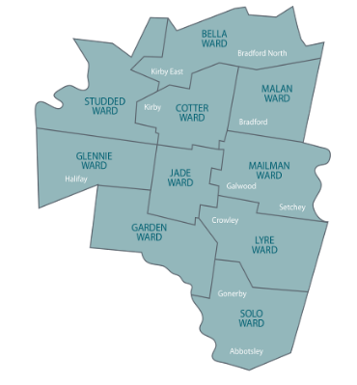

Notes
- The City Profile is not required for the purposes of the legislation however it is considered better practice to provide the reader with contextual information about the purpose of council including location, population and demographics.
- The Regulations (regulation 10(e)) require for all Councillor’s disclosure of their names, dates of election and if applicable retirement. Additional information such as photos, profiles, contact details, wards represented (if applicable) and credentials are not required by legislation.

Section 4 - Our people

Organisational structure
Councils are required to present information relating to the organisational structure of the council, and must include the following information:
- Name of the Chief Executive Officer (CEO)
- The names and areas of responsibility of Council staff reporting directly to the CEO
- A chart setting out the organisational structure of the council


Chief Executive Officer (CEO)
Phillipa Phillips

Senior officers reporting directly to the CEO

Jennifer Lopez
Director City Planning
Areas of responsibility:
  - Building
  - Economic development
  - Local laws
  - Statutory planning

Julia Gulia
Director Community Development
Areas of responsibility:
  - Planning and development
  - Family, youth and leisure
  - Aged and disability

Bruce Spruce
Director Corporate Services
Areas of responsibility:
  - Business development
  - Finance
  - Information technology
  - People and culture

Graeme Reid
Director Environment and Infrastructure
Areas of responsibility:
  - Asset planning
  - Engineering and traffic
  - Environment and sustainability

An example of an organisational structure chart is shown below.
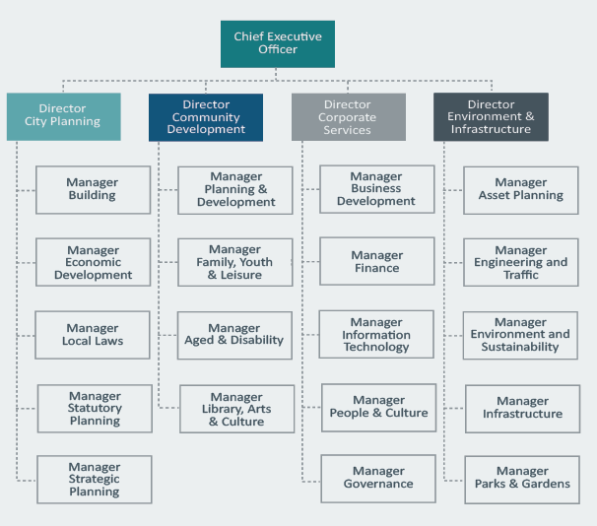

Council staff
Council is required to provide a summary of the number of full-time equivalent Council staff, categorised according to the organisational structure of the council categorised separately as:
Permanent full-time staff who are-
- Women
- Men
- Persons of self-described gender
Permanent Part time staff who are-
- Women
- Men
- Persons of self-described gender
Casual staff who are-
- Women
- Men
- Persons of self-described gender

Examples of the number of full time equivalent (FTE) council staff by organisational structure, employment type and gender are set out below.
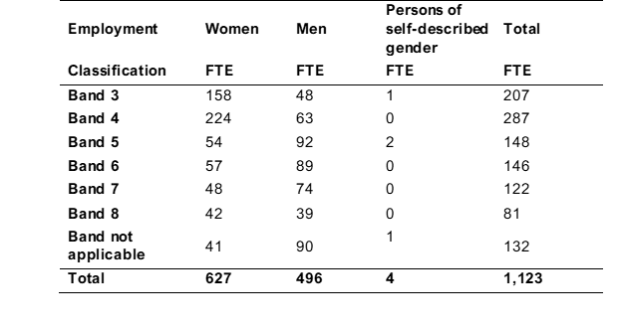

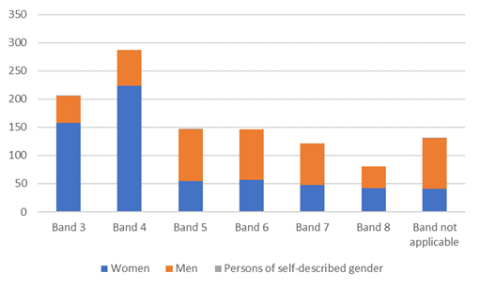
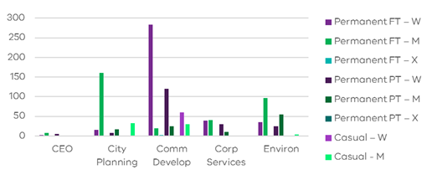

Other staff matters
Council may wish to provide additional information regarding council staff employment, including:
- Gender equity plan
- Enterprise bargaining agreement
- Professional development
- Preventing violence against women
- Health and safety

Notes
- Information in relation to the organisational structure of council is mandatory under the Planning and Reporting Regulations 2020, regulation 10(i)(i)(ii)(iii).
- A summary of the number of full-time equivalent Council staff, categorised according to the organisational structure of the Council is required under the Planning and Reporting Regulations 2020, regulation 10(l)(i)(ii(iii)
- A summary of the number of full-time equivalent Council staff, categorised by employment classification, and the number of full-time equivalent Council staff is mandatory under the Planning and Reporting Regulations 2020, regulation 10(m)
- The Other Staff Matters section is not required for the purposes of the legislation however it is considered better practice to provide additional information about council staff employment. Other information that could be considered includes volunteers; wellbeing; attraction and retention; and recognition of length of service.

Section 5 - Our performance

Integrated strategic planning and reporting framework
Council may wish to include a list of mandatory documents required as part of the Integrated Strategic Plan. For example:
Part 4 of the Local Government Act 2020 requires councils to prepare the following:
  - A Community Vision (for at least the next 10 financial years);
  - A Council Plan (for at least the next 4 financial years);
  - A Financial Plan (for at least the next 10 financial years);
  - An Asset Plan (for at least the next 10 financial years);
  - A Revenue and Rating Plan (for at least the next 4 financial years);
  - An Annual Budget (for each financial year and the subsequent 3 financial years);
  - A Quarterly Budget Report;
  - An Annual Report (for each financial year); and
  - Financial Policies.
The Act also requires councils to prepare:
- A Workforce Plan (including projected staffing requirements for at least 4 years);
Council plan
The council plan includes strategic objectives, strategies for achieving these for the four-year period, strategic indicators for monitoring achievement of the strategic objectives and a strategic resource plan.
The following example outlines five strategic objectives that might be included in a council plan:
1.Strengthening communities |  | We will identify and respond to community needs and provide opportunities to enable people in our community to be supported and involved.
2. Enhancing the environment |  | We will improve our natural and urban environment in a sustainable way.
3. Ensuring liveability and amenity |  | We will protect and improve the character of our neighbourhoods for current and future generations.
4. Providing facilities and assets |  | We will proactively manage the ongoing maintenance and development of council's assets and facilities to meet our community's current and future needs.
5. Responsible governance and management |  | We will demonstrate responsible governance and management by being consensus-oriented, equitable, effective and efficient and ensuring that sound financial and risk management and transparent business practices are carried out.

Performance
Council is required to report against each strategic objective to demonstrate how council is performing in achieving against its council plan. Performance has been measured as follows:
- Results achieved in relation to the strategic indicators in the council plan
- Progress in relation to the major initiatives identified in the budget
- Services funded in the budget and the persons or sections of the community who are provided those services
- Results against the prescribed service performance indicators and measures (LGPRF), including results achieved for the preceding 3 years and an explanation of any material variation between results.

Please refer to the example below:

Strategic objective 5: Responsible governance and management
Strategic indicators
The following statement reviews the performance of council against the council plan including results achieved in relation to the strategic indicators included in the council plan.

Strategic Indicator/measure |  |  |  | Result | Comments
Customer Responsiveness  Average time (seconds) callers wait before their call is answered |  |  |  | 29 | There has been a strong focus on improving customer responsiveness during the financial year. The industry average is 60 seconds
Workforce Turnover  Percentage of staff who resigned or were terminated from the organisation |  |  |  | 15% | The Chief Executive Officer undertook an organisational restructure during the financial year as part of cost containment measures. This resulted in a number of terminations
Major initiatives
The following statement reviews the progress of council in relation to major initiatives identified in the 202X-2X budget for the year.
Major Initiatives |  |  |  |  |  | Progress
Upgrade council's Document Management System and introduction of a Customer Relationship Management System  (Actual: $610,000 Budget: $620,000) |  |  |  |  |  | Completed
Services
The following statement provides information in relation to the services funded in the 2022-23 budget and the persons or sections of the community who are provided the service.

Service | Description |  |  |  |  |  |  | Net Cost  Actual  Budget  Variance  $000
Governance | Provision of the following to support council’s direct service delivery areas:  - council, Councillors, the Chief Executive Officer and the Executive Management Group and administrative support  - administering the conduct of council meetings and elections  - managing Freedom of Information, Information Privacy, protected disclosures and internal ombudsman functions |  |  |  |  |  |  | 2,320  2,330  10
Human Resources | Provision of the following to support council’s direct service delivery areas:  - delivering occupational health and safety, risk management, human resources and organisation development and learning  - coordinating recruitment, industrial relations, remuneration, award/agreement interpretation and work evaluation  - managing enterprise business risk including occupational health and safety, WorkCover, risk management and insurance including council's Disaster Recovery and Business Continuity Plans |  |  |  |  |  |  | 4,120  4,080  (40)
Finance | Provision of the following to support council’s direct service delivery areas:  - delivering phone, online, reception and cashiering customer and engagement services  - coordinating Audit Committee and external audit  - managing procurement, conduct of all public tenders and administers the purchasing system and purchasing card systems |  |  |  |  |  |  | 2,740  2,810  70
Information Technology | Provision of the following to support council’s direct service delivery areas:  - managing computing and communication systems  - managing corporate information and archival services |  |  |  |  |  |  | 7,510  7,410  (100)
Service performance indicators
The following statement provides the results of the prescribed service performance indicators and measures including explanation of results in the comments.
 |  | Results
Service/ Indicator/ measure |  | 20X1 | 20X2 | 20X3 | 20X4 |  | Comments
Governance  Transparency  Council decisions made at meetings closed to the public  [Number of council resolutions made at meetings of council, or at meetings of a delegated committee consisting only of councillors, closed to the public / Number of council resolutions made at meetings of council or at meetings of a delegated committee consisting only of councillors] x100 |  | 5.74% | 4.52% | 4.47% | 4.47% |  | Council decisions made at meetings closed to the public reduced in 202x-2x compared to 202X-2X as there were less reports in relation to contract matters. This was maintained in 202X-2X.
Consultation and engagement  Satisfaction with community consultation and engagement  [Community satisfaction rating out of 100 with how council has performed on community consultation and engagement] |  | 65.00 | 63.00 | 66.00 | 66.00 |  | Over the past year, Council has introduced a number of new community engagement initiatives, such as the District Advisory Committees and continuation of the Listening Post program, which has attributed to the increased satisfaction rating.
Attendance  Councillor attendance at council meetings  [The sum of the number of councillors who attended each meeting / (Number of council meetings) x (Number of councillors elected at the last council general election)] x100 |  | 78.36% | 92.58% | 96.89% | 96.89% |  | Cr John took extended leave from office during the 202X year due to ill health.
Service cost  Cost of elected representation  [Direct cost of the governance service / Number of councillors elected at the last council general election] |  | $42,458.25 | $45,970.56 | $43,970.56 | $43,970.56 |  | The cost of governance was slightly lower due to lower professional development costs.
Satisfaction  Satisfaction with council decisions  [Community satisfaction rating out of 100 with how council has performed in making decisions in the interest of the community] |  | 57.00 | 60.00 | 61.00 | 61.00 |  | The council introduced an engagement policy and guidelines in 2014 which has a strong focus on consulting with the community over major decisions resulting in increased engagement, and increased satisfaction.

Section 6 – Governance, management and other information

Governance
Councils should provide a detailed explanation of their commitment to good governance principles as outlined in the Local Government Act 2020. Councils may wish to use the following points as examples:
Councillor allowances
Councils are required to outline the details of current allowances fixed for the Mayor, Lord Mayor (if any), Deputy Mayor (if any) and Councillors. (Council may wish to include this information in a table.)
Councillor expenses
Councils are required to provide details of the expenses, including reimbursement of expenses, paid by the Council for each Councillor and member of a Council committee, categorised separately as —
- travel expenses
- professional development expenses
- expenses to support the performance of the role

Notes
- The Local Government (Planning and Reporting) Regulations 2020 Part 4, s10(g) only requires council to provide expenses across three broad categories (travel expenses, professional development expenses and expenses to support the performance of the role). Councils may choose additional sub-categories or detail specific expenses for transparency as desired (such as car mileage, childcare, information and communication expenses, conferences and training expenses).

Delegated committees
Councils must provide a list of any delegated committees established by the council that are in operation, and the purpose for which each committee was established.
For example:
Delegated committee | Councillors | Officers | Other | Purpose
Hearing of submissions committee | 10 | 0 | 0 | To consider all community submissions in accordance with the council’s Community Engagement Policy
Planning committee¹ | 5 | 0 | 0 | To make planning application decisions
Place naming committee | 2 | 2 | 0 | To recommend to council names for new suburbs and streets within the municipality
Economic development committee | 4 | 2 | 4 | To recommend to council actions to be undertaken to support economic activity within the municipality

Meetings of council
Council could provide information regarding the number of council meetings and attendance of its Councillors. Please see the example below:


For the 202X-2X year council held the following meetings 22 council meetings.
Councillors | Council Meetings attended
Cr Jack Wingman (Mayor) | 22
Cr Jim Part | 21
Cr Judith Vice | 20
Cr Coral Rose | 22

Internal Resolution Procedures
The Local Government Act requires council to implement and adopt procedures under section 140 of the Act that may be followed by Councillors to deal with alleged breaches of the Model Councillor Code of Conduct. Council may wish to include any information relating to these procedures.
Conflict of interest
The Local Government Act requires Councillors and council officers to disclose any conflict of interests to demonstrate that they are not using their public office for their own private benefit. Council may wish to include any reported Councillor conflict of interests in its annual report.

Management
Audit committee
As part of better practice principles, Council could provide details of the role and function of the committee, the members that make up its committee and number of times it meets within the year.
Internal audit
As part of better practice principles, council may wish to highlight the role and responsibilities of the independent auditors. It should provide an outline of the function and purpose of an internal council audit process.
External audit
Council may wish to provide a detailed explanation of the process of an external audit, as well as the requirements of council and the Auditor General’s office.
Risk management

Council should highlight the details of its risk management policy, including the date of its adoption and the items it addresses.

Governance and management checklist
Councils are required to provide an assessment of council’s Governance and Management. Council should include the Governance and Management Checklist (Data Output 3) of the LGPRF performance reporting template to complete this mandatory requirement.

Section 7 – Statutory information
The following information is provided in accordance with legislative and other requirements applying to council.
Contracts
Council is required to provide a list of the following:
- any contract entered by council higher than the value in which council has set within its Procurement Policy.
- any contract entered by Council higher than value in which Council has set within its Procurement Policy, but which council did not invite a tender or expression of interest.
Other statutory information
Documents available for public inspection
In accordance with section 57 (1) of the Local Government Act 2020, Council is required to adopt and maintain a public transparency policy. Council must provide a summary of the information which is publicly available under its Transparency Policy.

Disability action plan
In accordance with section 38(3) of the Disability Act 2006, council is required to report upon the implementation of its Disability Action Plan.
Domestic animal management plan
In accordance with the Domestic Animals Act 1994 Section 68a, council is required to prepare a Domestic Animal Management Plan at four yearly intervals and provide a summary of its implementation in the Annual Report.
Food act Ministerial directions
In accordance with section 7E of the Food Act 1984, council is required to publish a summary of any Ministerial Directions received during the financial year.
Freedom of information
In accordance with section 7(4AA)(a) and 7(4AA)(b) of the Freedom of Information Act 1982, council is required to publish certain statements in their annual report or separately such as on its website, concerning its functions and information available.
Protected disclosure procedures
In accordance with section 69 of the Protected Disclosure Act 2012 a council must include in their annual report information about how to access the procedures established by the council under Part 9 of that Act. Council is also required to provide certain information about the number and types of protected disclosures complaints investigated during the financial year.
Road management Act ministerial direction
In accordance with section 22 of the Road Management Act 2004, council must publish a copy or summary of any Ministerial direction in its report of operations.
Carers Recognition
Where applicable, Council is required to comply with the reporting obligations set out in the Carers Recognition Act 2012
Infrastructure and development plan
In accordance with section 46GM and 46QD of the Planning and Environment Act 1987, a council that is a collecting or development agency must prepare and give a report to the Minister for Planning on infrastructure and development contributions including levies and works in kind. The report must be published in a council’s report of operations.
Council may wish to refer to the example below:

Notes
- In addition to the legislated and other required information contained in the Statutory information section, councils commonly disclose a range of other information which may be of interest to readers of the Report of Operations. There is no legislative requirement to make the following disclosures and the decision to disclose will be a matter for each council:
  - Charter of Human Rights and Responsibilities commitment
  - Information privacy commitment and complaints received
  - Legislation impacting council including changes during the year
  - Local Laws current at the time of the report
  - National Competition Policy annual statement of compliance.
- From 2016-17 changes to sections 46GM and 46QM of the Planning and Environment Act 1987 require councils to provide a report on infrastructure and development contributions if they are considered collecting or development agencies for levies and works in kind. In accordance with Ministerial Reporting Requirements, the report must be included in the report of operations contained in a council’s annual report. The new tables included in the Statutory information section under Infrastructure and development contributions are aligned to these reporting requirements. In accordance with the new reporting requirements, a council must report annually on:
  - the levy amounts that it collects in a financial year through Development Contributions Plans and Infrastructure Contributions Plans;
  - any works-in-kind that it accepts in a financial year through Development Contributions Plans and Infrastructure Contributions Plans;
  - the total levy amounts it collected and the total works, services or facilities it accepted, and the total amount of levies it spent through Development Contributions Plans and Infrastructure Contributions Plans; and
  - the use made of any works-in-kind that it accepted and the expenditure of any levy it collected through Development Contributions Plans and Infrastructure Contributions Plans.

- Glossary
Act | means the Local Government Act 2020
Annual report | means a report of the council’s operations of the previous financial year and contains a report of operations, audited financial statements and an audited performance statement
Budget | means a plan setting out the services and initiatives to be funded for the financial year and how they will contribute to achieving the strategic objectives specified in the council plan
Council plan | means a plan setting out the medium-term strategic objectives, strategies, strategic indicators and resources reflecting vision and aspirations of the community for the next four year
Financial performance indicators | means a prescribed set of indicators and measures that assess the effectiveness of financial management in a council covering operating position, liquidity, obligations, stability and efficiency
Financial statements | means the financial statements and notes prepared in accordance with the Local Government Model Financial Report, Australian Accounting Standards and other applicable standards as they apply to the general-purpose financial reports and a statement of capital works and included in the annual report
Financial year | means the period of 12 months ending on 30 June each year
Governance and management checklist | means a prescribed checklist of policies, plans and documents that councils must report the status of in the report of operations, covering engagement, planning, monitoring, reporting and decision making
Indicator | means what will be measured to assess performance
Initiatives | means actions that are one-off in nature and/or lead to improvements in service
Major initiative | means significant initiatives that will directly contribute to the achievement of the council plan during the current year and have a major focus in the budget
Measure | means how an indicator will be measured and takes the form of a computation, typically including a numerator and denominator
Minister | means the Minister for Local Government
Performance statement | means a statement including the results of the prescribed service outcome indicators, financial performance indicators and sustainable capacity indicators for the financial year and included in the annual report
Integrated strategic planning and reporting framework | means the key statutory planning and reporting documents that are required to be prepared by councils to ensure accountability to local communities in the performance of functions and exercise of powers under the Act
Regulations | means the Local Government (Planning and Reporting) Regulations 2020
Relevance | means indicators or measures that have a logical and consistent relationship to an entity's objectives and are linked to the outcomes to be achieved
Report of operations | means a report containing a description of the operations of the council during the financial year and included in the annual report
Services | means assistance, support, advice and other actions undertaken by a council for the benefit of the local community
Service outcome indicators | means the prescribed service performance indicators to be included in the performance statement which measure whether the stated service objective has been achieved
Service performance indicators | means a prescribed set of indicators measuring the effectiveness and efficiency of council services covering appropriateness, quality, cost and service outcomes
Strategic objectives | means the outcomes a council is seeking to achieve over the next four years and included in the council plan
Financial plan | means a plan of the financial and non-financial resources for at least the next ten years required to achieve the strategic objectives in the council plan. It is also referred to as a long term financial plan
Strategies | means high level actions directed at achieving the strategic objectives in the council plan
Sustainable capacity indicators | means a prescribed set of indicators measuring whether councils have the capacity to meet the agreed service and infrastructure needs of the local community and absorb foreseeable changes and unexpected shocks into the future covering financial performance, capacity and governance and management

Summary of Changes
In line with the principles-based approach of the Local Government Act 2020 and the sector’s familiarity with reporting requirements over the past five years, this document has been redesigned to meet the current and future needs of the sector. The document has shifted from a prescriptive model to a more generalist guide.
Additionally, the document includes changes resulting from re-formatting the guide and updating relevant dates.

