LOCAL GOVERNMENT
BETTER PRACTICE GUIDE

Preparing Council’s Annual Report

2025-26 Edition

OFFICIAL
Table of Contents
Acronyms and Abbreviations 4
Introduction 5
The Local Government Act 2020 5
About this guide 6
SECTION 1 Integrated Strategic Planning and Reporting Framework 8
1.1 Legislative requirement 8
1.2 ISPRF Models 9
SECTION 2 Local Government Performance Reporting Framework 11
2.1 Aims of the Local Government Performance Reporting Framework (LGPRF) 11
2.2 Scope of the LGPRF 12
2.3 Assessing performance 13
2.4 Measuring service performance 16
2.5 Measuring financial performance 20
2.6 Monitoring the impact on sustainable capacity 22
2.7 Mandatory target setting 22
2.8 Governance and management checklist 22
2.9 Preparing the organisation for reporting 23
2.10 Quality and integrity of performance information 26
2.11 Services funded in the budget 29
2.12 Roles and responsibilities 31
2.13 Governance of the LGPRF 33
SECTION 3 Annual Report – Model Financial Report 37
3.1 Introduction 37
3.2 About the Annual Financial Report 39
3.3 Statutory requirements 40
3.4 Context and development of guidance 41
Section 4 – Annual Report - Performance Statement 44
4.1 Statutory requirements 44
4.2 Better practice guidance 45
4.3 Preparation of the performance statement 46
4.4 Materiality guidance 47
4.5 Audit of the performance statement 51
4.6 Certification 52
4.7 Sample workplan and timetable 54
SECTION 5 Annual Report – Report of Operations 57
5.1 Statutory requirements 57
5.2 Better practice guidance 57
5.3 Preparation of the report of operations 58
5.4 Materiality guidance 60
SECTION 6 Annual Report – Governance and Management Checklist 63
6.1 Statutory requirements 63
6.2 Preparation of the governance and management checklist 63
6.3 Certification 63
Glossary 65
Summary of changes 68

Acronyms and Abbreviations
AAS | Australian Accounting Standards
BPG | Better Practice Guide
CEO | Chief Executive Officer
COVID-19 | Coronavirus (COVID-19) Pandemic
CSS | Community Satisfaction Survey
DGS | Department of Government Services
EMT | Executive Management Team
FinPro | Local Government Finance Professionals
FTE | Full Time Equivalent
FY | Financial Year
FGRS | Fair Go Rates System
ISPRF | Integrated Strategic Planning and Reporting Framework
LGMFR | Local Government Model Financial Report
LGMSPR | Local Government Model Sector Performance Report
LGPRF | Local Government Performance Reporting Framework
LGV | Local Government Victoria
TWG | Technical Working Group
VAGO | Victorian Auditor-General’s Office
VCAT | Victorian Civil and Administrative Tribunal

Introduction
Local government in Victoria manages approximately $150.2 billion of community assets and infrastructure and spends around $11.7 billion on the provision of services annually. Local government, in partnership with other levels of government, is responsible for aspects of everyday life that people care about– from clean and safe public spaces, to accessible libraries, to strong local business and employment opportunities. Effective planning and reporting by councils is essential for ensuring transparency and accountability to the community and other levels of government as to how public money is being spent and the quality of services delivered.

The Local Government Act 2020

Objectives and purpose

The Local Government Act 2020 (the Act) received Royal Asset on 24 March 2020 with proclamation to occur in stages. The Act is a principles-based Act, removing unnecessary regulatory and legislative prescription.

The objectives of this Act are to ensure that –

local government continues to be constituted as a democratically elected tier of Government in Victoria; and

Councils are constituted as representative bodies that are accountable, transparent, collaborative, efficient and engaged with their communities; and

Councils have the functions and powers necessary to enable Councils to perform their role.

The purpose of the Act is as follows:

The purpose of this Act is to give effect to section 74A(1) of the Constitution Act 1975 which provides that local government is a distinct and essential tier of government consisting of democratically elected Councils having the functions and powers that the Parliament considers are necessary to ensure the peace, order and good government of each municipal district.

Role of a council
The Act specifies the role of a council is:
“…to provide good governance in its municipal district for the benefit and wellbeing of the municipal community.”
The provision of good governance includes a council performing its role in accordance with the overarching governance principles set out in section 9(2) of the Act. The overarching governance principles include (amongst other principles) that:
- Council decisions are to be made and actions taken in accordance with the relevant law;
- The economic, social and environmental sustainability of the municipal district, including mitigation and planning for climate change risks, is to be promoted;
- The ongoing financial viability of the Council is to be ensured; and
- The transparency of Council decisions, actions and information is to be ensured.
The overarching governance principles are supplemented by the supporting principles. Section 9(3) requires councils to consider the supporting principles in giving effect to the overarching governance principles. The supporting principles are:
• The community engagement principles;
• The public transparency principles;
• The strategic planning principles;
• The financial management principles; and
• The service performance principles.
It is a statutory requirement under the Act that councils prepare and report on long, medium and short-term plans to discharge their duties of accountability and transparency to their communities.

About this guide
Councils are required to prepare an annual report for each financial year consisting of four parts:
- Financial statements: audited financial statements prepared in accordance with the Australian Accounting Standards,
- Performance statement: audited results achieved against the prescribed performance indicators and measures,
- Report of operations: information about the operations of the council, including the results achieved against the prescribed indicators and measures of services funded by the council.
- The Governance and management checklist, demonstrating council’s compliance with the reporting requirements.
This guide has been developed to help local government in meeting the statutory requirements for the preparation of the Annual Report.
This guide is presented in six sections:
Section 1 Integrated Strategic Planning and Reporting Framework (ISPRF)
Provides an overview of the relationship between the key planning and reporting documents and guidance for ensuring the quality and integrity of information.
Section 2 Local Government Performance Reporting Framework (LGPRF)
Provides guidance for councils to collect and report on the prescribed indicators and measures for the service and financial performance of Council.
Section 3 Annual Report – Financial Statements
Provides detailed guidance on the preparation of the financial statements
Section 4 Annual Report – Performance Statement
Provides detailed guidance on the preparation and audit of the performance statement
Section 5 Annual Report – Report of Operations
Provides detailed guidance on the preparation of a report of operations.
Section 6 Annual Report – Governance and Management Checklist
Provides detailed guidance on the preparation and certification of the Governance and Management Checklist.
Each section outlines the requirements and includes references to other supporting documents, including models and other guidance.
This guide is intended for use by local government financial professionals and specialists in the field of local government planning and reporting. It will also be instructive for senior officers including chief executive officers (CEOs) and councillors. Each council retains the responsibility for preparing their annual report, including the format and the disclosures made. This guide, along with the associated models represents the required presentation by LGV.
Within this guide there are references to related information and further guidance, including Australian Accounting Standards (AAS). A full list of resources can be found in the reference section. Footnotes are used to reference legislative provisions and other information. Illustrative information and examples are provided in tables and boxed text.

SECTION 1
Integrated Strategic Planning and Reporting Framework

1.1 Legislative requirement
Part 4 of the Local Government Act 2020 addresses planning and financial management. The legislative requirements to develop strategic planning, budgeting and annual reporting documents in Part 4 came into operation on 24 October 2020.
The Act introduces strategic planning principles for Victorian councils which include an integrated approach to planning, monitoring and performance reporting. This important shift from a more prescriptive form of legislation to a new Act that is principles-based.
Part 4 of the Local Government Act 2020 requires councils to prepare the following:
- A Community Vision (for at least the next 10 financial years);
- A Council Plan (for at least the next 4 financial years);
- A Financial Plan (for at least the next 10 financial years);
- An Asset Plan (for at least the next 10 financial years);
- A Revenue and Rating Plan (for at least the next 4 financial years);
- An Annual Budget (for the next 4 financial years);
- A Quarterly Budget Report;
- An Annual Report (for each financial year);
- Financial Policies, and
- A Workforce Plan (including projected staffing requirements for at least 4 years).

1.2 ISPRF Models
The legislative timeframes for development, review and adoption of the elements of the Integrated Strategic Planning and Reporting Framework (ISPRF) and the time horizons for each element vary. However, there are also many linkages, including the central importance of community engagement. It is therefore vital to recognise the relationships and degrees of integration between different elements. To aid this process, visual representations of the ISPRF have been developed.
The following diagram provides an overview of the core legislated elements of an integrated strategic planning and reporting framework and outcomes. 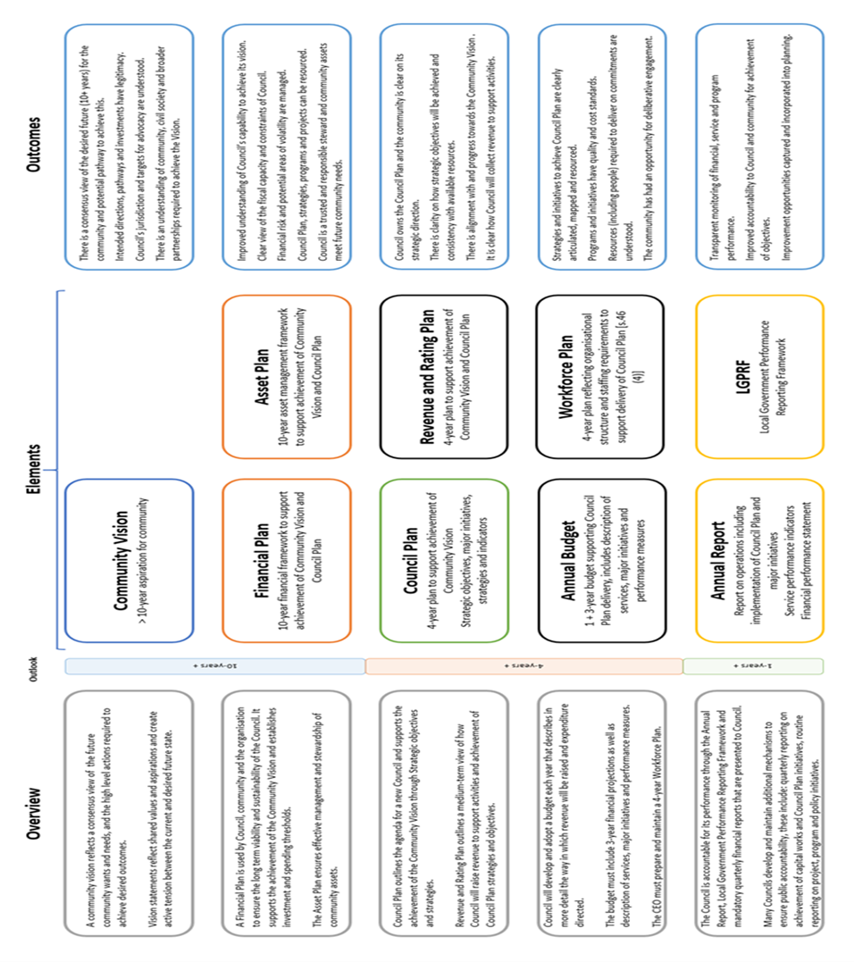

The following figure demonstrates how each element might inform or be informed by other parts of the integrated framework.
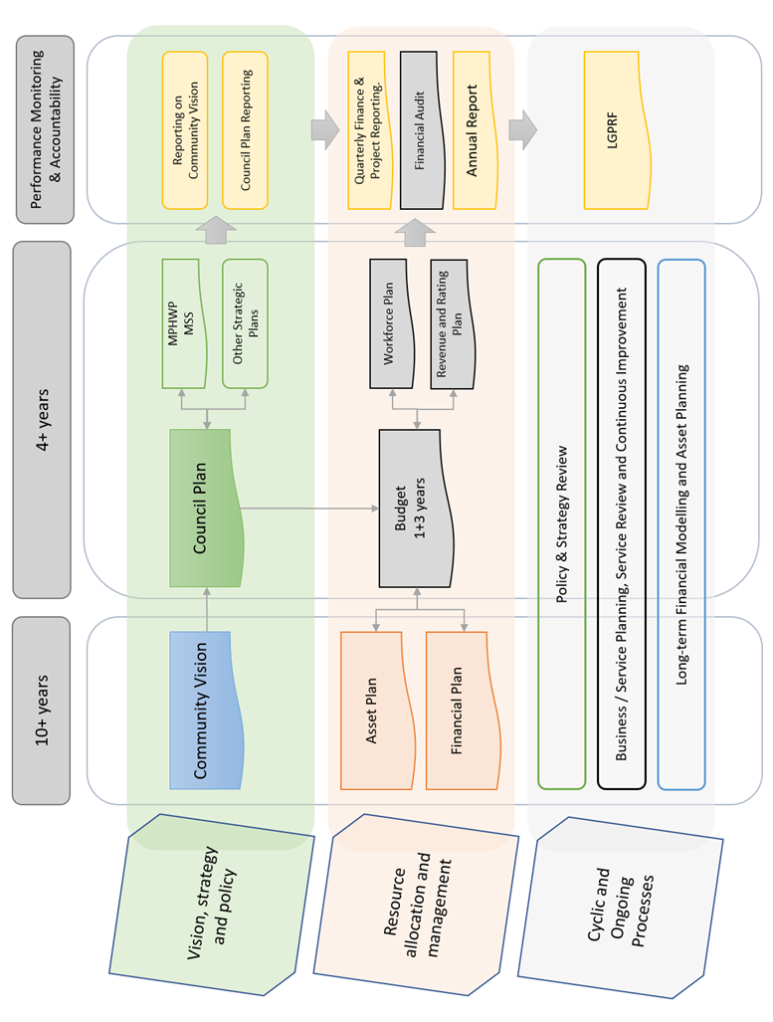
While this guide is focused on one element of the ISPRF, the Annual Report – it is important to recognise the broader framework within which this reporting occurs.

SECTION 2
Local Government Performance Reporting Framework

2.1 Aims of the Local Government Performance Reporting Framework (LGPRF)
Established in 2014, the objective of the LGPRF is to provide comprehensive performance information that meets the needs of several audiences. In meeting this objective:
- councils will have information to support strategic decision-making and continuous improvement
- communities will have information about council performance and productivity
- regulators will have information to monitor compliance with relevant reporting requirements
- state and federal governments will be better informed to make decisions that ensure an effective, efficient and sustainable system of local government.
The data generated by the LGPRF can also provide an incentive to improve the performance of local government services by:
- enhancing measurement approaches and techniques
- helping councils identify where there is scope for improvement
- promoting greater transparency and informed debate about comparative performance.
The results of the LGPRF are released publicly via two methods, Council’s Annual Report and the Local Government Sector Performance Reporting (Know Your Council website), see Figure 2.1.
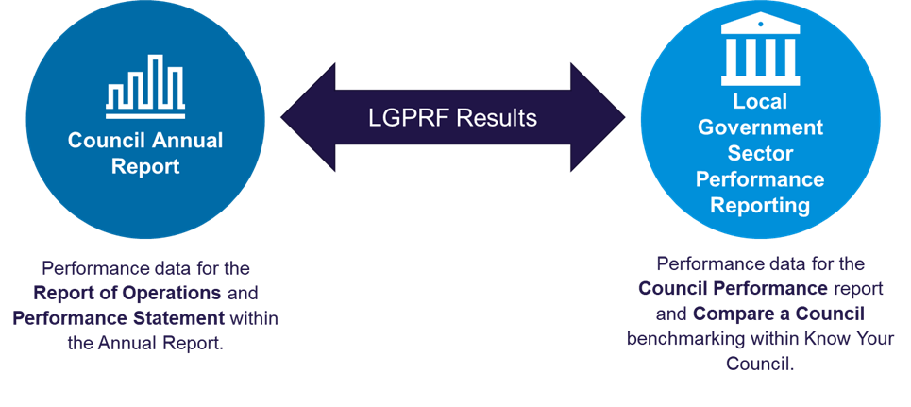

Figure 2.1: Release of LGPRF Results via Council Annual Report and the Local Government Sector Performance Reports

Reasons for measuring comparative performance
Performance measurement is most effective when comparisons are made over time. Since local councils generally operate without competitive pressure, comparative performance indicators enhance accountability and drive continuous improvement by:
- Highlighting successful councils and service areas
- Encouraging learning from peers delivering higher-quality or cost-effective services
- Providing incentives for ongoing improvement

To draw meaningful conclusions, councils should be compared to similar peers and assessed over time. The LGPRF supports trend analysis and, as the sector evolves, will enable more tailored comparisons.
Since no two councils are the same, performance results must be considered in context—population size, demographics, geography, and socio-economic factors all play a role. While the LGPRF does not prescribe service delivery methods, it provides valuable data to help councils assess and refine their approaches.

Integration with the ISPRF
The LGPRF has been operationalised as follows:
- service performance indicators – service indicators be included in the budget and reported against in the performance statement in the annual report. All service performance indicators and measures should be reported in the report of operations in the annual report
- financial performance indicators – all financial performance indicators and measures be reported in the performance statement in the annual report
- sustainable capacity indicators – all sustainable capacity indicators be reported in the performance statement in the annual report
- governance and management indicators – the checklist be reported in the report of operations in the annual report.
The performance statement is subject to audit by the Victorian Auditor-General’s Office (VAGO). Sufficient audit evidence will need to be provided to support the results and explanation of material variations.

2.2 Scope of the LGPRF
The LGPRF recognises that a core function of local government is to provide services to the community. Based on this, the framework also acknowledges that councils have obligations to maintain their capacity and capability to provide these services through effective financial management and governance.
Councils offer a range of services as diverse as the needs of their communities. Nevertheless, there are common services that the community expect from their local government or core functions that all local governments need to undertake to maintain service. The LGPRF focuses on a selection of these common services and core functions grouped into four thematic performance areas and indicator sets, see Figure 2.

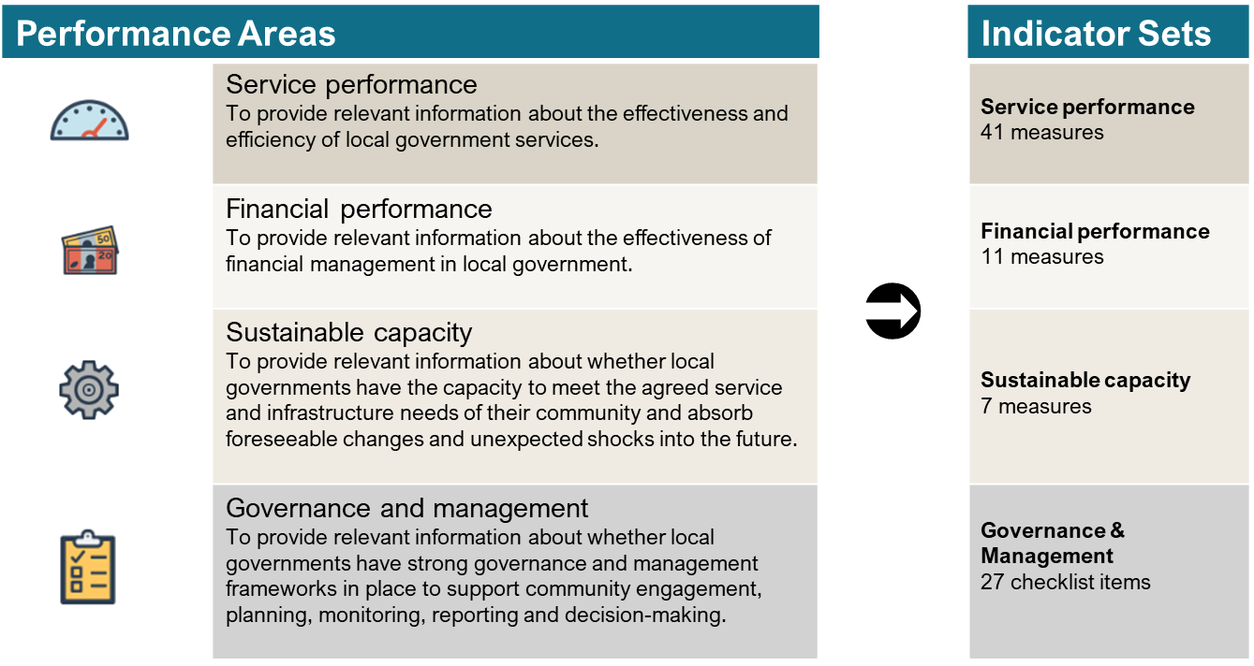

Figure 2.2: LGPRF performance areas and indicator sets
For more information on the indicators and measures, please refer to the Indicator Guide.

2.3 Assessing performance
The LGPRF takes a comprehensive view of performance reporting, with the performance framework giving equal importance to economy, efficiency and effectiveness as overarching dimensions of performance. The interplay of these dimensions creates depth for the analysis of performance.
When analysing the performance data, councils will need to consider the related indicators and how they highlight different aspects of the service. There are risks in allocating funding or resources based on only one aspect of a service. For example, a unit of service delivery may have a high cost but be more effective than a lower cost service and therefore be more cost effective. As such, it is important that results are looked at holistically when assessing performance.

Measuring levels of performance
To better understand a council’s performance, the LGPRF defines performance reporting on two levels:
- Operational performance – the successful performance of internal council operations to meet the community’s expectations; and,
- Strategic performance – the impact of council strategies on the community.
While operational performance looks at how the council transforms requirements into deliverables for the community, strategic performance looks at the higher level of why council offers certain services and the impact on the community, see Figure 2.3.
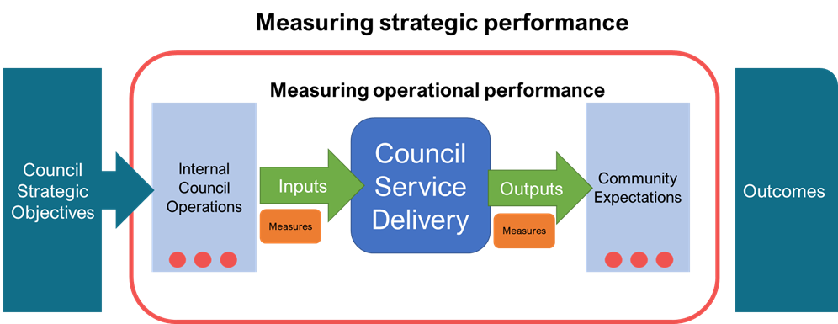

Figure 2.3: LGPRF measuring strategic and operational performance
Central to this model, the LGPRF recognises that while the ‘how’ is often common across similar organisations offering these services, the ‘why’ is often driven by the council and the intended impact it wants to make on the community, see Table 2.1.
Performance level | Reporting on | Internal driver | External driver
Operational | How | Improve internal operations based on… | Community demand or expectations
Strategic | Why | Setting organisational direction to… | Improve the community

Table 1: Summary of drivers between operational and strategic performance reporting
For comparability, the LGPRF focuses on the operational performance while encouraging councils to provide the broader context of their strategic objective and the impact on the community when explaining their results.

Distinguishing inputs, outputs, and outcomes
For each of the four performance areas (service, financial, sustainable capacity and, governance and management), the LGPRF strives to provide a balanced view of a council’s performance through the use of inputs, outputs and potential outcome measures.
Measurements of the internal operations to provide a service and its reception by the community will give a fair assessment of how the council is fulfilling its purpose (Figure 4). Input measures present information on what is required in council funding, resourcing, time and effort to provide a service, while output measures present the quality and satisfaction with the service delivered.
By differentiating between service inputs and outputs, it allows council when planning service improvements to target specific indicators to demonstrate how their actions will enhance council internal operational performance or bolster the value of the service to the community. A full list of indicators per classification is available in the Indicator Guide - Appendix A: Indicator Classifications.

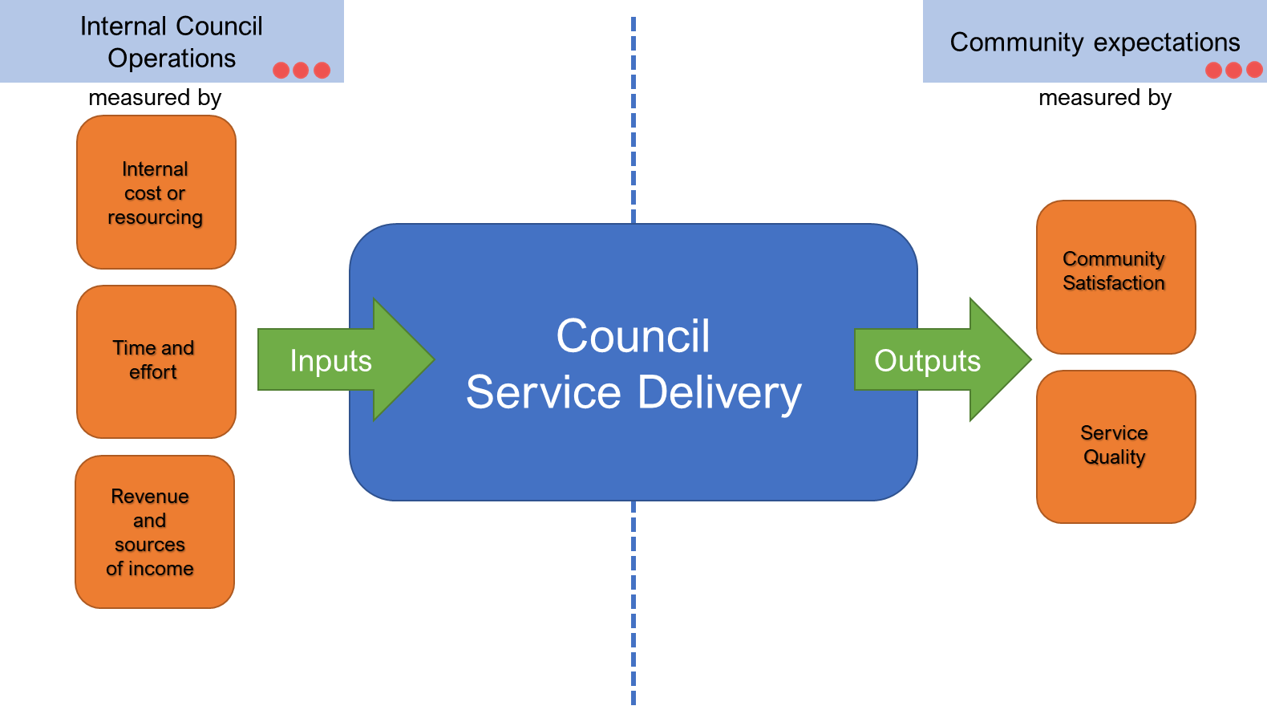

Figure 2.4: Measuring inputs and outputs in operational performance
In contrast to input and outputs, outcome measures relate to strategic performance reporting and provide information on the broader impact of a council strategy on the community, for example: improving public health, a clean safe environment, or a connected community. Outcome measures help the community understand the ‘bigger’ picture of why the service is important to them.
The LGPRF aims to present outcomes where possible, but there is recognition that outcomes can be specific to a council and the community it serves. To support this, the LGPRF encourages councils to draw the link between the inputs and outputs of a service or function and how it ultimately benefits its community. The commentary section in the performance report allows the organisation to explicitly state how the performance of any measured service improves overall life in their municipality.

Examples of commentary to explain the link between indictors to community outcomes:
“A greater educational focus on responsible pet ownership through face to face communications and other channels has resulted in owners ensuring their animals are securely contained.” | “Council will continue to focus on engagement, data analysis and reporting to support transparency and accountability, as well as improved decision making on behalf of the community.” | “This demonstrates that we are committed to provide core services and community facilities now and in the future in a cost effective way.”
Glenelg Shire Council – 2024 | Port Phillip City Council - 2024 | Manningham City Council - 2024

In addition, it is acknowledged that outcomes may be influenced by factors outside the control of councils. Again, by providing councils with an opportunity to support their results with a narrative, councils can explain instances where their activities are only one contributing factor. Councils are also encouraged to link to any relevant strategic objectives from their Council Plan and Annual Reports.

2.4 Measuring service performance
The LGPRF contains 41 service performance indicators across nine common service areas.
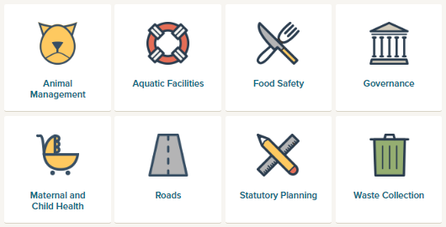



Figure 2.5: Service areas
The indicators for each service areas represents a mix of input and output measures to give a balanced perspective on the performance of the service area.

Input measures for service
With operational performance reporting overall focussed on the provision of service delivery and meeting public expectations, the service input measures present the council’s performance in relation to meeting the operational requirements to deliver a service. At the highest level, this includes:
  - Planning and resourcing – planning the service operation and allocation of resources;
  - Budgeting and cost management – assigning the required funds to support the service delivery and managing the financial cost of the service;
  - Service investment – building and developing the service, resources or infrastructure to meet future needs;
  - Processes and technology – ensuring council has the necessary processes and technology in place to ensure efficient service delivery.
Further, these operational requirements can be measured by indicators such as:
  - Service costs – how successful is council in managing the costs?
  - Timeliness – how successful is council in ensuring the efficiency of the processes and subsequent service?
  - Resource currency – is council managing its resource or service investment?
  - Conditions – is council effectively planning its resources or infrastructure?
These operational requirements and measurements for inputs are summarised in Figure 2.6.
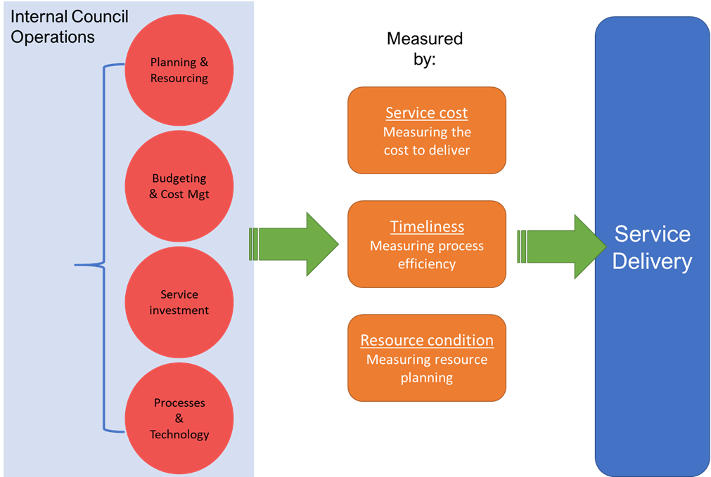

Figure 2.6: Measuring Service Inputs – Operational requirements and measures for service delivery
When seeking to improve internal operations, councils may implement improvement strategies or actions such as:
- Streamlining and simplifying processes;
- Reducing costs;
- Improving workforce planning; or
- Updating technology.
Any significant improvements to the internal operations, should be evident in the results of the input indicators. Furthermore, in planning service improvements, councils can set targets for the relevant input indicator to track and prove the successful attainment of the desired improvement, see Figure 2.7.
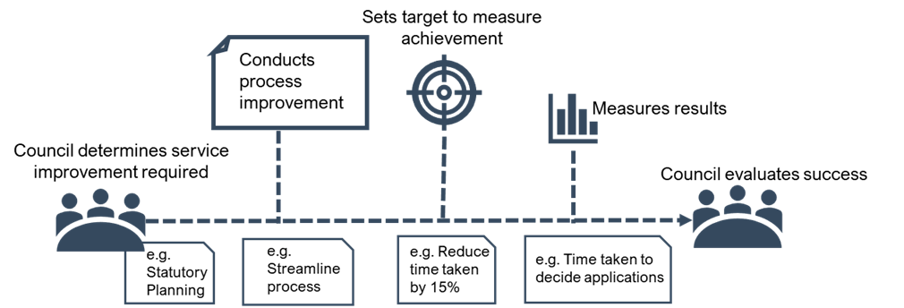

Figure 7: Measuring service improvements via input measures

Output measures for service
In contrast to input measures which focus inwardly on council, the output measures outwardly focus on how the services are received, consumed and appreciated by the community. Residents and ratepayers will develop and demonstrate expectations on local government, that may include:
- Valued services – expectations in respect to council offering services that met the community’s needs;
- Trusted council – expectations on whether the council is transparent, trustworthy and responsible;
- Engaged community – expectations on how the council interacts with the community and represents the community’s interests;
- Clean and safe spaces – expectations on the cleanliness, safety and health of the environment that the council manages.
These expectations can be measured by indicators such as:
- Service standards – is council meeting the expected quality standards for the service?
- Utilisation – is the community using the services?
- Satisfaction – is the community satisfied with the services or operations of the council?
- Consultation and engagement – does the community feel engaged with their council?
- Health and Safety – are the services council provides improving the public safety and health of its residents?
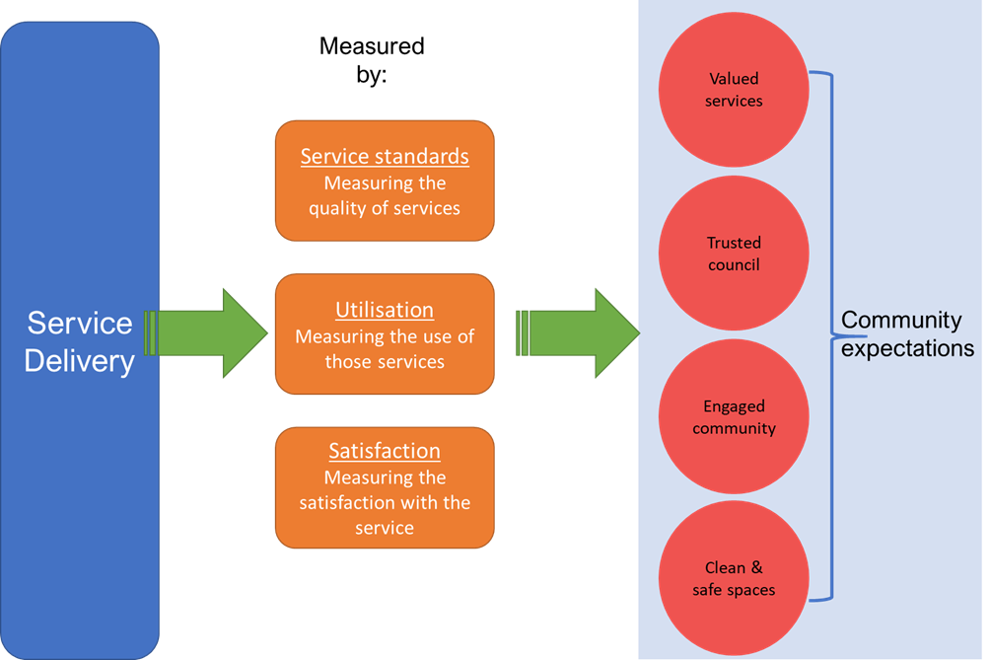
These community expectations and measurements for outputs are summarised in Figure 2.8.

Figure 2.8: Measuring service outputs – measures and community expectations for service delivery
When working to shift community expectations, councils may employ improvement strategies such as:
- Public education;
- Community engagement;
- Refurbishment or improvement to facilities.
Similar to improvements to internal operations, the impact of the improvement strategy or action should be evident in the results for the output measures. Councils can track changes to community expectations over time and assign targets where appropriate, see Figure 2.9.

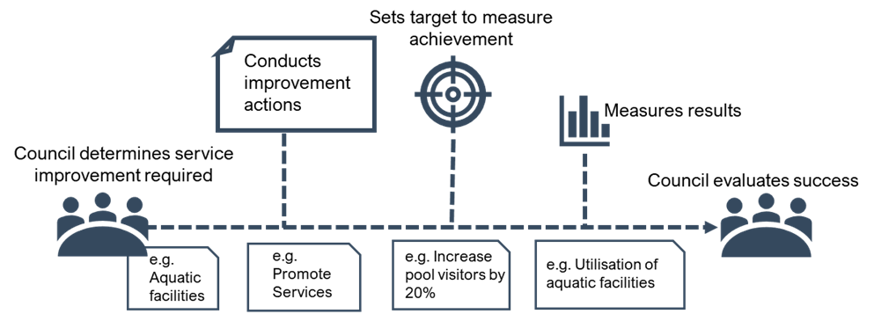

Figure 2.9: Measuring service improvements via output measures
Through the reporting of a combination of input and output measures, councils can optimise how they deliver value to the community.

2.5 Measuring financial performance
The LGPRF contains 11 financial indicators across five subareas which cover key financial objectives. These indicators provide relevant information about the efficiency, effectiveness and economy of financial management in local government.
Financial Subarea | Definition
Operating position | Measures whether a council can generate an adjusted underlying surplus
Liquidity | Measures whether a council can generate sufficient cash to pay bills on time
Obligations | Measures whether the level of debt and other long-term obligations is appropriate to the size and nature of the Council’s activities
Stability | Measures whether a council can generate revenue from a range of sources
Efficiency | Measures whether a council is using resources efficiently
Table 2.2: Financial subareas of the financial performance framework
Like service performance indicators, financial indicators can be considered in terms of inward focussing (or inputs) and outward focussing (or outputs). Understanding how council are managing their financial inputs and outputs provides an informed view of how a council is performing. The input and output measures for financial performance is explored in the following sections.

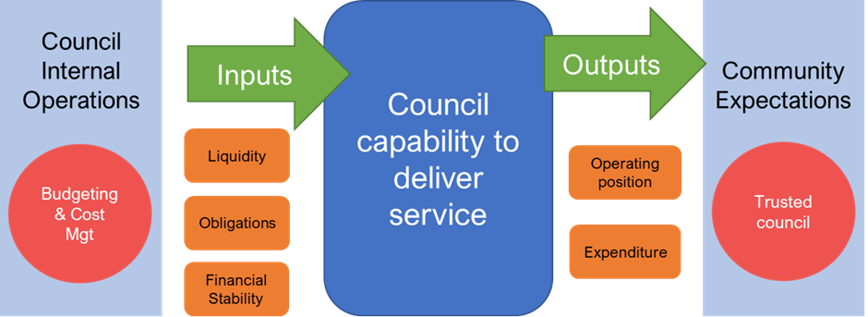

Figure 10: Inputs and output measures for financial performance

Input measures for financial performance
With the overall focus of operational reporting on measuring how a council is providing for their community, financial indicators concentrate on the actions that councils need to take to be financially capable to offer services and functions to the community. This includes requirements such as:
- Planning and budgeting;
- Revenue management; and
- Debt management.
Further, these financial requirements can be measured by indicators such as:
- Financial stability – is council generating enough revenue to remain operational?
- Obligations – is council managing its level of debt to meet current and future needs?
- Liquidity – can council meet its financial obligations with the liquid assets available?

Output measures for financial performance
In contrast to the financial performance input indicators, the output indicators seek to measure how the council meets the community expectations in respect to areas such as:
- Being financially responsible and accountable;
- Being fair in its rates and charges;
- Meetings its obligations both now and for the future.
These expectations can be measured through indicators including:
- Operating position – is council planning a surplus or a deficit?
- Expenditure – is council being efficient in managing its expenses?
The monitoring of the financial inputs and outputs will give a balanced view of financial performance.

2.6 Monitoring the impact on sustainable capacity
A council’s performance can be influenced by the broad social and economic environment in which the services are delivered. This indicator set acknowledges the external factors placed upon councils, including:
- Population size – growth or decline in resident numbers; and
- Socio-economic disadvantage – resident’s access to material and social resources, and their ability to participate in society.
While not a direct reflection of council’s performance, these indicators demonstrate a council’s ability to manage and deliver services and infrastructure within the community’s economic and social environment.

2.7 Mandatory target setting
The Victorian Auditor General’s Office, Local Government Victoria and the Local Government Performance Reporting Steering Committee have all recognised the importance of setting targets against selected performance indicators and supported amendments to the Local Government (Planning and Reporting) Regulations in 2022.
Councils are required to set targets against eight prescribed indicators for the 2025-26 budget and annual report. For more information on Target setting, please refer to the Better Practice Guide – LGPRF Performance Targets.

2.8 Governance and management checklist
In light of all the legislative requirements and best practice models placed upon local government, the Governance and Management checklist summarises the required and recommended frameworks, policies, procedures, and practices that councils can have in place to ensure strong and effective governance.
The annual checklist asks:
- What community engagement policies and procedures did council have in place during the 2025-26 year?
- What planning did Council conduct for the next (2026-27) financial year and future years?
- What monitoring did Council undertake during the 2025-26 year?
- What reporting did Council complete to track their performance during 2025-26?
- What policies and procedures did Council have in place to guide decision making for the 2025-26 year?

2.9 Preparing the organisation for reporting
Councils are required to collect data from 1 July of the reporting period and report the results of the performance indicators and measures in their annual reports for that financial year. To facilitate this process, it is recommended that councils undertake the following steps:
- appoint a senior officer to coordinate the collection and reporting of performance data
- prepare a project plan, covering the period from 1 July to 30 September, which identifies key milestones, dates and responsibilities
- form a working group consisting of representatives from each of the nine service areas and a representative from the finance team to be responsible for collecting data for each of the measures including supporting evidence for those that are subject to audit
- brief the executive team, senior management team and the audit committee on the LGRPF, their roles and responsibilities and key milestones between commencement of data collection and reporting in the annual report
- collect data and report performance indicator results to the key groups above on a quarterly basis including the identification of issues for resolution.

Reporting checklist
Reporting checklist
- The following checklist sets out the legislative requirements for incorporating the LGPRF into the key planning and reporting documents for local government for 2025-26.
Document | Requirement | Reference
Budget | The prescribed indicators and measures of service performance for services funded in the budget. | LGA 94(2)(d)
Budget | The prescribed indicators and measures and the results expected in relation to those indicators and measures. | LGR 8(4)(ea)
Report of operations | All prescribed indicators of service performance for the services provided and funded by the council during that financial year and the prescribed measures relating to those indicators. | LGA 98(3)(c)
Report of operations | Results achieved for that financial year in relation to the performance indicators and measures referred to above. | LGA 98(3)(c)
Report of operations | For the purposes of section 98(3)(c) of the Act, the prescribed indicators of service performance and the prescribed measures relating to those indicators are set out in Schedule 2. | LGR 9(1)
Report of operations | For the purposes of section 98(3)(d) of the Act, the report of operations must contain the results achieved in relation to the performance indicators and measures under section 98(3)(c) of the Act for the preceding 3 financial years and an explanation of any material variations between results referred to above. | LGR 9(2)(a) & (b)
Report of operations | For the purposes of section 98(3)(d) of the Act, the report of operations must contain an assessment of Council’s governance and management in the form set out in Schedule 1. | LGR 9(2)(c)
Report of operations | For the purposes of regulation 9(2)(c) of the Regulations the prescribed governance and management checklist is set out in column 1 of Schedule 1 to the regulations and the prescribed form of the results of council's assessment against the prescribed governance and management checklist is set out in column 2 of Schedule 1 to the regulations. | LGR Schedule 1
Report of operations | As per regulation 9(2)(c) of the Regulations, the report of operations must contain the certification of the governance and management checklist by the Chief Executive Officer and the Mayor. | LGR Schedule 1
Performance statement | All prescribed indicators of service performance for the services provided and funded by the council during that financial year, the prescribed measures relating to those indicators and the results achieved. | LGA 98(4)(a)
Performance statement | For the purposes of section 98(4)(a) of the Act, the prescribed indicators of service performance and the prescribed measures relating to those indicators are set out in Part 2 of Schedule 3 to the regulations. | LGR 11(1)
Performance statement | The prescribed indicators of financial performance and the prescribed measures relating to those indicators and the results achieved for the financial year. | LGA 98(4)(b)
Performance statement | For the purposes of section 98(4)(b) of the Act, the prescribed indicators of financial performance and the prescribed measures relating to those indicators are set out in Part 3 of Schedule 3 to the regulations. | LGR 11(2)
Performance statement | The prescribed indicators of sustainable capacity performance, the prescribed measures relating to those indicators and results achieved for the financial year. | LGA 98(4)(c)
Performance statement | For the purposes of section 98(4)(c) of the Act, the prescribed indicators of sustainable capacity performance and the prescribed measures relating to those indicators are set out in Part 4 of Schedule 3 to the regulations | LGR 11(3)
Performance statement | For the purposes of section 98(4)(d) of the Act, the performance statement must contain the results achieved in the preceding 3 financial years that correspond to the results for the service, financial and sustainable capacity indicators and measures as per section 98(4)(a), (b) and (c) of the Act. | LGR 12(a)
Performance statement | For the purposes of section 98(4)(d) of the Act, the performance statement must contain the results forecast by the council's budget or revised budget to be achieved in relation to the financial performance indicators and measures referred to in section 98(4)(b) of the Act. | LGR 12(b)
Performance statement | The performance statement must contain an explanation of any material variations in the results of the service, financial and sustainable capacity indicators and measures and the corresponding results in the preceding 3 financial years. | LGR 12(d)
Performance statement | The performance statement must contain an explanation of any material variations in the results of the financial indicators and measures and the results forecast by the council’s budget. | LGR 12(e)
Performance statement | The performance statement must contain the targets in relation to the performance indicators and measures set in the council’s budget. | LGR 12(f)
Performance statement | For the purposes of section 98(4)(d) of the Act, the performance statement must contain a description of the municipal district, including its size, location and population. | LGR 12(c)
Performance statement | The performance statement must be certified in accordance with the regulations by 2 councillors (authorised by the Council), the Chief Executive Officer and the Principal Accounting Officer. | LGA 99(3) and  LGR 13(1)
LGA = Local Government Act 2020
LGR = Local Government (Planning and Reporting) Regulations 2020

Annual audit by the Victorian Auditor General’s Office (VAGO)
The financial report and performance statement are subject to audit by the Victorian Auditor General’s Office (VAGO). This includes any LGPRF indicators included in the performance statement. As per VAGO requirements, councils will need to provide evidence and support materials for these indicators. Further information is provided per indicator in the indicator guidance section following.
The results of the annual audits for the sector are published on the VAGO website.

2.10 Quality and integrity of performance information

Internal control environment
All performance information reported by a council to the community, ratepayers and other stakeholders should be subjected to a robust review to ensure the factual accuracy and integrity of the information signed off by the CEO and councillors.
Internal control environment in this context refers to:
- a council’s tone and attitude towards transparent performance reporting
- the level of commitment to high quality internal and external reporting
- the policies, procedures and quality assurance protocols implemented to provide reasonable assurance regarding the accuracy of performance measures reported
- the level of oversight by a council’s Executive Management Team (EMT), audit committee and the councillors themselves.
In plain language, what the organisation does to provide councillors with assurance about the performance information the council reports to the community.
Councillors take ultimate responsibility for the performance of a council and are accountable to the ratepayers and community of the municipality. As councillors are not involved in the day-to-day operations of the council, they rely on the organisation’s policies, procedures and quality assurance protocols to provide assurance about the information reported to them and in turn reported to the community and other stakeholders.
Performance reporting by a council in the annual report, whether it is in the report of operations or the performance statement, can often be more readily understood by members of the community than the financial reports. While councils have an extensive and mature environment in place to provide assurance around financial performance information, the environment for reporting non-financial performance information about services and outcomes has not historically been as developed.

Policy
To support the need to have a strong internal control environment around performance reporting, a council should adopt a performance reporting policy providing an overview of a council’s attitude and commitment to performance reporting. Suggested content for a performance reporting policy is outlined below.
A performance reporting policy should include:
- the council’s objectives in reporting performance (i.e., is it a compliance exercise, or does council seek internal focus and motivation from performance reporting?)
- identification of the council’s stakeholders (i.e., does compliance with the regulations through the annual report disclosures meet stakeholders’ information requirements?)
- the protocols for the dissemination of performance information by the council in circumstances other than formal published performance reports (i.e., are performance measures reported to the audit committee and councillors throughout the year and how rigorous is the process of verifying the performance measures reported?)
- whether the council considers the prescribed indicators of service performance, financial performance and sustainable capacity to be a relevant, appropriate and comprehensive set of indicators of the council’s performance against its stated strategic objectives (i.e., has council identified a need to provide additional information, indicators and measures to communicate performance?)
- the level of assurance that the CEO and principal accounting officer require to enable them to certify the performance statement or governance and management checklist (i.e. is the assurance provided by a direct review of the supporting evidence by the CEO and principal accounting officer or is assurance provided by the responsible directors for each relevant service area?)
- the role of the audit committee in advising the council of the adequacy of the council’s performance reporting to external stakeholders
- the level of assurance the councillors require to enable adoption of the performance statement, the report of operations and the governance and management checklist.

Procedures
The council should also document the procedures involved in preparing performance reporting information to build and retain the organisation’s knowledge. Formalised procedures can provide efficiency and enhance planning to ensure timeframes are met where performance reporting is prepared infrequently throughout the year or in circumstances of staff transition. Standardised procedures for performance reporting can also enhance consistency of the information reporting, particularly where the measures are reported across a time span of several years. Suggested content for performance reporting procedures is outlined below.

Performance reporting procedures should include:
- specific sources of data for each indicator (i.e. software, report name, report fields selected, any filters applied and supported with screen captures or hard copy examples)
- contact details for relevant personnel both internally and where data is provided to the council by third parties (e.g. Department of Health or operators of outsourced services)
- nomination of officers responsible for the collation and verification of data collected
- the frequency at which data needs to be collected (i.e. daily, weekly, monthly, quarterly or annually) and the lead time on collecting the data
- identification of other controls that may exist in the collection and verification of indicator data to ensure it is complete and accurate (e.g. is the data monitored on a regular basis to identify unusual or unexplained variances?)
- nomination of the council officer responsible for ensuring performance reporting data is centrally collated in time for:
- internal reporting
- preparation of the performance statement
- audit of the performance statement
- preparation of the report of operations
- preparation of the governance and management checklist
- the timing and frequency with which performance indicators and measures are reviewed by the EMT
- the actions to be taken by the audit committee when reviewing the draft performance statement, report of operations and the governance and management checklist
- the format of any formal statements provided by responsible officers to the CEO, principal accounting officer and councillors.

Third party information
Some of the prescribed indicators require the collection of supporting data from sources external to the council. These include:
- annual community satisfaction survey (CSS) results from LGV or recognised supplier
- municipal population and socio-economic disadvantage data from the Australian Bureau of Statistics
- statutory planning results from the Planning Permit Activity Reporting System (PPARS)
- maternal and child health results from the Child Development Information System (CDIS) or equivalent system
- notice of decisions from VCAT hearings.
The planning process for the preparation of performance reporting should separately identify data required from external sources and the reporting timetable and data format requirements should be communicated to the third-party data providers to ensure the council receives the correct data at the required time.
The format and content of the data received from third parties should be sufficiently robust to support the level of assurance required by councillors, the CEO and the principal accounting officer in certifying the performance statement. As several of the indicators will be subject to audit, council officers should request supporting evidence at a level that enables a critical review and assessment of the reliability of the data provided. For example, an email advising a numeric input for a measure’s numerator or denominator does not provide the same level of assurance as a copy of the source report from that third party’s operational software.
It is not uncommon for a council to outsource the operation of some service areas such as the operation of swimming pools or the kerbside garbage and recycling collections. While a council can outsource some day-to-day operational activities, it still retains responsibility for the oversight of the provision of the service to the community and ultimate risk in the management of facilities and operations.
Councils may need to review and revise service level agreements with contracted service providers to ensure the data required for performance reporting is provided within the council’s required timeframe.

2.11 Services funded in the budget
Section 94(2d) of the Act requires the budget to contain the prescribed indicators and measures of service performance for services funded in the budget. Where a council does not fund a service then it will not be required to disclose the applicable service performance outcome indicator in their budget. While this sounds straightforward, there are a number examples where councils make a contribution to a service (such as maternal child health) but the service is provided by a not-for-profit organisation directly funded through a service agreement with the relevant agency. The test in this case comes down to what is termed 'operational control'.
Operational control
In some instances, a council that has outsourced the provision of services or transferred the functional operation of facilities through formalised contracts, leases or funding agreements may believe that it no longer has operational control of the service. If a council does not believe it has operational control of one of the prescribed services and does not collect data to facilitate performance reporting, it will need to obtain and document an understanding of the background of the original outsourcing decision and why it does not believe it can influence the outcome of the service delivered. Suggested tests for determining operational control of a service are outlined below.

Tests for operational control of a service:
- If the service is asset dependent such as in the case of a pool then the first test will be whether all the risks and rewards associated with owning the asset have been transferred away from the council (e.g. this could be done through a lease agreement)
- The second test relates to whether the council has significant influence over the service outcomes (i.e. does the council have the capacity [ability or power] to substantially affect the outcomes of the service. For example, this might be the case if, despite the council making a financial contribution, decisions over the service outcomes rest with the funding agency).

In many instances a council retains a sufficient level of responsibility and obligation under the formal agreement that would suggest the service is still ultimately under the control of council.

2.12 Roles and responsibilities
To meet the reporting timelines for the preparation and audit of the performance statement, the drafting of the report of operations and the submission of the LGPRF data to LGV, a council should formally allocate roles and responsibilities across the council. The following table provides a summary of the responsibilities for each of the key parties in the performance reporting process.
Role | Responsibilities
Service area officer | - extract /collate data to calculate results  - request and obtain data from third parties (if applicable)  - critically review data to ensure the data is accurate and complete  - provide supporting evidence in preparation for management review
Service area manager/director | - review results  - review the supporting source data to verify the calculation of the results  - investigate unusual or unexpected results  - monitor negative or unanticipated trends and recommend options for an appropriate response  - provide explanations for material variations  - provide assurance representations to EMT as to the accuracy and completeness of the results and the adequacy of the supporting source data
Performance reporting officer | - prepare the performance reporting workplan and timetable  - communicate requirements to responsible service areas  - collate quarterly and final results to be reported  - provide quarterly performance reports to the EMT, audit committee and council  - prepare the draft performance statement and supporting data evidence for audit  - prepare the governance and management checklist, service performance indicators and other performance information disclosures for review  - submit approved data to Local Government Victoria for sector publication
Executive Management Team (EMT) | - receive and consider quarterly performance reports  - consider recommendations for intervention where unfavourable or unanticipated trends are identified  - review the draft performance statement, the draft governance and management checklist, the service performance indicators and other performance information disclosures  - consider the results in the context of any quarterly reports received throughout the year  - identify material variations at the council level for explanation (i.e., in the context of the council’s priorities)  - review the assurance representations provided by service area managers/directors  - provide a recommendation to the CEO and principal accounting officer
Principal accounting officer | - review the materiality levels adopted in identifying the variations requiring explanations in the performance statement  - review and approve the draft explanations for material variances in the performance statement  - review the recommendation provided by EMT for certification of the performance statement  - once satisfied with the quality of reporting, certify the performance statement is in the required format
Chief Executive Officer (CEO) | - review the materiality levels adopted in identifying the variations requiring explanations in the performance statement and report of operations  - review and approve the draft explanations for material variations in the performance statement and report of operations  - review and approve the draft governance and management checklist  - review the recommendation provided by EMT for the draft service performance indicators and other performance information disclosures  - review the recommendation provided by EMT for certification of the performance statement  - provide a recommendation to the audit committee  - provide a recommendation to the council  - certify the performance statement in the required format following completion of the audit  - certify the governance and management checklist
Audit committee | - receive and consider quarterly performance reports  - review the draft performance statement  - review the draft governance and management checklist, service performance indicators and other performance information disclosures  - consider the results in the context of the quarterly reports received throughout the year challenging any unusual or unexpected results  - enquire as to the internal control framework and level of assurance received around the accuracy and completeness of the information reported  - review the report of operations to ensure that it is consistent with the audited financial statements and performance statement  - review the recommendation provided by the CEO for the draft governance and management checklist, service performance indicators and other performance information disclosures  - discuss the results of the audit of the performance statement with the external auditor  - provide a recommendation to the council
Council | - receive and consider quarterly performance reports  - review the draft performance statement and consider the results in the context of the reports received throughout the year challenging any unusual or unexpected results  - review the recommendations received from the CEO, principal accounting officer and audit committee  - adopt the performance statement in principle  - have two councillors certify the performance statement in the required format following completion of the audit  - have the mayor certify the governance and management checklist  - adopt the annual report  - have the mayor present the Annual Report at a Council meeting open to the public by 31 October

In addition to the above key parties, it is recommended that councils establish a performance reporting team to improve the coordination and integration of the performance reporting process. The team should be made up of the performance reporting officer, service area officers and principal accounting officer.

2.13 Governance of the LGPRF

Local Government Finance and Performance Steering Committee
LGV has established a steering committee for the LGPRF that oversees a triennial program of review and continuous improvement to the framework. The key responsibilities of the steering committee include:
- providing recommendations to LGV on the overarching framework, the set of indicators and content of reporting by councils and state;
- resolving issues brought to it from Technical Working Groups and sector consultation;
- working to improve the comparability, quality and integrity of reported data;
- recommending opportunities to streamline LGPRF data collections and reporting between the state and local governments;
- seeking to maximise the accessibility to key stakeholders of the performance data.
The steering committee is chaired by the Executive Director of LGV and is comprised of CEO and Senior Executives from councils along with representatives from peak bodies. The committee meets twice a year.

Development of indicators
All indicators and measures are developed and enhanced through consultation with the local government sector. Indicators are formally reviewed through Technical Working Groups enacted by the LGFP Steering Committee, see figure 2.13.
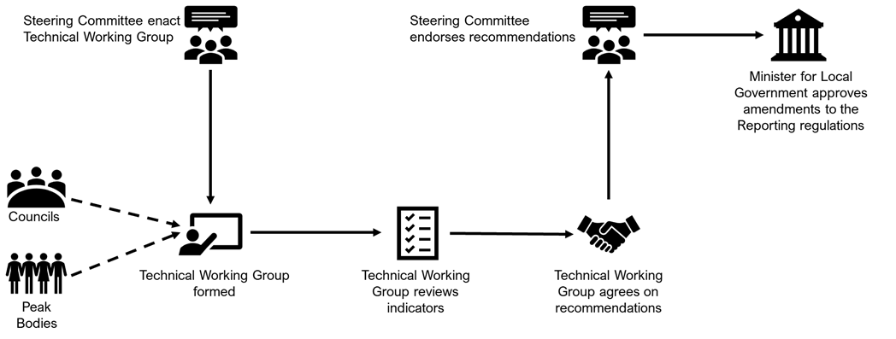

Figure 2.13 – Process for the creation and updating of indicators for the Local Government Performance Reporting Framework.
Councils are encouraged to nominate for the Technical Working Group and have input on improvements to the framework indicators.

Guiding principles
Guiding principles have been established to assist in the development and selection of indicators to measure local government performance, See Table 2.3.

Guiding principles of LGPRF
- Indicators should be ‘SMART’
The construction of specific indicators should seek to adhere to the SMART principles, that is, indicators should be:
- specific to the service, activity and/or dimension of performance being measured;
- based on measurable factors that can be observed, documented and verified (either by audits or other mechanisms);
- aligned with objectives;
- relevant to the service, activity and/or dimension of performance being measured; and
- time-bound with an appropriate and clear timeframe specified for measuring performance.
- Indicators should build a balanced picture of performance
A range of performance indicators should be developed to cover different aspects of performance. A single indicator is typically not able to provide a balanced picture of performance; therefore a suite of indicators, measuring different aspects of performance should be pursued.
- Indicators should be understandable to a broad audience
Performance indicators must be understandable to a broad audience. They should be clear and unambiguous so that stakeholders can draw meaningful conclusions about the performance of councils. A balance should be struck between performance indicators being understandable to the community, useful to councils to support continuous improvement and instructive to other levels of government. Performance indicators must also measure what they claim to measure. Proxy indicators should be clearly identified as such.
- Indicators should align with other reporting requirements
Use of performance indicators that are already in use in other reporting arrangements should be pursued where possible. Adopting existing indicators can ensure consistency with other reporting frameworks, lowers the cost of data collection and avoids delays in reporting. Performance indicators should also be developed with national standards and reporting regimes in mind to allow for inter-jurisdictional analysis.
- Indicators should be comparable across councils and consistent over time
Each indicator must be clearly defined with formulas, calculation and measurement standards established to facilitate a valid measure of performance and aid reasonable comparisons. Indicators should also allow for consistent comparisons of performance over time. This requires that performance indicators be well designed and robust from the outset and remain broadly stable over time. Indicators should be relevant to all councils and not geographically biased.
- The benefit of collecting information should outweigh the collection costs
The costs associated with collecting information needs to be balanced against the benefits of collecting that information.

Table 2.3: Guiding principles for creation of indicators.

For further information refer to:
- Department of Government Services (2025), Local Government Better Practice Guide Performance Reporting Framework Indicator Guide 2025-26, State of Victoria
- Department of Government Services (2026), Local Government Model Sector Performance Report template, State of Victoria

SECTION 3
Annual Report – Model Financial Report

3.1 Introduction
Council annual reports are prepared under the provisions of the Local Government Act 2020 and the Local Government (Planning and Reporting) Regulations 2020.
Under the regulations the financial statements in a council annual report must be prepared in accordance with the Local Government Model Financial Report (LGMFR).
In prior years a separate Better Practice Guide (BPG) has been published by LGV to accompany the LGMFR. For 2025-26 all the BPG guidance for annual reports has been incorporated into this single BPG.
This BPG sets out the broader Integrated Strategic Planning and Reporting Framework (ISPRF) to better contextualise the place of the annual report within the ISPRF.
The annual reporting responsibilities for Victorian councils also reflect the requirements of Australian Accounting Standards and the Local Government Performance Reporting Framework (LGPRF). The LGMFR and BPG are developed to assist councils in the preparation of financial statements for inclusion in their annual report.
LGV again convened a working group to guide the development of this year’s LGMFR and BPG. LGV thanks the Local Government Finance Professionals (FinPro), CPA Australia and the Victorian Auditor-General’s Office (VAGO) in an observer capacity, for their contributions to this year’s edition of the BPG and LGMFR.
The key changes to the LGMFR for 2025-26 include:
- Title page – A disclaimer has been added to the Model Accounts to reflect that it is designed for the Victorian local government sector and that it is not a substitute for specific professional advice.
- Note 2.1.1 and 2.1.2 Analysis of our results – the formulas in the percentage variance column (column I) have been revised to minimise the likelihood of a #DIV/0! Error.
- Note 5.3(b) Trust funds and deposits (and other instances in the Model) – Previous references to the Fire Services Property Levy have been updated to the Emergency Services and Volunteers Fund.
- Note 6.1 Non-current assets classified as held for sale – Note disclosure simplified to include line items based on the nature of assets classified as held for sale (eg. land, buildings etc.)
- Note 6.2 Valuation of land and buildings / Valuation of infrastructure - The text disclosure of how Council initially measures its property, infrastructure, plant and equipment assets has been updated to align better with AASB 116. The text disclosure around valuation of land has been strengthened with additional text regarding highest and best use. The text disclosures for both land and buildings and infrastructure assets valuations have been updated to include additional information about the most recent full revaluation of asset classes where an index based / desktop valuation has been conducted in the current year. This provides additional context for users of the financial statements on how recently Council assets have been subject to a full revaluation.
- Note 8.2 Australian Accounting Standards issued but not yet effective - The text at Note 8.2 has been updated to reflect the issue by the AASB of AASB 18 Presentation and Disclosure in Financial Statements. When applicable (expected to be 2028-29 for Councils) AASB 18 supersedes AASB 101 Presentation of Financial Statements and is expected to result in presentation and disclosure changes, primarily to a Council’s Comprehensive Income Statement. However for this year the change is simply to disclose at Note 8.2 that this Standard has been issued with impacts expected in future reporting periods.
- Note 9.3 Superannuation – The superannuation note disclosures have been updated for 2025-26 to match the wording issued by Vision Super in their Short-form Sample employer superannuation note for the financial statements for 30 June 2026. The superannuation contribution rate has been updated to 12 per cent.

A more detailed summary of the changes made to both the LGMFR and BPG is available in the ‘changes’ tab in the model accounts excel workbook on the Department’s website at www.localgovernment.vic.gov.au.
We trust that you find the LGMFR and the associated portion of this BPG very practical tools to assist in the preparation of your financial statements for the 2025-26 financial year.

3.2 About the Annual Financial Report
Councils are required to prepare an annual report in respect of each financial year¹⁶ consisting of four parts:
Report of operations: information about the operations of the council
Performance statement: audited results achieved against the prescribed performance indicators and measures
Governance and management checklist: demonstrating council’s compliance with the reporting requirements.
Financial statements: audited financial statements prepared in accordance with the Australian Accounting Standards
This section of the guidance has been developed to help local government in meeting statutory requirements relating to the preparation of their annual financial statements. Guidance on the preparation of the report of operations and audited performance statement can be found elsewhere in this BPG.
This guidance is intended for use by local government finance professionals. Each council retains the responsibility for preparing its annual financial statements, including the format and the disclosures made. This guidance, along with the LGMFR, represents the annual financial statements presentation required by LGV. The guidance in the LGMFR directs users to related information and further guidance, including Australian Accounting Standards (AAS). Footnotes are used to reference legislative provisions and other relevant information.
General principles of budget presentation and layout
This guidance is focused on the requirements of the legislation and detailing the essential elements of the financial statements in an annual report. These obligations are mandatory, but meeting the broader principles of transparency for an important public document obligates councils to consider presentation, layout and accessibility.
A council’s annual report is a document for conveying important information about the concluded financial year to the ratepayers, businesses and residents of the municipality. It should serve these readers through being engaging and clear on council’s financial performance and position. It should demonstrate how council’s finances have been managed and the stewardship of important public assets relevant to the interests of the readers and the municipality.
Therefore, a council should strive to succinctly describe its expenditure of public revenue for such an audience. Plain English descriptions of activities and projects are desirable. The use of imagery, motifs and photographs should be strictly limited, purposeful and connect directly to the content and purpose of the annual report.
Annual reports should at minimum be published in low-resolution portrait format and eschew multi-page spreads or elements that require high-resolution imagery or result in large file size that are slow to download. The use of other formats such as mobile friendly PDF or HTML should be considered to improve accessibility for ratepayers, businesses and residents.

Preparation of this section of the better practice guide
LGV is responsible for the development of this BPG and will update and reissue it on an annual basis. LGV convened a working group to guide the development of both the 2025-26 LGMFR and this guidance.
The working group is comprised of representatives from the accounting profession, the local government finance professionals (FinPro), CPA Australia and LGV. Technical advice and assistance in preparing the LGMFR and BPG was provided by the working group.
Representatives of VAGO also attended working group meetings in an observer capacity. LGV thanks members of the working group for their contribution to the development of the LGMFR and this guidance.

Model Accounts 2025-26 working group membership

Accounting profession
Ram Subramanian, CPA | CPA Australia
Local government finance professionals (FinPro)
Navec Lorkin, CPA | Knox City Council
Rahul Shah, CPA | Whittlesea City Council
Fiona Rae, CPA | Golden Plains Shire Council
Alan Wilson, CPA | Melbourne City Council
Department of Government Services
Dr Leighton Vivian | Local Government Victoria
Daniel O’Shea, CPA | Local Government Victoria
Attendance in observer capacity
Travis Derricott, CPA | Victorian Auditor-General’s Office (VAGO)
Christopher Wong, CA | Victorian Auditor-General’s Office (VAGO)

3.3 Statutory requirements
The Act requires a council’s annual report to contain audited financial statements

Sections 98, 99 and 100 of the Local Government Act 2020 state that:
- the financial statements must be prepared in accordance with the regulations and include any other information prescribed by the regulations
- the financial statements must be prepared by a Council as soon as practicable after the end of the financial year
- the financial statements must be submitted to the auditor for reporting on the audit after the Council has passed a resolution giving its approval in principle to the performance statement and financial statements
- the financial statements must be certified in their final form by two councillors, the CEO and Principal Accounting Officer
- the annual report must contain a copy of the auditor’s report on the financial statements
- the annual report must be presented by the Mayor at a council meeting open to the public within four months of the end of the financial year (eg. by 31 October) or, in the year of a general election, on a day not later than the day before election day
In addition to sections 98, 99 and 100 of the Act, councils should review part four of the regulations for further information required in the financial statements.

The regulations require a council’s financial statements to be prepared in accordance with the Local Government Model Financial Report

Regulation 14 in part four of the Local Government (Planning and Reporting) Regulations 2020 states that:
- the financial statements must be prepared in accordance with the Local Government Model Financial Report
- the financial statements must contain a statement of capital works
- the financial statements must include specified other information as notes.

Checklist
The financial statements must:
- Be prepared in accordance with the Local Government Model Financial Report including a statement of capital works; and
- Include other information required by the regulations.

3.4 Context and development of guidance
Under the Local Government (Planning and Reporting) Regulations 2020, Local Government Model Financial Report means the Local Government Model Financial Report published by the Department from time to time including on the Department’s Internet site. The LGMFR refers to the Microsoft excel workbook available on the website of Local Government Victoria (www.localgovernment.vic.gov.au). This LGMFR Better Practice Guide section is separate and is provided to assist preparers.
The LGMFR has been developed to illustrate as widely as possible the minimum disclosure requirements for councils. It is expected that councils will follow the format, presentation and disclosures in the LGMFR. In certain limited circumstances additional disclosures and presentation formats may be required in order to meet the requirements of AAS or report on specific local issues. The guidance in the LGMFR provides some examples of when additional disclosures and presentation formats may be required. Where disclosures illustrated in the LGMFR are not relevant to an individual council they may be omitted as appropriate.
It is expected that local government finance professionals exercise professional judgement in preparing their financial statements in accordance with the LGMFR.
The LGMFR is underpinned by seven guiding principles.

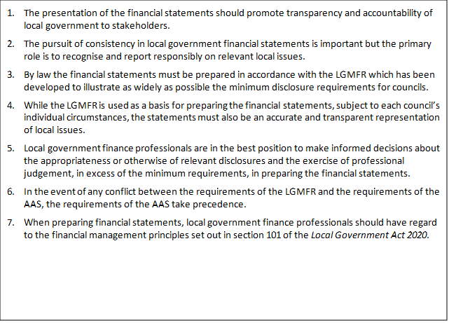

For the 2025-26 reporting year the detailed guidance supporting the model accounts is located as a tab within the LGMFR itself. This allows users to quickly access any relevant guidance from within the LGMFR template and includes hyperlinks for ease of use.

The detailed guidance in the LGMFR is provided to assist local government finance professionals in preparing the council’s annual financial statements. For ease of referencing each piece of guidance has been assigned a unique number. Where applicable, references to the Local Government Act 2020, the Local Government (Planning and Reporting) Regulations 2020, the Local Government Act 1989, the Local Government (Planning and Reporting) Regulations 2014 (those provisions saved for the purposes of Regional Library Corporations), Australian Accounting Standards and other authoritative pronouncements are also included.

Section 4 – Annual Report - Performance Statement

4.1 Statutory requirements
“The Act requires a council’s annual report to contain an audited performance statement”
Sections 98 and 99 of the Act state that:
- the performance statement must contain the prescribed indicators and measures of service performance outcome, financial performance and sustainable capacity and the results for each indicator
- the performance statement must be submitted to the auditor as soon as possible after the end of the financial year and certified in its final form by two councillors, the CEO and principal accounting officer
- the auditor must prepare a report on the performance statement to be included in the annual report.
In addition to sections 98, 99 and 100 of the Act, councils should review Part 4 (Annual Report) of the regulations for further information required in the performance statement.
Checklist
The performance statement must include:
- the indicators, measures and results of the prescribed service performance outcome indicators
- the indicators, measures and results of the prescribed financial performance indicators
- the indicators, measures and results of the prescribed sustainable capacity indicators
- the targets of the prescribed service performance outcome and financial performance outcome indicators
- any other information required by the regulations.

4.2 Better practice guidance
The performance statement is a key section of the annual report whereby council makes itself accountable to the community and contains information about the performance of the council for the financial year.
In 2012, the Victorian Auditor-General’s Office (VAGO) recommended that all councils should critically review the performance information in their annual reports to ensure it is relevant, balanced, appropriate and clearly aligned with their council plan strategic objectives to ensure performance reporting is meaningful to the community. In response, the Victorian Government introduced a mandatory system of performance reporting (Local Government Performance Reporting Framework – LGPRF) in 2014-15 which prescribes performance information to be included in council annual reports. Further guidance to support councils report against the prescribed performance indicators and measures can be found in the Local Government Performance Reporting Framework Indicator Guide.
Councils must describe the prescribed indicators and measures in the performance statement so it is clear what is being measured. The performance statement must include the results achieved in relation to the prescribed service performance outcome, financial performance and sustainable capacity for the financial year and three preceding years. For the financial performance indicators and measures, the performance statement must also include the forecast results for four years based on Council’s budget. Reporting trend information helps readers understand changes in council performance over time.
The regulations require councils to provide commentary and an explanation of any material variations in the results between the current year and other years disclosed, to enable the reader to form an understanding of the reason for the variation. To provide context to the performance results, the regulations also require the performance statement to contain a description of the municipal district, including its size, location and population.
Additional performance indicators can be included by councils in the performance statement but they will be subject to audit by VAGO and must pass the test of relevance and appropriateness as defined by VAGO.
Councils are also required to disclose other performance-related information in the report of operations in the annual report including:
- a governance and management checklist
- the prescribed indicators and measures of service performance, results achieved and an explanation of material variations
- a statement that reviews the performance of the council against the council plan including results achieved in relation to the strategic indicators included in the council plan.
This performance information in the report of operations along with that in the performance statement should form part of a performance reporting framework with quarterly or bi-annual reporting of performance results to senior management, the audit committee and councillors. Taking an integrated approach to performance reporting can help councils understand how well they are performing in meeting the needs of their communities as well as achieving the strategic objectives in their council plan.
For further information on the Report of Operations, please refer to Section 5.

4.3 Preparation of the performance statement

Form and content
The Act and regulations require the performance statement to contain:
- a description of the municipal district, including its size, location and population
- the results of the prescribed indicators and measures for:
  - service performance
  - financial performance
  - sustainable capacity performance
- for the prescribed indicators and measures, the results for:
  - the current financial year
  - the three preceding years
  - the estimates forecast by the council for the financial performance indicators
- for the prescribed indicators and measures requiring annual targets, the targets for the current financial year
- explanations of any material variations in the results, including variations in the trend, target or forecasts
- certification in the prescribed format by two councillors, the CEO, and the principal accounting officer
- a copy of the auditor’s report on the performance statement.
The calculation of the results for the prescribed indicators and measures is produced within the Local Government Model Sector Performance Report. See the Local Government Example Performance Statement for an example of a performance statement.

Basis of preparation
The primary purpose of the performance statement is to communicate the council’s performance to the community in the context of prior performance and for the financial performance indicators, forecast performance. To help the reader understand the objective and purpose of the performance statement and provide a context, the council should explain the performance reporting framework and key estimates and judgements used in preparing the performance statement.
This section should include a description of the preparation, relevant definitions and any other matters that provide context to the performance of the council.

4.4 Materiality guidance
The regulations require the performance statement to contain an explanation of any material variations in the results contained in the performance statement. For example:
An explanation should be provided for any significant change:
in the result between the current year and previous years. | between any target and the actual result. | for the current result and forecast years. | between the budget and the actual result.

The regulations require the performance statement to contain an explanation of any material variations in the results contained in the performance statement. Materiality, in the context of performance reporting, is the threshold at which omission or misstatement of information could influence the decisions made and expectations formed by reference to the data reported. For example:
- a significant change in a service performance result that does not have an explanation could give the reader the impression that the service is not being efficiently managed by council
- a significant misstatement in a sustainable capacity result could result in incorrect strategic planning decisions being made by the council in the future.
The decision about what is material has both qualitative and quantitative factors. The qualitative factors include:
- the council’s overall strategic objectives and priorities as identified in the council plan
- the relative importance of the service to the council in the context of its whole operations
- what is important to the stakeholders and readers of the performance statement
- the relevance and appropriateness of the indicator in accurately reporting performance
- the drivers underlying the calculation of the measure.
An indicator that is more important to a council or its stakeholders will be more sensitive and therefore will have a lower materiality threshold and require more expansive explanations. Conversely a less sensitive indicator can bear a higher materiality threshold and will require less of variances.
Quantitative factors are easier to define as indicators of materiality. However, councils should recognise that even if a variance is not statistically significant, it may still be important and require explanation when considered alongside qualitative materiality factors. The results of the prescribed indicators and measures consist of absolute numbers, percentages, ratios and dollars and accordingly the materiality threshold decision will be different for each indicator.
Where results sit inside the materiality threshold, councils are encouraged to provide a qualitative statement. In the case of Council not wishing to make a comment, the material variations section should simply be left blank in the Performance Reporting template. Councils may wish to publish the term ‘no material variations’ in the Annual Report, however comments on the expected or permissible range should be avoided in both the template and Annual Report. It is recommended that Council consider providing commentary around all indicators where possible, to provide context to readers, even in cases where year on year variances may be immaterial.
The nature of the Local Government Performance Reporting Framework is to ensure council performance is accessible to the public, and as such, councils should consider their audience when drafting comments or material variations. These comments and material variations should convey the same message and must be careful not to contradict each other. In the case of website comments, for example, councils may wish to include a URL link to corresponding documents or council pages where relevant. The link will then appear as a hyperlink in the sector performance reports, however may not be useful in the context of the Annual Report.
As all comments are made public, Council may wish to consider the involvement of their communications staff (if applicable) to review and ensure comments are consistent with council’s overall messaging.
In 2016, it was agreed with VAGO that for 2015-16 and 2016-17 year results, if incorrect, could be changed by councils to ensure comparable year on year data. In 2018 it was agreed that from 2017-18 onwards there would be no further changes to data from previous years. If information has come to light which changes the result for a previous year following the data being published on the Local Government Victoria website, councils should reference this in the current year commentary, particularly where it results in a significant year on year variation.
Councils are also required to identify whether data is to be reported for each measure using the DATA APPLICABLE column in the Performance Reporting Template. For each measure, councils must select from the drop-down box either APPLICABLE or NO DATA.
Material variations should be provided in some of these examples, as explained in the following table:
APPLICABLE | Council provides and has operational control of the service, and data will be reported in the template.
NO DATA | Council either provides the service but is unable to report data in the template for the reporting period, or does not have operational control of the service. If council provides the service, but is unable to report data, a material variation/comment must be provided in Input 4 of the template.
In the cases of ‘No Data’, this should be reflected accordingly in the Annual Report.

Materiality guidelines
This is provided as a guide to establish quantitative materiality thresholds for explaining material variations in results for the following comparisons:
- Current year result versus the prior year results
- Current year result versus the three preceding year results
- Current year result versus the results forecast by the financial plan (for financial performance indicators only).
The example materiality thresholds in the table below are based on +/- 10% of the state average results. Councils will need to make their own assessment of the appropriate materiality threshold, using their former actual results and taking account both quantitative and qualitative factors and circumstances specific to their council.
SERVICE PERFORMANCE (EXAMPLES)
Service / indicator / measure | Measure expressed as: | Materiality threshold:
Aquatic Facilities  Utilisation  Utilisation of aquatic facilities | Number of visits to aquatic facilities per head of municipal population | Movement of +/- 0.5 visits  (Based on the state average of 5.02 visits multiplied by +/-10%)
Food Safety  Health and safety  Critical and major non-compliance outcome notifications | % of critical and major non-compliance outcome notifications that are followed up by council | Movement of +/- 9%  (Based on the state average of 89.90% multiplied by +/-10%)
Governance  Satisfaction  Satisfaction with community consultation and engagement | Community satisfaction rating out of 100 | Movement of +/- 5  (Based on the state average of 55 multiplied by +/-10%)

FINANCIAL PERFORMANCE INDICATORS (EXAMPLES)
Dimension / indicator / measure | Measure expressed as: | Materiality guideline:
Efficiency  Revenue level  Average rate per property assessment | General rates & Municipal charges per Number of property assessments | Movement of +/- $140  (Based on the state average of $1,409.36 multiplied by +/-10%)
Liquidity  Working capital  Current assets compared to current liabilities | Current assets as a % of current liabilities | Movement of +/- 23%  (Based on the state average of 231.21% multiplied by +/-10%)

SUSTAINABLE CAPACITY INDICATORS (EXAMPLES)
Indicator / measure | Measure expressed as: | Materiality guideline:
Population  Expenses per head of municipal population | Total expenses per head of municipal population | Movement of +/- $180  (Based on the state average of $1,805.28 multiplied by +/-10%)
Disadvantage  Relative socio-economic disadvantage | Relative socio-economic disadvantage of the municipality by decile | Movement of +/- 1 decile  (Based on the state average of 6 multiplied by +/-10%)

For the thresholds for target setting, please refer to the Local Government Better Practice Guide – Performance Target Guide 2025-26 Edition.

4.5 Audit of the performance statement
The purpose of an audit is to enhance the credibility of the information reported through the provision of an independent opinion on the report. The opinion provided is in addition to the certification of the performance statement by the relevant officers and councillors. The audit opinion does not take the place of this certification.
The audit will be conducted by VAGO or appointed contractors in accordance with the Audit Act 1994, Australian auditing standards and professional and ethical requirements. This audit framework provides a methodology for auditors to plan an audit, gather sufficient appropriate audit evidence and conclude on results of testing to form an audit opinion on the performance statement. The opinion provided is not a guarantee that the information is 100 per cent correct, rather it is an opinion providing reasonable, but not absolute assurance.
The major objectives of the audit process from a council’s point of view are:
- to provide sufficient supporting documentation for the results of the prescribed indicators and measures and explanations of material variations in the results to obtain a ‘clear’ audit opinion to co-ordinate the preparation for and conduct of the audit to meet the performance statement reporting milestones;
- to have the audit conducted in an efficient and effective manner with as little disruption to the organisation’s operations as possible.
A council will have the best chance of achieving these objectives through the creation of a strong internal control environment, planning and coordinating the year-end performance statement preparation and anticipating the amount and persuasiveness of the supporting data required to be presented for audit.
During the audit, the council’s officers will be required to make representations to the auditors about the completeness and accuracy of the performance reporting data and about the occurrence of any events after year end that could impact on the performance statement. The Australian auditing standards require the auditor to obtain confirmation of such representations in writing in the form of a management representation letter signed by the CEO and principal accounting officer. This is usually requested at the end of the audit prior to certification of the performance statement. A suggested checklist for audit is outlined below.

Checklist for audit
Before the audit, the council must ensure:
- the audit committee, principal accounting officer and performance reporting officer have met with VAGO regarding the audit plan and there is a clear understanding of the audit requirements and expectations as they relate to the performance statement audit
- the performance statement has been drafted and includes all the indicators, measures, results and other information prescribed by the Act and regulations
- the results of each indicator and measure is supported by copies of documentation identifying the data source of the numerator and denominator and has been collated centrally
- information provided as source data by third parties is robust, the source of the data is evident and the calculation of the measures is supported by copies of documents
- the explanation of material variations in the results is capable of substantiation, is supported by adequate source documentation and the basis for identifying the materiality threshold for each indicator and measure has been documented
- the draft performance statement including the results, explanation of material variations and supporting documentation has been reviewed by the relevant service area director
- the draft performance statement including the results and explanation of material variations has been reviewed by the principal accounting officer, CEO and EMT
- staff in each service area are aware that the audit is being conducted and additional information may be requested (the auditor has authorisation to request access to confidential file data)
- third party data providers are aware that the audit is being conducted, that their information is subject to audit and they will respond to any additional information requests from the auditor
- the basis for a decision to not report the results of the indicators and measures for a funded service in the performance statement, is documented and is available for review by the auditor.

4.6 Certification
The regulations prescribe the format and content of the performance statement certification and require that it be certified by two councillors, the CEO and principal accounting officer. The content of the certification should include:
- an opinion as to the fair presentation of the council’s performance presented in accordance with the Act and regulations
- confirmation that the performance statement contains the relevant performance indicators, measures and results in relation to service performance, financial performance and sustainable capacity
- confirmation that at the date of signing, the persons signing are not aware of any circumstances that would render any particulars in the performance statement to be misleading or inaccurate
- confirmation that the persons signing have been authorised by the council to certify the performance statement in its final form.
The council, the CEO and principal accounting officer need to obtain sufficient assurance about the quality of performance reporting and the explanation of variations to enable them to certify the performance statement. A suggested checklist for certification is outlined below.
Checklist for certification
The checklist for certification must include:
- the results of the prescribed indicators and measures are supported by sufficient and appropriate documentation
- the explanations for material variations are consistent with the adopted materiality thresholds and include explanation for unusual or unexpected results
- appropriate enquiries have been made up to, including and post the date of certification about the existence of any circumstances that may have arisen that would render the performance statement misleading or inaccurate
- the performance statement includes all the indicators, measures, results and other information prescribed by the Act and regulations
- the certification is in the format prescribed by the regulations
- the EMT has reviewed the results of the prescribed indicators and measures, materiality thresholds and explanations provided for material variations and provided a recommendation that the performance statement be certified by the CEO and principal accounting officer
- the audit committee has reviewed the performance statement and explanations for material variations and recommended the performance statement be adopted in principle by the council and certified
- the council has adopted the performance statement in principle and authorised the relevant officers and councillors to certify the performance statement once audit clearance has been obtained
- all issues raised by the auditor have been resolved and VAGO has provided clearance to certify the performance statement.

4.7 Sample workplan and timetable
Before year end
Meet with VAGO to discuss the audit plan as it relates to the performance statement audit | (Prior to 30 June)
Communicate performance reporting plan and timetable to all personnel involved in providing data | (Prior to 30 June)
Notify third party providers of source data of the data required and the timetable for reporting (examples) | (Prior to 30 June)
-Aquatic facility managers
-Australian Taxation Office (ABR)
-Local Government Victoria (CSS)
-Department of Health
-Regional library corporation
-Animal prosecutor
After year end
Collated data for measures and copies of supporting documentation to be provided to performance reporting officer for drafting of the performance statement (examples)
-Aquatic facilities
-Animal management
-Food safety
-Governance
-Libraries
-Maternal and Child Health
-Roads
-Statutory planning
-Waste collection
-Finance
Draft performance statement is provided to Directors for review. Material variances are identified at service area level and explanations are provided
Draft performance statement, including explanations of material variances, is reviewed by the EMT. Materiality thresholds are reviewed and confirmed in the context of the whole council
Draft performance statement is reviewed by the principal accounting officer
Draft performance statement is reviewed by the CEO
Supporting documentation is made available for audit of the draft performance statement
Preliminary clearance from auditors
Review of the draft performance statement by the audit committee
Adoption in principle of the performance statement by council
VAGO provides clearance for certification of the performance statement
Pre-certification confirmation of any events occurring after balance date that should be disclosed
Performance Statement is certified by:
-two councillors
-CEO
-principal accounting officer
The original, certified report is sent to the auditors, together with the signed management representation letter
VAGO provides the audit opinion on the performance statement to council
Preparation of the annual report
The printers proof and web-file versions of the annual report are provided to auditors for review prior to publication
Council adopts the annual report
Annual report is published on council’s website

For further information refer to:
- Department of Government Services (2026), Local Government Model Performance Statement 2025-26, State of Victoria
- Department of Government Services (2026), Local Government Model Sector Performance Report template, State of Victoria

SECTION 5
Annual Report – Report of Operations

5.1 Statutory requirements
“The Act requires a council’s annual report to contain a report of operations.”
The report of operations provides a vital interface for demonstrating the operational efficiency, effectiveness and overall performance of the council organisation to its residents and ratepayers.
Distinct from the performance statement which has a financial focus, the report of operations is the key mechanism for presenting how a council is achieving its operational and strategic goals.
The statutory requirements for the report of operations are set out in section 98 of the Act which states that a “council must prepare an annual report in respect to each financial year”. Within that annual report, section 98(2) of the Act requires the council to include a ‘report of operations’.
Section 98(3) of the Act states that the report of operations must contain:
Checklist
The report of operations must include:
- a statement of progress on the implementation of the Council Plan
- a statement of progress in relation to the major initiatives identified in the budget
- the indicators, measures and results of the prescribed service performance outcome indicators as detailed in Schedule 2 of the Local Government (Planning and Reporting) Regulations 2020
- the results of council’s assessment against the governance and management checklist as detailed in Schedule 1 of the Local Government (Planning and Reporting) Regulations 2020 (see Section 6)
- and general information on the activities of the council as required by the regulations.

5.2 Better practice guidance
The report of operations is a key section of the annual report whereby council makes itself accountable to the community and contains information about the performance of the council for the financial year.
Further guidance to assist councils report against the prescribed performance indicators and measures can be found in the Local Government Performance Reporting Framework Indicator Guide.

5.3 Preparation of the report of operations

Form and content
The Act requires a council to include a report of operations in its annual report. While the format of the report of operations is not prescribed, the Act and regulations require the report of operations to contain:
- a statement of progress in relation to the major initiatives identified in the budget
- the results of council’s assessment against the governance and management checklist (see Section 6)
- the results against the prescribed LGPRF service performance indicators and measures for the financial year and three preceding years along with an explanation of material variances
- a statement which reviews the performance of the council against the council plan including outcomes in relation to the strategic indicators in the council plan
- economic or other factors which have had an impact on the council’s performance
- major capital works expenditure
- major changes which have taken place during the financial year and the reasons for those changes
- other major achievements
- the services funded in the budget and the persons or sections of the community who are provided the services
- information about the councillors, Chief Executive Officer and Executive Management Team, organisational structure and contact details
- details of current allowances fixed for the mayor and councillors
- details of the expenses including reimbursements of expenses, paid by the council for each councillor and member of a council committee categorised separately as:
  - travel expenses
  - professional development expenses
  - expenses to support the performance of the role
- a list of any delegated committees established by the council including their purpose
- a summary of the number, gender (women, men or persons of self-described gender) and employment classification of council staff
- a list of any documents made publicly available as per Council’s public transparency policy and the ways in which they are available to the public.
In addition, for councils who have adopted a Procurement Policy (consistent with section 108 of the 2020 Act) from 1 July 2021 or for any period during the financial year where council had a policy that complied with the 2020 Act, council must:
- include a list of contracts entered into with a value above Council’s Procurement Policy contract value (threshold) for invitation to tender or expression of interest, and
- identify any contract as listed above where the Council did not invite a tender or seek an expression of interest and which did not meet the conditions to purchase goods or services without inviting a public tender or expression of interest.
Additional service performance indicators can be included by councils in the report of operations, but they should be consistent in design with the performance reporting framework.
Councils are also required to disclose other performance related information in the performance statement in the annual report including the prescribed indicators and measures of service performance outcome, financial performance and sustainable capacity and the results for each indicator.
The calculation of the results for the prescribed indicators and measures is produced within the Local Government Model Sector Performance Report.
See the Local Government Example Report of Operations for an example of a report of operations.
The performance information in the report of operations along with that in the performance statement should form part of an overall council performance reporting framework with quarterly reporting of performance results to senior management, the audit committee and councillors. Taking an integrated approach to performance reporting can assist councils understand how well their organisations are performing in meeting the needs of their communities as well as achieving the strategic objectives in their council plan.

5.4 Materiality guidance
The regulations require the report of operations to contain an explanation of any material variations in the results against the prescribed service performance indicators and measures. Materiality, in the context of performance reporting is the threshold at which omission or misstatement of information could influence the decisions made and expectations formed by reference to the data reported. For example:
- a significant change in a service performance result that does not have an explanation could give the reader the impression that the service is not important to the council
- a significant misstatement in a sustainable capacity result could result in incorrect strategic planning decisions being made by the council in the future.

The decision about what is material has both qualitative and quantitative factors. The qualitative factors include:
- the council’s overall strategic objectives and priorities as identified in the council plan
- the relative importance of the service to the council in the context of its whole operations
- what is important to the stakeholders and readers of the performance statement
- the relevance and appropriateness of the indicator in accurately reporting performance
- the drivers underlying the calculation of the measure.
An indicator that is more important to a council or its stakeholders will be more sensitive and therefore will have a lower materiality threshold and require more expansive explanations. Conversely a less sensitive indicator can bear a higher materiality threshold and will require less or no explanation of variations.
Quantitative factors are easier to define as indicators of materiality. However, councils should recognise that even if a variance is not statistically significant, it may still be important and require explanation when considered alongside qualitative materiality factors. The results of the prescribed indicators and measures consist of absolute numbers, percentages, ratios and dollars and accordingly the materiality threshold decision will be different for each indicator.
This guide contains quantitative materiality guidance for explaining material variations in the results of the prescribed performance indicators and measures in the report of operations for the following comparisons:
- current year versus the prior year results
- current year versus the three preceding year results.
Each council will need to make their own assessment of the appropriate materiality threshold taking account both qualitative and quantitative factors and circumstances specific to themselves. While the explanations of material variations will not be subject to audit, they should be capable of substantiation and supported by adequate source documentation.

Material Variations
There is only a minor difference between material variation statements (or ‘material variations’) and comments. Comments, while not mandatory, are strongly encouraged to allow councils to provide context around their results, especially in cases of particularly high or low results. Material variations on the other hand, are mandatory, and explain a year on year variation exceeding the materiality threshold (which is either set by council or taken from Local Government Victoria’s Report of Operations and Performance Statement Better Practice Guidance).
Material variation explanations should be provided in the following circumstances:
- material variations between the current year and prior years’ results (as explained under ‘Materiality’). For the Financial Performance indicators, this will also include material variations between the current year and forecast results.
- zero results. This includes where the Council has operational control over the service but did not provide the service during the reporting period or is unable to report any data for the service.
- major changes. This includes changes to services or unplanned financial or other events which have impacted the result(s).
In the case of Council not wishing to make a comment, the material variations section may simply be left blank in the Performance Reporting template. Councils may wish to publish the term ‘no material variations’ in the Annual Report, however comments with regard to the expected or permissible range should be avoided in both the template and Annual Report. It is recommended that Council consider providing commentary around all indicators where possible, to provide context to readers, even in cases where year on year variances may be immaterial.
The nature of the Local Government Performance Reporting Framework is to ensure council performance is accessible to the public, and as such, councils should consider their audience when drafting comments or material variations. Comments and material variations should convey the same message and must be careful not to contradict each other. In the case of website comments, for example, councils may wish to include a URL link to corresponding documents or council where relevant. The link will then appear as a hyperlink on the website, however, may not be useful in the context of the Annual Report.
In 2016, it was agreed with VAGO that for 2015-16 and 2016-17 previous year results, if incorrect, could be changed by councils to ensure comparable year on year data. In 2018 it was agreed that from 2017-18 onwards there would be no further changes to data from previous years. If information has come to light which changes the result for a previous year following the data being published by LGV, councils should reference this in the current year commentary, particularly where it results in a significant year on year variation.
Councils are also required to identify whether data is to be reported for each measure using the DATA APPLICABLE column in the Performance Reporting Template. For each measure, councils must select from the drop-down box either APPLICABLE or NO DATA.

For further information refer to:
- Department of Government Services (2026), Local Government Model Report of Operations 2025-26, State of Victoria
- Department of Jobs, Precincts and Regions (2025), Local Government Better Practice Guide Performance Reporting Framework Indicator Guide, State of Victoria
- Department of Government Services (2026), Local Government Model Sector Performance Report template, State of Victoria

SECTION 6
Annual Report – Governance and Management Checklist

6.1 Statutory requirements
As per section 98(3)(d) of the Act, the regulations require Councils to provide an assessment of their performance against the governance and management checklist within the report of operations.

6.2 Preparation of the governance and management checklist

Form and content
The governance and management checklist should be presented as per the checklist form in the Local Government Sector Performance Model. Output 3- GM Checklist provides an exportable version of the checklist for insertion in the Annual Report.
This includes:
- the name of the governance and management item
- an acknowledgement of the fulfilment of the item requirements
- the associated date when achieved
- the name or details of the policy, plan or report
- or the reason for non-achievement of the governance and management item.

6.3 Certification
The regulations prescribe the format and content of the governance and management checklist certification and require that it be certified by the CEO and Mayor. The content of the certification should include:
- an opinion as to the fair presentation of the council’s governance and management arrangements presented in accordance with the regulations;
- confirmation that the checklist contains the relevant performance against each governance and management checklist item;
- confirmation that at the date of signing, the persons signing are not aware of any circumstances that would render any particulars in the governance and management checklist to be misleading or inaccurate, and
- confirmation that the persons signing have been authorised by the council to certify the governance and management checklist in its final form.
The CEO needs sufficient assurance about the quality of performance reporting and the explanations to enable them to certify the governance and management checklist. A suggested checklist for certification is outlined below.
Steps for certification
The steps for certification should include:
- the results of the governance and management checklist are supported by sufficient and appropriate documentation
- the explanations for non-compliance are completed
- appropriate enquiries have been made up to, including and post the date of certification about the existence of any circumstances that may have arisen that would render the governance and management checklist misleading or inaccurate
- the governance and management checklist includes all the items and format as prescribed by the regulations
- the EMT has reviewed the results of the governance and management checklist and provided a recommendation that the governance and management checklist be certified by the CEO and Mayor
- the council has adopted the governance and management checklist in principle and authorised the Mayor to certify the checklist.

For further information refer to:
- Department of Government Services (2026), Local Government Model Report of Operations 2025-26, State of Victoria
- Department of Jobs, Precincts and Regions (2025), Local Government Better Practice Guide Performance Reporting Framework Indicator Guide, State of Victoria
- Department of Government Services (2026), Local Government Model Sector Performance Report template, State of Victoria

Glossary
Act | means the Local Government Act 2020
Annual report | means a report of the council’s operations of the previous financial year and contains a report of operations, audited financial statements and an audited performance statement
Appropriateness | means indicators or measures that provide users with sufficient information to assess the extent to which an entity has achieved a pre-determined target, goal or outcome
Australian Accounting Standards (AAS) | means the accounting standards published by the Australian Accounting Standards Board
Better practice | means that in the absence of legislation or a relevant Australian Accounting Standard this commentary is considered by Local Government Victoria to reflect better practice reporting
Budget | means a plan setting out the services and initiatives to be funded for the financial year and how they will contribute to achieving the strategic objectives specified in the council plan
Council plan | means a plan setting out the medium-term strategic objectives, strategies, strategic indicators and resources reflecting vision and aspirations of the community for the next four year
Financial performance indicators | means a prescribed set of indicators and measures that assess the effectiveness of financial management in a council covering operating position, liquidity, obligations, stability and efficiency
Financial plan | means a plan of the financial and non-financial resources for at least the next ten years required to achieve the strategic objectives in the council plan
Financial statements | means the financial statements and notes prepared in accordance with the Local Government Model Financial Report, Australian Accounting Standards and other applicable standards as they apply to the general purpose financial reports and a statement of capital works and included in the annual report
Financial year | means the period of 12 months starting with 1 July and ending on 30 June each year
Governance and management checklist | means a prescribed checklist of policies, plans and documents that councils must report the status of in the report of operations, covering engagement, planning, monitoring, reporting and decision making
Heritage asset | means an asset with historic, artistic, scientific, technological, geographical or environmental qualities that is held and maintained principally for its contribution to knowledge and culture and this purpose is central to the objectives of the entity holding it
Indicator | means what will be measured to assess performance
Initiatives | means actions that are one-off in nature and/or lead to improvements in service
Integrated Strategic Planning and Reporting Framework | means the integrated approach to planning and reporting set out in the Act and Regulations. The framework includes documents that are required to be prepared by Councils to ensure transparency and accountability to local communities in the performance of functions and exercise of powers under the Act. Community engagement is a key aspect of the ISPRF.
Local Government Model Sector Performance Report | means the model performance report provided by the Department of Government Services to outline the required content and structure of the Council’s Performance statement, report of operations and Governance and management checklist.
Local Government Performance Reporting Framework | means the performance reporting framework enacted by the Local Government (Planning and Reporting) Regulations 2020.
Local Government Performance Reporting Steering Committee | means the governing body for the Local Government Performance Reporting Framework, comprising representatives from councils and peak bodies.
Major initiative | means significant initiatives that will directly contribute to the achievement of the council plan during the current year and have a major focus in the budget
Measure | means how an indicator will be measured and takes the form of a calculation, typically including a numerator and denominator
Minister | means the Minister for Local Government
Performance statement | means a statement including the results of the prescribed service indicators, financial performance indicators and sustainable capacity indicators for the financial year and included in the annual report
Principal accounting officer | means the person designated by the Chief Executive Officer of a Council as the officer responsible for managing the Council’s finances
Regulations | means the Local Government (Planning and Reporting) Regulations 2020
Relevance | means indicators or measures that have a logical and consistent relationship to an entity's objectives and are linked to the outcomes to be achieved
Report of operations | means a report containing a description of the operations of the council during the financial year and included in the annual report
Services | means assistance, support, advice and other actions undertaken by a council for the benefit of the local community
Service performance indicators | means a prescribed set of indicators measuring the effectiveness and efficiency of council services covering appropriateness, quality, cost and service outcomes
Specialised assets | means assets designed for a specific limited purpose. Specialised assets include buildings such as schools, hospitals, court houses, emergency services buildings (police, fire, ambulance and emergency services), specialised buildings to house infrastructure (pump stations, etc.), some heritage properties and most infrastructure assets
Strategic objectives | means the outcomes a council is seeking to achieve over the next four years and included in the council plan
Strategies | means high level actions directed at achieving the strategic objectives in the council plan
Sustainable capacity indicators | means a prescribed set of indicators measuring whether councils have the capacity to meet the agreed service and infrastructure needs of the local community and absorb foreseeable changes and unexpected shocks into the future covering financial performance, capacity and governance and management
Technical Working Group | means a working group of council and peak body representatives appointed by the Local Government Performance Reporting Steering Committee to review and provide recommendations on the framework.

Summary of changes
The following section provides an overview of the significant changes, however LGV recommends that the reader familiarise themselves with this document in its entirety.
Overview of changes
Section Ref | Change | Description
All | Annual references updated | Date references updated to reflect the 2025-26 reporting year.
3 | 3.1 Introduction | Notes updated
3 | 3.2 About the Annual Financial Report | Preparation and working group details updated.

Victorian Auditor-General’s Office (2025), Results of 2023-24 Audits: Local Government
Section 89(2)(a) of the Local Government Act 2020
Section 88 of the Local Government Act 2020
Section 90 of the Local Government Act 2020
Section 91 of the Local Government Act 2020
Section 92 of the Local Government Act 2020
Section 93 of the Local Government Act 2020
Section 94 of the Local Government Act 2020
Section 97 of the Local Government Act 2020
Section 98 of the Local Government Act 2020
Section 102 of the Local Government Act 2020
Section 46(4)(a) of the Local Government Act 2020
. The officer responsible for centrally collating the performance reporting data
. Section 3 of this guide contains a sample workplan and timetable for performance reporting
Section 100 of the Local Government Act 2020
Section 98(5)(a) and (b) of the Local Government Act 2020
Section 99(1) of the Local Government Act 2020
Section 99(2) of the Local Government Act 2020
Section 99(3) of the Local Government Act 2020
Section 98(2)(e) of the Local Government Act 2020
Section 100(1) and (2) of the Local Government Act 2020
Regulation 14(2)(a) of the Local Government (Planning and Reporting) Regulations 2020
. Section 98(4) of the Local Government Act 2020
. Section 99(2) and (3) of the Local Government Act 2020
. Section 99(4) of the Local Government Act 2020
. Victorian Auditor-General's Office (2012), Performance Reporting by Local Government
. Regulation 12(b) of the Local Government (Planning and Reporting) Regulations 2020
. Regulation 12(d) of the Local Government (Planning and Reporting) Regulations 2020.
. Regulation 12(c) of the Local Government (Planning and Reporting) Regulations 2020
. Regulation 9(2)(c) of the Local Government (Planning and Reporting) Regulations 2020
. Regulation 9(2)(a) and (b) of the Local Government (Planning and Reporting) Regulations 2020
. Section 98(3)(a) of the Local Government Act 2020
. Regulation 12(c) of the Local Government (Planning and Reporting) Regulations 2020
. Regulation 11(1) of the Local Government (Planning and Reporting) Regulations 2020
. Regulation 11(2) of the Local Government (Planning and Reporting) Regulations 2020
. Regulation 11(3) of the Local Government (Planning and Reporting) Regulations 2020
. Regulation 12(a) of the Local Government (Planning and Reporting) Regulations 2020
. Regulation 12(b) of the Local Government (Planning and Reporting) Regulations 2020
Regulation 12(f) of the Local Government (Planning and Reporting) Regulations 2020
Regulation 10(g) of the Local Government (Planning and Reporting) Regulations 2020
Regulations 9 and 10 of the Local Government (Planning and Reporting) Regulations 2020
Regulations 10(c)(ii)(A) and (B) of the Local Government (Planning and Reporting) Regulations 2020
Section 98(4) of the Local Government Act 2020
Regulation 9(2)(c) of the Local Government (Planning and Reporting) Regulations 2020

